**Request for Proposal**

**for**

**<Efficient** Flight Itinerary**>**

**Version 1.0 draft 1**

**Prepared by <Lance D., Bradley T., Lawrence S.>**

**<CS 441 - Software Engineering>**

**<09/09/2022>**

**Table of Contents**

**Table of Contents ii**

**Revision History ii**

**1. Statement of Confidentiality 1**

**2. Abbreviations, Acronyms, and Definitions 1**

**3. Introduction 1**

3.1 About Our Company 1

3.2 About this Request for Proposal 1

3.3 Submitting Proposals 1

3.4 Accepting Proposals 2

3.5 Contracting Schedule 2

**4. Proposal Preparation Guidelines 2**

**5. Project Overview 4**

**6. Statement of Work 4**

6.1 Project Organization 4

6.2 Communication 4

6.3 Dependencies and Constraints 4

6.4 Design, Development, and Implementation Methods 4

6.5 Evaluation and Monitoring 5

6.6 Change Management 5

6.7 Product Acceptance 5

6.8 Support and Maintenance 6

**7. Supplier Requirements 6**

**8. Technical Requirements 7**

**9. Deliverables 7**

**10. Cost and Schedule Estimates 8**

**11. Contracts and Licenses 8**

11.1 Purchase Agreement 8

11.2 Licensing Agreements 8

11.3 Intellectual Property Ownership 8

11.4 Supplier Warranties 8

11.5 Performance Bonds, Late-Delivery Penalties, and Early-Delivery Bonuses 8

11.6 Maintenance Contract 9

11.7 Supplier-Supplied Training 9

11.8 Nondisclosure Agreements 9

**12. Proposal Evaluation Criteria 9**

**Revision History**

| **Name** | **Date** | **Reason for Changes** | **Version** |
| --- | --- | --- | --- |
| Lance, Brad, Lawrence | 09/09/22 | initial draft | 1.0 draft 1 |
|  |  |  |  |
|  |  |  |  |
|  |  |  |  |
|  |  |  |  |
|  |  |  |  |
|  |  |  |  |

# **Statement of Confidentiality**

This Request for Proposal (RFP) contains confidential and proprietary information that is the property of West-Central Airlines, which is provided for the sole purpose of permitting the recipient to respond to the RFP. The recipient agrees to maintain such information in confidence and not to copy nor disclose this information to any person outside the group directly responsible for responding to its contents. The contents of this document may not be used for any purpose other than preparation of a response to this RFP. Should Enterprising Software not be chosen for the engagement described in this RFP, Enterprising Software must return all copies of this RFP to <acquirer contact person> at <acquirer address> immediately upon notification that Enterprising Software was not selected.

# **Abbreviations, Acronyms, and Definitions**

* Request for Proposal (RFP)
* Risk Assessment (RA)
* Application Programming Interface (API)
* Efficient Flight Itinerary (EFI)
* Finish to Start (FS)
* (*) = Subject to Change
* Flight requirements - parameters the user inputs to generate the iternary

# **Introduction**

## **About Our Project Team**

Our company is proud to receive its first software project. West-Central Airlines is based in San Marcos, California and consists of three software engineers. As its members are primarily students, being subcontracted allows for a great opportunity to gain experience in the field fitting within their schedules. We are a team of passionate developers with a combined goal of streamlining the general user's experience in finding a time & cost efficient flight itinerary that is most compatible with their schedule.

# **Project Overview**

Efficient Flight Itinerary (EFI) will be an algorithm specialized for West-Central Airline’s operation space. Namely, U.S. domestic flights in the Pacific and Central time zones. The algorithm will be intended to provide potential customers with a flight itinerary tailored to the customer’s needs, striking a balance between time and price. Airports outside the given time zones shall not be included. Flight itineraries will be contained between two airports (tentative) dependent on the arrival/departures in order to maintain a manageable overhead.

# **Statement of Work**

* **Project Scope:** West-Central Airlines will develop a user-friendly API that incorporates an algorithm designed to find a flight itinerary that best matches a customer's needs as pulled from a database of existing and available flights.
* **Project Objectives:** Simplify a customers flight booking experience by filtering an airlines database for flights that are the closest match to their requirements.
* **Location:** West-Central Airlines will operate primarily on CSUSM’s campus labs as well as remotely from individual homes.
* **Project Deliverables:** Software deliverables is TBD.
* **Schedules:** Bi-weekly* meetings will be conducted to confirm progress on deliverables related to API/algorithm development.
* **Requirements:** Project resources will be hosted and shared on Github for ease of modification and access. Personal hardware will be used to develop software.

## **Communication**

Communications will be conducted between team members primarily through face-to-face meetings and contact through online chat services. Occasional teleconferences will be conducted, and work documents will be subjected to markup and annotation. Shared access to table logs will be created, managed, and maintained for records of deliverable timelines, progress, and potential changes/obstacles which will serve as guidelines & reminders for points of discussion and decisions to be made as a group.

## **Dependencies and Constraints**

A majority of dependencies encountered during the development of the EFI software will require a Finish to Start (FS) approach. Before work can progress in a sequential manner, the initial task must be completed before moving on to the next primary task.

1. Project deliverables with provisional target completion dates must be established (Milestones).
2. Indicating milestone goals to achieve will then allow us to begin development with a proper sense of direction and timeline.
3. Development begins with consistent logging and documentation being conducted throughout the development life cycle.
4. Any changes/constraints encountered during the development period must be addressed by group members and managed in a timely manner in order to remain on track with target completion dates to meet expectations.

Constraints to the conduct of the supplier will be held to the standards of ACM/IEEE-CS Software Engineering Code of Ethics and Professional Practice according to industry standards. The acquirer has indicated the product is not safety or mission critical, so stress testing will not need to be extreme.

## **Design, Development, and Implementation Methods**

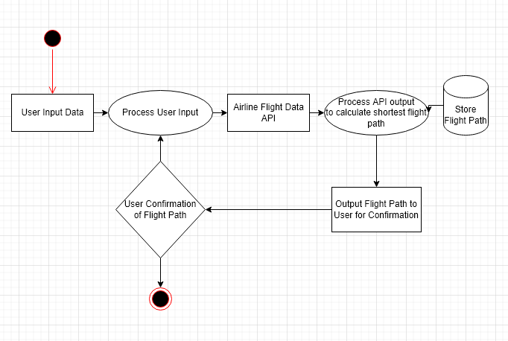

Flowchart Diagram of Efficient Flight Itinerary Architecture

* Software development will be carried out entirely in the Java Programming Language.
* IDE’s utilized will vary depending on the developers preferences but more commonly used options will be Eclipse, VS Code, and Repl.it.
* All files pertaining to the project (program, documentation, logs) will be stored on a google shared drive for safekeeping and ease of access/modification.
* Quality assurance and testing procedures will be carried out in a collaborative manner through multiple cycles of test runs to ensure that the software is progressing and operating as intended.
* West-Central Airlines maintains complete *intellectual property ownership* of entire project and design documentation.

## **Change Management**

For any changes in scope, requirements, technology, they will be logged within a Risk Assessment (RA) table. This table will consist of the proposed change, potential risks as a result of these changes, who will be affected by these changes, and a detailed description of the proposed changes. Following the logging of the proposed changes, a meeting will be conducted to determine if/how the change will be conducted effectively within the scope of the project by the group members.

# **Technical Requirements**

This software will require an API with a user-friendly interface. The API will take in user provided parameters for a flight which the software will use to calculate an itinerary with said parameters giving weights to aspects of it (parameters can include total time required, total time in flight, total time on layover in airports, total cost of trip, etc.). Access to databases of scheduled flights for all major U.S. airports in the Pacific and Central time zones will be required.

# External Interface Requirements

# User Interfaces

* User’s Flight Destination/Origin port Input, date of departure/Arrival from Origin port and date of departure/arrival from destination back to origin
  + Query user for one way trip or round trip
* User’s filter requests/requirements (Time/Cost)
* Once weighted options are generated, display top candidates suitable for customer
* Options that remain modifiable for user: departure/arrival dates limited up to a week
  + as well as users filter requests/requirements
  + Flight Destination/Origin remains static
* Once user confirms preferred flight, simulate generating a confirmed flight ticket for user

# Software Interfaces