KONE IoT Platform
Architecture OverviewRevision Status: draft

Document Control Information

Document Author: Juho Tikkala
Document Owner: Juho Tikkala

Document Approver(s):

Approver Name | Role

Summary of Changes:

Changes to this document are summarized in the following table in reverse chronological order (latest version first).

Revision | Date | Created by | Short Description of Changes
1 | 23 Feb 2016 | Juho Tikkala | Initial version
3 | 23 Mar 2016 | Juho Tikkala | Added Chinese Government integration
4 | 8 Apr 2016 | Juho Tikkala | Added security perspective section
5 | 6 May 2016 | Juho Tikkala | Updated based on review comments. Added Configuration Update subsection.
6 | 23 May 2016 | Juho Tikkala | Addressed review comments
7 | 28 Jul 2016 | Juho Tikkala | Added Provisioning
8 | 5 Sep 2016 | Juho Tikkala | Added Environment Distribution subsection. Added Service Order integration.
9 | 24 Oct 2016 | Juho Tikkala | Changed the Chinese replication decision
10 | 24 Nov 2016 | Juho Tikkala | Added public API authentication according to decision
11 | 9 Feb 2017 | Juho Tikkala | Added sizing perspective section
12 | 22 Mar 2017 | Juho Tikkala | Added data flows
13 | 18 Jul 2017 | Juho Tikkala | Added public application authentication
14 | 27 Oct 2017 | Juho Tikkala | Added new services. Updated volumetrics.
15 | 1 Feb 2017 | Fareed Ahmed | Updated reference architecture diagram

Document Source:

The latest version of this controlled document is stored in https://kone.sharepoint.com/:w:/r/teams/IoT/Platform/_layouts/15/WopiFrame.aspx?sourcedoc=%7B9987E55A-E923-4986-BF51-1F0590DE9BF4%7D&file=KONE%20-%20Architecture%20Overview.doc&action=default

Table of Contents
1. Introduction 1
1.1 Purpose 1
1.2 Scope 1
1.3 Intended Audience 1
1.4 Intellectual Property Rights 1
1.5 References 1
1.6 Open Issues 1
2. Architecture Overview Diagrams 2
2.1 System Context perspective 2
2.1.1 Logical System Context 2
2.1.2 Data Flows 3
2.2 Infrastructure perspective 5
2.2.1 Platform Components 5
2.2.2 Environments 7
2.2.3 Geographical Distribution 7
2.2.4 Geographical Data Replication 7
2.2.5 Availability 8
2.3 Connectivity perspective 9
2.3.1 Device Connectivity 9
2.4 Component perspective 10
2.4.1 Component Model 10
2.4.2 Three-Layer Architecture 11
2.5 Functional perspective 12
2.5.1 Receive Events / Send Commands 12
2.5.2 Software Update 13
2.5.3 Configuration Update 14
2.5.4 Raw Data Upload 15
2.5.5 Provisioning 15
2.5.6 Equipment / Service Order Integration 17
2.5.7 KPI/Fault Database Integration 18
2.5.8 Automatic Building Topology Analysis 19
2.6 Sizing perspective 20
2.6.1 Devices 20
2.6.2 Throughput 20
2.6.3 Storage 21
2.7 Security perspective 21
2.7.1 Confidentiality 21
2.7.2 Server Authentication 22
2.7.3 User Authentication and User Identity 22
2.7.4 Integrity 26
2.7.5 Authorization 26
2.7.6 Infrastructure Security 27
2.7.7 Data Ownership 29

Introduction

Purpose
The purpose of Architecture Overview is to:
- Communicate to both internal and external stakeholders a conceptual understanding of the architectural goals and intended architecture
- Provide a high-level vision of the architecture and its scope to developers
- Facilitate effective communication between different communities of stakeholders and developers
- Facilitate orientation for new people who join the project

Scope
The scope of this document is to be an overview of key architectural aspects of the KONE IoT platform, without going to individual technical details of each architectural area or functionality. More detailed description is available in separate documents for functional areas that require it, typically those that require significant KONE specific custom implementation.
This document only describes architectural areas or functionalities for which architecture has been defined. Thus this document doesn’t contain functional areas which are still being explored. This document doesn’t define implementation scope of any particular project or state of implemented architecture at any particular point of time.
This document does not attempt to describe application architecture of KONE-built custom applications running within the platform and consuming its services. This is only a description of “core” platform features, as jointly designed by IBM and KONE. This distinction is necessarily vague.

Intended Audience
This document is written in such high level that it should be helpful to all IT architects or developers and other technical stakeholders associated with the KONE IoT platform.

Intellectual Property Rights
This document is a summary description of other work. Intellectual property rights for this document remain with author of each passage. There is no transfer of any intellectual property rights, including rights to any architecture, design, idea, or pattern, caused by this document.

References
- “Using Blue-Green Deployment to Reduce Downtime and Risk”, https://docs.cloudfoundry.org/devguide/deploy-apps/blue-green.html

Open Issues
Not a complete list.
- End user authorization

Architecture Overview Diagrams
This section describes architecture overview of the KONE IoT Platform from various perspectives — as no single diagram can capture all essential aspects of the platform. First, a System Context perspective provides a “black box” view to the platform. Then, the Infrastructure perspective provides a static view on platform infrastructure. After that, the Connectivity perspective describes key connectivity of the platform. The Component perspective presents a summarized component model with comparison to a layered architecture model and the Functional perspective presents key dynamic functional flows across the platform. Finally, there is a brief Security perspective, although this document is not an exhaustive security walkthrough.

System Context perspective
This diagram illustrates the platform as a “black box”, exposing a set of services, surrounded by parties that connect to it (not intended as a definite list of user groups). This perspective doesn’t describe how these services are implemented in the platform, which will be detailed in the following subsections.

Logical System Context
The logical system context diagram defines a set of logical functional services within the KONE IoT Platform and its surroundings. These services include:
- Public APIs for consumption by KONE Developer Ecosystem
- Platform Portal, providing user interfaces to KONE IoT Platform. More specifically: KONE Device Management Portal will allow KONE technicians to monitor device metadata/health and perform device operations such as software or configuration update. KONE Customer Portal would be used by KONE customers. And KONE IoT Platform can provide views for administrative monitoring by KONE or IBM administrators. The KONE portal user interfaces is custom developed for KONE, as no existing user interface solution sufficiently well matches KONE IoT business process requirements.
- Integration of KONE systems. Currently the following have been defined:
  - Equipment (elevator/escalator) master integration from KONE SAP system
  - Service Need and Service Order integration from both KONE SAP and KONECT systems
- Single Sign-On experience by integrating a KONE enterprise identity provider over the SAML protocol
- Operational Database that is used by platform components for critical processing. This is using a non-relational documented-oriented database, for high availability configuration is significantly easier to achieve than with a relational database.
- Relational Database is required for some applications that only work with the relational database model
- Data Warehouse that provides persistent storage and access to historical data. Access by KONE Predictive Maintenance and Advanced Analytics tools is facilitated using regular relational database views.
- Object Storage for storing potentially large binary objects. This can be accessed by KONE devices and thus utilized for storing device software.
- Message Queue provides support for asynchronous, buffered data flows
- MQTT protocol endpoint that is used by KONE devices to connect to the platform, using this connection commands can be sent to devices and devices can send telemetry data
- Site Agent is a software component that can be optionally deployed to a KONE device. In its current version it provides store-and-forward buffering capability, so KONE devices do not need to implement a MQTT buffer in case of network outage. If Site Agent is not deployed, KONE devices can also directly initiate MQTT connections into the IoT Platform.

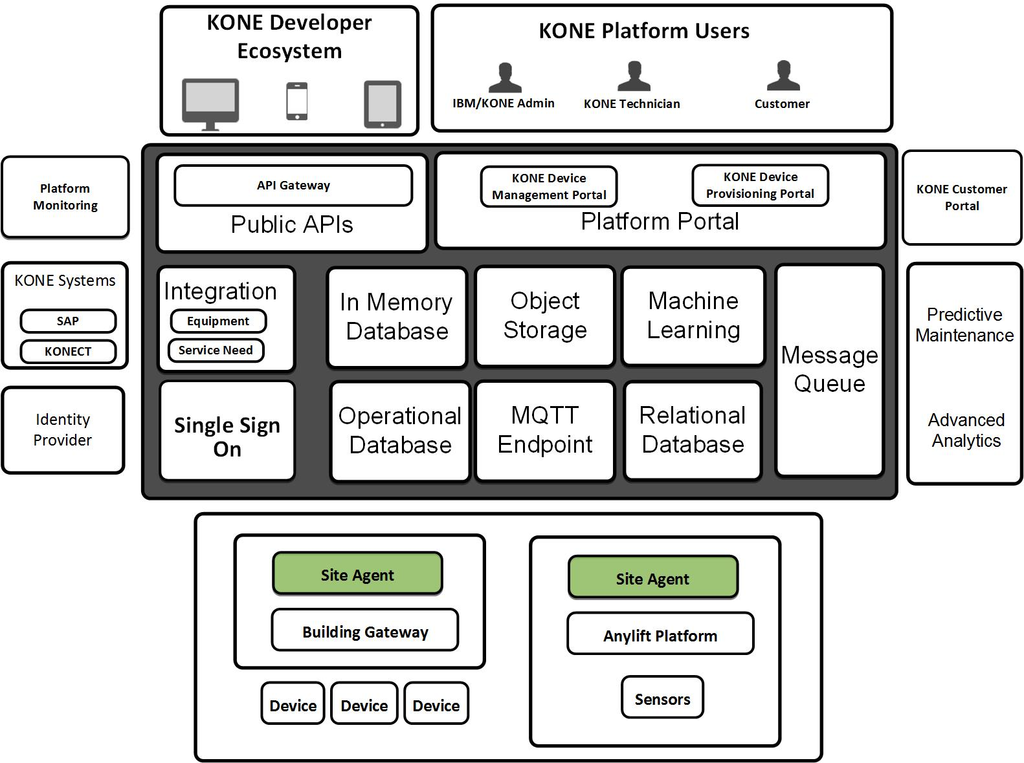

Data Flows
The diagram below represents data flows between KONE IoT Platform and its surrounding systems for high level data entities.
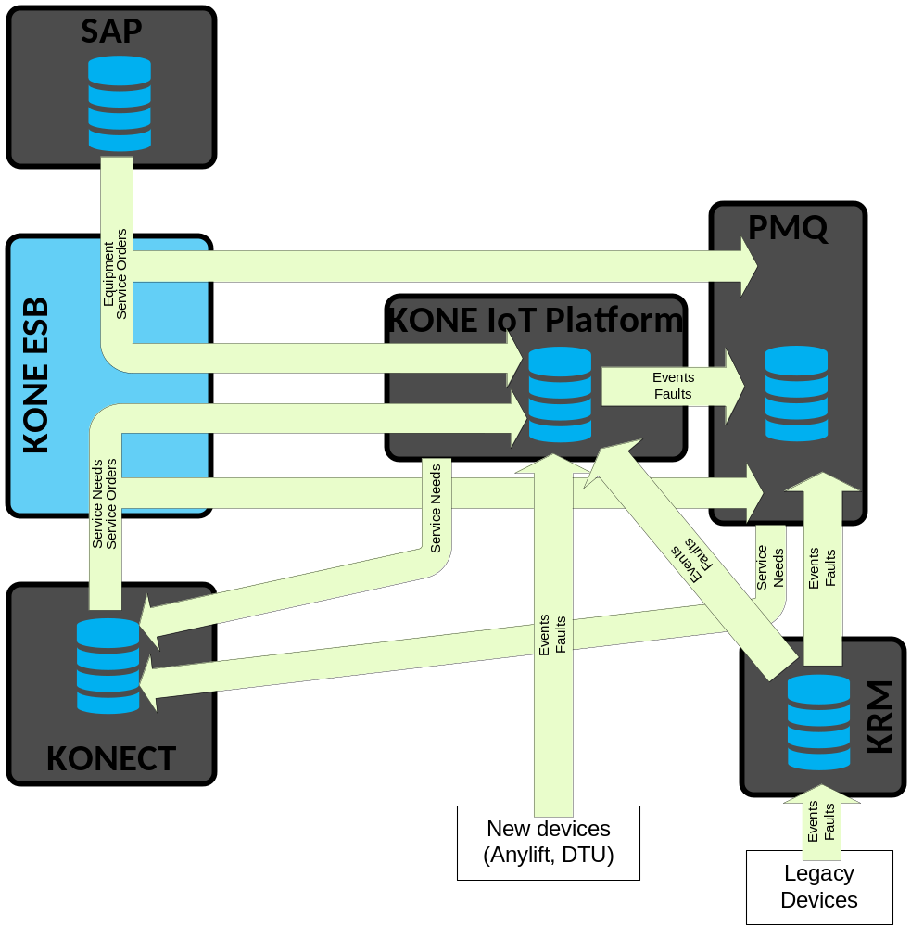
The key data flows are:
- Equipment master data is integrated from KONE SAP, through KONE ESB, into both KONE IoT Platform and the PMQ platform. PMQ is the KONE predictive maintenance platform, a deployment of IBM Predictive Maintenance and Quality platform. KONE IoT platform persistently stores this data for use by custom applications.
- Service Order and Service Need data is integrated from the KONECT system into both KONE IoT Platform and the PQM system. KONE IoT platform persistently stores this data for use by custom applications.
- Legacy KONE devices send telemetry, events and faults, into the legacy KONE Remote Monitoring (KRM) platform. This is further integrated both KONE IoT Platform and PMQ. However, within KONE IoT Platform this data is currently only made available to custom applications as it comes in, it is not stored or processed by the KONE IoT Platform.
- New devices (currently including Anylift and DTU) send events to KONE IoT Platform. These are stored in Watson IoT Platform database and can be processed using platform functionality. These events are then integrated into the PMQ platform.
- Service Needs are identified (in this case automatically) conditions that potentially require dispatching a technician on-site, in which case a Service Need generates a Service Request. Generating a Service Request from a Service Need is done by the operator of the KONECT system. Both Watson IoT Platform and the PMQ platform are able to generate Service Needs into KONECT, based on following consideration:
  - Safety critical faults: always processed in KONE IoT, as it does not fit the analytical role of the PMQ platform to perform such critical processing. Example: elevator controller sends an error code indicating a safeguard has triggered. The elevator controlled has already undertaken any automatic protective actions possible to minimize damage, the cloud side will need to create a Service Need.
  - “Simple” conditions indicating pre-fail symptoms but not critical: not that urgent, since anyway a technician will not be dispatched immediately. Examples: certain failure codes from elevator controller or simple boundary checks of sensor values. These have no firm rule, they could be either in KONE IoT Platform or PMQ platform, due to their simple implementation.
  - "Complex" conditions and scoring that results from running predictive models, typically something more complex than simple one-variable boundary checks. These are run in the PMQ platform.

Infrastructure perspective

Platform Components
The IoT platform is based on the IBM Bluemix cloud platform-as-a-service solution, which in turn is based on the Cloud Foundry open source cloud computing platform. The table lists the Bluemix services deployed as a part of the KONE IoT Platform solution. Please note that this lists the currently planned use of these services — it is not an indicator of these services being included in any particular commercial model.
Bluemix Service | Functions Addressed
Watson IoT Platform | - Device registration  - Send commands to devices  - Provide programming APIs  - Set up rules to take action when certain KPI values are exceeded
Cloudant | - Distributed non-relational database  - Used for operational data storage. This includes storing entities from the following categories:  - Equipment metadata (integrated from KONE SAP)  - Device metadata, including mapping between IoT platform device identifier and KONE equipment number  - Device configuration meta-model and configuration settings for individual devices  - Software package metadata  - Generated Service Needs
dashDB for Analytics | - Used for analytical data storage  - Long-term storage and management of IoT device telemetry data  - Provide SQL access to data for analytical tools
Redis | - In-memory database  - Used for storing state of low-value short-term interactions that do not require availability guarantees brought by persistence. An example is tracking state of a single elevator call (i.e., push of the call button).
Message Hub | - Enable intra-platform asynchronous messaging scenarios  - Acts as a throttle or buffer for data, allowing solution components to have different rates of processing without data loss
Object Storage | - Storage for (large) binary objects  - Implements the standard OpenStack SWIFT API  - Used to store KONE software packages
API Connect | - Can be used for creation of external APIs into the cloud platform
Single Sign-On | - Allows logging on to the Bluemix platform with Single Sign-On experience  - Requires user’s identity to be verified by a KONE enterprise Identity Provider, which can implement any authentication form, including multi-factor authentication
Watson Machine Learning | - Enables executing SPSS models within Bluemix  - Used when models are required as part of an operational flow not related to preventive maintenance (done in the PMQ platform)
DevOps | - Supporting services from Bluemix “DevOps” sections.  - Auto-Scaling: automatically increase/decrease computing capacity for a Bluemix application (doesn’t directly apply to Bluemix services)  - Delivery Pipeline: deploy an application into Bluemix automatically when a change is pushed into project’s (Git) source code repository  - IBM Alert Notification: system administrators to receive notifications about Bluemix and application issues  - Monitoring and Analytics: basic visibility to Bluemix application metrics such as response times  - Track & Plan: agile project planning tool
In addition to these services, Bluemix Node.JS and Java runtimes are used to implement KONE specific functionality not directly provided by IoT services. The choice of programming language (Node.JS / JavaScript or Java) depends on the task at hand — simple applications are often faster to implement with Node.JS while some software libraries are more mature for the Java platform.
Increasingly, Cloud Functions is seen to become the preferred application runtime. This is mainly because Function-as-a-Service pattern enables more fine-grained microservices that do not need to be artificially grouped into applications to conserve runtime memory requirements and thus also enables more efficient concurrent development due to reduced dependencies between microservices. However, Cloud Functions is not yet available in all Bluemix regions, so its use is currently limited to non-critical use cases that do not require local deployment in each region.
Docker containers are used when necessary as a Docker container requires more management than an application runtime. However, Bluemix VPN connectivity can only be terminated into a Docker container, not into a Bluemix runtime.

Environments
A platform-as-a-service cloud deployment, KONE IoT Platform doesn’t have environments in the traditional IT deployment sense of disparate network segments, servers, etc. However, subdivision of the single KONE IoT Platform Bluemix organization into Bluemix “spaces” is used to achieve similar effect. There are five such Bluemix spaces: Dev, Test, Pre-Production, UAT, and Production. All Bluemix spaces will by default have all Bluemix services and applications that are a part of the KONE IoT Platform solution and there will by default be no connections between spaces. These Bluemix spaces are often called “environments” for simplicity.
The above describes the set of environments available in the United Kingdom Bluemix region. Other geographies (e.g., the China Bluemix region) will have local production and pre-production environments only, but not the three lower environments.
In addition, to facilitate independent parallel development of other business projects, KONE can implement their own “sandbox” Bluemix organizations and spaces, which are not be related to the spaces used by the KONE IoT Platform described above.

Geographical Distribution
The table below illustrates the geographical distribution of the services, i.e., which services are deployed locally within each Bluemix region and which services are deployed in a single central region (to reduce deployment complexity and also taking into account that not all services are available in all Bluemix regions).
Bluemix Service | Distribution
Watson IoT Platform | Locally for each region
Cloudant | Locally for each region
dashDB | Locally for each region
Message Hub | Locally for each region
Object Storage | Single central deployment in “United Kingdom” Bluemix region (service currently available in “United Kingdom” and “US South” regions)
API Connect | Single central deployment in “United Kingdom” Bluemix region (service currently available in “United Kingdom” and “US South” regions)
Cloud Single Sign-On | Locally for each region
Watson Machine Learning | Single central deployment in “United Kingdom” Bluemix region (service currently available in “United Kingdom” and “US South” regions)

Geographical Data Replication
SAP integrations are only deployed into the Bluemix United Kingdom region. Other Bluemix regions replicate SAP master data from there.
Cloudant synchronization between Bluemix regions will implement simple multi-master model, in which every region gets a full copy of everything. China is a special case that is currently only processing Chinese devices, thus Chinese equipment master data is replicated from UK into China (filtering only the Chinese company codes), but no replication is performed the other way. Cloudant → dashDB synchronization can be implemented separately in any Bluemix region that requires metadata to be available locally for analytical purposes.
Service Order integration happens via other regions reading from the UK Message Hub instance. Each region will locally write service orders to their local dashDB instance (service orders can also be consumed by other local applications, each reading from UK Message Hub).
KPI and fault data in dashDB is not planned to be continuously replicated between Bluemix regions due to volumes involved.
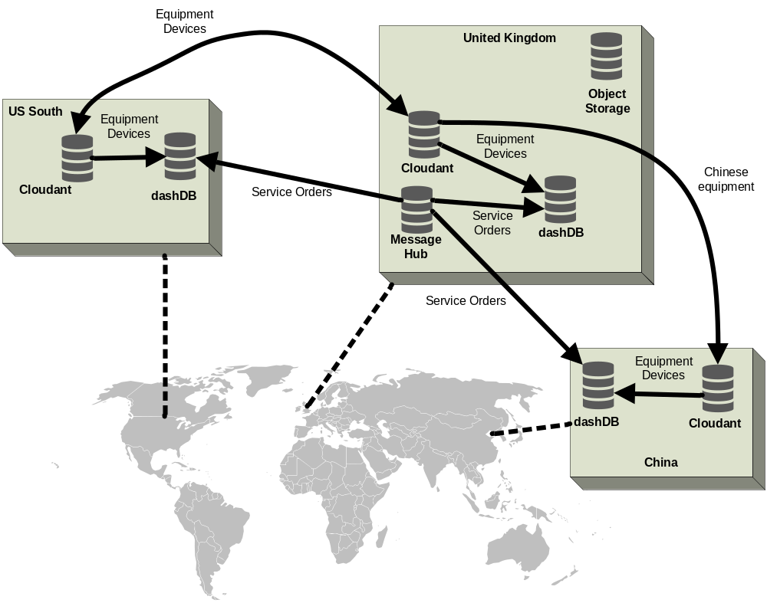

Availability
Currently each Bluemix region only has one Availability Zone, so within one region there is no protection against network, power, or similar failures, or planned downtime affecting the entire region. Within to these constraints, application within Bluemix region can be made continuously available in limited fashion by implementing “Blue-Green” deployment model [1], so there is no additional downtime because of application deployments.
Regarding Bluemix services, table below lists known availability constraints.
Bluemix Service | Availability Constraints
Watson IoT Platform | Watson IoT Platform has a defined uptime SLA within a single Bluemix region.
Cloudant | Cloudant has a defined uptime SLA within a single Bluemix region.  Cloudant “Enterprise” plan, which will be transitioned to later for production environment, is a 3-node cluster running on dedicated hardware. All data is essentially stored 3 times, making simple database failures unlikely. Cloudant “Lite” plan, currently used in all environments, is a shared instance: also a cluster, but shared with other tenants.  In both cases the cluster is within a single data center so it’s by itself not a fully high available solution. Further level of high availability can be achieved by replicating data to a Cloudant cluster in a different data center, which is relatively easy to set up in a document-oriented database such as Cloudant. However, this is not currently done. In KONE context this could be, e.g., replication between “United Kingdom” and “US South” Bluemix regions.
dashDB for Analytics | dashDB for Analytics SMP, use in production, pre-production, and UAT environments, is a database instance running on a dedicated server. It is not a high availability offering. It is a single database instance and has scheduled maintenance breaks. It is meant to be a high volume analytical data store and lack of high availability places some constraints on using it operationally.  There is a high availability dashDB offering available (dashDB Enterprise for Transactions High Availability) but dashDB for Analytics currently used with KONE IoT Platform is not a high availability offering.
Message Hub | Message Hub is a shared, multi-tenant instance. Underlying Apache Kafka is set up as clustered for added redundancy. Minimum number of in-sync brokers is set to 2, meaning that the cluster can survive a single node failure without data loss, reducing likelihood of simple failures.  However, Message Hub does not currently have single Bluemix region SLA with defined uptime.
API Connect | API Connect has a defined uptime SLA within a single Bluemix region.
Bluemix services used in the solution other than those listed above do not have single Bluemix region SLA with defined uptime.

Connectivity perspective

Device Connectivity
The following diagram illustrates the manner KONE devices connect to the IoT platform. Connectivity between devices and the IoT platform is based on the MQTT protocol, with the only identified exception in currently designed platform functionality being large binary object transfer, which is implemented using the HTTPS protocol. All connections (both MQTT and HTTPS) are encrypted using TLS.
Site Agent is an optional component that can be deployed to a device running at a KONE customer site. It provides store-and-forward buffering capability, so that device software doesn’t need to buffer MQTT in case of network connectivity issues. The component is optional because it would be equally possible for the device to make a direct MQTT connection straight to Watson IoT Platform and this is a supported connectivity scenario as well. The Site Agent has an associated Controller component, which is able to update connectivity related configuration when receiving a command message from the IoT platform.
Site Agent can be deployed inside a data transfer device, such as the Anylift device or a DTU for Chinese Remote Monitoring. Or it could support more complex deployment scenarios with multiple devices on a site connecting through a single Site Agent installation (these are not yet defined in detail).
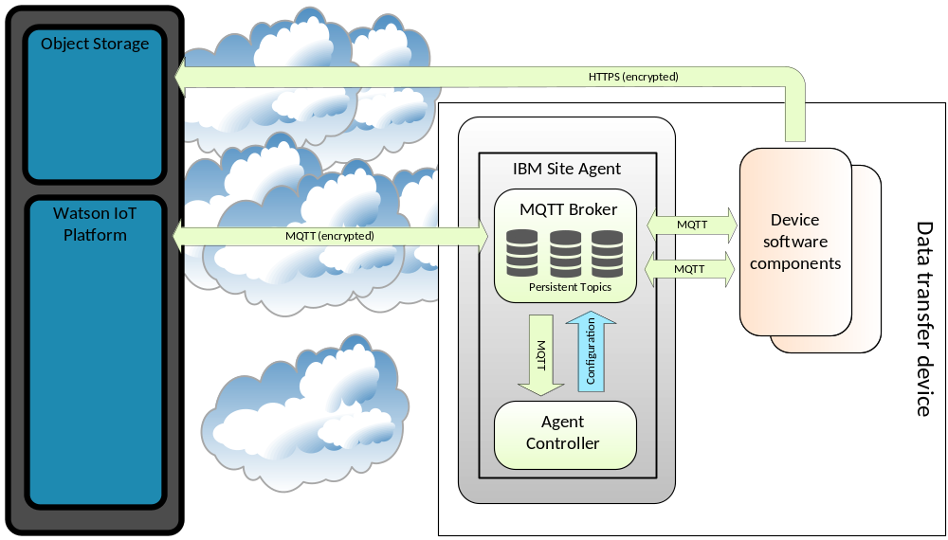

Component perspective

Component Model
The UML Component Diagram below specifies a high level component model of the KONE IoT Platform solution. This is a high level summary only — more details can be found from component model documents of respective subsystems.

Device Management
This is a component model of the Device Management subsystem, i.e., application components that have to with operational device maintenance and predictive maintenance.
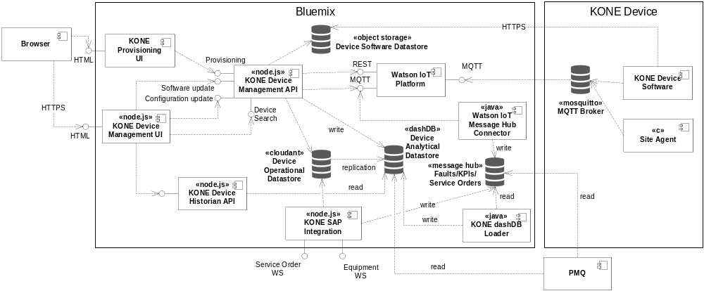
At high level, the KONE specific application components in the diagram are:
- KONE Provisioning UI is the user interface component implementing device provisioning process, used by installing technicians when connecting new devices into the platform
- KONE Device Management UI is the user interface component implementing KONE end user device management functionality (device search, device software update, device configuration update, device dashboard, etc.): a user interface specifically tailored to meet requirements of KONE IoT business processes
- Device Operational Datastore is a Cloudant document database, having a JSON document representing each SAP equipment and KONE IoT platform registered device. It is used for operational use cases of the KONE IoT platform.
- Device Analytical Datastore is a dashDB relational database, which has a relational view to data within Device Operational Datastore, in addition to having KPI/fault history for the devices. It is primarily for use by analytical purposes — although operational applications can also be written that take advantage of this data if they can tolerate small amount of latency caused by replication from Cloudant.
- Device Software Datastore is a Bluemix Object Storage repository for binary software packages, to be used in context of device software update functionality
- KONE Device Management API provides backend functionality for the KONE Device Management UI, but is not tied to that, so the REST services can also be used by other applications. It is implementing the KONE specific business rules on top of functionality provided by underlying Watson IoT Platform. This is drawn as a single component in the diagram, but it consists of three microservices:
  - Device Provisioning, for registering new devices into the platform according to the KONE device provisioning process
  - Device Search, for searching the Device Operational Datastore (in Cloudant) by various criteria
  - Device Management, for performing KONE device management operations, such as software update and configuration update
- KONE Device Historian API provides historical (in practice this is near-real-time, with some minutes delay) KPI data from the Device Analytical Datastore (in dashDB), including also performing specified statistical calculations on this data
- KONE SAP Integration provides SOAP web services for integrating both equipment and service order data to KONE IoT platform, currently called by KONE ESB. Data is transformed and then forwarded to Cloudant (equipment) or Message Hub (service orders).
- KONE dashDB Loader loads Device Analytical Datastore (in dashDB) with KPI/fault data by transforming from JSON messages into relational schemas
- MQTT Broker is a deployment of Mosquitto MQTT Broker in a KONE device, providing message buffering in case of network connectivity issues
- Site Agent provides command and control functionality for the MQTT Broker

Three-Layer Architecture
The KONE IoT Platform as a whole doesn’t implement pure layered architecture. However, the subset responsible for rendering KONE specific portal user interface represents a traditional three-layer architecture. This is illustrated in the diagram below.
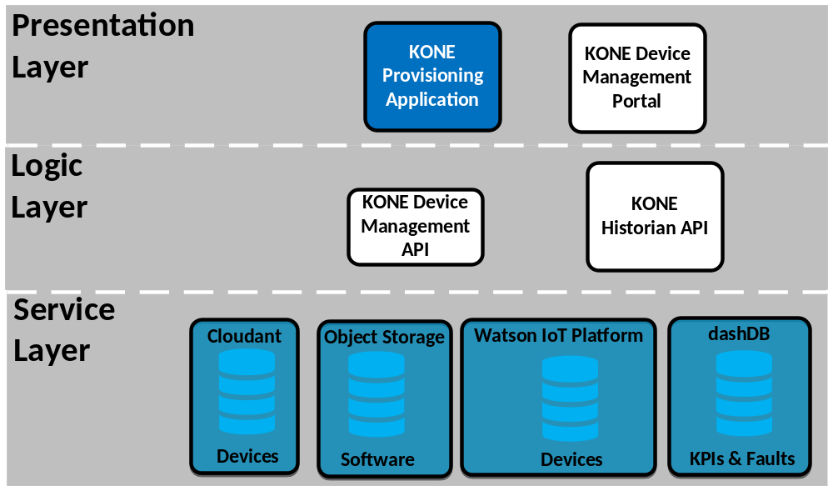
The Service Layer is formed mostly from Bluemix service components and does not contain significant KONE specific code. In addition to databases, it also includes the Watson IoT Platform. Semantically this layer forms services used as building blocks for the KONE specific solution.
Logic Layer is already KONE specific. It forms the KONE specific business logic on top of Service Layer.
Presentation Layer implements KONE specific user interfaces.
It is generally not allowed to skip layers, so user interfaces would need to go through Logic Layer. This is to be able to enforce, e.g., KONE specific authorization and other business rules. However, this is not a strict policy.

Functional perspective
This subsection documents how key functionalities are realized within the KONE IoT Platform. This subsection will grow as more functional architecture is designed — the current contents is not an exhaustive list of all possible functionality.
Regarding notation, arrows in all diagrams imply data flow direction, i.e., they do not imply dependency or initiator of a connection — these are topics for more detailed design.

Receive Events / Send Commands
The diagram below illustrates two flows: IoT platform receiving events (communication of any type, including KPIs and faults) from a device and sending commands to a device. The flow for receiving events is:
- KONE site software publishes an MQTT message to a local MQTT topic at Site Agent
- Site Agent stores the message locally. If connectivity is currently enabled, the message will be immediately forward to the IoT platform and deleted from local storage. Otherwise, the message is buffered and sent once connectivity resumes.
- The IoT Platform receives the message, which can be visualized in the IoT user interface. Besides this simple visualization, other processing that can happen to events is a different functional scenario.
The flow for sending a command to a device is:
- Sending of a command is initiated either through the IoT user interface or by sending a message to the appropriate MQTT topic from a custom application (which custom application depends on the type of the command, details of these are different functional scenarios). The IoT user interface only supports sending IoT predefined commands (reboot, factory reset, firmware download, firmware upload). Sending other, KONE specific, commands require a custom user interface application to be developed.
- Site Agent reads the IoT platform MQTT topic and stores the command message into a local MQTT topic
- KONE site software reads the MQTT topic from Site Agent and acts on the command
- If the command requires a response to be delivered to the originating application, this can be arranged by following the receiving event flow above
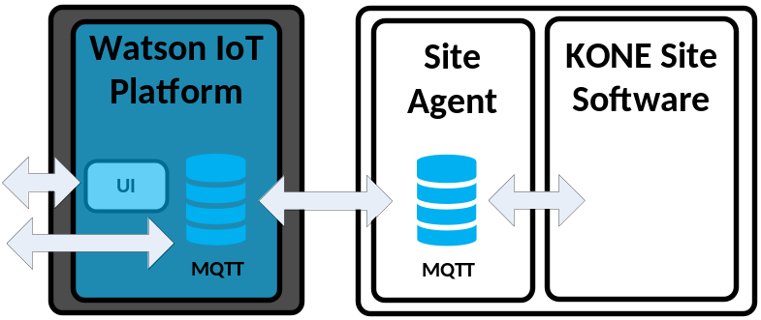

Software Update
The software update functional scenario is a bit similar to the Send Command scenario described above. This scenario covers only the simple Anylift/DTU devices, process for more advanced devices will be more complex.
- Sending of software update command is initiated from the KONE Device Management Portal, a custom web application implementing the KONE specific device management user interface
- The application calls the KONE Device Management API, a custom API that implements KONE specific device management business rules and functionality, on top of what the IoT platform offers. In this case it reads device information from Cloudant and software package metadata from Object Storage and uses these to send an update request to the Watson IoT Platform API
- From here on it is the same flow as Send Command above, up to the point where the KONE device would act on the command, i.e., start preparing the update. At this point the device needs to connect to Object Storage and, using the HTTPS protocol, to download the user-selected new software for the device. The device will respond with an acknowledgment message with success status of the update.
- The device acknowledgment is propagated all the way to the KONE Device Management API, which saves the new device status to Cloudant
- The KONE Device Management Portal will poll for the status and display progress status of update to the user
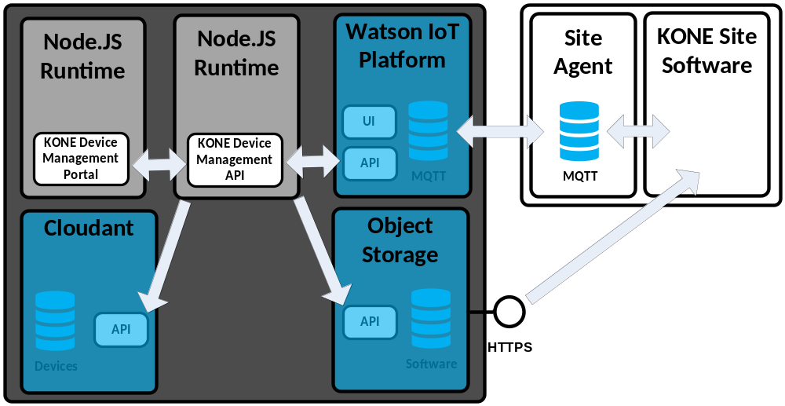
There is a potential future development path in which Site Agent could download the update on behalf of the device and make the update available to other devices on the same site (so the upgrade would be downloaded only once per site with multiple similar devices).
There is also a supporting flow of uploading new firmware images to Object Storage, which also happens through the KONE Device Management Portal and Device Management API.

Configuration Update
Configuration update flow is very similar to Software Update flow above — the main difference being that Object Storage is not involved in this process. Also, the Watson IoT Platform doesn’t have a REST API for this, instead, update messages are sent by the KONE Device Management API through MQTT. The KONE Device Management API abstracts away such implementation differences. This scenario covers only the simple Anylift/DTU devices, process for more advanced devices will be more complex.
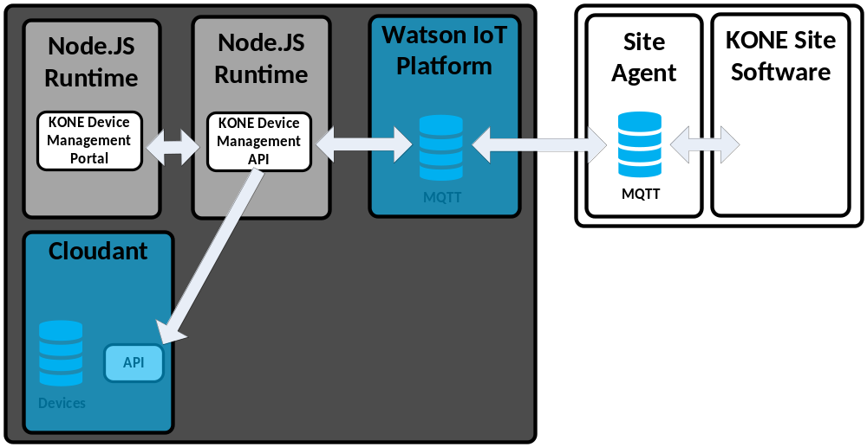

Raw Data Upload
This scenario is about uploading arbitrary large binary files from the device into the IoT platform, as a response to a command received from the IoT platform. It is assumed this is mostly done for device diagnosis purposes. It is essentially the reverse of the software upgrade scenario — in this case, instead of downloading a binary package the device is uploading a binary package to Object Storage. The binary package can be subsequently downloaded from Object Storage, through its user interface, for offline analysis — the current IoT platform doesn’t support online analysis for binaries uploaded this way.
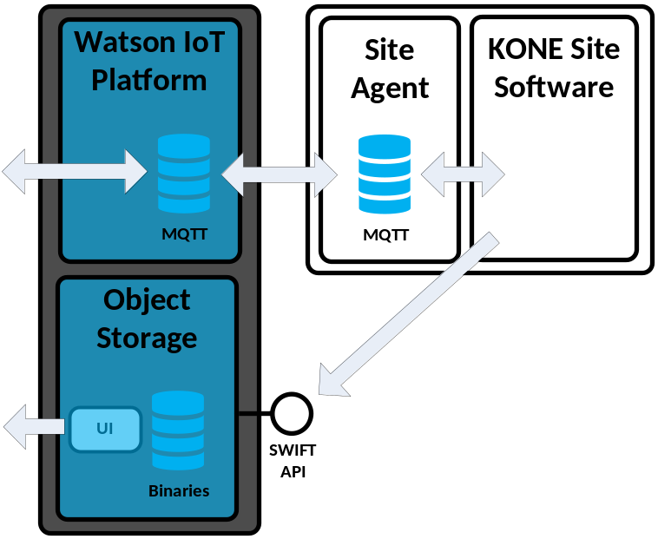

Provisioning
The provisioning scenario involves registering a device into the KONE IoT platform, so it has to be invoked before any other functionality can be performed for that device. This scenario covers only the simple Anylift/DTU devices, process for more advanced devices will be more complex.
The scenario involves two instances of Watson IoT platform: a separate instance is used only during provisioning and another after that for production use (which is therefore the instance referred in all other functional flows). This is because the initial connection from the device is with an algorithmically generated and thus less secure authentication token (password) and only after the devices has connected once can it be given the randomized authentication token shared with the IoT Platform for use in all subsequent communication. At this point the device can also be conveniently directed to any production instance in another Bluemix region. The flow given below illustrates this multi-region case.
Steps in the flow are:
- A KONE installing technician, while at site, uses the KONE provisioning user interface web application, running within the Bluemix platform, to start the process. Starting the process requires the technician to specify the device identifier, which can be, e.g., printed on the physical device.
- KONE Provisioning Application then calls the provisioning operation of the KONE Device Management API
- KONE Device Management API will register the device into the “provisioning” Watson IoT Platform instance and Cloudant device database
- The device establishes the connection to the platform (it may have been periodically trying to do that since power-on, but now it succeeds, having been registered), with the algorithmically generated authentication token
- KONE Device Management API detects the device connecting and sends the Site Agent on the device instructions to switch connection to the production Watson IoT Platform instance (potentially in a different Bluemix region) along with a new, randomized, authentication token. It also registers the device with the production IoT platform instance with this authentication token. However, unless steps 1–3 above have been performed, this does not happen, so any device simply connecting by itself without actions by a technician will remain in the provisioning Watson IoT Platform instance indefinitely. A device only in provisioning instance is still essentially isolated from the rest of the solution.
- Site Agent on the device updates its connectivity settings, breaks the existing connection, and reconnects to the production Watson IoT platform instance, as instructed
- Another KONE Device Management API instance, collocated with the production Watson IoT Platform instance, detects the new connection and updates its local Cloudant database that the device is now in active status
- Cloudant is replicated between Bluemix regions and eventually the original Bluemix region sees this state update as well
- KONE provisioning application can query this state and knows that the process has been finished
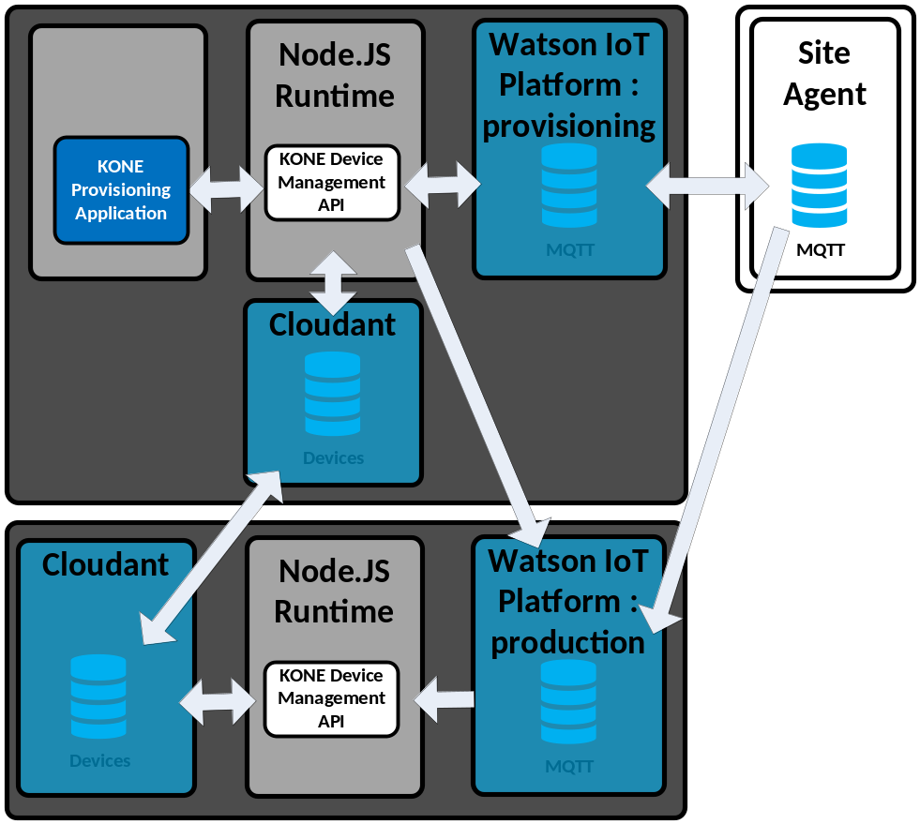

Equipment / Service Order Integration
The first scenario is about integrating equipment metadata to the IoT platform. The source for this metadata is KONE SAP system. The flow is a follows:
- KONE SAP will notify KONE ESB (Enterprise Service Bus) about a change in equipment data
- KONE ESB will call a web service interface exposed by the KONE custom Equipment Integration Application running in the IoT platform
- The SAP Integration Application will persist the equipment updates into a Cloudant database
- The Cloudant database is configured to replicate its content to dashDB, so in a few moments this information will also be replicated to dashDB and is available there for analytical purposes
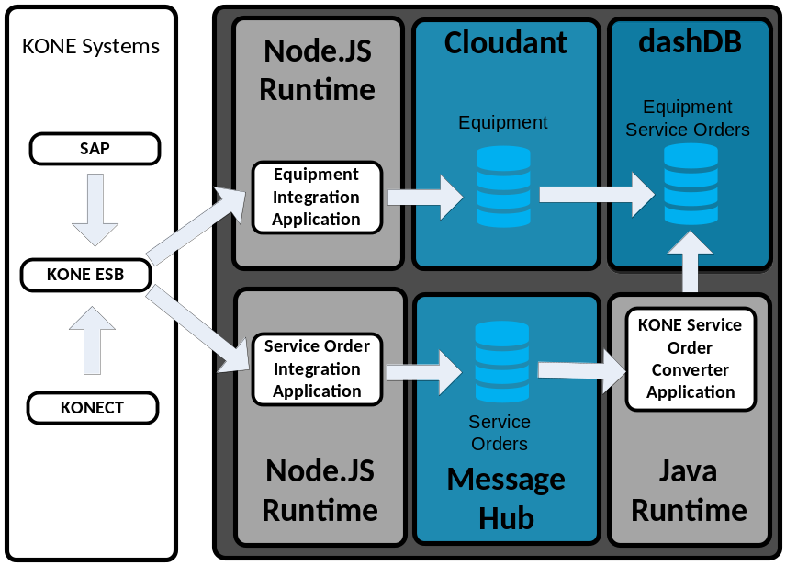
Another scenario illustrated in the same figure above involves integrating service order data from SAP and KONECT systems to the IoT platform.
- KONE SAP and KONECT will notify KONE ESB about changes to service order data. It is not visible to the IoT platform which of these is the originating system.
- KONE ESB will call a web service interface exposed by the KONE custom Service Order Integration Application running in the IoT platform
- Service Order Integration Application will persist the service order updates into a Message Hub topic. Unlike equipment, service order updates are not saved to Cloudant, as service orders are considered historical data, not operational data, from IoT platform perspective. This also reduces space consumption within Cloudant. From Message Hub, service orders can be subscribed up by any interested application.
- A KONE specific Service Order Converter Application continuously consumes messages from Message Hub, converts them into KONE data warehouse schema, and loads dashDB. Also this application runs on the Java platform, this is because Java-based Message Hub APIs are currently more mature.

KPI/Fault Database Integration
This scenario is about loading the IoT relational database, i.e., dashDB, with KPI and fault data. The flow is as follows:
- KPI/fault MQTT message is received by the IoT platform (from a device, as discussed above)
- Watson IoT Platform built-in functionality is used to bridge KPI/fault events from MQTT topics into Message Hub topics
- A KONE specific KPI/Fault Converter Application continuously consumes messages from Message Hub, converts them into KONE data warehouse schema, and loads dashDB. Also this application runs on the Java platform, this is because Java-based Message Hub APIs are currently more mature. DashDB load is performed using regular SQL insert statements. While this is not the most high throughput way to load dashDB, it is robust, as it doesn’t require exporting the data into a CSV file or similar intermediate storage.
- The KONE Historian API exposes a REST interface for querying KPI data
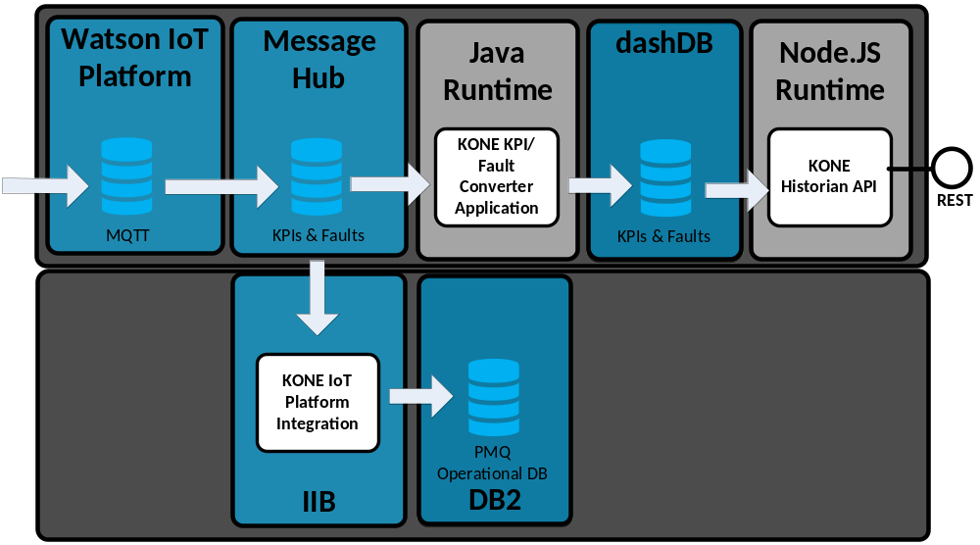
Message Hub is required in this flow to provide buffering to facilitate spikes in traffic volumes and temporary unavailability of connection into dashDB. Message Hub is technically able to buffer traffic indefinitely, limited only by allocated disk space. Thus, even long breaks for dashDB connectivity can be facilitated. However, the Bluemix service does place some limitations on amount of space that can be consumed and age of messages that can be retained.
Currently Watson IoT platform will buffer up to 1 gigabyte of messages for MQTT. Thus if Message Hub is not available for an extended period of time, Watson IoT Platform can only buffer messages up to this size before there is irrecoverable data loss. Bluemix uptime guarantee is not sufficient to guarantee the required level of uptime for Message Hub to avoid such data loss in all cases.
Also the PMQ system reads Message Hub. Thus PMQ gets messages that comes from devices directly, without processing by the KONE IoT Platform.

Automatic Building Topology Analysis
The Anylift device requires building floor topology information, that is, number of floors in the building and each floor distances in meters, in order to be able to include floor numbers within messages. It is not viable to manually configure this information. There are two ways to teach the device this: a manual learning run can be conducted by installing technician, which involves driving the elevator to each floor one-by-one, or a cloud analytical solution can derive floor information from accumulated data after sufficient period of normal use. This latter method is preferred due to significant savings in technician’s time and has been implemented. The flow in this scenario is as follows:
- Daily trigger within Cloud Functions runtime invokes the Floor Calculation function
- The function starts the Floor Calculation SPSS Model deployed into the Watson Machine Learning service
- The model gets a list of devices without floor numbers from last week from dashDB. It will then attempt to infer floor positions for all such devices from available KPI data. Results of this are written back to dashDB into a dedicated temporary table.
- The function polls the model task periodically to detect when it has completed its run. Then the function reads the results of the model execution form database. For devices for which the model converged, newly-obtained floor information is sent as configuration update for each affected device, using Configuration Update mechanism described in subsection 2.5.3.
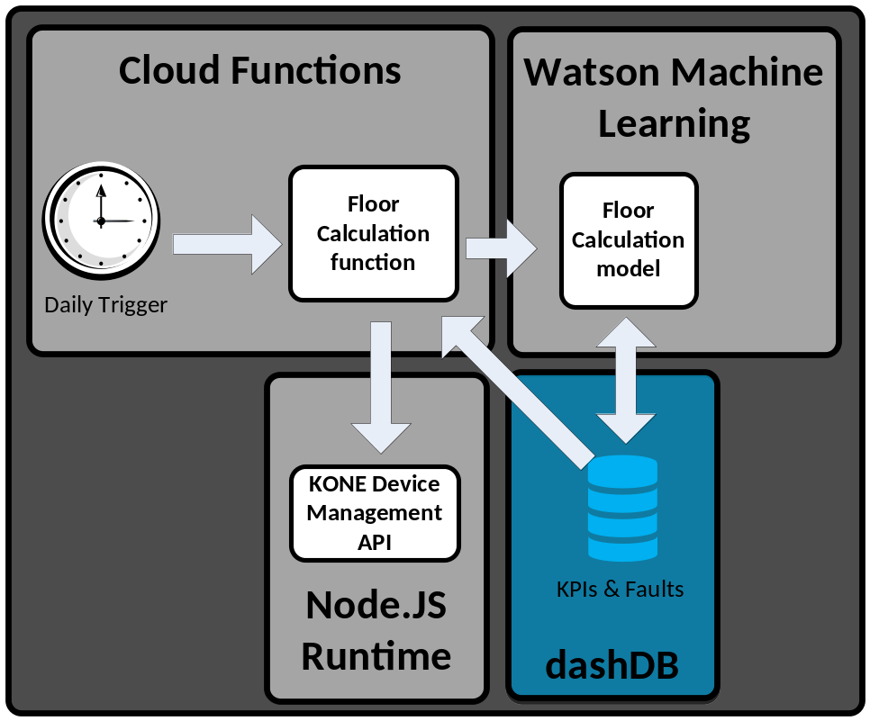

Sizing perspective
Key capacity metric for the platform is number of connected devices of given type. This, combined with device characteristics, specifies number of messages per time unit. Combined with average message size this gives data storage requirement.
This estimate is based on currently in-production device types: legacy KONE Remote Monitoring, Anylift, DTU. It does not take into account possible needs for more advanced products. Also it doesn’t take into account messages generated by devices when in “real time” mode.
Discussion below does not specify how different devices are globally distributed, volume figures given are global total values.

Devices
In the target state, number of connected devices is estimated as:
- 600 000 Anylift devices
- 2 000 000 other devices
- = 2 600 000 total devices
Anylift device volume is specifically significant due to it being much more “chatty” in normal operation towards cloud than any other current KONE device, sending messages per movement instead of merely periodic routine calls

Throughput
Anylift capacity requirement is estimated by following numbers for KPI messages:
- An average Anylift device has 100 000 starts/year = 274 starts/day. Each start generates one KPI message and 1.2 door messages, so a total of 2.2 messages per start.
- Anylift device duty cycle is assumed to be 12 h/day. However, also assuming even global distribution, this is not relevant to the total number.
- Anylift average message throughput: 600 000 × 274 / day × 2.2 = 361 680 000 / day = 15 070 000 / hour ≈ 4186 / s
Other devices capacity requirement for other devices is estimated as follows:
- Other devices send 100 persistent messages of any type / day
- Other device persistent message throughput: 2 000 000 × 100 / day = 200 000 000 / day ≈ 8 333 333 / hour ≈ 2315 / s
- 10 % of other devices will be sending a real-time status message once per second at all times
- Other device real-time message throughput: 2 000 000 × 10 % × 1 / s = 200 000 / s = 720 000 000 / hour = 17 280 000 000 / day
Total throughput of messages from devices is 361 680 000 / day + 200 000 000 / day + 17 280 000 000 / day = 17 841 680 000 / day ≈ 743 403 333 / hour ≈ 206 501 / s.
Service order / service need messages (that are integrated to IoT platform but do not come from devices) are assumed to occur at rate of 6 message / month / device: 2 600 000 × 6 / month = 520 000 / day ≈ 21 667 / hour ≈ 6 / second.

Storage
From these throughput figures, storage space consumption can be roughly estimated. If average messages sizes when stored as binary to database are:
- 200 bytes for Anylift message
- 1000 bytes for other device message
…total space required to store can be estimated as:
- For Anylift KPI messages 361 680 000 / day × 200 bytes = 72 336 000 000 bytes/day ≈ 72 gigabytes / day ≈ 2 170 gigabytes / month ≈ 26 403 gigabytes / year
- For other device persistent messages 200 000 000 / day × 1000 bytes = 200 000 000 000 bytes/day = 200 gigabytes / day ≈ 6000 gigabytes / month ≈ 73 000 gigabytes / year
…total space required to store everything above can estimated as (72 336 000 000 bytes/day + 200 000 000 000 bytes/day) = 272 336 000 000 bytes/day ≈ 272 gigabyte/day ≈ 8170 gigabytes/month ≈ 99 403 gigabytes/year.
In addition to the above device-originated flows, database storage must be reserved for other things stored in the platform as well, such as service order/need data and equipment data, etc. The purpose of above calculation is to be a rough indication on how storage requirement scales as a function of device count.

Security perspective

Confidentiality
All transport over the public Internet is to be encrypted using the TLS protocol. The set of offered TLS protocol versions and cipher suites is managed by Bluemix platform. For MQTT connectivity from devices, the minimum required TLS version is currently 1.2. For HTTPS connectivity, TLS is currently allowed for protocol versions 1.0–1.2 for enhanced compatibility with various clients.
No VPN solution is required strictly for confidentiality purposes, however, in some cases VPN might still be the easiest way to arrange connectivity to KONE enterprise systems behind KONE firewall.
This document does not discuss mechanisms used in the public Bluemix platform to isolate customer data in a multi-tenant environment.

Server Authentication
All TLS secured communication will be authenticated by the client verifying the server certificate (third party clients are of course not under platform control) according to usual TLS conventions.
MQTT connectivity from devices will follow the same pattern as regular web browser connectivity, i.e., it is verified that the server holds a valid certificate for the domain, signed by a trusted root certificate authority, the certificate of which has been deployed to the device (currently IBM Watson IoT platform MQTT TLS certificates are signed by DigiCert).

User Authentication and User Identity
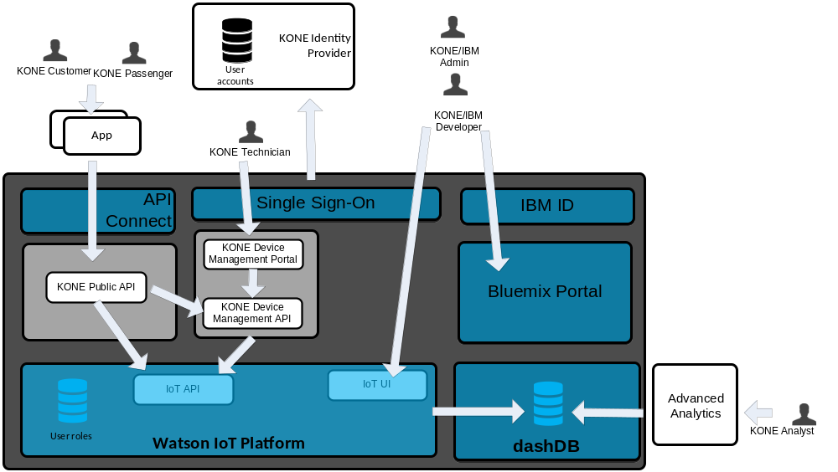

Human Users
Platform users can be divided into user groups as in table below. Each group is then discussed in more detail in following subsections.
Bluemix Service | Functions Addressed
KONE Users | KONE employee end users, who access the KONE IoT platform over the public Internet. Authenticated by KONE Active Directory. For authorization purposes the users are also created into Watson IoT Platform user registry.
Administrator Users | Developer or administrator access Bluemix platform dashboard over the public Internet. Log in via an “IBM ID”.
Public API Users | Partner companies using Public APIs can be considered as users. These users are managed in API Connect. Authentication is via a shared secret (password).  In some, but not all, business scenarios KONE maintains identity of passenger users who access public APIs. In these cases passenger user repository is Single Sign-On Bluemix service Cloud Directory.

KONE Users
Platform employee end users, who access the KONE IoT platform over the public Internet, are authenticated by KONE Active Directory, which generates the SAML token consumed by the IoT platform. This user groups includes KONE call center, technical support, field technicians, etc. This allows leveraging any authentication mechanism supported by the KONE SAML authentication endpoint, including multi-factor authentication. Email address is the unique identifier for user accounts both in the IoT platform and in SAML. The IoT platform by itself doesn’t implement any additional authentication mechanisms beyond what is leveraged through SAML.
This is illustrated on the diagram below. This is standard SAML and OpenID Connect flow with nothing particularly KONE specific. After this flow communication is between application and browser, with SSO no longer in the loop. More specifically, session is maintained by the application and SSO has no subsequent control over application session.
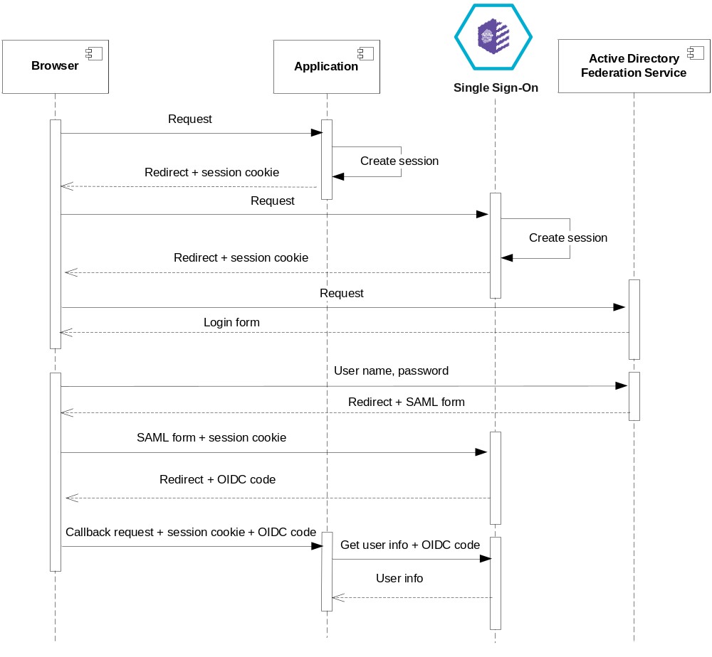
It has not yet been defined what will be the authentication mechanism for employee end users not in KONE Active Directory.

KONE IoT Platform Administrator Users
Developer or administrator access to the Bluemix platform dashboard over the public Internet is secured by logging in via an “IBM ID”. This is a user name / password based login mechanism. Bluemix dashboard is the tool using which the KONE IoT platform is administered, which is different from platform end user interfaces. The administration dashboard does not participate in SAML Single Sign-On. Amongst other things, it is used to administer the SSO solution.
KONE analysts using analytical tools can partially bypass other IoT platform user authentication mechanism as they have read-only access to data through a database view using database credentials. Management of database credentials has not been currently defined.

Passenger API Users
In some, but not all, business scenarios KONE maintains identity of passenger users who access public APIs. In these cases passenger user repository is Single Sign-On Bluemix service Cloud Directory. This has been integrated as a user repository into API Connect, which implements the OAuth 2 server on top of that. Caller of a KONE Public API will first connect into API Connect OAuth 2 server to obtain the access token. API Connect is then calling the Single Sign-On service to verify user identity — a separate “KONE IoT Passenger Directory” component is required due to API Connect “authentication URL” client interface not exactly matching the SSO authentication service interface. This token will then be included in all API operations that go through API Connect.
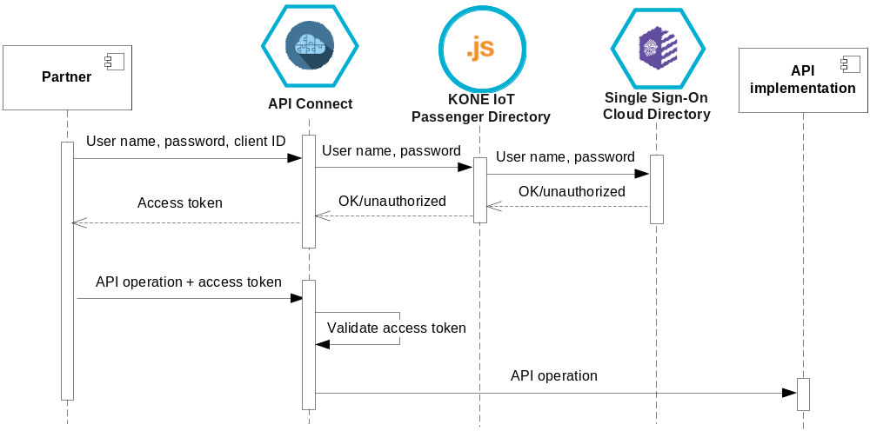
It is also possible to utilize form based authentication, in which case the caller does not sent the user name and password credentials directly, rather the user will enter them into a form provided by API Connect. It is not known if any APIs will use this method, though, since that requires the caller to be HTML capable.
Due to path between Bluemix API Connect service and API implementation traveling within public Internet it needs to be secured as well to ensure that API Connect cannot be bypassed and, less critically, that API implementation cannot be spoofed. This is achieved via mutual TLS certificate authentication.

Passenger Application Users
Passenger users can in some cases log into KONE-developed publicly accessible applications as well as to public APIs. For mobile applications it is desirable that user credentials not be stored into the mobile device and also that the user not need to key in credentials every time. For this purpose the OAuth 2 server from API Connect can again be leveraged similar to the API authentication solution — in this case the API Connect component is not mediating requests, so that an application needs to explicitly call token introspection API to validate the token.
Also it is illustrated how a mobile application can use this functionality to create a web session with a transparent “single sign-on” experience, by passing its OAuth 2 token onwards to a web application.
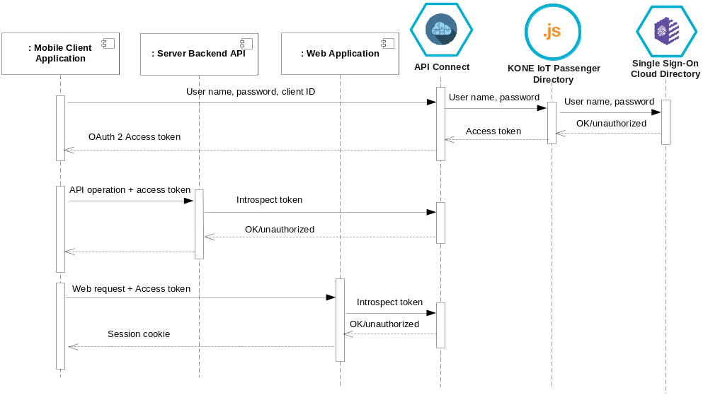
A web application can also create sessions the regular way by integrating into the SSO service as usual.
An application can act as a trusted “partner” towards public APIs. This means that while the application has identified the user, it will not propagate user information onwards to the public APIs.

Partners
Partners (organizational entities allowed to call public APIs) are managed in API Connect as “clients”. Authentication is via a shared secret. This approach is obviously not applicable to implementing secure serverless (e.g., mobile) client applications as integrity of the shared secret cannot be maintained. But the problem of fully securely authenticating a particular public client application is in general unsolvable if it assumed an attacker can always reverse engineer whatever authentication mechanism or secret is put into the application.

IoT Devices
MQTT connectivity from devices will be authenticated by a device specific MQTT protocol device ID / authentication token pair, which conceptually corresponds to user name / password authentication. The device ID is unique for each device. Device’s initial authentication token is generated by taking a cryptographic hash from the device ID and a platform-wide shared secret. Once connectivity has been established, there is an option (if implemented) to change the authentication token into a random one (this will require deleting and re-provisioning the device into the Watson IoT platform with the random authentication token).

Internal APIs
Authentication to KONE IoT Platform private APIs is in general done using private/public key pairs, where the caller has a private key and the micro service implementing the API has been configured with the corresponding public key. A JSON Web Token (JWT) included in each API request is then signed with the private key. Keys are (can be) different for different environments (see subsection 2.2.2).
“Internal” or “private” API is a conceptual definition. Within public Bluemix, also private APIs are open to Internet at network level.

External KONE Systems
HTTP based system-to-system integrations to other KONE systems are secured with HTTP basic authentication with application credentials.

Integrity
There are no specific checks in place for data or message integrity, except that messages correspond to interface syntax to extent they can be processed and message endpoints are authenticated as described above. However, transport integrity is to some extent provided by encrypted transport.

Authorization

Human Users

KONE Users
Current version of the KONE IoT Platform does implement a simple end user (non-administrator) authorization scheme that has three user roles:
- Admin: can view any end-user visible data and perform any end-user functionality
- Operator: can view any end-user visible data and perform any end-user functionality for selected devices (such as software or configuration update), but cannot perform any functionality that affects other system state (like altering device profiles)
- Read-only: can view any end-user visible data, cannot perform any functionality that would affect device or system state
…it is planned that future versions of the platform will have a more advanced authorization scheme.
Authorization level for each user is stored in Watson IoT Platform user directory.

KONE IoT Platform Administrator Users
Developer or administrator user access to Bluemix is restricted by access control configuration of each Bluemix service. These privileges are broad and in most cases do not support row level access control, so anyone with administrator access to a particular Bluemix service in a particular environment can be assumed to have full read/write access to all data in it. This can be controlled separately for different environments (see subsection 2.2.2) but there is no fine grained control what the administrator can do within an environment.

Passenger API Users
Authorization for Public APIs is currently implemented within each API implementation application. KONE IoT Platform does provide an API to query whether a registered passenger user has access to a building ID. Building ID based authorization is based on building ID specific user groups as stored in Bluemix Single Sign-On service Cloud Directory repository.

Passenger Application Users
Implementing authorization decisions for passenger-targeted applications is not currently in scope of KONE IoT Platform. While an application can get passenger user authentication from KONE IoT Platform, it is responsible for performing its own authorization logic.

Partners
Partner authorization is implemented similar to Passenger API User authorization describe above.

IoT Devices
Device MQTT connectivity is authorized so that each device can only publish to its event topic and subscribe to its command topic. Devices cannot access topics of other devices. Devices also cannot publish commands to own command topic.

Internal APIs
Most Bluemix services do not support row level access control. Possessing a valid API key to a particular Bluemix service in a particular environment in general allows full read/write access to it. Thus API keys for Bluemix services cannot be directly passed to third parties but any access needs to be mediated by a KONE IoT platform specific API to implement KONE authorization policy. API keys can be different for different environments (see subsection 2.2.2).
Internal APIs developed specifically for KONE do in some cases contain the authorization logic as well. However, there is currently no secure end-to-end authentication from the user through a user interface component up to backend APIs, so even in these cases, the internal API is trusting user identity provided by the user interface layer, which has received authentication in secure manner.

External KONE Systems
Current system-to-system integrations with external KONE systems are not authorized beyond authentication, i.e., the connecting system can fully use the interface once authenticated. This is because current system-to-system integrations are system specific, with only one potential client.

Infrastructure Security
Public Bluemix is primarily a platform for developing Internet applications. From application point of view, a simplified public Bluemix network infrastructure model is illustrated in the diagram below.
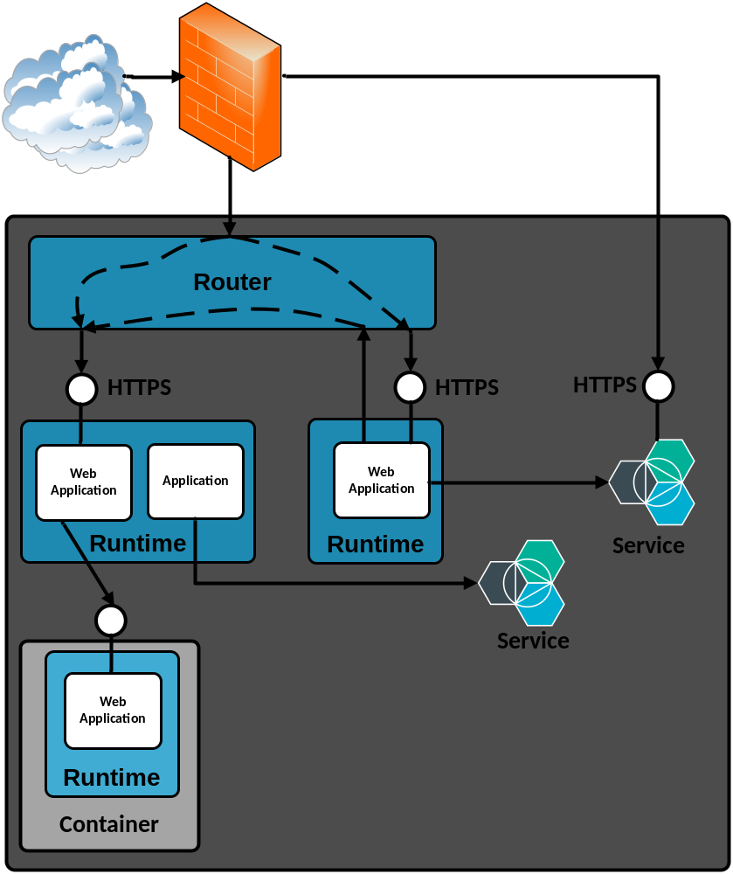
All custom Bluemix web applications deployed to Bluemix application runtimes are protected by an external firewall and are accessed exclusively through an application level proxy (the “Router” component). Each web application within a public Bluemix runtime does expose its HTTP(S) access point to Internet using this mechanism, there is no concept of a private network. Thus each application is responsible for implementing necessary authentication. This also applies to APIs that are to be used exclusively by other Bluemix applications — they will also be accessible to Internet and must be secured via an API key to prevent unauthorized access.
Not all Bluemix applications are web applications. In this case they do not have an HTTP(S) access point. This type of application does, e.g., only message oriented processing. In such case an application is not exposed to Internet.
Bluemix services are not necessarily fully exposed to Internet — but many of them have a publicly visible access point for a subset of functionality and thus can be accessible from Internet as well, for parties in possession of a suitable API key. In general, API keys for production Bluemix services should only be known by system administrators who have administrator level access to the system and not shared with third parties.
Docker containers deployed into Bluemix get an IP address from the Bluemix organization’s container network and thus are not automatically exposed to Internet. It is possible to leverage this to develop backend services (or microservices) that cannot be directly accessed from Internet, as an additional layer of security. The container’s IP address is dynamic and usually changes upon container startup, so this strategy requires leveraging a micro service discovery solution.

Data Ownership
It is assumed KONE will manage information stored in the platform in such manner that legal or privacy requirements related to, e.g., personal information are fulfilled. The KONE IoT platform does not by default contain any particular provisions to meet legal requirements related to storing personal information, beyond what is done to protect any information in general. Thus sensitive personal information should not be stored into the IoT platform.
Regarding possibility of data loss, there are two main scenarios to protect against:
- Catastrophic failure, e.g., a total failure of a redundant disk subsystem
- Major data loss due to user / customer application misuse
The Bluemix platform itself offers a certain level of protection against scenario 1 above. This document does not discuss extent of Bluemix platform reliability.
High availability mechanisms build into the public Bluemix platform do not in general protect for scenario 2 above, as this scenario is caused by user / customer activity. Protecting against such eventuality will, in general, require maintaining customer specific backup copies of data. This level of additional protection is included in some, but not all, Bluemix services. Full KONE IoT Platform backup strategy is described in the Operational Model document. For the key services that hold a significant amount of data:
- dashDB service currently (subject to change) includes backup taken every 24 hours and retained for 2 days
- Cloudant Enterprise service currently (subject to change) includes a backup solution. Non-Enterprise Cloudant service (as currently used) does not. It is possible to implement customer specific backup solution for non-Enterprise Cloudant databases using scheduled database replication. This solution has not been currently implemented.
- Device data within Watson IoT platform can be backed up by maintaining a copy of device metadata in another database. This could be implemented as a part of a custom device provisioning API solution. However, if the device authentication token is not algorithmically generated from device identifier, this would involve maintaining an additional clear-text copy of the authentication token, so this approach is not chosen. Backup strategy is based on contacting Watson IoT Platform service administration to perform a full restore for KONE data when required. Partial restore is not possible.
Any such backups would by default be stored within the Bluemix platform. This document does not discuss relative merits of backup storage locations.
No particular mechanisms are in place to avoid keeping copies of deleted data for technical reasons. In general, the platform does not guarantee physical deletion of data within any particular timeframe.

