PawPortion System Architecture
Control | Value
Document ID | PP-SA-001
Revision and date | 1.0 | 21 October 2026

PawPortion has two main parts: a physical scale and an Android app. The scale measures and manages the meal; the app guides the owner and stores completed meal history. This document defines their responsibilities and the connections between them.

1. System overview
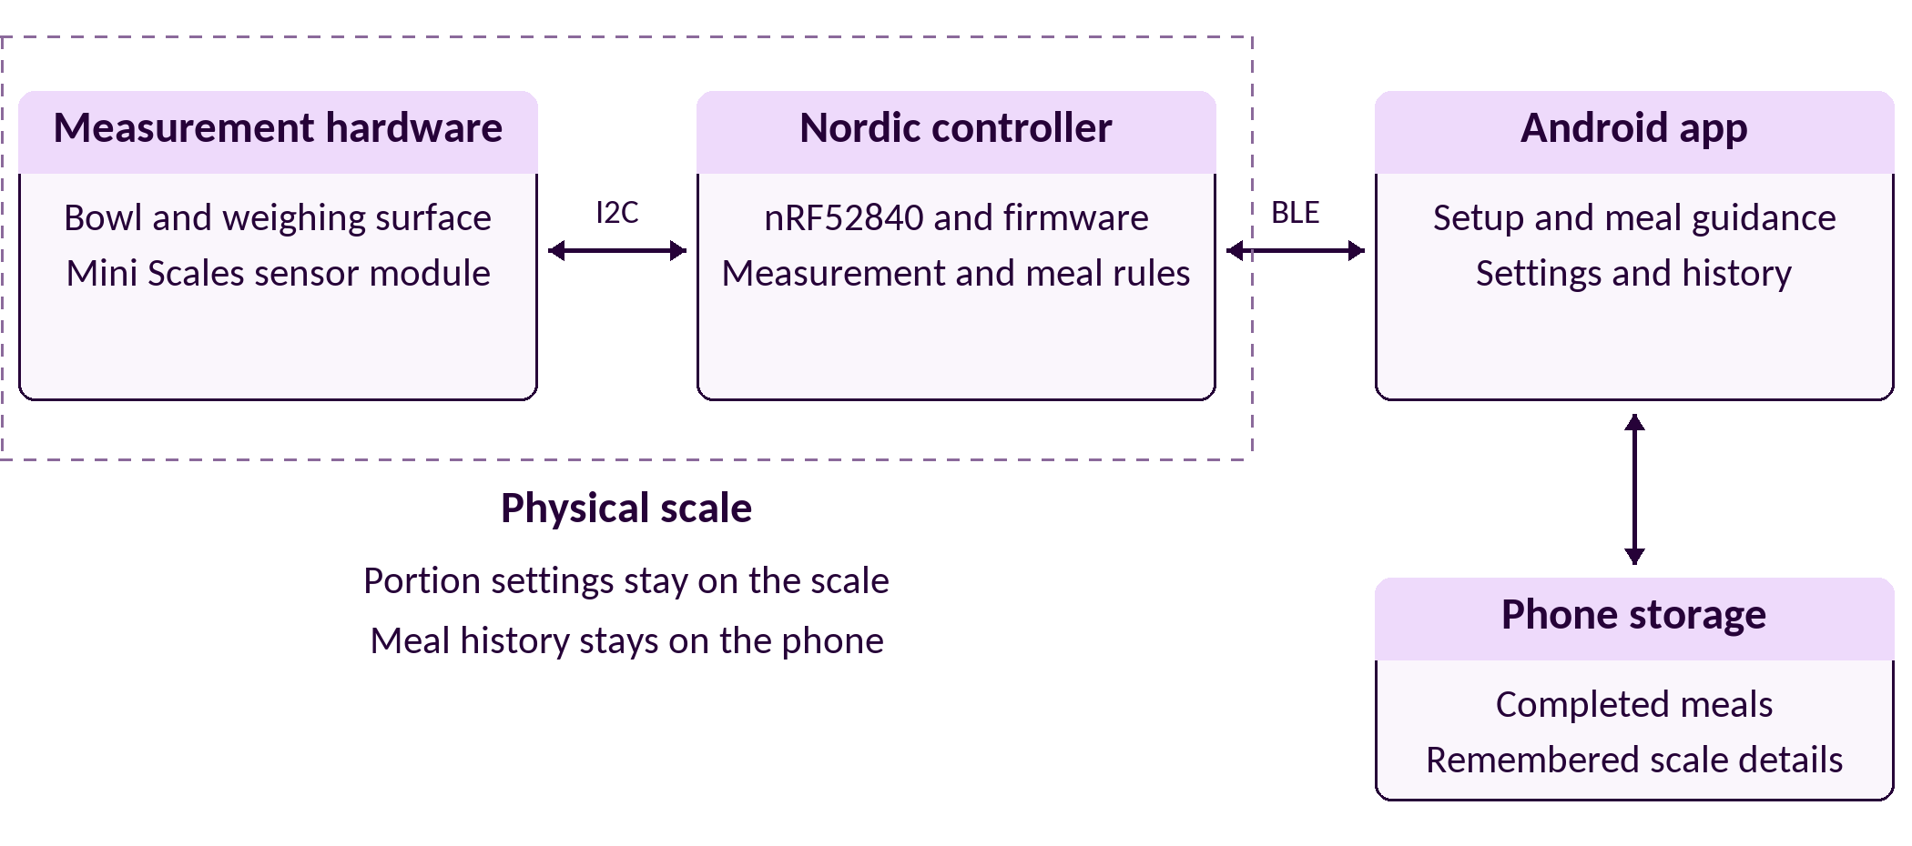
The measurement module and Nordic controller form the physical scale. I2C connects the module to the controller. BLE connects the scale to Android. The app’s database stays on the phone; neither a server nor a cloud connection is part of the system.

2. Component responsibilities
Component | Responsibility
Measurement hardware | Sense the load on the weighing surface and provide readings through the module’s I2C interface.
Nordic firmware | Interpret readings, manage measurement validity and meal behavior, retain portion settings, and provide the BLE interface.
Android app | Handle setup and the remembered scale, collect owner choices, guide meal preparation, show connection and measurement status, and present history.
Phone database | Retain completed meal records for the app to display. It is owned by Android, not by the scale.

3. Main information flow

Setup and settings
Android helps the owner connect to a scale, prepare the unloaded weighing surface, and enter target and tolerance values. The scale captures the unloaded reference and retains accepted portion settings. Android shows the scale’s confirmation before treating setup or a settings change as complete.

Measurement and meal preparation
Measurement hardware supplies readings to the Nordic controller. Firmware evaluates measurement quality and applies the meal’s bowl reference and portion rules. BLE carries readings and status to Android. The app translates that information into weight, progress and guidance for the owner.
The owner confirms an empty bowl for each meal. Firmware confirms stable tare before the app advances to adding food. The unloaded reference remains separate from this bowl reference so removal of the bowl can be recognized during an active meal.

Meal completion and history
The owner finishes the meal in Android. The scale supplies the confirmed final measurement and associated meal information. Android saves the completed record with the phone’s finish time and presents it in History. Cancelled meals create no history record.

4. Responsibility boundaries
The scale owns measurement meaning: tare, validity, stability, net food weight and portion evaluation. Android uses the scale’s reported result rather than independently recreating those measurement decisions. The app owns user interaction, confirmation screens, friendly device names and completed-meal storage.
Scale measurement acquisition continues independently of the phone connection. A temporary disconnect does not erase the active meal or tare while the scale remains powered. Android shows the lost connection, reconnects and obtains current information. Invalid, unavailable or disconnected data is not presented as live weight.
The active meal belongs to the scale; history belongs to Android. Persistent portion settings and temporary tare are separate. Keeping those responsibilities clear avoids making the phone connection the owner of the weighing process.

5. Design detail
This document establishes the starting components, connections and responsibilities. Internal firmware modules, Android classes, database schema, detailed state transitions and retry algorithms are designed as their features develop. Review the system boundaries when new requirements or experience warrant a change.

