Easy Questions

1. How many unique students are included in the dataset?

Code:

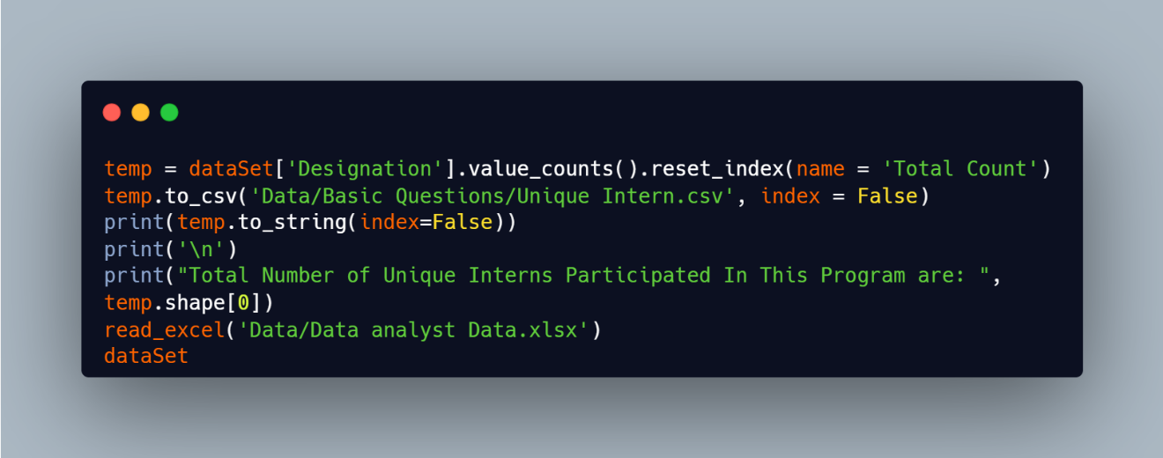

Output:

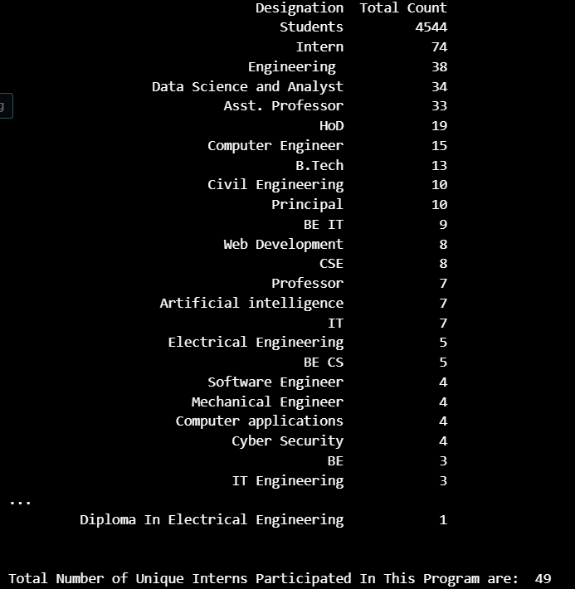

Conclusion:

There is total 49 unique interns that participated in this event and from different Designations mentioned above, for example Data Science and Analyst are 34, Web Development interns are 8 etc.

1. What is the average GPA of the students?

Code:

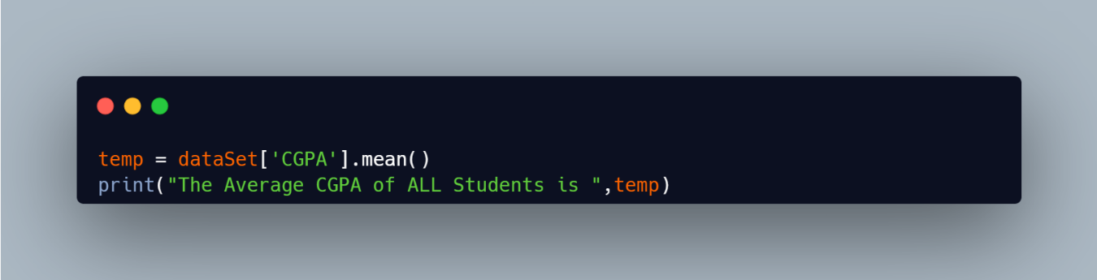

Output:



Conclusion:

The Average CGPA of Interns is about 8.03 which is comparatively good for placement as major companies ask more than 7.5 CGPA from on campus.

1. What is the distribution of students across different graduation years?

Code:

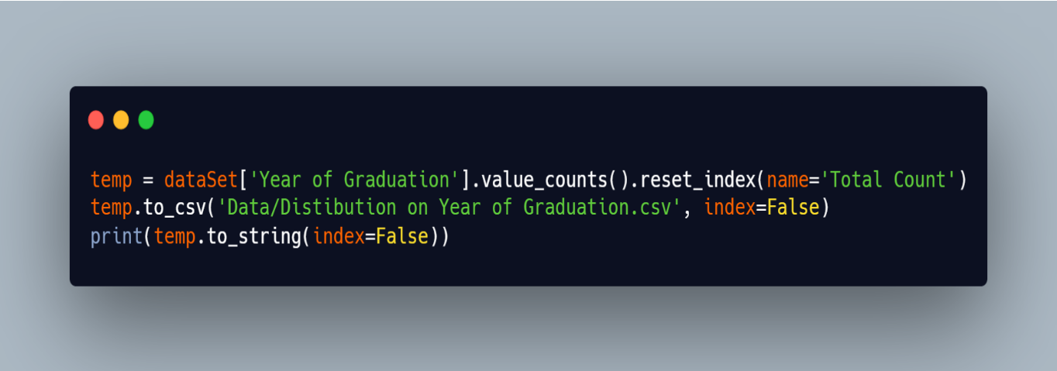

Output:

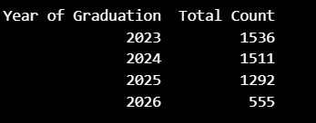

Conclusion:

From the data we can see that most of the students are freshers or having at most experience of 2 years.

1. What is the distribution of student's experience with Python programming?

Code:

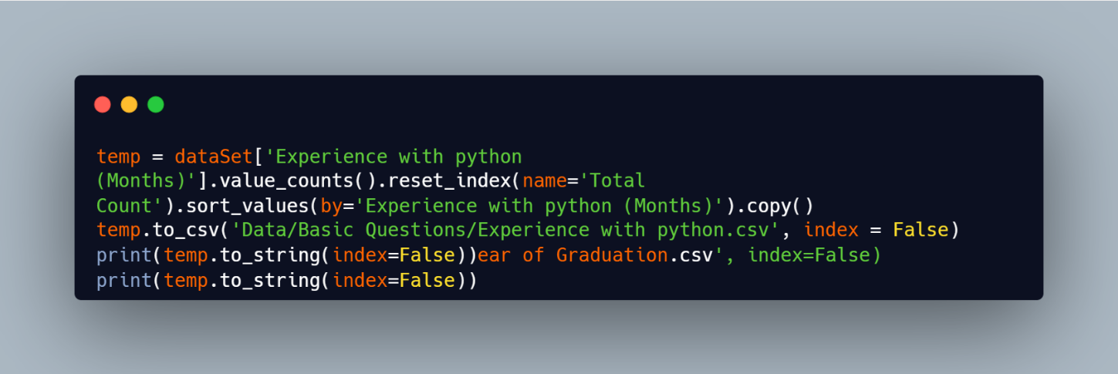

Output:

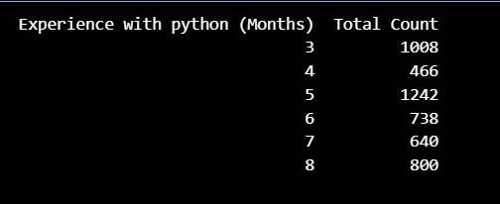

Conclusion:

From The Output we can see that major inters are new to python programming almost 1008 students have experience of 3 months in programming .

1. What is the average family income of the student?

Code:

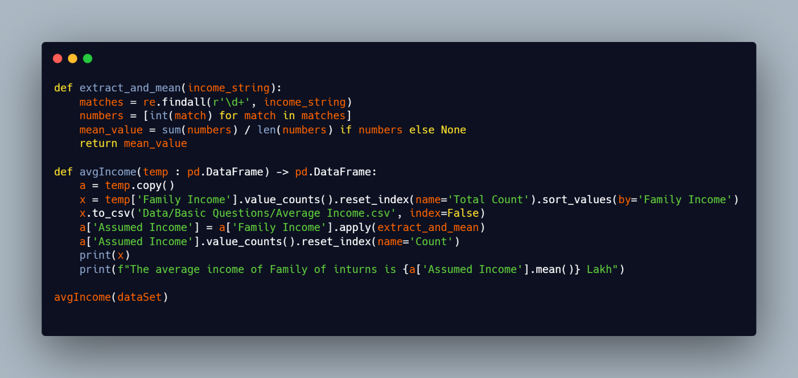

Output:

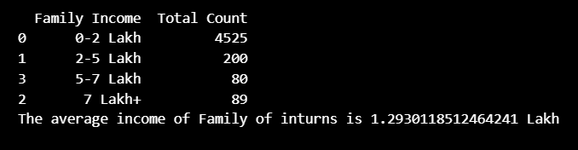

Conclusion:

From the code we can see that we created two function the function extract_and_mean will convert the Family income that is in the string form as we can see in the output into numeric value, here we took mean of the range i.e. for 0-2 Lakh we took 1, 2-5 lakh we took 3.5 and so on.

Thus after all analysis we found that average income of Family is about 1.30 Lakhs

1. How does the GPA vary among different colleges? (Show top 5 results only)

Code:

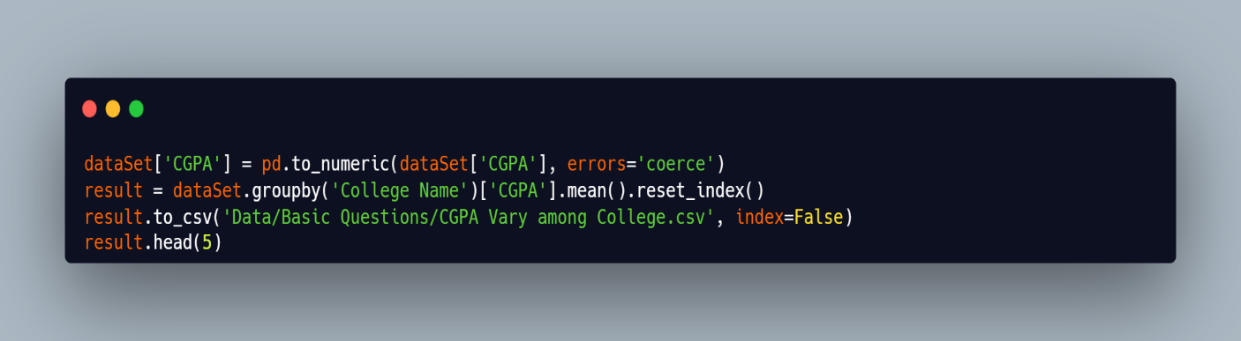

Output:

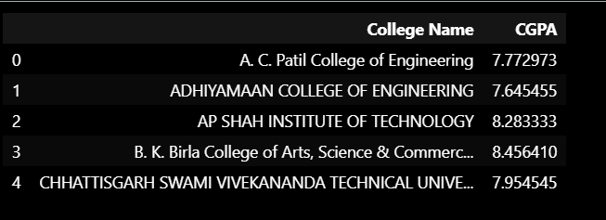

1. What is the average GPA for student from each city?

Code:

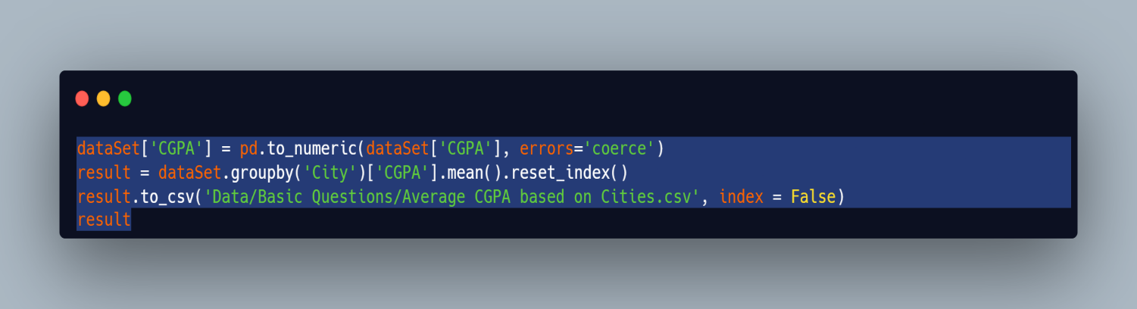

Output:

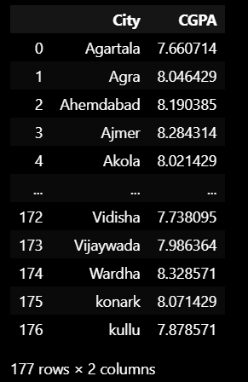

1. Are there any outliers in the quantity (number of courses completed) attribute?

Code:

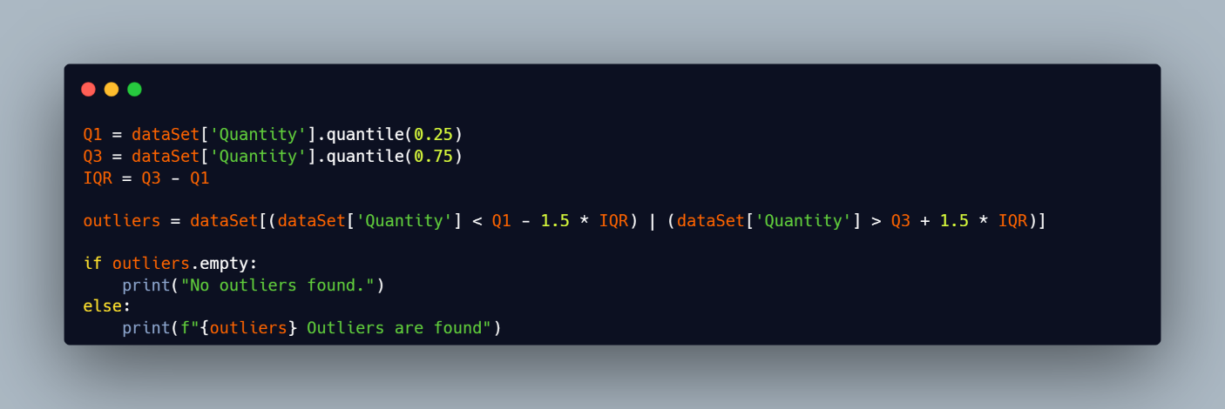

Output:

