Moderate Questions

1. How many students from various cities? (Solve using data visualisation tool).

Code:

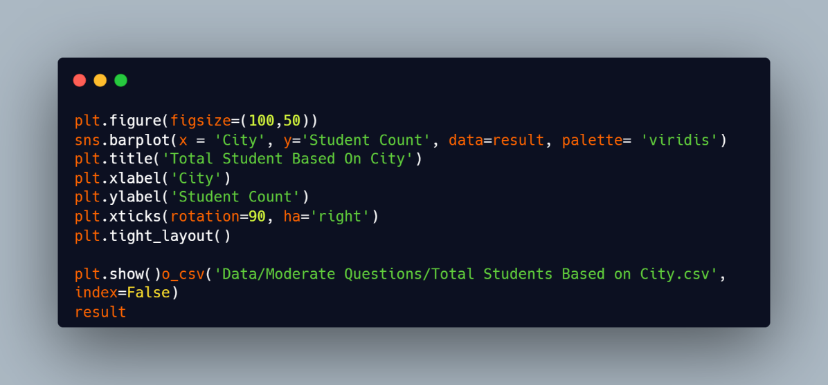

Output:

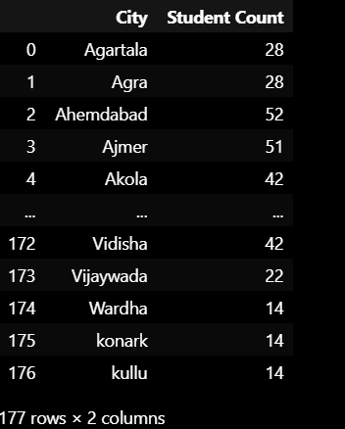

Graph:

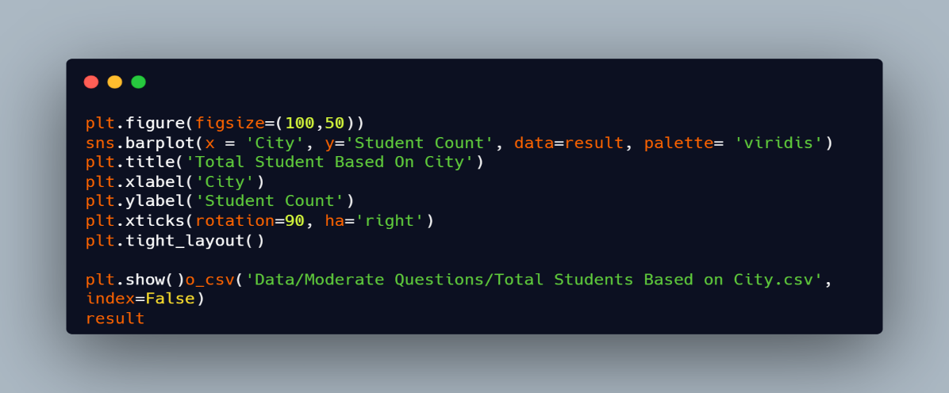

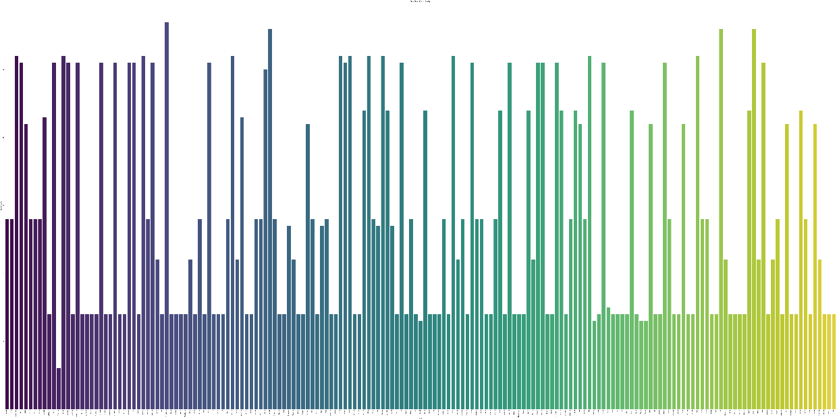

1. Which event tend to attract more students from specific fields of study?

Code:

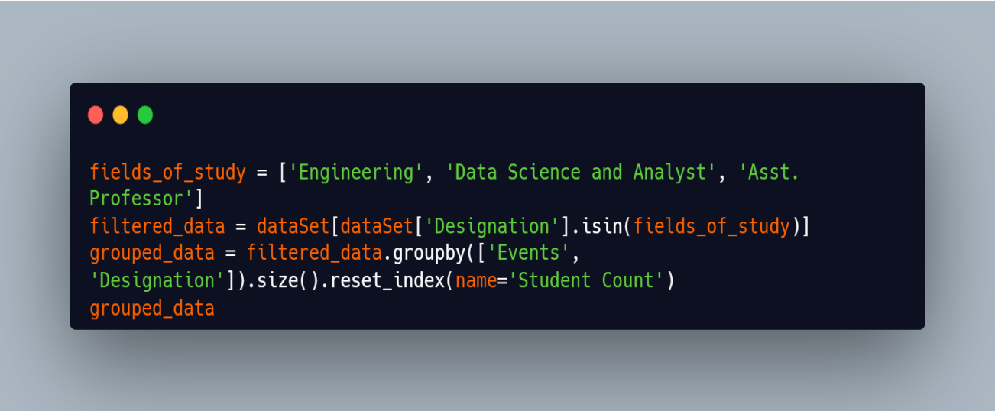

Output:

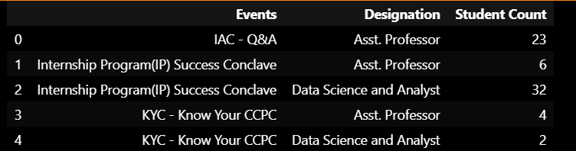

1. Do students in leadership positions during their college years tend to have higher GPAs or better expected salary?

Code:

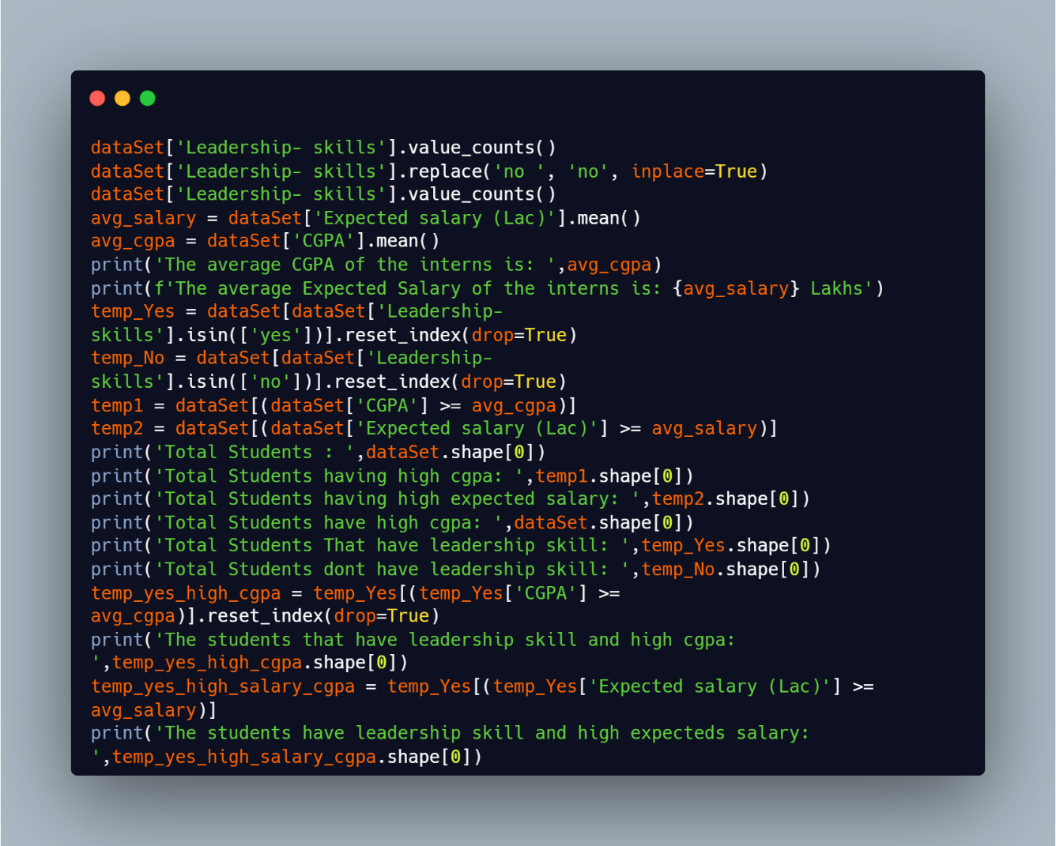

Output:

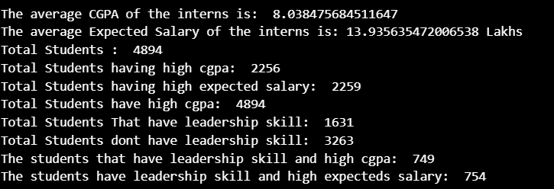

1. How many students are graduating by the end of 2024?

Code:

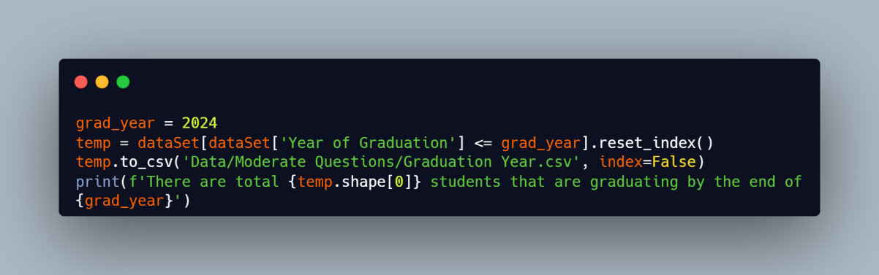

Output:



1. Which promotion channel brings in more student participations for the event?

Code:

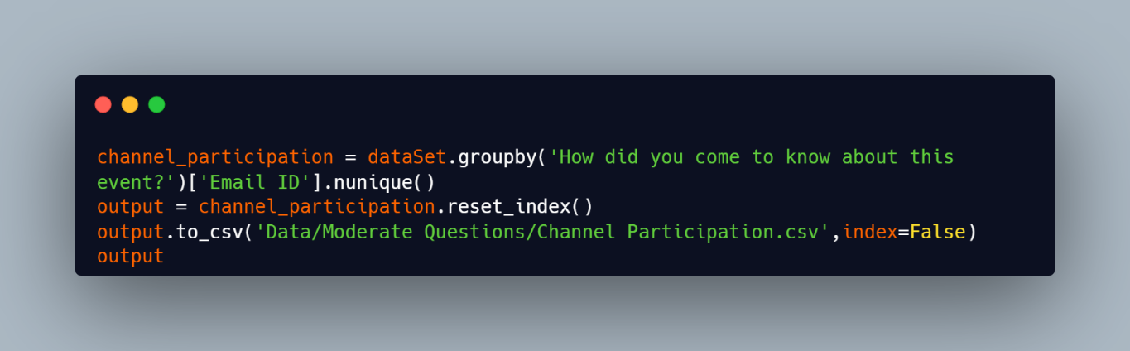

Output:

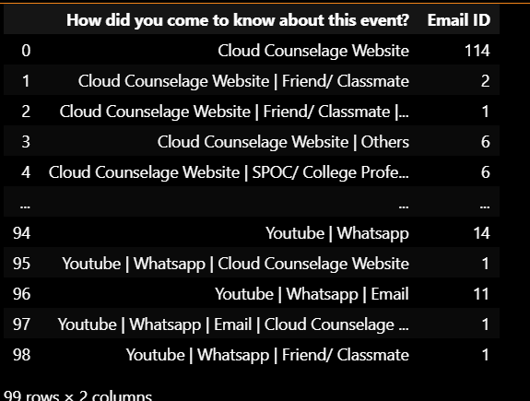

1. Find the total number of students who attended the events related to Data Science? (From all Data Science related courses.)

Code:

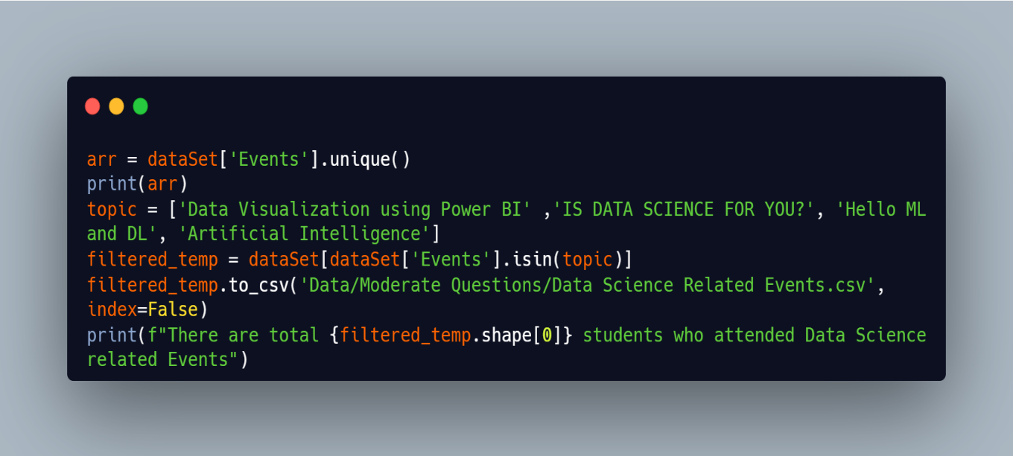

Output:

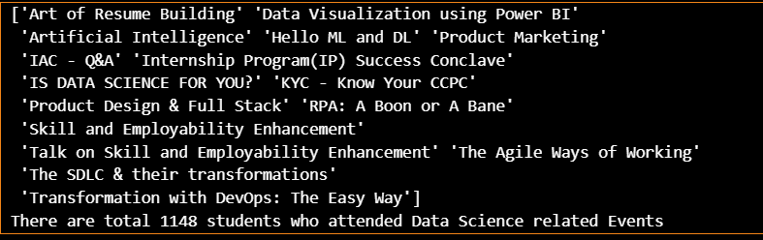

1. Those who have high CGPA & More experience in language those who had high expectations for salary? (Avg)

Code:

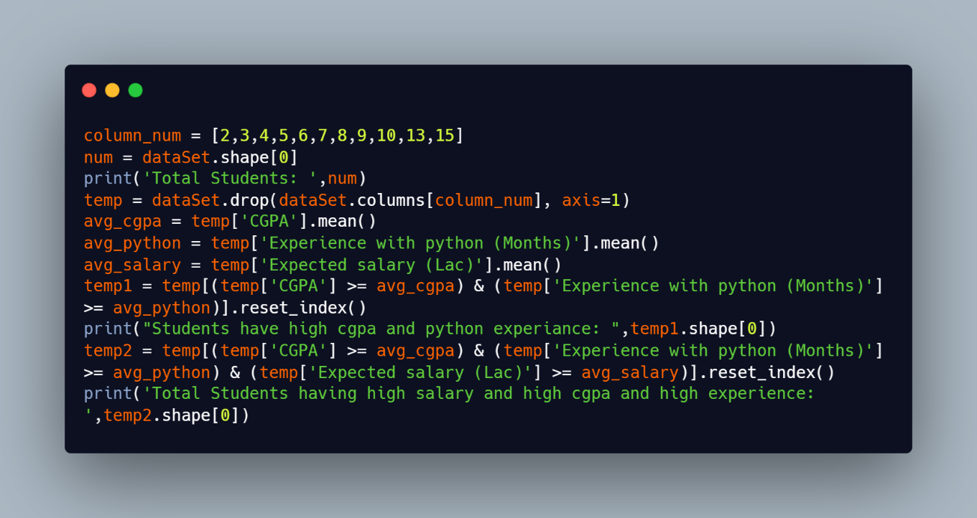

Output:

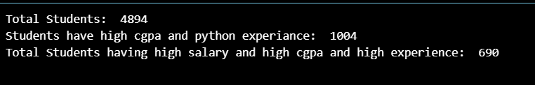

1. How many students know about the event from their colleges? Which of these Top colleges?

Code:

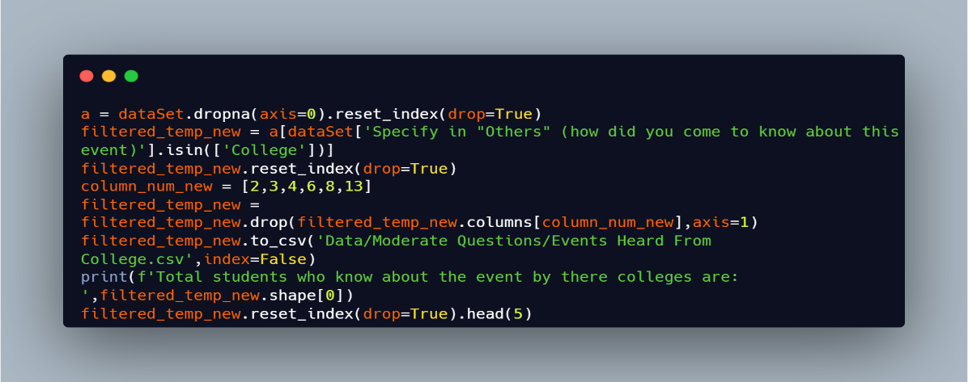

Output:

