**Proof Of Concept - Sechi Mobile iOS8 Swift app**

**Deployment Guide**

Revision History

|  |  |  |
| --- | --- | --- |
| **Author** | **Revision Number** | **Date** |
| TCSASSEMBLER | 1 | 17.06.2014 |
|  |  |  |
|  |  |  |

Deployment Instructions 3

1. Organization of Submission 3

2. Application Setup 3

2.1 Ant .Properties File 3

2.2 Build Scripts Setup 3

3. Database Setup 3

4. Deployment Instructions 3

5. Starting 3

6. Verification 3

7. Resource Contact List 3

# Deployment Instructions

# Organization of Submission

All sources are in root directory of archive. Application is using RestKit library, and it's headers must be available to include for Sechi application.

All images are available in sechi/Resources folder.

Configuration file is sechi/values.plist.

# Application Setup

RestKit library is already included. Nothing more is needed.

## Ant .Properties File

|  |  |  |
| --- | --- | --- |
| **Property Name** | **File property is stored** | **Example Setting** |
| SyncInterval | Sechi/values.plist | 10 |
| APIUrl | Sechi/values.plist | http://my-heroku-sechi.herokuapp.com/ |

## Build Scripts Setup

No special scripts were used here.

# Database Setup

Application is using CoreData to persist data when offline. No special setup needed.

# Deployment Instructions

Just build and run in xcode needed.

# Starting

Just build and run in xcode needed.

# Verification

To build the app, you need to have Xcode 6 Beta, and this app runs on only iOS 8. Open the project using Xcode and select a device to run. You will see the same function like before. But the add function does not work right now (which is acceptable according to the requirement). Please follow the deployment guide for the previous challenge to verify the updated app.

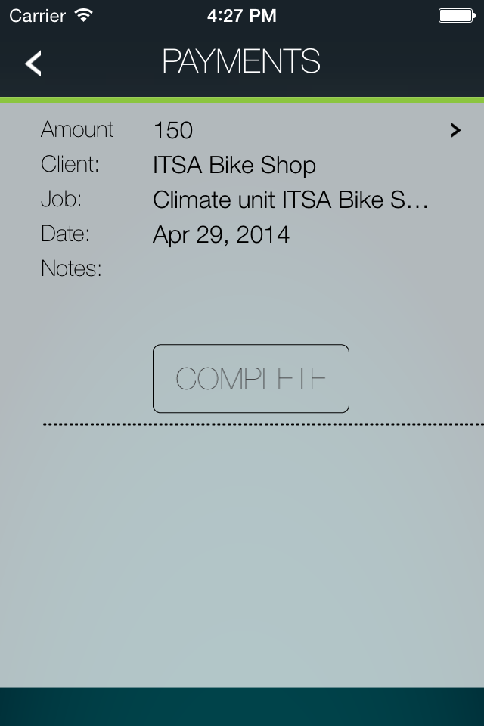

# Resource Contact List

|  |  |
| --- | --- |
| **Name** | **Resource Email** |
|  |  |