# NAAN MUTHALVAN

ARTIFICIAL INTELLIGENCE PROJECT TITLE

FACK NEWS DETECTING

USING NPL

REG.NO : 712221106002

NAME:DEVARAJ KANNAN S

DEPT : ECE YEAR & SEM : III & 05

COLLEGE : PARK COLLEGE OF ENGINEERING AND TECHNOLOGY

PHASE 1

# FACK NEWS DETECTING USING NPL

PROBLEM DEFINITION

Sentiment analysis, also referred to as opinion mining, is an approach to natural language processing (NLP) that identifies the emotional tone behind a body of text. This is a popular way for organizations to determine and categorize opinions about a product, service or idea.

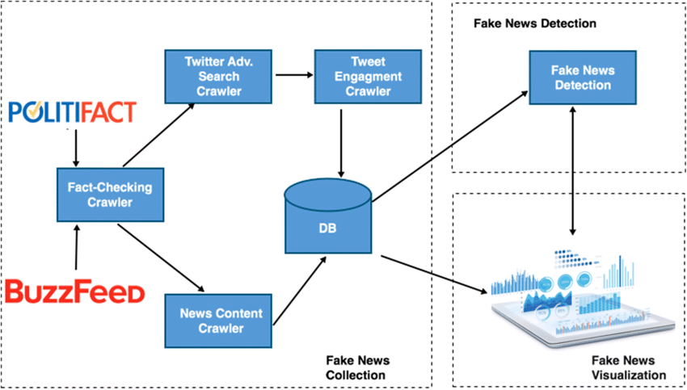

## 

FACK NEWS DETECTING USING NPL

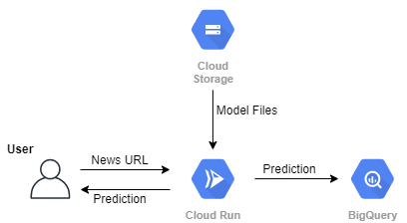

## Data collection

Identify a dataset containing customer reviews and NPL about competitor products.



## Data Preprocess

 Clean and preprocess the textual data for analysis.



Clean

Analysis



Preprocess

## Fack news detecting Analysis Techniques

Employ different NLP techniques like Bag of Words, Word Embeddings, or Transformer models for sentiment analysis.



Bag of words

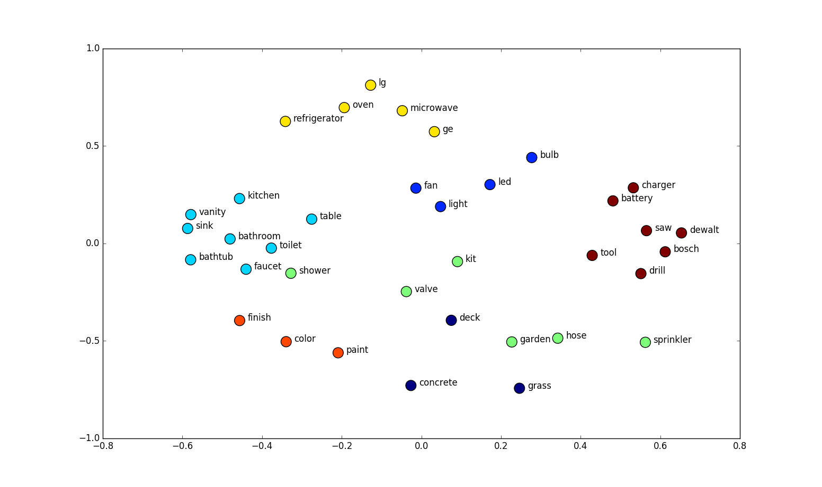

Word Embeddings

Feature Extraction

Extract features and fack news from the text data



## Visualization

Create visualizations to depict the fack news distribution and analyze trends.



Visual Insights

## Insights Generation

Extract meaningful insights from the fack news analysis results to guide business decisions.

Visualization Process

