Pediatric cardiologists

December 25, 2020

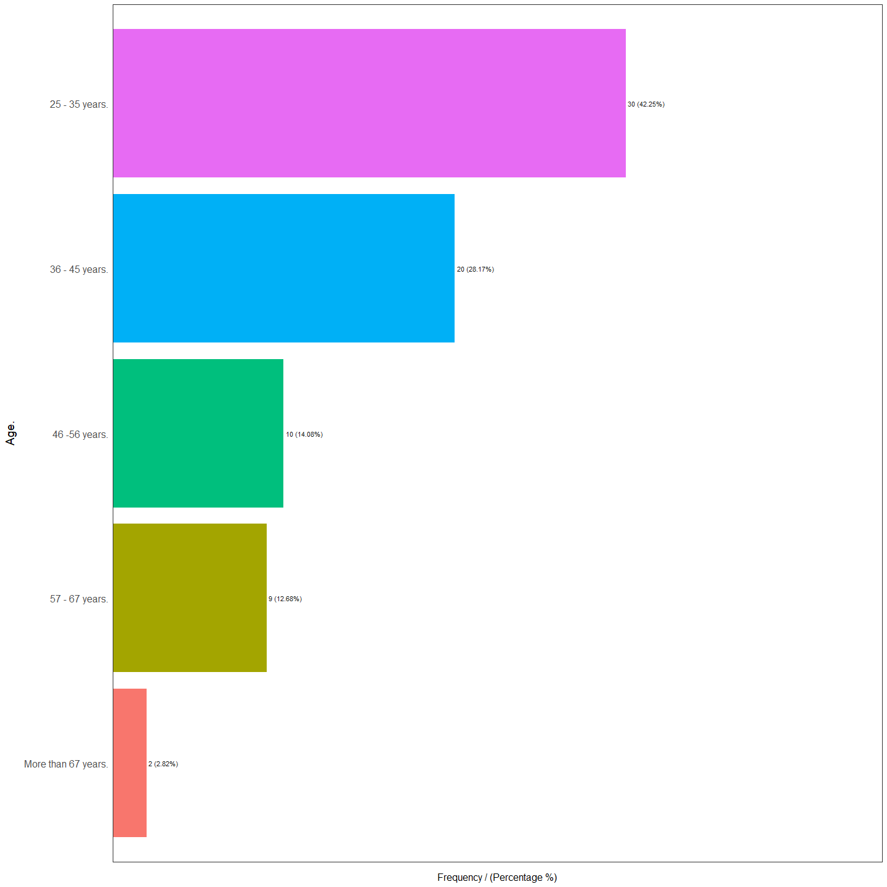

Age. frequency percentage cumulative_perc  
1 25 - 35 years. 30 42.25 42.25  
2 36 - 45 years. 20 28.17 70.42  
3 46 -56 years. 10 14.08 84.50  
4 57 - 67 years. 9 12.68 97.18  
5 More than 67 years. 2 2.82 100.00

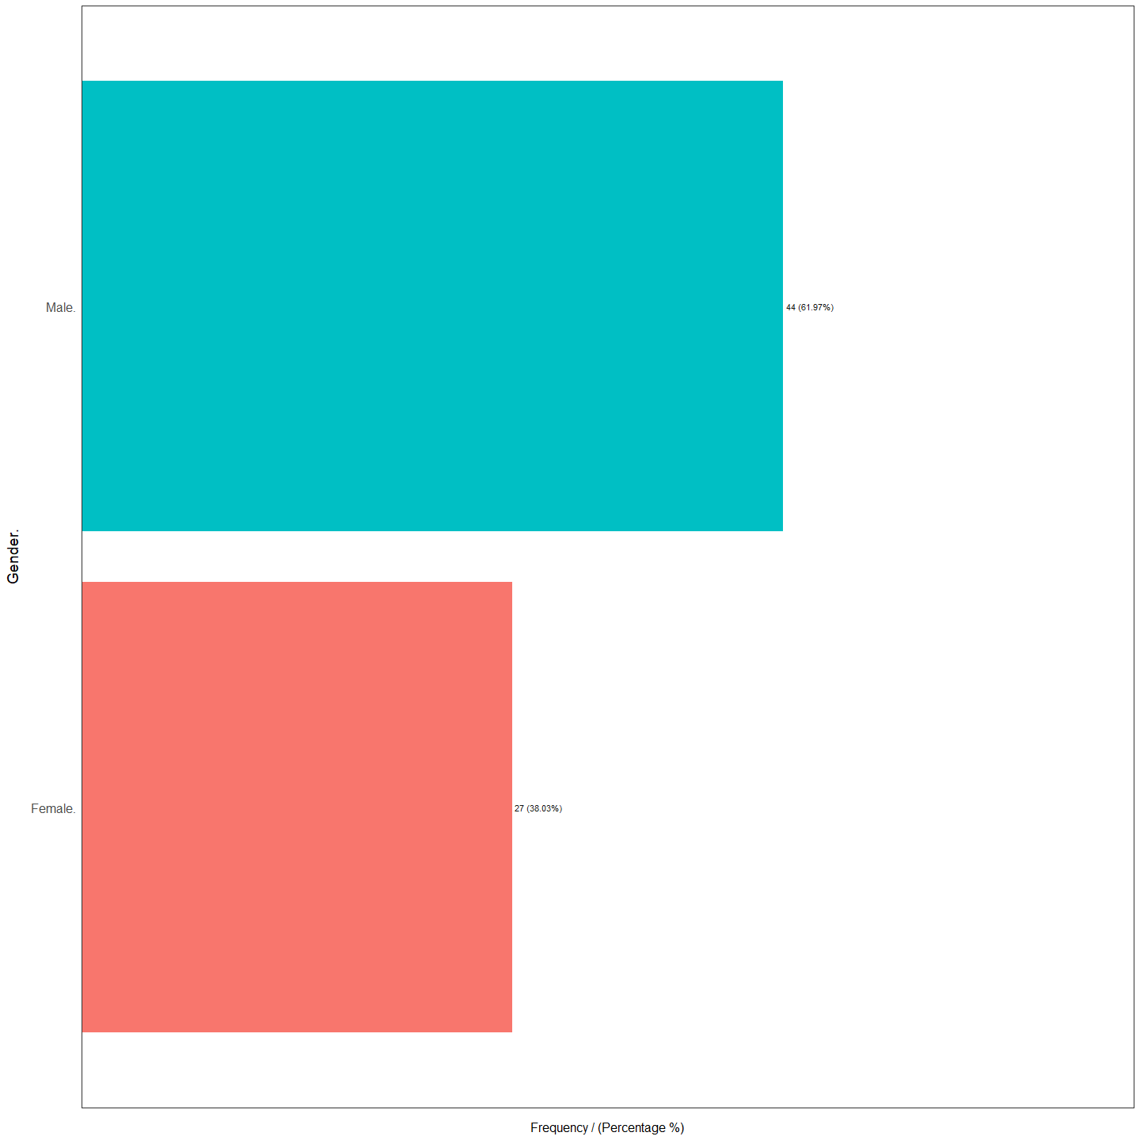

Gender. frequency percentage cumulative_perc  
1 Male. 44 61.97 61.97  
2 Female. 27 38.03 100.00

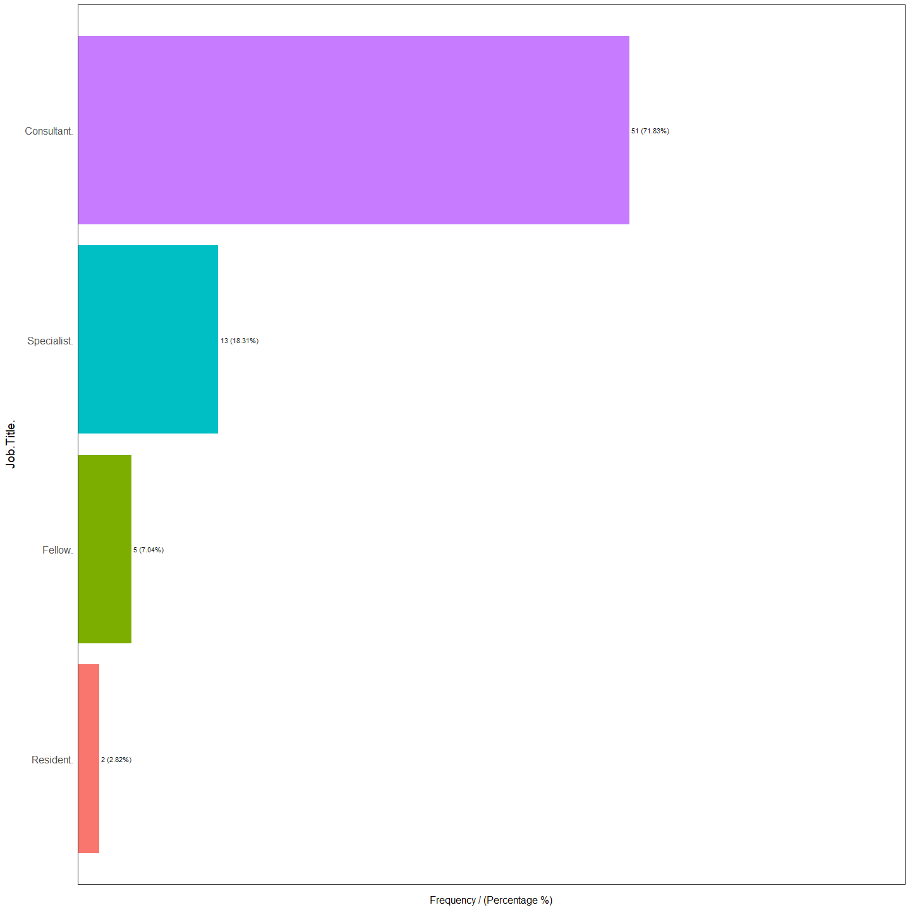

Job.Title. frequency percentage cumulative_perc  
1 Consultant. 51 71.83 71.83  
2 Specialist. 13 18.31 90.14  
3 Fellow. 5 7.04 97.18  
4 Resident. 2 2.82 100.00

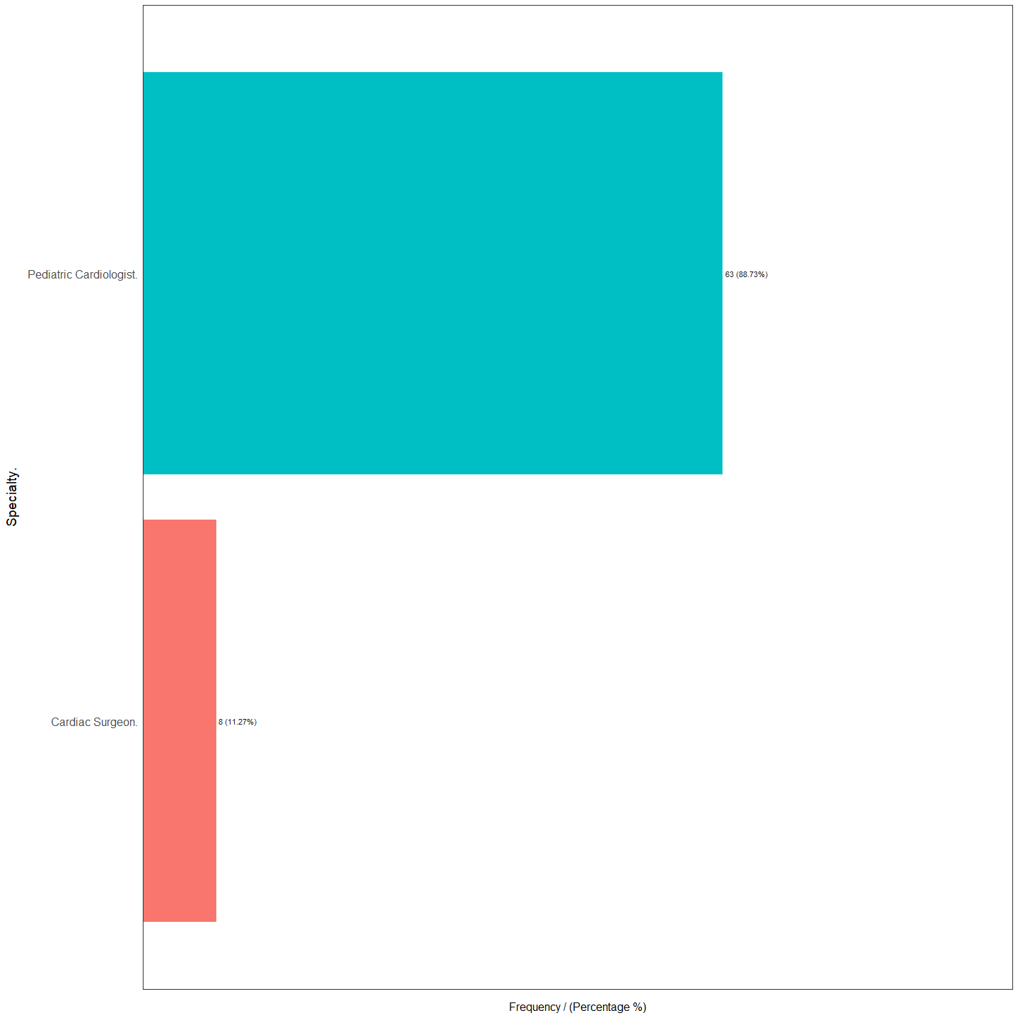

Specialty. frequency percentage cumulative_perc  
1 Pediatric Cardiologist. 63 88.73 88.73  
2 Cardiac Surgeon. 8 11.27 100.00

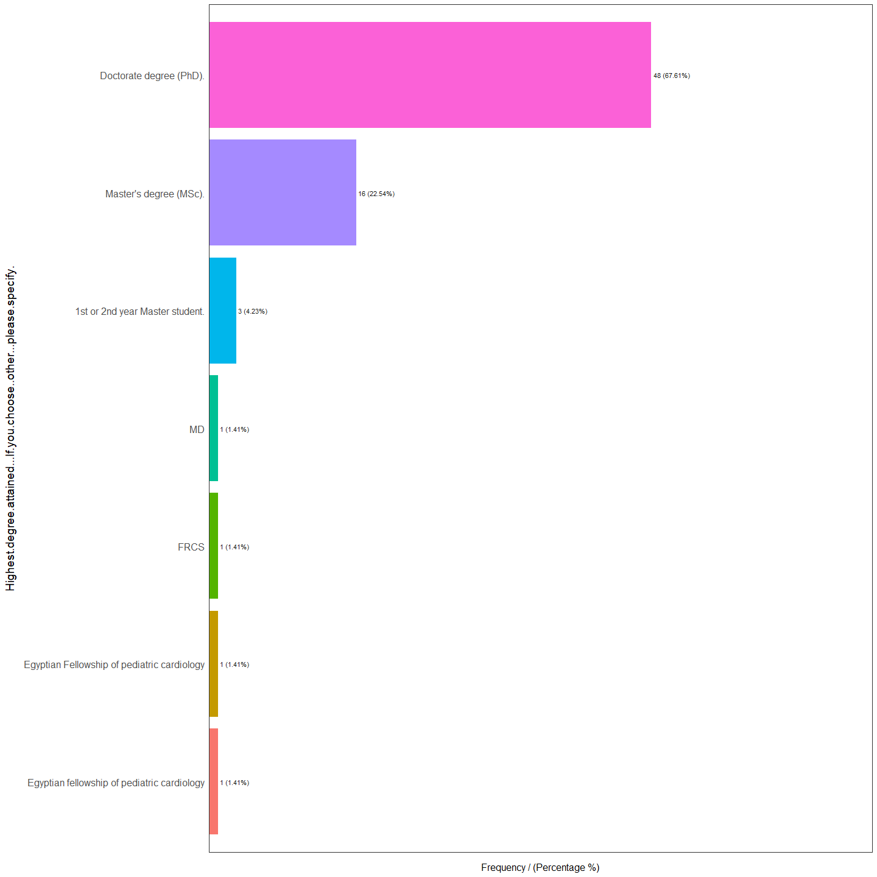

Highest.degree.attained...If.you.choose..other...please.specify. frequency  
1 Doctorate degree (PhD). 48  
2 Master's degree (MSc). 16  
3 1st or 2nd year Master student. 3  
4 Egyptian fellowship of pediatric cardiology 1  
5 Egyptian Fellowship of pediatric cardiology 1  
6 FRCS 1  
7 MD 1  
 percentage cumulative_perc  
1 67.61 67.61  
2 22.54 90.15  
3 4.23 94.38  
4 1.41 95.79  
5 1.41 97.20  
6 1.41 98.61  
7 1.41 100.00

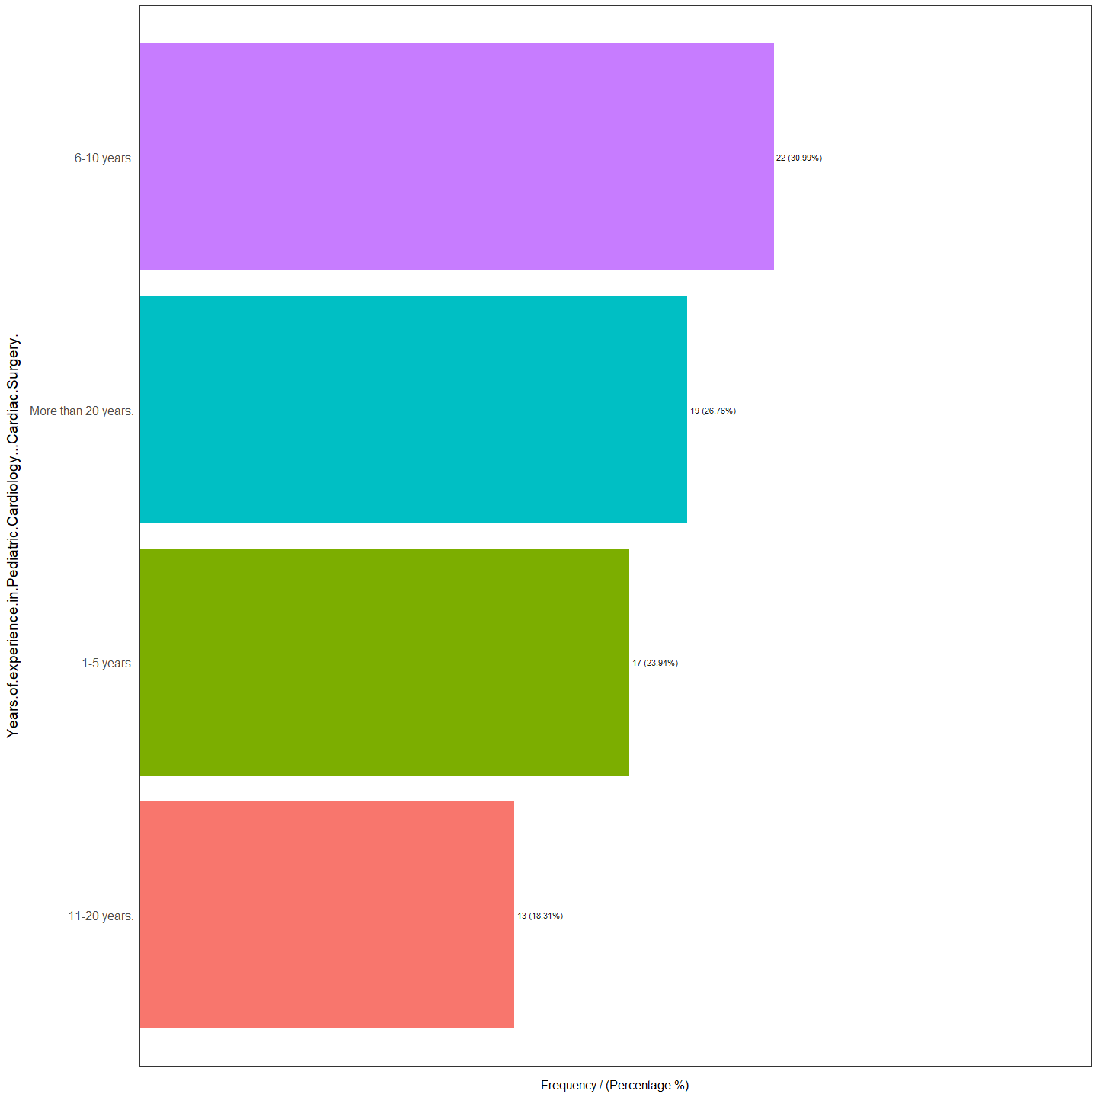

Years.of.experience.in.Pediatric.Cardiology...Cardiac.Surgery. frequency  
1 6-10 years. 22  
2 More than 20 years. 19  
3 1-5 years. 17  
4 11-20 years. 13  
 percentage cumulative_perc  
1 30.99 30.99  
2 26.76 57.75  
3 23.94 81.69  
4 18.31 100.00

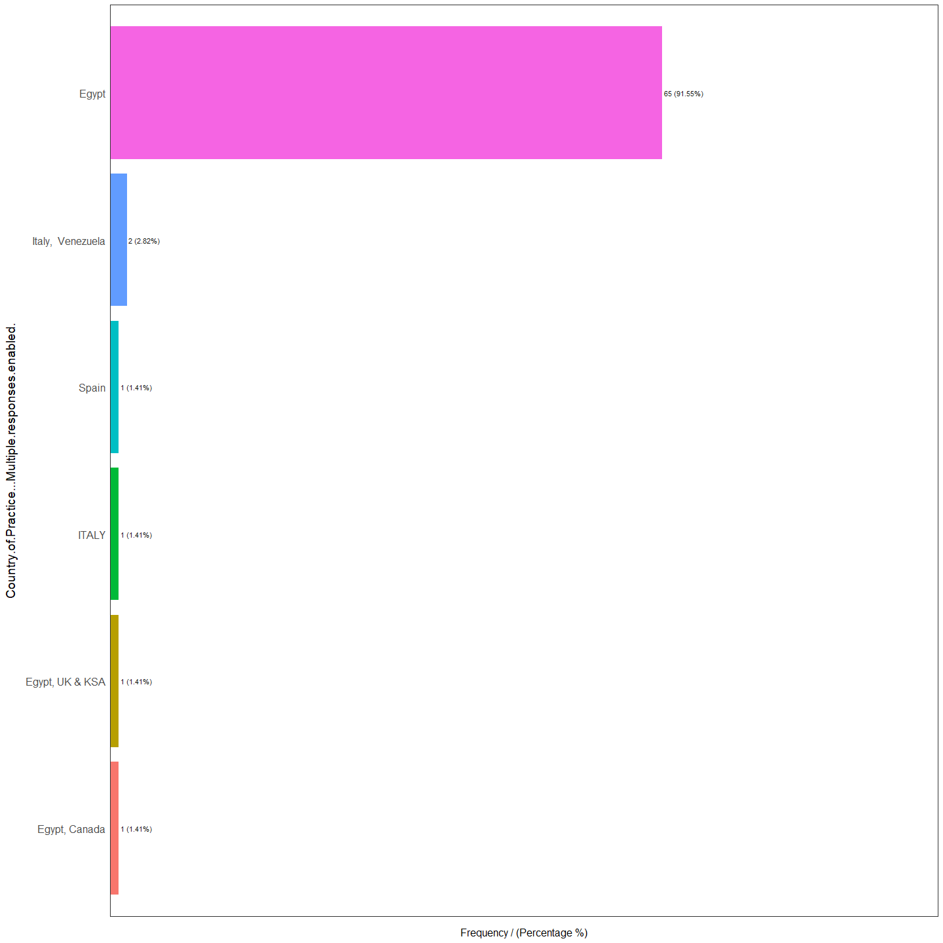

Country.of.Practice...Multiple.responses.enabled. frequency percentage  
1 Egypt 65 91.55  
2 Italy, Venezuela 2 2.82  
3 Egypt, Canada 1 1.41  
4 Egypt, UK & KSA 1 1.41  
5 ITALY 1 1.41  
6 Spain 1 1.41  
 cumulative_perc  
1 91.55  
2 94.37  
3 95.78  
4 97.19  
5 98.60  
6 100.00

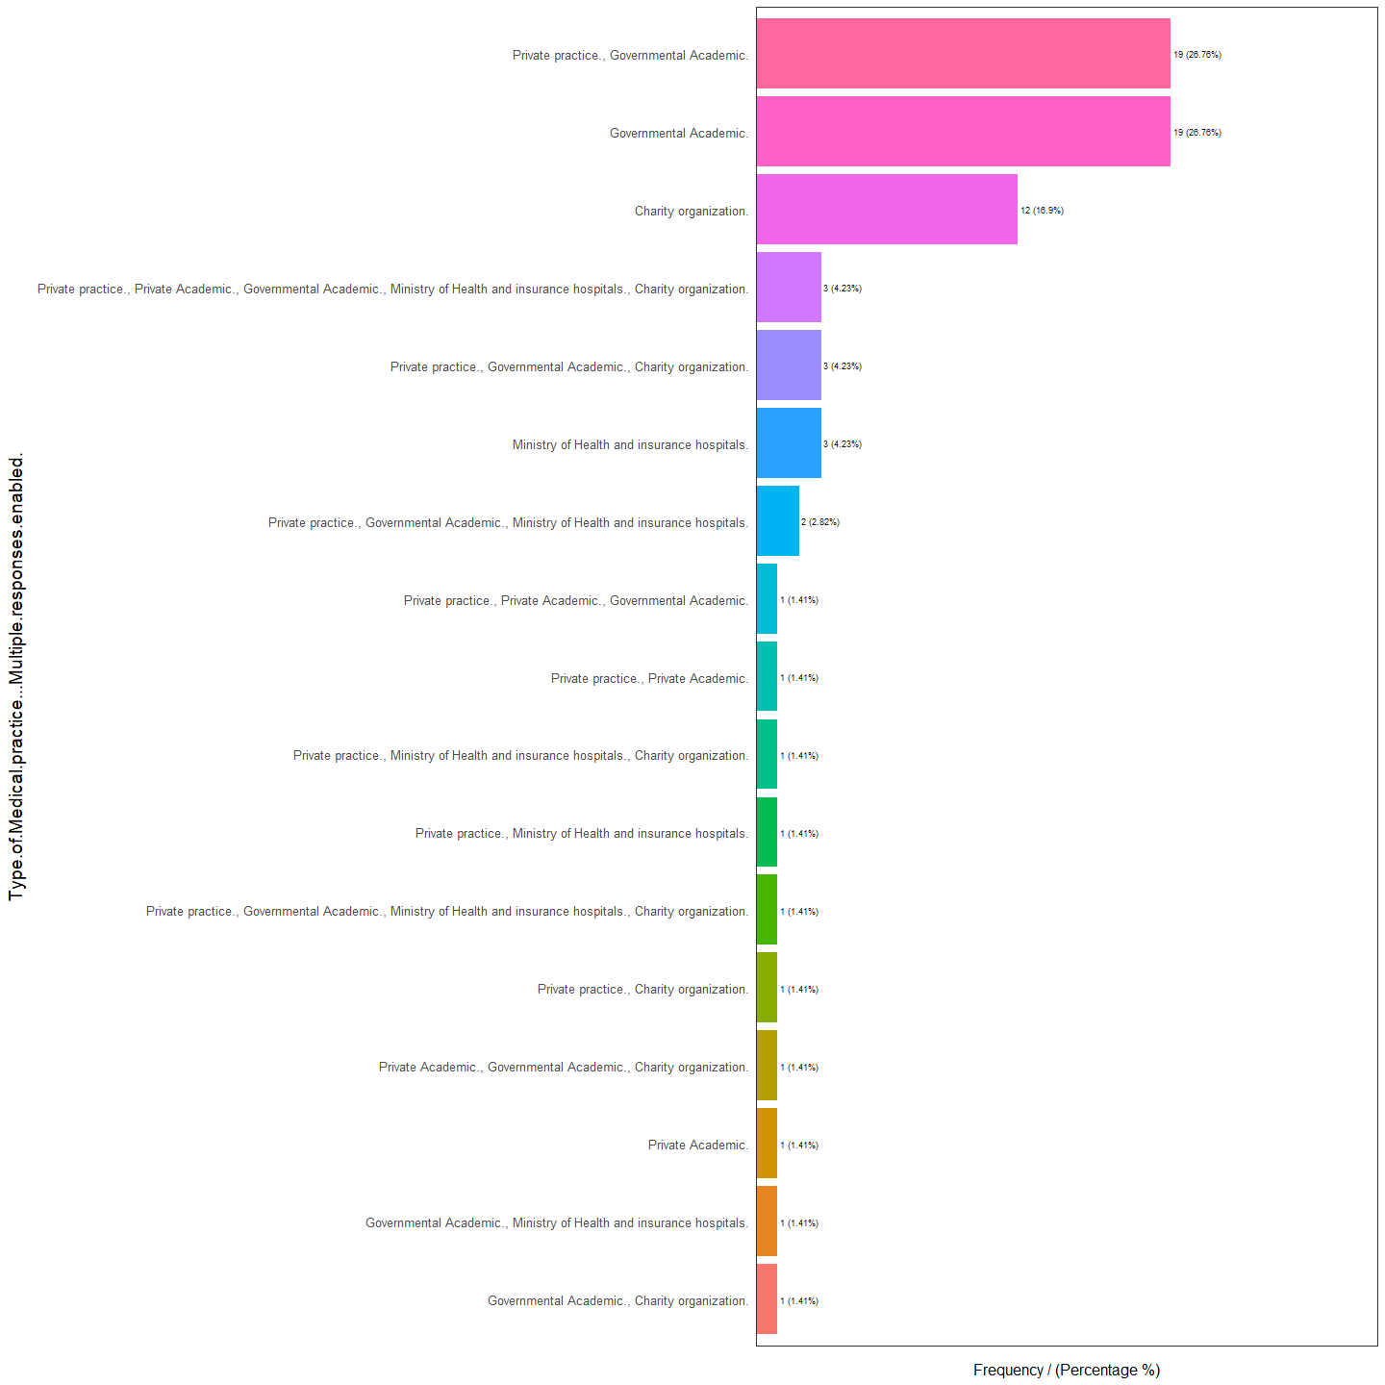

Type.of.Medical.practice...Multiple.responses.enabled.  
1 Governmental Academic.  
2 Private practice., Governmental Academic.  
3 Charity organization.  
4 Ministry of Health and insurance hospitals.  
5 Private practice., Governmental Academic., Charity organization.  
6 Private practice., Private Academic., Governmental Academic., Ministry of Health and insurance hospitals., Charity organization.  
7 Private practice., Governmental Academic., Ministry of Health and insurance hospitals.  
8 Governmental Academic., Charity organization.  
9 Governmental Academic., Ministry of Health and insurance hospitals.  
10 Private Academic.  
11 Private Academic., Governmental Academic., Charity organization.  
12 Private practice., Charity organization.  
13 Private practice., Governmental Academic., Ministry of Health and insurance hospitals., Charity organization.  
14 Private practice., Ministry of Health and insurance hospitals.  
15 Private practice., Ministry of Health and insurance hospitals., Charity organization.  
16 Private practice., Private Academic.  
17 Private practice., Private Academic., Governmental Academic.  
 frequency percentage cumulative_perc  
1 19 26.76 26.76  
2 19 26.76 53.52  
3 12 16.90 70.42  
4 3 4.23 74.65  
5 3 4.23 78.88  
6 3 4.23 83.11  
7 2 2.82 85.93  
8 1 1.41 87.34  
9 1 1.41 88.75  
10 1 1.41 90.16  
11 1 1.41 91.57  
12 1 1.41 92.98  
13 1 1.41 94.39  
14 1 1.41 95.80  
15 1 1.41 97.21  
16 1 1.41 98.62  
17 1 1.41 100.00

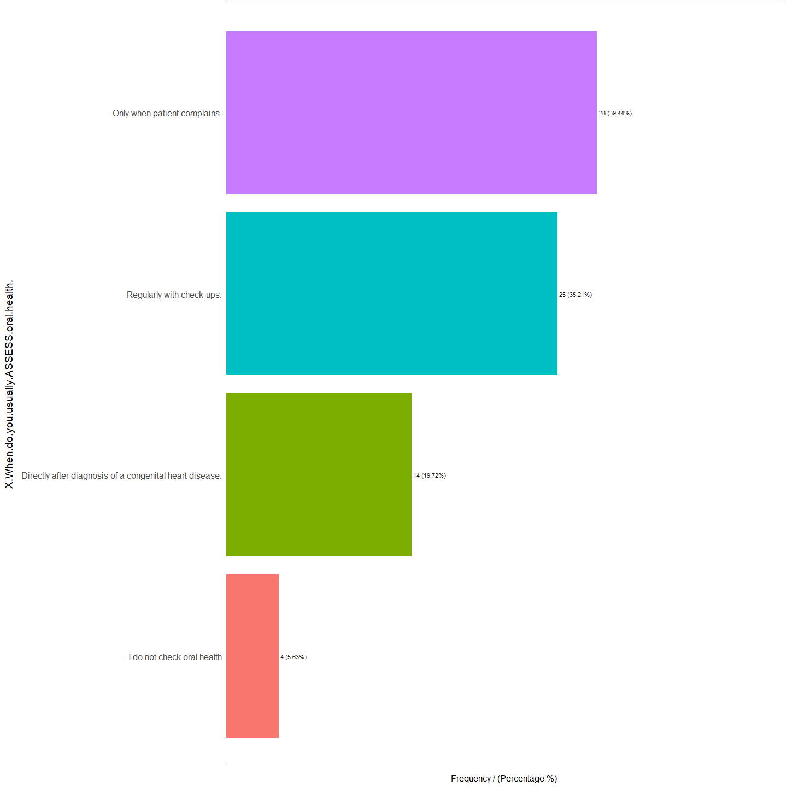

X.When.do.you.usually.ASSESS.oral.health. frequency percentage  
1 Only when patient complains. 28 39.44  
2 Regularly with check-ups. 25 35.21  
3 Directly after diagnosis of a congenital heart disease. 14 19.72  
4 I do not check oral health 4 5.63  
 cumulative_perc  
1 39.44  
2 74.65  
3 94.37  
4 100.00

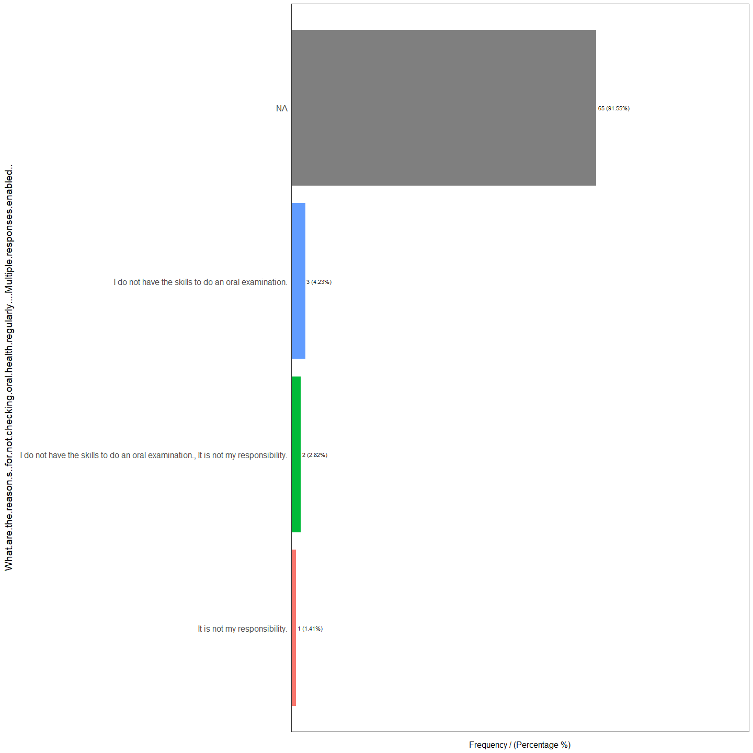

What.are.the.reason.s..for.not.checking.oral.health.regularly....Multiple.responses.enabled..  
1 <NA>  
2 I do not have the skills to do an oral examination.  
3 I do not have the skills to do an oral examination., It is not my responsibility.  
4 It is not my responsibility.  
 frequency percentage cumulative_perc  
1 65 91.55 91.55  
2 3 4.23 95.78  
3 2 2.82 98.60  
4 1 1.41 100.00

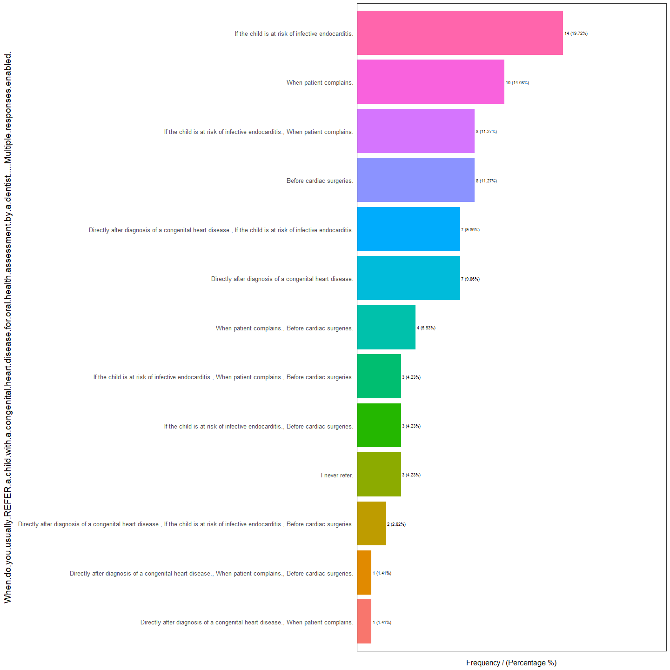

When.do.you.usually.REFER.a.child.with.a.congenital.heart.disease.for.oral.health.assessment.by.a.dentist.....Multiple.responses.enabled.  
1 If the child is at risk of infective endocarditis.  
2 When patient complains.  
3 Before cardiac surgeries.  
4 If the child is at risk of infective endocarditis., When patient complains.  
5 Directly after diagnosis of a congenital heart disease.  
6 Directly after diagnosis of a congenital heart disease., If the child is at risk of infective endocarditis.  
7 When patient complains., Before cardiac surgeries.  
8 I never refer.  
9 If the child is at risk of infective endocarditis., Before cardiac surgeries.  
10 If the child is at risk of infective endocarditis., When patient complains., Before cardiac surgeries.  
11 Directly after diagnosis of a congenital heart disease., If the child is at risk of infective endocarditis., Before cardiac surgeries.  
12 Directly after diagnosis of a congenital heart disease., When patient complains.  
13 Directly after diagnosis of a congenital heart disease., When patient complains., Before cardiac surgeries.  
 frequency percentage cumulative_perc  
1 14 19.72 19.72  
2 10 14.08 33.80  
3 8 11.27 45.07  
4 8 11.27 56.34  
5 7 9.86 66.20  
6 7 9.86 76.06  
7 4 5.63 81.69  
8 3 4.23 85.92  
9 3 4.23 90.15  
10 3 4.23 94.38  
11 2 2.82 97.20  
12 1 1.41 98.61  
13 1 1.41 100.00

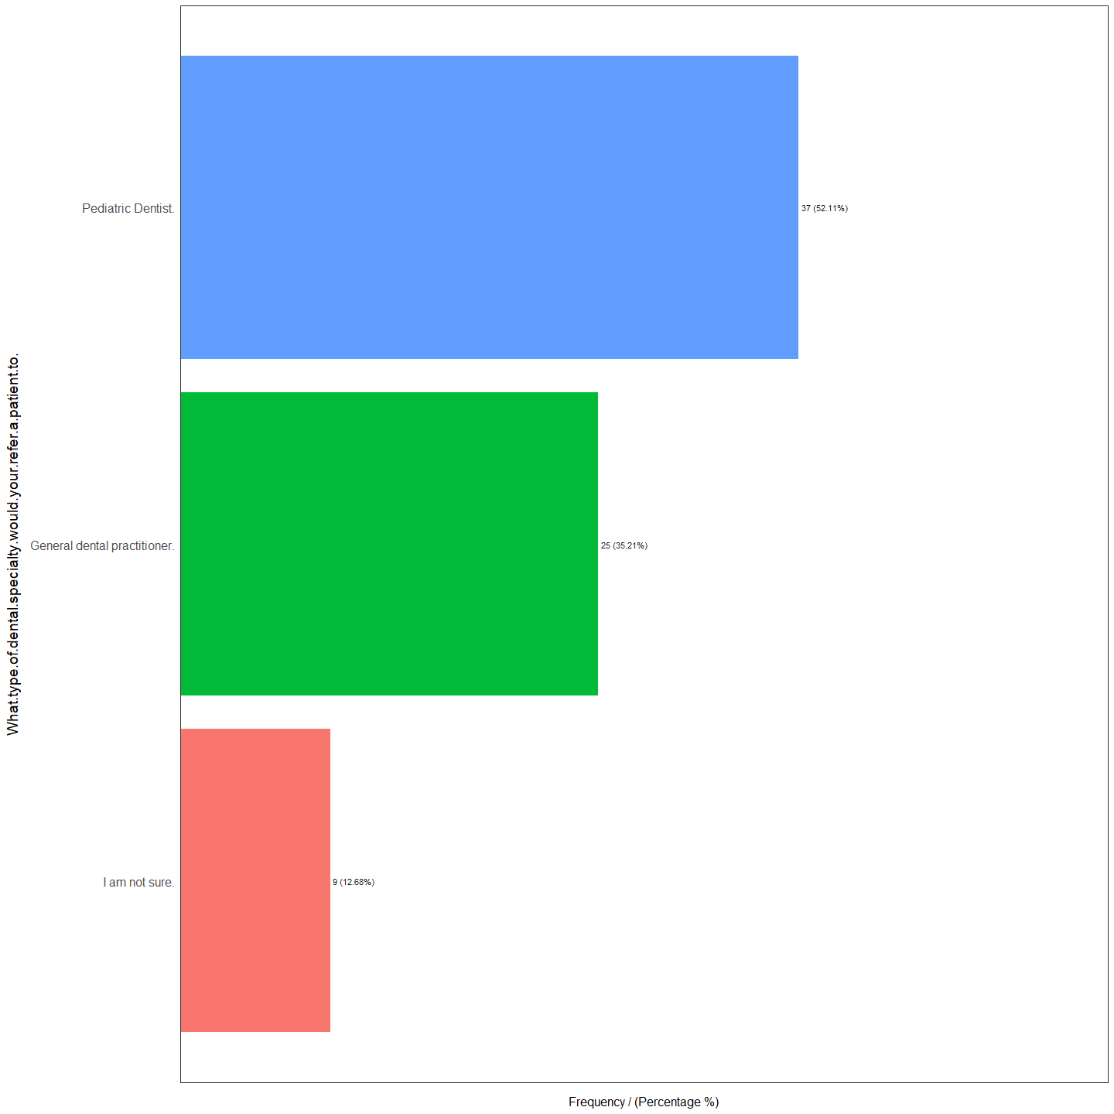

What.type.of.dental.specialty.would.your.refer.a.patient.to. frequency  
1 Pediatric Dentist. 37  
2 General dental practitioner. 25  
3 I am not sure. 9  
 percentage cumulative_perc  
1 52.11 52.11  
2 35.21 87.32  
3 12.68 100.00

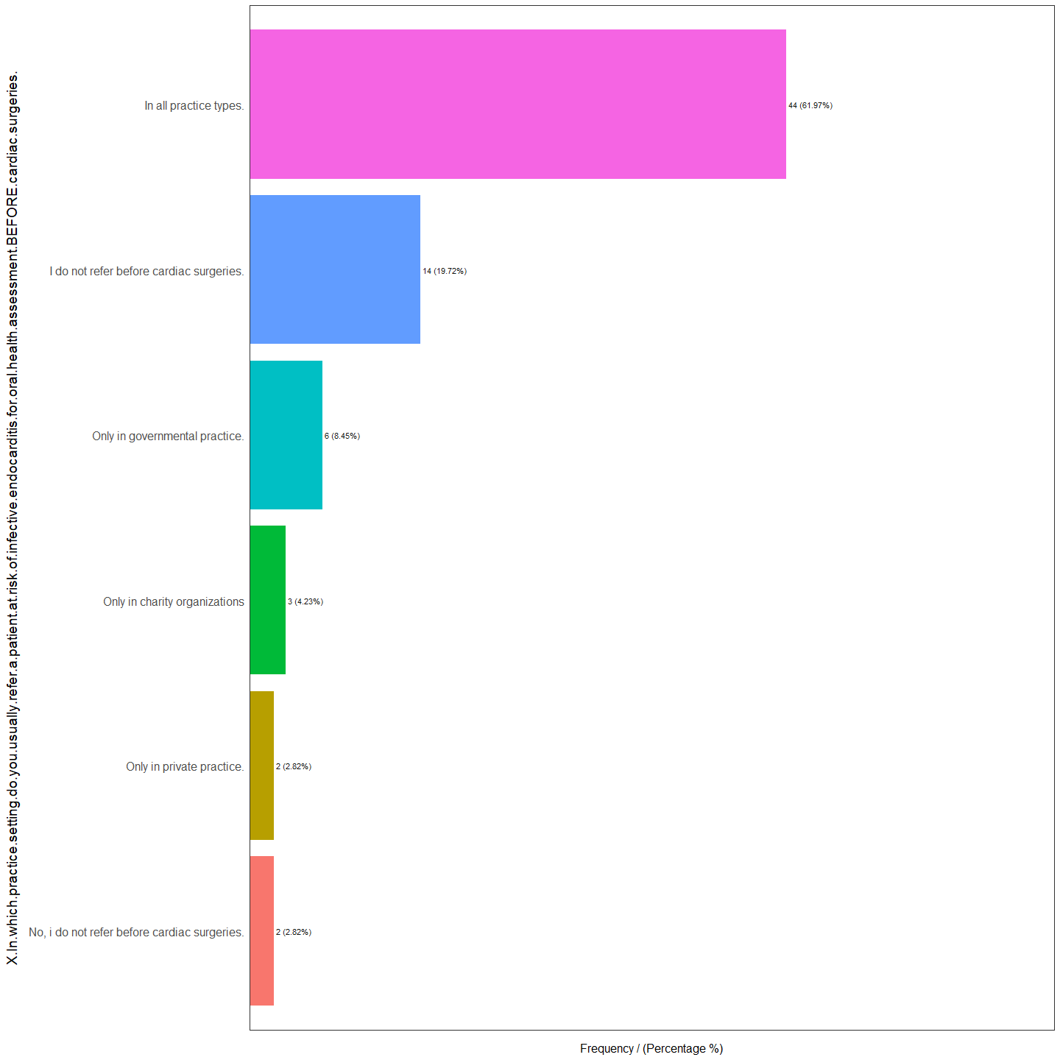

X.In.which.practice.setting.do.you.usually.refer.a.patient.at.risk.of.infective.endocarditis.for.oral.health.assessment.BEFORE.cardiac.surgeries.  
1 In all practice types.  
2 I do not refer before cardiac surgeries.  
3 Only in governmental practice.  
4 Only in charity organizations  
5 No, i do not refer before cardiac surgeries.  
6 Only in private practice.  
 frequency percentage cumulative_perc  
1 44 61.97 61.97  
2 14 19.72 81.69  
3 6 8.45 90.14  
4 3 4.23 94.37  
5 2 2.82 97.19  
6 2 2.82 100.00

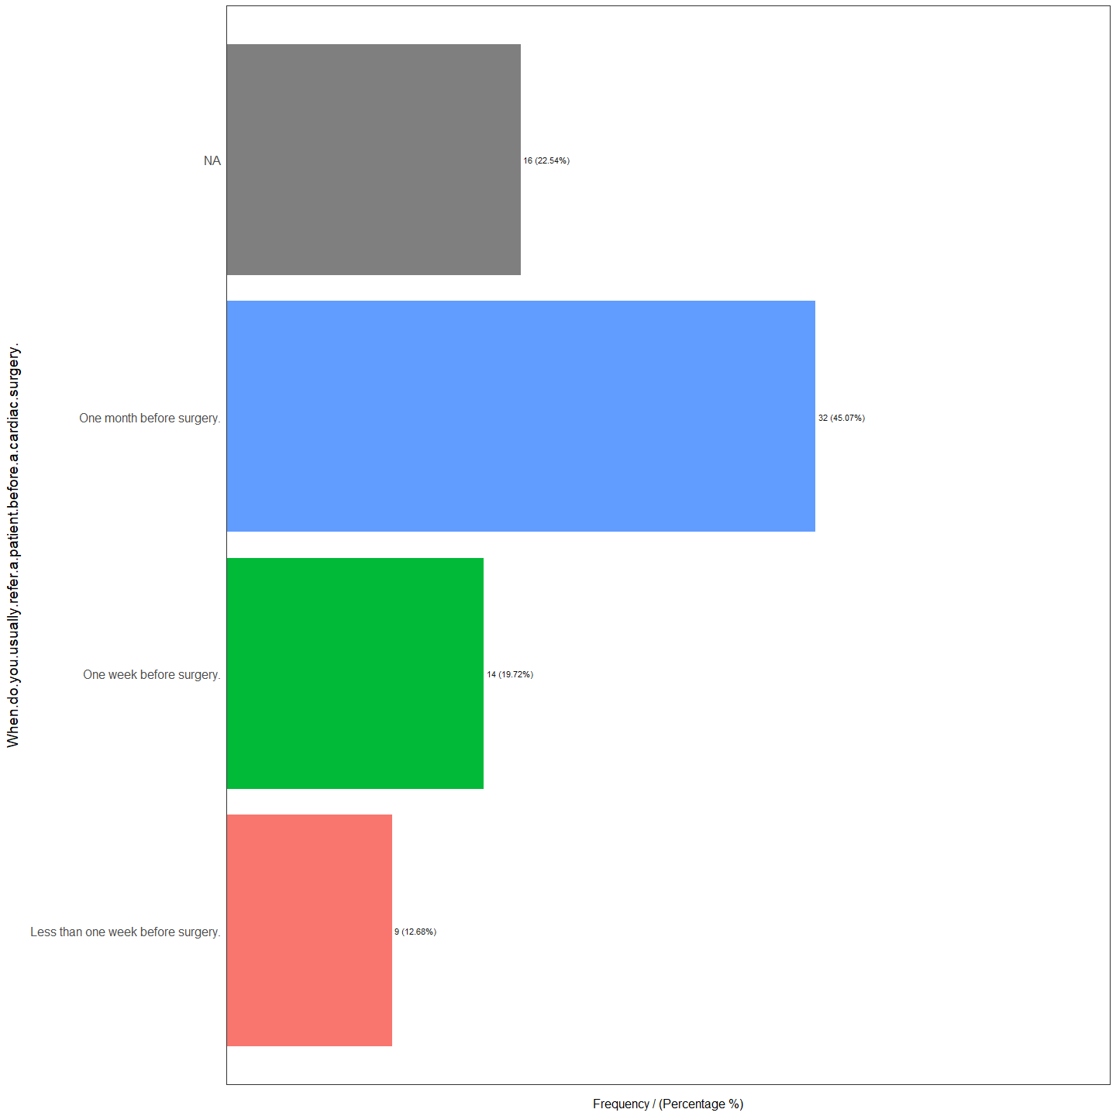

When.do.you.usually.refer.a.patient.before.a.cardiac.surgery. frequency  
1 One month before surgery. 32  
2 <NA> 16  
3 One week before surgery. 14  
4 Less than one week before surgery. 9  
 percentage cumulative_perc  
1 45.07 45.07  
2 22.54 67.61  
3 19.72 87.33  
4 12.68 100.00

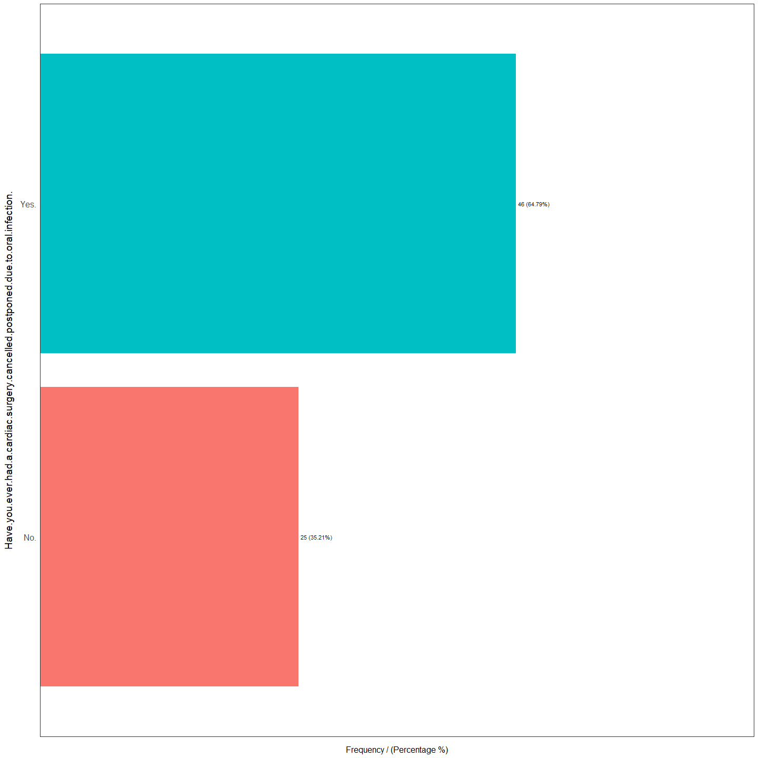

Have.you.ever.had.a.cardiac.surgery.cancelled.postponed.due.to.oral.infection.  
1 Yes.  
2 No.  
 frequency percentage cumulative_perc  
1 46 64.79 64.79  
2 25 35.21 100.00

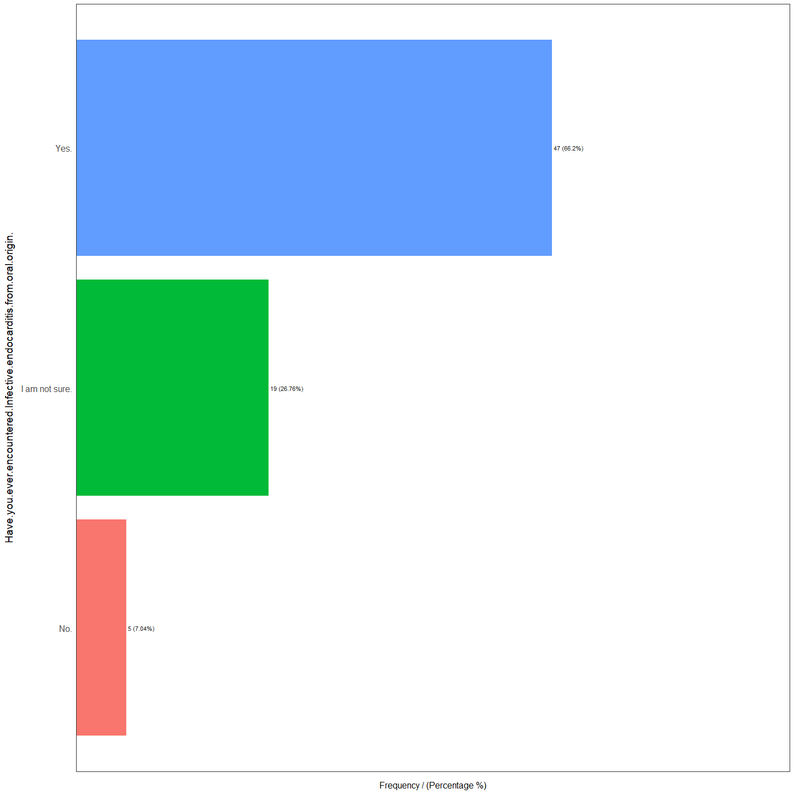

Have.you.ever.encountered.Infective.endocarditis.from.oral.origin. frequency  
1 Yes. 47  
2 I am not sure. 19  
3 No. 5  
 percentage cumulative_perc  
1 66.20 66.20  
2 26.76 92.96  
3 7.04 100.00

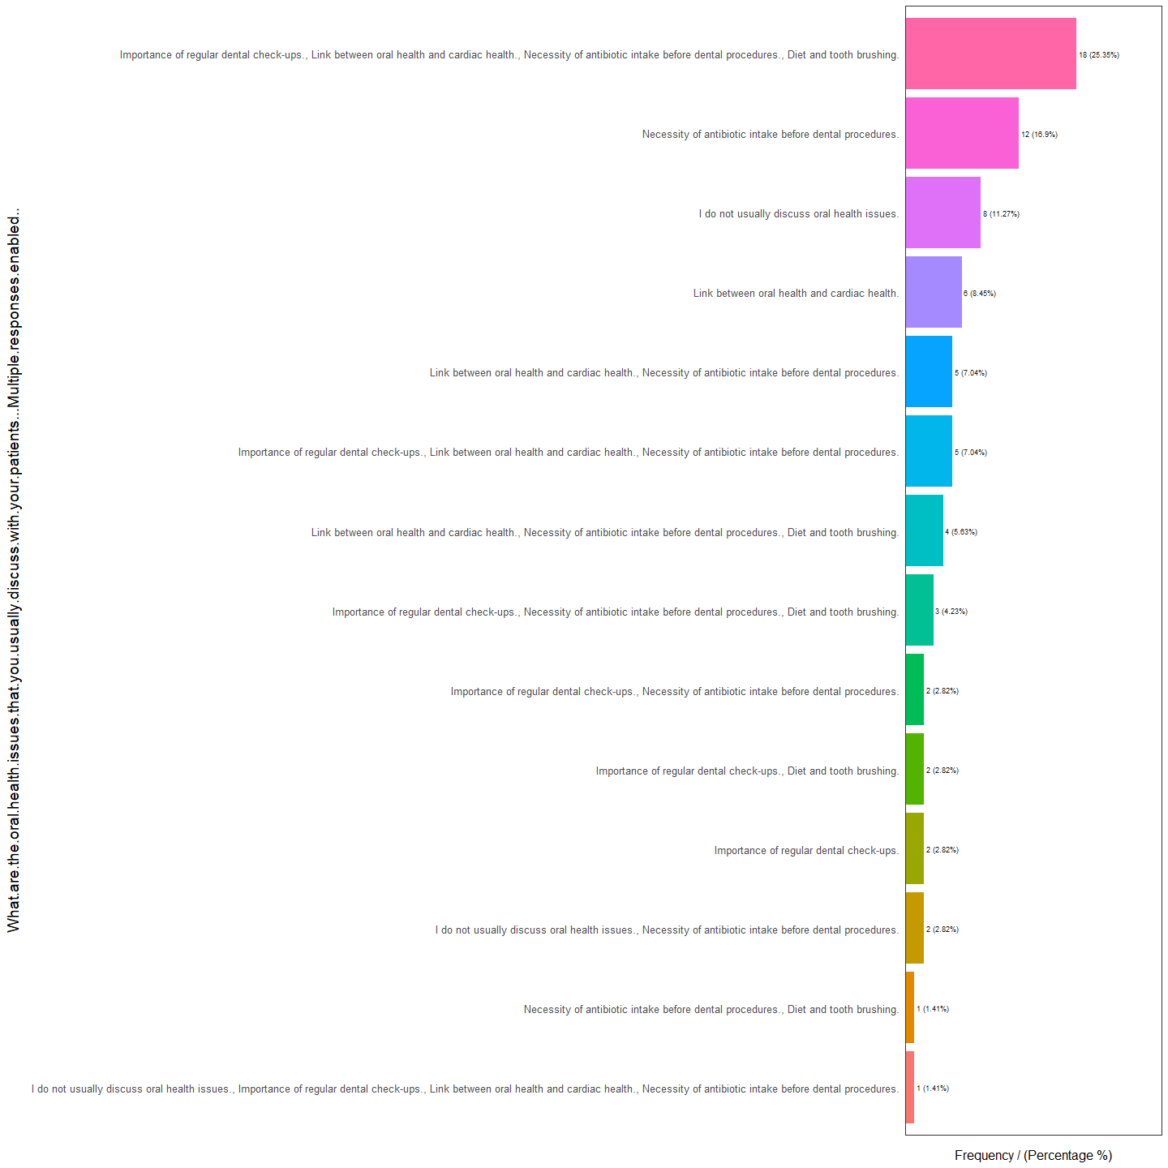

What.are.the.oral.health.issues.that.you.usually.discuss.with.your.patients...Multiple.responses.enabled..  
1 Importance of regular dental check-ups., Link between oral health and cardiac health., Necessity of antibiotic intake before dental procedures., Diet and tooth brushing.  
2 Necessity of antibiotic intake before dental procedures.  
3 I do not usually discuss oral health issues.  
4 Link between oral health and cardiac health.  
5 Importance of regular dental check-ups., Link between oral health and cardiac health., Necessity of antibiotic intake before dental procedures.  
6 Link between oral health and cardiac health., Necessity of antibiotic intake before dental procedures.  
7 Link between oral health and cardiac health., Necessity of antibiotic intake before dental procedures., Diet and tooth brushing.  
8 Importance of regular dental check-ups., Necessity of antibiotic intake before dental procedures., Diet and tooth brushing.  
9 I do not usually discuss oral health issues., Necessity of antibiotic intake before dental procedures.  
10 Importance of regular dental check-ups.  
11 Importance of regular dental check-ups., Diet and tooth brushing.  
12 Importance of regular dental check-ups., Necessity of antibiotic intake before dental procedures.  
13 I do not usually discuss oral health issues., Importance of regular dental check-ups., Link between oral health and cardiac health., Necessity of antibiotic intake before dental procedures.  
14 Necessity of antibiotic intake before dental procedures., Diet and tooth brushing.  
 frequency percentage cumulative_perc  
1 18 25.35 25.35  
2 12 16.90 42.25  
3 8 11.27 53.52  
4 6 8.45 61.97  
5 5 7.04 69.01  
6 5 7.04 76.05  
7 4 5.63 81.68  
8 3 4.23 85.91  
9 2 2.82 88.73  
10 2 2.82 91.55  
11 2 2.82 94.37  
12 2 2.82 97.19  
13 1 1.41 98.60  
14 1 1.41 100.00

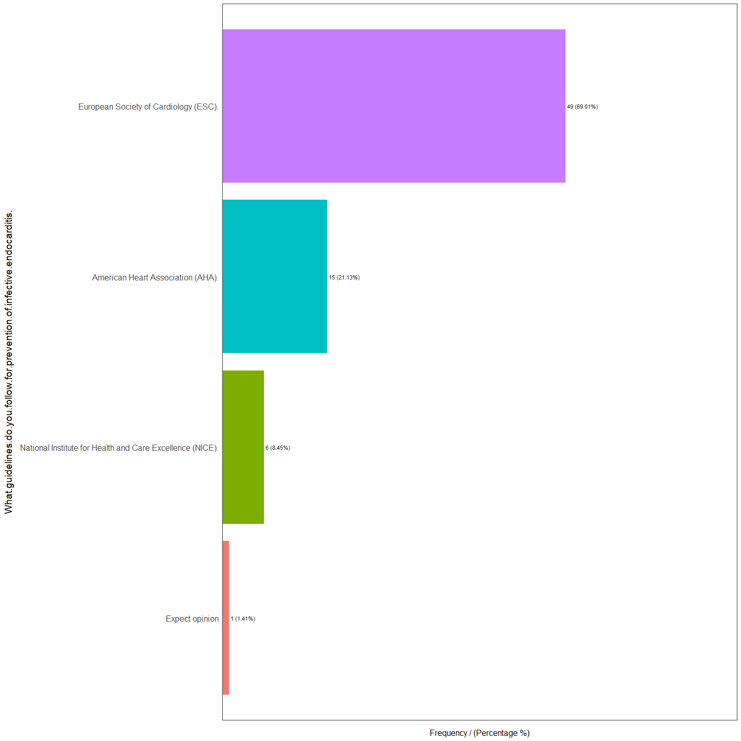

What.guidelines.do.you.follow.for.prevention.of.infective.endocarditis.  
1 European Society of Cardiology (ESC).  
2 American Heart Association (AHA).  
3 National Institute for Health and Care Excellence (NICE).  
4 Expect opinion  
 frequency percentage cumulative_perc  
1 49 69.01 69.01  
2 15 21.13 90.14  
3 6 8.45 98.59  
4 1 1.41 100.00

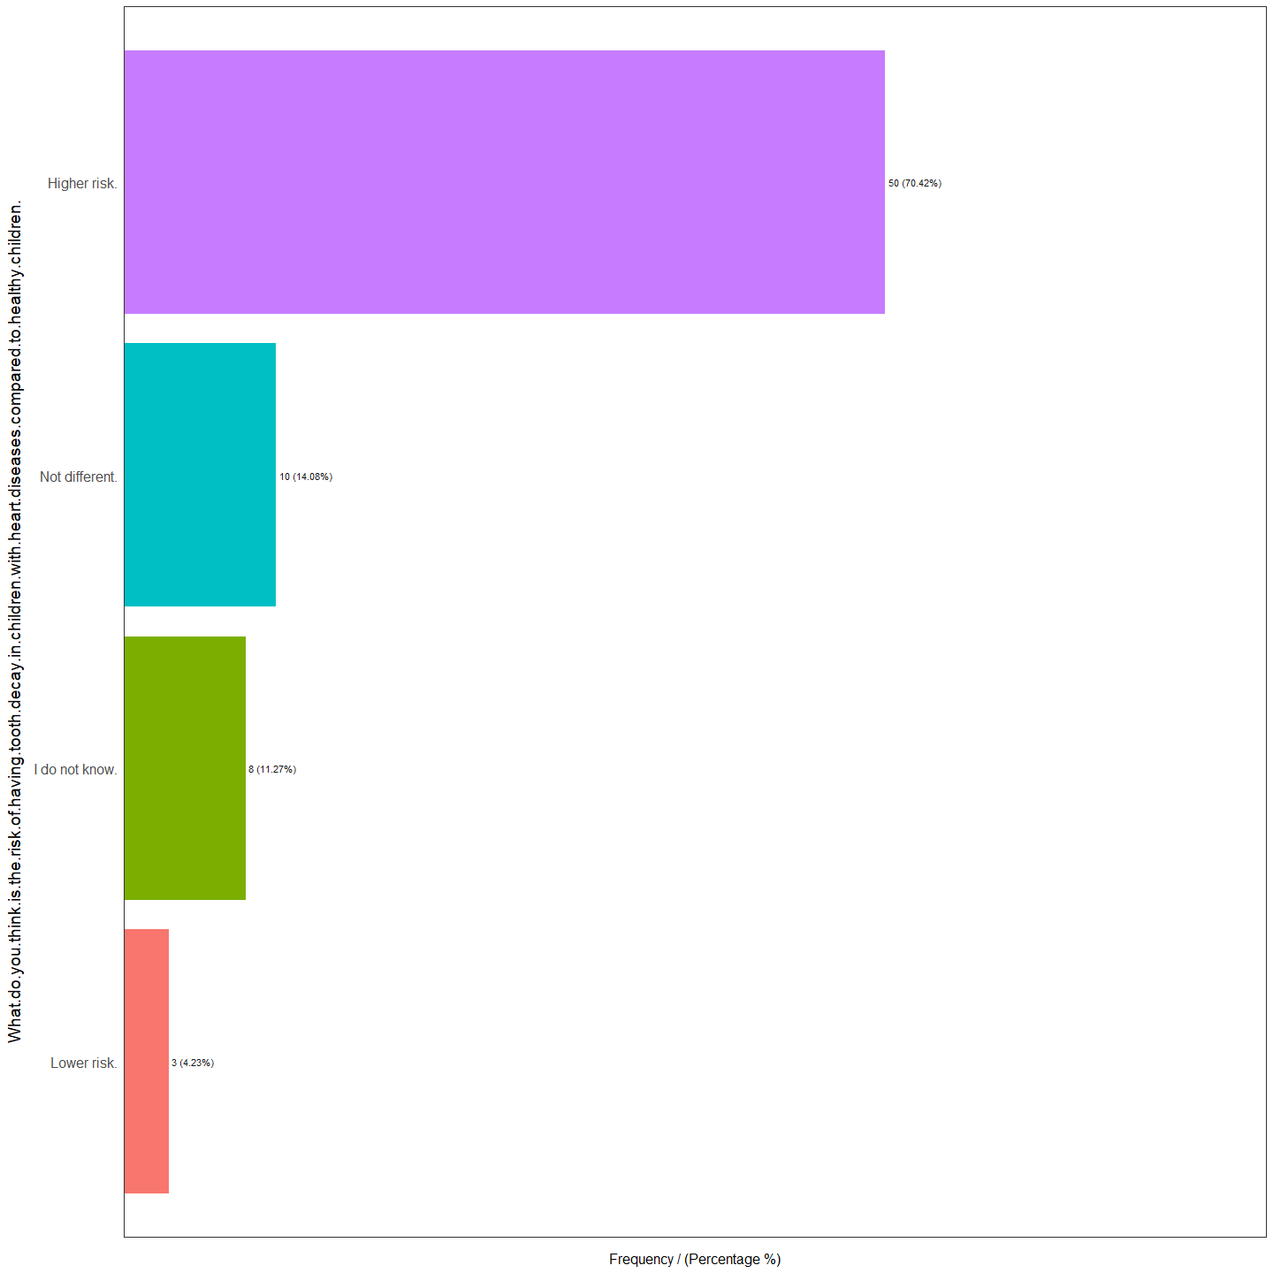

What.do.you.think.is.the.risk.of.having.tooth.decay.in.children.with.heart.diseases.compared.to.healthy.children.  
1 Higher risk.  
2 Not different.  
3 I do not know.  
4 Lower risk.  
 frequency percentage cumulative_perc  
1 50 70.42 70.42  
2 10 14.08 84.50  
3 8 11.27 95.77  
4 3 4.23 100.00

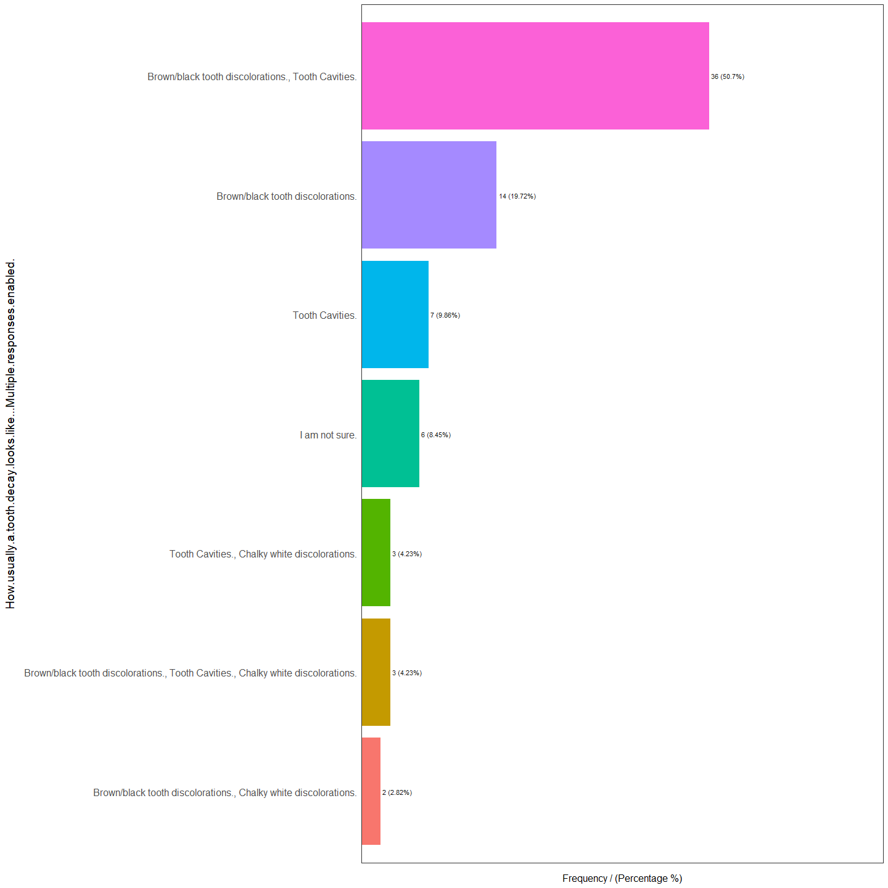

How.usually.a.tooth.decay.looks.like...Multiple.responses.enabled.  
1 Brown/black tooth discolorations., Tooth Cavities.  
2 Brown/black tooth discolorations.  
3 Tooth Cavities.  
4 I am not sure.  
5 Brown/black tooth discolorations., Tooth Cavities., Chalky white discolorations.  
6 Tooth Cavities., Chalky white discolorations.  
7 Brown/black tooth discolorations., Chalky white discolorations.  
 frequency percentage cumulative_perc  
1 36 50.70 50.70  
2 14 19.72 70.42  
3 7 9.86 80.28  
4 6 8.45 88.73  
5 3 4.23 92.96  
6 3 4.23 97.19  
7 2 2.82 100.00

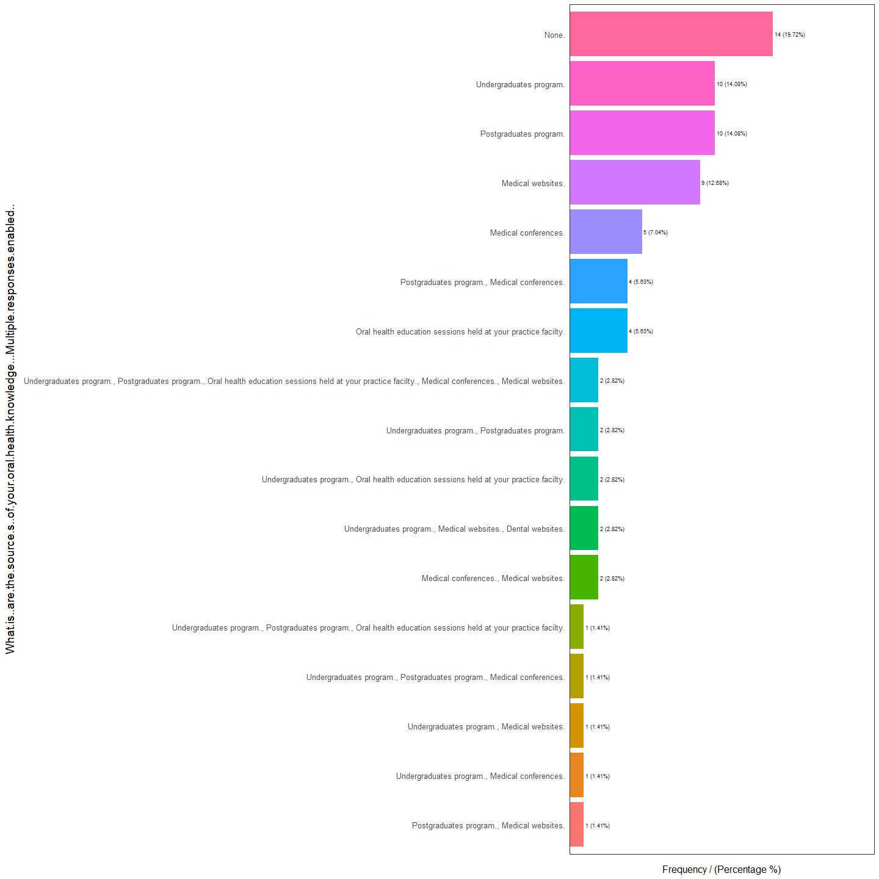

What.is..are.the.source.s..of.your.oral.health.knowledge...Multiple.responses.enabled..  
1 None.  
2 Postgraduates program.  
3 Undergraduates program.  
4 Medical websites.  
5 Medical conferences.  
6 Oral health education sessions held at your practice facilty.  
7 Postgraduates program., Medical conferences.  
8 Medical conferences., Medical websites.  
9 Undergraduates program., Medical websites., Dental websites.  
10 Undergraduates program., Oral health education sessions held at your practice facilty.  
11 Undergraduates program., Postgraduates program.  
12 Undergraduates program., Postgraduates program., Oral health education sessions held at your practice facilty., Medical conferences., Medical websites.  
13 Postgraduates program., Medical websites.  
14 Undergraduates program., Medical conferences.  
15 Undergraduates program., Medical websites.  
16 Undergraduates program., Postgraduates program., Medical conferences.  
17 Undergraduates program., Postgraduates program., Oral health education sessions held at your practice facilty.  
 frequency percentage cumulative_perc  
1 14 19.72 19.72  
2 10 14.08 33.80  
3 10 14.08 47.88  
4 9 12.68 60.56  
5 5 7.04 67.60  
6 4 5.63 73.23  
7 4 5.63 78.86  
8 2 2.82 81.68  
9 2 2.82 84.50  
10 2 2.82 87.32  
11 2 2.82 90.14  
12 2 2.82 92.96  
13 1 1.41 94.37  
14 1 1.41 95.78  
15 1 1.41 97.19  
16 1 1.41 98.60  
17 1 1.41 100.00

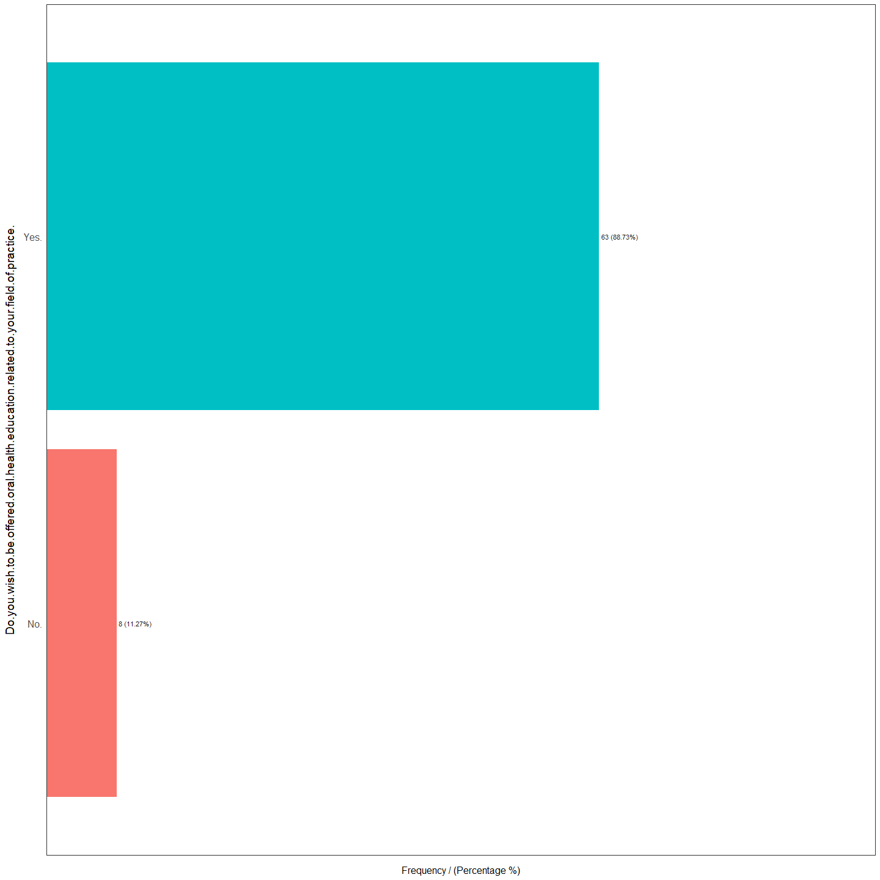

Do.you.wish.to.be.offered.oral.health.education.related.to.your.field.of.practice.  
1 Yes.  
2 No.  
 frequency percentage cumulative_perc  
1 63 88.73 88.73  
2 8 11.27 100.00

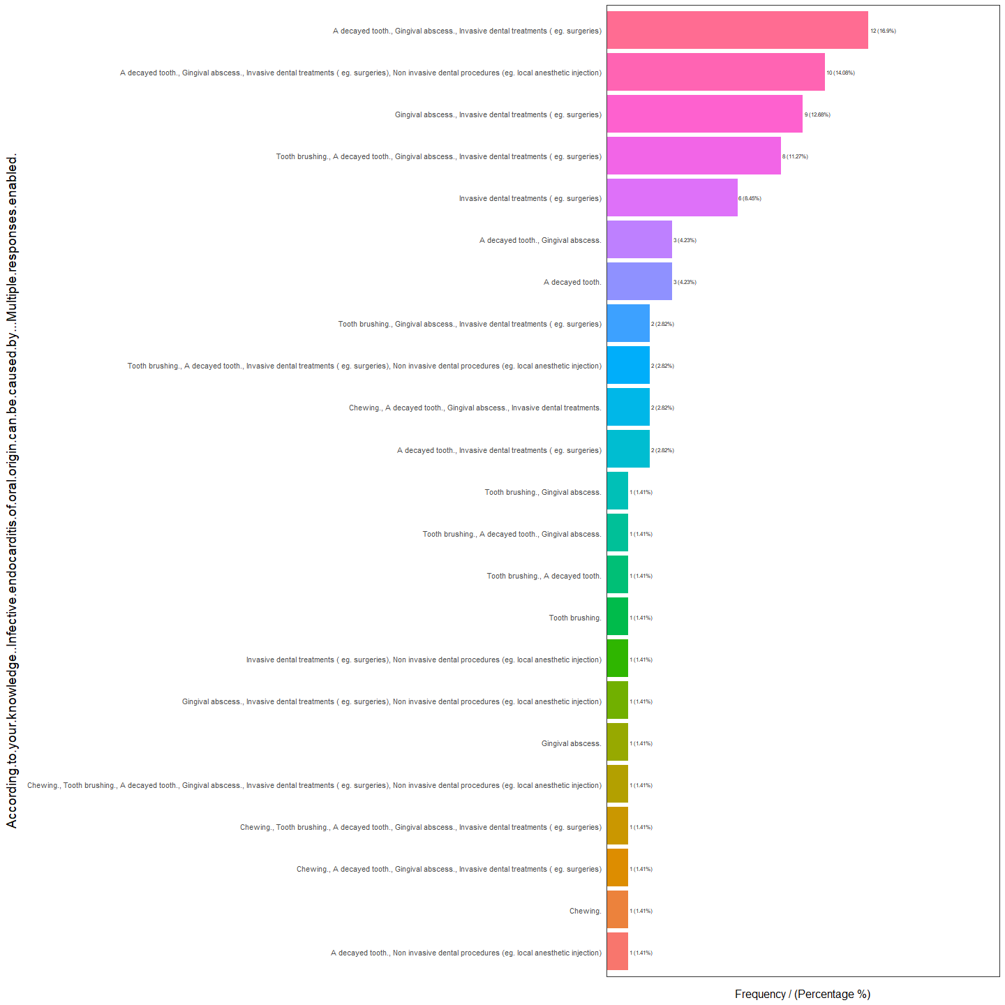

According.to.your.knowledge..Infective.endocarditis.of.oral.origin.can.be.caused.by...Multiple.responses.enabled.  
1 A decayed tooth., Gingival abscess., Invasive dental treatments ( eg. surgeries)  
2 A decayed tooth., Gingival abscess., Invasive dental treatments ( eg. surgeries), Non invasive dental procedures (eg. local anesthetic injection)  
3 Gingival abscess., Invasive dental treatments ( eg. surgeries)  
4 Tooth brushing., A decayed tooth., Gingival abscess., Invasive dental treatments ( eg. surgeries)  
5 Invasive dental treatments ( eg. surgeries)  
6 A decayed tooth.  
7 A decayed tooth., Gingival abscess.  
8 A decayed tooth., Invasive dental treatments ( eg. surgeries)  
9 Chewing., A decayed tooth., Gingival abscess., Invasive dental treatments.  
10 Tooth brushing., A decayed tooth., Invasive dental treatments ( eg. surgeries), Non invasive dental procedures (eg. local anesthetic injection)  
11 Tooth brushing., Gingival abscess., Invasive dental treatments ( eg. surgeries)  
12 A decayed tooth., Non invasive dental procedures (eg. local anesthetic injection)  
13 Chewing.  
14 Chewing., A decayed tooth., Gingival abscess., Invasive dental treatments ( eg. surgeries)  
15 Chewing., Tooth brushing., A decayed tooth., Gingival abscess., Invasive dental treatments ( eg. surgeries)  
16 Chewing., Tooth brushing., A decayed tooth., Gingival abscess., Invasive dental treatments ( eg. surgeries), Non invasive dental procedures (eg. local anesthetic injection)  
17 Gingival abscess.  
18 Gingival abscess., Invasive dental treatments ( eg. surgeries), Non invasive dental procedures (eg. local anesthetic injection)  
19 Invasive dental treatments ( eg. surgeries), Non invasive dental procedures (eg. local anesthetic injection)  
20 Tooth brushing.  
21 Tooth brushing., A decayed tooth.  
22 Tooth brushing., A decayed tooth., Gingival abscess.  
23 Tooth brushing., Gingival abscess.  
 frequency percentage cumulative_perc  
1 12 16.90 16.90  
2 10 14.08 30.98  
3 9 12.68 43.66  
4 8 11.27 54.93  
5 6 8.45 63.38  
6 3 4.23 67.61  
7 3 4.23 71.84  
8 2 2.82 74.66  
9 2 2.82 77.48  
10 2 2.82 80.30  
11 2 2.82 83.12  
12 1 1.41 84.53  
13 1 1.41 85.94  
14 1 1.41 87.35  
15 1 1.41 88.76  
16 1 1.41 90.17  
17 1 1.41 91.58  
18 1 1.41 92.99  
19 1 1.41 94.40  
20 1 1.41 95.81  
21 1 1.41 97.22  
22 1 1.41 98.63  
23 1 1.41 100.00

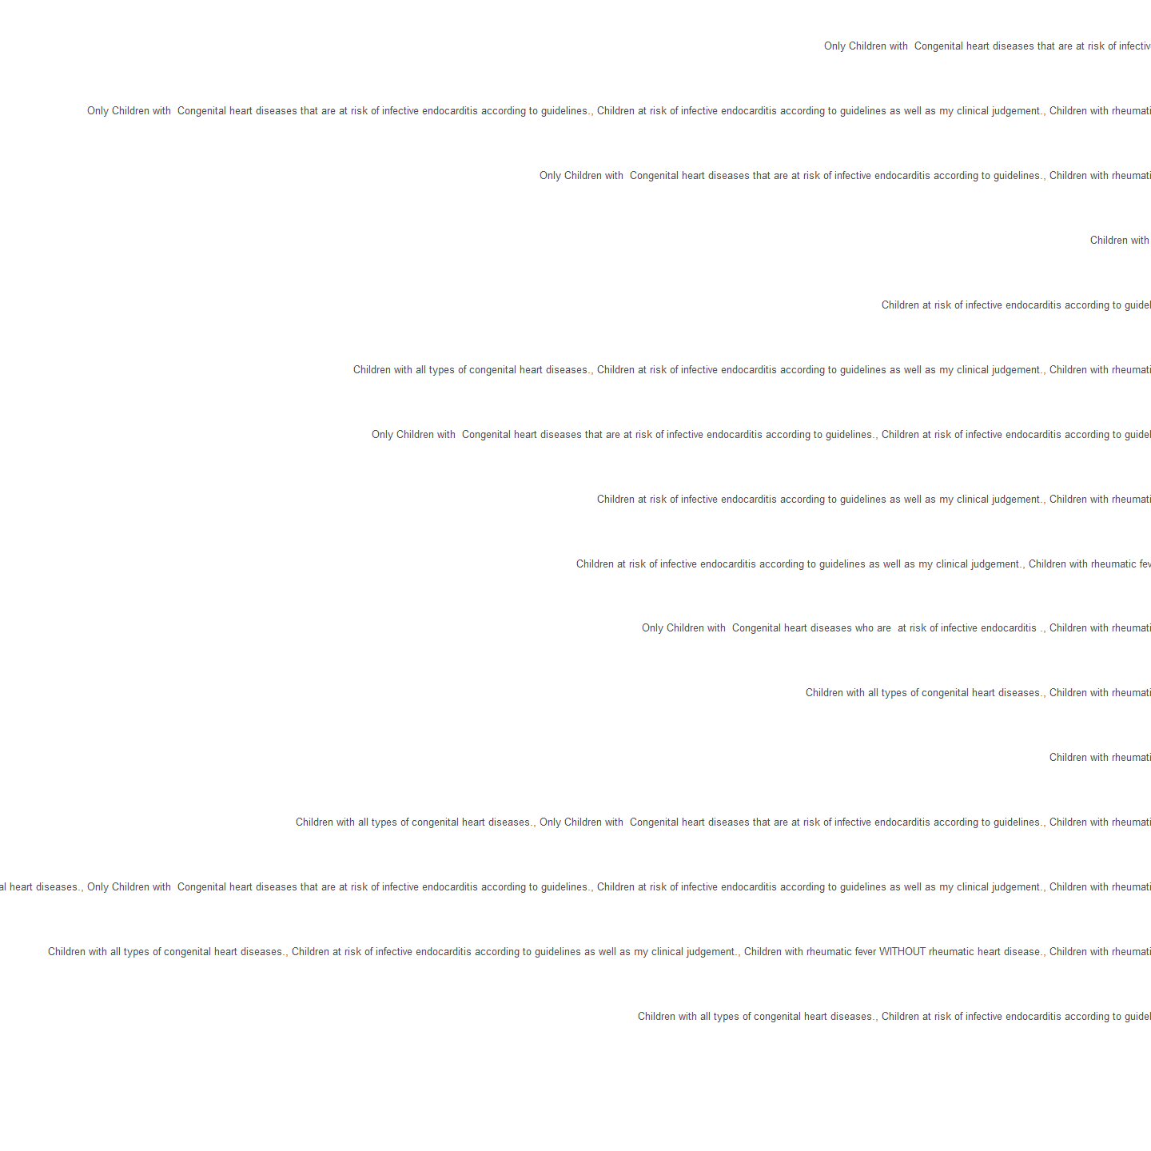

For.whom.do.you.usually.prescribe.prophylactic.antibiotics.before.invasive.dental.procedures...Multiple.responses.enabled..  
1 Only Children with Congenital heart diseases that are at risk of infective endocarditis according to guidelines.  
2 Only Children with Congenital heart diseases that are at risk of infective endocarditis according to guidelines., Children at risk of infective endocarditis according to guidelines as well as my clinical judgement., Children with rheumatic fever WITH rheumatic heart disease.  
3 Only Children with Congenital heart diseases that are at risk of infective endocarditis according to guidelines., Children with rheumatic fever WITH rheumatic heart disease.  
4 Children at risk of infective endocarditis according to guidelines as well as my clinical judgement.  
5 Children with all types of congenital heart diseases.  
6 Children with all types of congenital heart diseases., Children at risk of infective endocarditis according to guidelines as well as my clinical judgement., Children with rheumatic fever WITH rheumatic heart disease.  
7 Children at risk of infective endocarditis according to guidelines as well as my clinical judgement., Children with rheumatic fever WITH rheumatic heart disease.  
8 Only Children with Congenital heart diseases that are at risk of infective endocarditis according to guidelines., Children at risk of infective endocarditis according to guidelines as well as my clinical judgement.  
9 Children at risk of infective endocarditis according to guidelines as well as my clinical judgement., Children with rheumatic fever WITHOUT rheumatic heart disease.  
10 Children with all types of congenital heart diseases., Children with rheumatic fever WITH rheumatic heart disease.  
11 Only Children with Congenital heart diseases who are at risk of infective endocarditis ., Children with rheumatic fever WITH rheumatic heart disease.  
12 Antibiotics are not needed.  
13 Children with all types of congenital heart diseases., Children at risk of infective endocarditis according to guidelines as well as my clinical judgement.  
14 Children with all types of congenital heart diseases., Children at risk of infective endocarditis according to guidelines as well as my clinical judgement., Children with rheumatic fever WITHOUT rheumatic heart disease., Children with rheumatic fever WITH rheumatic heart disease.  
15 Children with all types of congenital heart diseases., Only Children with Congenital heart diseases that are at risk of infective endocarditis according to guidelines., Children at risk of infective endocarditis according to guidelines as well as my clinical judgement., Children with rheumatic fever WITH rheumatic heart disease.  
16 Children with all types of congenital heart diseases., Only Children with Congenital heart diseases that are at risk of infective endocarditis according to guidelines., Children with rheumatic fever WITH rheumatic heart disease.  
17 Children with rheumatic fever WITH rheumatic heart disease.  
 frequency percentage cumulative_perc  
1 11 15.49 15.49  
2 9 12.68 28.17  
3 8 11.27 39.44  
4 7 9.86 49.30  
5 7 9.86 59.16  
6 6 8.45 67.61  
7 5 7.04 74.65  
8 5 7.04 81.69  
9 3 4.23 85.92  
10 2 2.82 88.74  
11 2 2.82 91.56  
12 1 1.41 92.97  
13 1 1.41 94.38  
14 1 1.41 95.79  
15 1 1.41 97.20  
16 1 1.41 98.61  
17 1 1.41 100.00

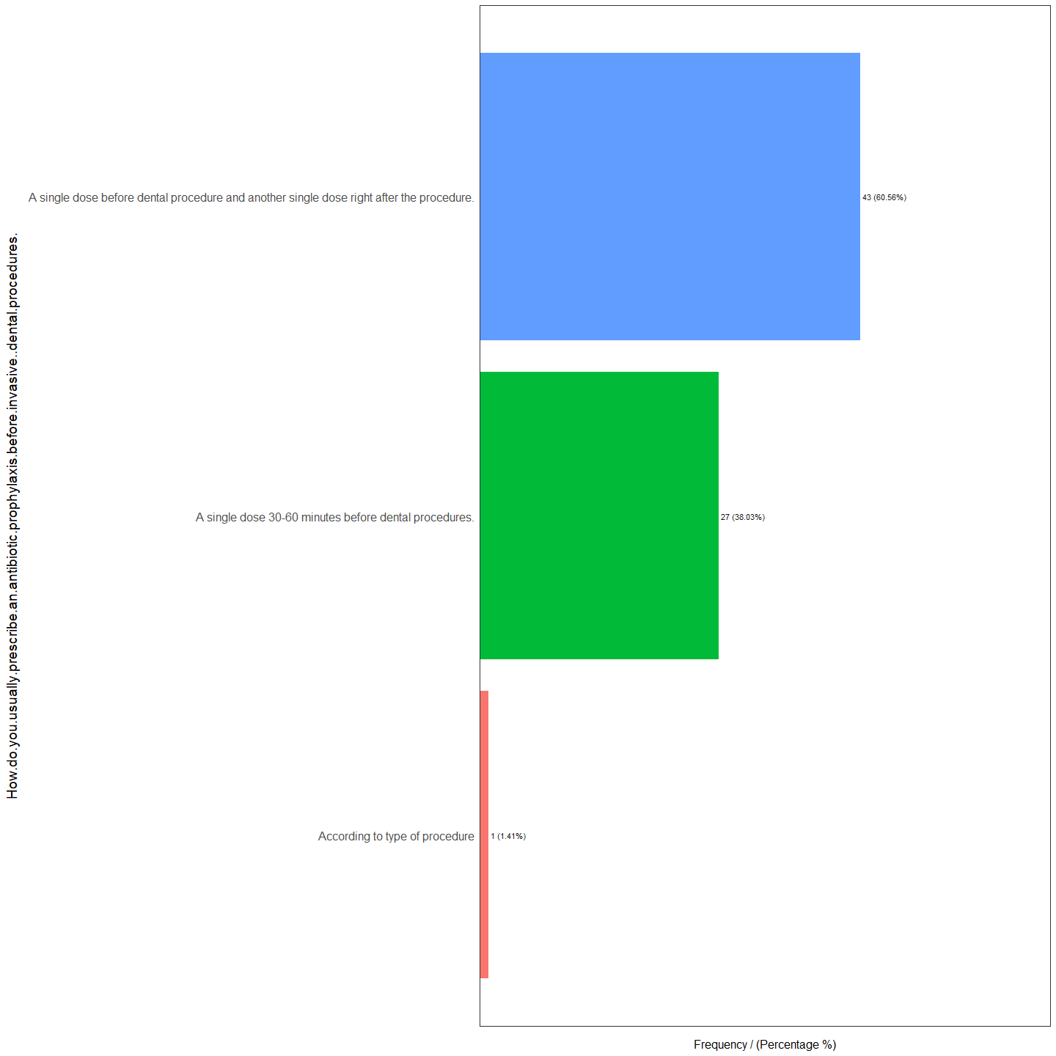

How.do.you.usually.prescribe.an.antibiotic.prophylaxis.before.invasive..dental.procedures.  
1 A single dose before dental procedure and another single dose right after the procedure.  
2 A single dose 30-60 minutes before dental procedures.  
3 According to type of procedure  
 frequency percentage cumulative_perc  
1 43 60.56 60.56  
2 27 38.03 98.59  
3 1 1.41 100.00

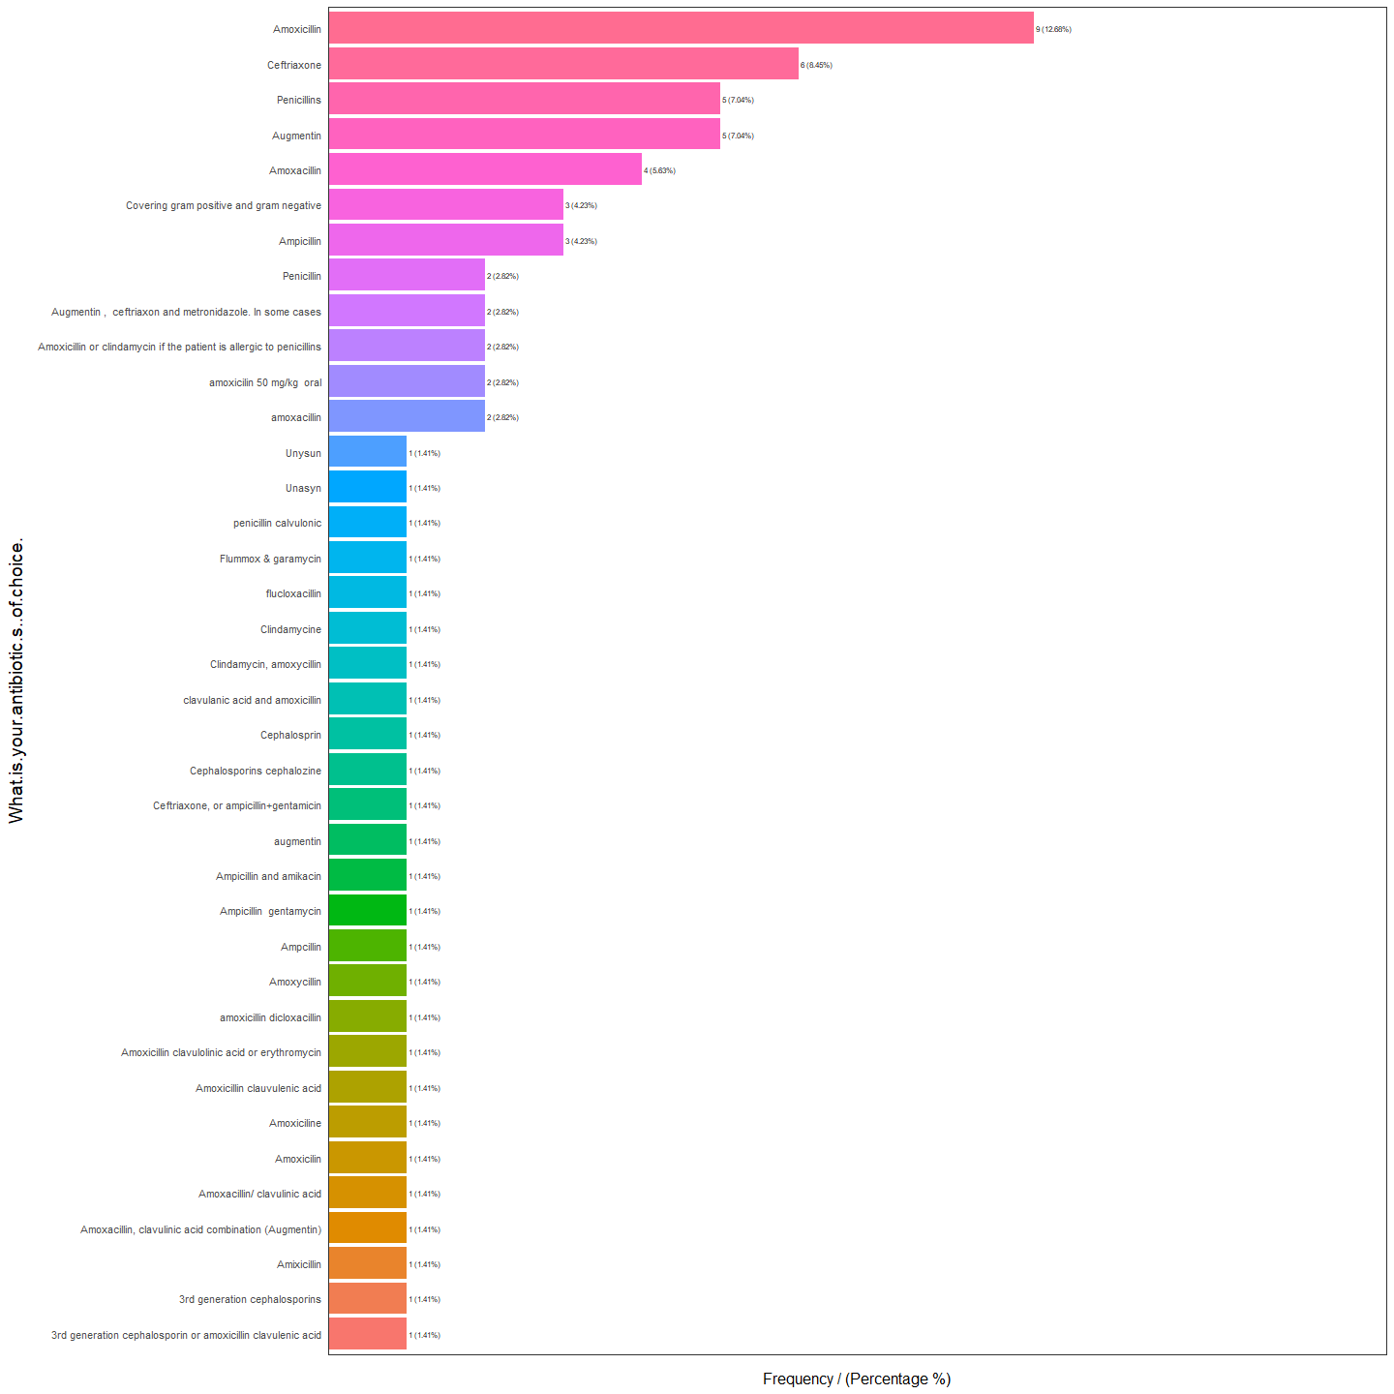

What.is.your.antibiotic.s..of.choice.  
1 Amoxicillin  
2 Ceftriaxone  
3 Augmentin  
4 Penicillins  
5 Amoxacillin  
6 Ampicillin  
7 Covering gram positive and gram negative  
8 amoxacillin  
9 amoxicilin 50 mg/kg oral  
10 Amoxicillin or clindamycin if the patient is allergic to penicillins  
11 Augmentin , ceftriaxon and metronidazole. In some cases  
12 Penicillin  
13 3rd generation cephalosporin or amoxicillin clavulenic acid  
14 3rd generation cephalosporins  
15 Amixicillin  
16 Amoxacillin, clavulinic acid combination (Augmentin)  
17 Amoxacillin/ clavulinic acid  
18 Amoxicilin  
19 Amoxiciline  
20 Amoxicillin clauvulenic acid  
21 Amoxicillin clavulolinic acid or erythromycin  
22 amoxicillin dicloxacillin  
23 Amoxycillin  
24 Ampcillin  
25 Ampicillin gentamycin  
26 Ampicillin and amikacin  
27 augmentin  
28 Ceftriaxone, or ampicillin+gentamicin  
29 Cephalosporins cephalozine  
30 Cephalosprin  
31 clavulanic acid and amoxicillin  
32 Clindamycin, amoxycillin  
33 Clindamycine  
34 flucloxacillin  
35 Flummox & garamycin  
36 penicillin calvulonic  
37 Unasyn  
38 Unysun  
 frequency percentage cumulative_perc  
1 9 12.68 12.68  
2 6 8.45 21.13  
3 5 7.04 28.17  
4 5 7.04 35.21  
5 4 5.63 40.84  
6 3 4.23 45.07  
7 3 4.23 49.30  
8 2 2.82 52.12  
9 2 2.82 54.94  
10 2 2.82 57.76  
11 2 2.82 60.58  
12 2 2.82 63.40  
13 1 1.41 64.81  
14 1 1.41 66.22  
15 1 1.41 67.63  
16 1 1.41 69.04  
17 1 1.41 70.45  
18 1 1.41 71.86  
19 1 1.41 73.27  
20 1 1.41 74.68  
21 1 1.41 76.09  
22 1 1.41 77.50  
23 1 1.41 78.91  
24 1 1.41 80.32  
25 1 1.41 81.73  
26 1 1.41 83.14  
27 1 1.41 84.55  
28 1 1.41 85.96  
29 1 1.41 87.37  
30 1 1.41 88.78  
31 1 1.41 90.19  
32 1 1.41 91.60  
33 1 1.41 93.01  
34 1 1.41 94.42  
35 1 1.41 95.83  
36 1 1.41 97.24  
37 1 1.41 98.65  
38 1 1.41 100.00

[1] "Variables processed: Age., Gender., Job.Title., Specialty., Highest.degree.attained...If.you.choose..other...please.specify., Years.of.experience.in.Pediatric.Cardiology...Cardiac.Surgery., Country.of.Practice...Multiple.responses.enabled., Type.of.Medical.practice...Multiple.responses.enabled., X.When.do.you.usually.ASSESS.oral.health., What.are.the.reason.s..for.not.checking.oral.health.regularly....Multiple.responses.enabled.., When.do.you.usually.REFER.a.child.with.a.congenital.heart.disease.for.oral.health.assessment.by.a.dentist.....Multiple.responses.enabled., What.type.of.dental.specialty.would.your.refer.a.patient.to., X.In.which.practice.setting.do.you.usually.refer.a.patient.at.risk.of.infective.endocarditis.for.oral.health.assessment.BEFORE.cardiac.surgeries., When.do.you.usually.refer.a.patient.before.a.cardiac.surgery., Have.you.ever.had.a.cardiac.surgery.cancelled.postponed.due.to.oral.infection., Have.you.ever.encountered.Infective.endocarditis.from.oral.origin., What.are.the.oral.health.issues.that.you.usually.discuss.with.your.patients...Multiple.responses.enabled.., What.guidelines.do.you.follow.for.prevention.of.infective.endocarditis., What.do.you.think.is.the.risk.of.having.tooth.decay.in.children.with.heart.diseases.compared.to.healthy.children., How.usually.a.tooth.decay.looks.like...Multiple.responses.enabled., What.is..are.the.source.s..of.your.oral.health.knowledge...Multiple.responses.enabled.., Do.you.wish.to.be.offered.oral.health.education.related.to.your.field.of.practice., According.to.your.knowledge..Infective.endocarditis.of.oral.origin.can.be.caused.by...Multiple.responses.enabled., For.whom.do.you.usually.prescribe.prophylactic.antibiotics.before.invasive.dental.procedures...Multiple.responses.enabled.., How.do.you.usually.prescribe.an.antibiotic.prophylaxis.before.invasive..dental.procedures., What.is.your.antibiotic.s..of.choice."