Pediatric denstists

November 26, 2020

# Table 1 Participants’ demographics

Imp notes :

Gender distribution is greatly shifted towards females

| Characteristic | N | N = 2361 |
| --- | --- | --- |
| **Gender** | 236 |  |
| *Female* |  | 196 (83%) |
| *Male* |  | 40 (17%) |
| **Degree** | 236 |  |
| *1st or 2nd year Master student* |  | 80 (34%) |
| *Diploma* |  | 8 (3.4%) |
| *Doctorate degree (PhD)* |  | 39 (17%) |
| *MSc* |  | 109 (46%) |
| **Years.of.experience.in.pediatric.dentistry** | 236 |  |
| *1-5 years* |  | 126 (53%) |
| *11-20 years* |  | 43 (18%) |
| *6-10 years* |  | 64 (27%) |
| *More than 20 years* |  | 3 (1.3%) |
| **country** | 236 |  |
| *Egypt and others* |  | 7 (3.0%) |
| *Egypt only* |  | 229 (97%) |
| 1Statistics presented: n (%) | | |

# Table 2

| Characteristic | N | N = 2361 |
| --- | --- | --- |
| **How.regularly.do.you.encounter.a.child.with.Congenital..Rheumatic.Heart.Disease.in.your.practice.** | 236 |  |
| *Almost daily* |  | 1 (0.4%) |
| *Rarely* |  | 121 (51%) |
| *Several times a month* |  | 30 (13%) |
| *Several times a week* |  | 7 (3.0%) |
| *Several times a year* |  | 77 (33%) |
| **guideline** | 236 |  |
| *AHA* |  | 144 (61%) |
| *NICE* |  | 7 (3.0%) |
| *AAPD Guidline* |  | 0 (0%) |
| *ESC* |  | 5 (2.1%) |
| *Not sure* |  | 80 (34%) |
| **Do.you.refer.a.child.with.congenital.acquired.heart.disease.to.pediatric.cardiologists.for.consultation.before.dental.treatment.** | 236 |  |
| *No, i don't refer patients.* |  | 16 (6.8%) |
| *Yes, all children with congenital/acquired heart diseases.* |  | 154 (65%) |
| *Yes, only children at risk of infective endocarditis.* |  | 66 (28%) |
| **If.a.prophylactic.antibiotic.is.needed..who.prescribes..it.** | 236 |  |
| *I prescribe it myself* |  | 66 (28%) |
| *The pediatric cardiologist* |  | 170 (72%) |
| **How.do.you.consider.a.child.as.having.a.risk.for.infective.endocarditis.** | 236 |  |
| *According to the guidelines.* |  | 78 (33%) |
| *According to the physician consultation.* |  | 125 (53%) |
| *I ask the parents.* |  | 33 (14%) |
| **Pediatric denstists involved in oral health education for children with heart diseases** | 236 | 80 (34%) |
| **Pediatric denstists involved in oral health education of pediatric cardiologists** | 236 | 25 (11%) |
| 1Statistics presented: n (%) | | |

# cause of infective endocarditis

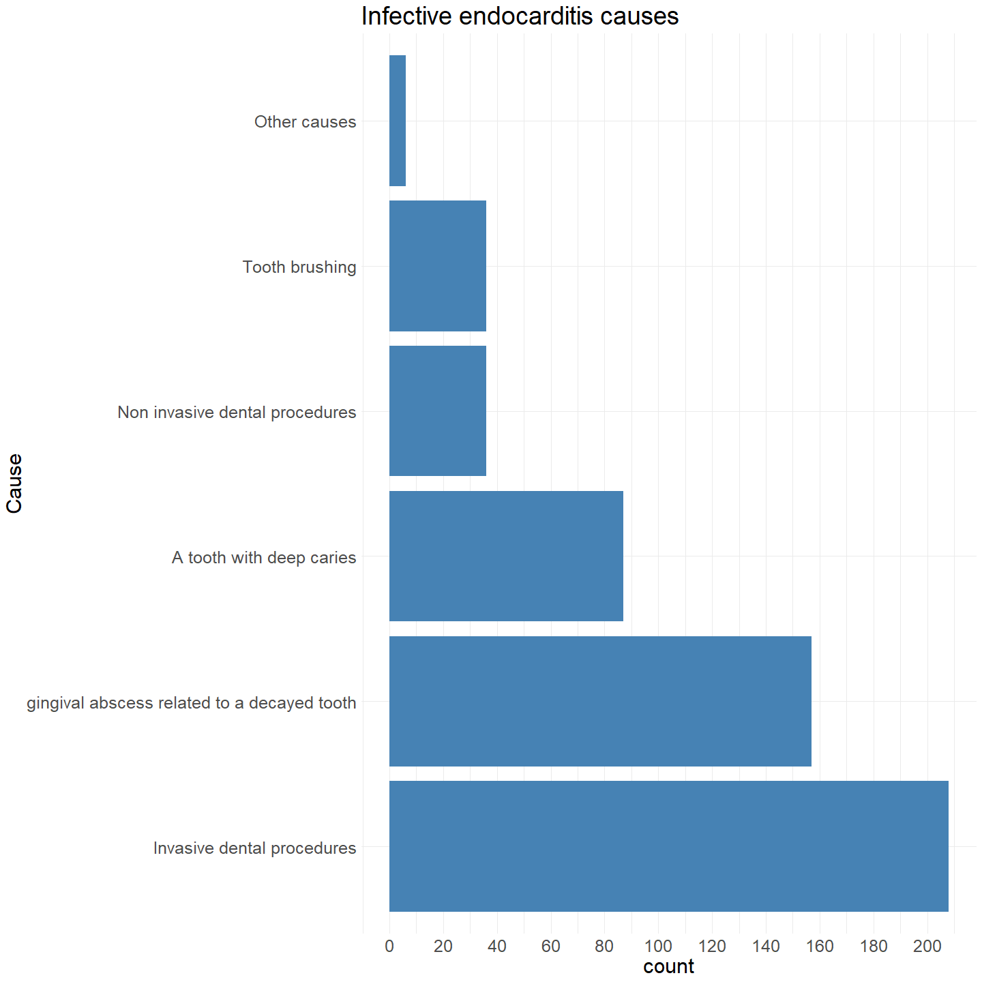

Other causes included 4 dentists who have choosen chewing and 2 dentists who have chosen root canal treatment and 1 intraligament injection.

### Safe procedures

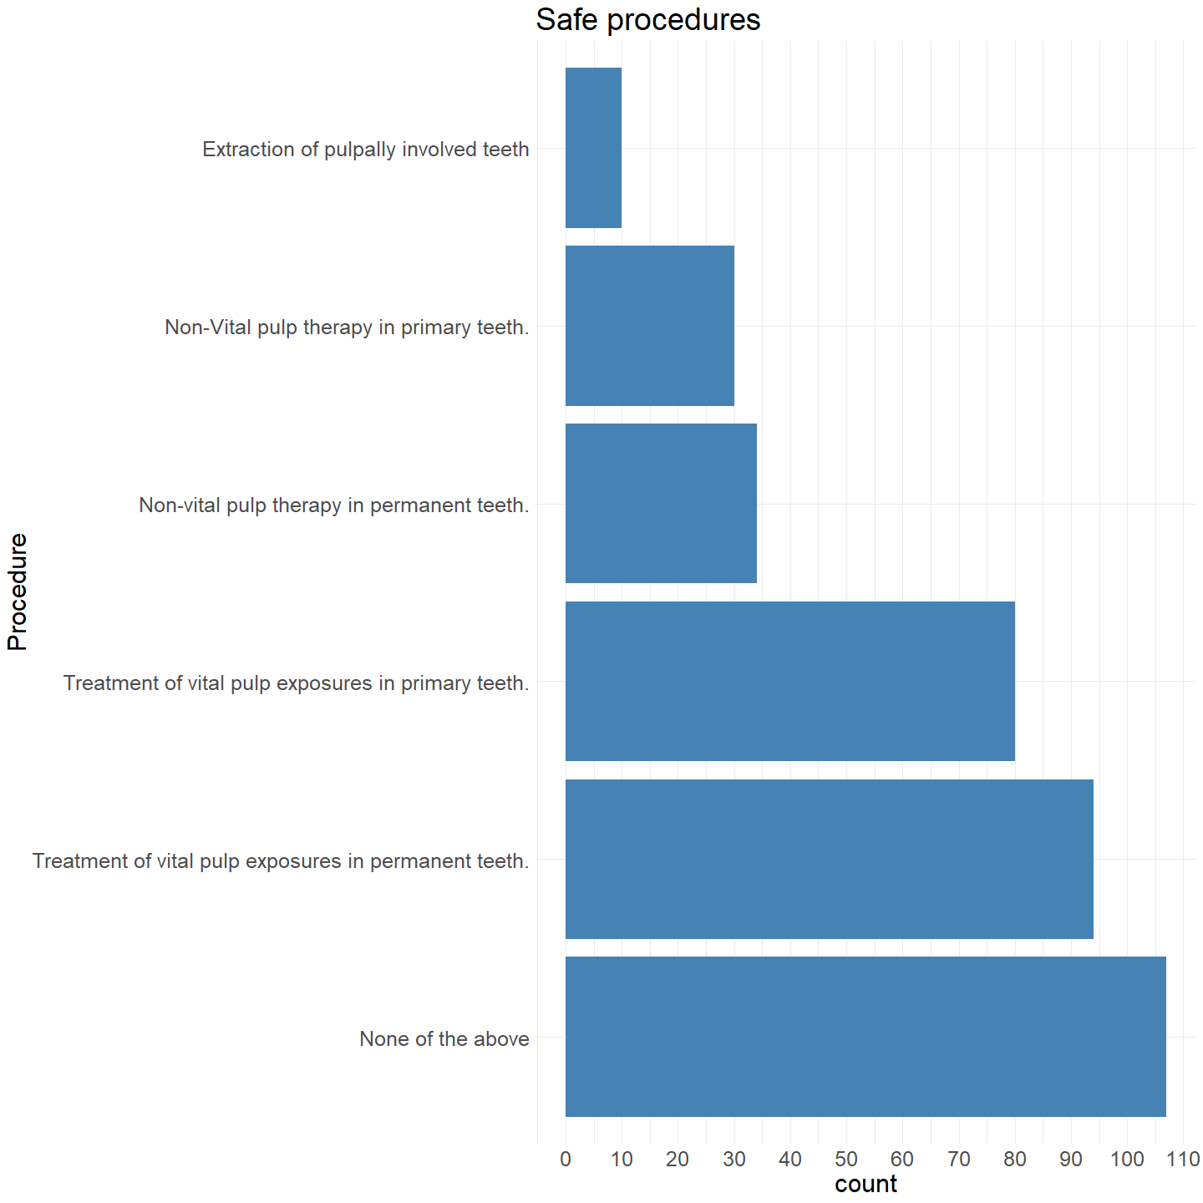

N.B. In others, I have taken only responses that included the word extraction and grouped them into extraction of pulpally involved teeth

### Antibiotics

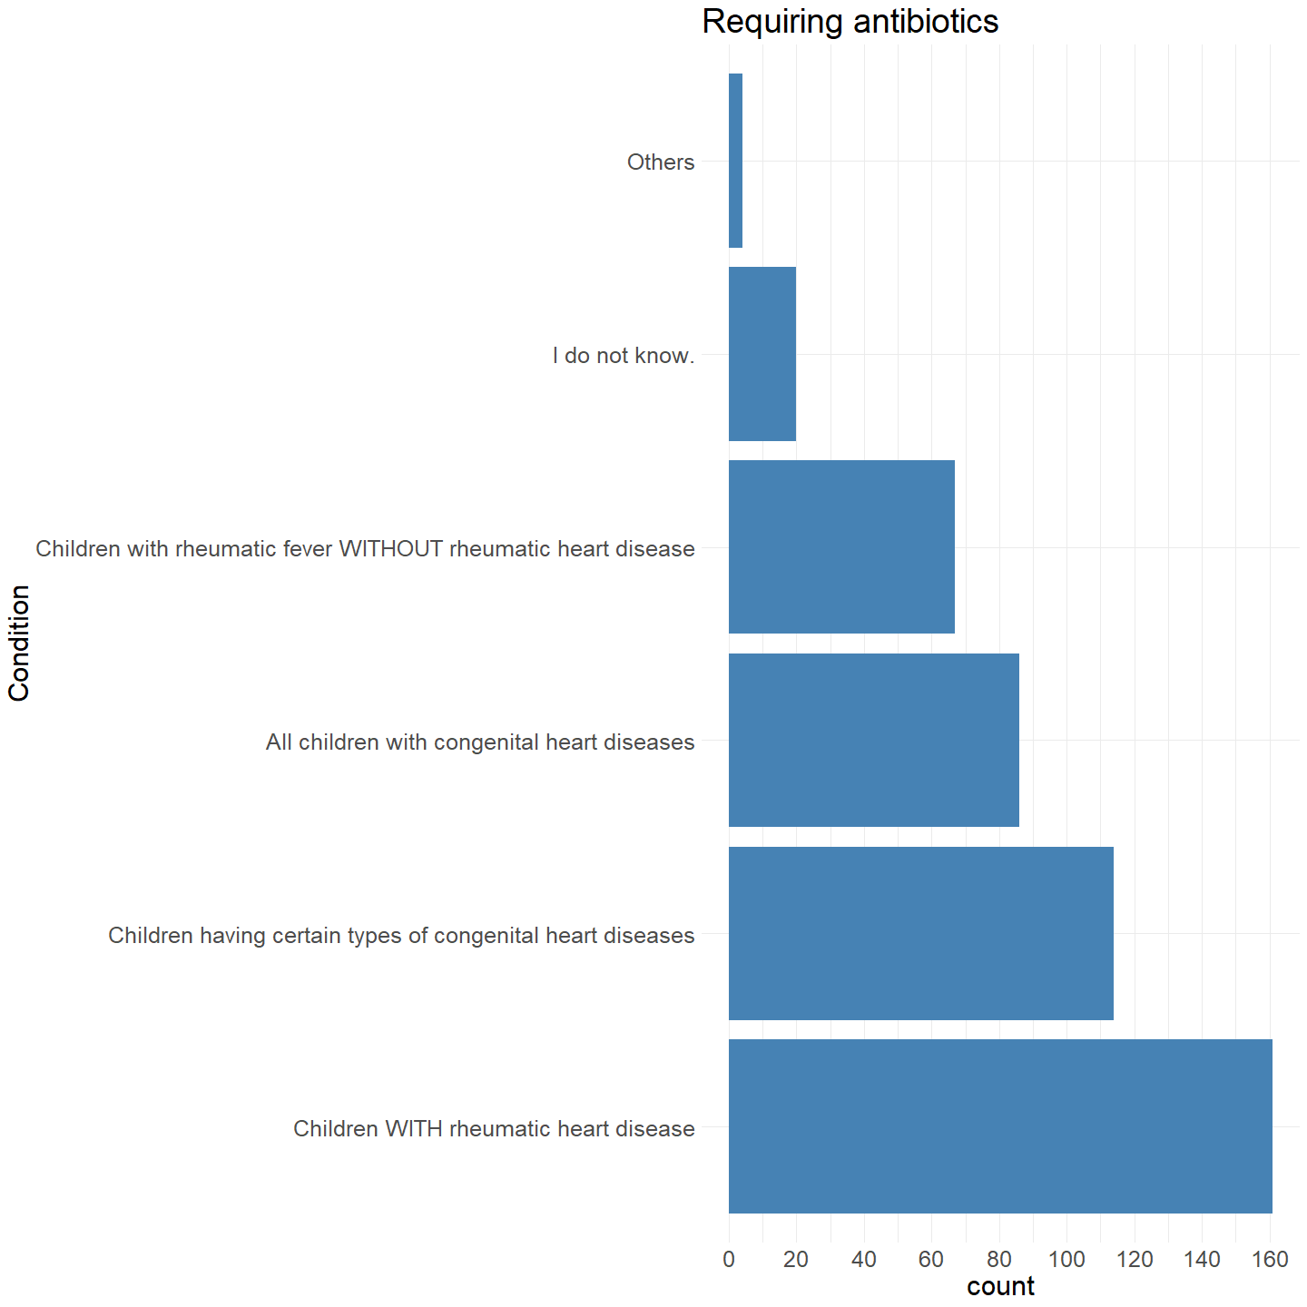

Others include three dentists choosing “previous risk of infective endocarditis or prosthetic valve” and one who has chosen "partially repaires , unrepaired and that repaired with prithetic materials

### Guideline adopted grouped by years of experience

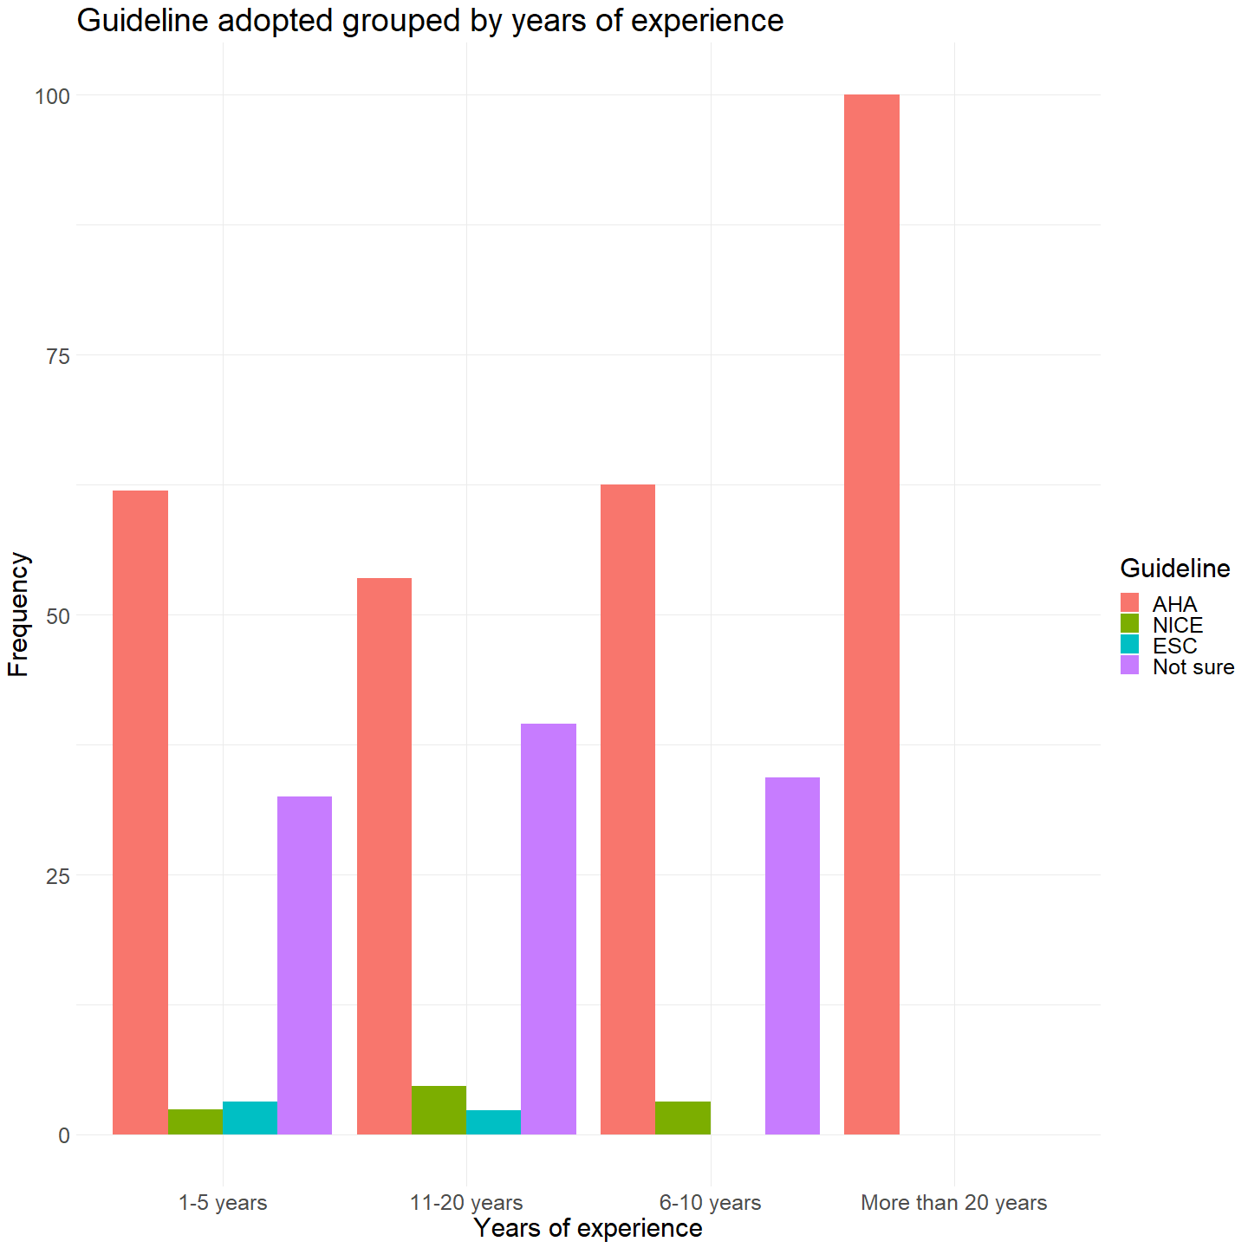

### Guideline adopted grouped by highest degree

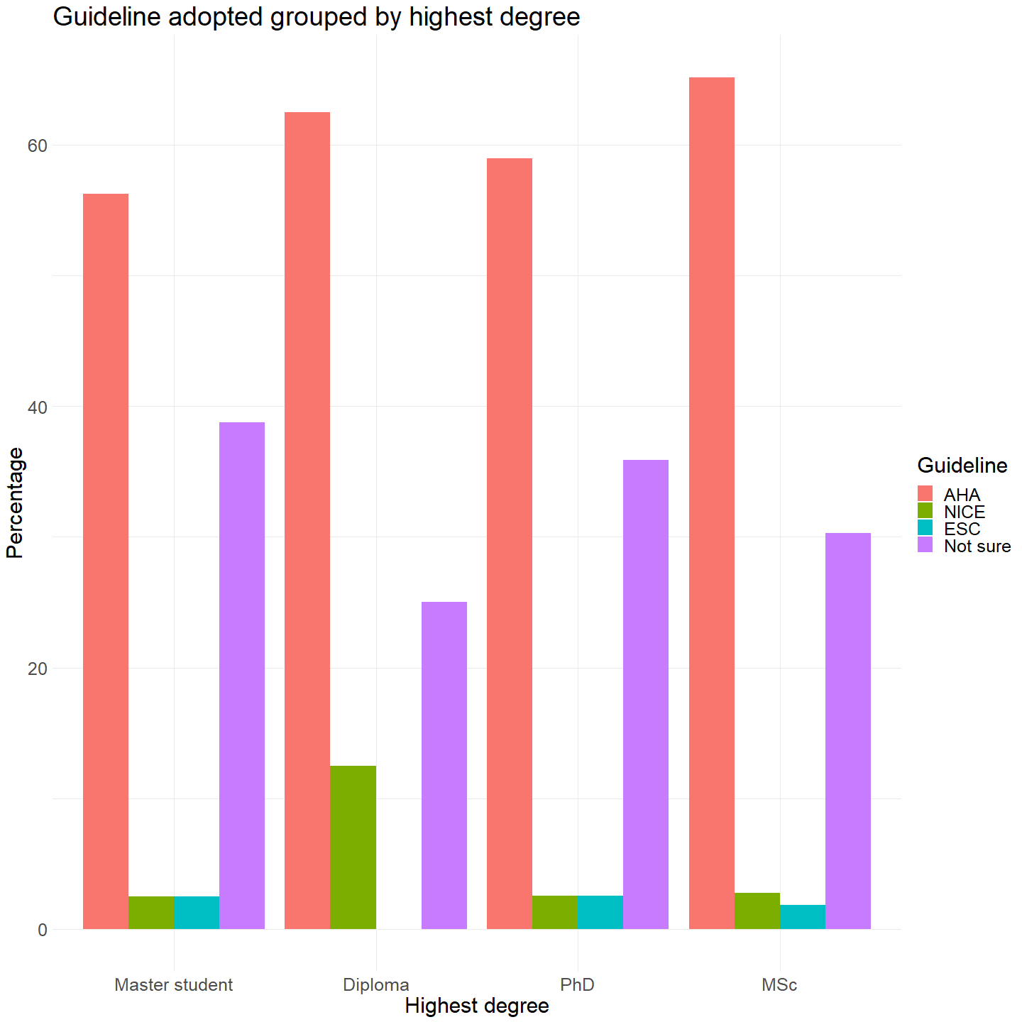

### Referal by years of experience

