2016年10月19日

1.已完成内容
- Android studio 布局

2.工作成果

package com.example.administrator.myapplication;
import android.app.Activity;
import android.graphics.Color;
import android.os.Bundle;
import android.view.ViewGroup;
import android.widget.Button;
import android.widget.LinearLayout;
import android.widget.RelativeLayout;
import android.widget.TextView;
public class MainActivity extends Activity {
@SuppressWarnings("ResourceType")
protected void onCreate(Bundle savedInstanceState) {
super.onCreate(savedInstanceState);
LinearLayout linearLayoutAll = new LinearLayout(this);
linearLayoutAll.setOrientation(LinearLayout.VERTICAL);
// 定义线性布局1
TextView textView =new TextView(this);
textView.setHeight(1100);
textView.setBackgroundColor(Color.CYAN);
LinearLayout linearLayout = new LinearLayout(this);
linearLayout.setOrientation(LinearLayout.HORIZONTAL);
Button button1 = new Button(this);
button1.setText("按钮1");
Button button2 = new Button(this);
button2.setText("按钮2");
Button button3 = new Button(this);
button3.setText("按钮3");
Button button4 = new Button(this);
button4.setText("按钮4");
linearLayout.addView(button1);
linearLayout.addView(button2);
linearLayout.addView(button3);
linearLayout.addView(button4);
// 定义线性布局 2
LinearLayout linearLayout1 = new LinearLayout(this);
linearLayout1.setOrientation(LinearLayout.HORIZONTAL);
Button button5 = new Button(this);
button5.setText("按钮5");
Button button6 = new Button(this);
button6.setText("按钮6");
Button button7 = new Button(this);
button7.setText("按钮7");
Button button8 = new Button(this);
button8.setText("按钮8");
linearLayout1.addView(button5);
linearLayout1.addView(button6);
linearLayout1.addView(button7);
linearLayout1.addView(button8);
// 定义线性布局 3
LinearLayout linearLayout2 = new LinearLayout(this);
linearLayout2.setOrientation(LinearLayout.HORIZONTAL);
Button button9 = new Button(this);
button9.setText("按钮9");
Button button10 = new Button(this);
button10.setText("按钮10");
Button button11 = new Button(this);
button11.setText("按钮11");
Button button12 = new Button(this);
button12.setText("按钮12");
linearLayout2.addView(button9);
linearLayout2.addView(button10);
linearLayout2.addView(button11);
linearLayout2.addView(button12);
// 定义线性布局 4
LinearLayout linearLayout3 = new LinearLayout(this);
linearLayout3.setOrientation(LinearLayout.HORIZONTAL);
Button button13 = new Button(this);
button13.setText("按钮13");
Button button14 = new Button(this);
button14.setText("按钮14");
Button button15 = new Button(this);
button15.setText("按钮15");
Button button16 = new Button(this);
button16.setText("按钮16");
linearLayout3.addView(button13);
linearLayout3.addView(button14);
linearLayout3.addView(button15);
linearLayout3.addView(button16);
//
linearLayoutAll.addView(textView);
linearLayoutAll.addView(linearLayout);
linearLayoutAll.addView(linearLayout1);
linearLayoutAll.addView(linearLayout2);
linearLayoutAll.addView(linearLayout3);
setContentView(linearLayoutAll);
}
}

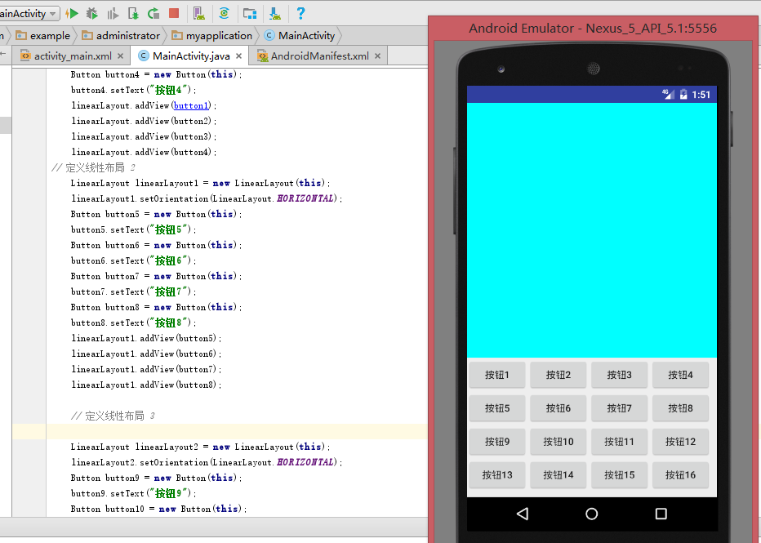

3.未完成工作**

4.未完成原因

5.遇到的问题及解决方案

