2016-10-21工作日志
- 应完成工作 实现打电话发短信功能 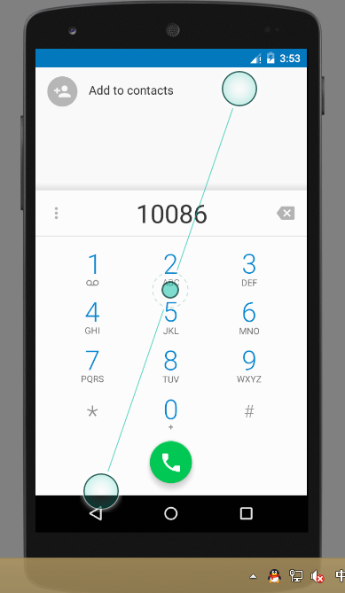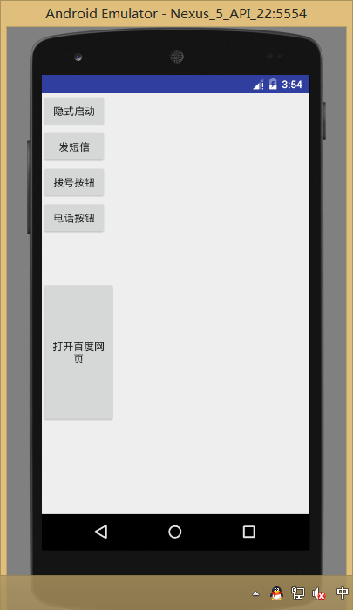
public class MainActivity extends Activity {
@Override protected void onCreate(Bundle savedInstanceState) { super.onCreate(savedInstanceState); setContentView(R.layout.activity_main);
Button button1= (Button) findViewById(R.id.button1);
button1.setOnClickListener(new View.OnClickListener() {
@Override
public void onClick(View v) {
Intent intent =new Intent("com.example.administrator.chang.ACTION_START");
startActivity(intent);
}
});
//发短信
Button button2= (Button) findViewById(R.id.button2);
button2.setOnClickListener(new View.OnClickListener() {
@Override
public void onClick(View v) {
Intent intent = new Intent();
intent.setAction(Intent.ACTION_SENDTO);
intent.setData(Uri.parse("smsto:10086"));
intent.putExtra("sms_body","The SMS text");
startActivity(intent);
}
});
// 拨号
Button button3= (Button) findViewById(R.id.button3);
button3.setOnClickListener(new View.OnClickListener() {
@Override
public void onClick(View v) {
Intent intent =new Intent();
intent.setAction(Intent.ACTION_DIAL);
intent.setData(Uri.parse("tel:10086"));
startActivity(intent);
}
});
//打电话
Button button4= (Button) findViewById(R.id.button4);
button4.setOnClickListener(new View.OnClickListener() {
@Override
public void onClick(View v) {
Intent intent=new Intent();
intent.setAction(Intent.ACTION_CALL);
intent.setData(Uri.parse("tel:10086"));
startActivity(intent);
}
});

Button button5= (Button) findViewById(R.id.button5);
button5.setOnClickListener(new View.OnClickListener() {
@Override
public void onClick(View v) {
Intent intent=new Intent();
intent.setAction(Intent.ACTION_VIEW);
intent.setData(Uri.parse("http://www.baidu.com"));
startActivity(intent);
}
});
}
}
public class SecondActivity extends Activity { @Override protected void onCreate(Bundle savedInstanceState) { super.onCreate(savedInstanceState); setContentView(R.layout.first_layout); } }
<?xml version="1.0" encoding="utf-8"?> <LinearLayout xmlns:android="http://schemas.android.com/apk/res/android" xmlns:tools="http://schemas.android.com/tools" android:orientation="vertical" android:layout_width="match_parent" android:layout_height="match_parent"
tools:context=".MainActivity">

<LinearLayout
android:layout_width="100dp"
android:layout_height="wrap_content"
android:layout_weight="1"
android:orientation="vertical">

<Button
android:id="@+id/button1"
android:layout_width="wrap_content"
android:layout_height="wrap_content"
android:text="隐式启动" />

<Button
android:id="@+id/button2"
android:layout_width="wrap_content"
android:layout_height="wrap_content"
android:text="发短信" />

<Button
android:id="@+id/button3"
android:layout_width="wrap_content"
android:layout_height="wrap_content"
android:text="拨号按钮" />

<Button
android:id="@+id/button4"
android:layout_width="wrap_content"
android:layout_height="wrap_content"
android:text="电话按钮" />
</LinearLayout>

<LinearLayout
android:layout_width="100dp"
android:layout_height="wrap_content"
android:layout_weight="2">

<Button
android:id="@+id/button5"
android:layout_width="match_parent"
android:layout_height="192dp"
android:text="打开百度网页"
/>

</LinearLayout>
<?xml version="1.0" encoding="utf-8"?>
<EditText
android:id="@+id/editText1"
android:layout_width="match_parent"
android:layout_height="match_parent"
android:text="这是第二个界面"/>
- 未完成工作
- 未完成原因
- 工作成功
- 遇到的问题及解决方法

