Device Control Example Software Manual

# outline

This book supports control software (Santec Instrument DLL sample) for a variety of devices.

# Software system components

2-1 Recommended Configuration

|  |  |
| --- | --- |
| operating system | Windows 10 |
| development environment (computer) | Microsoft Visual Studio 2015  Visual Basic: Microsoft Visual Basic 2015  C#: Microsoft Visual C# 2015  C++: Microsoft Visual C++ 2015 |
| GPIB driver | National Instruments NI488.2 Version 15.5  National Instruments NI VISA Version 15.5  Keysight Visa Version 18.1 |
| DAQ driver | National Instruments DAQ Version 15.5 |

2-2 Compilation Conditions

This sample software was created using the Santec Instrument DLL.

　　　The DLL used in this sample software is compiled by x86 platform through Debug configuration. Please use it in conjunction with the compilation conditions of the software.

# system environment

The driver in the following table must be installed to use this software.

|  |  |
| --- | --- |
| Framework | NET Framework 4.5.2 |
| GPIB driver | National Instruments NI488.2 version 15.5 |
| DAQ driver | National Instruments DAQ Version 15.5 |
| USB Driver | CDM Version 2.12.28 |

Among them, GPIB and DAQ drivers are required to be installed only when using GPIB, Visa connection, and USB driver is installed when USB connection.

1. Install ". NET Framework 4.5.2".
2. When installing "National Instruments NI-488.2", you need to add three installation options: ".NET Framework 4.0 Language Support", ".NET Framework 4.5 Language Support", and ".NET Framework 4.5.1 Language Support". NET Framework 4.0 Language Support", "NET Framework 4.5 Language Support", and "NET Framework 4.5.1 Language Support" are required to install "National Instruments NI-488.2".

Installation screen (Figure 3-1).

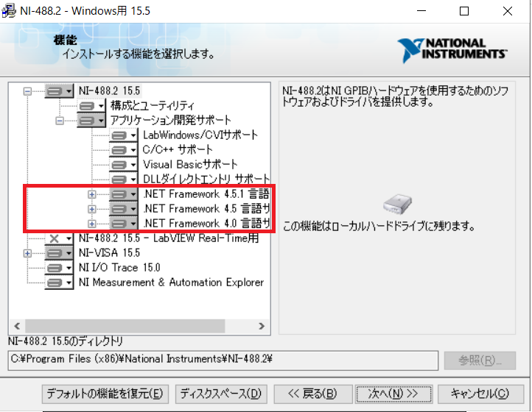

Figure 3-1. National Instruments NI-488 Installation Screen

1. When installing "National Instruments NI-DAQmx", three additional installation options are required: ".NET Framework 4.0 Language Support", ".NET Framework 4.5 Language Support", and ".NET Framework 4.5.1 Language Support". NET Framework 4.0 Language Support", "NET Framework 4.5 Language Support", and "NET Framework 4.5.1 Language Support" are required to install "National Instruments NI-DAQmx".

Installation screen (Figure 3-2).

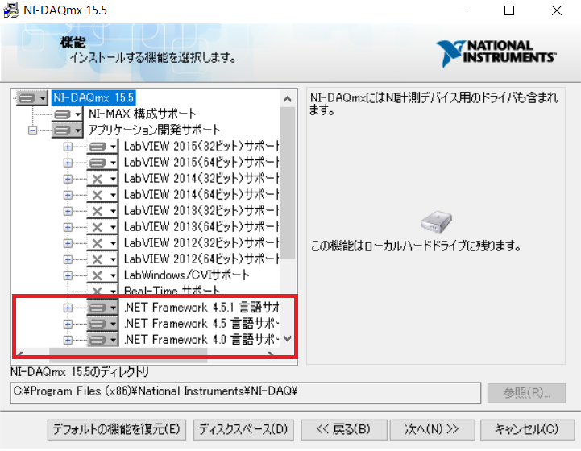

Figure 3-2. National Instruments NI-DAQmx Installation Screen

# Device Connection Diagram

TSL connection schematic

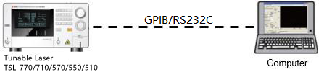

Figure 4-1. TSL Connection Diagram

PCU connection schematic

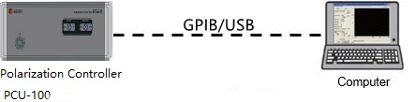

Figure 4-2. PCU-100 Connection Diagram

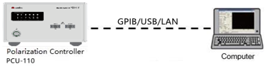

Figure 4-3. PCU-110 Connection Diagram

Schematic diagram of MPM connection

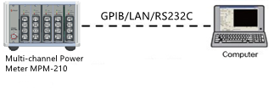

Figure 4-4. MPM Connection Diagram

OSU Connection Diagram

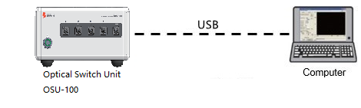

Figure 4-5. OSU Connection Diagram

Table 4-1.

|  |  |
| --- | --- |
| installations | address (GPIB) |
| TSL | Default: 1 |
| PCU | Default: 5 |
| MPM | Default: 16 |
| OSU | Default: 4 |

# Sample Software Outline

The sample software consists of three language (C#, VB.net, C++) projects within one solution. The default startup project is the VB.net language project, and the user can choose the corresponding language project according to the requirements.

* 1. Main screen

Corresponds to the main interface of each language project.

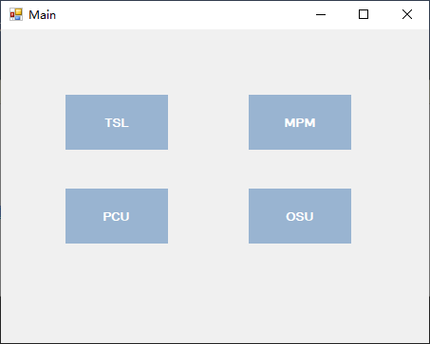

Figure 5-1.

The buttons correspond to various devices according to their names, and the control interface of the corresponding device is displayed when they are pressed.

* 1. TSL Control Example

Sample TSL interfaces corresponding to each language project.

This example software consists of the following 3 tabs.

1. Communication Setting
2. Normal Function
3. Sweep Function

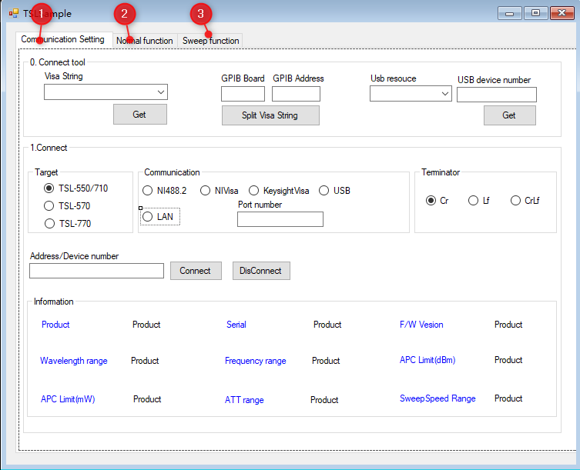

Figure 5-2. TSLSample Interface

1. The Communication Setting tab is shown in Figure 5-2-1.

This tab consists of the following 3 functions.

1. Connect tool (access to communication resources)
2. Connect(Setting the communication method)
3. Information

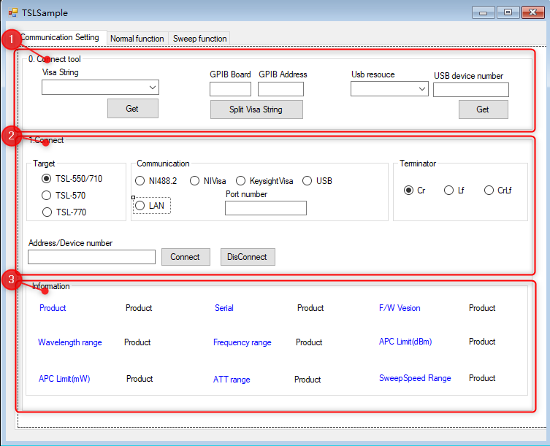

Figure 5-2-1 Communication Setting Tab Page

1. "Connect tool" grouping box: Getting communication resources

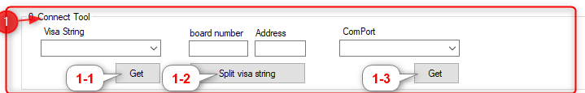

Figure 5-2-2. Connect tool interface

・"Visa String": Get the display of GPIB resources.

・"board number" text box: GPIB main address

・"Address" text box: GPIB slave address

・"ComPort" drop-down box: Display of port resources

1. "Get" button: Get the GPIB resource.
2. "Split visa string" button: Split the obtained GPIB address into master and slave address.
3. "Get" button: Get port resources
4. "Connect" sets the communication method.

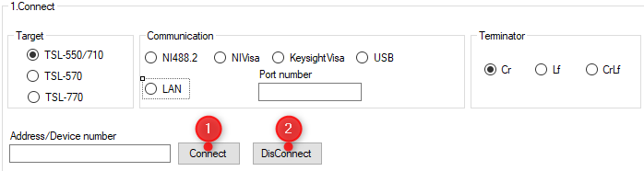

Figure 5-2-3.

・"Target" grouping box: Select the instrument model, according to the actual instrument model.

・"Communication" grouping box: Selects the communication method.

(a)NI488.2 radio button (b)NIVisa radio button (c)KeysightVisa radio button (d)USB radio button (e)LAN radio button

(a) to (c) are GPIB communication methods. Please select them according to the environment in which they are used.

・"Terminator" grouping box: select the terminator.

Please choose to use it according to the settings of the device.

(a) Cr (b) Lf (c) CrLf

Address/Port" text box: Enter the GPIB address or USB port number or IP address.

　・"Connect" button: TSL connection function

Connect the TSL according to the above settings.

　　 If the connection is successful, (2) TSL information is displayed in "Information".

With successful communication, the TSL is set to SCPI command mode.

　・"DisConnect" button: Disconnects the TSL connection.

　　 Disconnect from TSL.

　 　With the TSL-570, the TSL reverts to the command mode it was in before the connection.

1. "Information" TSL information representation function

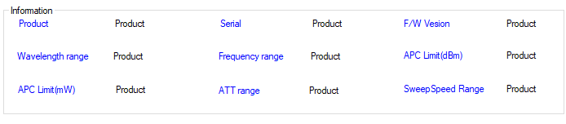

Figure 5-2-4. TSL Specification Information

・Product label: display product name

・Serial label: display serial number

・F/W Version label: Displays the firmware version.

・Wavelength range label: Displays the specification wavelength range (nm).

・Frequency range label: Displays the specification frequency range (THz).

・APC Limited(dBm) label: Displays the power range (dBm) that can be set in auto power mode.

・APC Limited (mW) label: Displays the power range (mW) that can be set in auto power mode.

・ATT range label: Displays the setting range of the attenuation amount in dB.

・SweepSpeed Range label: Upper/lower limit of scanning speed

1. The Normal function tab is shown in Figure 5-2-5.

This tab consists of the following 5 functional parts.

1. Power Control (power-related setting function)
2. Power status (status reading function)
3. Wavelength Control (Wavelength Setting Function)
4. Wavelength Status (wavelength reading function)
5. Common Function(Common Read Function)

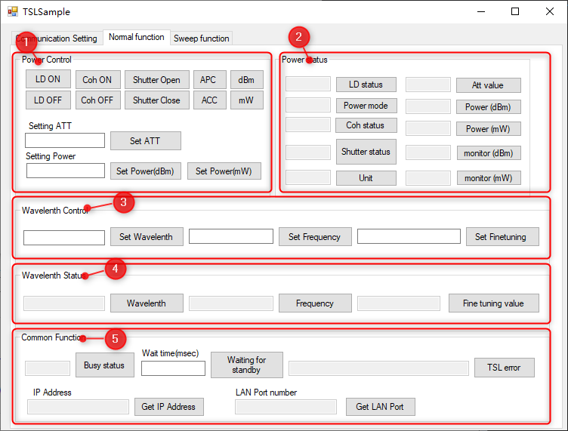

Figure 5-2-5.

* + 1. "Power Control" grouping box: power-related settings

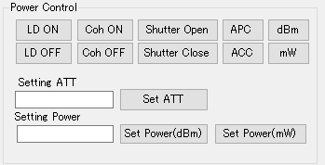

Figure 5-2-6. Power Control Interface

・"LD ON" button: Turns on the LD function.

・"LD OFF" button: Turns off the LD function.

・"Coh ON" button: Turns on the coherence control function.

・"Coh OFF" button: Variable-ratio coherent control function

・"Shutter Open" button: Turns on the masking function.

・"Shutter Close" button: Turns off the masking function.

・"APC" button: Switch the APC (Auto) power mode function.

・"ACC" button: Switch the ACC (manual) power mode function.

・"dBm" button: Switch the power unit to dBm.

・"mW" button: Switches the power unit to mW.

・"Set ATT" button: Set the attenuation amount function (not available for TSL-770)

Set the attenuation to the value entered in the Setting ATT text box.

　After executing this function, the power mode switches to ACC (manual) power mode.

・"Set Power(dBm)" button: Set the output power (dBm) function.

　Set the output power to the value entered in the Setting Power text box.

　After executing this function, the power mode is switched to APC (Auto) power mode.

・"Set Power(mW)" button: Sets the output power (mW) function.

　Set the output power to the value entered in the Setting Power text box.

　After executing this function, the power mode is switched to APC (Auto) power mode.

* + 1. "Power status" grouping box: obtains and represents various power status functions.

The status of the acquisition is displayed in the text box to the left of the button.

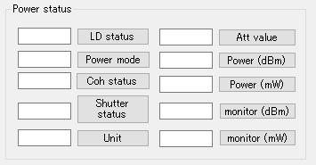

Figure 5-2-7. Power Status Screen

・"LD status" button: Displays the LD lighting status.

・"Power mode" button: Displays the power output mode.

・"Coh Status" button: Displays the coherent control status.

・"Shutter status" button: Displays the status of shuttering.

・"Unit" button: Displays the power output unit.

・"Att value" button: Displays the attenuation value (not applicable to TSL-770).

・"Power(dBm)" button: Displays the output power (dBm) of APC (auto).

・"Power(mW)" button: Displays the APC (auto) output power (mW).

・"monitor(dBm)" button: Displays the value of power monitoring (dBm).

・"monitor(mW)" button: Displays the value of power monitoring (mW).

* + 1. "Wavelength Control" grouping box: Wavelength-related control function

Sets the value to the value entered in the text box to the left of the button.

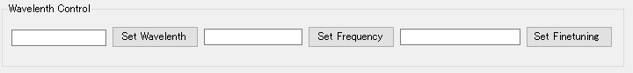

Figure 5-2-8. Wavelength Control Interface

・"Set Wavelength" button: Wavelength (nm) setting function

・"Set Frequency" button: Frequency (THz) setting function

・"Set Finetuning" button: Set the wavelength fine tuning value.

* + 1. "Wavelength Status" grouping box: get wavelength information function

　 The corresponding wavelength information is displayed in the text box to the left of each button.

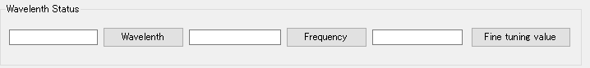

Figure 5-2-9. Wavelength Status Screen

・"Wavelength" button: Indicates the set wavelength (nm).

・"Frequency" button: Indicates the set frequency (THz).

・"Fine tuning value" button: Indicates the set fine tuning value.

* + 1. "Common Function" grouping box: Common Function

The text boxes to the left of the buttons correspond to the individual buttons.

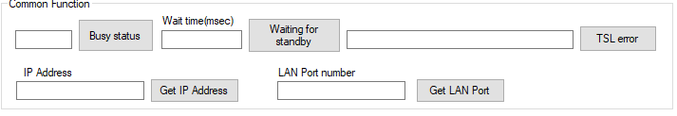

Figure 5-2-10. Common Function Screen

・"Busy status" button: Get the TSL busy status function.

・"Waiting for standby" button: Function to monitor the busy status of TSL for a specified period of time.

Returns a "timeout" error if the TSL busy state is not released within the specified time.

・"TSL error": Displays the TSL error message function.

・"Get IP Address": Get the IP address of TSL-570/770, disabled for other models.

・"Get LAN Port": Get the communication port of TSL-570/770, disabled for other models.

1. The Sweep function tab is shown in Figure 5-2-11.

This tab consists of the following 3 functions.

* 1. Sweep Setting (Scanning Wavelength Parameter Setting Function)
  2. Sweep setting status (get the set scanning parameters)
  3. Other(Other scanning functions)

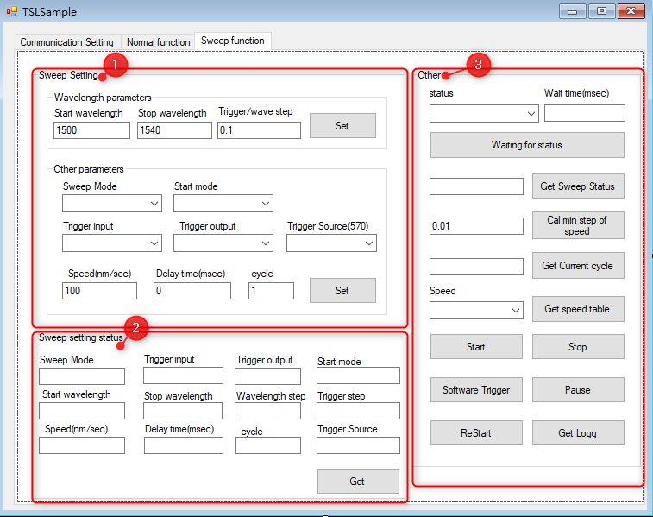

Figure 5-2-11. Sweep Function Screen

* + 1. "Wavelength parameters" grouping box: scanning wavelength parameter setting function

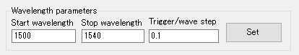

Figure 5-2-12. Wavelength parameter screen

・"Set" button: Set the scanning wavelength parameter.

Setting the scanning range, wavelength step/trigger interval

・"Start Wavelength" text box: Start wavelength (nm)

・"Stop Wavelength" text box: Stop Wavelength (nm)

・"Trigger/Wave Step" text box: Trigger/Wave Step (nm)

* + 1. "Other parameters" grouping box: sets the scanning parameters.

Set other scanning related parameters.

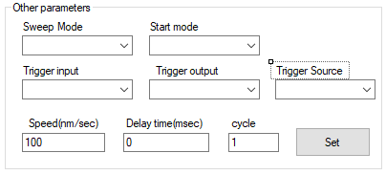

Figure 5-2-13. Other parameter screen

Set" button: Sets the scanning parameter function.

Scan Mode, Trigger Input Mode, Scan Start Mode, Trigger Output Mode, Trigger Output Mode, Scan Speed, Delay Time, and Number of Cycles are uniquely set for the TSL570/770.

・"Sweep Mode" drop-down box: Select the scanning mode.

The options are shown below:

0 Step one way: step scanning, unidirectional

1 Continuous one way: continuous scanning, unidirectional

2 Step round trip: step scanning, round trip

3 Continuous round trip: continuous scanning, round trip

・"Trigger input" drop-down box: Set the external trigger input signal valid/invalid.

0 Disable.

1 Enable: effective

・"Start mode" drop-down box: Select the scanning start mode.

0 Normal: Normal mode

1 Waiting for Trigger: Waiting for trigger input to start scanning mode

・"Trigger output" drop-down box: Set the point in time when the output is triggered.

0 None: No trigger output

1 Stop: output triggered at the end of the scan

2 Start: Trigger output when scanning starts

3 Step: In scanning, trigger outputs at regular intervals

・"Trigger Source" drop-down box: TSL570/770 Special setting to set trigger output mode, disabled for non-TSL570/770 instruments.

0 Wavelength: Output in fixed trigger steps.

1 Time: Output by a certain time

・"Speed(nm/sec)" text box: scanning speed (unit: nm/sec)

・"Delay time(sec)" text box: Waiting time between scans (unit: sec)

・"cycle" text box: number of scans

* + 1. "Sweep setting status" grouping box: get the set scanning parameters

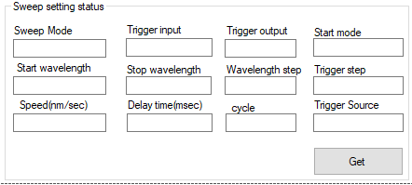

Figure 5-2-14. Sweep Setting status screen

・"Get" button: Get the set scanning parameter function.

Get scan mode, trigger input mode, trigger output mode, scan start mode, start wavelength, end wavelength, wavelength step, trigger step, scan speed, delay time, number of scans, and TSL570/770 unique setting of the trigger output mode, and displayed in the corresponding text box.

・"Sweep Mode" text box: Displays the sweep mode.

・"Trigger input" text box: Displays the valid/invalid external trigger input signal.

・"Trigger output" text box: Display the point in time when the output is triggered.

・"Start mode" text box: Displays the scanning start mode.

・"Start wavelength" text box: Displays the start wavelength (nm) of the scan.

・"Stop wavelength" text box: Displays the end wavelength (nm) of the scan.

・"Wavelength step" text box: Displays the wavelength step (nm).

・"Trigger step" text box: Display the trigger step (nm).

・"Speed(nm/sec)" text box: Displays the scanning speed

・"Delay time(msec)" text box: Displays the waiting time between scans.

・"cycle" text box: displays the number of scans

・"Trigger Source" text box: Display TSL570/770 specific setting trigger output mode, disabled for non-TSL570/770.

* + 1. "Other" grouping box: other scanning functions

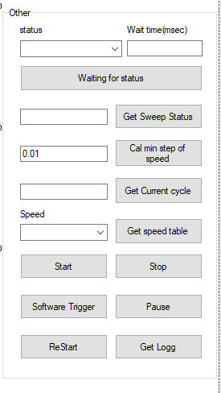

Figure 5-2-15. Other Scanning Functions Screen

・"Waiting for status" button: Waiting for the scanning status function.

　　　Standby for the 　　　specified time until the scan state is specified for the specified scan state designation.

　　　Displays a timeout error if the specified scan status cannot be obtained within the 　　　specified time.

・"status" drop-down box: select the scanning status.

　The options are shown below:

0 Standby: stopped state

1 Running: Running status

2 Pausing: suspended

3 WaitingforTrigger: Waiting for Trigger Signal Status

4 Returning: Returns to the scanning start wavelength status.

・"Wait time(msec)" text box: Set the wait time.

・"Get Sweep Status" button: Get the sweep status.

Get the scan status and display it in the text box on the left.

・"Cal min step" button: Calculates the minimum trigger step that can be set when the scanning speed is specified.

Calculates the minimum trigger interval that can be set based on the scanning speed entered in the text box on the left.

・"Get Current cycle" button: Get the number of scans.

Gets the number of scans that have now been performed and displays them in the text box on the left.

・"Get speed table" button: Get the scanning speed table.

Gets the scanning speedometer and displays it in the drop-down box on the left.

・"Start" button: scanning start function

Pause" button: Sweep pause function.

・"Restart" button: Scanning Continuation Function

Stop" button: stops the scanning function.

・"Get Logg" button: Get the logged wavelength data.

Get the recorded scanned wavelength data and save it as a csv file.

・"Software Trigger" button: Soft trigger signaling function

* 1. PCU Control Example

Sample PCU interfaces for each language version.

This example software has the following 3 functional components.

1. Connect tool (access to communication resources)
2. Connect(Setting the communication method)
3. Function

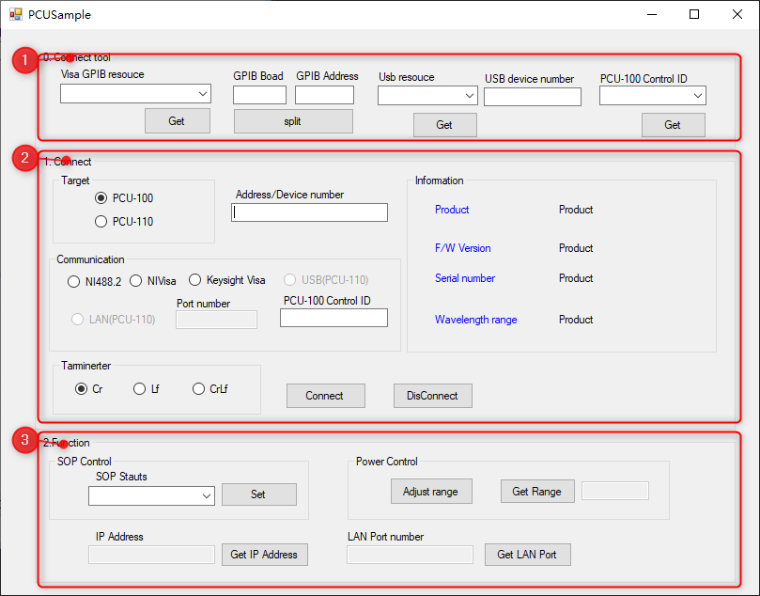

Figure 5-3. PCUSample Interface

1. "Connect tool" for communication resources

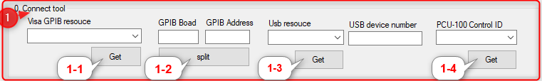

Figure 5-3-1.

・"Visa GPIB resource" drop-down box: Get the display of GPIB resource.

・"GPIB Board" text box: GPIB main address

・"GPIB Address" text box: GPIB slave address

・"USB resource" drop-down box: USB resource display

・"USB device number" text box: USB device number

・"PCU-100 Control ID" drop-down box: Device number of DAQ.

* 1. "Get" button: Get the GPIB resource.
  2. "Split" button: Split the acquired GPIB address into master and slave address.
  3. "Get" button: Get the USB resource.
  4. "Get" button: Get the device number of DAQ for PCU100 control

1. "Connect" grouping box: sets the communication method

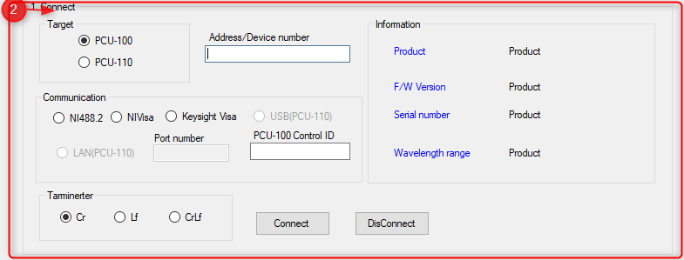

Figure 5-3-2.

・"Target" grouping box: Select the instrument model.

(a) PCU-110 radio button (b) PCU-110 radio button

Please select according to the actual equipment.

・"Address/Device number" text box: Enter GPIB address or USB port number or IP address.

・ "Communication" grouping box: Selects the communication method.

(a)NI488.2 radio button (b)NIVisa radio button (c)KeysightVisa radio button (d)USB(PCU-110) radio button (e)LAN(PCU-110) radio button

(a) to (c) are GPIB communication methods. Please select them according to the environment in which they are used.

(d)(e) is a communication method only available in PCU-110.

・"Port number" text box: Fill in the port number when the instrument is PCU-110 and connected by LAN port.

・"PCU-100 Control ID" text box: Fill in the DAQ information when the instrument is PCU-100.

・"Terminator" grouping box: select the terminator.

Please choose to use it according to the settings of the device.

(a) Cr (b) Lf (c) CrLf

　・"Connect" button: PCU connection function

Connect the PCU according to the above settings.

　　　If the connection is successful, information about the PCU is displayed in "Information".

　・"DisConnect" button: Disconnect the PCU.

　　 Disconnect from the PCU.

・"Information" grouping box: PCU information representation

(a) Product label: display product name

(b) Serial number tag: displays the serial number

(c) F/W Version label: displays the firmware version

(d) Wavelength range label: displays the wavelength range of the specification (nm).

1. "Function" grouping box: function

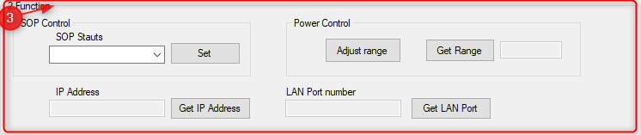

Figure 5-3-3. Function Screen

・"SOP Stauts" drop-down box: Select the polarization state.

Set" button: Sets the polarization status.

・"Adjust range" button: Set to automatically adjust the power monitoring range.

・"Get Range" button: Get the current power monitoring range.

Gets the current power monitoring range and displays it in the text box on the left.

・"Get IP Address" button: Get IP address, this function only supports PCU-110.

Get the IP address and display it in the text box on the right.

・"Get LAN Port" button: Get the LAN port number, this function only supports PCU-110.

Get the LAN port number and display it in the text box on the right.

* 1. Example of MPM control

Sample MPM interfaces for each language project.

This example software consists of the following 4 tabs.

1. TabPage1 ( Setting the communication method and device information)
2. Normal function(Normal function)
3. Logging1 (Logging setting in each mode)
4. Logging2 (Logging mode parameter reading)

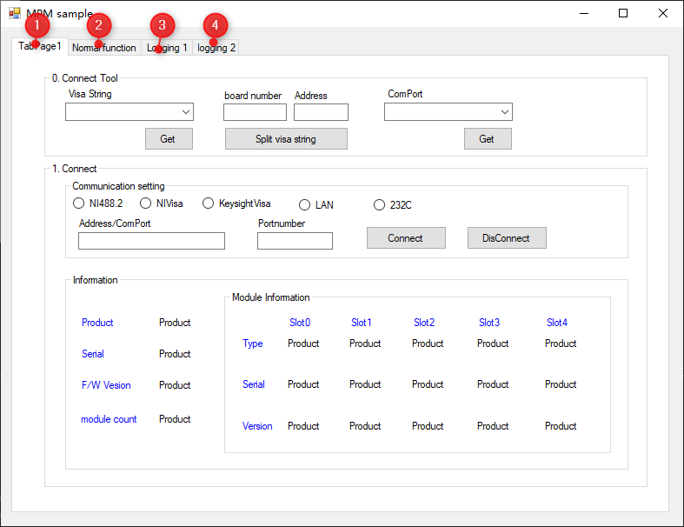

Figure 5-4. MPMSample Interface

1. The TabPage1 tab is shown in Figure 5-4-1.

This tab consists of the following 3 functions.

1. Connect tool (access to communication resources)
2. Connect(Setting the communication method)
3. Information

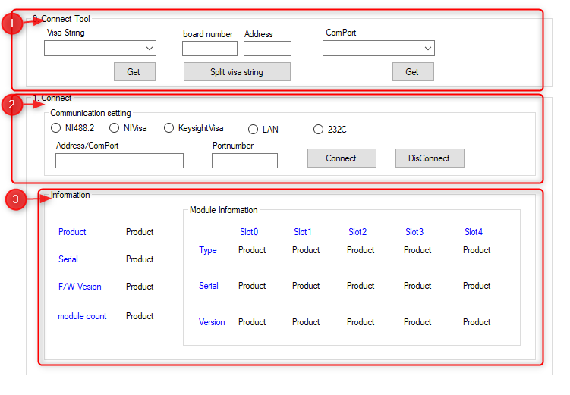

Figure 5-4-1. TabPage1 Tab Page

1. "Connect tool" grouping box: Getting communication resources



Figure 5-4-2. Connect tool interface

・"Visa String": Get the display of GPIB resources.

・"board number" text box: GPIB main address

・"Address" text box: GPIB slave address

・"ComPort " drop-down box : Display of port resources

1. "Get" button: Get the GPIB resource.
2. " Split visa string " button: Split the obtained GPIB address into master and slave addresses.
3. "Get" button: Get port resources
4. "Connect" grouping box: set the communication method

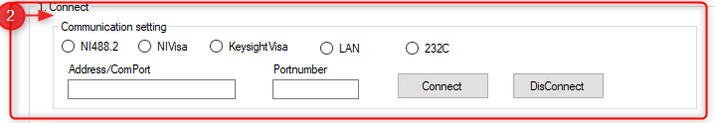

Figure 5-4-3.

・"Communication setting" grouping box: Select the communication method.

(a) NI488.2 radio button (b) NIVisa radio button (c) KeysightVisa radio button (d) LAN radio button (e) 232C radio button

(a) to (c) are GPIB communication methods. Please select them according to the environment in which they are used.

・"Address/ComPort" text box: Enter GPIB address or USB port number or IP address.

・"Port number" text box: Fill in the port number when the instrument is connected using the LAN port.

・"Connect" button: MPM connection function

Connect the MPM according to the above settings.

　　　If the connection is successful, information about the MPM is displayed in "Information".

・"DisConnect" button: Disconnects the MPM.

Disconnect from the MPM.

1. "Information" grouping box: MPM information representation function

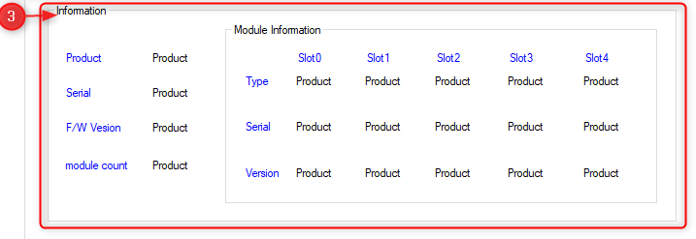

Figure 5-4-4.

・Product label: display product name

・Serial label: display serial number

・F/W Version label: Displays the firmware version.

・module count label: shows the number of valid modules.

・"Module Information" grouping box: displays module information.

Type label: display module type

Serial tag: show serial number

Version tag: show firmware version

Slot(0~4) label: indicates the slot position

1. The Normal function tab is shown in Figure 5-4-5.

This tab consists of the following 3 functions.

1. Set( set normal function )
2. Get(Read Normal Function)
3. Common function

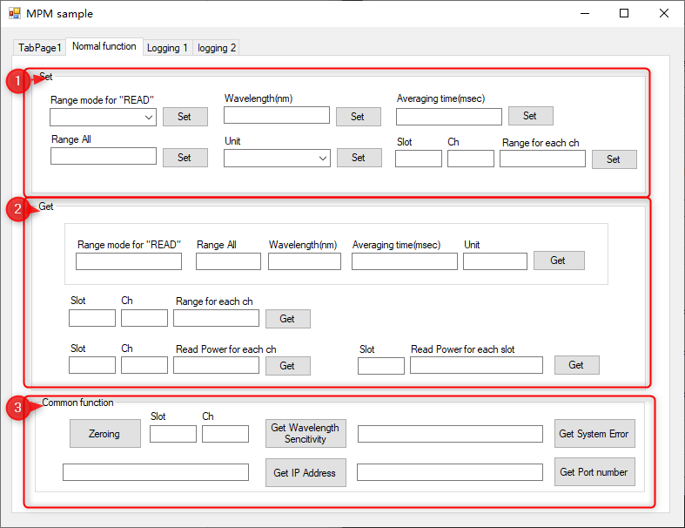

Figure 5-4-5. The Normal function tab.

1. "Set" grouping box: sets the normal functionality

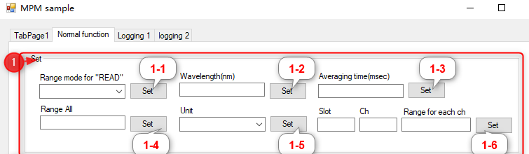

Figure 5-4-6.

1. "Set" button: Sets the reading power range mode.

Set the read power Range mode to the mode selected in the " Range mode for "READ"" drop-down box.

" Range mode for "READ" " drop-down box: read power Range mode

The options are shown below:

0 Auto:Auto

1 Manual.

1. "Set" button: set the wavelength (nm)

Set the wavelength to the value entered in the "Wavelength(nm)" text box.

1. "Set" button: Set the mean time (mse) ( 0.01 ~10000msec).

Set the averaging time to the value entered in the "Averaging time(msec)" text box.

1. "Set" button: Set TIA gain (Range)

Set the TIA gain (Range) to the value entered in the Range All text box.

1. "Set" button: Set power unit

Set the power unit to the mode selected in the "Unit" drop-down box.

"Unit" drop-down box: power unit

The options are shown below:

0 dBm: Power in dBm.

1 mW: Power in mW

1. "Set" button: TIA gain (Range) for each channel.

Setting the TIA gain (Range) for each channel is determined by the value entered in the "Slot" text box.

The channel number is determined by the value entered in the "Ch" text box, and the channel number is determined by the value entered in the "Range for each ch" text box.

The value entered in the text box determines the TIA gain.

1. "Get" grouping box: reads normal functionality

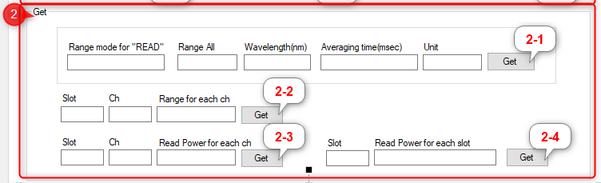

Figure 5-4-7.

1. "Get" button: Get Range mode, get all modules TIA gain (Range), get settings

Wavelength, get set averaging time, get set power units

・"Range mode for "READ"" text box: Read the power Range mode.

・"Range All" text box: TIA gain (Range)

・"Wavelength(nm)" text box: Wavelength (nm)

・"Averaging time(msec)" text box: averaging time

・"Unit" text box: Power unit

1. "Get" button: the module number is determined by the value entered in the "Slot" text box, and the module number is determined by the value entered in the "Ch" text box.

The value entered in the box determines the channel number to get the channel TIA gain (Range)

・"Slot" text box: Module No.

・"Ch" text box: channel number

・"Range for each ch" text box: TIA gain (Range)

1. "Get" button: the module number is determined by the value entered in the "Slot" text box, and the module number is determined by the value entered in the "Ch" text box.

The value entered in the box determines the channel number to get the power of the channel

・"Slot" text box: Module No.

・"Ch" text box: channel number

・"Read Power for each ch" text box: Channel Power

1. Button "Get": Get the module number of the module channel by determining it from the value entered in the "Slot" text box.

Power.

・"Slot" text box: Module No.

・"Read Power for each slot" text box: Power of each channel of the module.

1. "Common function" grouping box: (Common functions)

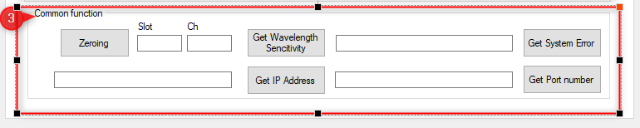

Figure 5-4-8. Common function interface

・"Zeroing" button: Zeroing function

・"Get Wavelength Sensitivity" button: Determine the module number by the value entered in the "Slot" text box, and the channel number by the value entered in the "Ch" text box to get the wavelength sensitivity data of the channel. Get Wavelength Sencitivity" button: Determine the module number by the value entered in the "Slot" text box, and the channel number by the value entered in the "Ch" text box.

・"Slot" text box: Module No.

・"Ch" text box: channel number

・"Get System Error" button: Get the system error information and display it in the text box on the left.

・"Get IP Address" button: Get the IP address and display it in the text box on the left.

・"Get Port number" button: Get the LAN port number and display it in the text box on the right.

1. The Logging1 tab is shown in Figure 5-4-9.

This tab consists of the following 4 functions.

1. Const Mode (Const scan mode parameter setting)
2. Sweep Mode (Sweep scan mode parameter setting)
3. Freerun Mode (Freerun scan mode parameter setting)
4. Common (generic function)

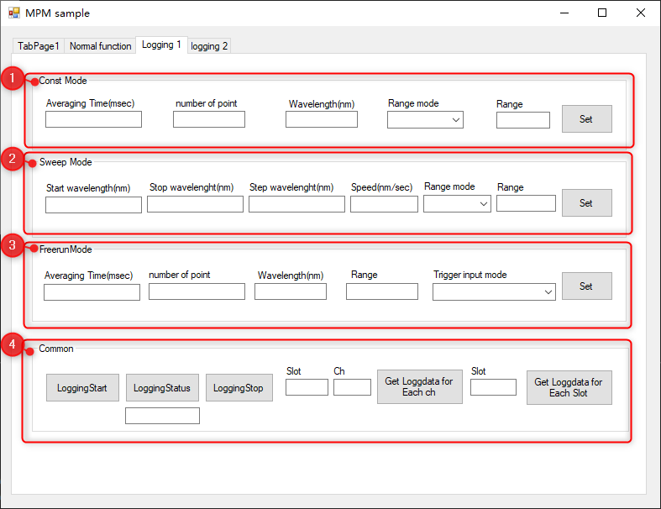

Figure 5-4-9. The Logging1 tab.

1. "Const Mode" grouping box: sets scanning parameters

Const scan mode parameter settings.

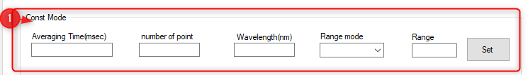

Figure 5-4-10. Const Mode Screen

・"Set" button: Set Const mode parameters.

Set the averaging time, number of test points, wavelength (nm), test mode, and power range (in Manual mode).

Settings).

Setting the Range Mode to Auto adopts the "Const2" mode, while if it is Manual, it adopts the "Const2" mode.

Use "Const1" mode.

・"Averaging Time(msec)" text box: Averaging time (unit: msec)

・"number of point" text box: Test the number of points.

・"Wavelength(nm)" text box: Wavelength (nm)

・"Range Mode" drop-down box: Test Mode

The options are shown below:

0 Auto:Auto

1 Manual.

・"Range" text box: power range

1. "Sweep Mode" grouping box: sets scanning parameters

Sweep scan mode parameter settings.

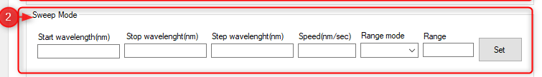

Figure 5-4-11. SweepMode Interface

・"Set" button: Set the parameters of Sweep mode.

Setting of scanning start wavelength, scanning end wavelength, wavelength step, scanning speed, test mode, power range

(set in Manual mode).

Setting Range Mode to Auto adopts the "Sweep2" mode, and if it is Manual, it will select the "Sweep2" mode.

Select "Sweep1" mode.

・"Start wavelength(nm)" text box: Displays the start wavelength (nm) of the scan.

・"Stop wavelength(nm)" text box: Displays the end wavelength (nm) of the scan.

・"Step wavelength(nm)" text box: Display the wavelength step (nm).

・"Speed(nm/sec)" text box: Displays the scanning speed (nm/sec).

・"Range Mode" drop-down box: Test Mode

The options are shown below:

0 Auto:Auto

1 Manual.

・"Range" text box: power range

1. "Freerun Mode" grouping box: sets scanning parameters

Freerun scan mode parameter settings.

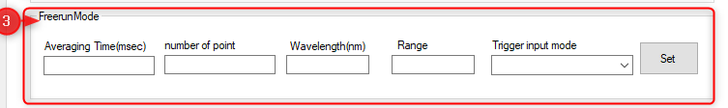

Figure 5-4-12. FreerunMode Interface

・"Set" button: Set Freerun mode parameters.

Set the averaging time, number of test points, wavelength (nm), power range, and trigger input mode.

・"Averaging Time(msec)" text box: Averaging time (unit: msec)

・"number of point" text box: Test the number of points.

・"Wavelength(nm)" text box: Wavelength (nm)

・"Range" text box: power range

・"Trigger input mode" drop-down box: Trigger input mode

The options are shown below:

0 Internal: Internal trigger

1 External: External trigger

1. "Common" grouping box: (generic functions)

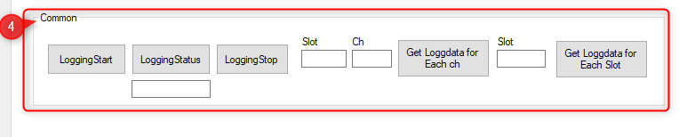

Figure 5-4-13.

・"LoggingStart" button: Starts collecting data.

・"LoggingStatus" button: get the status of the test and display it in the text box on the bottom side.

・"LoggingStop" button: stops collecting data.

・"Get Loggdata for Each ch" button: Determine the module number by the value entered in the "Slot" text box, and the channel number by the value entered in the "Ch" text box to get the log data of the channel. Get Loggdata for Each Channel" button: The module number is determined by the value entered in the "Slot" text box, and the channel number by the value entered in the "Ch" text box.

・"Slot" text box: Module No.

・"Ch" text box: channel number

・"Get Loggdata for Each Slot" button: Get the log data of the channel by determining the module number by the value entered in the "Slot" text box.

・"Slot" text box: Module No.

1. The logging2 tab is shown in Figure 5-4-14.

This tab is to get the various parameters of the test mode

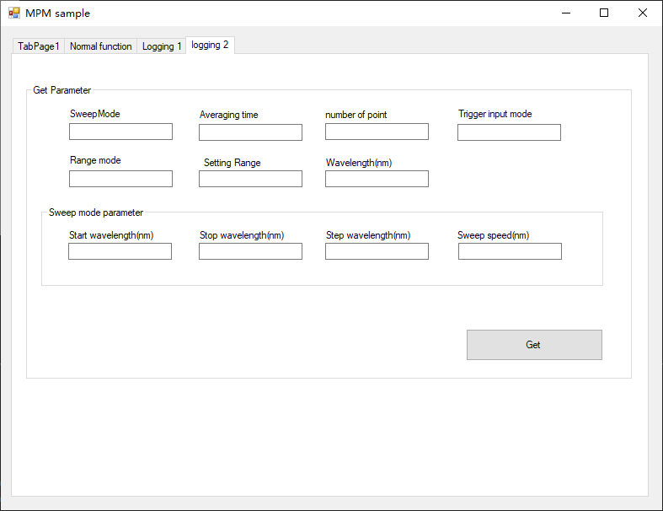

Figure 5-4-14. logging2 tab.

・"Get" button : Get the test mode, average time, number of test points, wavelength, and trigger input mode.

Read power Range mode, TIA gain (Range), start wavelength, stop wavelength, step waveforms

length, scanning speed and is displayed in the corresponding text box.

・"Sweep Mode" text box: Displays the test mode.

・"Averaging time" text box: Displays the averaging time.

・"number of point" text box: Displays the number of test points.

・"Trigger input mode" text box: Displays the trigger input mode.

・"Range mode" text box: Displays the reading power range mode.

・"Setting Range" text box: Displays the TIA gain (Range).

・"Wavelength(nm)" text box: display the wavelength (nm).

* 1. "Sweep mode parameter" grouping box: The "Sweep mode parameter" will only display data if Sweep mode is set.

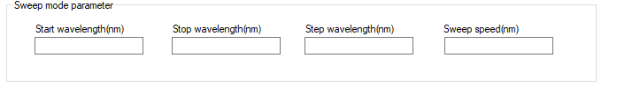

Figure 5-4-15. Sweep mode parameter interface

・"Start wavelength(nm)" text box: Displays the start wavelength (nm) of the scan.

・"Stop wavelength(nm)" text box: Displays the end wavelength (nm) of the scan.

・"Step wavelength(nm)" text box: Display the wavelength step (nm).

・"Sweep speed(nm)" text box: Displays the sweep speed (nm/sec).

* 1. OSU Control Example

Sample OSU interfaces corresponding to each language project.

This example software consists of the following 2 functions.

1. Connect
2. Setting function(Setting function)

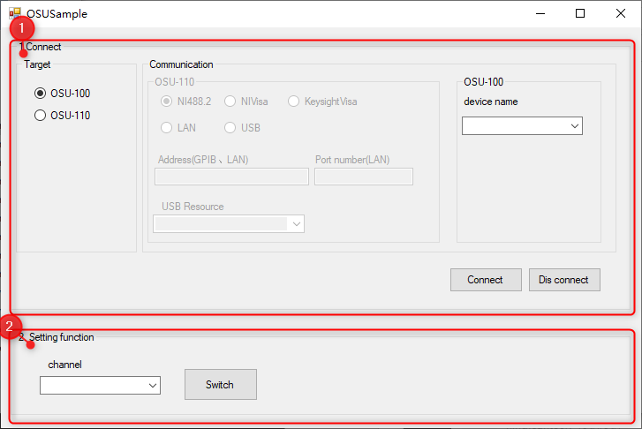

Figure 5-5 OSUSample Interface

1. "Connect" sets the communication method.

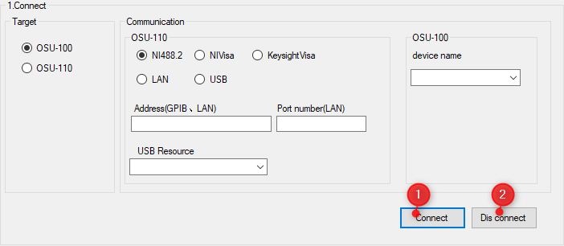

Figure 5-5-1.

・"Target" grouping box: Select the instrument model, according to the actual instrument model.

・"Communication" grouping box: Selects the communication method.

(a) NI488.2 radio button (b) NIVisa radio button (c) KeysightVisa radio button

(d) LAN radio button (e) USB radio button

(a) to (e) are the connection methods available for OSU-100, where (a) to (c) are GPIB communication methods. Please select them according to the environment in which they are used.

・"Address(GPIB, LAN)" text box: Enter the GPIB address or IP address.

・"Port number(LAN)" text box: Enter the Lan connection port number.

・"USB Resource" drop-down box: Display of port resource

・"OSU Control device name" group box: Displays the acquired device number (at the startup form).

Get)

・"Connect" button: OSU connection function

Connect the OSU according to the device number selected above

　・"DisConnect" button: Disconnect the OSU.

1. " Setting function" Grouping box:Setting function

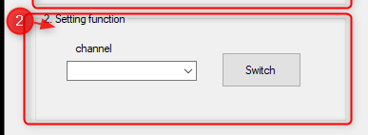

Figure 5-5-2. Setting function interface

・"Channel" drop-down box: select the optical channel.

The options are shown below:

0 Ch1: first channel

1 Ch2: second channel

2 Ch3: Third channel

3 Ch4: fourth channel

・"Switch" button: Setting the optical channel

# Creating projects and installing libraries in them

When using InstrumentDLL.DLL to create a new project or to perform built-in operations on an existing project, you need to perform the following steps.

6.1 Reference settings for the project

Add the item "InstrumentDLL.DLL".

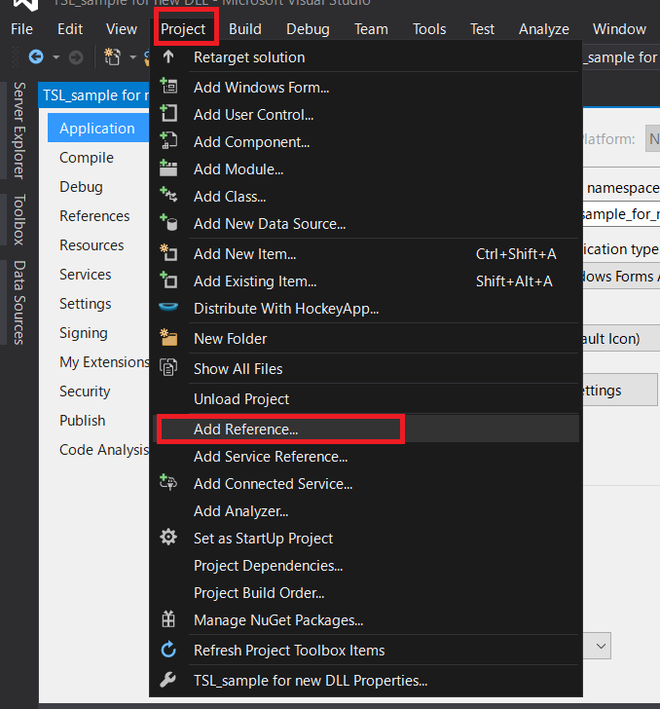

Figure 6-1. Select "Add Reference...".

Select "InstrumentDLL. dll" in the following location.

"Program Storage Location" \NewDllSample\DLL\ InstrumentDLL.dll

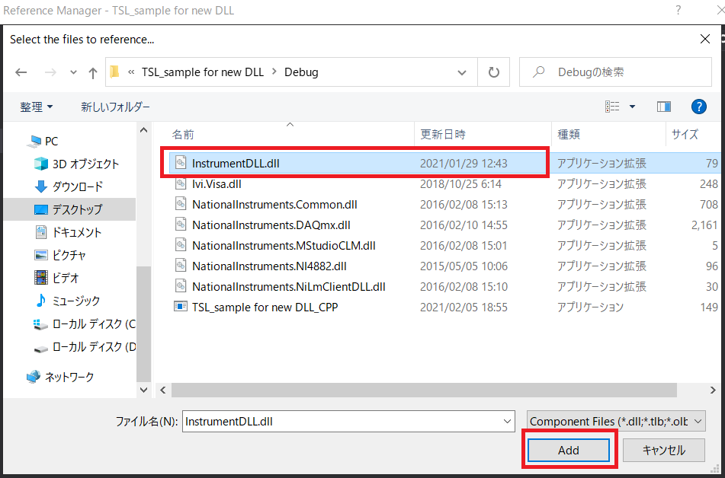

Figure 6-2. Reference Settings for DLLs

6.2 Changing the detailed settings of the compiler

VB2015.

Displays the properties of the item.

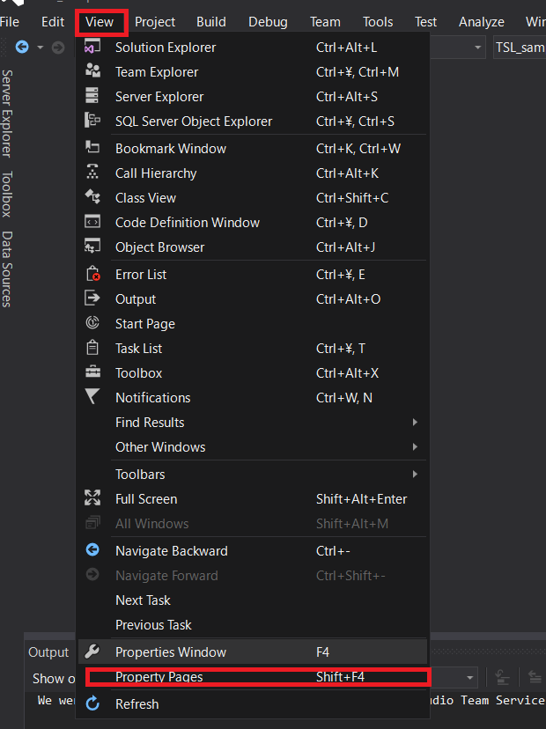

Figure 6-3.

NET Framework 4.5.2" in the "Target framework (all configurations)" option.

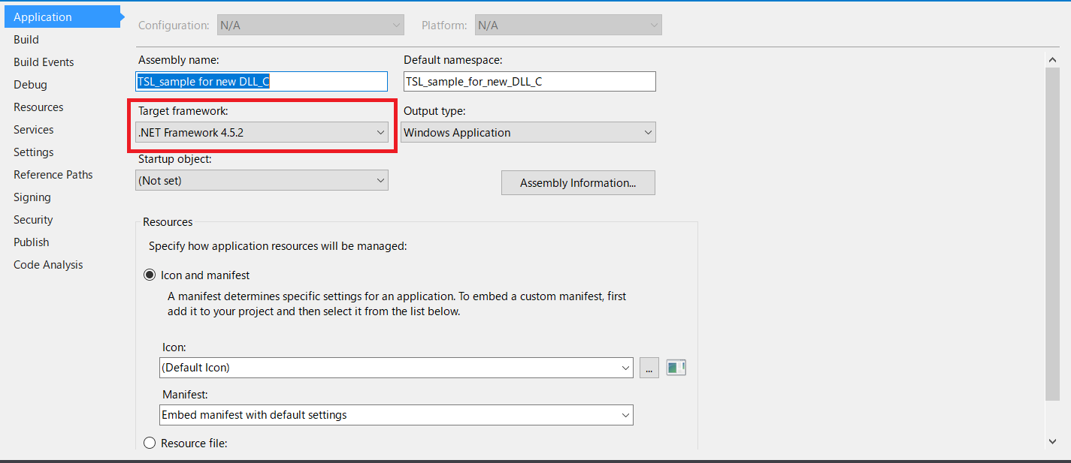

Figure 6-4. Detailed Compiler Settings

C#.

Displays the properties of the item.



Figure 6-5.

NET Framework 4.5.2" in the "Target framework (all configurations)" option.



Figure 6-6. Detailed Compiler Settings