PENETRATION TESTING REPORT
FOOTPRINTING & NETWORK SCANNING PHASES
W2-PM-FINAL | CYBERSECURITY | NETWORKWALKS

COVER PAGE
PENETRATION TESTING REPORT
Footprinting & Network Scanning Phases
- Program: Cybersecurity Training – Networkwalks
- Report ID: W2-PM-FINAL
- Pentester Name: SANJO
- Program / Batch: B084 – Networkwalks
- Completion Date: 13-11-2026
- Modules Completed: W2-PM1 and W2-PM5
- Assessment Environment: Kali Linux and Virtual Lab Network

1. REPORT INFORMATION
Field | Details
Pentester Name | SANJO
Program / Batch | B084 – Networkwalks
Modules Completed | W2-PM1, W2-PM5
Client / Target | Networkwalks domain and own lab network
Permission | Confirm documented authorization before submission
Phase 1 | Reconnaissance and Footprinting
Phase 2 | Scanning and Network Discovery
Report Status | Week 2 Final Report
2. LIABILITY DISCLAIMER
All activities documented in this report were performed for educational and cybersecurity research purposes within systems and networks that I own or was authorized to assess.
The information is provided for learning and documentation purposes only. Unauthorized access, scanning or testing of systems without appropriate permission is prohibited.
No exploitation or destructive testing was performed as part of these exercises.
3. INTRODUCTION
This report documents the practical cybersecurity activities completed during Week 2 of my Cybersecurity Training Program at Networkwalks.
The report covers two modules:
- W2-PM1: Footprinting using multiple Kali Linux tools.
- W2-PM5: Network scanning and host discovery using Zenmap and Nmap.
The first activity focused on gathering publicly available information about the Networkwalks domain using six reconnaissance tools.
The second activity involved discovering active hosts, identifying IP and MAC address information, and visualizing the network topology of my virtual lab environment.
The main objective was to understand how reconnaissance and network discovery contribute to the early stages of a penetration testing engagement.
4. TOOLS USED
Tool | Purpose
Kali Linux | Cybersecurity testing environment
WHOIS | Domain registration information
WhatWeb | Website technology fingerprinting
Nslookup | DNS resolution
Curl | HTTP response header inspection
Wafw00f | Web Application Firewall detection
DNSRecon | DNS information gathering
Nmap | Network host discovery
Zenmap | Graphical network scanning
Linux Terminal | Executing commands
5. ACTIVITIES PERFORMED
5.1 W2-PM1 – FOOTPRINTING AND RECONNAISSANCE
Target: networkwalks.com
I used six Kali Linux tools to collect publicly available information about the target domain.
Activity 1 – WHOIS
Command:
whois networkwalks.com
Objective:
To identify publicly available domain registration information, registration dates and name servers.
Observation:
The command returned domain registration information and name server details.
Evidence:
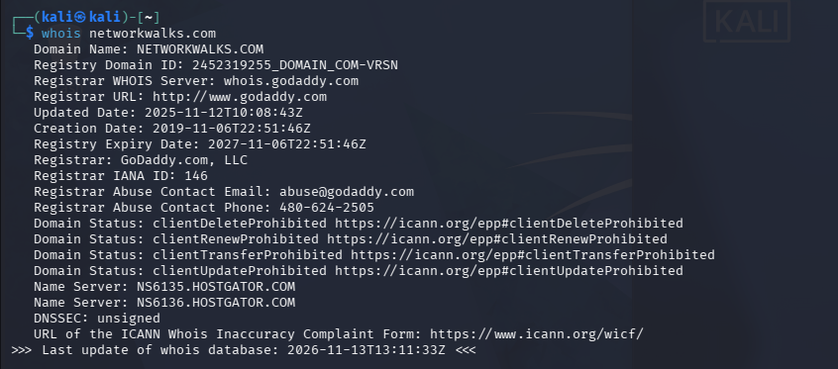
Activity 2 – WhatWeb
Command:
whatweb networkwalks.com
Objective:
To identify technologies and software used by the website.
Observation:
The recorded results identified WordPress 7.0.4 and WP Download Manager 3.3.58.
Evidence:
Activity 3 – Nslookup
Command:
nslookup networkwalks.com
Objective:
To resolve the domain name to its corresponding IP address.
Observation:
The recorded result identified:
IP Address: 192.232.216.135
Evidence:
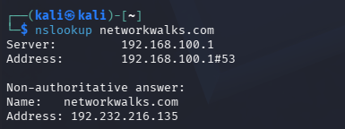
Activity 4 – Curl
Command:
curl -I https://networkwalks.com
Objective:
To inspect HTTP response headers returned by the website.
Observation:
The response provided information about the website's HTTP configuration and technical headers. The WordPress REST API endpoint /wp-json/ was also observed during the exercise.
Evidence:

Activity 5 – Wafw00f
Command:
wafw00f https://networkwalks.com
Objective:
To identify whether a Web Application Firewall was detectable.
Observation:
The recorded result identified ModSecurity (SpiderLabs).
Evidence: 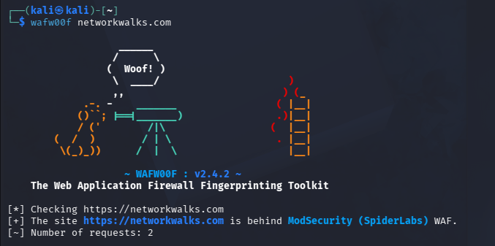

Activity 6 – DNSRecon
Command:
dnsrecon -d networkwalks.com
Objective:
To gather publicly available DNS information and identify DNS records.
Observation:
The results included information relating to name servers, mail servers, SPF/TXT records and other DNS records.
Evidence: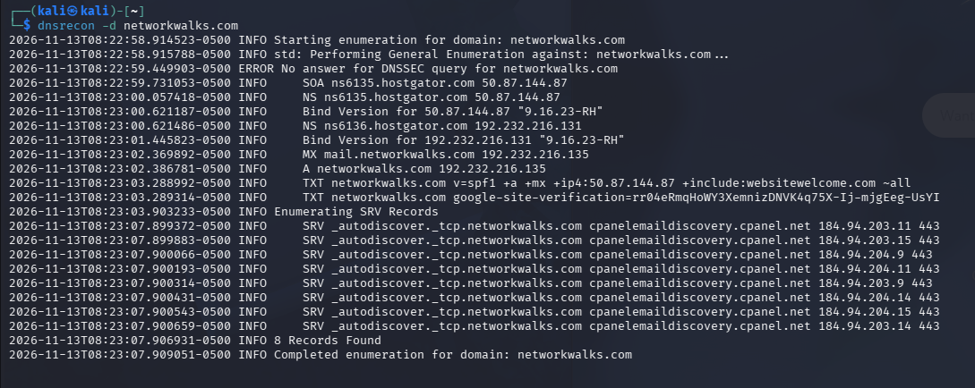

5.2 W2-PM5 – ZENMAP NETWORK SCANNING
Environment: Kali Linux Virtual Lab
Network: 10.0.2.0/24
Tool: Nmap / Zenmap
Step 1 – Network Discovery
I performed a host discovery scan to identify active devices within my virtual lab subnet.
Command:
sudo nmap -sn 10.0.2.0/24
Objective:
To identify active hosts without performing a port scan.
Step 2 – Scan Results
The scan examined 256 IP addresses and identified four live hosts.
Observed Results:
No. | IP Address | Status
1 | 10.0.2.2 | Up
2 | 10.0.2.3 | Up
3 | 10.0.2.4 | Up
4 | 10.0.2.15 | Up
Total Live Hosts: 4
Evidence:
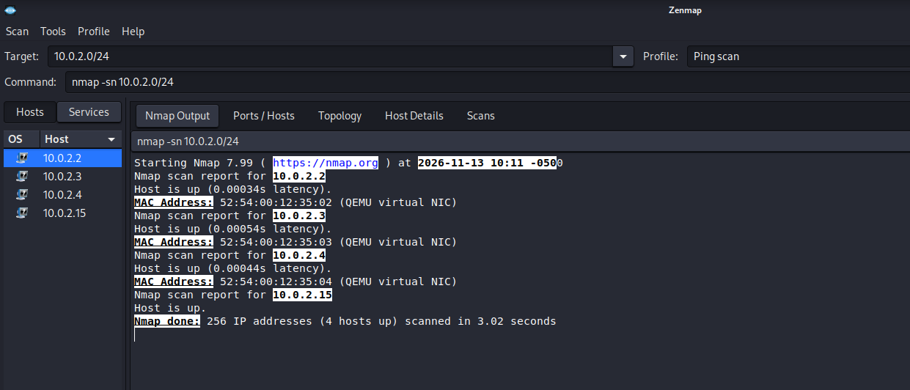
Step 3 – MAC Address Identification
The scan reported the following MAC addresses:
IP Address | MAC Address | Manufacturer
10.0.2.2 | 52:54:00:12:35:02 | QEMU virtual NIC
10.0.2.3 | 52:54:00:12:35:03 | QEMU virtual NIC
10.0.2.4 | 52:54:00:12:35:04 | QEMU virtual NIC
10.0.2.15 | Not reported | Unknown
Observation:
Nmap reported MAC addresses for three of the four discovered hosts. The MAC address for 10.0.2.15 was not displayed.
Step 4 – Network Topology
I used the Zenmap Topology tab to visualize the discovered hosts in my lab network.
The topology view was reviewed with the legend enabled and exported in PDF format.
Evidence:
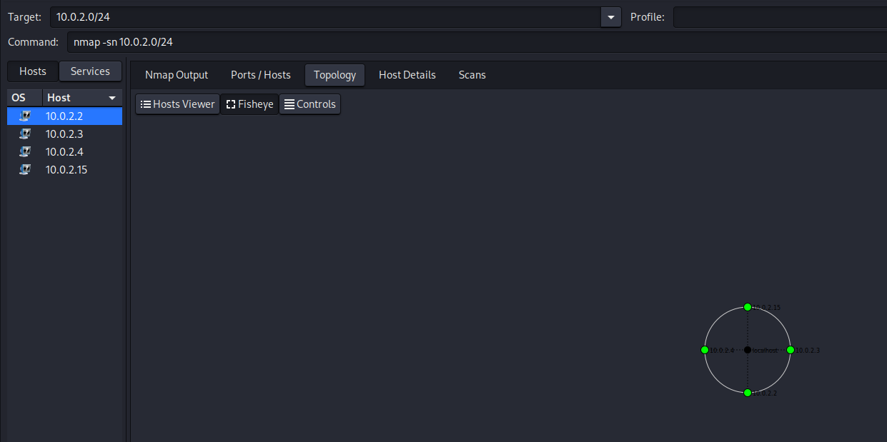
6. RISK ANALYSIS AND OBSERVATIONS
The following table summarizes potential information exposure observed during the practical exercises.
No. | Finding | Potential Impact | Risk
1 | Website technology identified | Helps build a technology profile | Medium
2 | Public server IP identified | Reveals hosting infrastructure information | Low
3 | HTTP response headers inspected | May expose technical details | Low
4 | WAF technology identified | Reveals security architecture information | Low
5 | DNS information collected | Helps map public infrastructure | Medium
6 | Four live lab hosts discovered | Provides visibility into network devices | Informational
Risk Assessment Note:
These findings represent observations from information-gathering and host-discovery activities. They are not confirmed vulnerabilities.
No exploitation or vulnerability validation was performed during these exercises.
7. RECOMMENDATIONS
Based on the activities performed, I recommend the following security improvements:
- Regularly review publicly exposed website technology information.
- Keep CMS platforms, plugins and other software updated.
- Review HTTP response headers and remove unnecessary technical disclosures.
- Periodically review DNS records.
- Maintain and properly configure Web Application Firewall protection.
- Perform regular authorized internal network discovery.
- Investigate unknown or unexpected network devices.
- Maintain updated network topology documentation.
- Ensure all security assessments are conducted within an authorized scope.
8. CONCLUSION
During Week 2 of my cybersecurity training program, I completed practical activities covering footprinting, reconnaissance and network scanning.
Through W2-PM1, I learned how to use WHOIS, WhatWeb, Nslookup, Curl, Wafw00f and DNSRecon to gather information about a domain and its publicly visible infrastructure.
Through W2-PM5, I used Nmap and Zenmap to discover live hosts in my virtual lab network, examine available MAC address information and visualize network topology.
The exercises helped me understand the importance of information gathering and network discovery during the early stages of penetration testing.
I also learned the importance of documenting commands, recording actual results, collecting screenshots and distinguishing security observations from confirmed vulnerabilities.
Finally, I understood that reconnaissance and scanning must always be performed within an authorized scope.
9. EVIDENCE COLLECTION
The following screenshots and files should be included as evidence of the activities performed.
No. | Evidence | Filename
1 | WHOIS output | whois.png
2 | WhatWeb output | whatweb.png
3 | Nslookup output | nslookup.png
4 | Curl output | curl.png
5 | Wafw00f output | wafw00f.png
6 | DNSRecon output | dnsrecon.png
7 | Zenmap scan results | zenmap-scan.png
8 | Zenmap network topology | zenmap-topology.png
9 | Exported network topology | network-topology.pdf

REPORT END
Program: Cybersecurity Training – Networkwalks
Week: 02
Modules: W2-PM1 and W2-PM5
Submission: W2-PM-FINAL
Prepared by: SANJO

