NORTHWIND TRADE
Interactive Sales Analysis using Power BI
Project Report on Sales, Product, Customer and Employee Performance
Submitted by
SANTHA
Course: B.Com FinTech with AI
Tool: Microsoft Power BI Desktop
October 2026

Table of Contents
Table of Contents 1
1. Introduction 1
2. Objectives of the Project 1
3. Dataset and Data Model 1
3.1 Key Measures Created 1
4. Tools and Methodology 1
5. Page 1: Sales Overview 1
5.1 Key Performance Indicators 1
5.2 Total Orders by Month 1
5.3 Total Sales by Category 1
5.4 Total Orders by Employee 1
6. Page 2: Product & Customer Analysis 1
6.1 Number of Customers by Country 1
6.2 Product Sales Table 1
7. Page 3: Interactive Sales Dashboard 1
7.1 Slicers Used 1
8. Page 4: Tool Tips 1
9. Key Findings 1
10. Recommendations 1
11. Scope for FinTech and AI 1
12. Conclusion 1

1. Introduction
Northwind Trade is a well-known sample trading company that imports and exports speciality food products to customers around the world. Its data covers customers, employees, products, categories, orders, order details and shippers, which makes it an ideal case for practising business intelligence and data analytics.
This report presents an interactive sales dashboard built in Microsoft Power BI Desktop for Northwind Trade. The dashboard converts raw transactional data into clear visuals and key performance indicators (KPIs) so that management can quickly understand total sales, order volume, freight cost, customer spread and employee performance. For a student of FinTech with AI, this kind of analysis is a foundation for data-driven decision making, financial reporting and, later, predictive modelling.

2. Objectives of the Project
- Measure overall performance: total sales, total orders, quantity sold and freight cost.
- Identify top categories and products: find which product groups generate the most revenue.
- Understand the customer base: analyse the number of customers by country.
- Evaluate employee contribution: compare total orders handled by each sales employee.
- Build an interactive dashboard: allow slicing by country, category and order date, with tooltip pages for quick KPI previews.

3. Dataset and Data Model
The dataset used is the Northwind database, loaded into Power BI as seven related tables. Relationships between the tables (for example orders to order_details, and products to categories) allow measures such as Total Sales and Total Orders to be calculated across any dimension.
Table | Description
categories | Product category names (Beverages, Dairy Products, Confections, etc.)
customers | Customer details including company and country
employees | Sales employees who handle the orders
orders | Order header information such as order date, employee, customer and freight
order_details | Line items of each order: product, unit price and quantity
products | Product names linked to their categories
shippers | Shipping companies used to deliver orders

3.1 Key Measures Created
Measure | Purpose
Total Sales | Sum of unit price × quantity (after discount) across all order lines
Total Orders | Count of distinct orders
Total Quantity Sold | Sum of quantity across all order lines
Total Freight | Sum of freight charges on orders
Average Freight | Average freight cost per order
Number of Customers | Distinct count of customers

4. Tools and Methodology
- Data loading and cleaning: tables were imported and checked in Power Query (Transform data).
- Data modelling: relationships were set between fact and dimension tables.
- Measures: DAX measures were written for the KPIs listed above.
- Visualisation: card visuals, line chart, column chart, bar charts, a table and slicers were used.
- Design: a dark blue themed background was applied across all four report pages for a consistent look.
The final report contains four pages: Sales Overview, Product & Customer Analysis, Interactive Sales Dashboard and Tool Tips.

5. Page 1: Sales Overview
The first page gives a quick summary of the business using six KPI cards and three supporting charts.
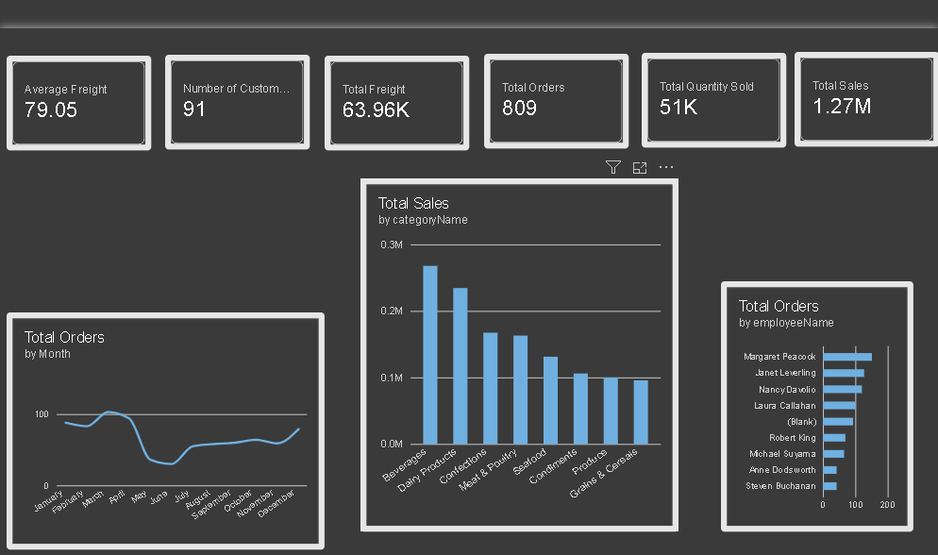
Figure 1: Sales Overview page in Power BI

5.1 Key Performance Indicators
KPI | Value | Remark
Average Freight | 79.05 | Per order
Number of Customers | 91 | Distinct customers
Total Freight | 63.96K | All orders
Total Orders | 809 | Orders placed
Total Quantity Sold | 51K (51,317) | Units
Total Sales | 1.27M (1,265,793.04) | Revenue

5.2 Total Orders by Month
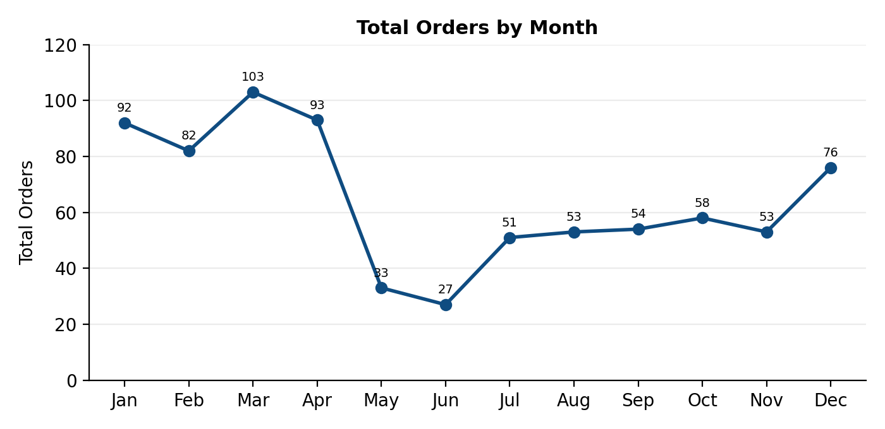
Figure 2: Monthly order trend (values read approximately from the dashboard line chart)
Order volume is highest in the first quarter, peaking around March at roughly 100 orders. There is a sharp fall in May and June, which are the weakest months, followed by a partial recovery in the second half of the year, with a rise again in December.

5.3 Total Sales by Category
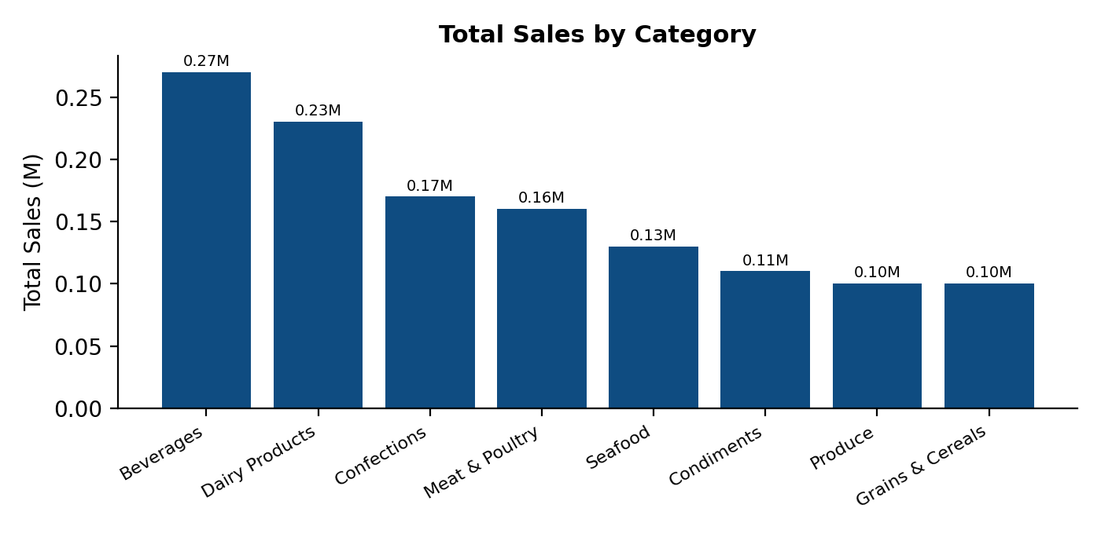
Figure 3: Total sales by product category (approximate values)
Beverages is the top-selling category at about 0.27M, followed by Dairy Products (about 0.23M) and Confections (about 0.17M). Produce and Grains & Cereals contribute the least, at about 0.10M each.
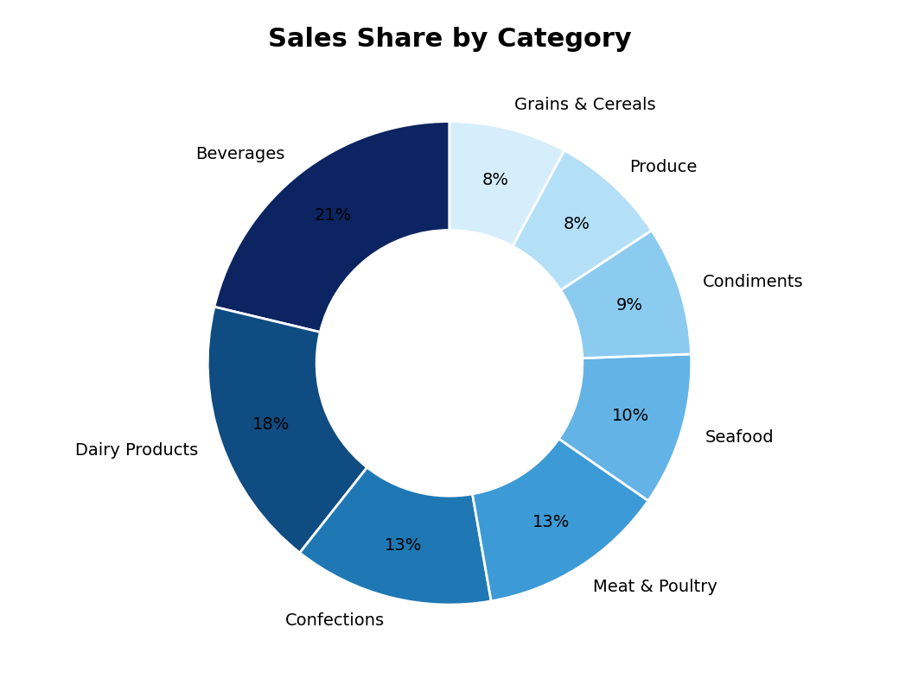
Figure 4: Share of total sales by category

5.4 Total Orders by Employee
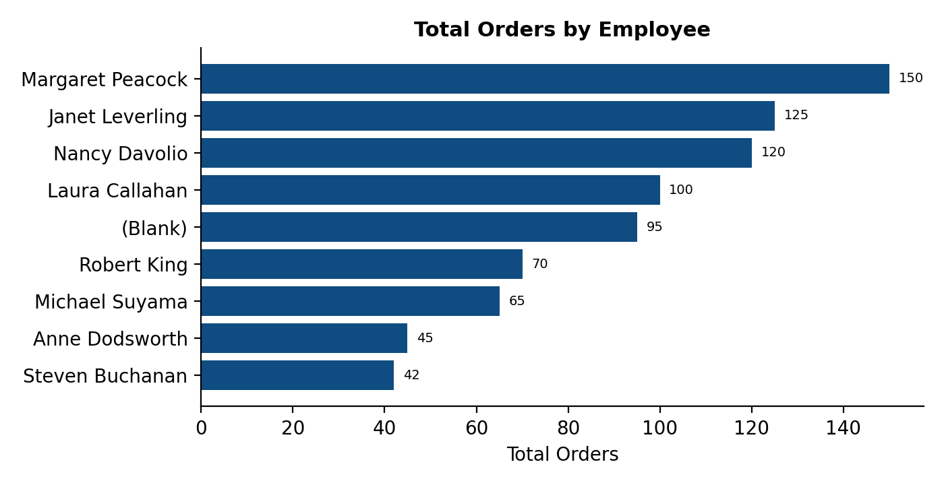
Figure 5: Orders handled by each employee (approximate values)
Margaret Peacock handled the most orders (about 150), followed by Janet Leverling and Nancy Davolio. A (Blank) employee entry of roughly 95 orders also appears, which indicates orders with no employee assigned in the data.

6. Page 2: Product & Customer Analysis
The second page looks at who the customers are and which products drive sales.
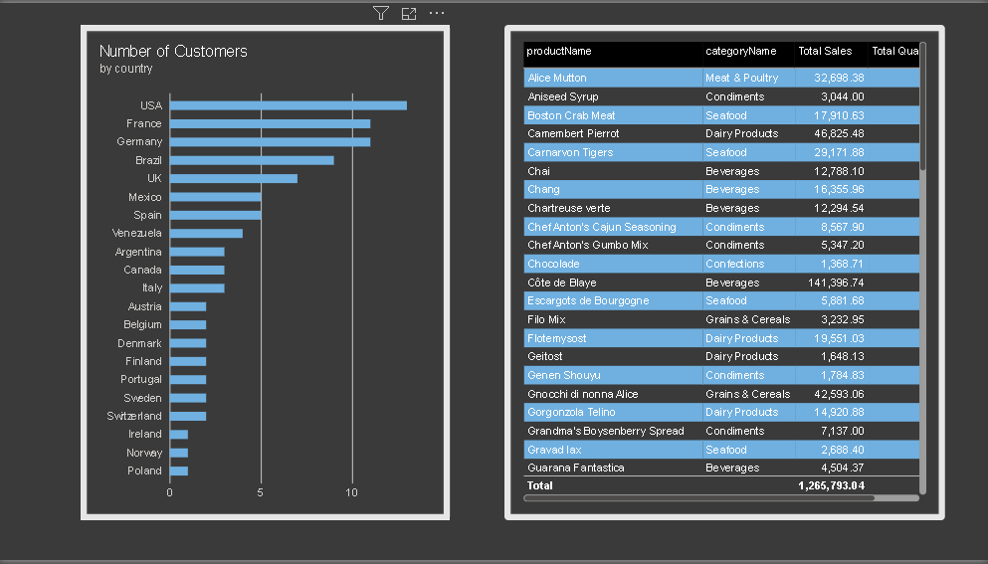
Figure 6: Product & Customer Analysis page in Power BI

6.1 Number of Customers by Country
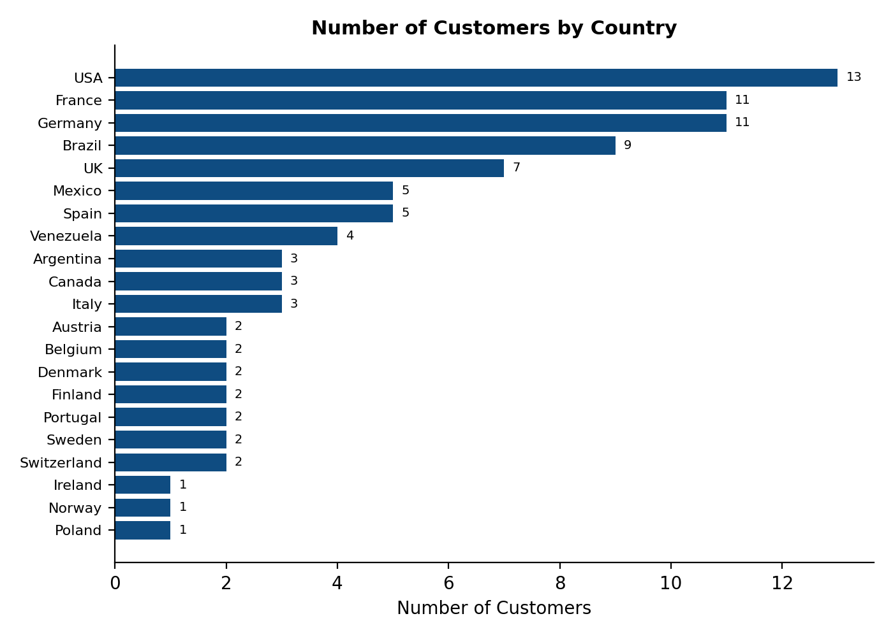
Figure 7: Customers by country (91 customers in total)
The USA has the most customers (13), followed by France and Germany (11 each) and Brazil (9). These four countries together account for 44 of the 91 customers. Ireland, Norway and Poland have only one customer each.

6.2 Product Sales Table
The table below lists total sales and total quantity sold by product and category, as shown on the dashboard (first 29 products alphabetically).
Product Name | Category | Total Sales | Quantity Sold
Alice Mutton | Meat & Poultry | 32,698.38 | 978
Aniseed Syrup | Condiments | 3,044.00 | 328
Boston Crab Meat | Seafood | 17,910.63 | 1,103
Camembert Pierrot | Dairy Products | 46,825.48 | 1,577
Carnarvon Tigers | Seafood | 29,171.88 | 539
Chai | Beverages | 12,788.10 | 828
Chang | Beverages | 16,355.96 | 1,057
Chartreuse verte | Beverages | 12,294.54 | 793
Chef Anton's Cajun Seasoning | Condiments | 8,567.90 | 453
Chef Anton's Gumbo Mix | Condiments | 5,347.20 | 298
Chocolade | Confections | 1,368.71 | 138
Côte de Blaye | Beverages | 141,396.74 | 623
Escargots de Bourgogne | Seafood | 5,881.68 | 534
Filo Mix | Grains & Cereals | 3,232.95 | 500
Flotemysost | Dairy Products | 19,551.03 | 1,057
Geitost | Dairy Products | 1,648.13 | 755
Genen Shouyu | Condiments | 1,784.83 | 122
Gnocchi di nonna Alice | Grains & Cereals | 42,593.06 | 1,263
Gorgonzola Telino | Dairy Products | 14,920.88 | 1,397
Grandma's Boysenberry Spread | Condiments | 7,137.00 | 301
Gravad lax | Seafood | 2,688.40 | 125
Guaraná Fantástica | Beverages | 4,504.37 | 1,125
Gudbrandsdalsost | Dairy Products | 21,942.36 | 714
Gula Malacca | Condiments | 9,915.95 | 601
Gumbär Gummibärchen | Confections | 19,849.14 | 753
Gustaf's Knäckebröd | Grains & Cereals | 7,122.36 | 348
Ikura | Seafood | 20,867.34 | 742
Inlagd Sill | Seafood | 13,458.46 | 805
Ipoh Coffee | Beverages | 23,526.70 | 580
Grand Total (all products) |  | 1,265,793.04 | 51,317

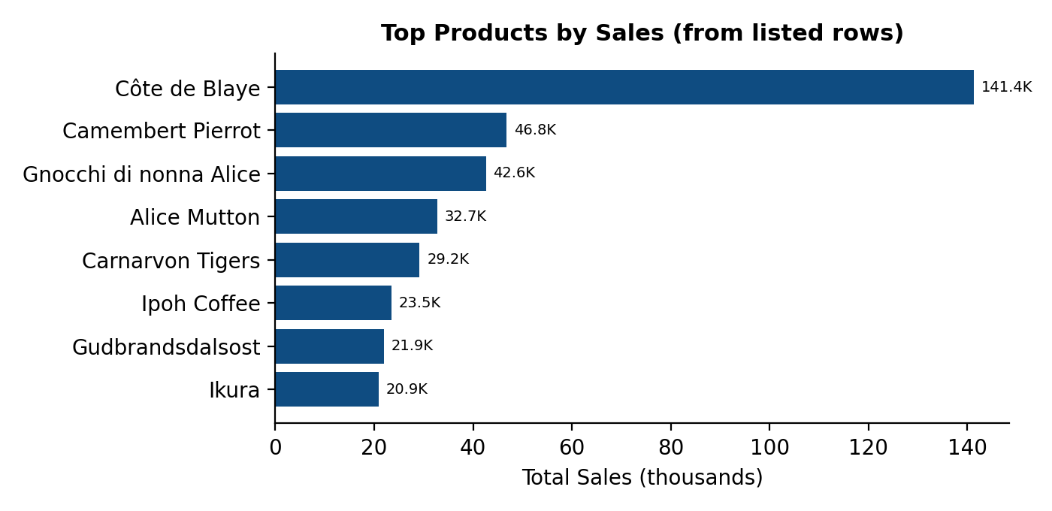
Figure 8: Highest-selling products among the rows listed above
Côte de Blaye is the standout product with sales of about 141K, roughly 11% of total company sales from a single item, even though only 623 units were sold. This shows it is a high-value product. Camembert Pierrot and Gnocchi di nonna Alice follow, with sales of about 46.8K and 42.6K.

7. Page 3: Interactive Sales Dashboard
The third page, titled Northwind Interactive Sales Dashboard, brings the KPI cards and the main charts together on one screen and adds slicers so that the viewer can filter the data.
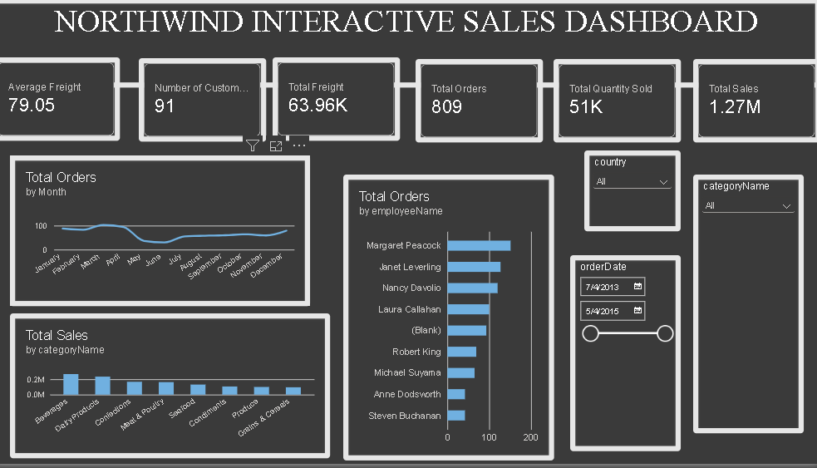
Figure 9: Northwind Interactive Sales Dashboard

7.1 Slicers Used
Slicer | How it helps
country | Filters every visual to show data for a chosen country
categoryName | Shows sales and orders for one product category at a time
orderDate | Date range slider to analyse any time period

Because Keep all filters is switched on, selecting a value in one visual or slicer automatically updates the KPI cards, monthly orders, category sales and employee orders. This makes the dashboard useful for quick what-if style questions, such as how many orders a particular employee handled in a given country.

8. Page 4: Tool Tips
The fourth page is a tooltip page. It holds three compact cards (Total Orders 809, Total Sales 1.27M and Quantity Sold 51K) that appear as a small pop-up when the user hovers over a visual on the other pages. This gives extra context without crowding the main report.
H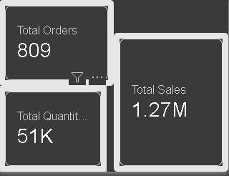
Figure 10: Tooltip page design

9. Key Findings
Metric | Result
Total sales | 1.27 million (1,265,793.04)
Total orders | 809
Average sales per order | about 1,565 (1,265,793 ÷ 809)
Average quantity per order | about 63 units
Average orders per customer | about 8.9 (809 ÷ 91)
Freight as share of sales | about 5% (63.96K ÷ 1.27M)
Top category | Beverages (about 21% of sales)
Top three categories | Beverages, Dairy Products and Confections (about 53% of sales)
Top product listed | Côte de Blaye (about 141K sales)
Top country by customers | USA (13), then France and Germany (11 each)
Top employee by orders | Margaret Peacock (about 150 orders)

- Seasonality: orders fall sharply in May and June and peak in the first quarter.
- Concentration: a few categories and one product contribute a large share of revenue.
- Customer spread: about 38% of customers are in the USA, France and Germany.
- Data quality: a (Blank) employee value shows that some orders are missing an employee assignment.

10. Recommendations
- Plan promotions and marketing campaigns for May and June to lift the low-order months.
- Protect the supply and pricing of Beverages and Dairy Products, as they drive over 40% of sales.
- Review stock and pricing of high-value items such as Côte de Blaye to reduce dependence on a single product.
- Increase customer acquisition in countries with few customers, such as Ireland, Norway and Poland.
- Fix the missing employee records so that performance can be measured fairly.
- Monitor freight cost per order to keep it at or below its current level of about 5% of sales.

11. Scope for FinTech and AI
The dashboard can be extended using AI and financial analytics techniques. Examples include forecasting monthly sales with time-series models, customer segmentation and churn prediction using machine learning, detecting unusual orders or freight charges using anomaly detection, and using Copilot in Power BI to ask questions of the data in plain language. These extensions connect directly with the skills studied in B.Com FinTech with AI.

12. Conclusion
The Northwind Trade interactive sales dashboard successfully turns transaction data into useful business insight. With total sales of about 1.27 million from 809 orders and 91 customers, the report shows where revenue comes from, how it changes through the year, who the key customers and employees are, and where the business can improve. The use of KPI cards, slicers and tooltips makes the report easy to read and interactive, and it demonstrates practical Power BI, DAX and data storytelling skills.

Note: Chart values for monthly orders, category sales and employee orders were read from the dashboard visuals and are approximate. KPI values and the product table are taken directly from the dashboard.

