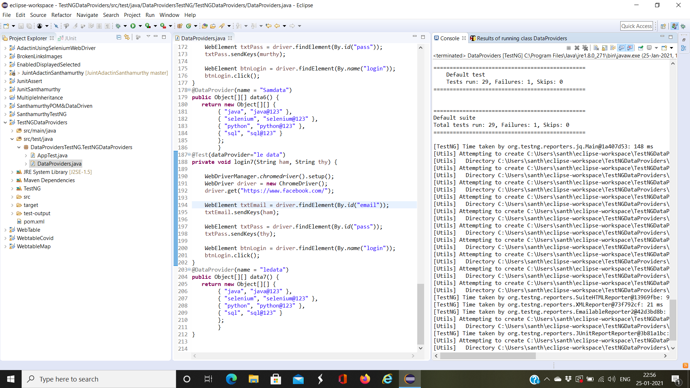

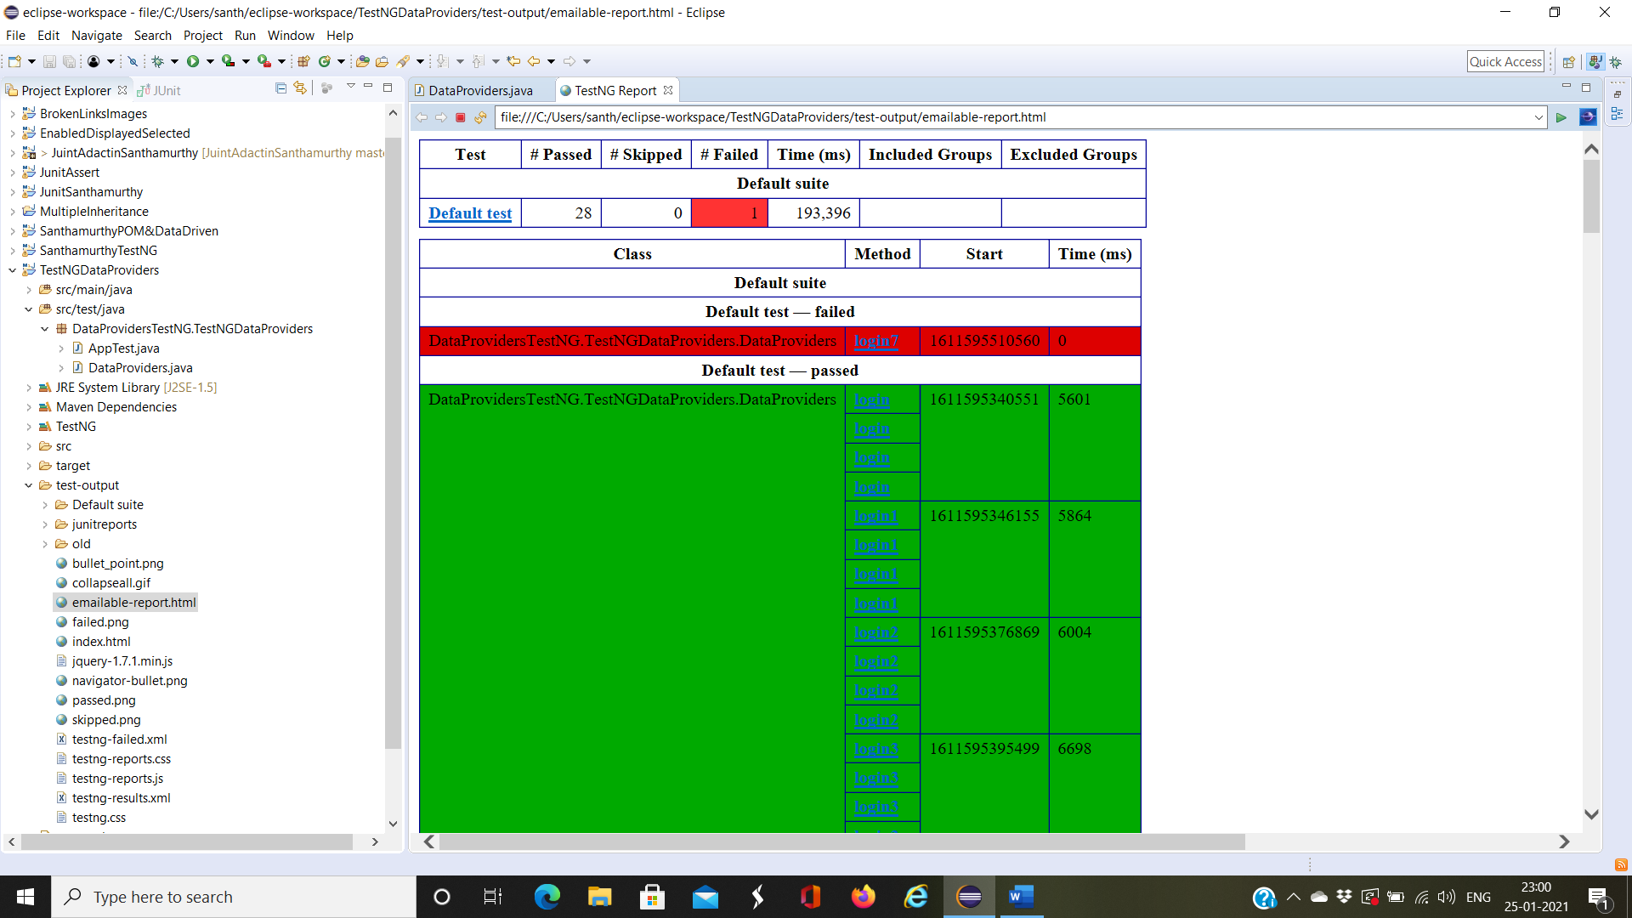

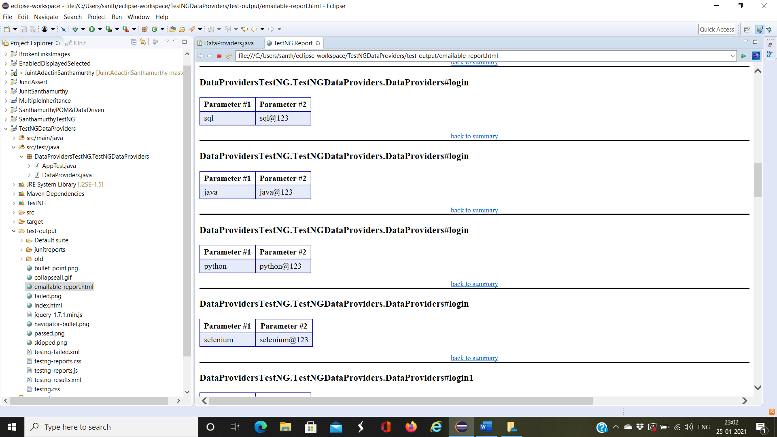

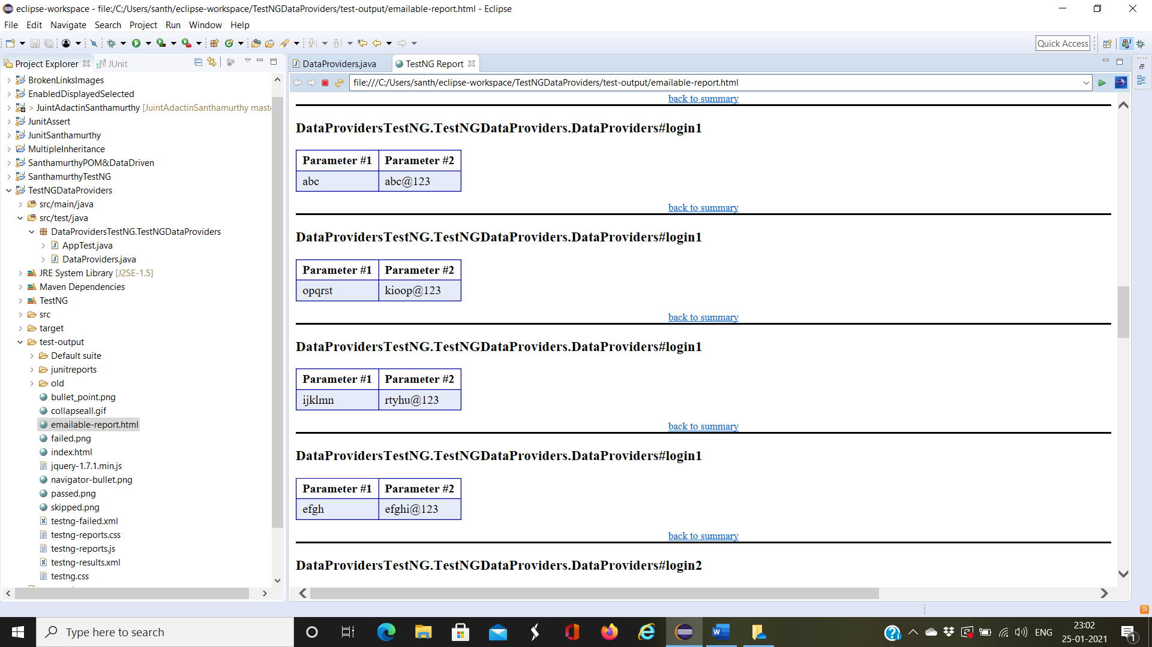

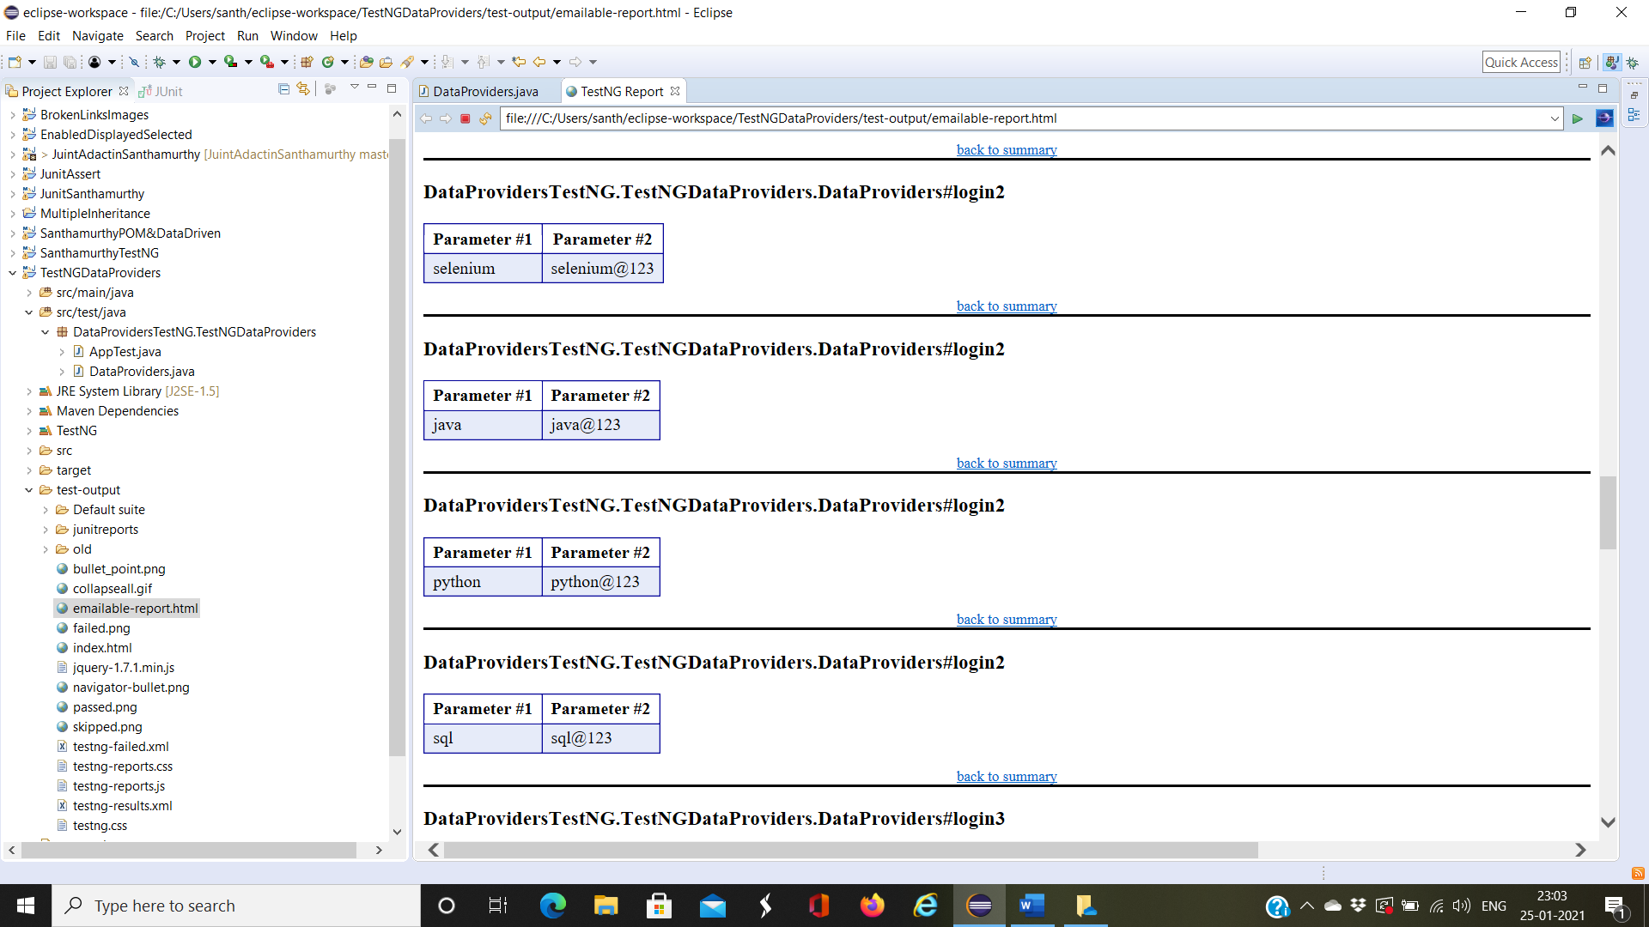

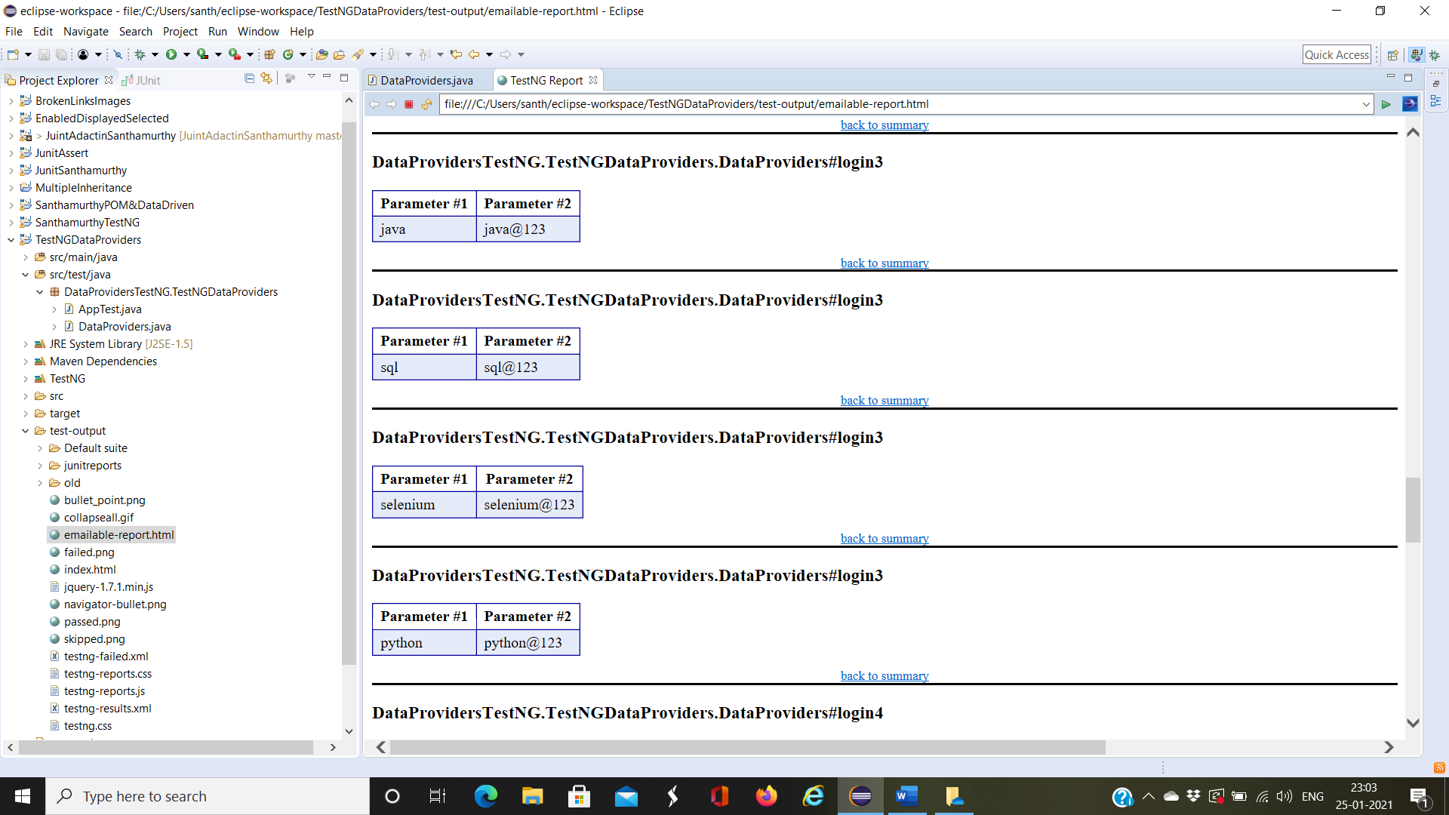

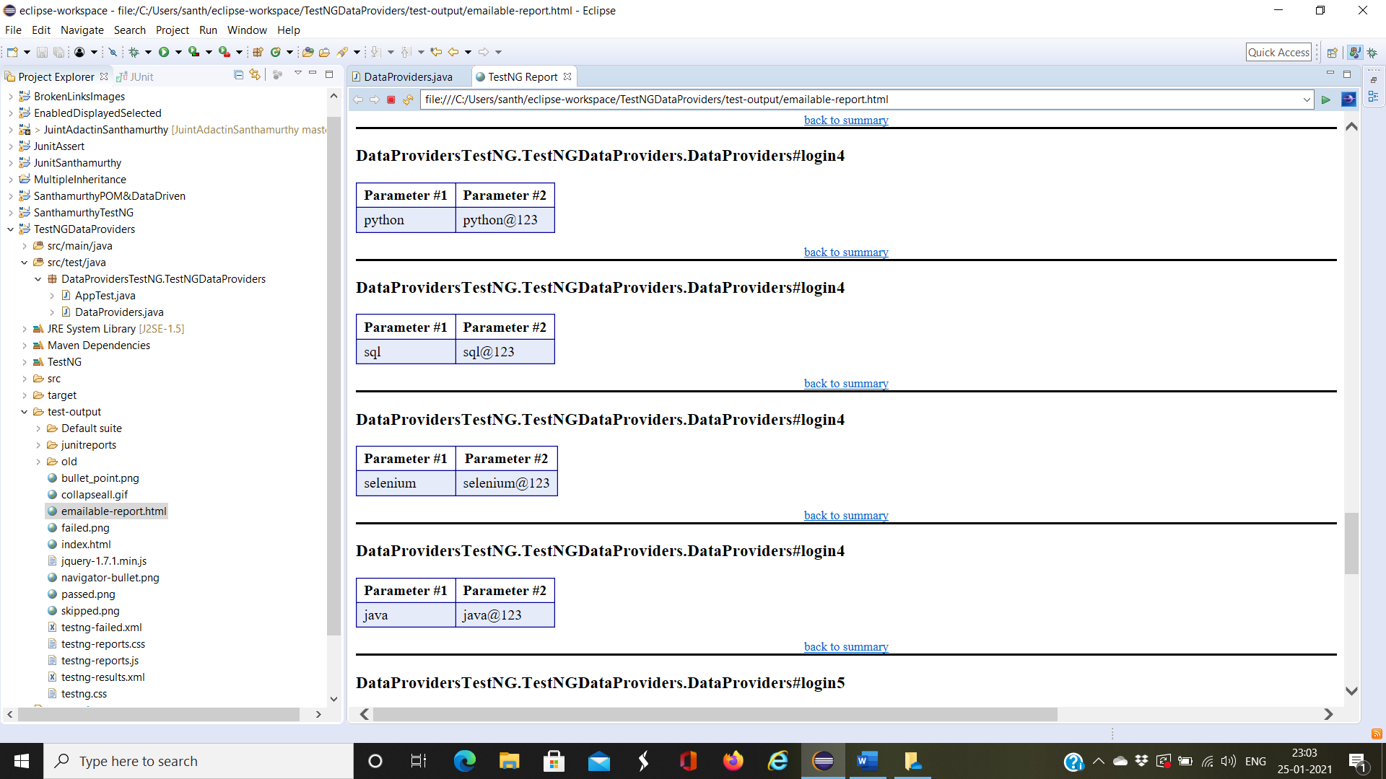

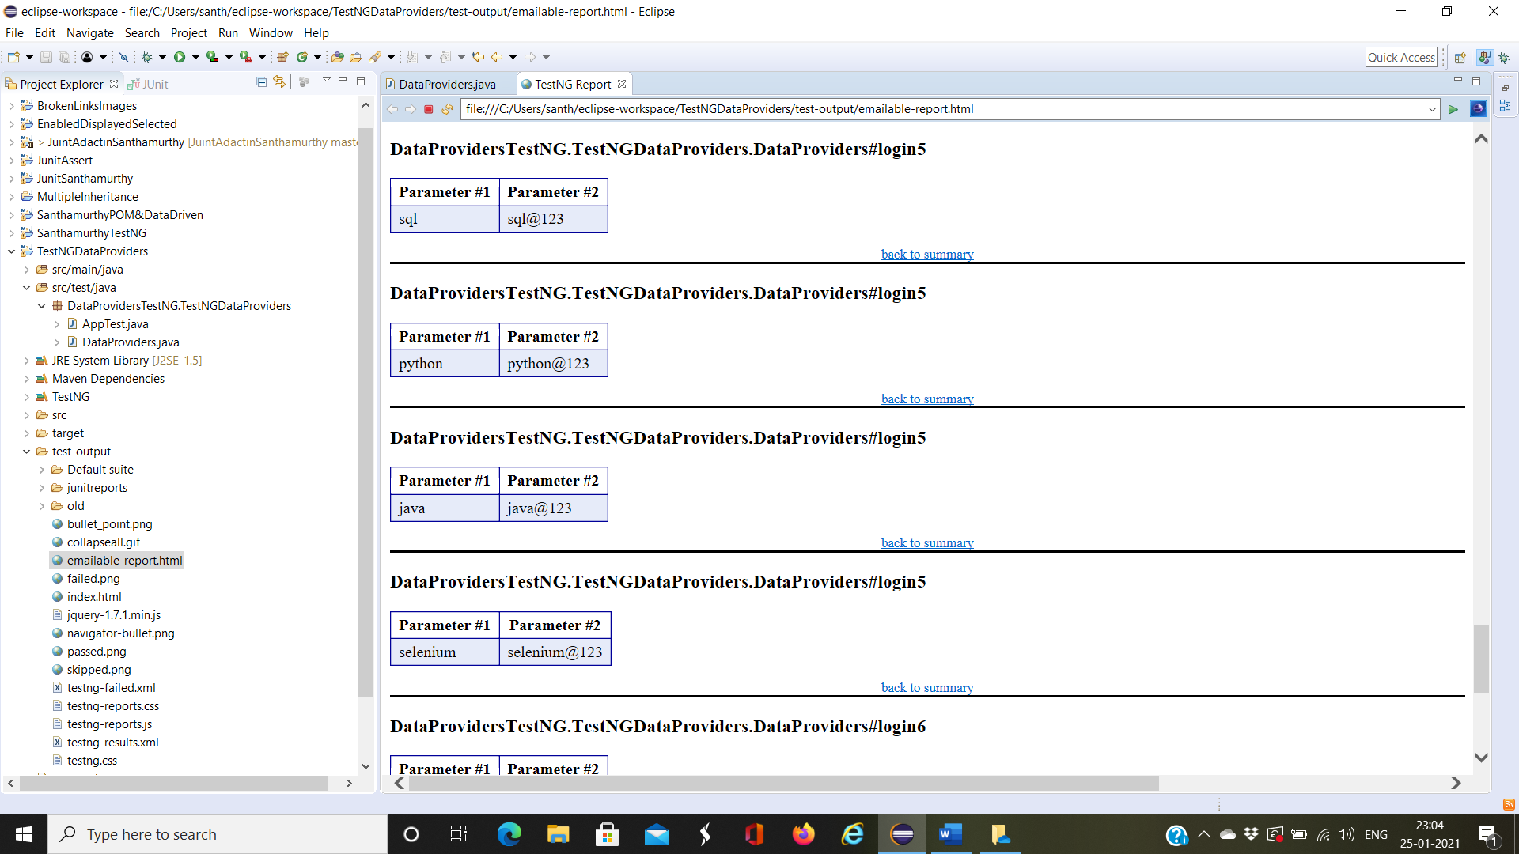

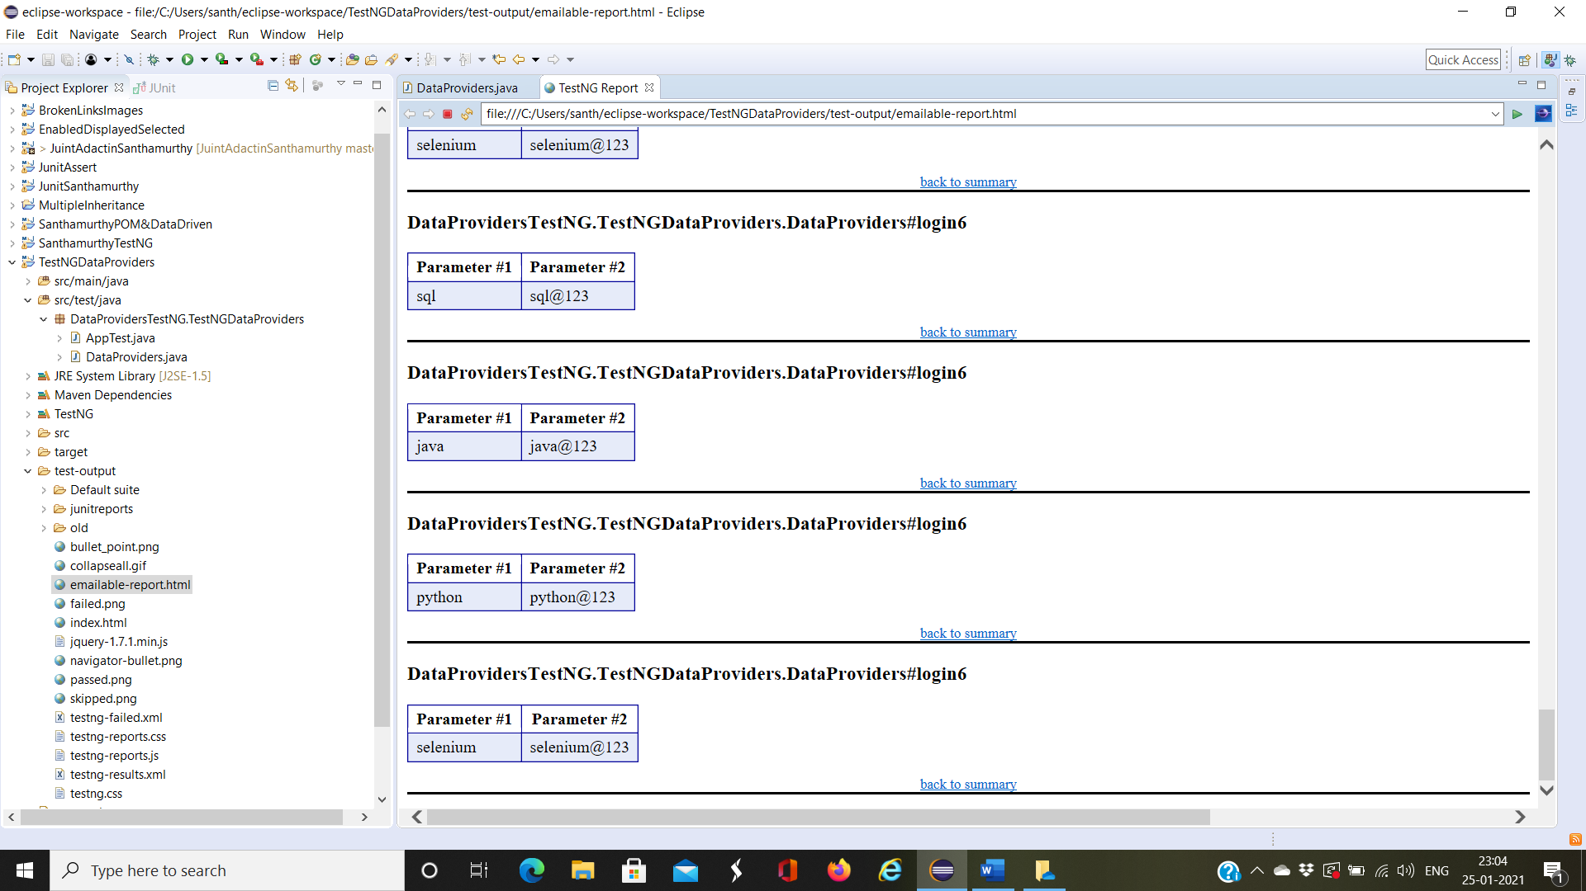

[TestNG] Running:

C:\Users\santh\AppData\Local\Temp\testng-eclipse--1205100151\testng-customsuite.xml

SLF4J: Failed to load class "org.slf4j.impl.StaticLoggerBinder".

SLF4J: Defaulting to no-operation (NOP) logger implementation

SLF4J: See http://www.slf4j.org/codes.html#StaticLoggerBinder for further details.

Starting ChromeDriver 87.0.4280.88 (89e2380a3e36c3464b5dd1302349b1382549290d-refs/branch-heads/4280@{#1761}) on port 32247

Only local connections are allowed.

Please see https://chromedriver.chromium.org/security-considerations for suggestions on keeping ChromeDriver safe.

ChromeDriver was started successfully.

Jan 25, 2021 10:52:01 PM org.openqa.selenium.remote.ProtocolHandshake createSession

INFO: Detected dialect: W3C

Starting ChromeDriver 87.0.4280.88 (89e2380a3e36c3464b5dd1302349b1382549290d-refs/branch-heads/4280@{#1761}) on port 45107

Only local connections are allowed.

Please see https://chromedriver.chromium.org/security-considerations for suggestions on keeping ChromeDriver safe.

ChromeDriver was started successfully.

Jan 25, 2021 10:52:07 PM org.openqa.selenium.remote.ProtocolHandshake createSession

INFO: Detected dialect: W3C

Starting ChromeDriver 87.0.4280.88 (89e2380a3e36c3464b5dd1302349b1382549290d-refs/branch-heads/4280@{#1761}) on port 18321

Only local connections are allowed.

Please see https://chromedriver.chromium.org/security-considerations for suggestions on keeping ChromeDriver safe.

ChromeDriver was started successfully.

Jan 25, 2021 10:52:15 PM org.openqa.selenium.remote.ProtocolHandshake createSession

INFO: Detected dialect: W3C

Starting ChromeDriver 87.0.4280.88 (89e2380a3e36c3464b5dd1302349b1382549290d-refs/branch-heads/4280@{#1761}) on port 37117

Only local connections are allowed.

Please see https://chromedriver.chromium.org/security-considerations for suggestions on keeping ChromeDriver safe.

ChromeDriver was started successfully.

Jan 25, 2021 10:52:23 PM org.openqa.selenium.remote.ProtocolHandshake createSession

INFO: Detected dialect: W3C

Starting ChromeDriver 87.0.4280.88 (89e2380a3e36c3464b5dd1302349b1382549290d-refs/branch-heads/4280@{#1761}) on port 17854

Only local connections are allowed.

Please see https://chromedriver.chromium.org/security-considerations for suggestions on keeping ChromeDriver safe.

ChromeDriver was started successfully.

Jan 25, 2021 10:52:29 PM org.openqa.selenium.remote.ProtocolHandshake createSession

INFO: Detected dialect: W3C

Starting ChromeDriver 87.0.4280.88 (89e2380a3e36c3464b5dd1302349b1382549290d-refs/branch-heads/4280@{#1761}) on port 11686

Only local connections are allowed.

Please see https://chromedriver.chromium.org/security-considerations for suggestions on keeping ChromeDriver safe.

ChromeDriver was started successfully.

Jan 25, 2021 10:52:35 PM org.openqa.selenium.remote.ProtocolHandshake createSession

INFO: Detected dialect: W3C

Starting ChromeDriver 87.0.4280.88 (89e2380a3e36c3464b5dd1302349b1382549290d-refs/branch-heads/4280@{#1761}) on port 23383

Only local connections are allowed.

Please see https://chromedriver.chromium.org/security-considerations for suggestions on keeping ChromeDriver safe.

ChromeDriver was started successfully.

Jan 25, 2021 10:52:41 PM org.openqa.selenium.remote.ProtocolHandshake createSession

INFO: Detected dialect: W3C

Starting ChromeDriver 87.0.4280.88 (89e2380a3e36c3464b5dd1302349b1382549290d-refs/branch-heads/4280@{#1761}) on port 26895

Only local connections are allowed.

Please see https://chromedriver.chromium.org/security-considerations for suggestions on keeping ChromeDriver safe.

ChromeDriver was started successfully.

Jan 25, 2021 10:52:47 PM org.openqa.selenium.remote.ProtocolHandshake createSession

INFO: Detected dialect: W3C

Starting ChromeDriver 87.0.4280.88 (89e2380a3e36c3464b5dd1302349b1382549290d-refs/branch-heads/4280@{#1761}) on port 37785

Only local connections are allowed.

Please see https://chromedriver.chromium.org/security-considerations for suggestions on keeping ChromeDriver safe.

ChromeDriver was started successfully.

Jan 25, 2021 10:52:53 PM org.openqa.selenium.remote.ProtocolHandshake createSession

INFO: Detected dialect: W3C

Starting ChromeDriver 87.0.4280.88 (89e2380a3e36c3464b5dd1302349b1382549290d-refs/branch-heads/4280@{#1761}) on port 43807

Only local connections are allowed.

Please see https://chromedriver.chromium.org/security-considerations for suggestions on keeping ChromeDriver safe.

ChromeDriver was started successfully.

Jan 25, 2021 10:53:00 PM org.openqa.selenium.remote.ProtocolHandshake createSession

INFO: Detected dialect: W3C

Starting ChromeDriver 87.0.4280.88 (89e2380a3e36c3464b5dd1302349b1382549290d-refs/branch-heads/4280@{#1761}) on port 43915

Only local connections are allowed.

Please see https://chromedriver.chromium.org/security-considerations for suggestions on keeping ChromeDriver safe.

ChromeDriver was started successfully.

Jan 25, 2021 10:53:06 PM org.openqa.selenium.remote.ProtocolHandshake createSession

INFO: Detected dialect: W3C

Starting ChromeDriver 87.0.4280.88 (89e2380a3e36c3464b5dd1302349b1382549290d-refs/branch-heads/4280@{#1761}) on port 38146

Only local connections are allowed.

Please see https://chromedriver.chromium.org/security-considerations for suggestions on keeping ChromeDriver safe.

ChromeDriver was started successfully.

Jan 25, 2021 10:53:12 PM org.openqa.selenium.remote.ProtocolHandshake createSession

INFO: Detected dialect: W3C

Starting ChromeDriver 87.0.4280.88 (89e2380a3e36c3464b5dd1302349b1382549290d-refs/branch-heads/4280@{#1761}) on port 12911

Only local connections are allowed.

Please see https://chromedriver.chromium.org/security-considerations for suggestions on keeping ChromeDriver safe.

ChromeDriver was started successfully.

Jan 25, 2021 10:53:18 PM org.openqa.selenium.remote.ProtocolHandshake createSession

INFO: Detected dialect: W3C

Starting ChromeDriver 87.0.4280.88 (89e2380a3e36c3464b5dd1302349b1382549290d-refs/branch-heads/4280@{#1761}) on port 7559

Only local connections are allowed.

Please see https://chromedriver.chromium.org/security-considerations for suggestions on keeping ChromeDriver safe.

ChromeDriver was started successfully.

Jan 25, 2021 10:53:25 PM org.openqa.selenium.remote.ProtocolHandshake createSession

INFO: Detected dialect: W3C

Starting ChromeDriver 87.0.4280.88 (89e2380a3e36c3464b5dd1302349b1382549290d-refs/branch-heads/4280@{#1761}) on port 7222

Only local connections are allowed.

Please see https://chromedriver.chromium.org/security-considerations for suggestions on keeping ChromeDriver safe.

ChromeDriver was started successfully.

Jan 25, 2021 10:53:32 PM org.openqa.selenium.remote.ProtocolHandshake createSession

INFO: Detected dialect: W3C

Starting ChromeDriver 87.0.4280.88 (89e2380a3e36c3464b5dd1302349b1382549290d-refs/branch-heads/4280@{#1761}) on port 6742

Only local connections are allowed.

Please see https://chromedriver.chromium.org/security-considerations for suggestions on keeping ChromeDriver safe.

ChromeDriver was started successfully.

Jan 25, 2021 10:53:38 PM org.openqa.selenium.remote.ProtocolHandshake createSession

INFO: Detected dialect: W3C

Starting ChromeDriver 87.0.4280.88 (89e2380a3e36c3464b5dd1302349b1382549290d-refs/branch-heads/4280@{#1761}) on port 42304

Only local connections are allowed.

Please see https://chromedriver.chromium.org/security-considerations for suggestions on keeping ChromeDriver safe.

ChromeDriver was started successfully.

Jan 25, 2021 10:53:45 PM org.openqa.selenium.remote.ProtocolHandshake createSession

INFO: Detected dialect: W3C

Starting ChromeDriver 87.0.4280.88 (89e2380a3e36c3464b5dd1302349b1382549290d-refs/branch-heads/4280@{#1761}) on port 12962

Only local connections are allowed.

Please see https://chromedriver.chromium.org/security-considerations for suggestions on keeping ChromeDriver safe.

ChromeDriver was started successfully.

Jan 25, 2021 10:53:51 PM org.openqa.selenium.remote.ProtocolHandshake createSession

INFO: Detected dialect: W3C

Starting ChromeDriver 87.0.4280.88 (89e2380a3e36c3464b5dd1302349b1382549290d-refs/branch-heads/4280@{#1761}) on port 4167

Only local connections are allowed.

Please see https://chromedriver.chromium.org/security-considerations for suggestions on keeping ChromeDriver safe.

ChromeDriver was started successfully.

Jan 25, 2021 10:53:58 PM org.openqa.selenium.remote.ProtocolHandshake createSession

INFO: Detected dialect: W3C

Starting ChromeDriver 87.0.4280.88 (89e2380a3e36c3464b5dd1302349b1382549290d-refs/branch-heads/4280@{#1761}) on port 38993

Only local connections are allowed.

Please see https://chromedriver.chromium.org/security-considerations for suggestions on keeping ChromeDriver safe.

ChromeDriver was started successfully.

Jan 25, 2021 10:54:05 PM org.openqa.selenium.remote.ProtocolHandshake createSession

INFO: Detected dialect: W3C

Starting ChromeDriver 87.0.4280.88 (89e2380a3e36c3464b5dd1302349b1382549290d-refs/branch-heads/4280@{#1761}) on port 6909

Only local connections are allowed.

Please see https://chromedriver.chromium.org/security-considerations for suggestions on keeping ChromeDriver safe.

ChromeDriver was started successfully.

Jan 25, 2021 10:54:12 PM org.openqa.selenium.remote.ProtocolHandshake createSession

INFO: Detected dialect: W3C

Starting ChromeDriver 87.0.4280.88 (89e2380a3e36c3464b5dd1302349b1382549290d-refs/branch-heads/4280@{#1761}) on port 45663

Only local connections are allowed.

Please see https://chromedriver.chromium.org/security-considerations for suggestions on keeping ChromeDriver safe.

ChromeDriver was started successfully.

Jan 25, 2021 10:54:21 PM org.openqa.selenium.remote.ProtocolHandshake createSession

INFO: Detected dialect: W3C

Starting ChromeDriver 87.0.4280.88 (89e2380a3e36c3464b5dd1302349b1382549290d-refs/branch-heads/4280@{#1761}) on port 18796

Only local connections are allowed.

Please see https://chromedriver.chromium.org/security-considerations for suggestions on keeping ChromeDriver safe.

ChromeDriver was started successfully.

Jan 25, 2021 10:54:29 PM org.openqa.selenium.remote.ProtocolHandshake createSession

INFO: Detected dialect: W3C

Starting ChromeDriver 87.0.4280.88 (89e2380a3e36c3464b5dd1302349b1382549290d-refs/branch-heads/4280@{#1761}) on port 30949

Only local connections are allowed.

Please see https://chromedriver.chromium.org/security-considerations for suggestions on keeping ChromeDriver safe.

ChromeDriver was started successfully.

Jan 25, 2021 10:54:35 PM org.openqa.selenium.remote.ProtocolHandshake createSession

INFO: Detected dialect: W3C

Starting ChromeDriver 87.0.4280.88 (89e2380a3e36c3464b5dd1302349b1382549290d-refs/branch-heads/4280@{#1761}) on port 12233

Only local connections are allowed.

Please see https://chromedriver.chromium.org/security-considerations for suggestions on keeping ChromeDriver safe.

ChromeDriver was started successfully.

Jan 25, 2021 10:54:42 PM org.openqa.selenium.remote.ProtocolHandshake createSession

INFO: Detected dialect: W3C

Starting ChromeDriver 87.0.4280.88 (89e2380a3e36c3464b5dd1302349b1382549290d-refs/branch-heads/4280@{#1761}) on port 10830

Only local connections are allowed.

Please see https://chromedriver.chromium.org/security-considerations for suggestions on keeping ChromeDriver safe.

ChromeDriver was started successfully.

Jan 25, 2021 10:54:50 PM org.openqa.selenium.remote.ProtocolHandshake createSession

INFO: Detected dialect: W3C

Starting ChromeDriver 87.0.4280.88 (89e2380a3e36c3464b5dd1302349b1382549290d-refs/branch-heads/4280@{#1761}) on port 14100

Only local connections are allowed.

Please see https://chromedriver.chromium.org/security-considerations for suggestions on keeping ChromeDriver safe.

ChromeDriver was started successfully.

Jan 25, 2021 10:54:59 PM org.openqa.selenium.remote.ProtocolHandshake createSession

INFO: Detected dialect: W3C

Starting ChromeDriver 87.0.4280.88 (89e2380a3e36c3464b5dd1302349b1382549290d-refs/branch-heads/4280@{#1761}) on port 28201

Only local connections are allowed.

Please see https://chromedriver.chromium.org/security-considerations for suggestions on keeping ChromeDriver safe.

ChromeDriver was started successfully.

Jan 25, 2021 10:55:07 PM org.openqa.selenium.remote.ProtocolHandshake createSession

INFO: Detected dialect: W3C

[Utils] Attempting to create C:\Users\santh\eclipse-workspace\TestNGDataProviders\test-output\Default suite\Default test.xml

[Utils] Directory C:\Users\santh\eclipse-workspace\TestNGDataProviders\test-output\Default suite exists: true

PASSED: login("java", "java@123")

PASSED: login("selenium", "selenium@123")

PASSED: login("python", "python@123")

PASSED: login("sql", "sql@123")

PASSED: login1("abc", "abc@123")

PASSED: login1("efgh", "efghi@123")

PASSED: login1("ijklmn", "rtyhu@123")

PASSED: login1("opqrst", "kioop@123")

PASSED: login2("java", "java@123")

PASSED: login2("selenium", "selenium@123")

PASSED: login2("python", "python@123")

PASSED: login2("sql", "sql@123")

PASSED: login3("java", "java@123")

PASSED: login3("selenium", "selenium@123")

PASSED: login3("python", "python@123")

PASSED: login3("sql", "sql@123")

PASSED: login4("java", "java@123")

PASSED: login4("selenium", "selenium@123")

PASSED: login4("python", "python@123")

PASSED: login4("sql", "sql@123")

PASSED: login5("java", "java@123")

PASSED: login5("selenium", "selenium@123")

PASSED: login5("python", "python@123")

PASSED: login5("sql", "sql@123")

PASSED: login6("java", "java@123")

PASSED: login6("selenium", "selenium@123")

PASSED: login6("python", "python@123")

PASSED: login6("sql", "sql@123")

FAILED: login7

org.testng.TestNGException:

Method private void DataProvidersTestNG.TestNGDataProviders.DataProviders.login7(java.lang.String,java.lang.String) requires a @DataProvider named : le data

at org.testng.internal.Parameters.findDataProvider(Parameters.java:263)

at org.testng.internal.Parameters.handleParameters(Parameters.java:425)

at org.testng.internal.Invoker.handleParameters(Invoker.java:1253)

at org.testng.internal.Invoker.createParameters(Invoker.java:980)

at org.testng.internal.Invoker.invokeTestMethods(Invoker.java:1070)

at org.testng.internal.TestMethodWorker.invokeTestMethods(TestMethodWorker.java:129)

at org.testng.internal.TestMethodWorker.run(TestMethodWorker.java:112)

at org.testng.TestRunner.privateRun(TestRunner.java:753)

at org.testng.TestRunner.run(TestRunner.java:607)

at org.testng.SuiteRunner.runTest(SuiteRunner.java:368)

at org.testng.SuiteRunner.runSequentially(SuiteRunner.java:363)

at org.testng.SuiteRunner.privateRun(SuiteRunner.java:321)

at org.testng.SuiteRunner.run(SuiteRunner.java:270)

at org.testng.SuiteRunnerWorker.runSuite(SuiteRunnerWorker.java:52)

at org.testng.SuiteRunnerWorker.run(SuiteRunnerWorker.java:86)

at org.testng.TestNG.runSuitesSequentially(TestNG.java:1284)

at org.testng.TestNG.runSuitesLocally(TestNG.java:1209)

at org.testng.TestNG.runSuites(TestNG.java:1124)

at org.testng.TestNG.run(TestNG.java:1096)

at org.testng.remote.AbstractRemoteTestNG.run(AbstractRemoteTestNG.java:132)

at org.testng.remote.RemoteTestNG.initAndRun(RemoteTestNG.java:236)

at org.testng.remote.RemoteTestNG.main(RemoteTestNG.java:81)

===============================================

Default test

Tests run: 29, Failures: 1, Skips: 0

===============================================

===============================================

Default suite

Total tests run: 29, Failures: 1, Skips: 0

===============================================

[TestNG] Time taken by org.testng.reporters.jq.Main@1a407d53: 148 ms

[Utils] Attempting to create C:\Users\santh\eclipse-workspace\TestNGDataProviders\test-output\old\Default suite\toc.html

[Utils] Directory C:\Users\santh\eclipse-workspace\TestNGDataProviders\test-output\old\Default suite exists: true

[Utils] Attempting to create C:\Users\santh\eclipse-workspace\TestNGDataProviders\test-output\old\Default suite\Default test.properties

[Utils] Directory C:\Users\santh\eclipse-workspace\TestNGDataProviders\test-output\old\Default suite exists: true

[Utils] Attempting to create C:\Users\santh\eclipse-workspace\TestNGDataProviders\test-output\old\Default suite\index.html

[Utils] Directory C:\Users\santh\eclipse-workspace\TestNGDataProviders\test-output\old\Default suite exists: true

[Utils] Attempting to create C:\Users\santh\eclipse-workspace\TestNGDataProviders\test-output\old\Default suite\main.html

[Utils] Directory C:\Users\santh\eclipse-workspace\TestNGDataProviders\test-output\old\Default suite exists: true

[Utils] Attempting to create C:\Users\santh\eclipse-workspace\TestNGDataProviders\test-output\old\Default suite\groups.html

[Utils] Directory C:\Users\santh\eclipse-workspace\TestNGDataProviders\test-output\old\Default suite exists: true

[Utils] Attempting to create C:\Users\santh\eclipse-workspace\TestNGDataProviders\test-output\old\Default suite\classes.html

[Utils] Directory C:\Users\santh\eclipse-workspace\TestNGDataProviders\test-output\old\Default suite exists: true

[Utils] Attempting to create C:\Users\santh\eclipse-workspace\TestNGDataProviders\test-output\old\Default suite\reporter-output.html

[Utils] Directory C:\Users\santh\eclipse-workspace\TestNGDataProviders\test-output\old\Default suite exists: true

[Utils] Attempting to create C:\Users\santh\eclipse-workspace\TestNGDataProviders\test-output\old\Default suite\methods-not-run.html

[Utils] Directory C:\Users\santh\eclipse-workspace\TestNGDataProviders\test-output\old\Default suite exists: true

[Utils] Attempting to create C:\Users\santh\eclipse-workspace\TestNGDataProviders\test-output\old\Default suite\testng.xml.html

[Utils] Directory C:\Users\santh\eclipse-workspace\TestNGDataProviders\test-output\old\Default suite exists: true

[Utils] Attempting to create C:\Users\santh\eclipse-workspace\TestNGDataProviders\test-output\old\index.html

[Utils] Directory C:\Users\santh\eclipse-workspace\TestNGDataProviders\test-output\old exists: true

[TestNG] Time taken by org.testng.reporters.SuiteHTMLReporter@13969fbe: 96 ms

[TestNG] Time taken by org.testng.reporters.XMLReporter@73f792cf: 21 ms

[TestNG] Time taken by org.testng.reporters.EmailableReporter2@42d3bd8b: 15 ms

[Utils] Attempting to create C:\Users\santh\eclipse-workspace\TestNGDataProviders\test-output\junitreports\TEST-DataProvidersTestNG.TestNGDataProviders.DataProviders.xml

[Utils] Directory C:\Users\santh\eclipse-workspace\TestNGDataProviders\test-output\junitreports exists: true

[TestNG] Time taken by org.testng.reporters.JUnitReportReporter@3b81a1bc: 15 ms

[Utils] Attempting to create C:\Users\santh\eclipse-workspace\TestNGDataProviders\test-output\testng-failed.xml

[Utils] Directory C:\Users\santh\eclipse-workspace\TestNGDataProviders\test-output exists: true

[Utils] Attempting to create C:\Users\santh\eclipse-workspace\TestNGDataProviders\test-output\Default suite\testng-failed.xml

[Utils] Directory C:\Users\santh\eclipse-workspace\TestNGDataProviders\test-output\Default suite exists: true

[TestNG] Time taken by [FailedReporter passed=0 failed=0 skipped=0]: 21 ms

[TestNG] Running:

C:\Users\santh\AppData\Local\Temp\testng-eclipse--1205100151\testng-customsuite.xml

SLF4J: Failed to load class "org.slf4j.impl.StaticLoggerBinder".

SLF4J: Defaulting to no-operation (NOP) logger implementation

SLF4J: See http://www.slf4j.org/codes.html#StaticLoggerBinder for further details.

Starting ChromeDriver 87.0.4280.88 (89e2380a3e36c3464b5dd1302349b1382549290d-refs/branch-heads/4280@{#1761}) on port 32247

Only local connections are allowed.

Please see https://chromedriver.chromium.org/security-considerations for suggestions on keeping ChromeDriver safe.

ChromeDriver was started successfully.

Jan 25, 2021 10:52:01 PM org.openqa.selenium.remote.ProtocolHandshake createSession

INFO: Detected dialect: W3C

Starting ChromeDriver 87.0.4280.88 (89e2380a3e36c3464b5dd1302349b1382549290d-refs/branch-heads/4280@{#1761}) on port 45107

Only local connections are allowed.

Please see https://chromedriver.chromium.org/security-considerations for suggestions on keeping ChromeDriver safe.

ChromeDriver was started successfully.

Jan 25, 2021 10:52:07 PM org.openqa.selenium.remote.ProtocolHandshake createSession

INFO: Detected dialect: W3C

Starting ChromeDriver 87.0.4280.88 (89e2380a3e36c3464b5dd1302349b1382549290d-refs/branch-heads/4280@{#1761}) on port 18321

Only local connections are allowed.

Please see https://chromedriver.chromium.org/security-considerations for suggestions on keeping ChromeDriver safe.

ChromeDriver was started successfully.

Jan 25, 2021 10:52:15 PM org.openqa.selenium.remote.ProtocolHandshake createSession

INFO: Detected dialect: W3C

Starting ChromeDriver 87.0.4280.88 (89e2380a3e36c3464b5dd1302349b1382549290d-refs/branch-heads/4280@{#1761}) on port 37117

Only local connections are allowed.

Please see https://chromedriver.chromium.org/security-considerations for suggestions on keeping ChromeDriver safe.

ChromeDriver was started successfully.

Jan 25, 2021 10:52:23 PM org.openqa.selenium.remote.ProtocolHandshake createSession

INFO: Detected dialect: W3C

Starting ChromeDriver 87.0.4280.88 (89e2380a3e36c3464b5dd1302349b1382549290d-refs/branch-heads/4280@{#1761}) on port 17854

Only local connections are allowed.

Please see https://chromedriver.chromium.org/security-considerations for suggestions on keeping ChromeDriver safe.

ChromeDriver was started successfully.

Jan 25, 2021 10:52:29 PM org.openqa.selenium.remote.ProtocolHandshake createSession

INFO: Detected dialect: W3C

Starting ChromeDriver 87.0.4280.88 (89e2380a3e36c3464b5dd1302349b1382549290d-refs/branch-heads/4280@{#1761}) on port 11686

Only local connections are allowed.

Please see https://chromedriver.chromium.org/security-considerations for suggestions on keeping ChromeDriver safe.

ChromeDriver was started successfully.

Jan 25, 2021 10:52:35 PM org.openqa.selenium.remote.ProtocolHandshake createSession

INFO: Detected dialect: W3C

Starting ChromeDriver 87.0.4280.88 (89e2380a3e36c3464b5dd1302349b1382549290d-refs/branch-heads/4280@{#1761}) on port 23383

Only local connections are allowed.

Please see https://chromedriver.chromium.org/security-considerations for suggestions on keeping ChromeDriver safe.

ChromeDriver was started successfully.

Jan 25, 2021 10:52:41 PM org.openqa.selenium.remote.ProtocolHandshake createSession

INFO: Detected dialect: W3C

Starting ChromeDriver 87.0.4280.88 (89e2380a3e36c3464b5dd1302349b1382549290d-refs/branch-heads/4280@{#1761}) on port 26895

Only local connections are allowed.

Please see https://chromedriver.chromium.org/security-considerations for suggestions on keeping ChromeDriver safe.

ChromeDriver was started successfully.

Jan 25, 2021 10:52:47 PM org.openqa.selenium.remote.ProtocolHandshake createSession

INFO: Detected dialect: W3C

Starting ChromeDriver 87.0.4280.88 (89e2380a3e36c3464b5dd1302349b1382549290d-refs/branch-heads/4280@{#1761}) on port 37785

Only local connections are allowed.

Please see https://chromedriver.chromium.org/security-considerations for suggestions on keeping ChromeDriver safe.

ChromeDriver was started successfully.

Jan 25, 2021 10:52:53 PM org.openqa.selenium.remote.ProtocolHandshake createSession

INFO: Detected dialect: W3C

Starting ChromeDriver 87.0.4280.88 (89e2380a3e36c3464b5dd1302349b1382549290d-refs/branch-heads/4280@{#1761}) on port 43807

Only local connections are allowed.

Please see https://chromedriver.chromium.org/security-considerations for suggestions on keeping ChromeDriver safe.

ChromeDriver was started successfully.

Jan 25, 2021 10:53:00 PM org.openqa.selenium.remote.ProtocolHandshake createSession

INFO: Detected dialect: W3C

Starting ChromeDriver 87.0.4280.88 (89e2380a3e36c3464b5dd1302349b1382549290d-refs/branch-heads/4280@{#1761}) on port 43915

Only local connections are allowed.

Please see https://chromedriver.chromium.org/security-considerations for suggestions on keeping ChromeDriver safe.

ChromeDriver was started successfully.

Jan 25, 2021 10:53:06 PM org.openqa.selenium.remote.ProtocolHandshake createSession

INFO: Detected dialect: W3C

Starting ChromeDriver 87.0.4280.88 (89e2380a3e36c3464b5dd1302349b1382549290d-refs/branch-heads/4280@{#1761}) on port 38146

Only local connections are allowed.

Please see https://chromedriver.chromium.org/security-considerations for suggestions on keeping ChromeDriver safe.

ChromeDriver was started successfully.

Jan 25, 2021 10:53:12 PM org.openqa.selenium.remote.ProtocolHandshake createSession

INFO: Detected dialect: W3C

Starting ChromeDriver 87.0.4280.88 (89e2380a3e36c3464b5dd1302349b1382549290d-refs/branch-heads/4280@{#1761}) on port 12911

Only local connections are allowed.

Please see https://chromedriver.chromium.org/security-considerations for suggestions on keeping ChromeDriver safe.

ChromeDriver was started successfully.

Jan 25, 2021 10:53:18 PM org.openqa.selenium.remote.ProtocolHandshake createSession

INFO: Detected dialect: W3C

Starting ChromeDriver 87.0.4280.88 (89e2380a3e36c3464b5dd1302349b1382549290d-refs/branch-heads/4280@{#1761}) on port 7559

Only local connections are allowed.

Please see https://chromedriver.chromium.org/security-considerations for suggestions on keeping ChromeDriver safe.

ChromeDriver was started successfully.

Jan 25, 2021 10:53:25 PM org.openqa.selenium.remote.ProtocolHandshake createSession

INFO: Detected dialect: W3C

Starting ChromeDriver 87.0.4280.88 (89e2380a3e36c3464b5dd1302349b1382549290d-refs/branch-heads/4280@{#1761}) on port 7222

Only local connections are allowed.

Please see https://chromedriver.chromium.org/security-considerations for suggestions on keeping ChromeDriver safe.

ChromeDriver was started successfully.

Jan 25, 2021 10:53:32 PM org.openqa.selenium.remote.ProtocolHandshake createSession

INFO: Detected dialect: W3C

Starting ChromeDriver 87.0.4280.88 (89e2380a3e36c3464b5dd1302349b1382549290d-refs/branch-heads/4280@{#1761}) on port 6742

Only local connections are allowed.

Please see https://chromedriver.chromium.org/security-considerations for suggestions on keeping ChromeDriver safe.

ChromeDriver was started successfully.

Jan 25, 2021 10:53:38 PM org.openqa.selenium.remote.ProtocolHandshake createSession

INFO: Detected dialect: W3C

Starting ChromeDriver 87.0.4280.88 (89e2380a3e36c3464b5dd1302349b1382549290d-refs/branch-heads/4280@{#1761}) on port 42304

Only local connections are allowed.

Please see https://chromedriver.chromium.org/security-considerations for suggestions on keeping ChromeDriver safe.

ChromeDriver was started successfully.

Jan 25, 2021 10:53:45 PM org.openqa.selenium.remote.ProtocolHandshake createSession

INFO: Detected dialect: W3C

Starting ChromeDriver 87.0.4280.88 (89e2380a3e36c3464b5dd1302349b1382549290d-refs/branch-heads/4280@{#1761}) on port 12962

Only local connections are allowed.

Please see https://chromedriver.chromium.org/security-considerations for suggestions on keeping ChromeDriver safe.

ChromeDriver was started successfully.

Jan 25, 2021 10:53:51 PM org.openqa.selenium.remote.ProtocolHandshake createSession

INFO: Detected dialect: W3C

Starting ChromeDriver 87.0.4280.88 (89e2380a3e36c3464b5dd1302349b1382549290d-refs/branch-heads/4280@{#1761}) on port 4167

Only local connections are allowed.

Please see https://chromedriver.chromium.org/security-considerations for suggestions on keeping ChromeDriver safe.

ChromeDriver was started successfully.

Jan 25, 2021 10:53:58 PM org.openqa.selenium.remote.ProtocolHandshake createSession

INFO: Detected dialect: W3C

Starting ChromeDriver 87.0.4280.88 (89e2380a3e36c3464b5dd1302349b1382549290d-refs/branch-heads/4280@{#1761}) on port 38993

Only local connections are allowed.

Please see https://chromedriver.chromium.org/security-considerations for suggestions on keeping ChromeDriver safe.

ChromeDriver was started successfully.

Jan 25, 2021 10:54:05 PM org.openqa.selenium.remote.ProtocolHandshake createSession

INFO: Detected dialect: W3C

Starting ChromeDriver 87.0.4280.88 (89e2380a3e36c3464b5dd1302349b1382549290d-refs/branch-heads/4280@{#1761}) on port 6909

Only local connections are allowed.

Please see https://chromedriver.chromium.org/security-considerations for suggestions on keeping ChromeDriver safe.

ChromeDriver was started successfully.

Jan 25, 2021 10:54:12 PM org.openqa.selenium.remote.ProtocolHandshake createSession

INFO: Detected dialect: W3C

Starting ChromeDriver 87.0.4280.88 (89e2380a3e36c3464b5dd1302349b1382549290d-refs/branch-heads/4280@{#1761}) on port 45663

Only local connections are allowed.

Please see https://chromedriver.chromium.org/security-considerations for suggestions on keeping ChromeDriver safe.

ChromeDriver was started successfully.

Jan 25, 2021 10:54:21 PM org.openqa.selenium.remote.ProtocolHandshake createSession

INFO: Detected dialect: W3C

Starting ChromeDriver 87.0.4280.88 (89e2380a3e36c3464b5dd1302349b1382549290d-refs/branch-heads/4280@{#1761}) on port 18796

Only local connections are allowed.

Please see https://chromedriver.chromium.org/security-considerations for suggestions on keeping ChromeDriver safe.

ChromeDriver was started successfully.

Jan 25, 2021 10:54:29 PM org.openqa.selenium.remote.ProtocolHandshake createSession

INFO: Detected dialect: W3C

Starting ChromeDriver 87.0.4280.88 (89e2380a3e36c3464b5dd1302349b1382549290d-refs/branch-heads/4280@{#1761}) on port 30949

Only local connections are allowed.

Please see https://chromedriver.chromium.org/security-considerations for suggestions on keeping ChromeDriver safe.

ChromeDriver was started successfully.

Jan 25, 2021 10:54:35 PM org.openqa.selenium.remote.ProtocolHandshake createSession

INFO: Detected dialect: W3C

Starting ChromeDriver 87.0.4280.88 (89e2380a3e36c3464b5dd1302349b1382549290d-refs/branch-heads/4280@{#1761}) on port 12233

Only local connections are allowed.

Please see https://chromedriver.chromium.org/security-considerations for suggestions on keeping ChromeDriver safe.

ChromeDriver was started successfully.

Jan 25, 2021 10:54:42 PM org.openqa.selenium.remote.ProtocolHandshake createSession

INFO: Detected dialect: W3C

Starting ChromeDriver 87.0.4280.88 (89e2380a3e36c3464b5dd1302349b1382549290d-refs/branch-heads/4280@{#1761}) on port 10830

Only local connections are allowed.

Please see https://chromedriver.chromium.org/security-considerations for suggestions on keeping ChromeDriver safe.

ChromeDriver was started successfully.

Jan 25, 2021 10:54:50 PM org.openqa.selenium.remote.ProtocolHandshake createSession

INFO: Detected dialect: W3C

Starting ChromeDriver 87.0.4280.88 (89e2380a3e36c3464b5dd1302349b1382549290d-refs/branch-heads/4280@{#1761}) on port 14100

Only local connections are allowed.

Please see https://chromedriver.chromium.org/security-considerations for suggestions on keeping ChromeDriver safe.

ChromeDriver was started successfully.

Jan 25, 2021 10:54:59 PM org.openqa.selenium.remote.ProtocolHandshake createSession

INFO: Detected dialect: W3C

Starting ChromeDriver 87.0.4280.88 (89e2380a3e36c3464b5dd1302349b1382549290d-refs/branch-heads/4280@{#1761}) on port 28201

Only local connections are allowed.

Please see https://chromedriver.chromium.org/security-considerations for suggestions on keeping ChromeDriver safe.

ChromeDriver was started successfully.

Jan 25, 2021 10:55:07 PM org.openqa.selenium.remote.ProtocolHandshake createSession

INFO: Detected dialect: W3C

[Utils] Attempting to create C:\Users\santh\eclipse-workspace\TestNGDataProviders\test-output\Default suite\Default test.xml

[Utils] Directory C:\Users\santh\eclipse-workspace\TestNGDataProviders\test-output\Default suite exists: true

PASSED: login("java", "java@123")

PASSED: login("selenium", "selenium@123")

PASSED: login("python", "python@123")

PASSED: login("sql", "sql@123")

PASSED: login1("abc", "abc@123")

PASSED: login1("efgh", "efghi@123")

PASSED: login1("ijklmn", "rtyhu@123")

PASSED: login1("opqrst", "kioop@123")

PASSED: login2("java", "java@123")

PASSED: login2("selenium", "selenium@123")

PASSED: login2("python", "python@123")

PASSED: login2("sql", "sql@123")

PASSED: login3("java", "java@123")

PASSED: login3("selenium", "selenium@123")

PASSED: login3("python", "python@123")

PASSED: login3("sql", "sql@123")

PASSED: login4("java", "java@123")

PASSED: login4("selenium", "selenium@123")

PASSED: login4("python", "python@123")

PASSED: login4("sql", "sql@123")

PASSED: login5("java", "java@123")

PASSED: login5("selenium", "selenium@123")

PASSED: login5("python", "python@123")

PASSED: login5("sql", "sql@123")

PASSED: login6("java", "java@123")

PASSED: login6("selenium", "selenium@123")

PASSED: login6("python", "python@123")

PASSED: login6("sql", "sql@123")

FAILED: login7

org.testng.TestNGException:

Method private void DataProvidersTestNG.TestNGDataProviders.DataProviders.login7(java.lang.String,java.lang.String) requires a @DataProvider named : le data

at org.testng.internal.Parameters.findDataProvider(Parameters.java:263)

at org.testng.internal.Parameters.handleParameters(Parameters.java:425)

at org.testng.internal.Invoker.handleParameters(Invoker.java:1253)

at org.testng.internal.Invoker.createParameters(Invoker.java:980)

at org.testng.internal.Invoker.invokeTestMethods(Invoker.java:1070)

at org.testng.internal.TestMethodWorker.invokeTestMethods(TestMethodWorker.java:129)

at org.testng.internal.TestMethodWorker.run(TestMethodWorker.java:112)

at org.testng.TestRunner.privateRun(TestRunner.java:753)

at org.testng.TestRunner.run(TestRunner.java:607)

at org.testng.SuiteRunner.runTest(SuiteRunner.java:368)

at org.testng.SuiteRunner.runSequentially(SuiteRunner.java:363)

at org.testng.SuiteRunner.privateRun(SuiteRunner.java:321)

at org.testng.SuiteRunner.run(SuiteRunner.java:270)

at org.testng.SuiteRunnerWorker.runSuite(SuiteRunnerWorker.java:52)

at org.testng.SuiteRunnerWorker.run(SuiteRunnerWorker.java:86)

at org.testng.TestNG.runSuitesSequentially(TestNG.java:1284)

at org.testng.TestNG.runSuitesLocally(TestNG.java:1209)

at org.testng.TestNG.runSuites(TestNG.java:1124)

at org.testng.TestNG.run(TestNG.java:1096)

at org.testng.remote.AbstractRemoteTestNG.run(AbstractRemoteTestNG.java:132)

at org.testng.remote.RemoteTestNG.initAndRun(RemoteTestNG.java:236)

at org.testng.remote.RemoteTestNG.main(RemoteTestNG.java:81)

===============================================

Default test

Tests run: 29, Failures: 1, Skips: 0

===============================================

===============================================

Default suite

Total tests run: 29, Failures: 1, Skips: 0

===============================================

[TestNG] Time taken by org.testng.reporters.jq.Main@1a407d53: 148 ms

[Utils] Attempting to create C:\Users\santh\eclipse-workspace\TestNGDataProviders\test-output\old\Default suite\toc.html

[Utils] Directory C:\Users\santh\eclipse-workspace\TestNGDataProviders\test-output\old\Default suite exists: true

[Utils] Attempting to create C:\Users\santh\eclipse-workspace\TestNGDataProviders\test-output\old\Default suite\Default test.properties

[Utils] Directory C:\Users\santh\eclipse-workspace\TestNGDataProviders\test-output\old\Default suite exists: true

[Utils] Attempting to create C:\Users\santh\eclipse-workspace\TestNGDataProviders\test-output\old\Default suite\index.html

[Utils] Directory C:\Users\santh\eclipse-workspace\TestNGDataProviders\test-output\old\Default suite exists: true

[Utils] Attempting to create C:\Users\santh\eclipse-workspace\TestNGDataProviders\test-output\old\Default suite\main.html

[Utils] Directory C:\Users\santh\eclipse-workspace\TestNGDataProviders\test-output\old\Default suite exists: true

[Utils] Attempting to create C:\Users\santh\eclipse-workspace\TestNGDataProviders\test-output\old\Default suite\groups.html

[Utils] Directory C:\Users\santh\eclipse-workspace\TestNGDataProviders\test-output\old\Default suite exists: true

[Utils] Attempting to create C:\Users\santh\eclipse-workspace\TestNGDataProviders\test-output\old\Default suite\classes.html

[Utils] Directory C:\Users\santh\eclipse-workspace\TestNGDataProviders\test-output\old\Default suite exists: true

[Utils] Attempting to create C:\Users\santh\eclipse-workspace\TestNGDataProviders\test-output\old\Default suite\reporter-output.html

[Utils] Directory C:\Users\santh\eclipse-workspace\TestNGDataProviders\test-output\old\Default suite exists: true

[Utils] Attempting to create C:\Users\santh\eclipse-workspace\TestNGDataProviders\test-output\old\Default suite\methods-not-run.html

[Utils] Directory C:\Users\santh\eclipse-workspace\TestNGDataProviders\test-output\old\Default suite exists: true

[Utils] Attempting to create C:\Users\santh\eclipse-workspace\TestNGDataProviders\test-output\old\Default suite\testng.xml.html

[Utils] Directory C:\Users\santh\eclipse-workspace\TestNGDataProviders\test-output\old\Default suite exists: true

[Utils] Attempting to create C:\Users\santh\eclipse-workspace\TestNGDataProviders\test-output\old\index.html

[Utils] Directory C:\Users\santh\eclipse-workspace\TestNGDataProviders\test-output\old exists: true

[TestNG] Time taken by org.testng.reporters.SuiteHTMLReporter@13969fbe: 96 ms

[TestNG] Time taken by org.testng.reporters.XMLReporter@73f792cf: 21 ms

[TestNG] Time taken by org.testng.reporters.EmailableReporter2@42d3bd8b: 15 ms

[Utils] Attempting to create C:\Users\santh\eclipse-workspace\TestNGDataProviders\test-output\junitreports\TEST-DataProvidersTestNG.TestNGDataProviders.DataProviders.xml

[Utils] Directory C:\Users\santh\eclipse-workspace\TestNGDataProviders\test-output\junitreports exists: true

[TestNG] Time taken by org.testng.reporters.JUnitReportReporter@3b81a1bc: 15 ms

[Utils] Attempting to create C:\Users\santh\eclipse-workspace\TestNGDataProviders\test-output\testng-failed.xml

[Utils] Directory C:\Users\santh\eclipse-workspace\TestNGDataProviders\test-output exists: true

[Utils] Attempting to create C:\Users\santh\eclipse-workspace\TestNGDataProviders\test-output\Default suite\testng-failed.xml

[Utils] Directory C:\Users\santh\eclipse-workspace\TestNGDataProviders\test-output\Default suite exists: true

[TestNG] Time taken by [FailedReporter passed=0 failed=0 skipped=0]: 21 ms