Updating Headers

Code

admin.py

from django.contrib import admin
from .models import Products,Order

# Register your models here.
admin.site.site_header = "E-commerce Site"
admin.site.site_title = "Blue Shopping"
admin.site.index_title = "Manage Blue Shopping"

admin.site.register(Products)
admin.site.register(Order)

Oc

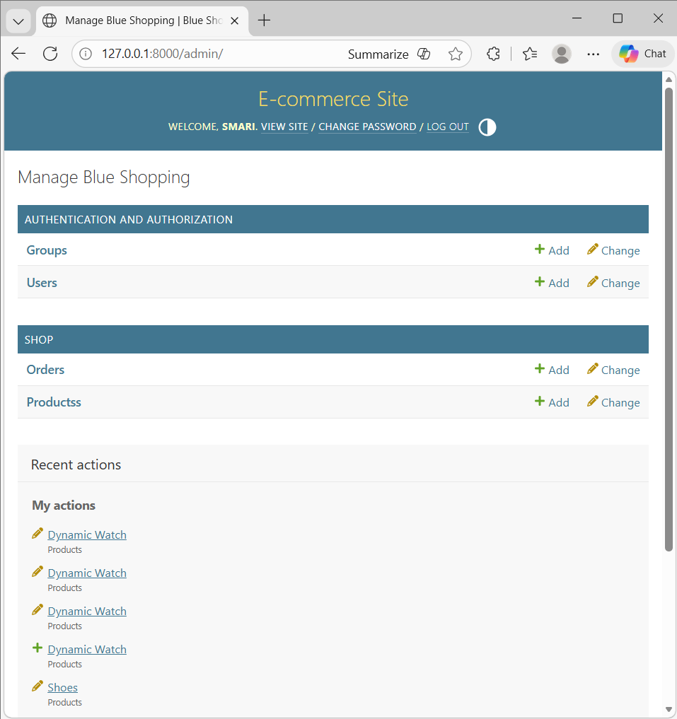

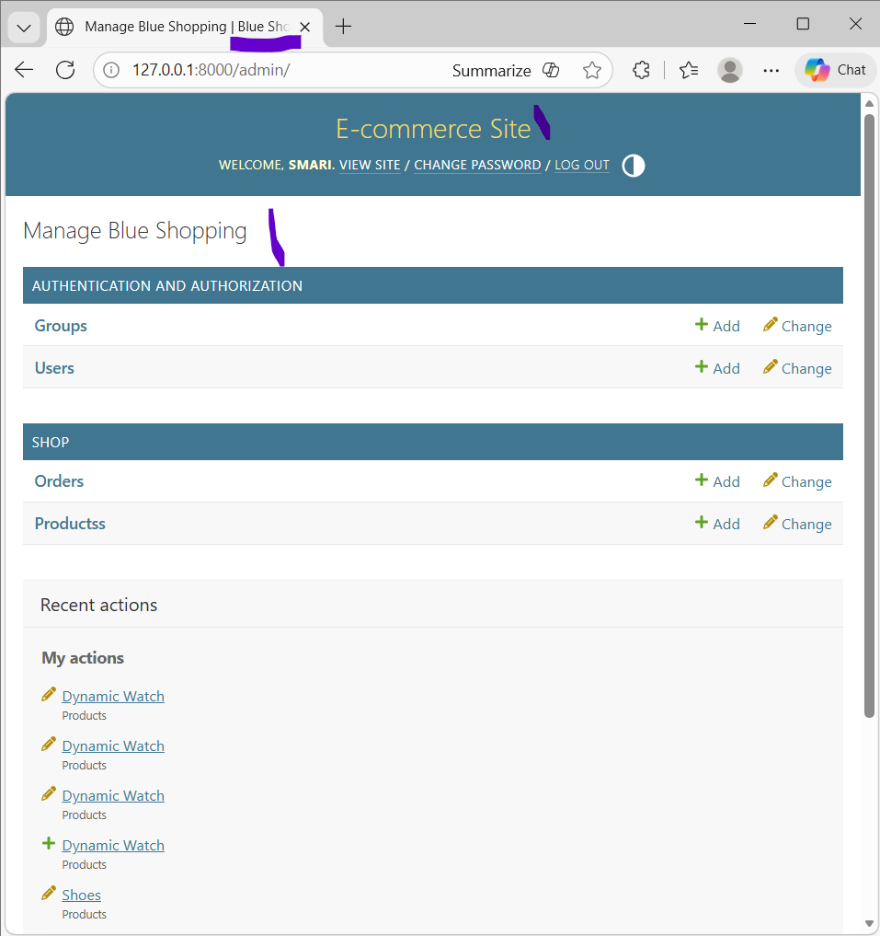

____________________________________________________________________________

Adding Custom Fields

Oc

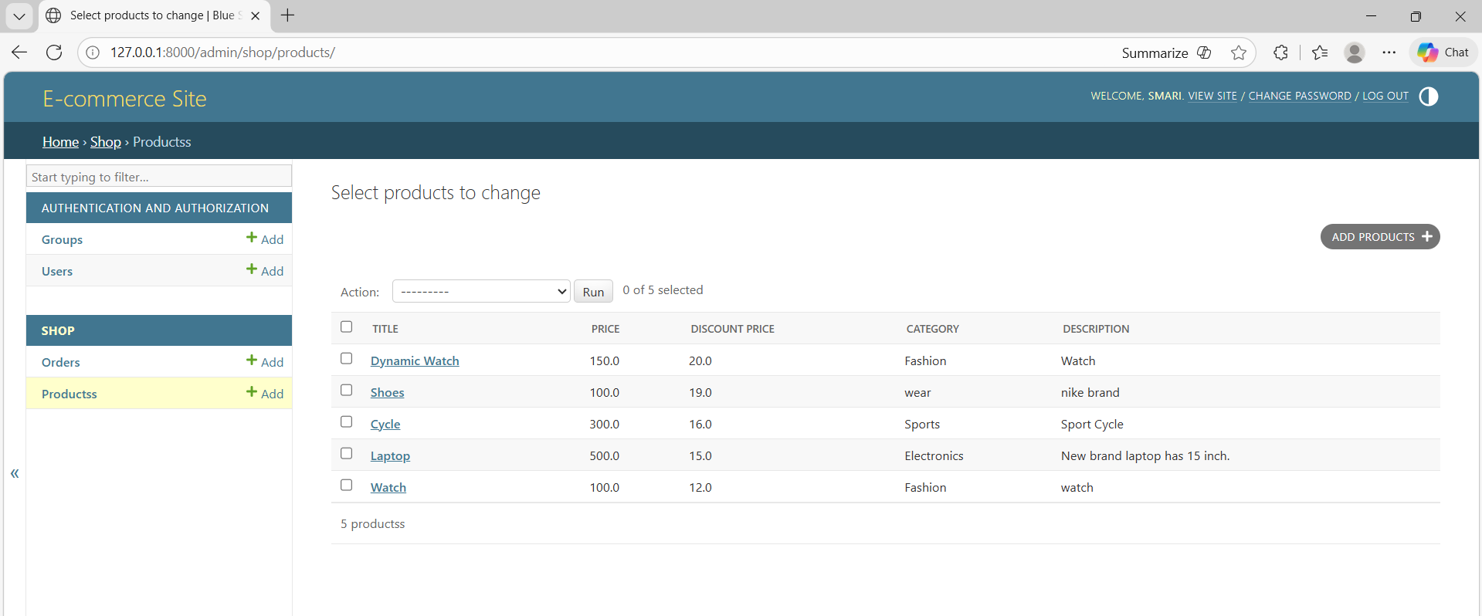

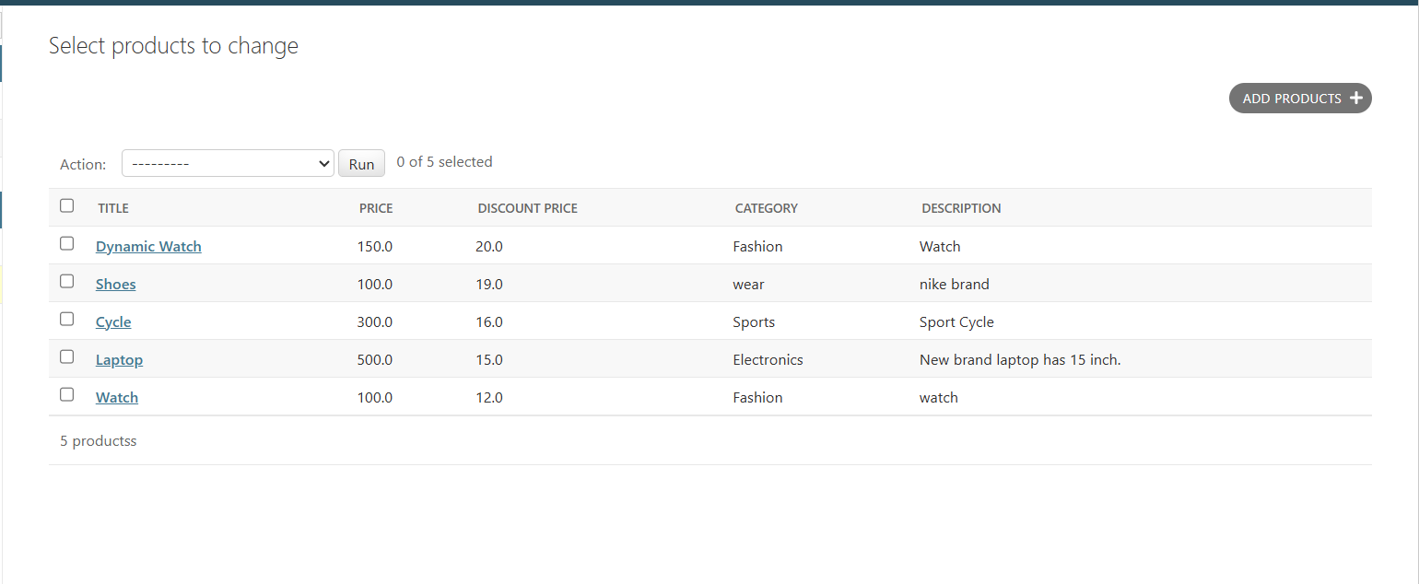

Code

admin.py

from django.contrib import admin
from .models import Products,Order

# Register your models here.
admin.site.site_header = "E-commerce Site"
admin.site.site_title = "Blue Shopping"
admin.site.index_title = "Manage Blue Shopping"

class ProductsAdmin(admin.ModelAdmin):
list_display = ('title', 'price', 'discount_price', 'category','description')

admin.site.register(Products,ProductsAdmin)
admin.site.register(Order)

models.py

class Products(models.Model):
title = models.CharField(max_length=200)
price = models.FloatField()
discount_price = models.FloatField()
category = models.CharField(max_length=200)
description = models.TextField()
image = models.URLField(max_length=2000)

def __str__(self):
return self.title

____________________________________________________________________________

Adding Custom Search Fields

Oc

Search based on title
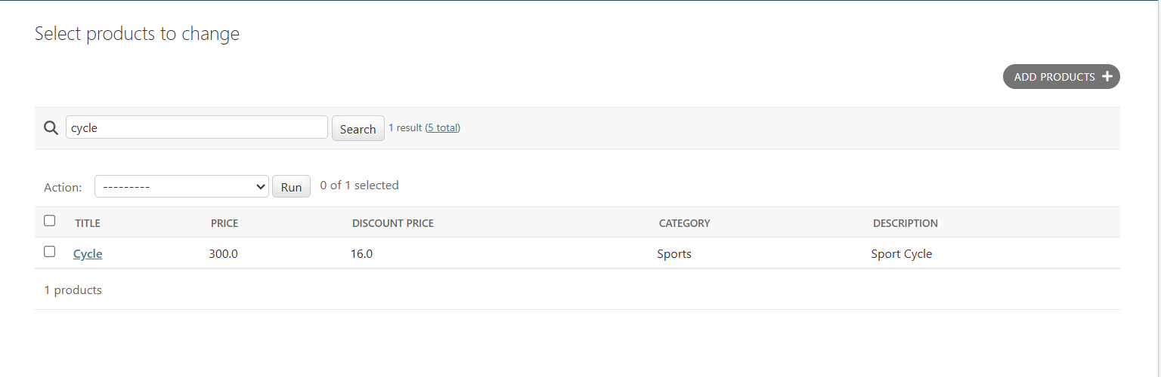

Search based on category

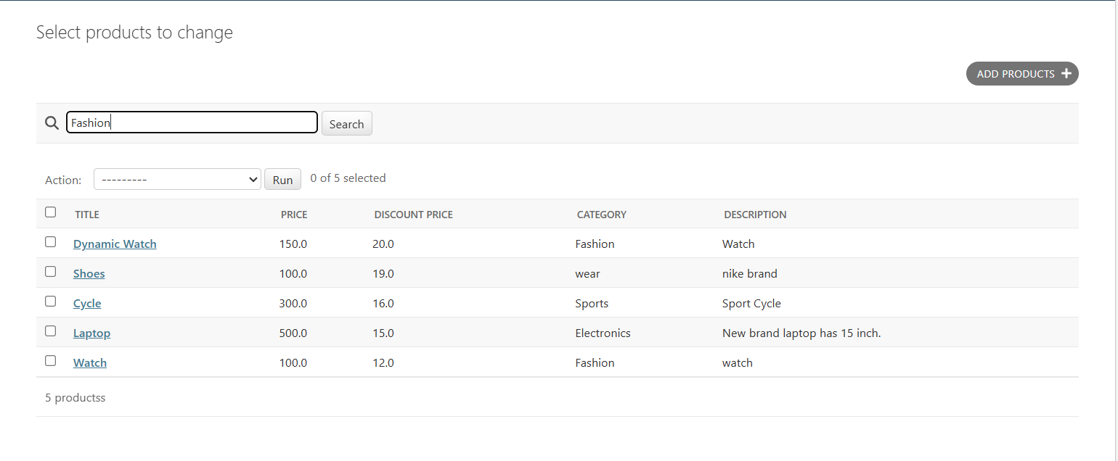
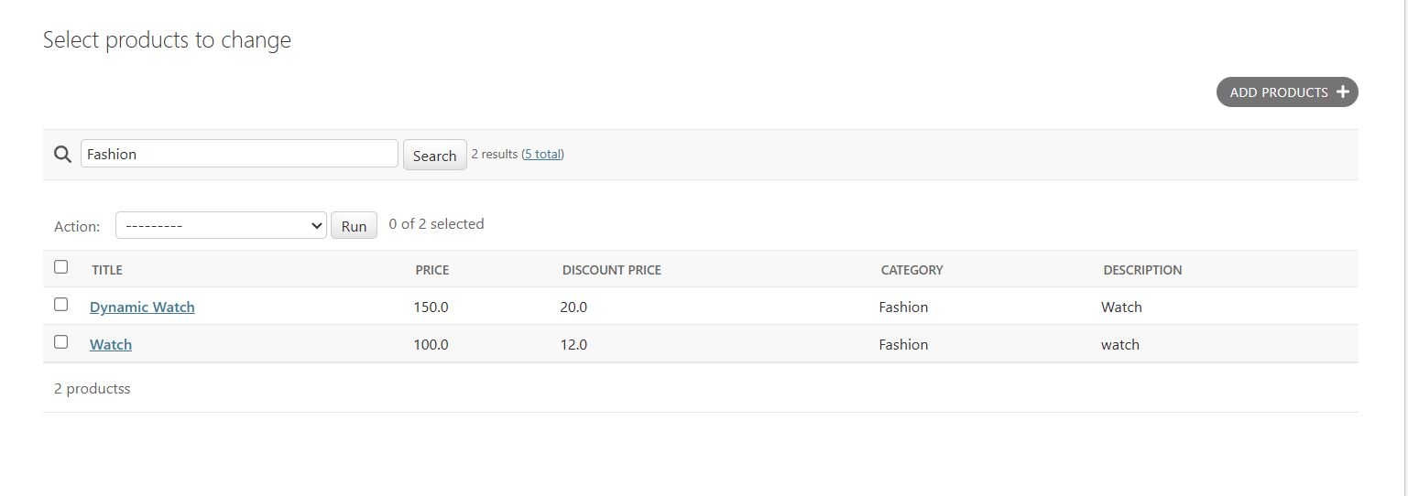

Code

admin.py

class ProductsAdmin(admin.ModelAdmin):
list_display = ('title', 'price', 'discount_price', 'category','description',)
#Search
search_fields = ('title','category')

____________________________________________________________________________

Modifying Action List

Oc

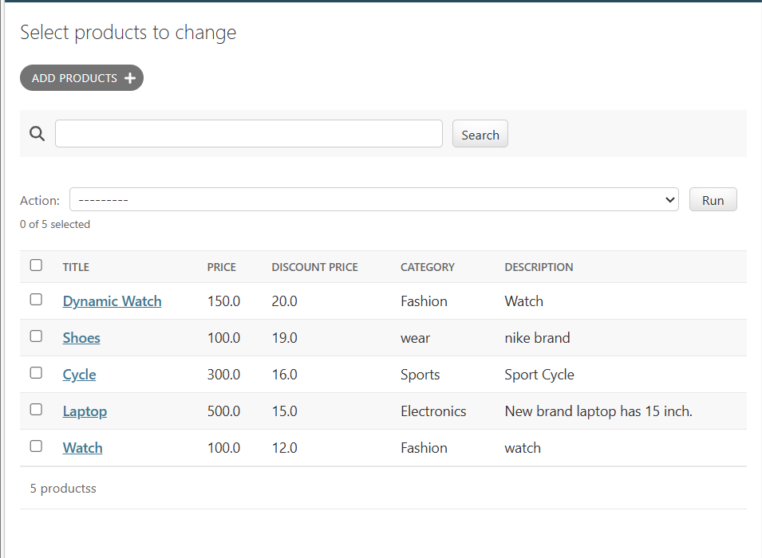

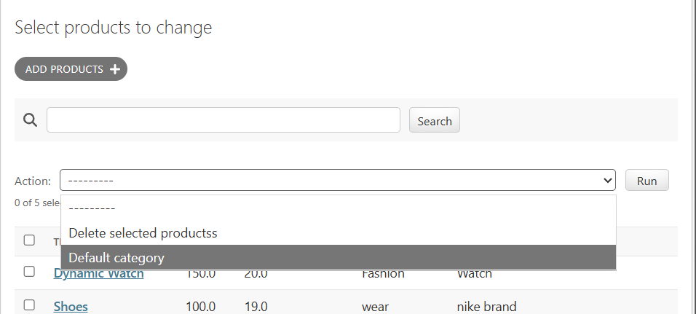

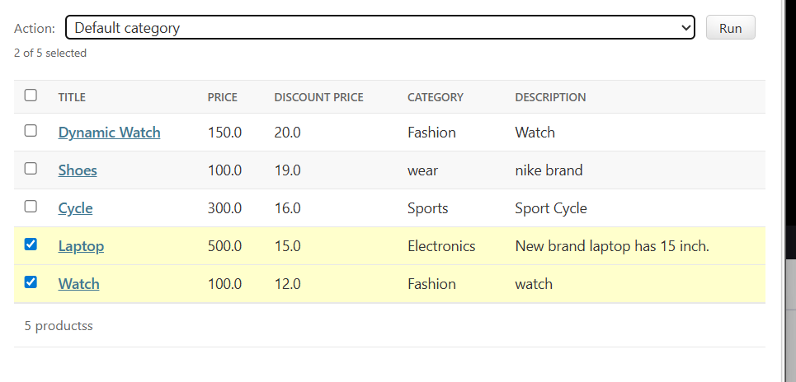
Click run

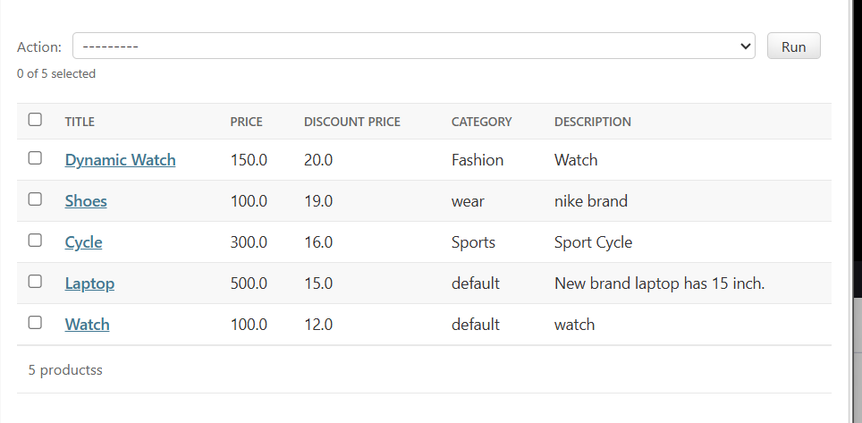
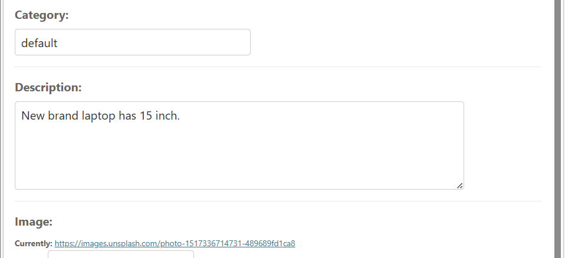

Code

admin.py

from django.contrib import admin
from .models import Products,Order

# Register your models here.
admin.site.site_header = "E-commerce Site"
admin.site.site_title = "Blue Shopping"
admin.site.index_title = "Manage Blue Shopping"

class ProductsAdmin(admin.ModelAdmin):

def change_category_to_default(self, request, queryset):
queryset.update(category='default')

change_category_to_default.short_description = 'Default category'
list_display = ('title', 'price', 'discount_price', 'category','description',)
search_fields = ('title','category')
actions = ('change_category_to_default',)

admin.site.register(Products,ProductsAdmin)
admin.site.register(Order)

____________________________________________________________________________

Making Fields Ediable

Oc

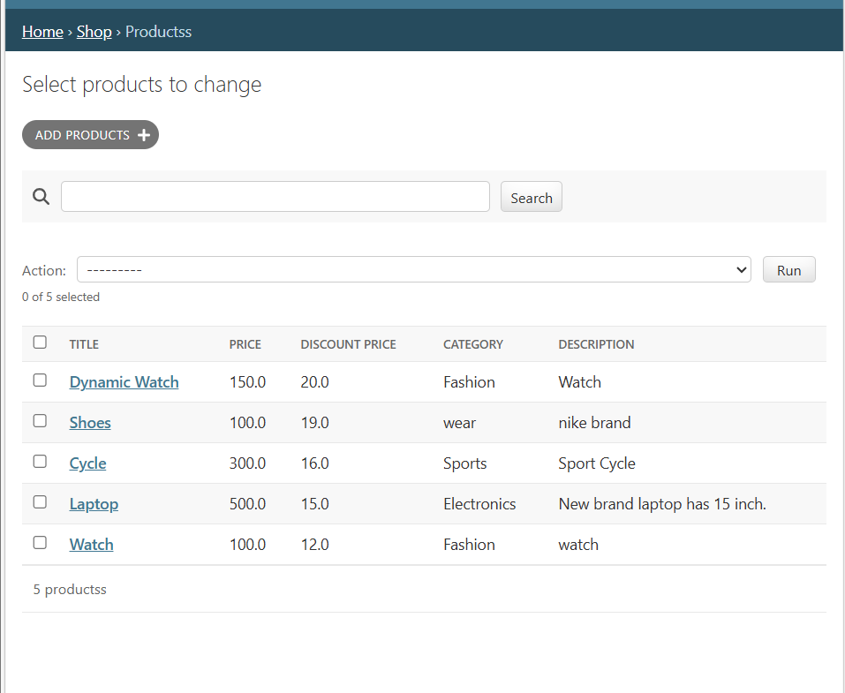

Click cycle

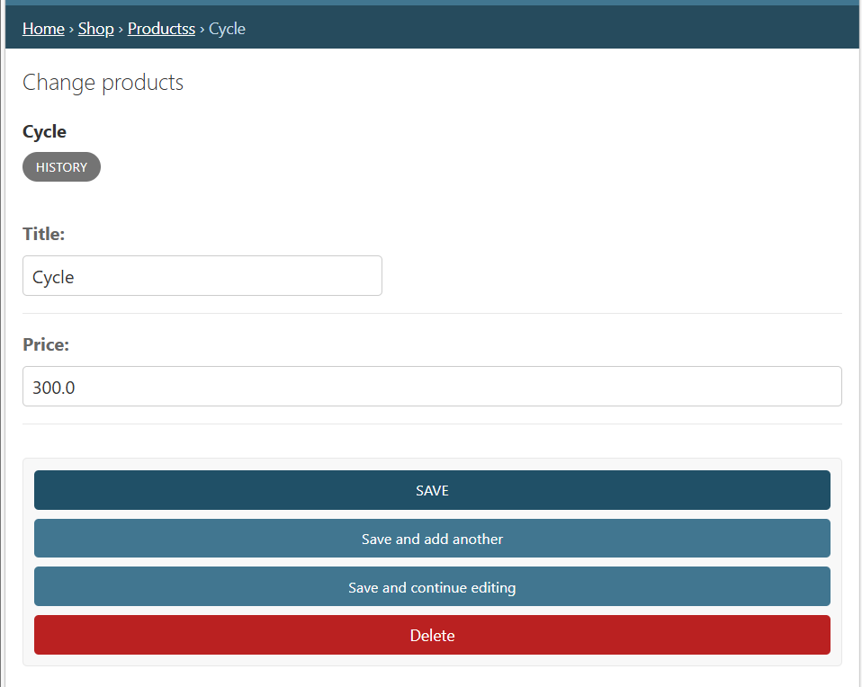

Editable

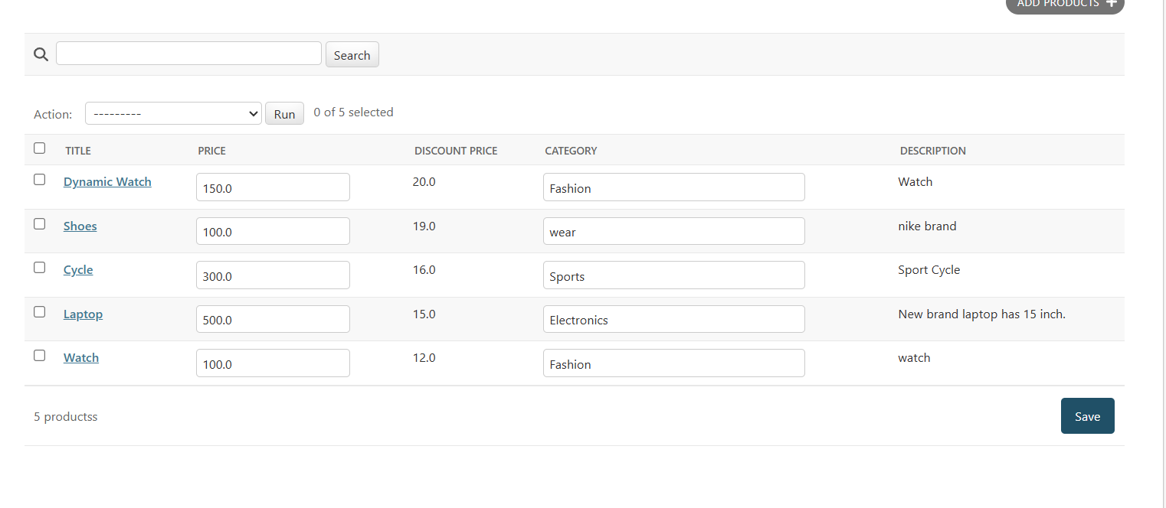
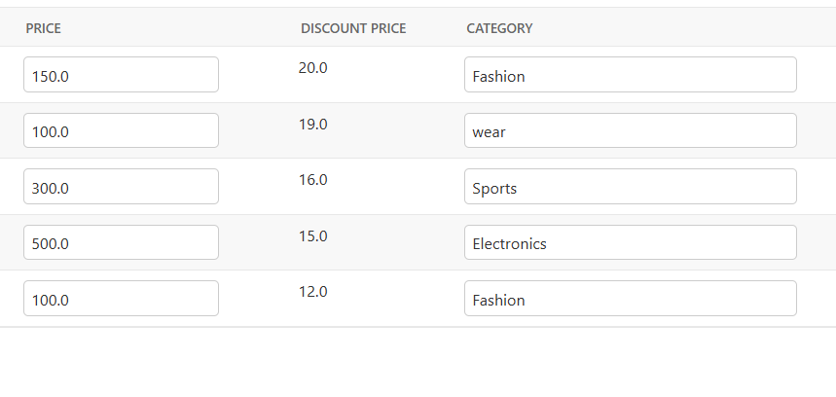

Code

admin.py

from django.contrib import admin
from .models import Products,Order

# Register your models here.
admin.site.site_header = "E-commerce Site"
admin.site.site_title = "Blue Shopping"
admin.site.index_title = "Manage Blue Shopping"

class ProductsAdmin(admin.ModelAdmin):

def change_category_to_default(self, request, queryset):
queryset.update(category='default')

change_category_to_default.short_description = 'Default category'
list_display = ('title', 'price', 'discount_price', 'category','description',)
search_fields = ('title','category')
actions = ('change_category_to_default',)
fields = ('title','price',)
list_editable = ('price','category',)
admin.site.register(Products,ProductsAdmin)
admin.site.register(Order)

____________________________________________________________________________

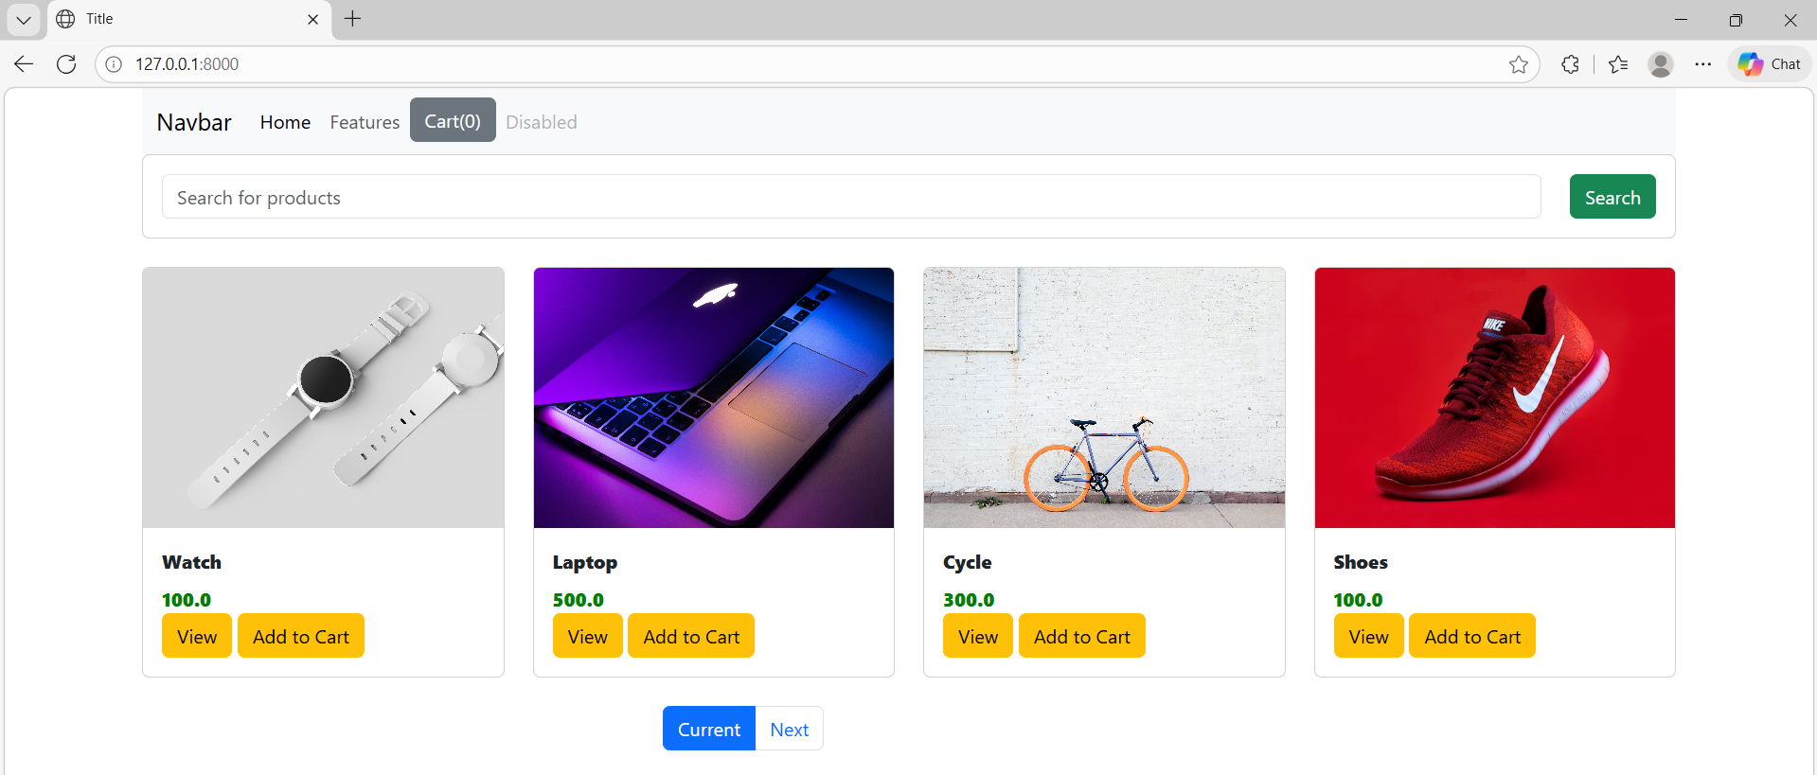

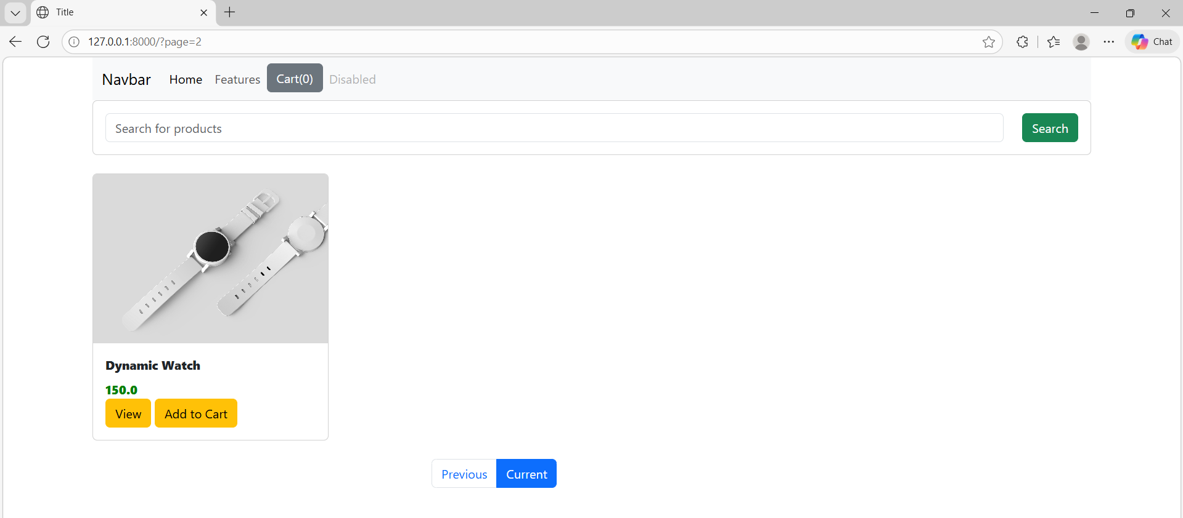

Click view button

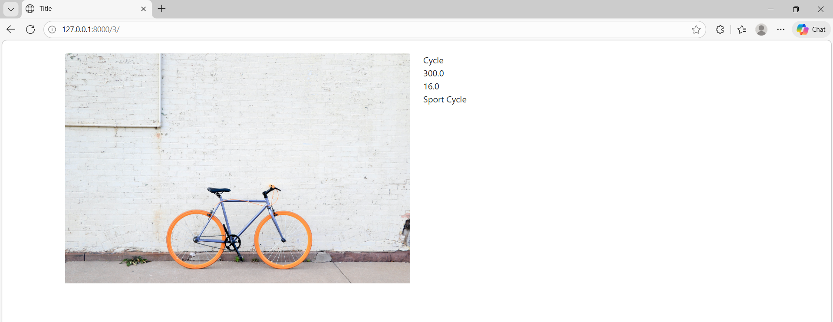

Search

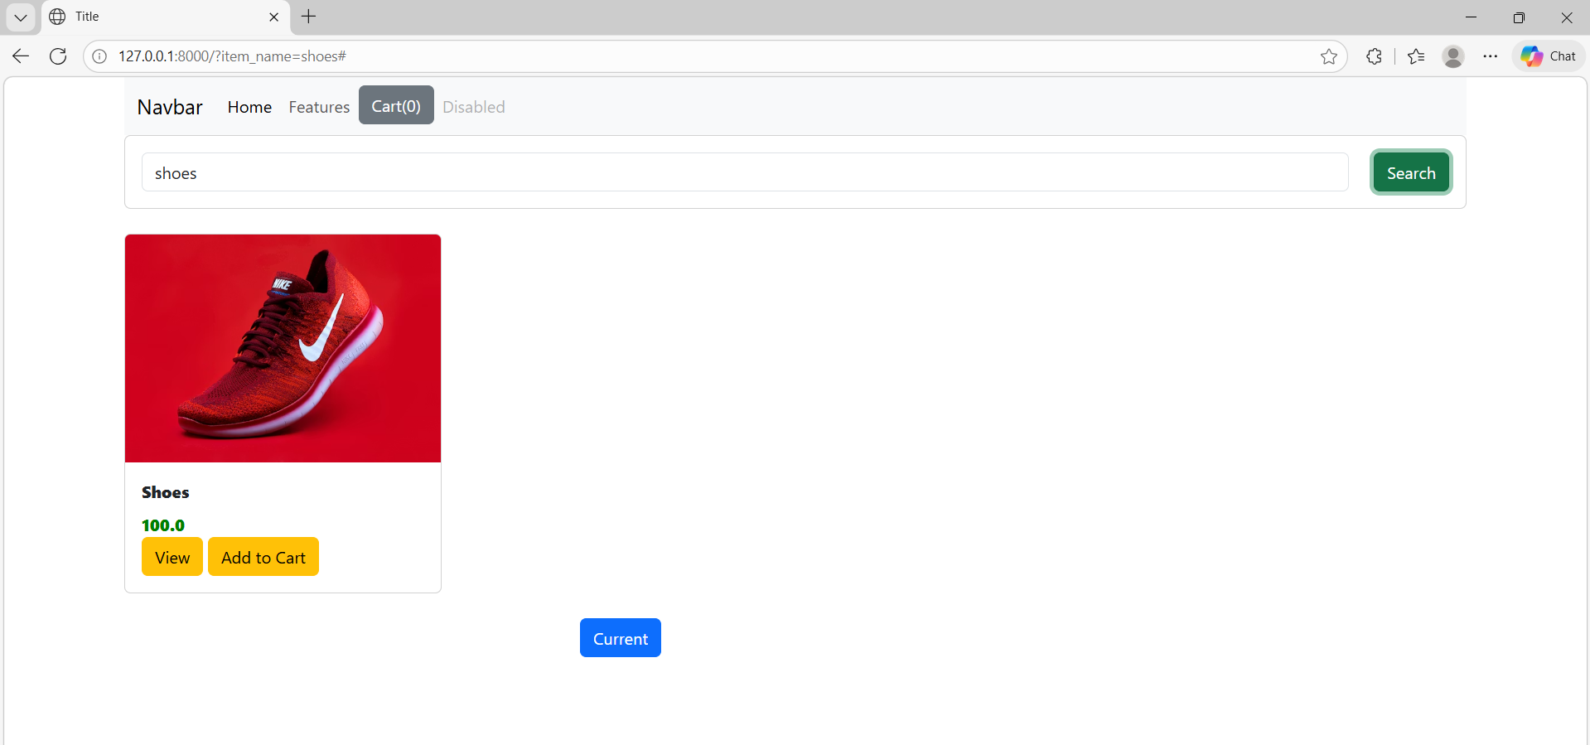

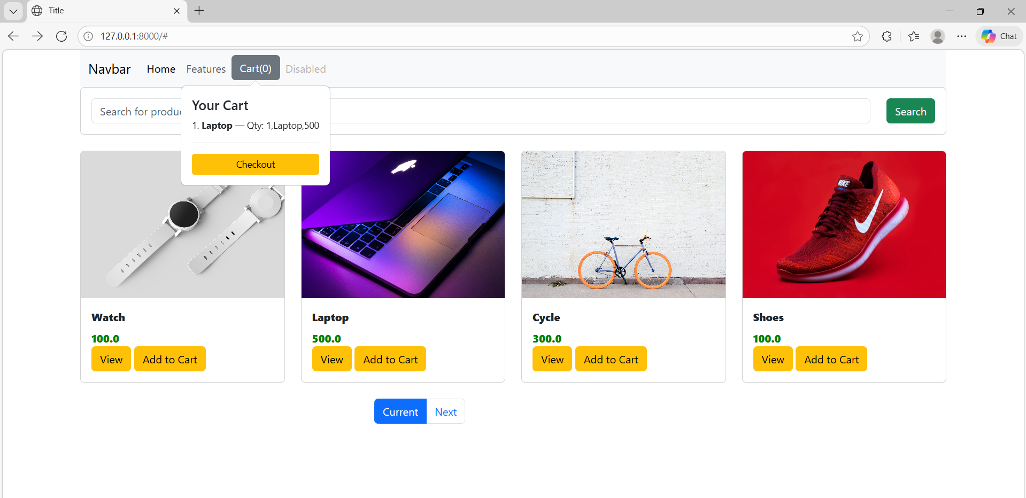

Click checkout button





