Install env and django, create an app.

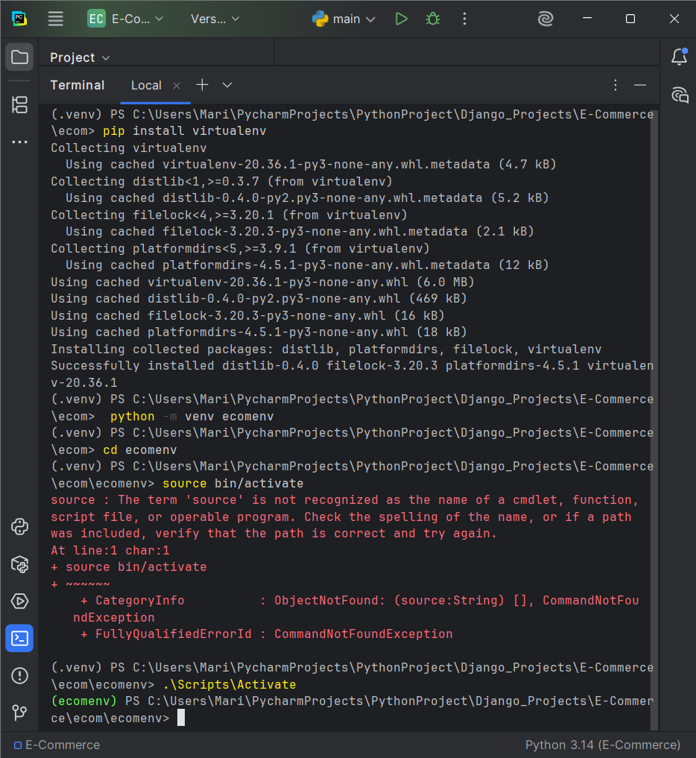

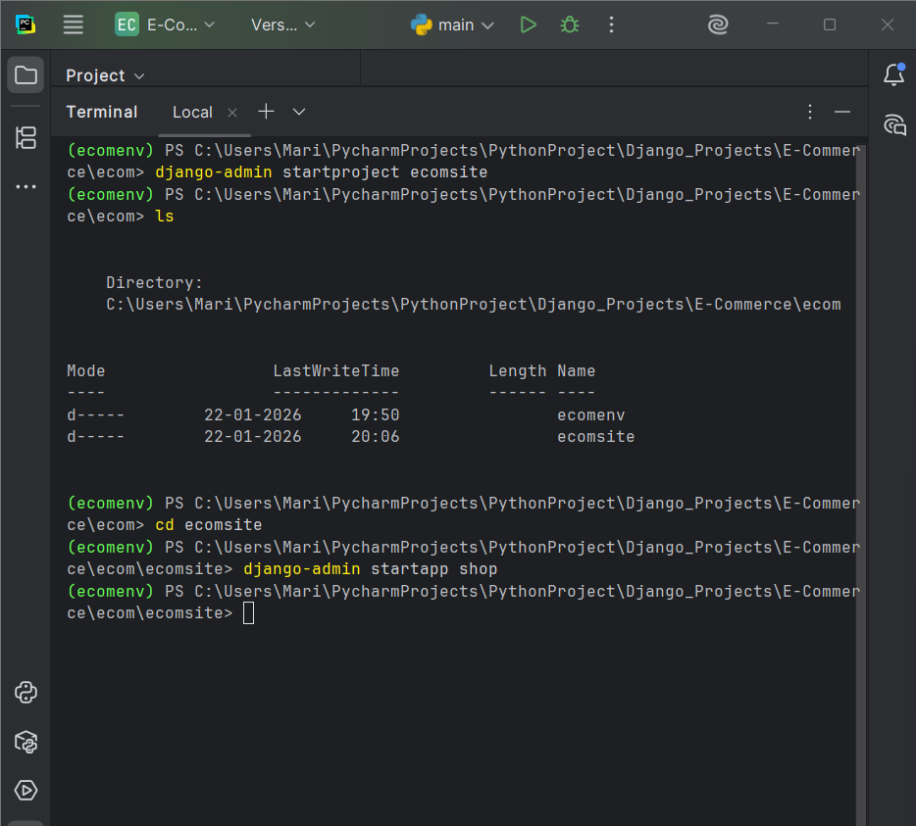

settings.py
INSTALLED_APPS = [
'shop',
'django.contrib.admin',
'django.contrib.auth',
'django.contrib.contenttypes',
'django.contrib.sessions',
'django.contrib.messages',
'django.contrib.staticfiles',
]

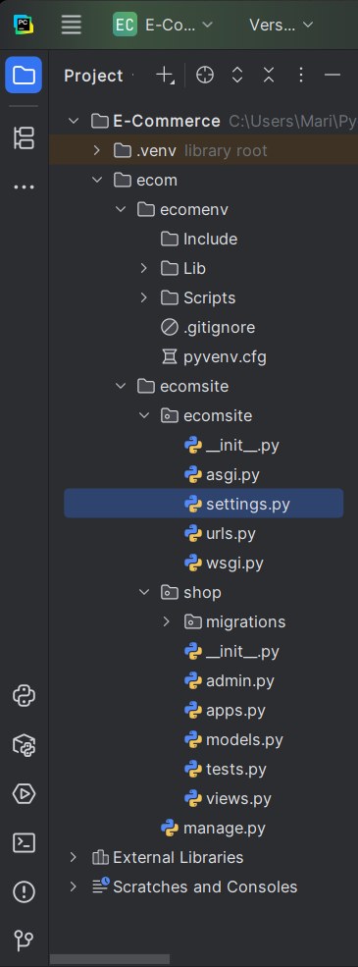
____________________________________________________________________________

Create Product Model

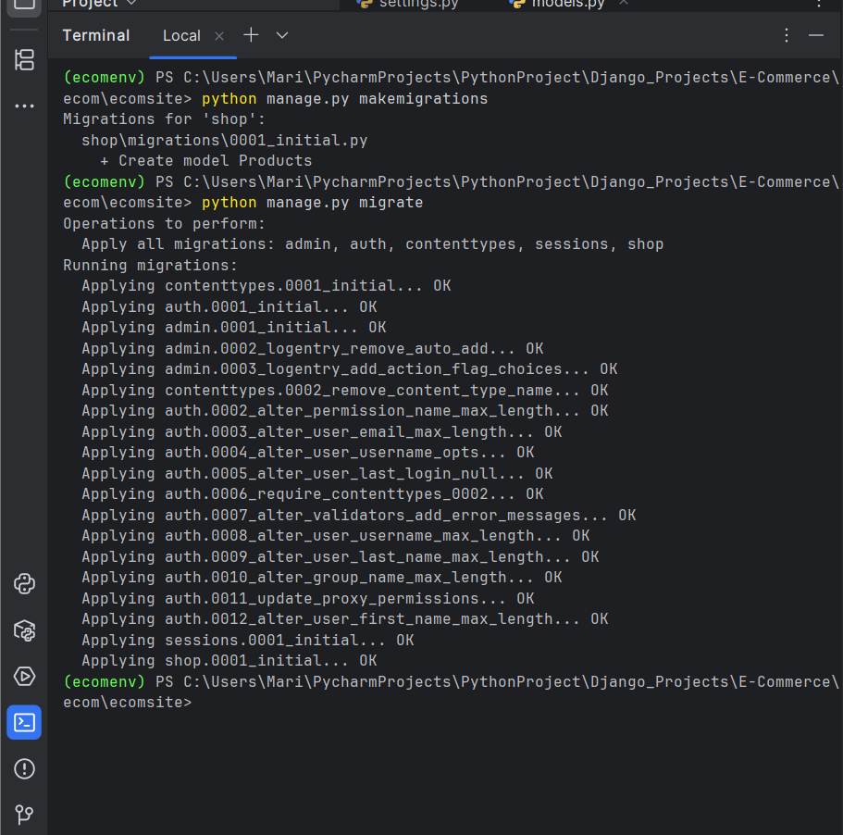

models.py
from django.db import models

# Create your models here.
class Products(models.Model):
title = models.CharField(max_length=200)
price = models.FloatField()
discount_price = models.FloatField()
category = models.CharField(max_length=200)
description = models.TextField()
image = models.CharField(max_length=300)

____________________________________________________________________________

Add products in admin page

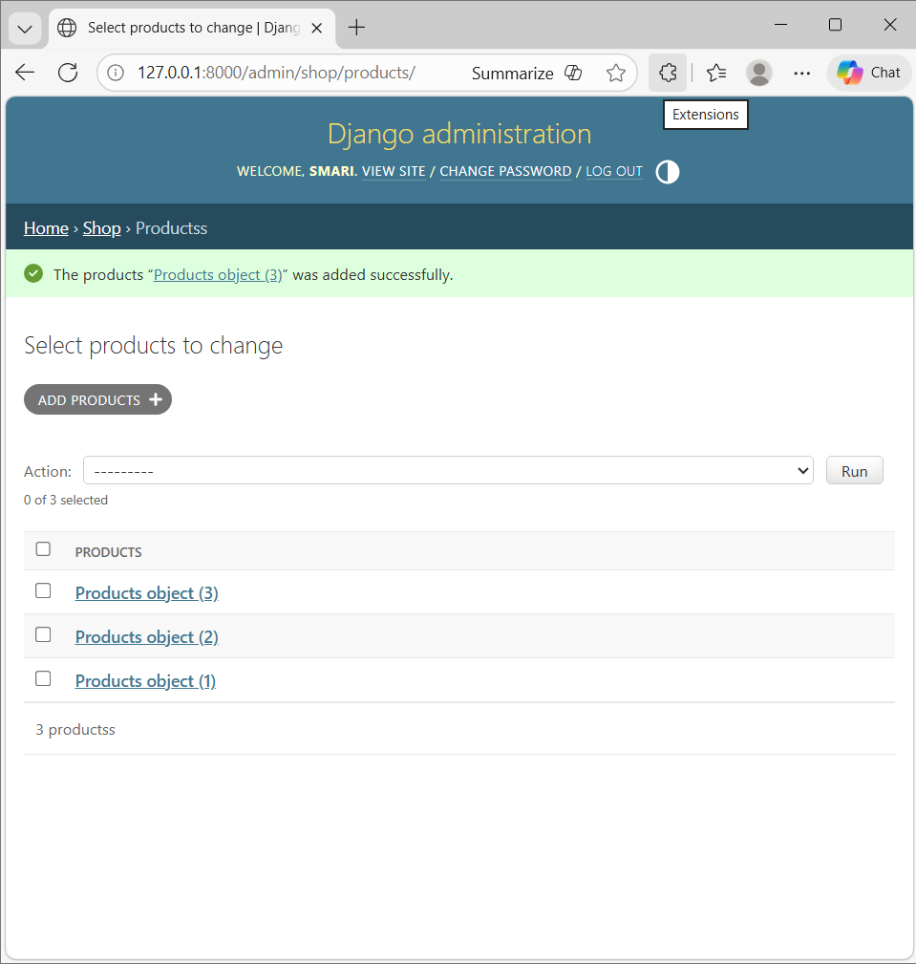

____________________________________________________________________________

Oc

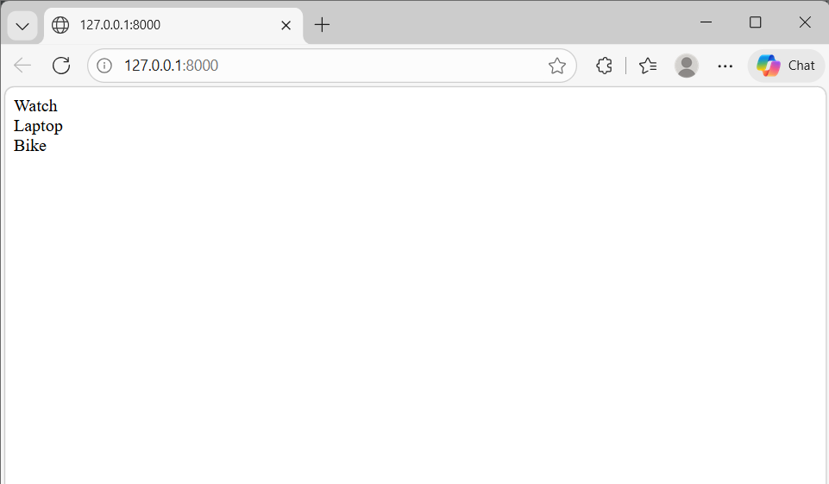

views.py
from django.shortcuts import render
from .models import Products

def index(request):
product_objects = Products.objects.all()
return render(request, 'shop/index.html', {
'product_objects': product_objects
})

models.py
from django.db import models

# Create your models here.
class Products(models.Model):
title = models.CharField(max_length=200)
price = models.FloatField()
discount_price = models.FloatField()
category = models.CharField(max_length=200)
description = models.TextField()
image = models.CharField(max_length=300)
Index.html
{% for product in product_objects %}
{{ product.title }}
<br>
{% endfor %}

admin.py
from django.contrib import admin
from .models import Products

# Register your models here.
admin.site.register(Products)

____________________________________________________________________________

Code for image and search items

Index.html
{% load static %}
<!DOCTYPE html>
<html lang="en">
<head>
<meta charset="UTF-8">
<link href="https://cdn.jsdelivr.net/npm/bootstrap@5.0.2/dist/css/bootstrap.min.css" rel="stylesheet" integrity="sha384-EVSTQN3/azprG1Anm3QDgpJLIm9Nao0Yz1ztcQTwFspd3yD65VohhpuuCOmLASjC" crossorigin="anonymous">
<script src="https://cdn.jsdelivr.net/npm/bootstrap@5.0.2/dist/js/bootstrap.bundle.min.js" integrity="sha384-MrcW6ZMFYlzcLA8Nl+NtUVF0sA7MsXsP1UyJoMp4YLEuNSfAP+JcXn/tWtIaxVXM" crossorigin="anonymous"></script>
<link rel="stylesheet" href="{% static 'shop/style.css' %}">
<title>Title</title>
</head>
<body>

<div class="container">

<div class="row">
<div class="col-md-12">
<form class="card card-sm">
<div class="card-body row no-gutters align-items-center">
<div class="col">
<input type="search" name="item_name" placeholder="Search for products" class="form-control form-control-borderless">
</div>
<div class="col-auto">
<button class="btn btn-success" type="submit">Search</button>
</div>
</div>
</form>
</div>
</div>
<br>

<div class="row">
{% for product in product_objects %}
<div class="col-md-3">
<div class="card">
<img src="{{ product.image }}" class="card-img-top">
<div class="card-body">
<div class="card-title">
{{ product.title }}
</div>
<div class="card-text">
$ {{ product.price }}
</div>
</div>
</div>
</div>
{% endfor %}
</div>
</div>
</body>
</html>

views.py
from django.shortcuts import render
from .models import Products

def index(request):
product_objects = Products.objects.all()

item_name = request.GET.get('item_name')
if item_name != '' and item_name is not None:
product_objects = Products.objects.filter(title__icontains=item_name)
return render(request, 'shop/index.html', {'product_objects': product_objects})

urls.py

from django.contrib import admin
from django.urls import path
from shop import views
from django.conf import settings
from django.conf.urls.static import static

urlpatterns = [
path('admin/', admin.site.urls),
path('', views.index, name='index'),
]

if settings.DEBUG:
urlpatterns += static(settings.MEDIA_URL, document_root=settings.MEDIA_ROOT)

settings.py
import os

STATIC_URL = 'static/'
STATICFILES_DIRS = [os.path.join(BASE_DIR, 'static')]

MEDIA_URL = '/media/'
MEDIA_ROOT = os.path.join(BASE_DIR, 'media')

models.py

from django.db import models

# Create your models here.
class Products(models.Model):
title = models.CharField(max_length=200)
price = models.FloatField()
discount_price = models.FloatField()
category = models.CharField(max_length=200)
description = models.TextField()
image = models.URLField(max_length=2000)

def __str__(self):
return self.title

Style.css
.card-text{
color: green;
font-weight: 800;
}

.card-title{
font-weight: 900;
}

.card-img-top {
width: 100%;
height: 220px;
object-fit: cover;
}

Outcome

Image

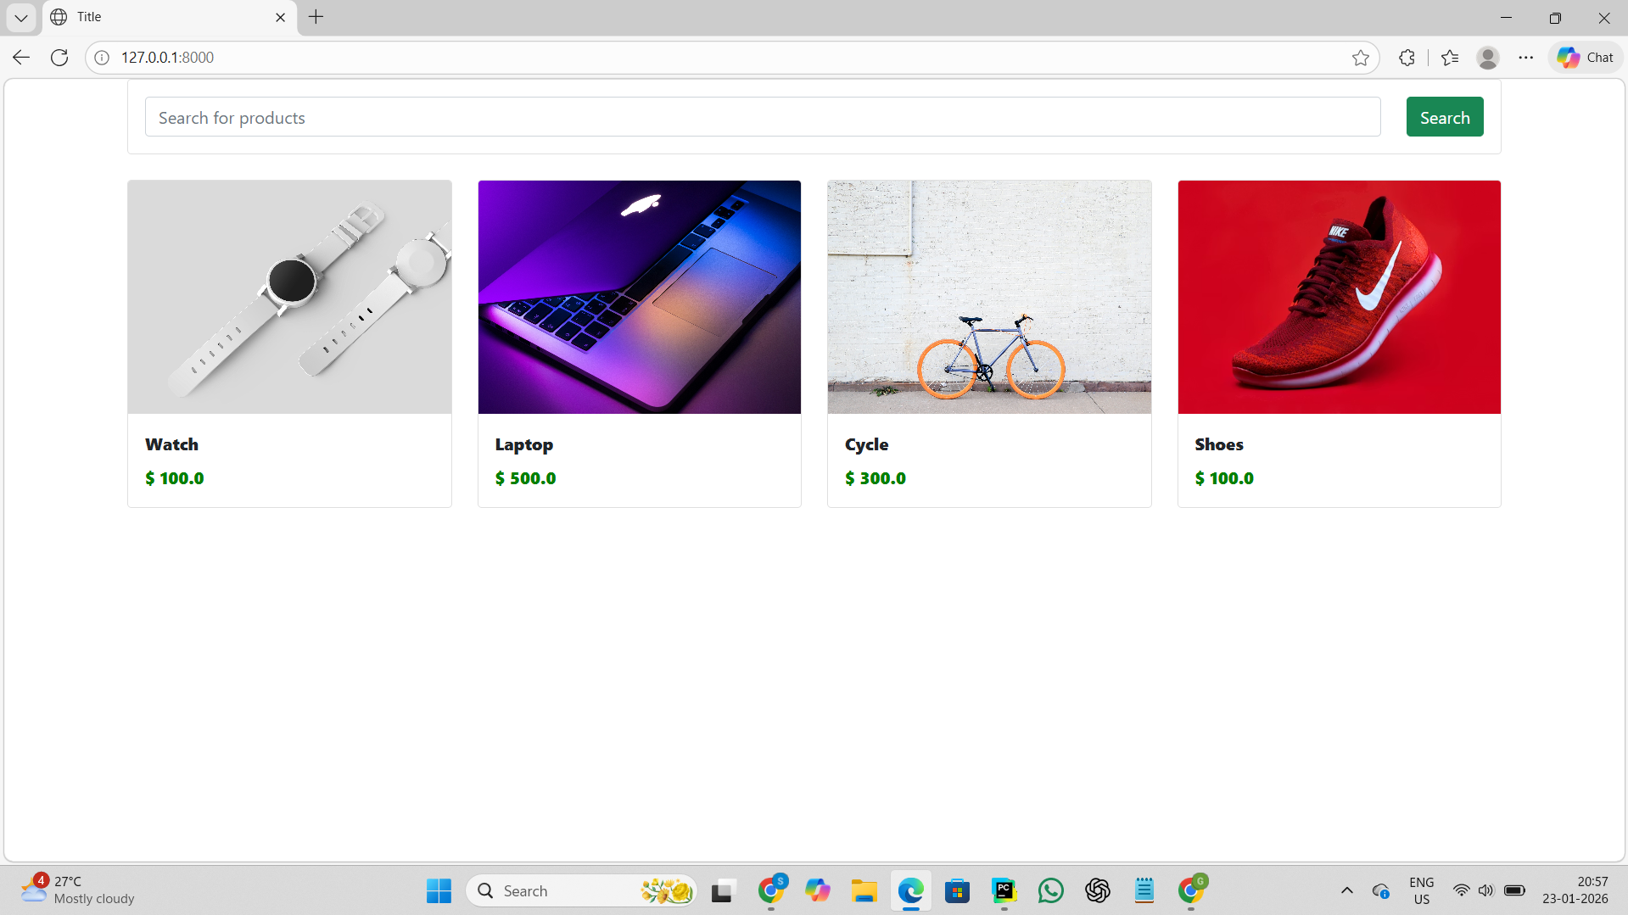

Search

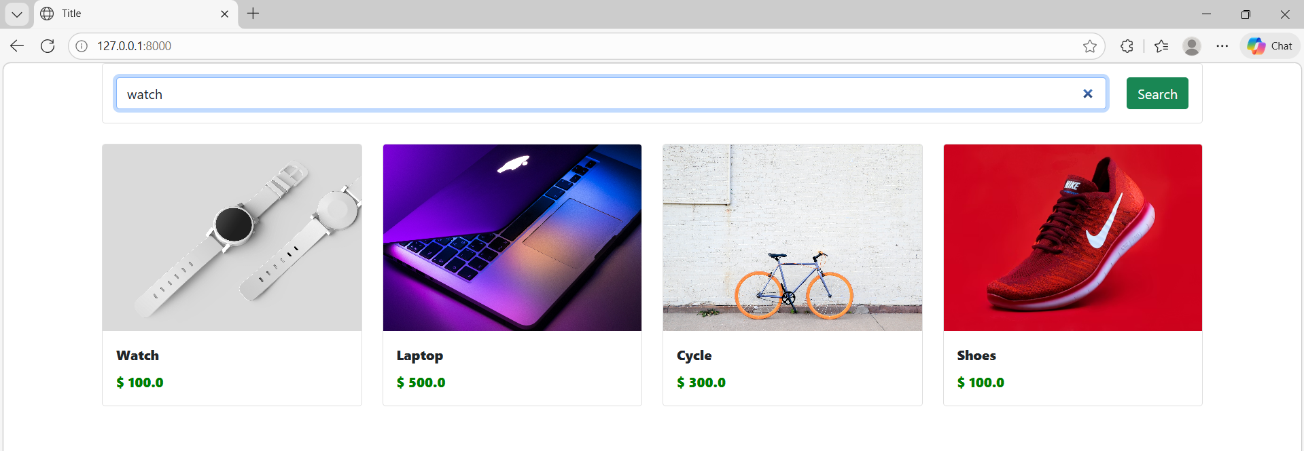

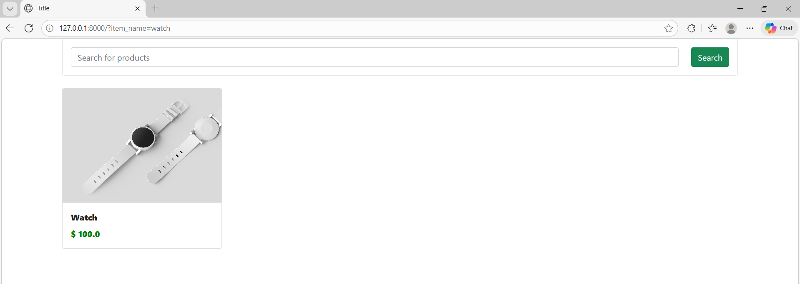

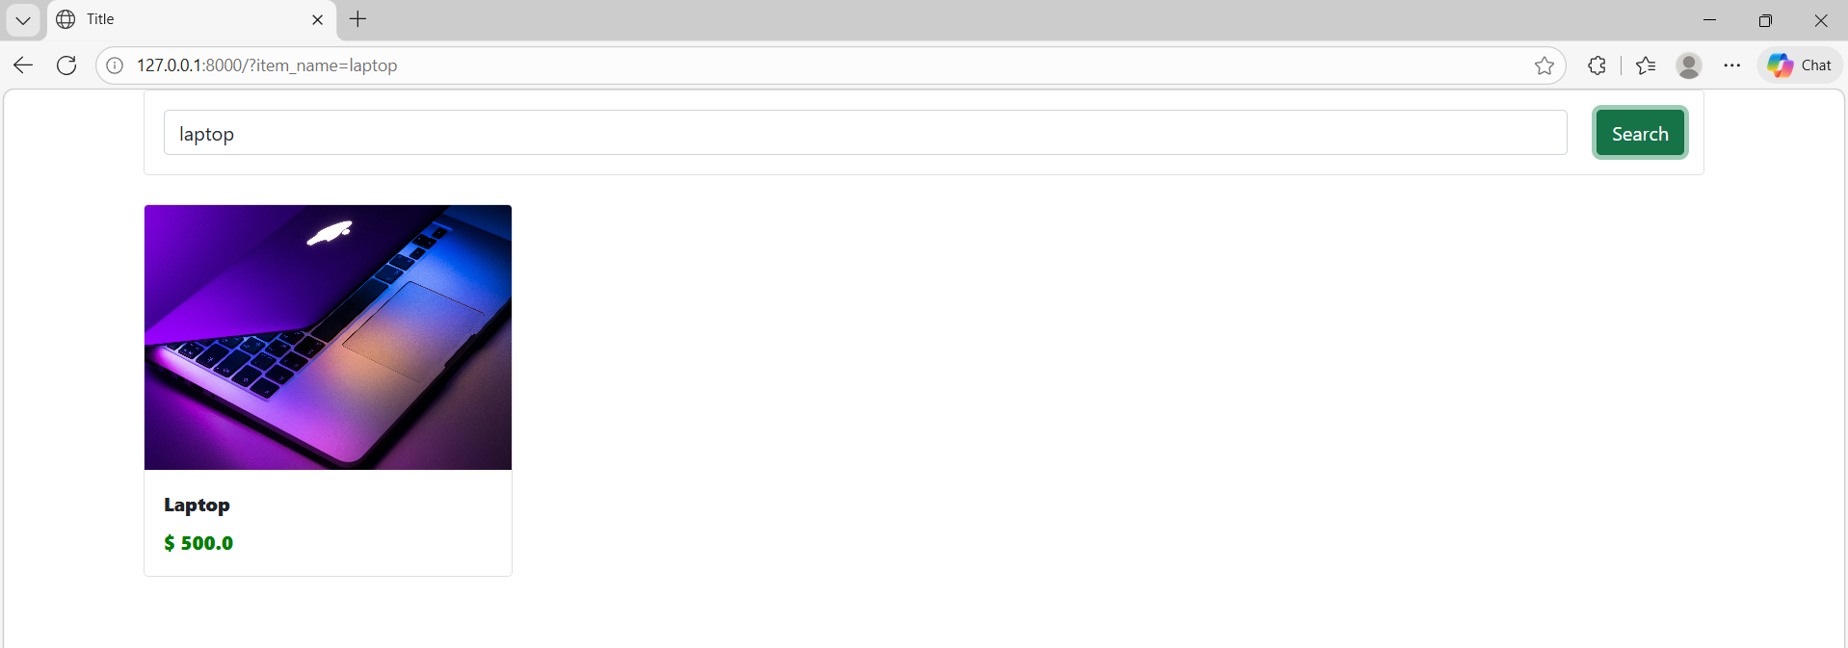

___________________________________________________________________________

Pagination

Oc

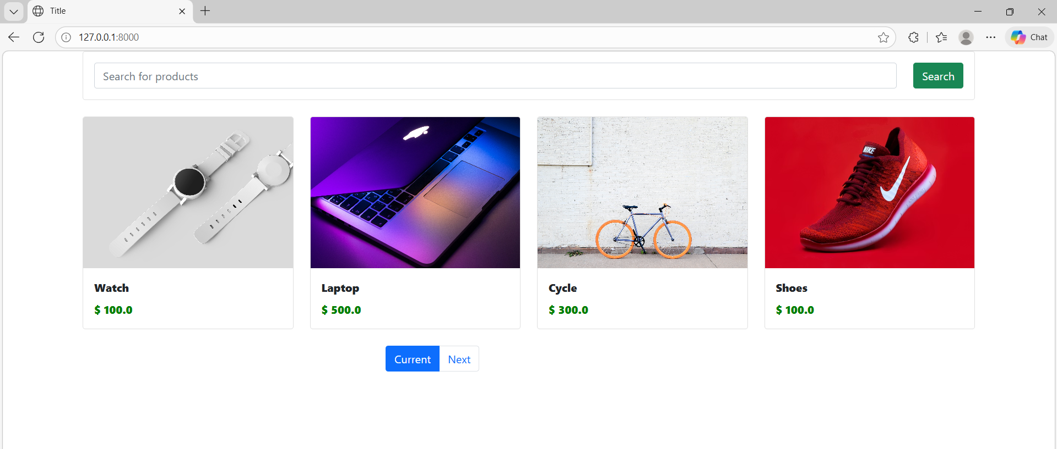

Click next button

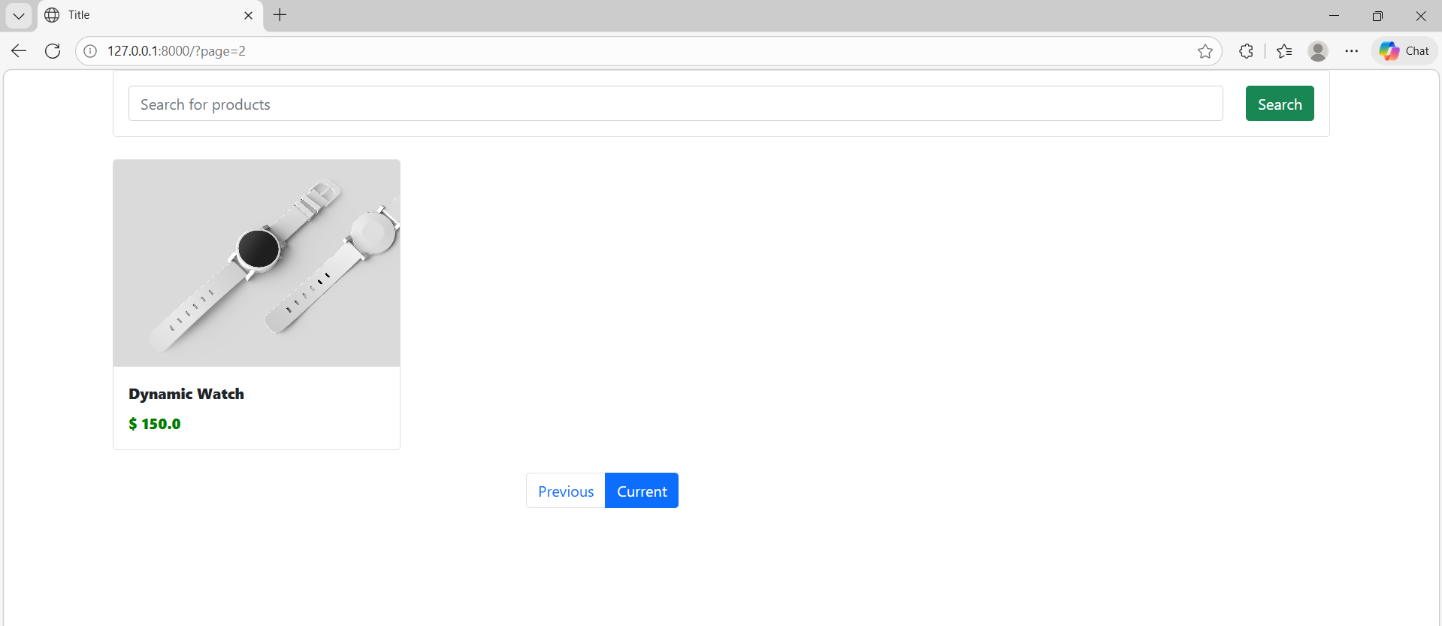
Click previous button

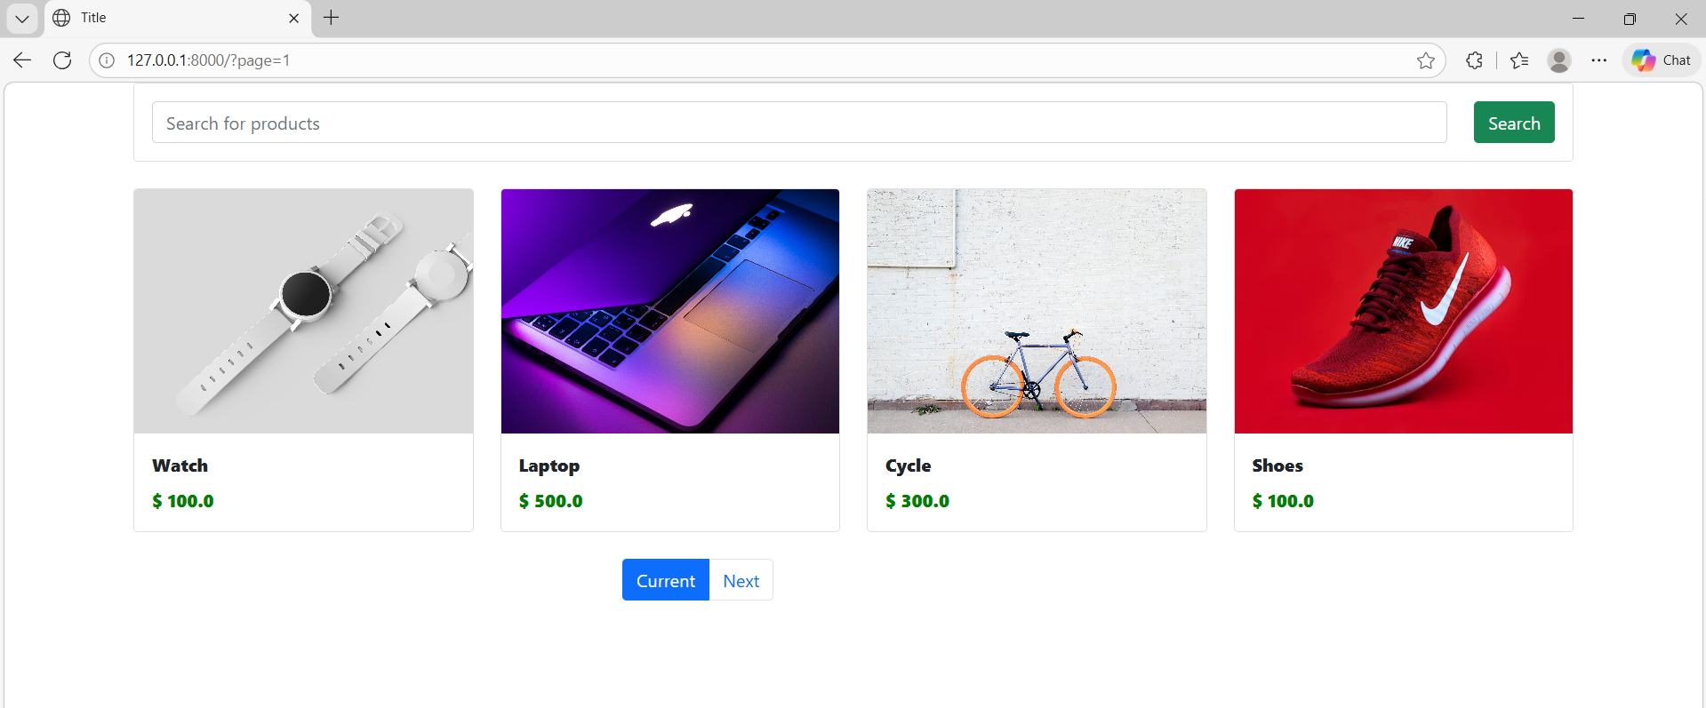
Code

Index

<div class="row">
<div class="col-md-3 offset-md-4">
<ul class="pagination">
{% if product_objects.has_previous %}
<li class="page-item">
<a class="page-link" href="?page={{ product_objects.previous_page_number }}">Previous</a>
</li>
{% endif %}

<li class="page-item active">
<a class="page-link" href="?page={{ product_objects.number }}">Current</a>
</li>

{% if product_objects.has_next %}
<li class="page-item">
<a class="page-link" href="?page={{ product_objects.next_page_number }}">Next</a>
</li>
{% endif %}

</ul>
</div>
</div>

____________________________________________________________________________

Detail View For Products

Detail.html
<!--{% load static %}-->
<!DOCTYPE html>
<html lang="en">
<head>
<meta charset="UTF-8">
<link href="https://cdn.jsdelivr.net/npm/bootstrap@5.0.2/dist/css/bootstrap.min.css" rel="stylesheet" integrity="sha384-EVSTQN3/azprG1Anm3QDgpJLIm9Nao0Yz1ztcQTwFspd3yD65VohhpuuCOmLASjC" crossorigin="anonymous">
<script src="https://cdn.jsdelivr.net/npm/bootstrap@5.0.2/dist/js/bootstrap.bundle.min.js" integrity="sha384-MrcW6ZMFYlzcLA8Nl+NtUVF0sA7MsXsP1UyJoMp4YLEuNSfAP+JcXn/tWtIaxVXM" crossorigin="anonymous"></script>
<!-- <link rel="stylesheet" href="{% static 'shop/style.css' %}">-->
<title>Title</title>
</head>
<body>
<div class="container">
<div class="row">
<div class="col-md-6">
<div class="row">
<div class="col-md-12">
<img src="{{ product_object.image }}">
</div>
</div>
</div>

<div class="col-md-6">
<div class="row">
<div class="col-md-12">
{{ product_object.title }}
</div>
</div>

<div class="row">
<div class="col-md-12">
{{ product_object.price }}
</div>
</div>

<div class="row">
<div class="col-md-12">
{{ product_object.discount_price }}
</div>
</div>

<div class="row">
<div class="col-md-12">
{{ product_object.description }}
</div>
</div>

</div>

</div>
</div>
</body>
</html>

views.py

def detail(request, id):
product_object = Products.objects.get(id=id)
return render(request, 'shop/detail.html', {'product_object': product_object})

____________________________________________________________________________

Enter an item number get that item details

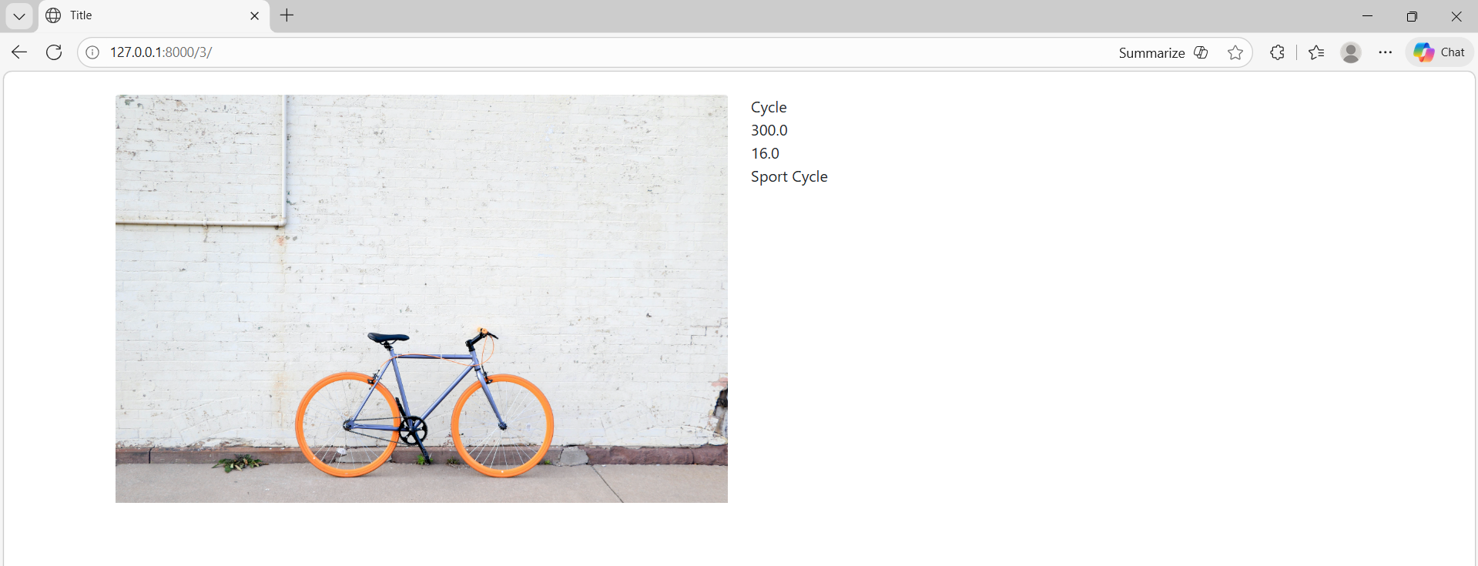

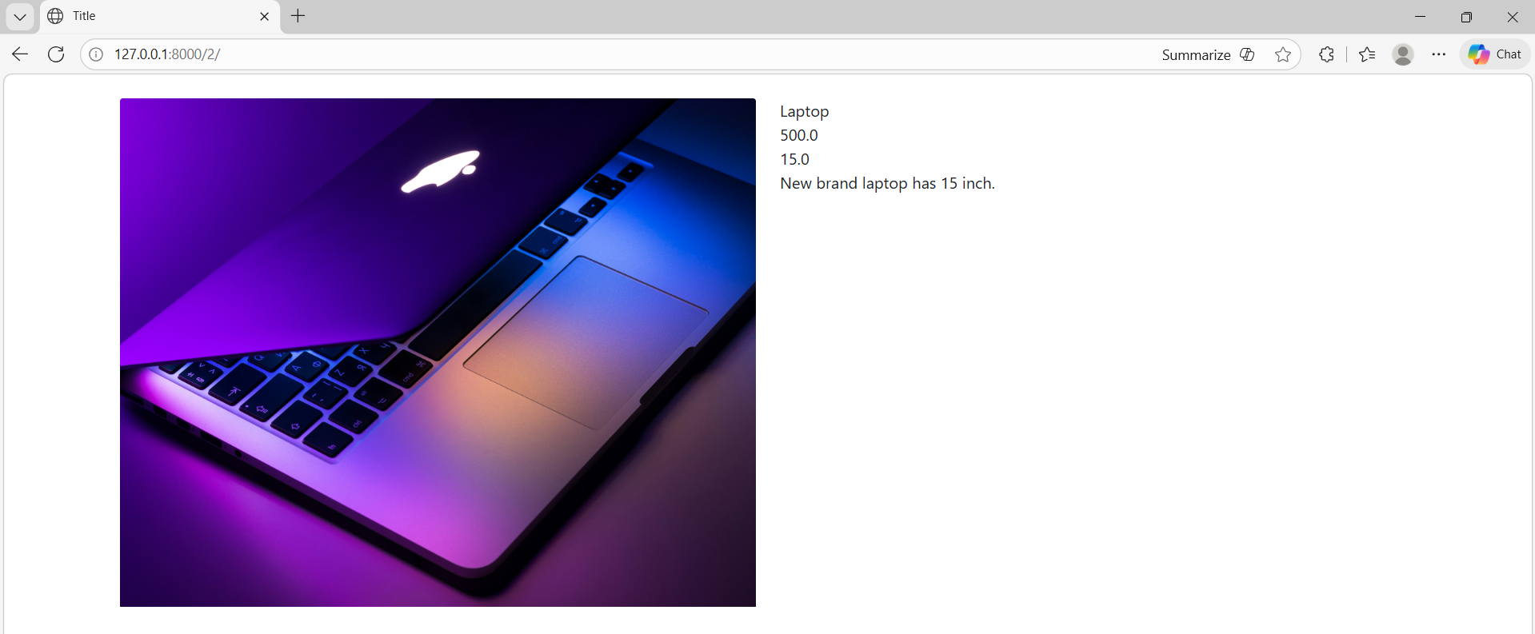

View and add to cart button

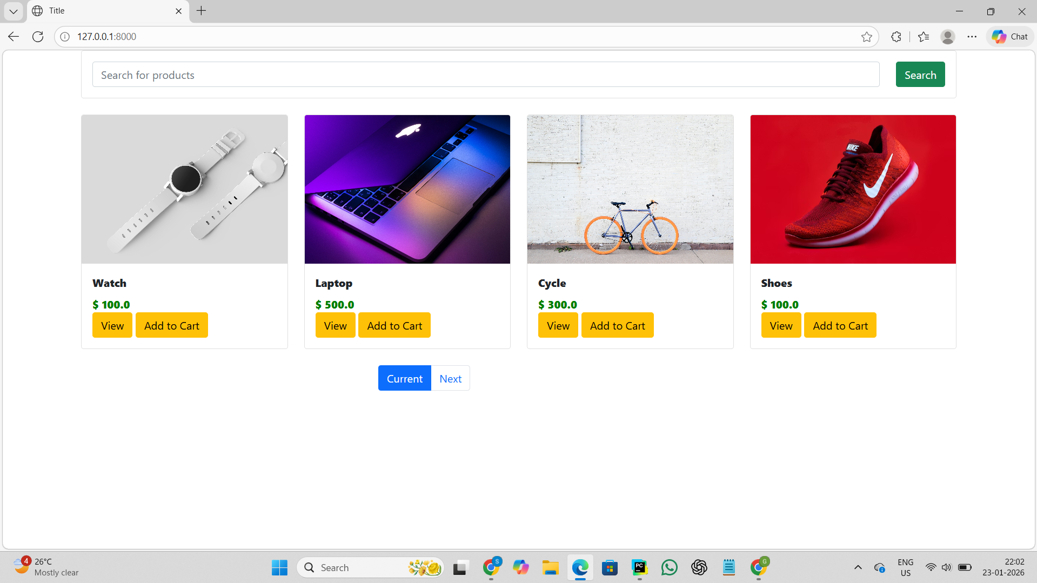

index.html

<button class="btn btn-warning">View</button>
<button class="btn btn-warning">Add to Cart</button>

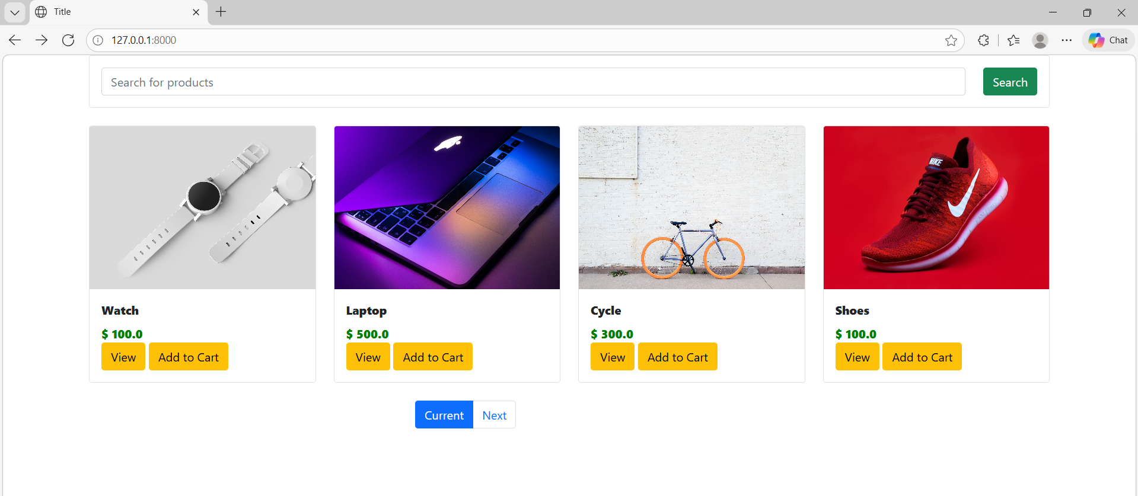

Click view button

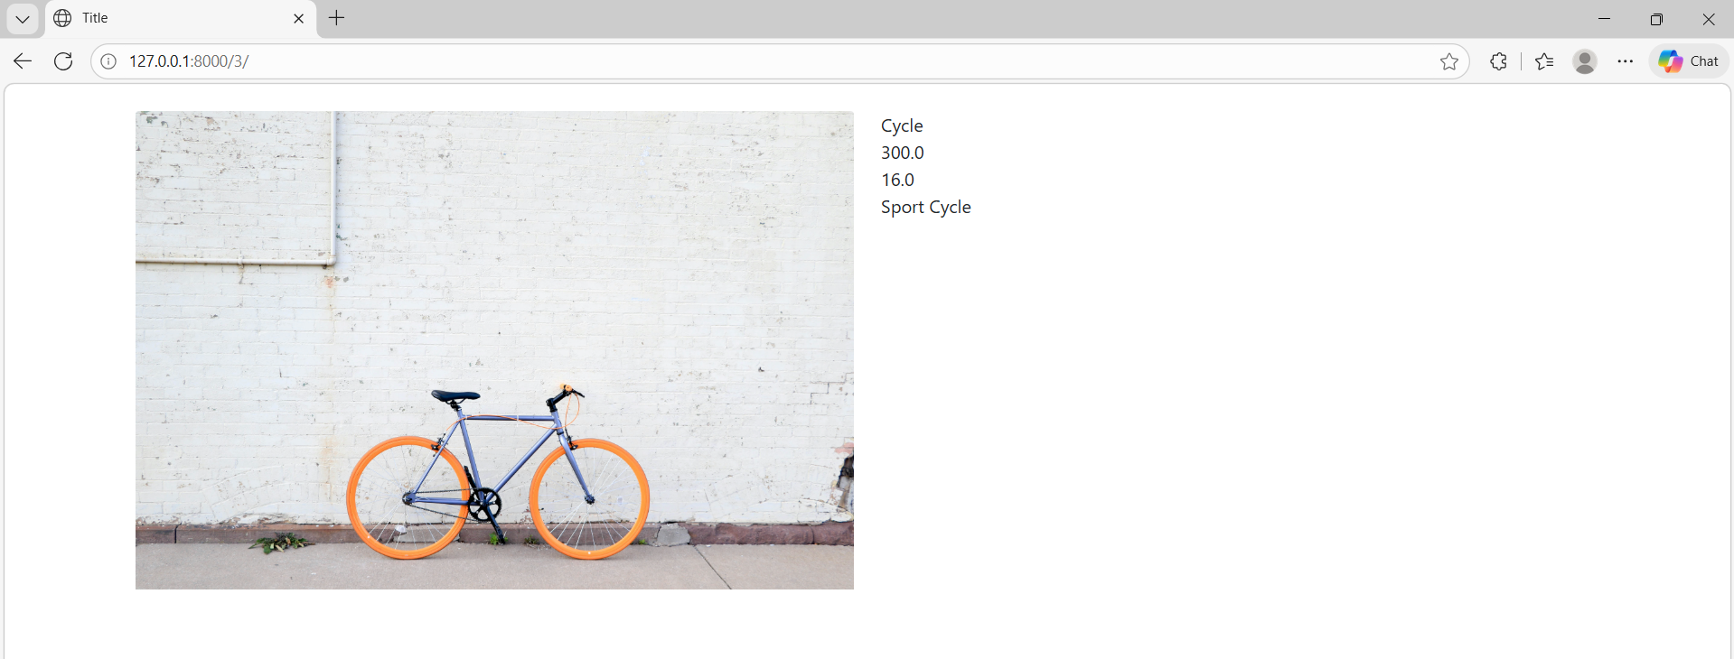

Code for view button link
index.html

<a href="/{{product.id}}" class="btn btn-warning">View</a>
<a class="btn btn-warning">Add to Cart</a>

____________________________________________________________________________
Using Local Storage To Save Cart Item

Inspect watch image

Local storage

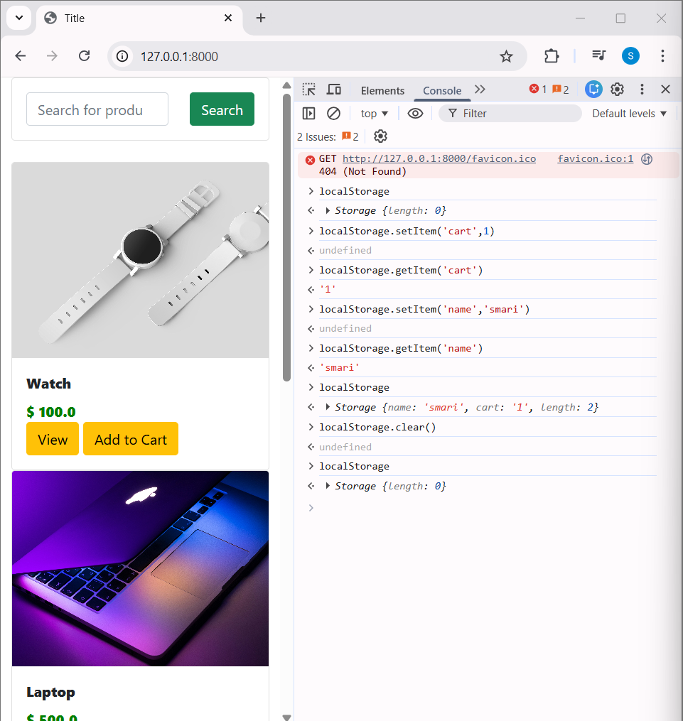

____________________________________________________________________________

Adding Query and Creating The Cart

Jquery is a library. Allows us to work with the HTML dom (document object model).

Jquery helps handle the button clicks and the actions which happen after handle the button clicks.

=> card does not exist, create a card.

Index.html

{% load static %}
<!DOCTYPE html>
<html lang="en">
<head>
<meta charset="UTF-8">
<link href="https://cdn.jsdelivr.net/npm/bootstrap@5.0.2/dist/css/bootstrap.min.css" rel="stylesheet" integrity="sha384-EVSTQN3/azprG1Anm3QDgpJLIm9Nao0Yz1ztcQTwFspd3yD65VohhpuuCOmLASjC" crossorigin="anonymous">
<script src="https://cdn.jsdelivr.net/npm/bootstrap@5.0.2/dist/js/bootstrap.bundle.min.js" integrity="sha384-MrcW6ZMFYlzcLA8Nl+NtUVF0sA7MsXsP1UyJoMp4YLEuNSfAP+JcXn/tWtIaxVXM" crossorigin="anonymous"></script>
<script src="https://code.jquery.com/jquery-4.0.0.js" integrity="sha256-9fsHeVnKBvqh3FB2HYu7g2xseAZ5MlN6Kz/qnkASV8U=" crossorigin="anonymous"></script>
<link rel="stylesheet" href="{% static 'shop/style.css' %}">
<title>Title</title>
</head>
<body>

<div class="container">

<div class="row">
<div class="col-md-12">

<form class="card card-sm" method="get" action="">
<div class="card-body row no-gutters align-items-center">
<div class="col">
<input
type="search"
name="item_name"
placeholder="Search for products"
class="form-control form-control-borderless"
>
</div>
<div class="col-auto">
<button class="btn btn-success" type="submit">
Search
</button>
</div>
</div>
</form>

</div>
</div>
<br>

<div class="row">
{% for product in product_objects %}
<div class="col-md-3">
<div class="card">
<img src="{{ product.image }}" class="card-img-top">
<div class="card-body">
<div class="card-title">
{{ product.title }}
</div>
<div class="card-text">
$ {{ product.price }}
</div>

<a href="/{{product.id}}" class="btn btn-warning">View</a>
<a class="btn btn-warning">Add to Cart</a>

</div>
</div>
</div>
{% endfor %}
</div>

<br>

<div class="row">
<div class="col-md-3 offset-md-4">
<ul class="pagination">
{% if product_objects.has_previous %}
<li class="page-item">
<a class="page-link" href="?page={{ product_objects.previous_page_number }}">Previous</a>
</li>
{% endif %}

<li class="page-item active">
<a class="page-link" href="?page={{ product_objects.number }}">Current</a>
</li>

{% if product_objects.has_next %}
<li class="page-item">
<a class="page-link" href="?page={{ product_objects.next_page_number }}">Next</a>
</li>
{% endif %}

</ul>
</div>
</div>

</div>
</body>
<script type="text/javascript">
console.log('This is working');

if(localStorage:.getItem('cart')==null){
var cart = {};
}

</script>
</html>

Oc
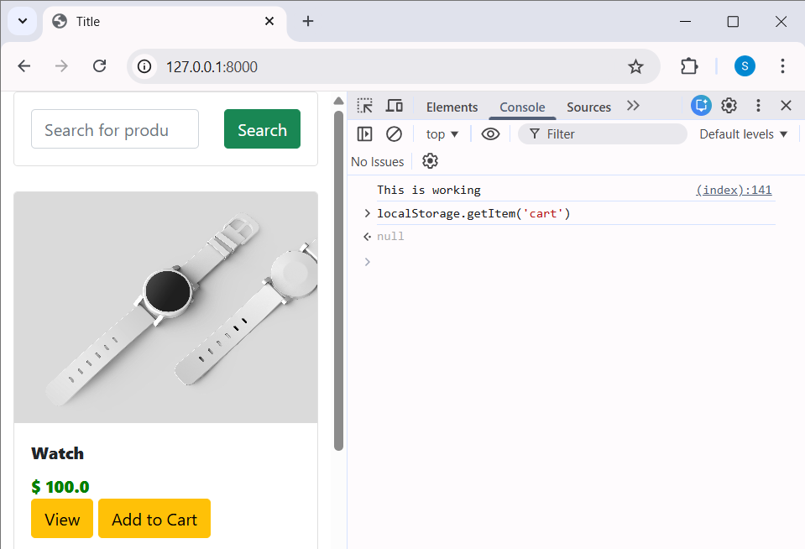

____________________________________________________________________________

Handling Button Clicks

Document Object Model access to this entire HTML.

->localStorage is like a small storage box in the browser.
->It can save data even after the page is refreshed.
If there is no cart saved in localStorage
→ create an empty cart object {}
If a cart already exists
→ get it from localStorage and convert it from text (JSON) back into a JavaScript object.

Uses jQuery
Listens for a click on any element that has the class .atc
When clicked, it prints:
"The add to cart button is clicked"

Code

index.html

<button class="btn atc btn-warning">Add to Cart</button>

<script type="text/javascript">
console.log('This is working');

if(localStorage.getItem('cart')==null){
var cart = {};
}
else{
cart = JSON.parse(localStorage.getItem('cart'));
}

$(document).on('click','.atc',function(){
console.log("The add to cart button is clicked");
});
</script>

Oc
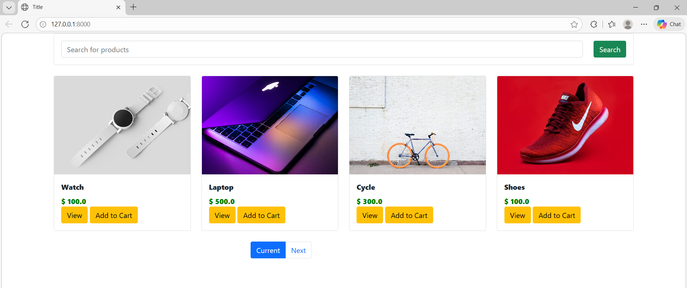

Click add to cart button in watch

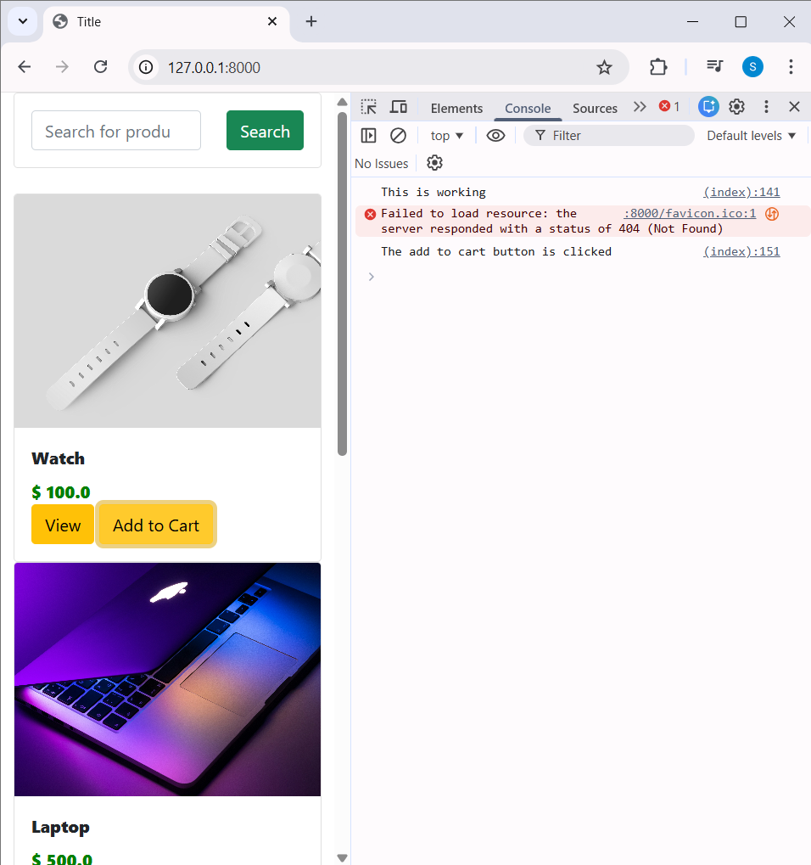

Click any product add to cart button it increase

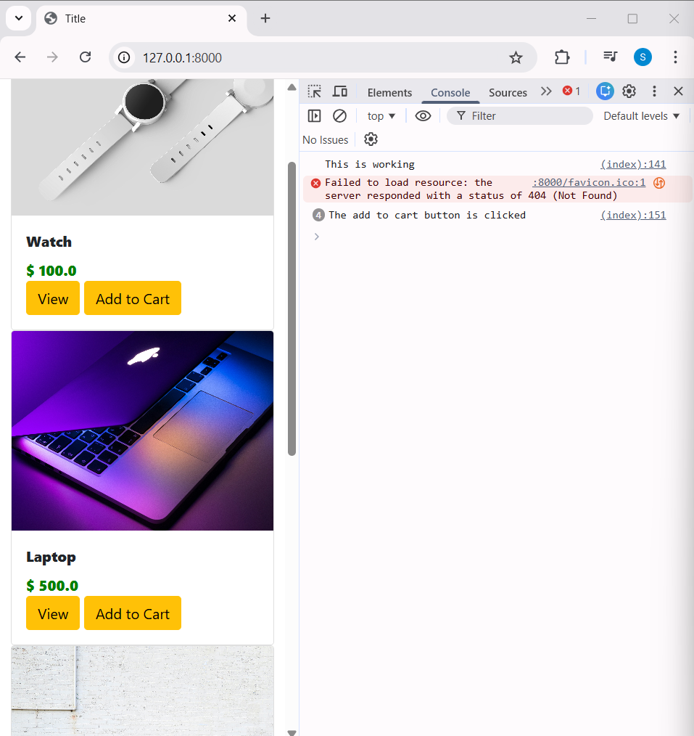
____________________________________________________________________________

Getting Product’s ID

<button id="{{product.id}}" class="btn atc btn-warning">Add to Cart</button>

<script type="text/javascript">
console.log('This is working');

if(localStorage.getItem('cart')==null){
var cart = {};
}
else{
cart = JSON.parse(localStorage.getItem('cart'));
}

$(document).on('click','.atc',function(){
console.log("The add to cart button is clicked");
var item_id = this.id.toString();
console.log(item_id);
});
</script>

Oc

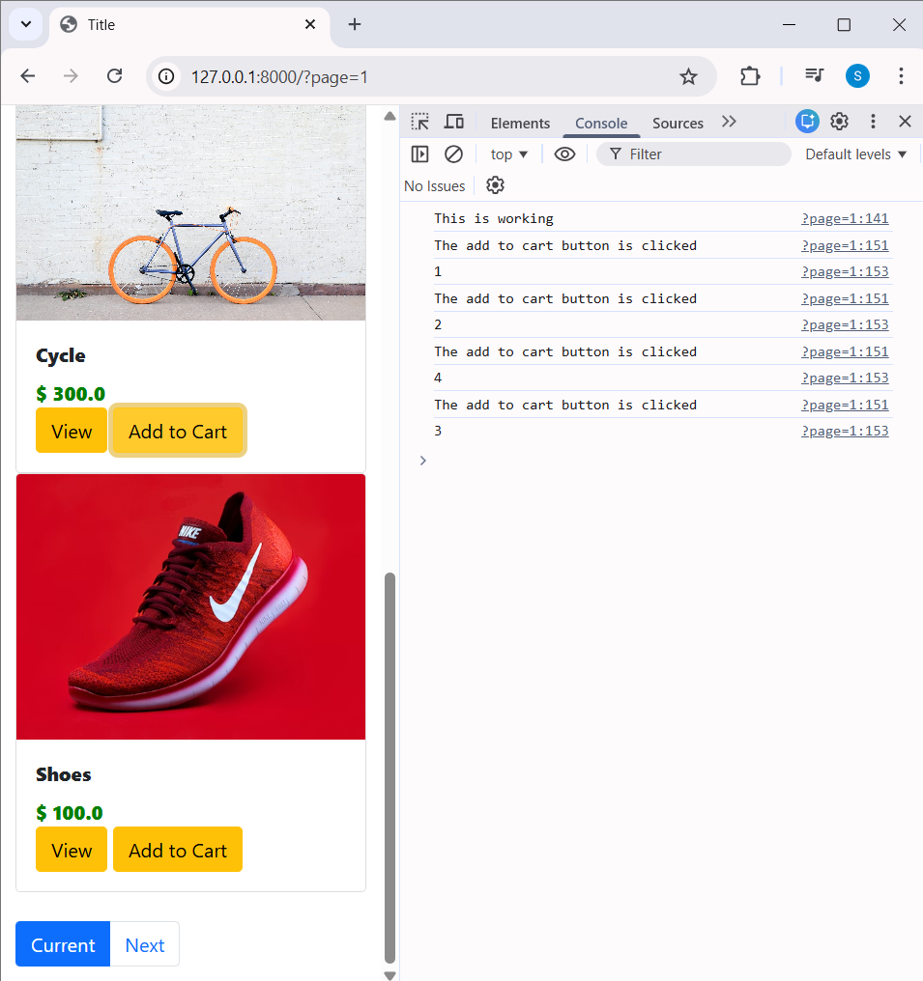

Click item 1 -> item 1 adds.
Click item 2 -> item 2 adds.

____________________________________________________________________________

Saving Item into Cards

Each item is added to cart and increase number of values.

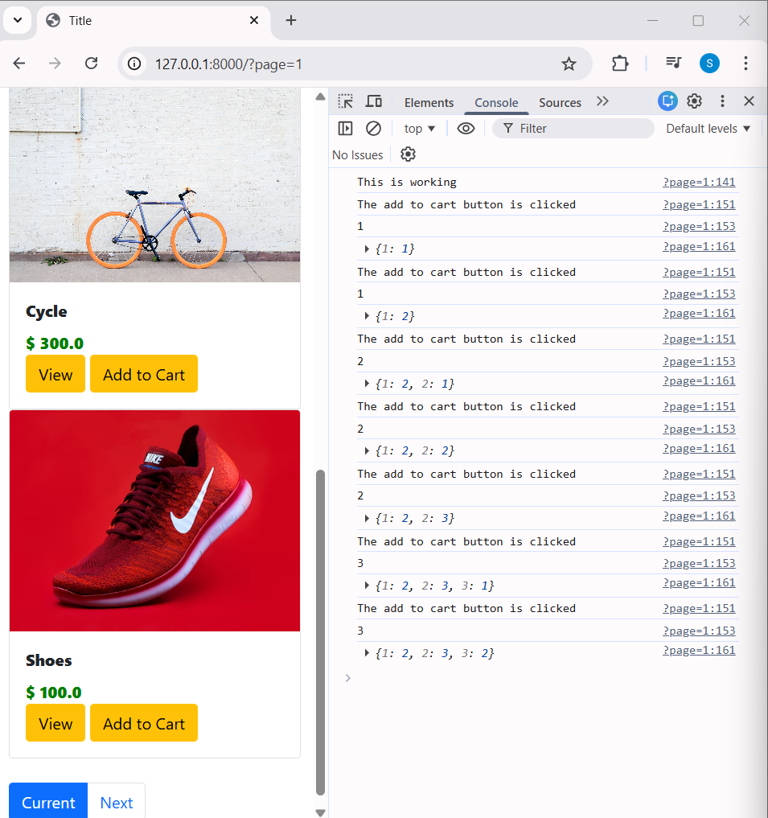

Code
<script type="text/javascript">
console.log('This is working');

if(localStorage.getItem('cart')==null){
var cart = {};
}
else{
cart = JSON.parse(localStorage.getItem('cart'));
}

$(document).on('click','.atc',function(){
console.log("The add to cart button is clicked");
var item_id = this.id.toString();
console.log(item_id);

if(cart[item_id]!=undefined){
cart[item_id] = cart[item_id] + 1;
}
else{
cart[item_id] = 1;
}
console.log(cart);
});
</script

___

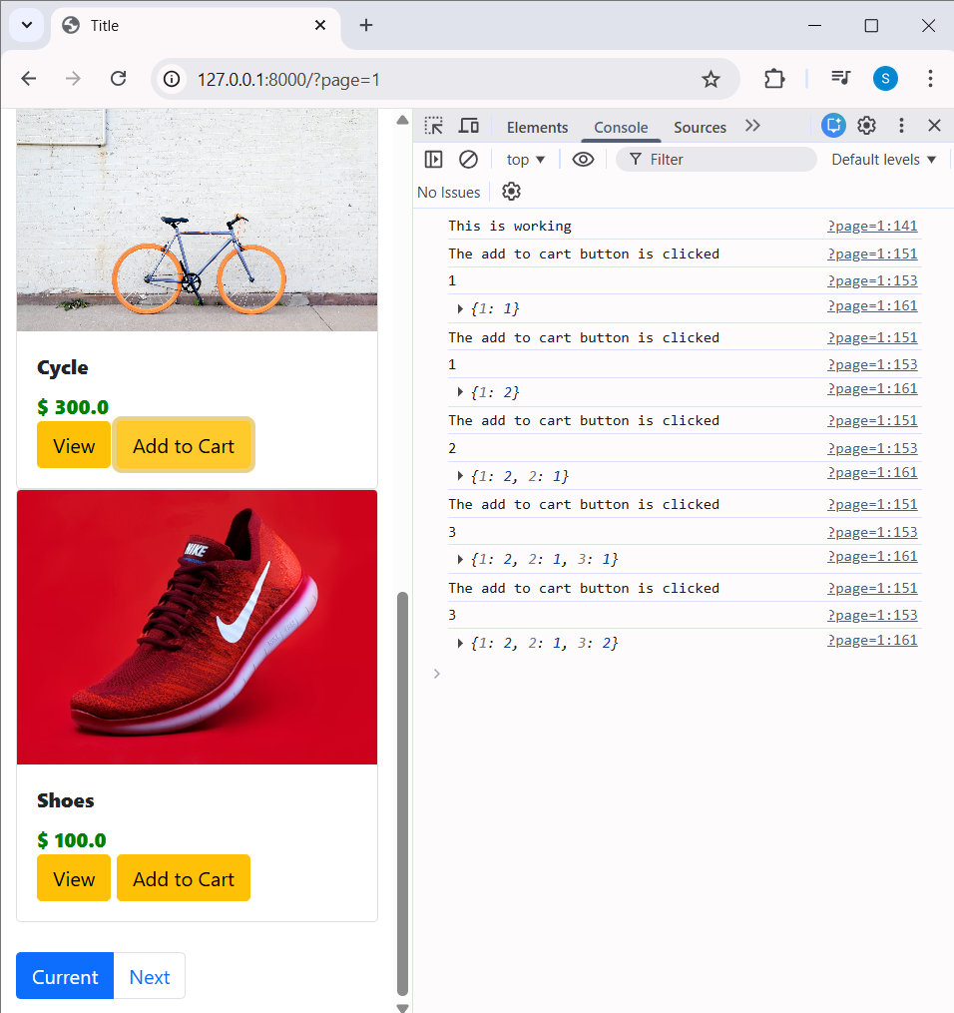

Item 4 added still before the added item also shows.

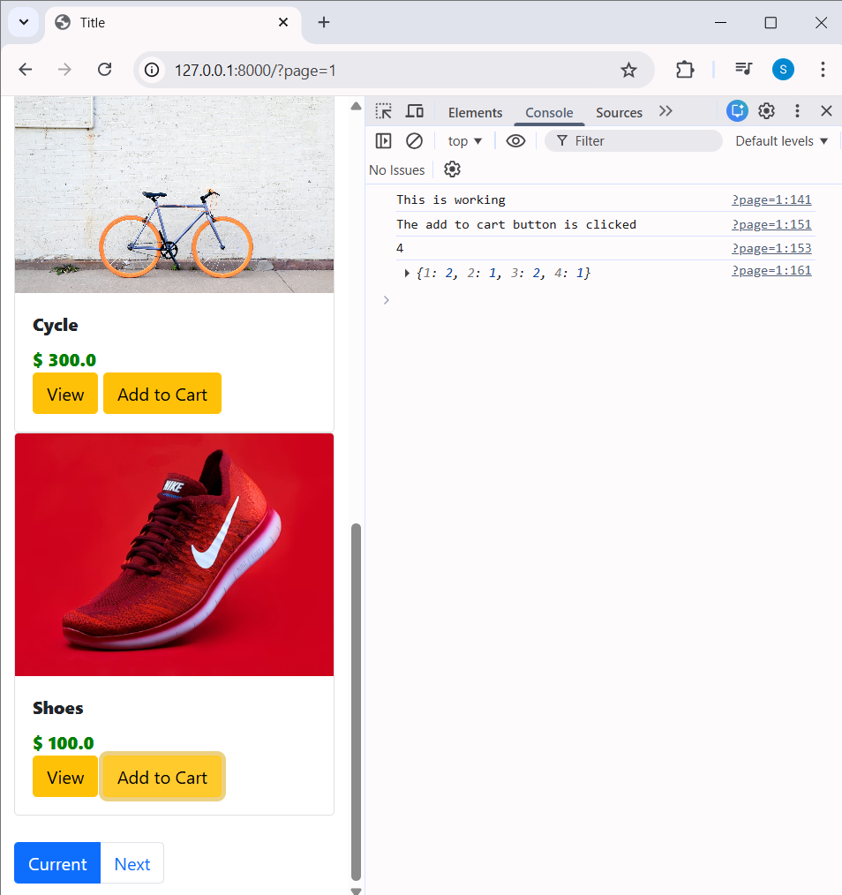

Code

<script type="text/javascript">
console.log('This is working');

if(localStorage.getItem('cart')==null){
var cart = {};
}
else{
cart = JSON.parse(localStorage.getItem('cart'));
}

$(document).on('click','.atc',function(){
console.log("The add to cart button is clicked");
var item_id = this.id.toString();
console.log(item_id);

if(cart[item_id]!=undefined){
cart[item_id] = cart[item_id] + 1;
}
else{
cart[item_id] = 1;
}
console.log(cart);
localStorage.setItem('cart',JSON.stringify(cart));
});
</script>

____________________________________________________________________________

Display number of items in navbar

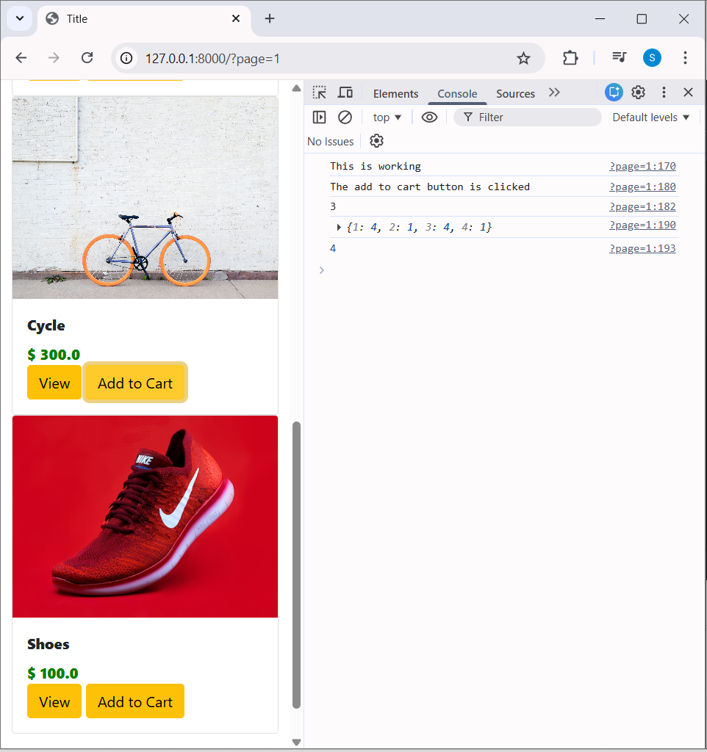

I clicked the item 3-4 times. -> {1: 4, 2: 1, 3: 4, 4: 1}

4 -> number of unique items.

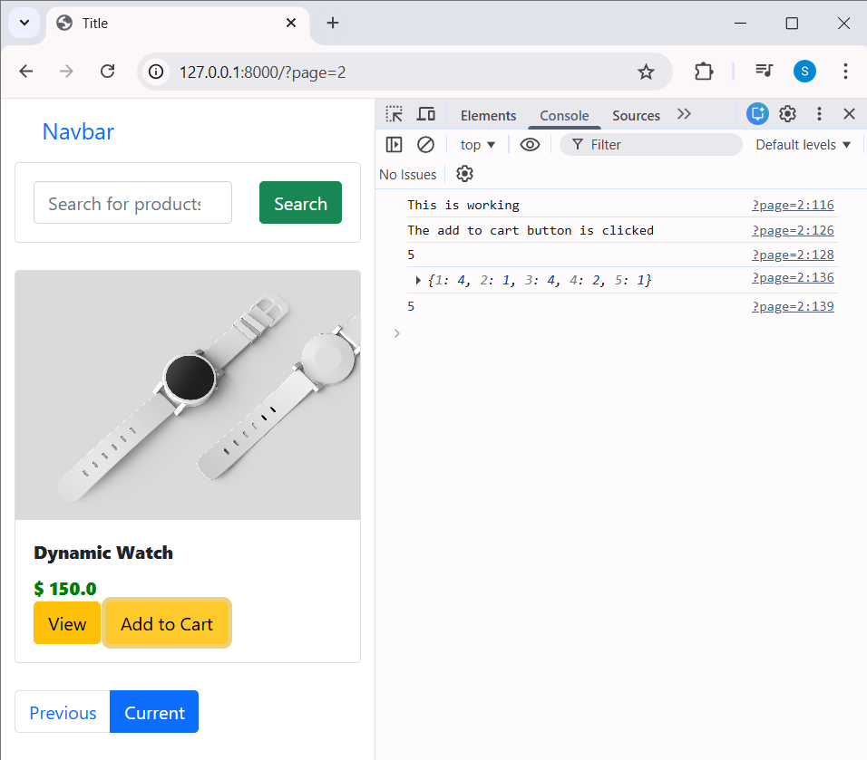

<li class="nav-item">
<a id="cart" class="nav-link" href="#">Pricing</a>
</li>

<li class="nav-item">
<a id="cart" class="nav-link" href="#">Cart(0)</a>
</li>

<script type="text/javascript">
console.log('This is working');

if(localStorage.getItem('cart')==null){
var cart = {};
}
else{
cart = JSON.parse(localStorage.getItem('cart'));
}

$(document).on('click','.atc',function(){
console.log("The add to cart button is clicked");
var item_id = this.id.toString();
console.log(item_id);

if(cart[item_id]!=undefined){
cart[item_id] = cart[item_id] + 1;
}
else{
cart[item_id] = 1;
}
console.log(cart);
localStorage.setItem('cart',JSON.stringify(cart));
document.getElementById("cart").innerHTML = "Cart("+ Object.keys(cart).length +")";
});
</script>

Oc
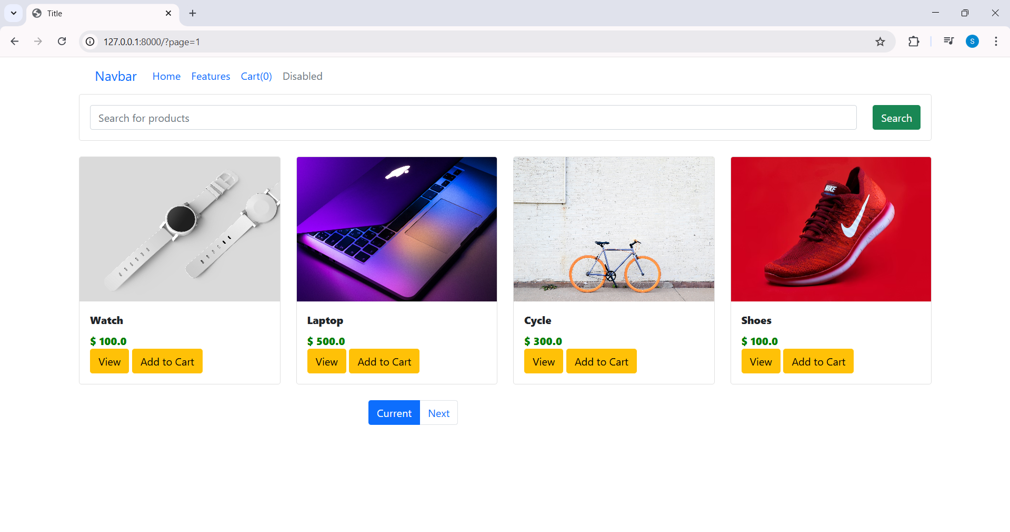

Click add to cart button cart(0) will change
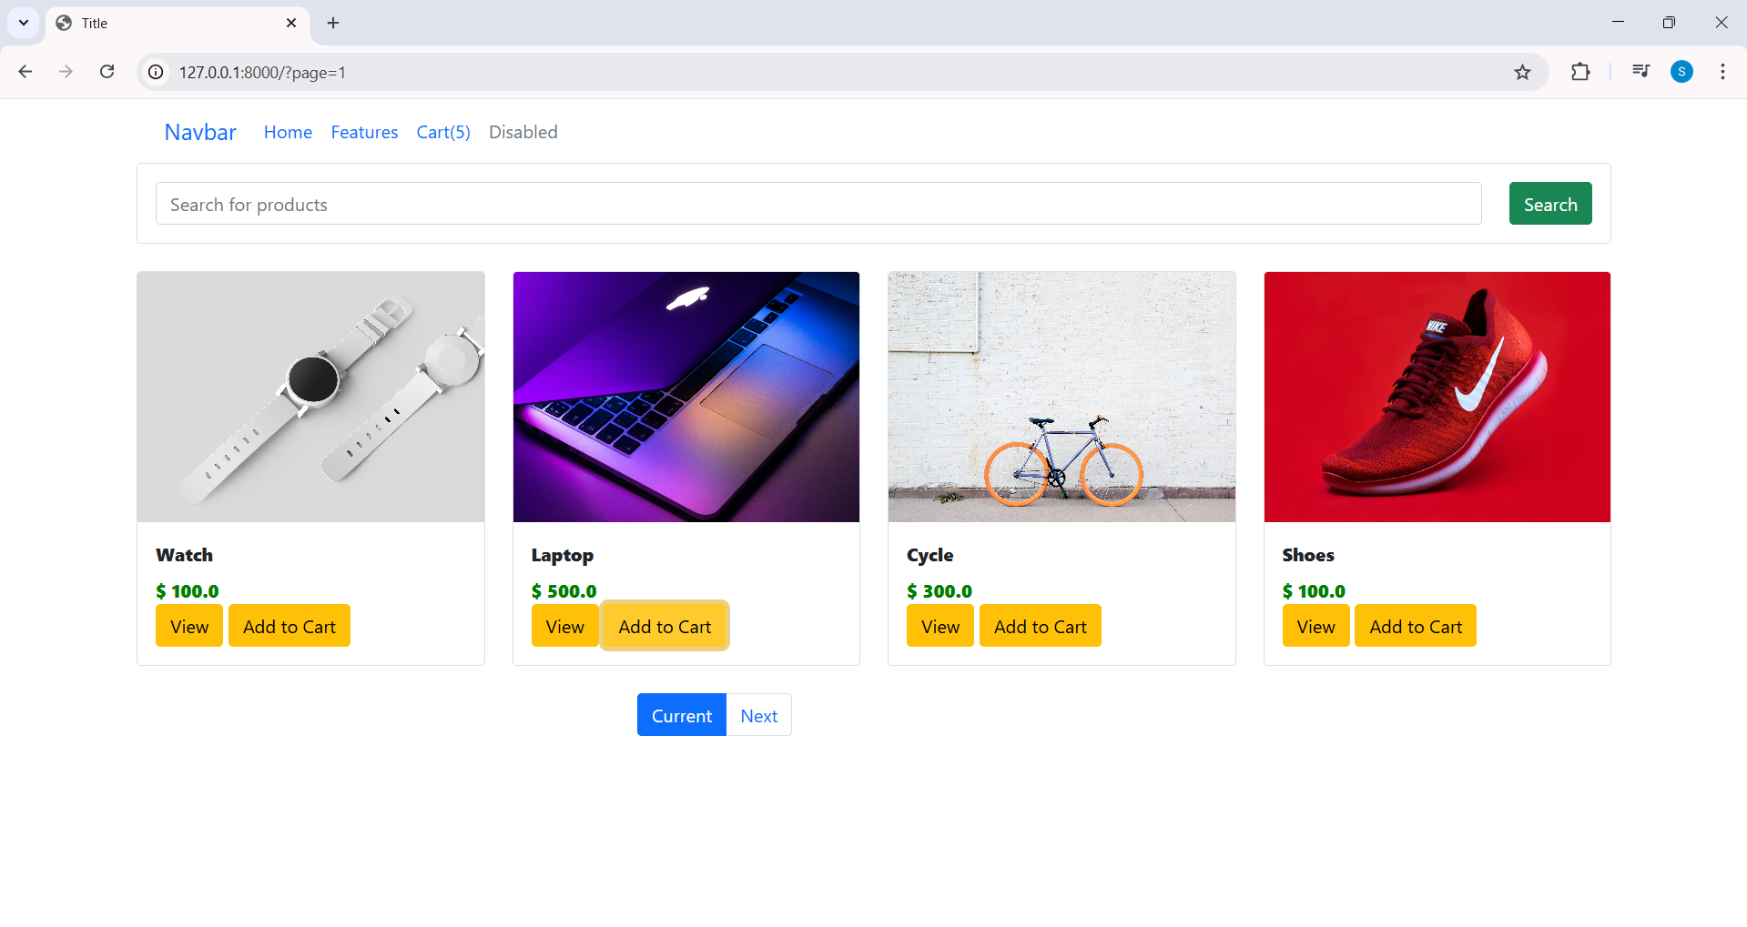

That cart(5) -> unique number of items.

____________________________________________________________________________

