Adding a Popover

Popover allows clicking on this particular card, and getting the items inside the cart.

Oc

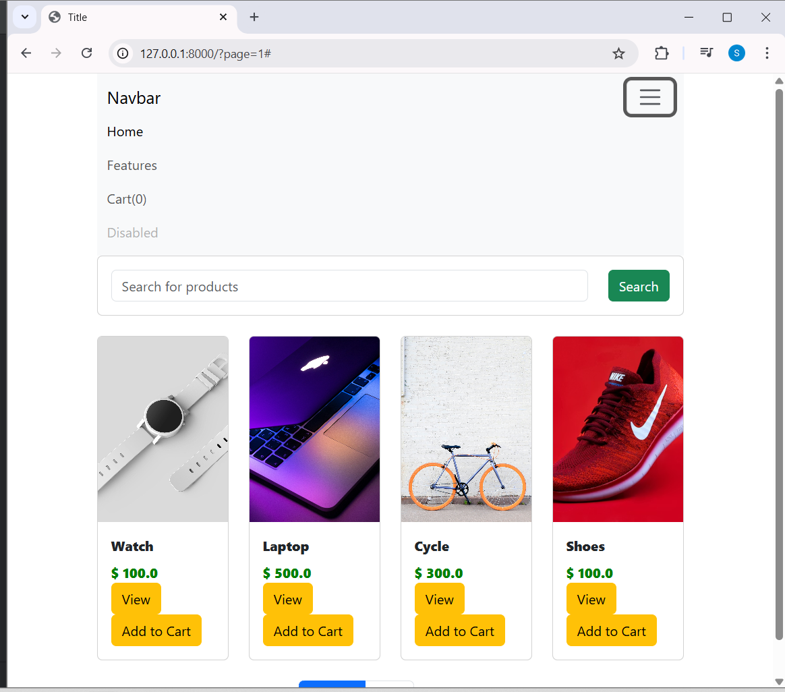

Popover

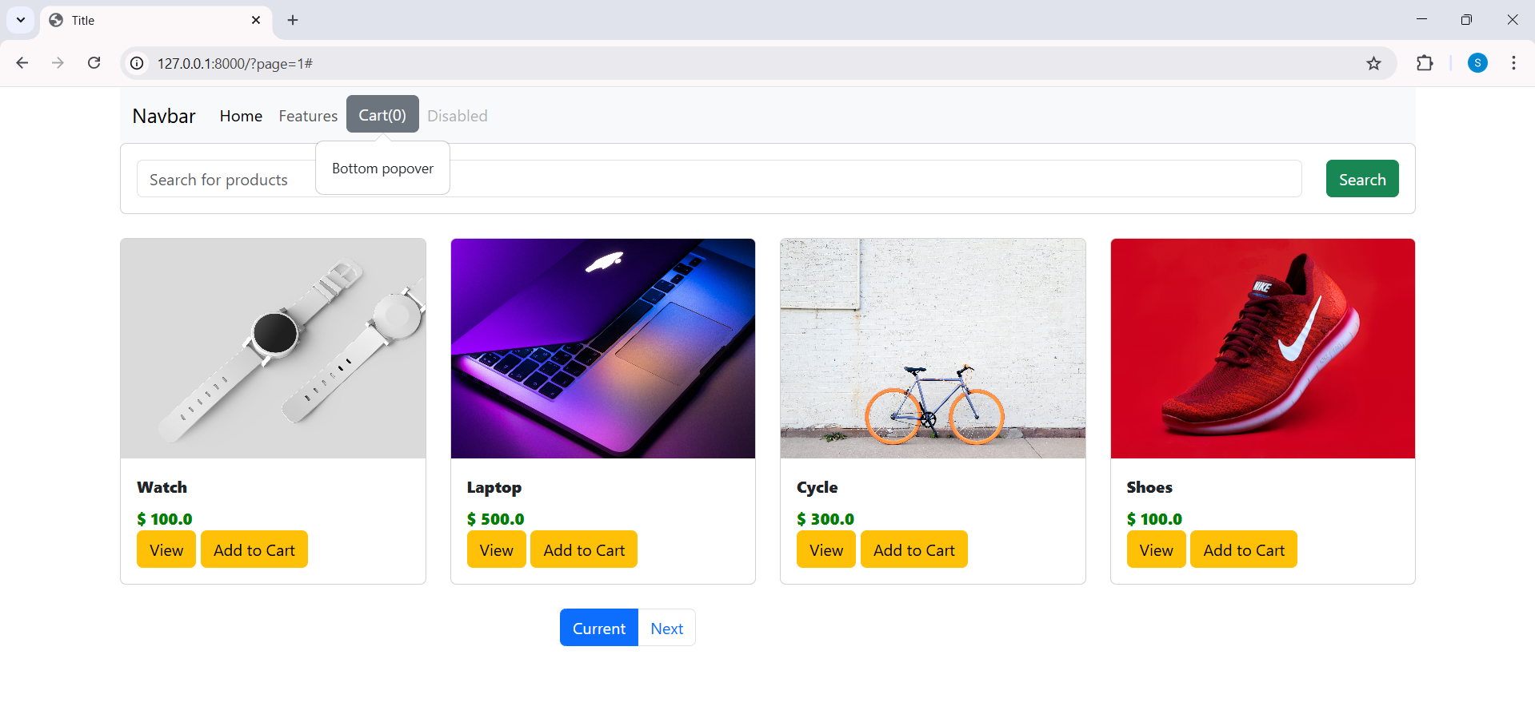

Code

Popover
const popoverTriggerList = document.querySelectorAll('[data-bs-toggle="popover"]')
const popoverList = [...popoverTriggerList].map(popoverTriggerEl => new bootstrap.Popover(popoverTriggerEl))
</script>

<li class="nav-item">
<!--<a id="cart" class="nav-link" href="#">Cart(0)</a>-->
<button id="cart" type="button" class="btn btn-secondary" data-bs-container="body" data-bs-toggle="popover" data-bs-placement="bottom" data-bs-content="Bottom popover">
Cart(0)
</button>
</li>

Dropdown list

<head>
<meta charset="UTF-8">
<!-- Bootstrap 5.3 CSS -->
<link href="https://cdn.jsdelivr.net/npm/bootstrap@5.3.2/dist/css/bootstrap.min.css" rel="stylesheet">

<!-- jQuery (needed for your Add to Cart JS) -->
<script src="https://code.jquery.com/jquery-3.7.1.min.js"></script>

<!-- Bootstrap 5.3 JS Bundle (includes Popper) -->
<script src="https://cdn.jsdelivr.net/npm/bootstrap@5.3.2/dist/js/bootstrap.bundle.min.js"></script>

<!-- Your CSS -->
<link rel="stylesheet" href="{% static 'shop/style.css' %}">
<title>Title</title>
</head>

___________________________________________________________________________

Modify popover

Code

<li class="nav-item">
<!--<a id="cart" class="nav-link" href="#">Cart(0)</a>-->
<button id="cart" data-bs-html="true" type="button" class="btn btn-secondary" data-bs-container="body" data-bs-toggle="popover" data-bs-placement="bottom" data-bs-content="<h5>This is your cart</h5>">
Cart(0)
</button>
</li>

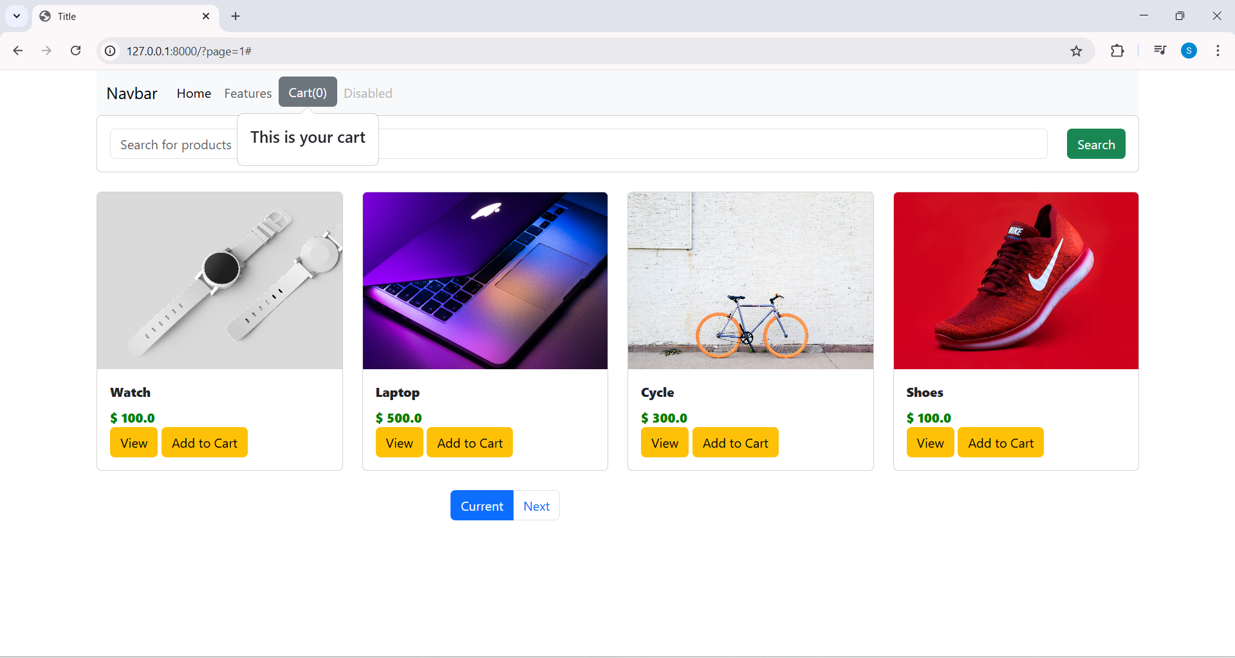

____________________________________________________________________________
Adding caritem in popover

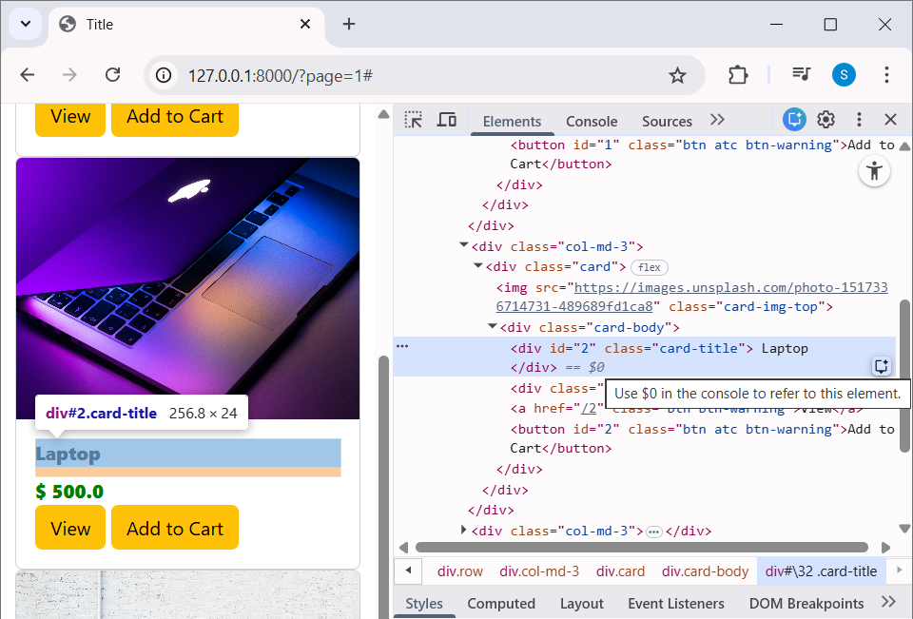

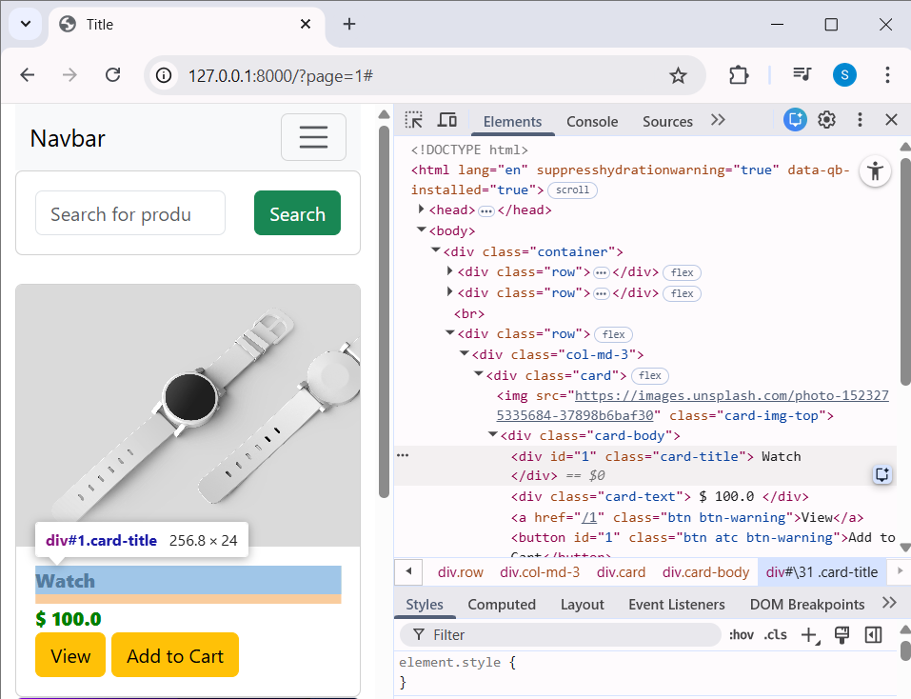

Item’s id in htmlpage.

Code

<div id="{{product.id}}" class="card-title">
{{ product.title }}
</div>

__________

Oc

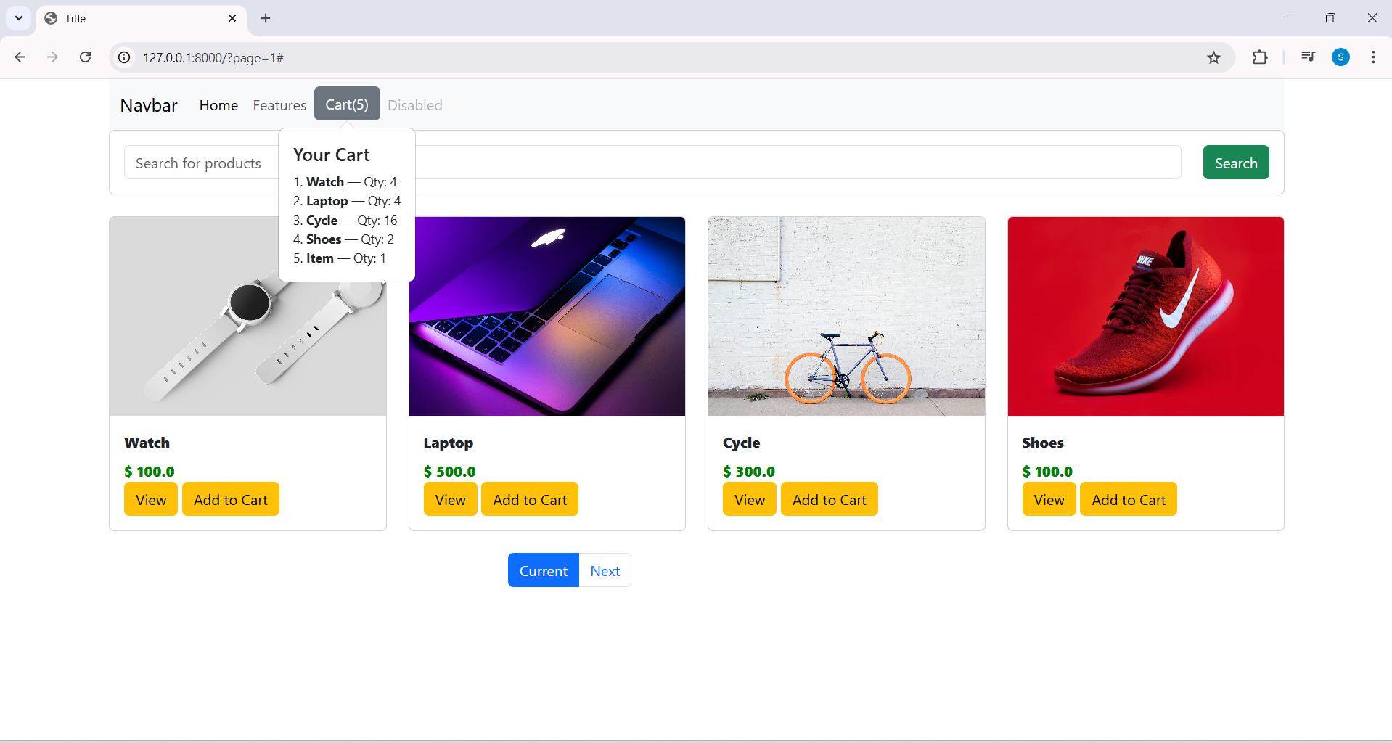

DisplayCart(cart);
function DisplayCart(cart) {
let cartString = "<h5>Your Cart</h5>";

let index = 1;
for (let x in cart) {
let name = document.getElementById("nm" + x)?.innerHTML || "Item";

cartString += `
<div>
${index}. <strong>${name}</strong> — Qty: ${cart[x]}
</div>
`;
index++;
}

if (Object.keys(cart).length === 0) {
cartString += "<div>Cart is empty</div>";
}

let cartBtn = document.getElementById("cart");

// Destroy old popover
let pop = bootstrap.Popover.getInstance(cartBtn);
if (pop) pop.dispose();

// Create new popover
new bootstrap.Popover(cartBtn, {
html: true,
content: cartString,
placement: "bottom"
});
}

</script>

<div id="nm{{product.id}}" class="card-title">
{{ product.title }}
</div>

____________________________________________________________________________

Checkoutpage template

Code
<!DOCTYPE html>
<html lang="en">
<head>
<meta charset="UTF-8">
<link href="https://cdn.jsdelivr.net/npm/bootstrap@5.3.2/dist/css/bootstrap.min.css" rel="stylesheet">
<title>Title</title>
</head>
<body>
<br>
<div class="container">
<div class="col-md-12">
<div class="row">
<ol class="list-group list-group-numbered">
<li class="list-group-item d-flex justify-content-between align-items-start">
<div class="ms-2 me-auto">
<div class="fw-bold">Subheading</div>
Content for list item
</div>
<span class="badge text-bg-primary rounded-pill">14</span>
</li>
<li class="list-group-item d-flex justify-content-between align-items-start">
<div class="ms-2 me-auto">
<div class="fw-bold">Subheading</div>
Content for list item
</div>
<span class="badge text-bg-primary rounded-pill">14</span>
</li>
<li class="list-group-item d-flex justify-content-between align-items-start">
<div class="ms-2 me-auto">
<div class="fw-bold">Subheading</div>
Content for list item
</div>
<span class="badge text-bg-primary rounded-pill">14</span>
</li>
</ol>
</div>
</div>
</div>
</body>
</html>

Oc

Click checkout button

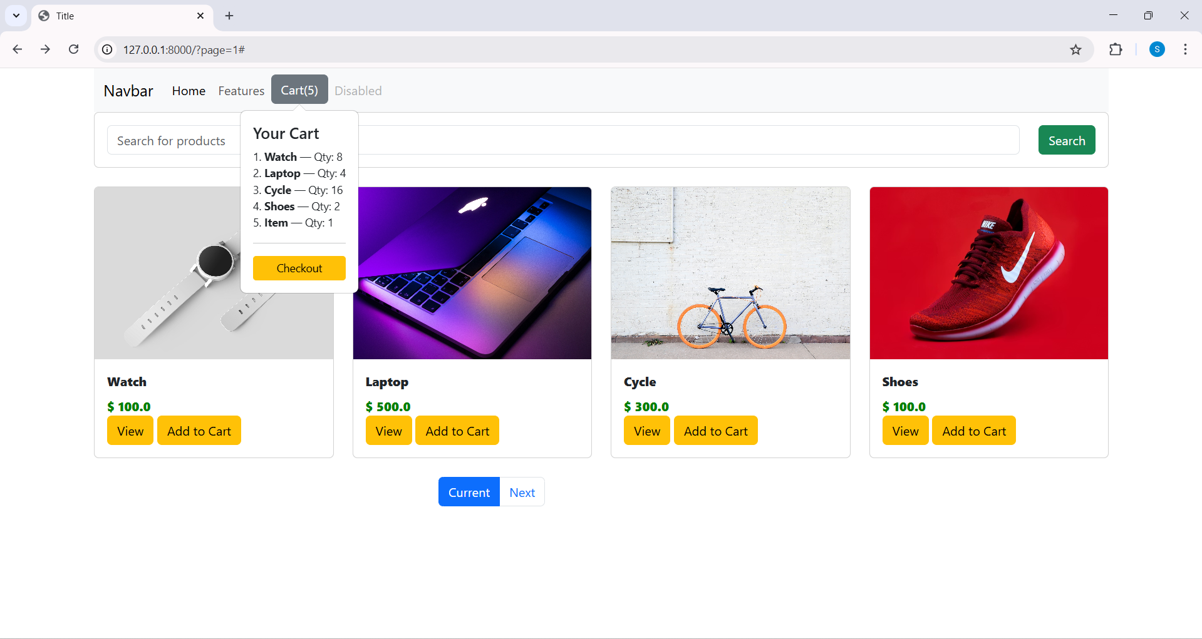

Modifying local storage

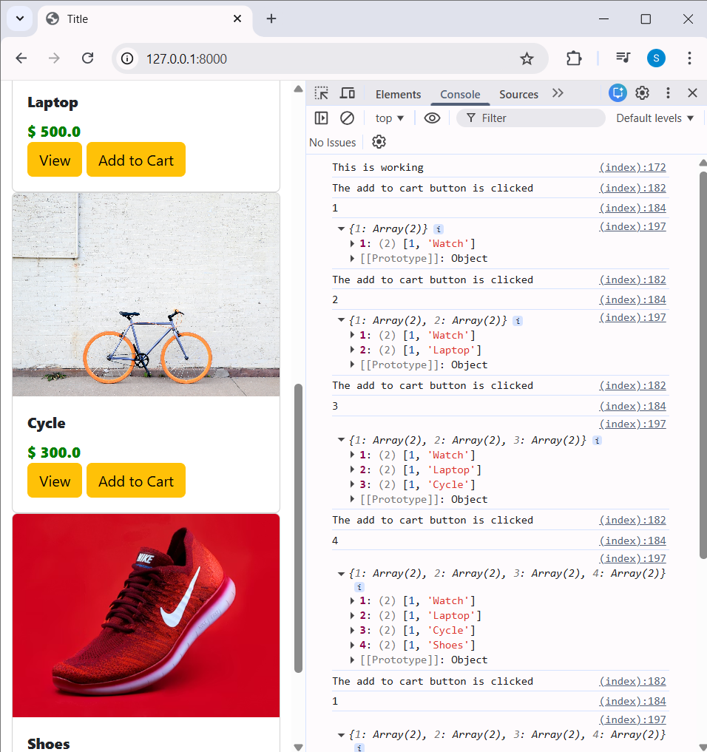

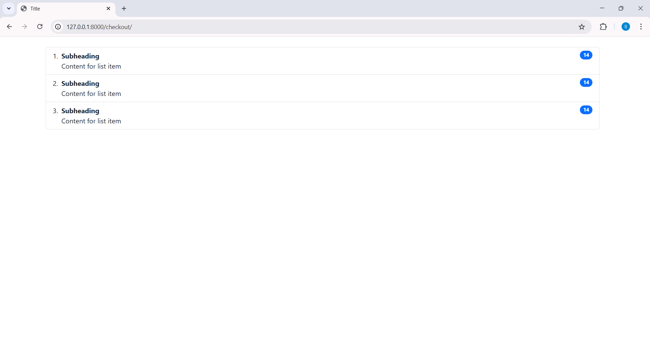
____________________________________________________________________________

Modifying local storage

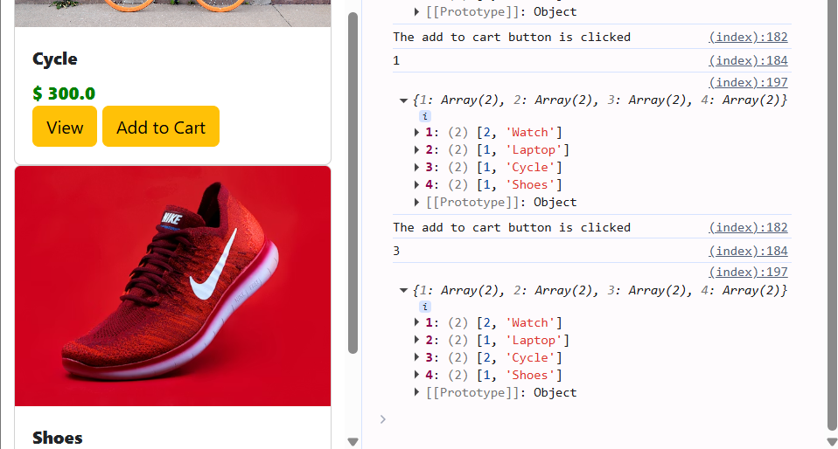

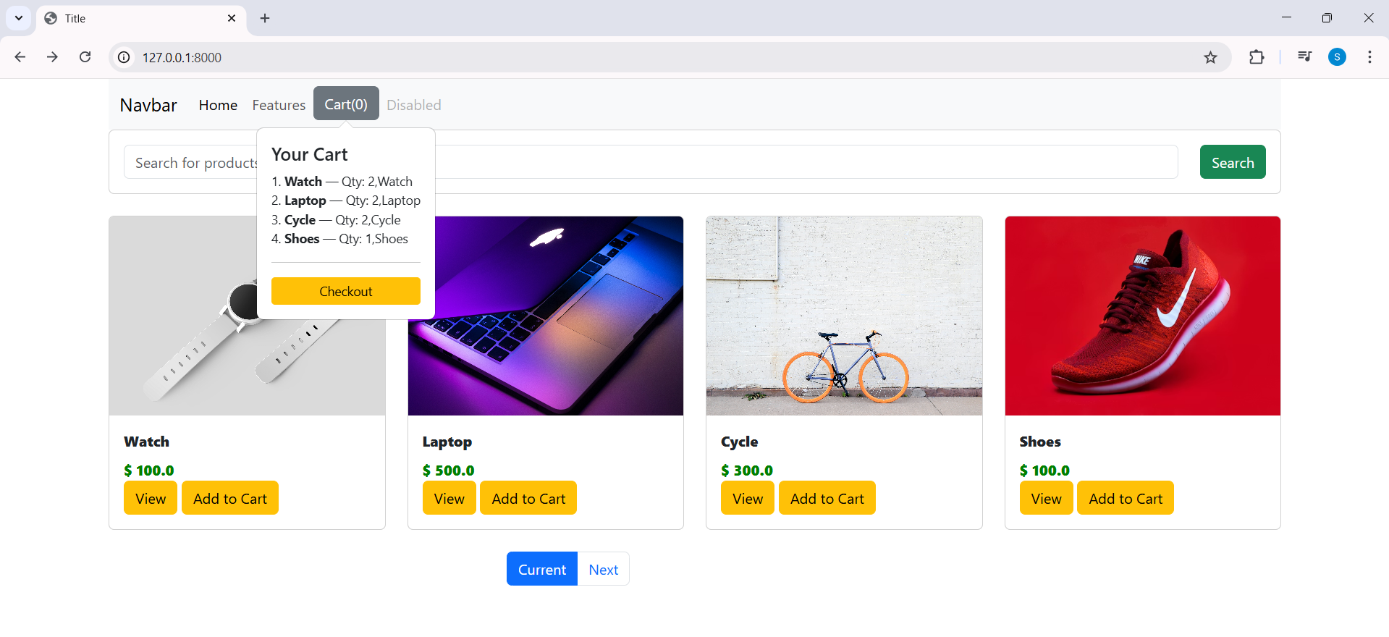

Code

<script type="text/javascript">
console.log('This is working');

if(localStorage.getItem('cart')==null){
var cart = {};
}
else{
cart = JSON.parse(localStorage.getItem('cart'));
}

$(document).on('click','.atc',function(){
console.log("The add to cart button is clicked");
var item_id = this.id.toString();
console.log(item_id);

if(cart[item_id]!=undefined){
<!-- cart[item_id] = cart[item_id] + 1;-->
quantity = cart[item_id][0] + 1;
cart[item_id] [0] = quantity;
}
else{
<!-- cart[item_id] = 1;-->
quantity = 1;
name = document.getElementById("nm"+item_id).innerHTML;
cart[item_id]=[quantity,name];
}
console.log(cart);
localStorage.setItem('cart',JSON.stringify(cart));
document.getElementById("cart").innerHTML = "Cart("+ Object.keys(cart).length +")";
});

const popoverTriggerList = document.querySelectorAll('[data-bs-toggle="popover"]')
const popoverList = [...popoverTriggerList].map(popoverTriggerEl => new bootstrap.Popover(popoverTriggerEl))

DisplayCart(cart);
function DisplayCart(cart) {
let cartString = "<h5>Your Cart</h5>";

let index = 1;
for (let x in cart) {
let name = document.getElementById("nm" + x)?.innerHTML || "Item";

cartString += `
<div>
${index}. <strong>${name}</strong> — Qty: ${cart[x]}
</div>
`;
index++;
}

if (Object.keys(cart).length > 0) {
cartString += `
<hr>
<div class="d-grid">
<a href="/checkout" class="btn btn-warning btn-sm">
Checkout
</a>
</div>
`;
} else {
cartString += "<div>Cart is empty</div>";
}

let cartBtn = document.getElementById("cart");

let pop = bootstrap.Popover.getInstance(cartBtn);
if (pop) pop.dispose();

new bootstrap.Popover(cartBtn, {
html: true,
content: cartString,
placement: "bottom",
container: "body"
});
}
</script>

____________________________________________________________________________

Adding cart items to the list group

Oc

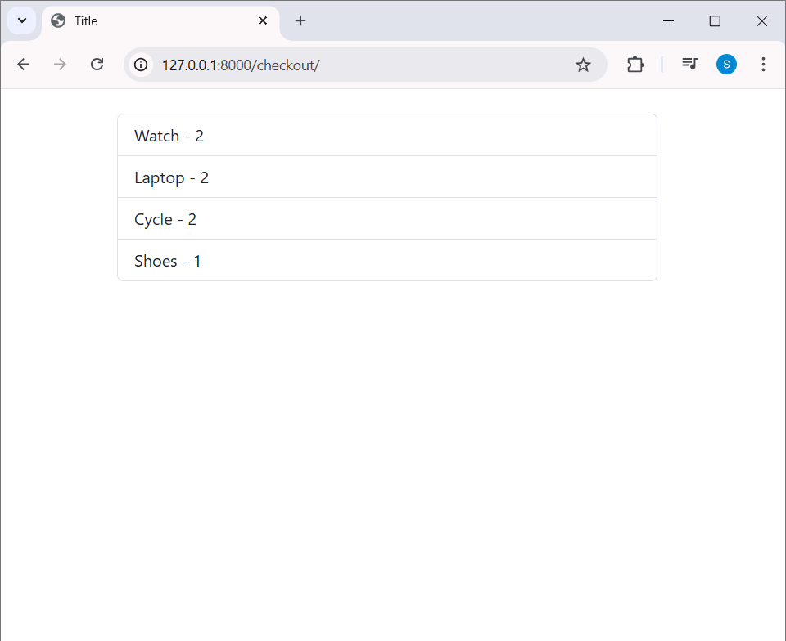

Add cycle it increased

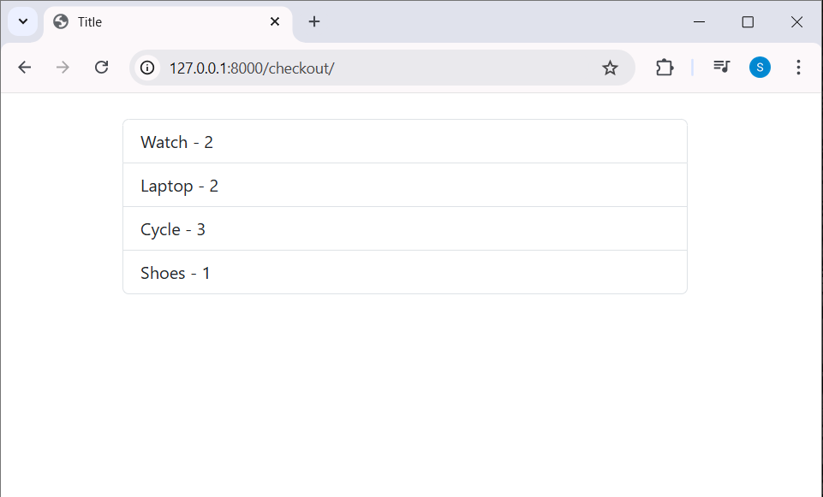

Code

Checkout.html
<!DOCTYPE html>
<html lang="en">
<head>
<meta charset="UTF-8">
<link href="https://cdn.jsdelivr.net/npm/bootstrap@5.3.2/dist/css/bootstrap.min.css" rel="stylesheet">
<script src="https://code.jquery.com/jquery-3.7.1.min.js"></script>
<title>Title</title>
</head>
<body>
<br>

<div class="container">
<div class="col-md-12">
<div class="row">
<ul class="list-group" id="item_list"></ul>
</div>
</div>
</div>

<script type="text/javascript">
let cart;

if (localStorage.getItem('cart') == null) {
cart = {};
} else {
cart = JSON.parse(localStorage.getItem('cart'));
}

for (let item in cart) {
let name = cart[item][1];
let quantity = cart[item][0];

let itemString = `<li class="list-group-item">${name} - ${quantity}</li>`;
$('#item_list').append(itemString);
}
</script>

</body>
</html>

____________________________________________________________________________

Adding Checkout Form

Oc

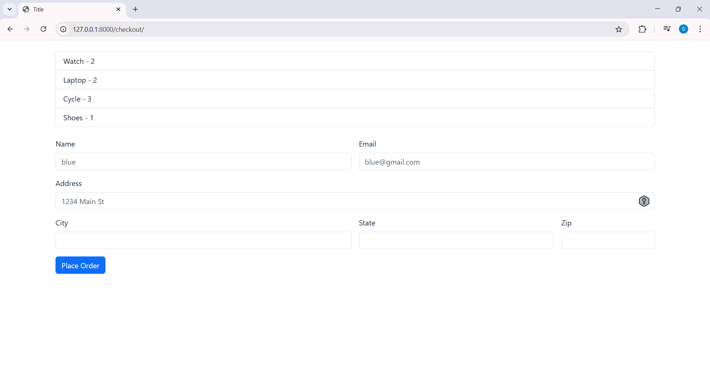

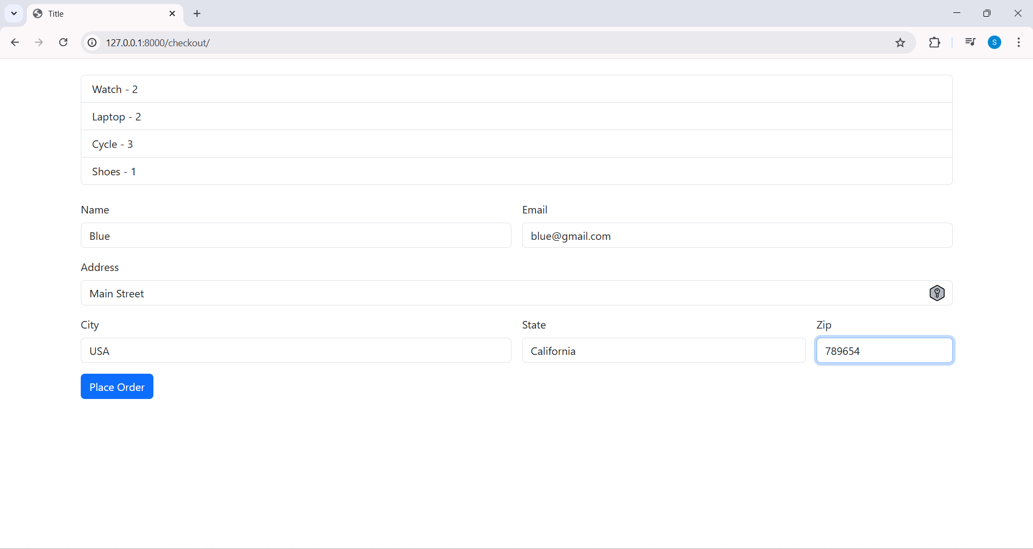

Click place order button

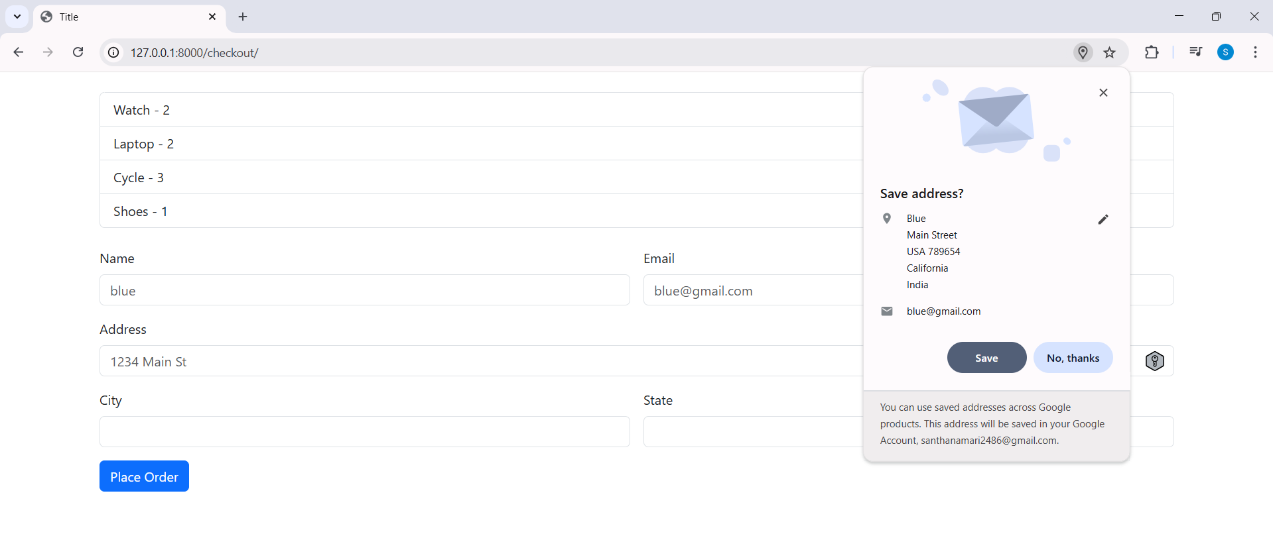

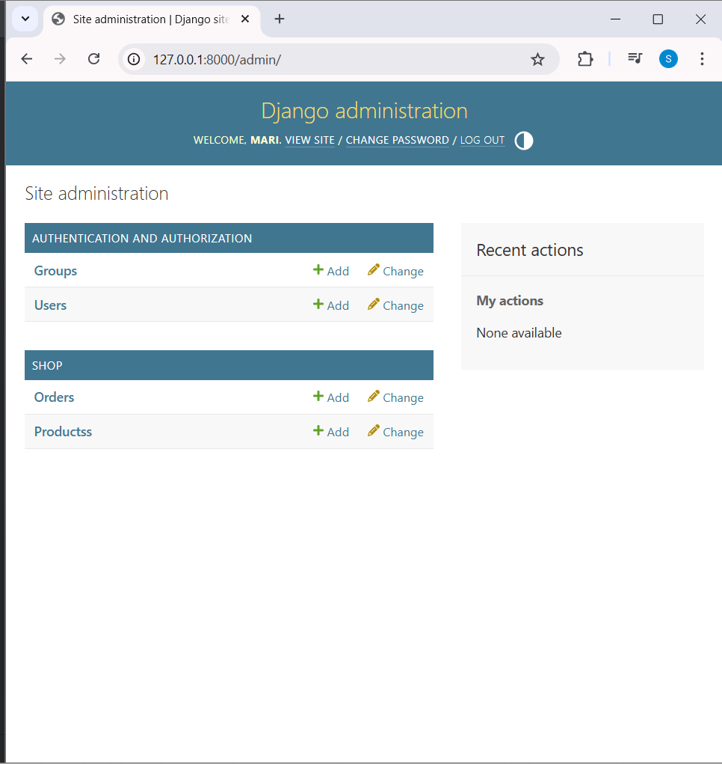

Click orders
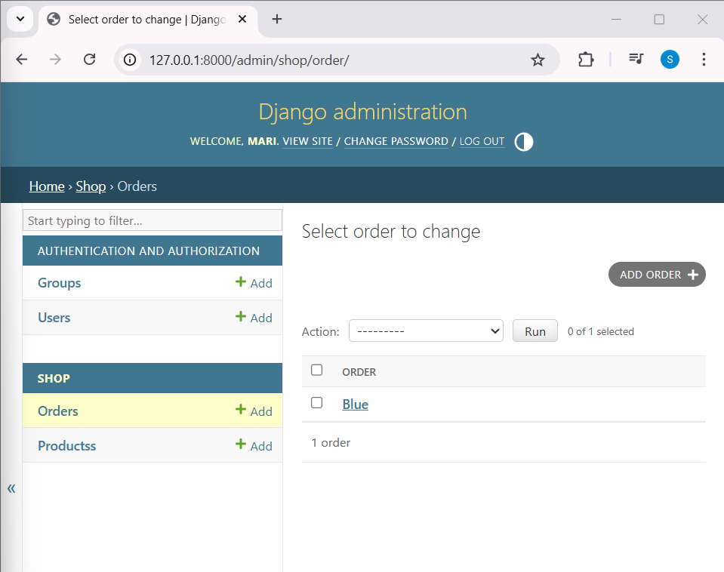

Click blue

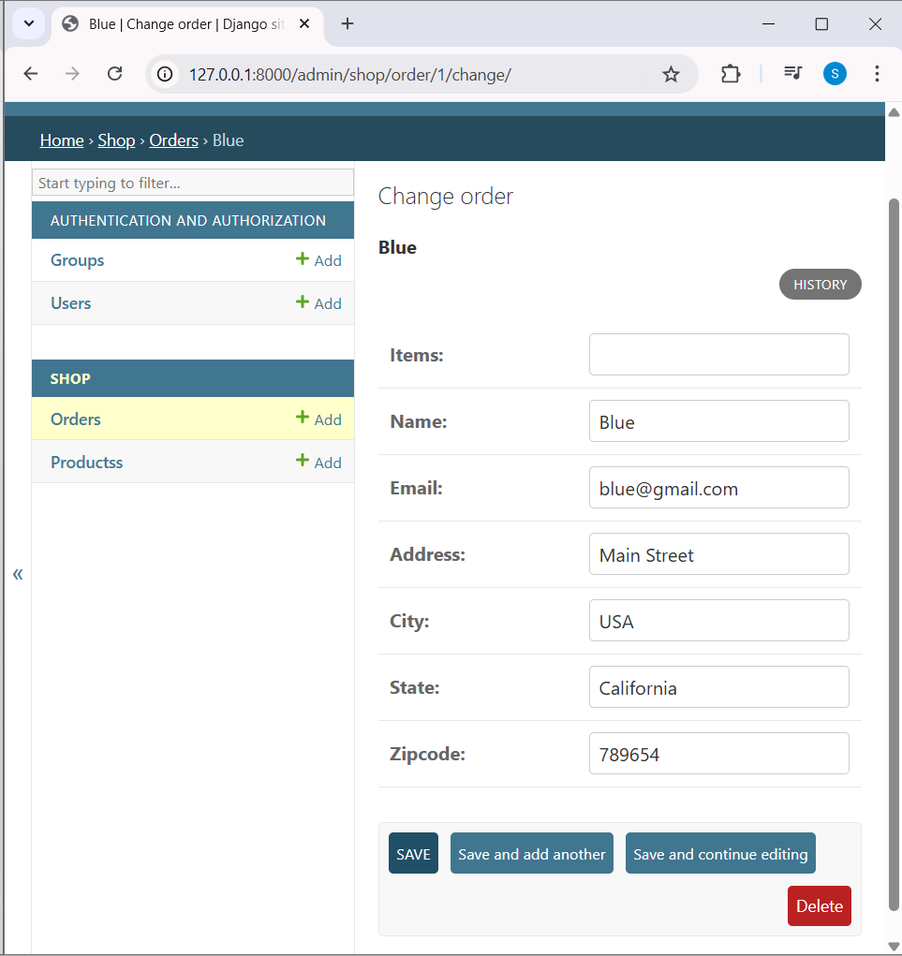

Code

models.py
from django.db import models

# Create your models here.
class Products(models.Model):
title = models.CharField(max_length=200)
price = models.FloatField()
discount_price = models.FloatField()
category = models.CharField(max_length=200)
description = models.TextField()
image = models.URLField(max_length=2000)

def __str__(self):
return self.title

class Order(models.Model):
items = models.CharField(max_length=1000)
name = models.CharField(max_length=200)
email = models.CharField(max_length=200)
address = models.CharField(max_length=1000)
city = models.CharField(max_length=200)
state = models.CharField(max_length=200)
zipcode = models.CharField(max_length=200)

def __str__(self):
return self.name

views.py
from django.shortcuts import render
from .models import Products, Order
from django.core.paginator import Paginator

def index(request):
product_objects = Products.objects.all()

#search code
item_name = request.GET.get('item_name')
if item_name != '' and item_name is not None:
product_objects = Products.objects.filter(title__icontains=item_name)

#paginator code
paginator = Paginator(product_objects, 4)
page = request.GET.get('page')
product_objects = paginator.get_page(page)

return render(request, 'shop/index.html', {'product_objects': product_objects})

def detail(request, id):
product_object = Products.objects.get(id=id)
return render(request, 'shop/detail.html', {'product_object': product_object})

def checkout(request):

if request.method == "POST":
name = request.POST.get('name',"")
email = request.POST.get('email',"")
address = request.POST.get('address',"")
city = request.POST.get('city',"")
state = request.POST.get('state',"")
zipcode = request.POST.get('zipcode',"")

order = Order(name=name,email=email,address=address,city=city,state=state,zipcode=zipcode)
order.save()

return render(request, 'shop/checkout.html')

admin.py

from django.contrib import admin
from .models import Products,Order

# Register your models here.
admin.site.register(Products)
admin.site.register(Order)

____________________________________________________________________________

Adding Cart items to database

Oc

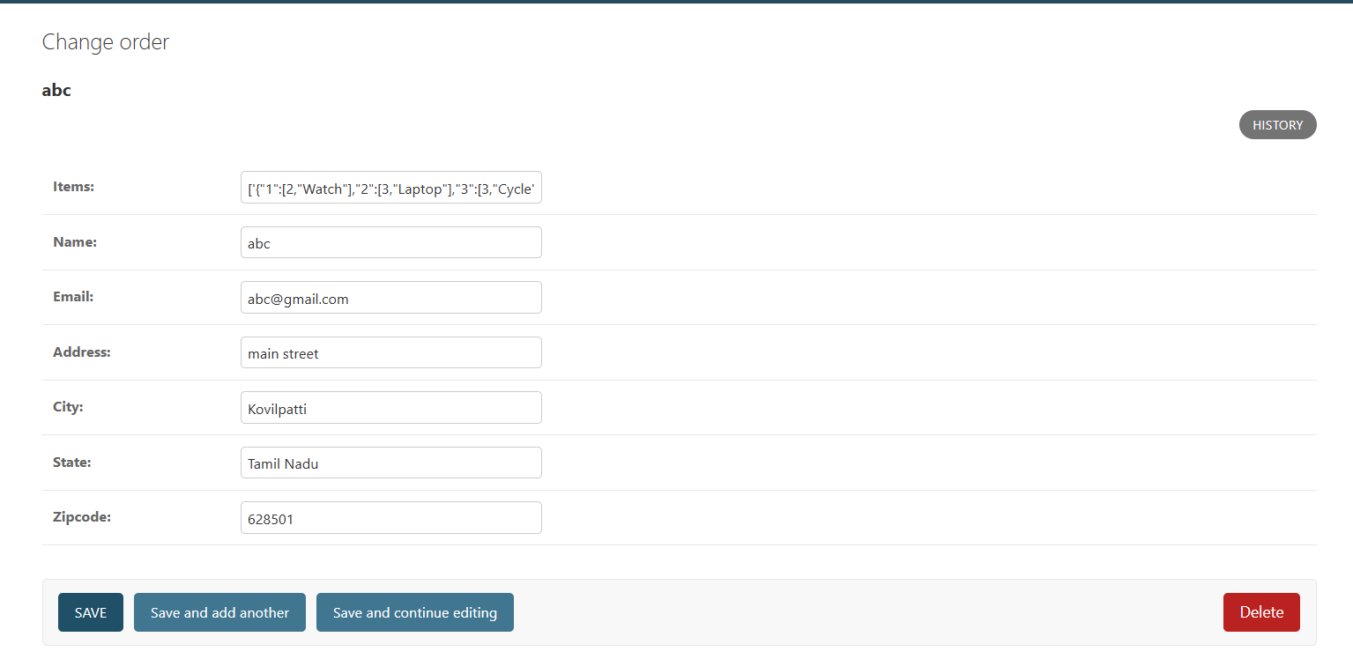

Code

views.py

def checkout(request):

if request.method == "POST":
items = request.POST.getlist('items','')
name = request.POST.get('name',"")
email = request.POST.get('email',"")
address = request.POST.get('address',"")
city = request.POST.get('city',"")
state = request.POST.get('state',"")
zipcode = request.POST.get('zipcode',"")

order = Order(items=items,name=name,email=email,address=address,city=city,state=state,zipcode=zipcode)
order.save()

return render(request, 'shop/checkout.html')

admin.py
from django.contrib import admin
from .models import Products,Order

# Register your models here.
admin.site.register(Products)
admin.site.register(Order)

models.py

class Order(models.Model):
items = models.CharField(max_length=1000)
name = models.CharField(max_length=200)
email = models.CharField(max_length=200)
address = models.CharField(max_length=1000)
city = models.CharField(max_length=200)
state = models.CharField(max_length=200)
zipcode = models.CharField(max_length=200)

def __str__(self):
return self.name

____________________________________________________________________________

Adding Item Prices

Oc

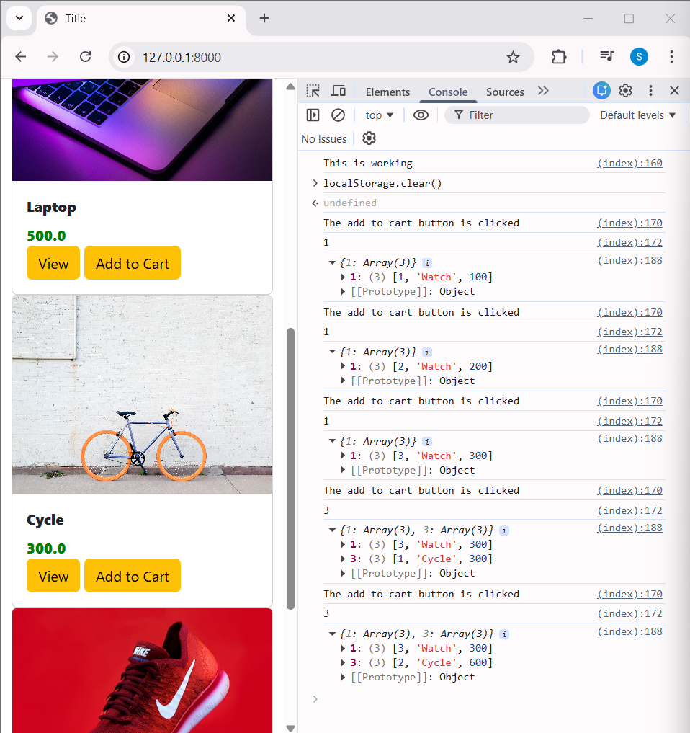

Index.html
<div id="price{{product.id}}" class="card-text">{{ product.price }}</div>

Checkout.html
<script type="text/javascript">
let cart;

if (localStorage.getItem('cart') == null) {
cart = {};
} else {
cart = JSON.parse(localStorage.getItem('cart'));
}

for (let item in cart) {
let name = cart[item][1];
let quantity = cart[item][0];

let itemString = `<li class="list-group-item">${name} - ${quantity}</li>`;
$('#item_list').append(itemString);
}
$('#items').val(JSON.stringify(cart));
</script>
____________________________________________________________________________

Calculating Order Total

Oc

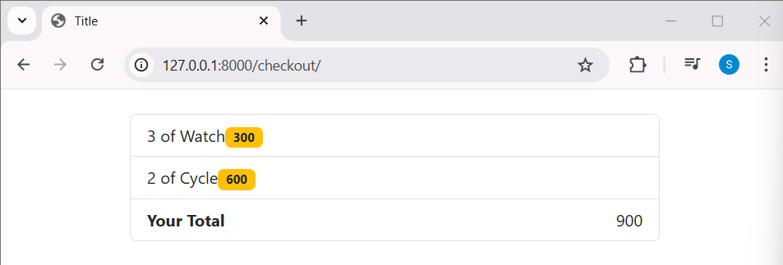

Code

<script type="text/javascript">
let cart;

if (localStorage.getItem('cart') == null) {
cart = {};
} else {
cart = JSON.parse(localStorage.getItem('cart'));
}

for (let item in cart) {
let name = cart[item][1];
let quantity = cart[item][0];
let price = cart[item][2];

let itemString = `<li class="list-group-item"><span>${quantity} of ${name}</span><span class="badge bg-warning text-dark">${price}</span></li>`;
$('#item_list').append(itemString);
}
$('#items').val(JSON.stringify(cart));
</script>

Checkout.html
<!DOCTYPE html>
<html lang="en">
<head>
<meta charset="UTF-8">
<link href="https://cdn.jsdelivr.net/npm/bootstrap@5.3.2/dist/css/bootstrap.min.css" rel="stylesheet">
<script src="https://code.jquery.com/jquery-3.7.1.min.js"></script>
<title>Title</title>
</head>
<body>
<br>

<div class="container">
<div class="row">
<div class="col-md-12">
<ul class="list-group" id="item_list"></ul>
</div>
</div>
<br>

<div class="row">
<div class="col-md-12">
<form class="row g-3" method="POST">
{% csrf_token %}
<input type="hidden" id="items" name="items">
<div class="col-md-6">
<label for="inputEmail14" class="form-label">Name</label>
<input id="name" name="name" type="text" class="form-control" id="inputEmail14" placeholder="blue">
</div>
<div class="col-md-6">
<label for="inputPassword4" class="form-label">Email</label>
<input id="email" name="email" type="text" class="form-control" id="inputPassword4" placeholder="blue@gmail.com">
</div>
<div class="col-12">
<label for="inputAddress" class="form-label">Address</label>
<input id="address" name="address" type="text" class="form-control" id="inputAddress" placeholder="1234 Main St">
</div>
<div class="col-md-6">
<label for="inputCity" class="form-label">City</label>
<input id="city" name="city" type="text" class="form-control" id="inputCity">
</div>
<div class="col-md-4">
<label class="form-label">State</label>
<input id="state" name="state" type="text" class="form-control">
</div>
<div class="col-md-2">
<label for="inputZip" class="form-label">Zip</label>
<input id="zipcode" name="zipcode" type="text" class="form-control" id="inputZip">
</div>
<div class="col-12">
<button type="submit" class="btn btn-primary">Place Order</button>
</div>
</form>
</div>
</div>

</div>

<script type="text/javascript">
let cart;

if (localStorage.getItem('cart') == null) {
cart = {};
} else {
cart = JSON.parse(localStorage.getItem('cart'));
}

let total = 0;
for (let item in cart) {
let name = cart[item][1];
let quantity = cart[item][0];
let price = cart[item][2];
total = total + cart[item][2];

let itemString = `<li class="list-group-item"><span>${quantity} of ${name}</span><span class="badge bg-warning text-dark">${price}</span></li>`;
$('#item_list').append(itemString);
}
let totalPrice = `<li class="list-group-item d-flex justify-content-between align-items-center"><b>Your Total</b>${total}</li> `
$('#item_list').append(totalPrice)
$('#items').val(JSON.stringify(cart));
</script>
</body>
</html>
____________________________________________________________________________

Adding Order Total to Database

Oc

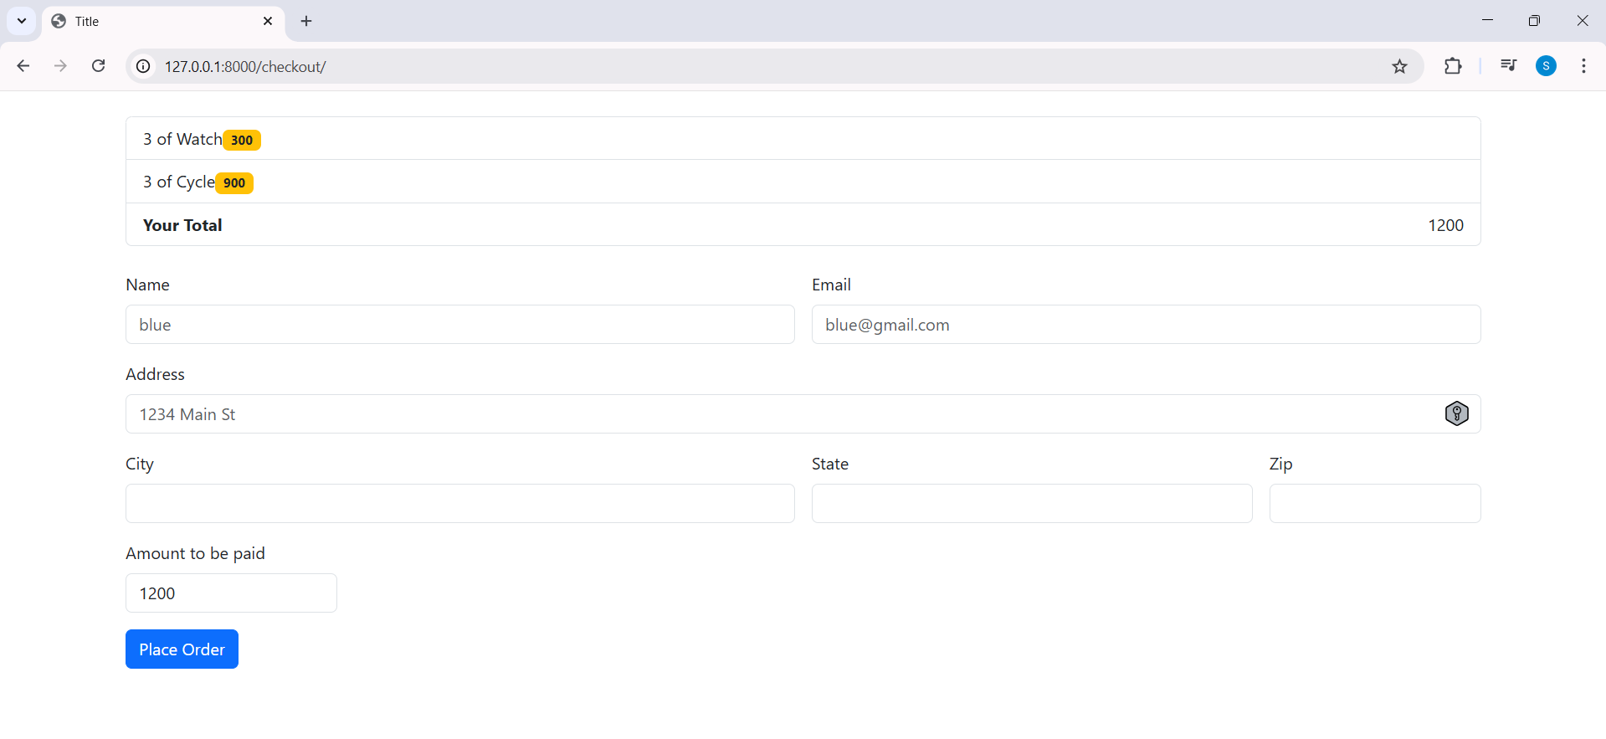

Amount to be paid automatically fill

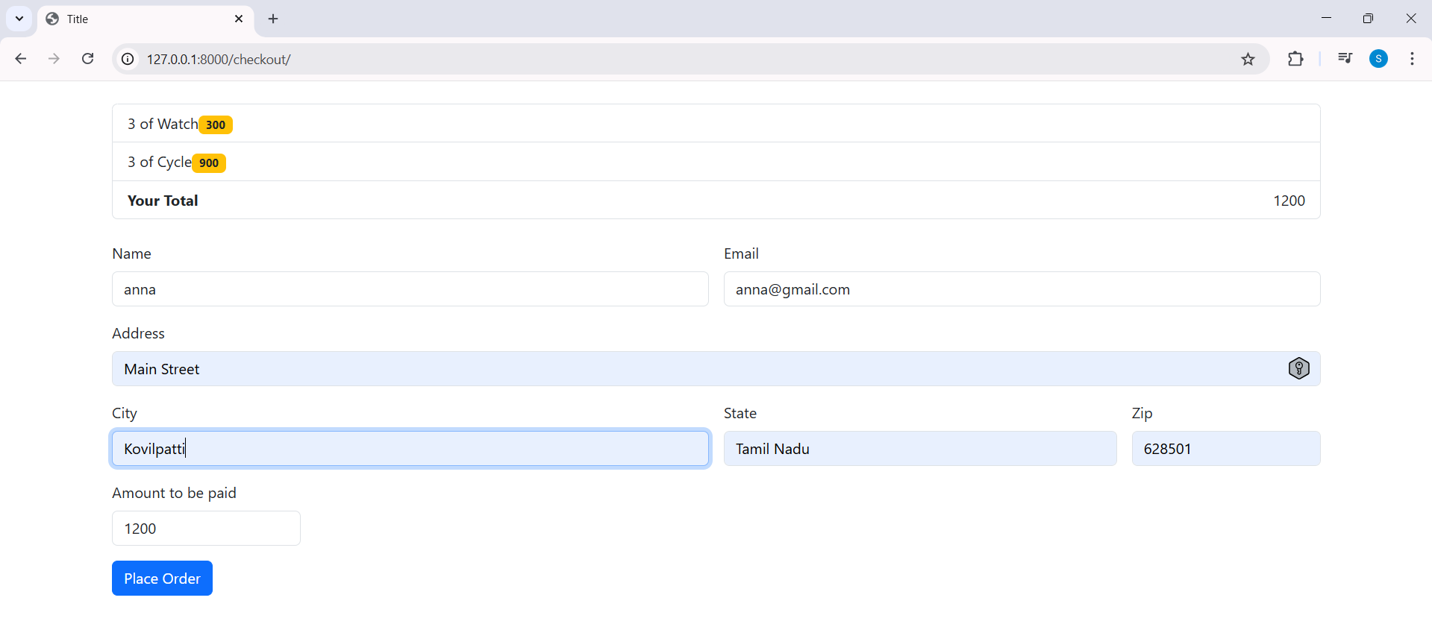

Data are in database

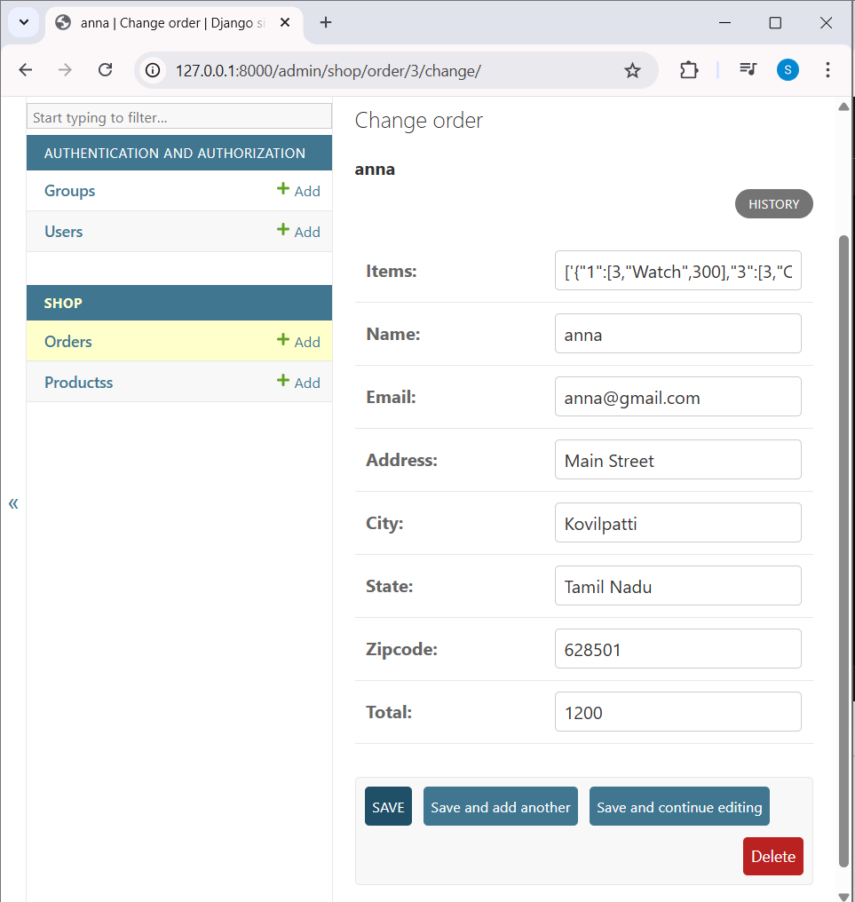

____________________________________________________________________________
Full code

urls.py

from django.contrib import admin
from django.urls import path
from shop import views
from django.conf import settings
from django.conf.urls.static import static

urlpatterns = [
path('admin/', admin.site.urls),
path('', views.index, name='index'),
path('<int:id>/',views.detail, name='detail'),
path('checkout/', views.checkout, name='checkout'),
]

if settings.DEBUG:
urlpatterns += static(settings.MEDIA_URL, document_root=settings.MEDIA_ROOT)

Style.css
.card-text{
color: green;
font-weight: 800;
}

.card-title{
font-weight: 900;
}

.card-img-top {
width: 100%;
height: 220px;
object-fit: cover;
}

Checkout.html
<!DOCTYPE html>
<html lang="en">
<head>
<meta charset="UTF-8">
<link href="https://cdn.jsdelivr.net/npm/bootstrap@5.3.2/dist/css/bootstrap.min.css" rel="stylesheet">
<script src="https://code.jquery.com/jquery-3.7.1.min.js"></script>
<title>Title</title>
</head>
<body>
<br>

<div class="container">
<div class="row">
<div class="col-md-12">
<ul class="list-group" id="item_list"></ul>
</div>
</div>
<br>

<div class="row">
<div class="col-md-12">
<form class="row g-3" method="POST">
{% csrf_token %}
<input type="hidden" id="items" name="items">
<div class="col-md-6">
<label for="inputEmail14" class="form-label">Name</label>
<input id="name" name="name" type="text" class="form-control" id="inputEmail14" placeholder="blue">
</div>
<div class="col-md-6">
<label for="inputPassword4" class="form-label">Email</label>
<input id="email" name="email" type="text" class="form-control" id="inputPassword4" placeholder="blue@gmail.com">
</div>
<div class="col-12">
<label for="inputAddress" class="form-label">Address</label>
<input id="address" name="address" type="text" class="form-control" id="inputAddress" placeholder="1234 Main St">
</div>
<div class="col-md-6">
<label for="inputCity" class="form-label">City</label>
<input id="city" name="city" type="text" class="form-control" id="inputCity">
</div>
<div class="col-md-4">
<label class="form-label">State</label>
<input id="state" name="state" type="text" class="form-control">
</div>
<div class="col-md-2">
<label for="inputZip" class="form-label">Zip</label>
<input id="zipcode" name="zipcode" type="text" class="form-control" id="inputZip">
</div>
<div class="col-md-2">
<label for="inputZip" class="form-label">Amount to be paid</label>
<input readonly="" type="text" class="form-control" id="total" name="total">
</div>
<div class="col-12">
<button type="submit" class="btn btn-primary">Place Order</button>
</div>
</form>
</div>
</div>

</div>

<script type="text/javascript">
let cart;

if (localStorage.getItem('cart') == null) {
cart = {};
} else {
cart = JSON.parse(localStorage.getItem('cart'));
}

let total = 0;
for (let item in cart) {
let name = cart[item][1];
let quantity = cart[item][0];
let price = cart[item][2];
total = total + cart[item][2];

let itemString = `<li class="list-group-item"><span>${quantity} of ${name}</span><span class="badge bg-warning text-dark">${price}</span></li>`;
$('#item_list').append(itemString);
}
let totalPrice = `<li class="list-group-item d-flex justify-content-between align-items-center"><b>Your Total</b>${total}</li> `
$('#total').val(total);
$('#item_list').append(totalPrice)
$('#items').val(JSON.stringify(cart));
</script>
</body>
</html>

Detail.html
<!--{% load static %}-->
<!DOCTYPE html>
<html lang="en">
<head>
<meta charset="UTF-8">
<link href="https://cdn.jsdelivr.net/npm/bootstrap@5.0.2/dist/css/bootstrap.min.css" rel="stylesheet" integrity="sha384-EVSTQN3/azprG1Anm3QDgpJLIm9Nao0Yz1ztcQTwFspd3yD65VohhpuuCOmLASjC" crossorigin="anonymous">
<script src="https://cdn.jsdelivr.net/npm/bootstrap@5.0.2/dist/js/bootstrap.bundle.min.js" integrity="sha384-MrcW6ZMFYlzcLA8Nl+NtUVF0sA7MsXsP1UyJoMp4YLEuNSfAP+JcXn/tWtIaxVXM" crossorigin="anonymous"></script>
<!-- <link rel="stylesheet" href="{% static 'shop/style.css' %}">-->
<title>Title</title>
</head>
<body>

<br>
<div class="container">
<div class="row">
<div class="col-md-6">
<div class="row">
<div class="col-md-12">
<img src="{{ product_object.image }}" class="card-img-top">
</div>
</div>
</div>

<div class="col-md-6">
<div class="row">
<div class="col-md-12">
{{ product_object.title }}
</div>
</div>

<div class="row">
<div class="col-md-12">
{{ product_object.price }}
</div>
</div>

<div class="row">
<div class="col-md-12">
{{ product_object.discount_price }}
</div>
</div>

<div class="row">
<div class="col-md-12">
{{ product_object.description }}
</div>
</div>

</div>

</div>
</div>
</body>
</html>

Index.html
{% load static %}
<!DOCTYPE html>
<html lang="en">
<head>
<meta charset="UTF-8">
<!-- Bootstrap 5.3 CSS -->
<link href="https://cdn.jsdelivr.net/npm/bootstrap@5.3.2/dist/css/bootstrap.min.css" rel="stylesheet">

<!-- jQuery (needed for your Add to Cart JS) -->
<script src="https://code.jquery.com/jquery-3.7.1.min.js"></script>

<!-- Bootstrap 5.3 JS Bundle (includes Popper) -->
<script src="https://cdn.jsdelivr.net/npm/bootstrap@5.3.2/dist/js/bootstrap.bundle.min.js"></script>

<!-- Your CSS -->
<link rel="stylesheet" href="{% static 'shop/style.css' %}">
<title>Title</title>
</head>
<body>

<div class="container">

<div class="row">
<div class="col-md-12">
<nav class="navbar navbar-expand-lg bg-body-tertiary">
<div class="container-fluid">
<a class="navbar-brand" href="#">Navbar</a>
<button class="navbar-toggler" type="button" data-bs-toggle="collapse" data-bs-target="#navbarNav" aria-controls="navbarNav" aria-expanded="false" aria-label="Toggle navigation">
<span class="navbar-toggler-icon"></span>
</button>
<div class="collapse navbar-collapse" id="navbarNav">
<ul class="navbar-nav">
<li class="nav-item">
<a class="nav-link active" aria-current="page" href="#">Home</a>
</li>
<li class="nav-item">
<a class="nav-link" href="#">Features</a>
</li>
<li class="nav-item">
<!--<a id="cart" class="nav-link" href="#">Cart(0)</a>-->
<button id="cart" data-bs-html="true" type="button" class="btn btn-secondary" data-bs-container="body" data-bs-toggle="popover" data-bs-placement="bottom" data-bs-content="<h5>This is your cart</h5>">
Cart(0)
</button>
</li>
<li class="nav-item">
<a class="nav-link disabled" aria-disabled="true">Disabled</a>
</li>
</ul>
</div>
</div>
</nav>
</div>
</div>

<div class="row">
<div class="col-md-12">

<form class="card card-sm" method="get" action="">
<div class="card-body row no-gutters align-items-center">
<div class="col">
<input
type="search"
name="item_name"
placeholder="Search for products"
class="form-control form-control-borderless"
>
</div>
<div class="col-auto">
<button class="btn btn-success" type="submit">
Search
</button>
</div>
</div>
</form>

</div>
</div>
<br>

<div class="row">
{% for product in product_objects %}
<div class="col-md-3">
<div class="card">
<img src="{{ product.image }}" class="card-img-top">
<div class="card-body">
<div id="nm{{product.id}}" class="card-title">{{ product.title }}</div>
<div id="price{{product.id}}" class="card-text">{{ product.price }}</div>
<a href="/{{product.id}}" class="btn btn-warning">View</a>
<button id="{{product.id}}" class="btn atc btn-warning">Add to Cart</button>

</div>
</div>
</div>
{% endfor %}
</div>

<br>

<div class="row">
<div class="col-md-3 offset-md-4">
<ul class="pagination">
{% if product_objects.has_previous %}
<li class="page-item">
<a class="page-link" href="?page={{ product_objects.previous_page_number }}">Previous</a>
</li>
{% endif %}

<li class="page-item active">
<a class="page-link" href="?page={{ product_objects.number }}">Current</a>
</li>

{% if product_objects.has_next %}
<li class="page-item">
<a class="page-link" href="?page={{ product_objects.next_page_number }}">Next</a>
</li>
{% endif %}

</ul>
</div>
</div>

</div>
</body>
<script type="text/javascript">
console.log('This is working');

if(localStorage.getItem('cart')==null){
var cart = {};
}
else{
cart = JSON.parse(localStorage.getItem('cart'));
}

$(document).on('click','.atc',function(){
console.log("The add to cart button is clicked");
var item_id = this.id.toString();
console.log(item_id);

if(cart[item_id]!=undefined){
<!--cart[item_id] = cart[item_id] + 1;-->
quantity = cart[item_id][0] + 1;
cart[item_id] [0] = quantity;
cart[item_id] [2] = cart[item_id] [2] + parseFloat(document.getElementById("price"+item_id).innerHTML);
<!--value of item(100) + add value for that item(100) => 200 -->
}
else{
<!--cart[item_id] = 1;-->
price = parseFloat(document.getElementById("price"+item_id).innerHTML);
quantity = 1;
name = document.getElementById("nm"+item_id).innerHTML;
cart[item_id]=[quantity,name,price];
}
console.log(cart);
localStorage.setItem('cart',JSON.stringify(cart));
document.getElementById("cart").innerHTML = "Cart("+ Object.keys(cart).length +")";
});

const popoverTriggerList = document.querySelectorAll('[data-bs-toggle="popover"]')
const popoverList = [...popoverTriggerList].map(popoverTriggerEl => new bootstrap.Popover(popoverTriggerEl))

DisplayCart(cart);
function DisplayCart(cart) {
let cartString = "<h5>Your Cart</h5>";

let index = 1;
for (let x in cart) {
let name = document.getElementById("nm" + x)?.innerHTML || "Item";

cartString += `
<div>
${index}. <strong>${name}</strong> — Qty: ${cart[x]}
</div>
`;
index++;
}

if (Object.keys(cart).length > 0) {
cartString += `
<hr>
<div class="d-grid">
<a href="/checkout" class="btn btn-warning btn-sm">
Checkout
</a>
</div>
`;
} else {
cartString += "<div>Cart is empty</div>";
}

let cartBtn = document.getElementById("cart");

let pop = bootstrap.Popover.getInstance(cartBtn);
if (pop) pop.dispose();

new bootstrap.Popover(cartBtn, {
html: true,
content: cartString,
placement: "bottom",
container: "body"
});
}
</script>
</html>

admin.py

from django.contrib import admin
from .models import Products,Order

# Register your models here.
admin.site.register(Products)
admin.site.register(Order)

apps.py
from django.apps import AppConfig

class ShopConfig(AppConfig):
name = 'shop'

models.py
from django.db import models

# Create your models here.
class Products(models.Model):
title = models.CharField(max_length=200)
price = models.FloatField()
discount_price = models.FloatField()
category = models.CharField(max_length=200)
description = models.TextField()
image = models.URLField(max_length=2000)

def __str__(self):
return self.title

class Order(models.Model):
items = models.CharField(max_length=1000)
name = models.CharField(max_length=200)
email = models.CharField(max_length=200)
address = models.CharField(max_length=1000)
city = models.CharField(max_length=200)
state = models.CharField(max_length=200)
zipcode = models.CharField(max_length=200)
total = models.CharField(max_length=200)

def __str__(self):
return self.name

views.py
from django.shortcuts import render
from .models import Products, Order
from django.core.paginator import Paginator

def index(request):
product_objects = Products.objects.all()

#search code
item_name = request.GET.get('item_name')
if item_name != '' and item_name is not None:
product_objects = Products.objects.filter(title__icontains=item_name)

#paginator code
paginator = Paginator(product_objects, 4)
page = request.GET.get('page')
product_objects = paginator.get_page(page)

return render(request, 'shop/index.html', {'product_objects': product_objects})

def detail(request, id):
product_object = Products.objects.get(id=id)
return render(request, 'shop/detail.html', {'product_object': product_object})

def checkout(request):

if request.method == "POST":
items = request.POST.getlist('items','')
name = request.POST.get('name',"")
email = request.POST.get('email',"")
address = request.POST.get('address',"")
city = request.POST.get('city',"")
state = request.POST.get('state',"")
zipcode = request.POST.get('zipcode',"")
total = request.POST.get('total',"")

order = Order(items=items,name=name,email=email,address=address,city=city,state=state,zipcode=zipcode,total=total)
order.save()

return render(request, 'shop/checkout.html')

manage.py
#!/usr/bin/env python
"""Django's command-line utility for administrative tasks."""
import os
import sys

def main():
"""Run administrative tasks."""
os.environ.setdefault('DJANGO_SETTINGS_MODULE', 'ecomsite.settings')
try:
from django.core.management import execute_from_command_line
except ImportError as exc:
raise ImportError(
"Couldn't import Django. Are you sure it's installed and "
"available on your PYTHONPATH environment variable? Did you "
"forget to activate a virtual environment?"
) from exc
execute_from_command_line(sys.argv)

if __name__ == '__main__':
main()

____________________________________________________________________________

