How payment gateway works

They enter their credit card information on Stripe, Stripe handles the payment.
Confirm the payment from the bank. Add that particular money into our account. After that send back the user to their own website.

Stripe will mention if the payment was successful or not.

In this application user has successfully made the payment and user has successfully made the payment and show the user the download link of particular product.

_________________________________________________________________________

Creating a Stripe checkout session

Code

@csrf_exempt
def create_checkout_session(request):
request_data = json.loads(request.body)
product = Product.objects.get(id=id)
stripe.api_key = settings.STRIPE_SECRET_KEY
checkout_session = stripe.checkout.Session.create(
customer_email = request_data['email'],
payment_method_types = ['card'],
line_items=[{
'price_data':{
'currency':'usd',
'product_data':{
'name':product.name,
},
'unit_amount': int(product.price * 100)
},
'quantity': 1,
}
],
mode='payment',
success_url = request.build_absolute_uri(reverse('success')) +
"?session_id={CHECKOUT_SESSION_ID}",
cancel_url = request.build_absolute_uri(reverse('failed')) ,
)

___________________________________________________________________________

Creating order Model

models.py

class OrderDetail(models.Model):
customer_email = models.EmailField()
product = models.ForeignKey(Product, on_delete=models.CASCADE)
amount = models.IntegerField()
stripe_payment_intent = models.CharField(max_length=100)
has_paid = models.BooleanField(default=False)
updated_on = models.DateTimeField(auto_now_add=True)

____________________________________________________________________________

Creating order in backend

views.py

order = OrderDetail()
order.customer_email = request_data['email']
order.product = product
order.stripe_payment_intent = request_data['payment_intent']
order.amount = int(product.price)
order.save()

return JsonResponse({'sessionId':checkout_session.id})

____________________________________________________________________________

Payment success view

urls.py

path('success/', views.payment_success_view, name='success'),

Payment_success.html

Success
views.py

def payment_success_view(request):
session_id = request.GET.get('session_id')
if session_id is None:
return HttpResponseNotFound()
stripe.api_key = settings.STRIPE_SECRET_KEY
session = stripe.checkout.Session.retrieve(session_id)
order = get_object_or_404(OrderDetail,stripe_payment_intent= session.payment_intent)
order.has_paid=True
order.save()

return render(request, 'myapp/payment_success.html', {'order': order})

____________________________________________________________________________
Payment failed view

urls.py

path('failed/', views.payment_failed_view, name='failed'),

Failed.html
Payment Failed

views.py
def payment_failed_view(request):
return render(request, 'myapp/failed.html')

____________________________________________________________________________

Url for create checkout session
urls.py

path('api/checkout-session/<int:id>/', views.create_checkout_session, name='api_checkout_session'),

___________________________________________________________________________

Font-end code for checkout using javascript

{% extends 'myapp/base.html' %}
{% block body %}
<div class="flex p-10">
<div>
<img src="https://www.pacificfoodmachinery.com.au/media/catalog/product/placeholder/default/no-product-image-400x400.png" alt="">
</div>
<div class="pl-10">
<div class="text-4xl mb-4">{{ product.name }}</div>
<div class="mb-4">{{ product.description }}</div>
<div class="mb-4 text-green-700 font-bold">${{ product.price }}</div>
<div>
<button id="checkout-button" class="bg-green-500 text-white px-4 py-2 rounded-sm">
Buy
</button>
</div>
<div id="myemail" hidden="">
{{ request.user.email }}
</div>
</div>
</div>
<script src="https://js.stripe.com/v3/"></script>
<script type="text/javascript">
var stripe = Stripe("{{ stripe_publishable_key }}");
var checkoutButton = document.getElementById("checkout-button");
checkoutButton.addEventListener("click", function () {
console.log("Button clicked");
var email = document.getElementById("myemail").innerText;

if (email.length == 0) {
alert("Please enter your email address");
return;
}

fetch("{% url 'api_checkout_session' id=product.id %}", {
method: 'POST',
body: JSON.stringify(
{ 'email': email },
)
})
.then(function (response) {
return response.json();
})
.then(function (session) {
return stripe.redirectToCheckout({ sessionId: session.sessionId });
})
.then(function (result) {
if (result.error) {
alert(result.error.message);
}
})
.catch(function (error) {
console.error("Error:", error);
});
});
</script><iframe name="__privateStripeController4881" frameborder="0" allowtransparency="true" scrolling="no" role="presentation" allow="payment *" src="https://js.stripe.com/v3/controller-with-preconnect-243f775a82246b7a9fd08f887002c074.html#__shared_params__[version]=v3&amp;__shared_params__[light_experiment_assignments]=%7B%22token%22%3A%224184eeb5-f78b-45d9-9734-1a6178b2b068%22%2C%22assignments%22%3A%7B%22elements_generic_skeleton_loader_v3%22%3A%22treatment%22%7D%7D&amp;apiKey=%7B%7B+stripe_publishable_key+%7D%7D&amp;stripeJsId=4184eeb5-f78b-45d9-9734-1a6178b2b068&amp;stripeObjId=sobj-69034001-a8a2-423a-94f0-5688fb071838&amp;firstStripeInstanceCreatedLatency=23&amp;controllerCount=1&amp;isCheckout=false&amp;stripeJsLoadTime=1770449864193&amp;manualBrowserDeprecationRollout=false&amp;mids[guid]=NA&amp;mids[muid]=NA&amp;mids[sid]=NA&amp;referrer=file%3A%2F%2F%2FC%3A%2FUsers%2FMari%2FAppData%2FLocal%2FTemp%2F78a7b45c-6ca0-4442-8b8a-b1163e3aa16e_digitalm.zip.16e%2Fdigitalm%2Fmysite%2Fmyapp%2Ftemplates%2Fmyapp%2Fdetail.html&amp;controllerId=__privateStripeController4881" aria-hidden="true" tabindex="-1" style="border: none !important; margin: 0px !important; padding: 0px !important; width: 1px !important; min-width: 100% !important; overflow: hidden !important; display: block !important; visibility: hidden !important; position: fixed !important; height: 1px !important; pointer-events: none !important; user-select: none !important;"></iframe>
{% endblock %}
<iframe name="__privateStripeMetricsController4880" frameborder="0" allowtransparency="true" scrolling="no" role="presentation" allow="payment *" src="https://js.stripe.com/v3/m-outer-3437aaddcdf6922d623e172c2d6f9278.html#url=file%3A%2F%2F%2FC%3A%2FUsers%2FMari%2FAppData%2FLocal%2FTemp%2F78a7b45c-6ca0-4442-8b8a-b1163e3aa16e_digitalm.zip.16e%2Fdigitalm%2Fmysite%2Fmyapp%2Ftemplates%2Fmyapp%2Fdetail.html&amp;title=&amp;referrer=&amp;muid=NA&amp;sid=NA&amp;version=6&amp;preview=false&amp;__shared_params__[version]=v3" aria-hidden="true" tabindex="-1" style="border: none !important; margin: 0px !important; padding: 0px !important; width: 1px !important; min-width: 100% !important; overflow: hidden !important; display: block !important; visibility: hidden !important; position: fixed !important; height: 1px !important; pointer-events: none !important; user-select: none !important;"></iframe></body>

____________________________________________________________________________
Fixing errors

____________________________________________________________________________

Creating Success Page

Payment_successful.html

{% extends 'myapp/base.html' %}
{% block body %}
<div class="grid place-tems-center h-screen">
<div class="font-bold text-6xl">Payment Successful</div>
<a class="bg-green-500 font-bold text-white px-4 py-2" href="{{ order.product.file.url }}" download>Click here to download</a>
</div>
{% endblock %}

Failed.html

{% extends 'myapp/base.html' %}
{% block body %}
<div class="grid place-tems-center h-screen">
<div class="font-bold text-6xl">Payment Failed</div>
<a class="bg-green-500 font-bold text-white px-4 py-2" href="{% url 'index' %}" download>Go back to the homepage</a>
</div>
{% endblock %}

Oc

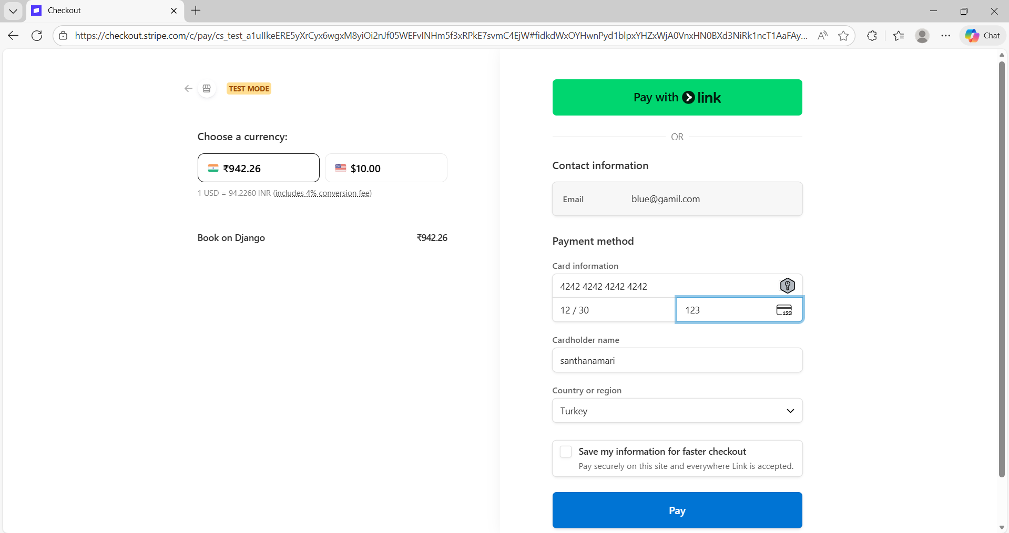

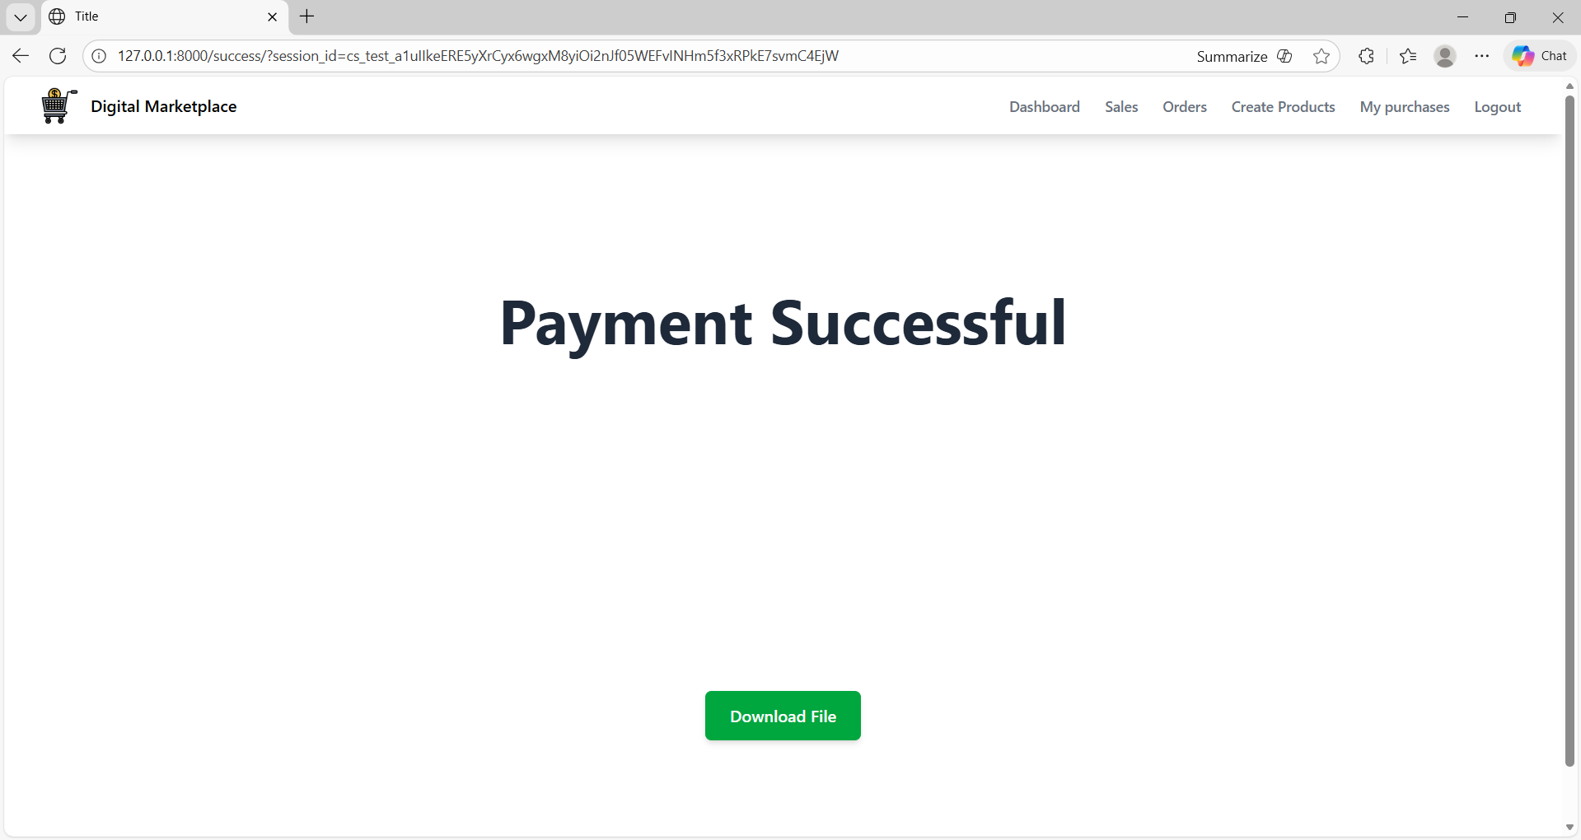

Click download

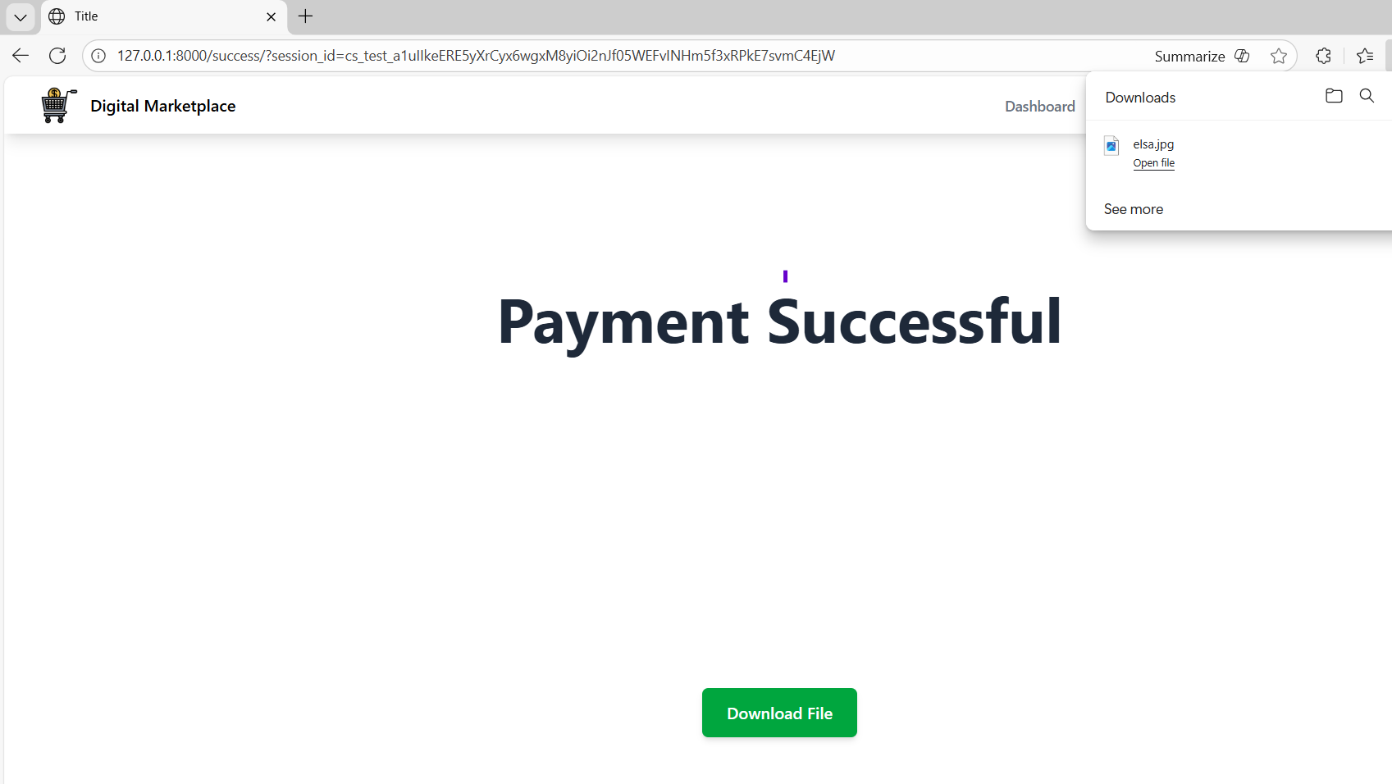

Admin

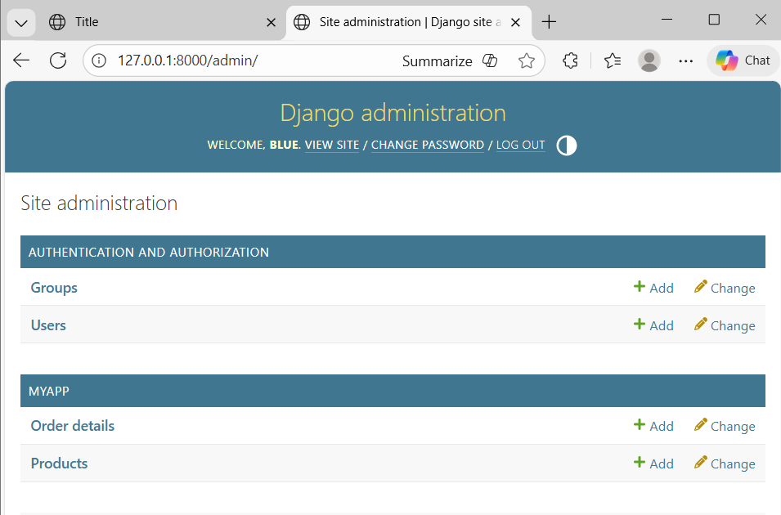

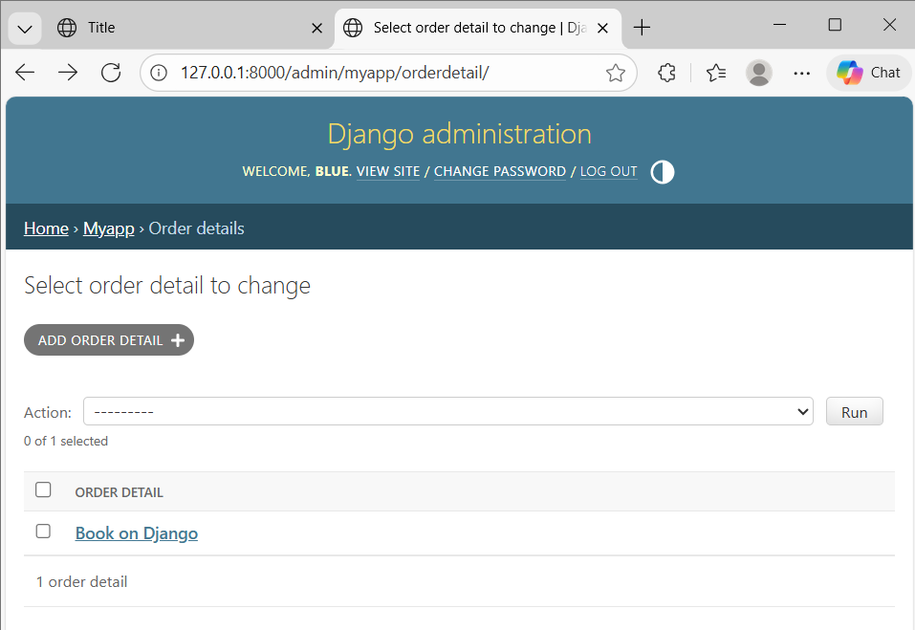
____________________________________________________________________________

Create Product Form

Oc

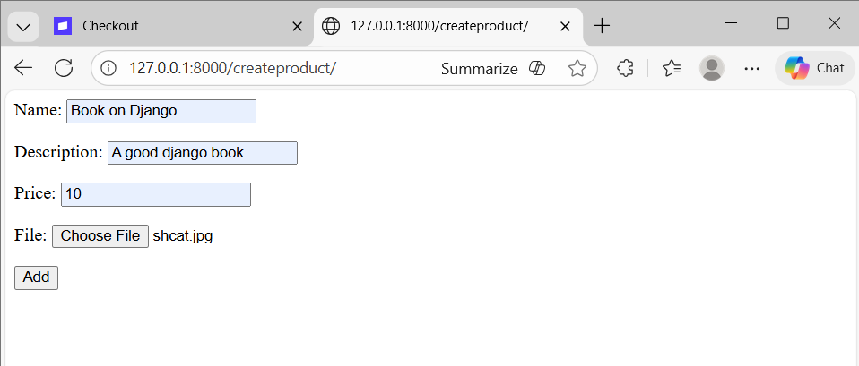

Click add form is submitted.

Code

Create_product.html

<form method="post">
{% csrf_token %}
{{ product_form.as_p }}
<button type="submit">Add</button>
</form>

views.py

def create_product(request):
product_form = ProductForm()
return render(request,
'myapp/create_product.html',
{'product_form': product_form})

urls.py

path('createproduct/',views.create_product, name='create_product'),

____________________________________________________________________________

Handling post request

Oc

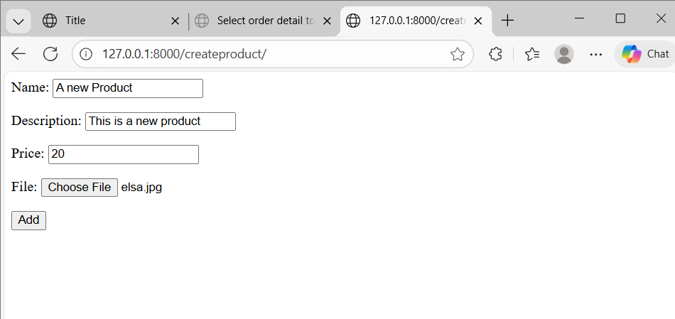

Click add

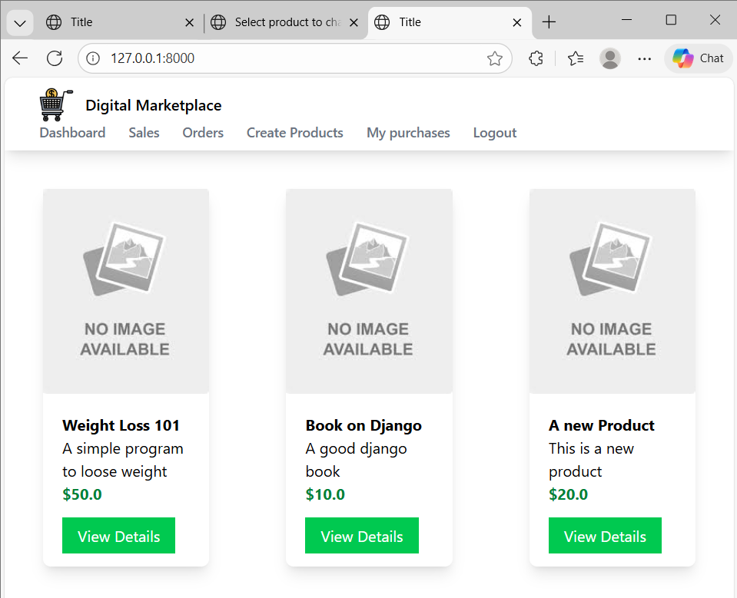

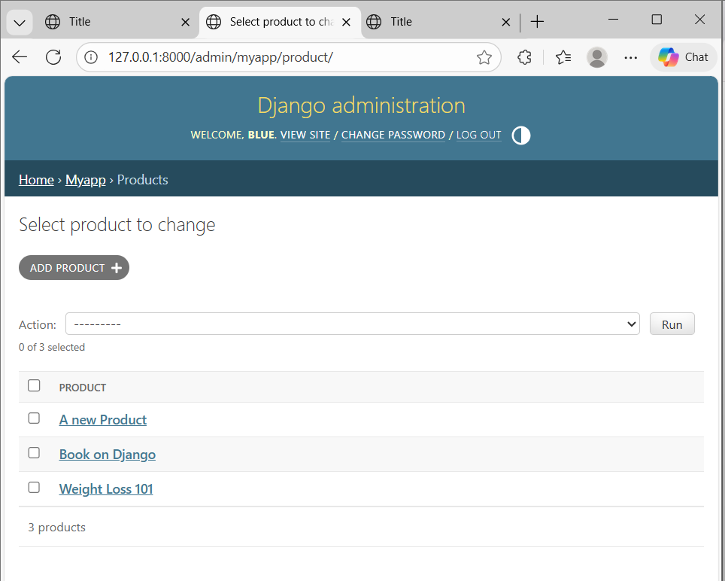

____________________________________________________________________________

Style create form

Oc

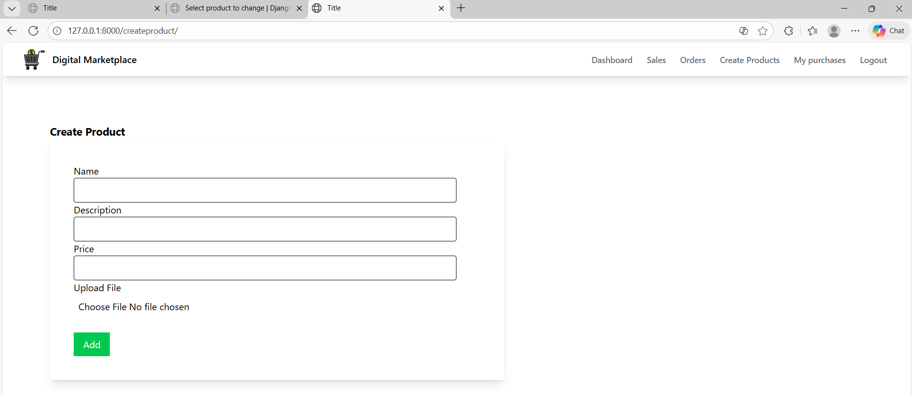

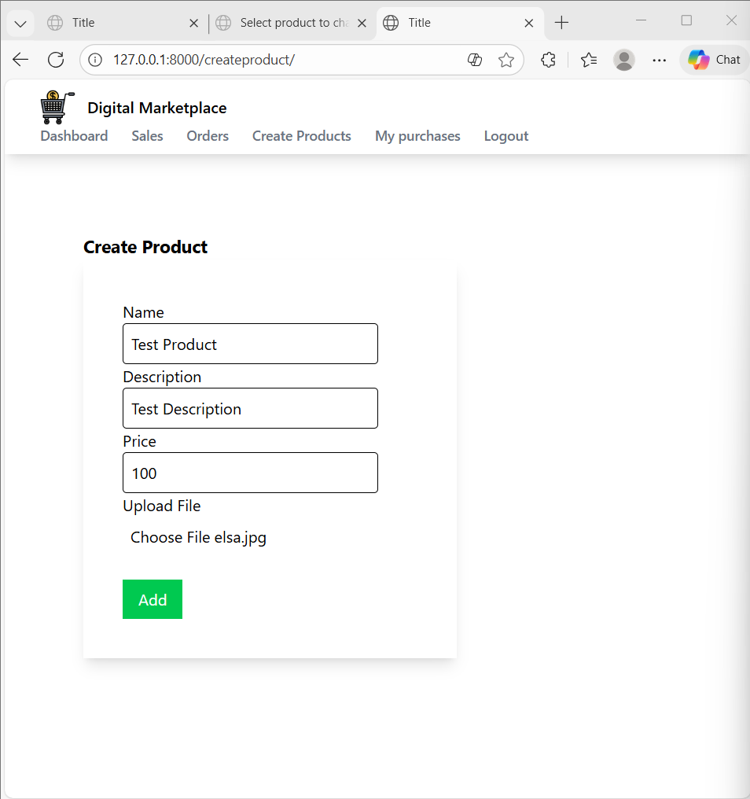

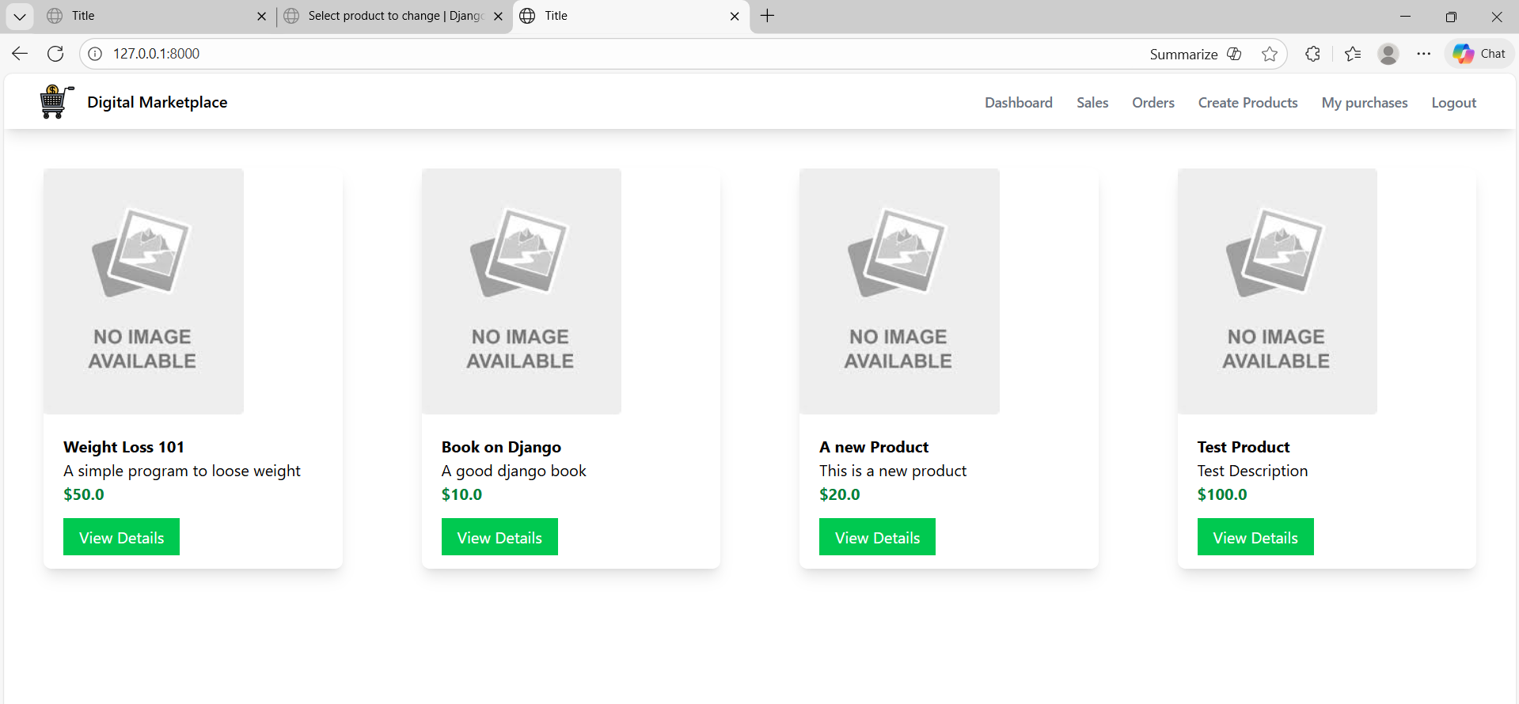

Code
Create_product.html

{% extends 'myapp/base.html' %}
{% block body %}
<div class="w-1/2 m-20">
<h1 class="font-bold text-lg">Create Product</h1>
<form class="shadow-lg p-10" method="post" enctype="multipart/form-data">
{% csrf_token %}
<div>
<label>Name</label>
<div class="border rounded appearance-none py-2 px-2 mr-10">{{ product_form.name }}</div>
</div>
<div>
<label>Description</label>
<div class="border rounded appearance-none py-2 px-2 mr-10">{{ product_form.description }}</div>
</div>
<div>
<label>Price</label>
<div class="border rounded appearance-none py-2 px-2 mr-10">{{ product_form.price }}</div>
</div>
<div>
<label>Upload File</label>
<div class=" rounded appearance-none py-2 px-2 mr-10">{{ product_form.file }}</div>
</div>
<div class="mt-6">
<button class="bg-green-500 text-white px-4 py-2" type="submit">Add</button>
</div>
</form>
</div>
{% endblock %}

___________________________________________________________________________

Editing product

Oc

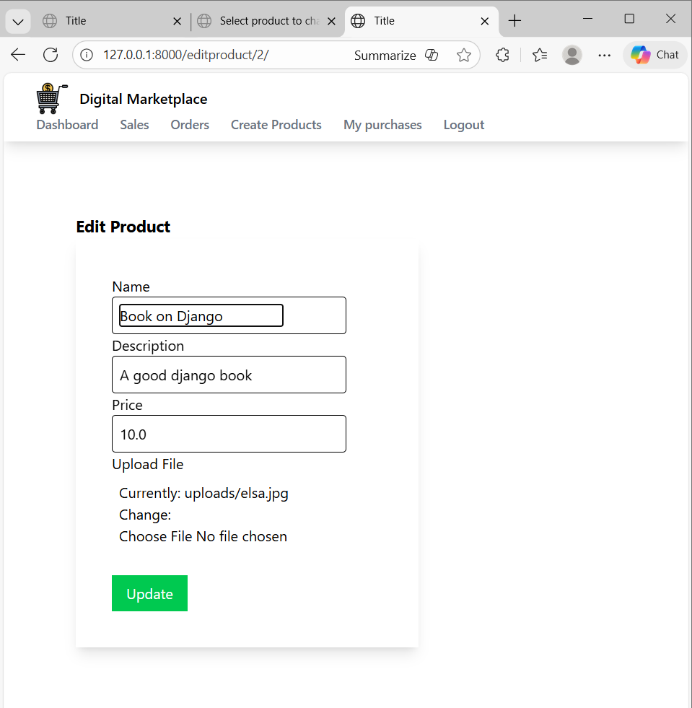

Code

views.py

def product_edit(request, id):
product = Product.objects.get(id=id)

if request.method == 'POST':
product_form = ProductForm(request.POST, request.FILES, instance=product)
if product_form.is_valid():
product_form.save()
return redirect('product_list') # change to your URL name
else:
product_form = ProductForm(instance=product)

return render(request, 'myapp/product_edit.html', {
'product_form': product_form
})

Product_edit.html

{% extends 'myapp/base.html' %}
{% block body %}
<div class="w-1/2 m-20">
<h1 class="font-bold text-lg">Edit Product</h1>
<form class="shadow-lg p-10" method="post" enctype="multipart/form-data">
{% csrf_token %}
<div>
<label>Name</label>
<div class="border rounded appearance-none py-2 px-2 mr-10">{{ product_form.name }}</div>
</div>
<div>
<label>Description</label>
<div class="border rounded appearance-none py-2 px-2 mr-10">{{ product_form.description }}</div>
</div>
<div>
<label>Price</label>
<div class="border rounded appearance-none py-2 px-2 mr-10">{{ product_form.price }}</div>
</div>
<div>
<label>Upload File</label>
<div class=" rounded appearance-none py-2 px-2 mr-10">{{ product_form.file }}</div>
</div>
<div class="mt-6">
<button class="bg-green-500 text-white px-4 py-2" type="submit">Update</button>
</div>
</form>
</div>
{% endblock %}

____________________________________________________________________________

Handing edit post request

Oc

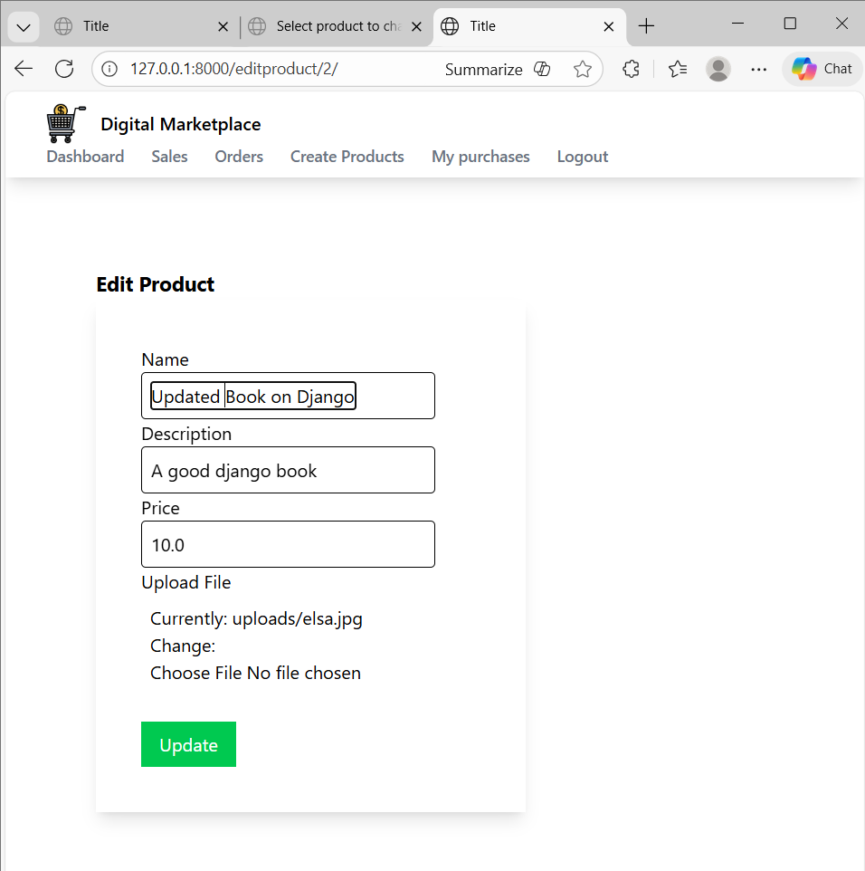

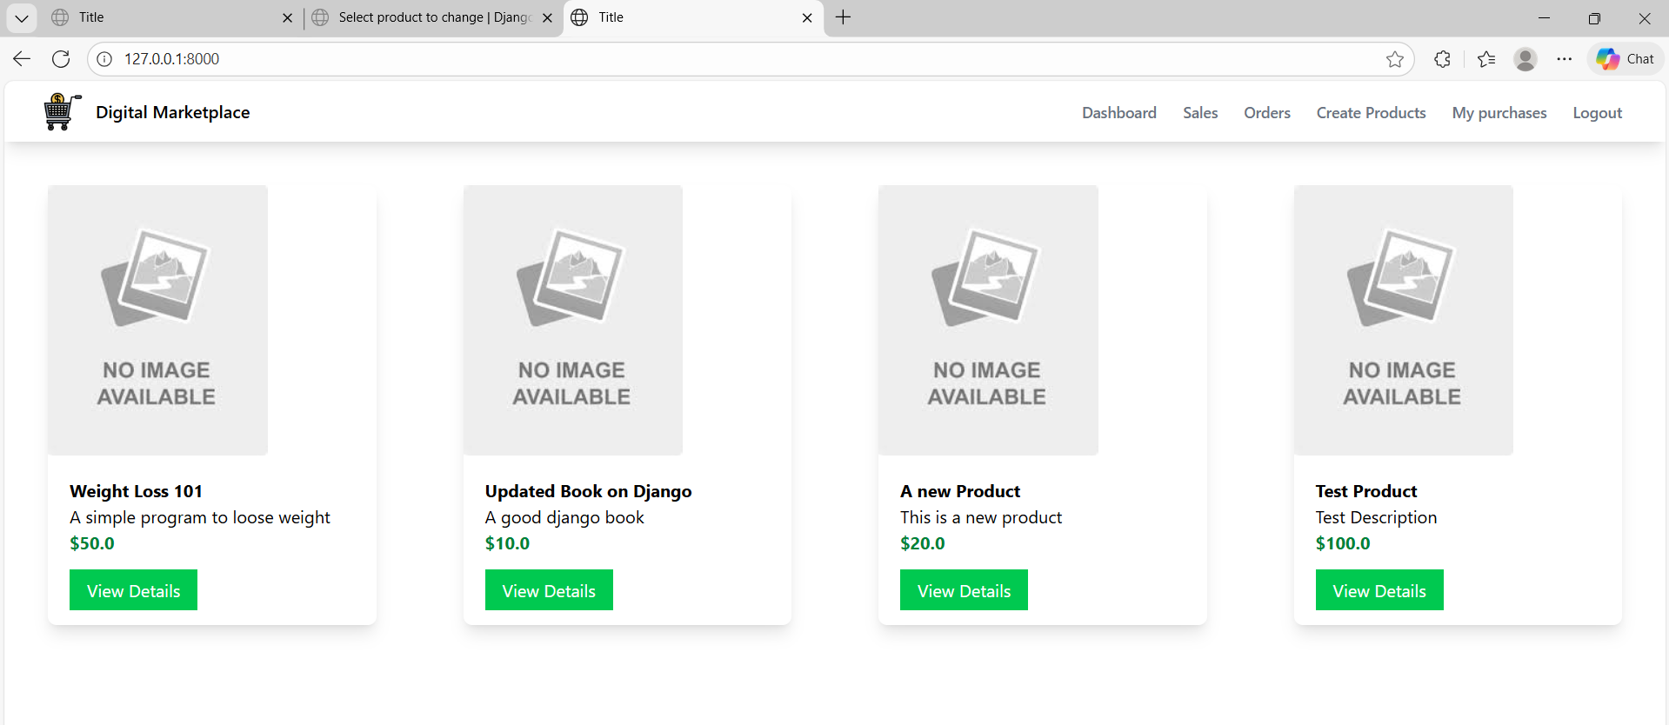

views.py

def product_edit(request, id):
product = Product.objects.get(id=id)

if request.method == 'POST':
product_form = ProductForm(request.POST, request.FILES, instance=product)
if product_form.is_valid():
product_form.save()
return redirect('index')
else:
product_form = ProductForm(instance=product)

return render(request, 'myapp/product_edit.html', {
'product_form': product_form
})

___________________________________________________________________________
Delete functionality

Oc

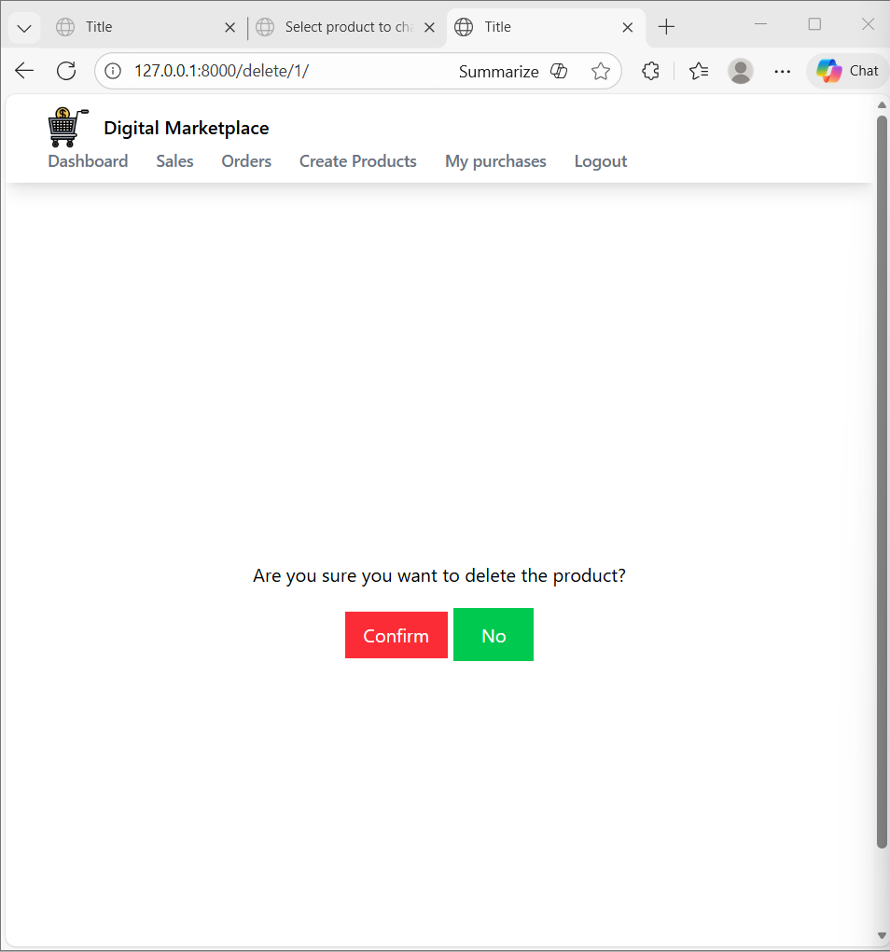
Click no go to index

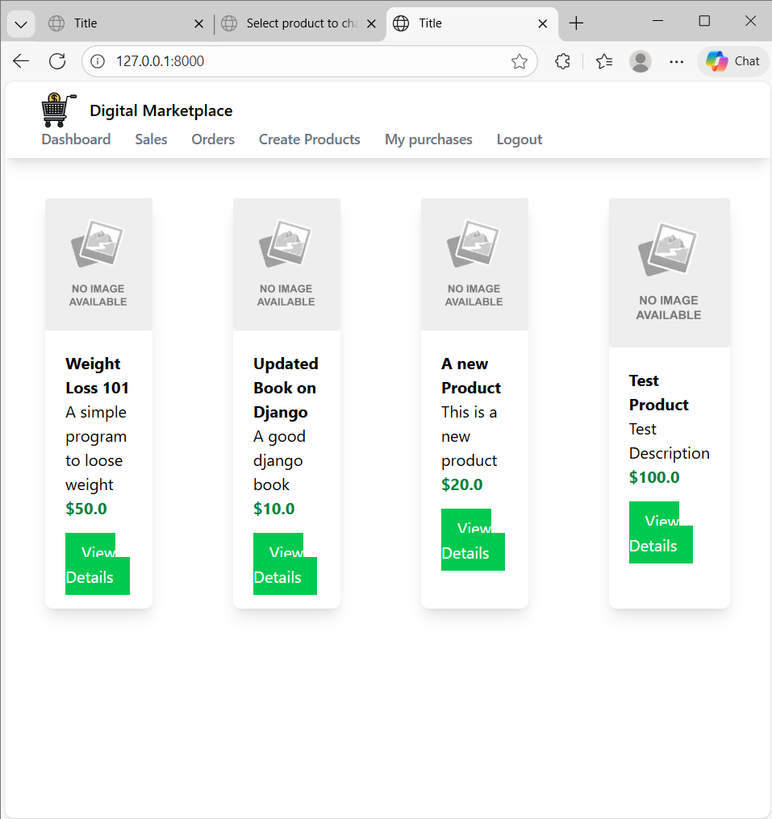

Delete third one

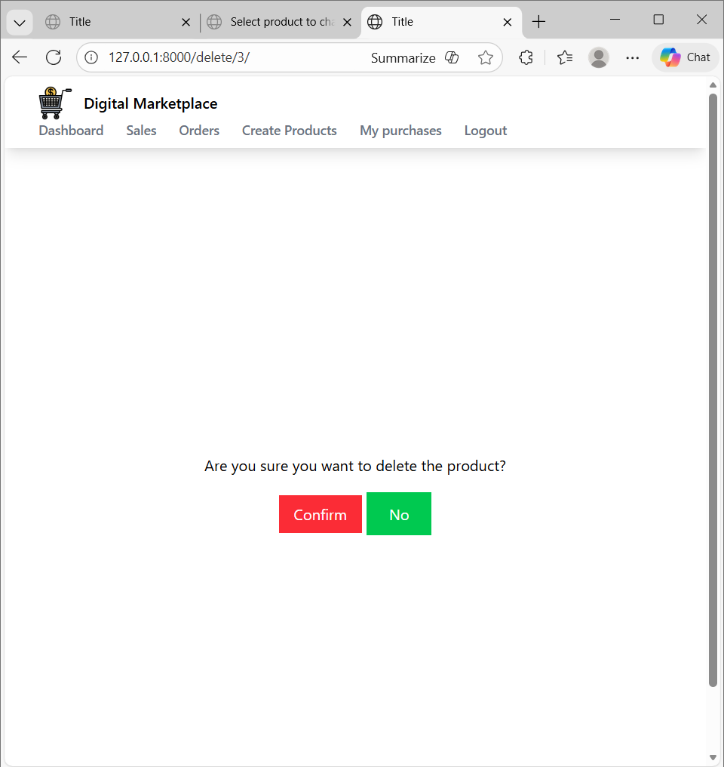

Click confirm 3 one is deleted

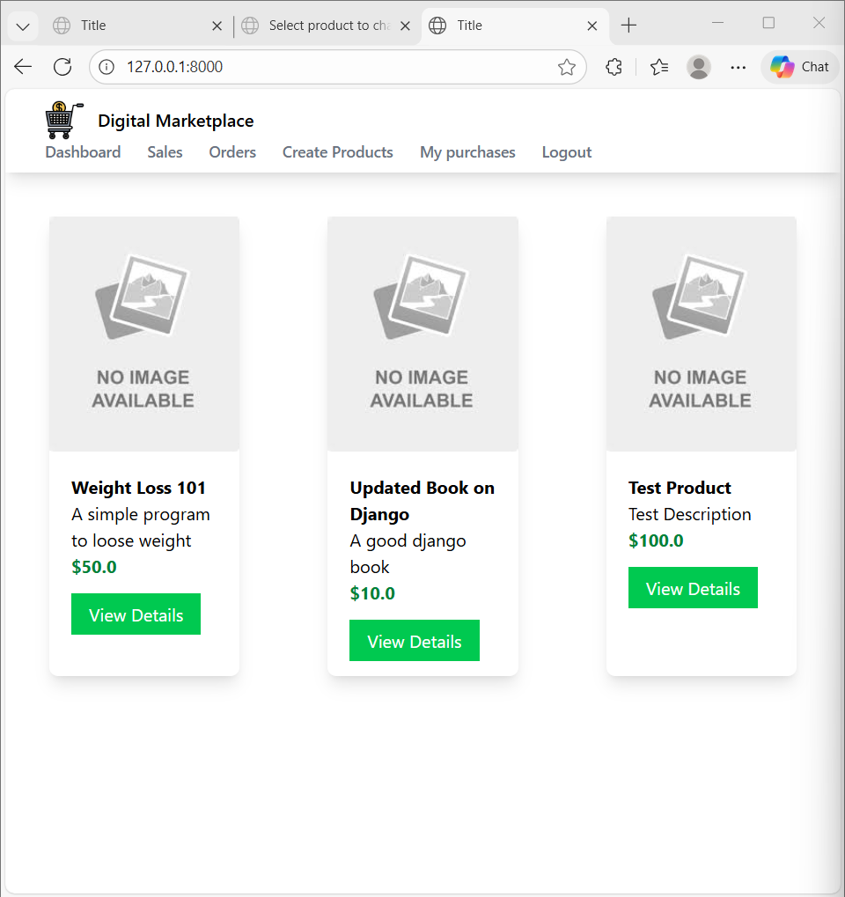

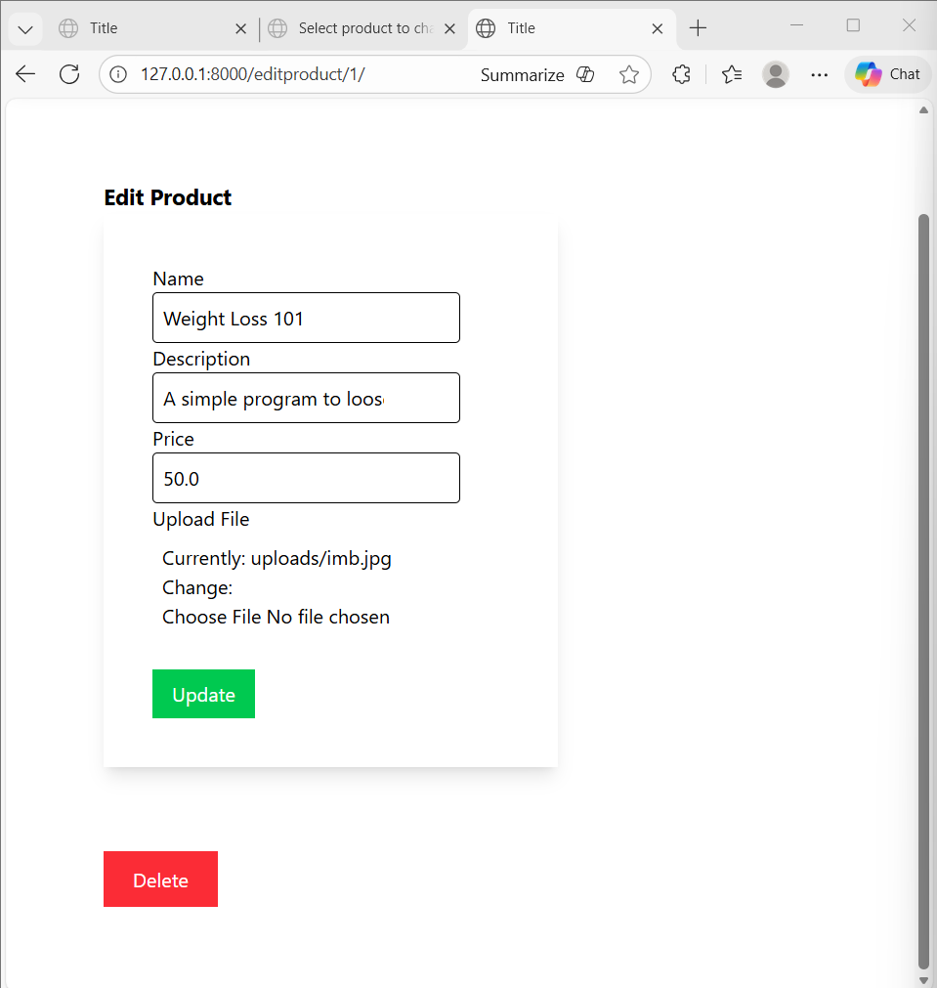

Code

Product_edit.html

{% extends 'myapp/base.html' %}
{% block body %}
<div class="w-1/2 m-20">
<h1 class="font-bold text-lg">Edit Product</h1>
<form class="shadow-lg p-10" method="post" enctype="multipart/form-data">
{% csrf_token %}
<div>
<label>Name</label>
<div class="border rounded appearance-none py-2 px-2 mr-10">{{ product_form.name }}</div>
</div>
<div>
<label>Description</label>
<div class="border rounded appearance-none py-2 px-2 mr-10">{{ product_form.description }}</div>
</div>
<div>
<label>Price</label>
<div class="border rounded appearance-none py-2 px-2 mr-10">{{ product_form.price }}</div>
</div>
<div>
<label>Upload File</label>
<div class=" rounded appearance-none py-2 px-2 mr-10">{{ product_form.file }}</div>
</div>
<div class="mt-6">
<button class="bg-green-500 text-white px-4 py-2" type="submit">Update</button>
</div>
</form>
</div>
<div class="m-20">
<a class="bg-red-500 text-white px-6 py-3" href="{% url 'delete_product' product.id %}">Delete</a>
</div>
{% endblock %}

Delete.html

{% extends 'myapp/base.html' %}
{% block body %}
<div class="flex flex-col justify-center items-center min-h-screen">
<h1 class="mb-5">Are you sure you want to delete the product?</h1>
<form action="{% url 'delete_product' product.id %}" method="post">
{% csrf_token %}
<button class="bg-red-500 text-white px-4 py-2">Confirm</button>
<a class="bg-green-500 text-white px-6 py-3" href="{% url 'index' %}">No</a>
</form>
</div>
{% endblock %}

views.py

def product_delete(request, id):
product = Product.objects.get(id=id)
if request.method == "POST":
product.delete()
return redirect('index')
return render(request, 'myapp/delete.html', {'product': product})

urls.py

path('editproduct/<int:id>/',views.product_edit, name='edit_product'),
path('delete/<int:id>/',views.product_delete, name='delete_product'),

____________________________________________________________________________

Creating Dashboard

Oc

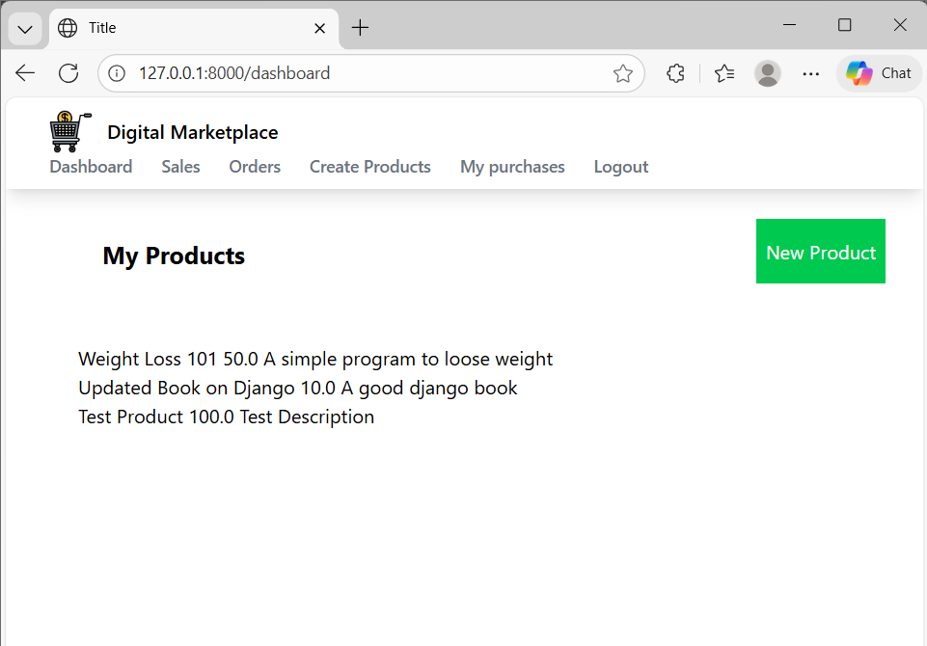
Click new product

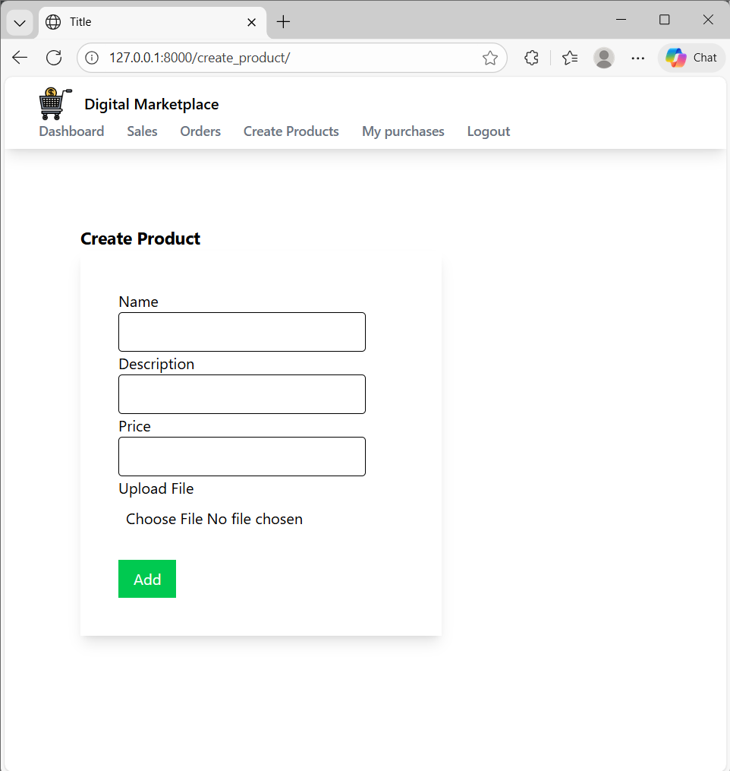

Code

Dashboard.html

{% extends 'myapp/base.html' %}
{% block body %}
<div class="flex justify-between">
<div class="ml-20 mt-10 font-bold text-xl">My Products</div>
<div class="ml-20 mt-10">
<a href="{% url 'create_product' %}"
class="bg-green-500 text-white px-2 py-4 mr-8">
New Product
</a>
</div>
</div>
</div>

<div class="products-container p-10 m-5">
{% for product in products %}
{{product.name}}
{{product.price}}
{{product.description}}<br>
{% endfor %}
</div>

{% endblock %}

____________________________________________________________________________

Styling Dashboard

Oc

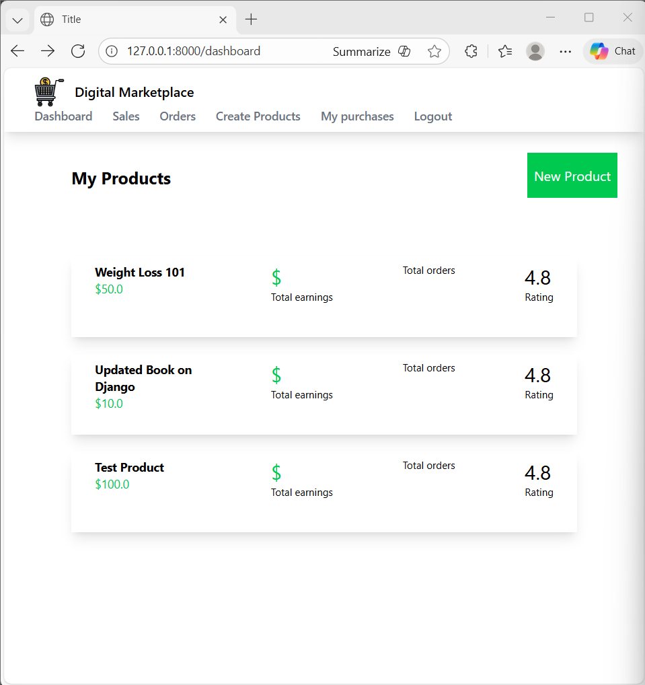

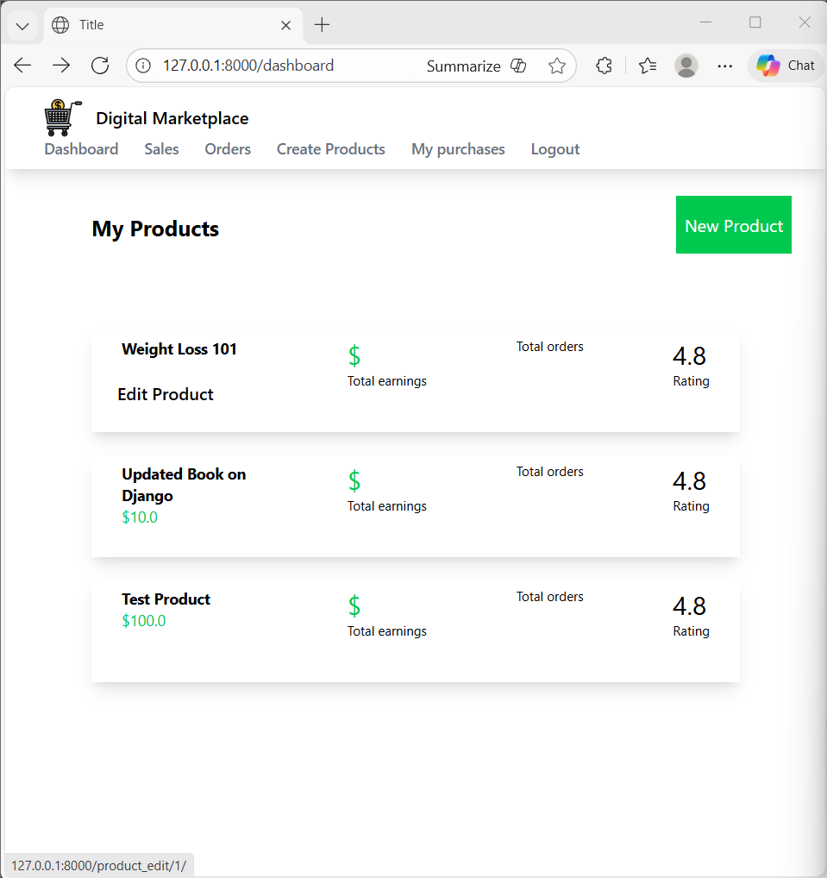

Click edit product

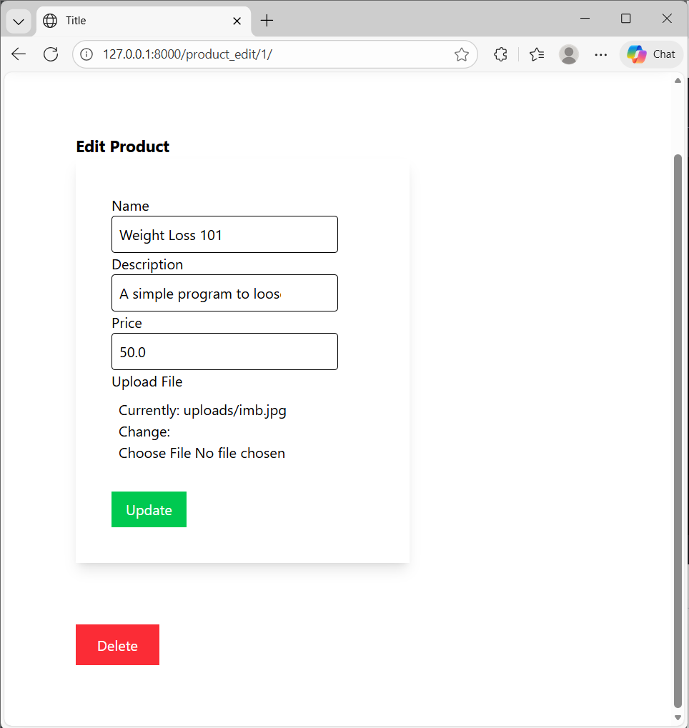

Code

Dashboard.html

{% extends 'myapp/base.html' %}
{% block body %}
<div class="flex justify-between">
<div class="ml-20 mt-10 font-bold text-xl">My Products</div>
<div class="ml-20 mt-10">
<a href="{% url 'create_product' %}"
class="bg-green-500 text-white px-2 py-4 mr-8">
New Product
</a>
</div>
</div>
</div>

<div class="products-container p-10 m-5">
{% for product in products %}
<div class="flex shadow-lg m-5 p-2 justify-between">
<div class="flex w-1/4">
<img class="h-20" src="https://www.pacificfoodmachinery.com.au/media/catalog/product/placeholder/default/no-product-image-400x400.png" alt="">
<div class="relative group">
<a href="{% url 'edit_product' product.id %}">
<div class="opacity-0 group-hover:opacity-100 duration-300 absolute inset-x-0 bottom-0 p-4 justify-center items-end bg-white font-semibold">
Edit Product
</div>
<div class="ml-5">
<div class="font-bold text-sm"> {{ product.name }}</div>
<div class="text-sm text-green-500">${{ product.price }}</div>
</div>
</a>
</div>
</div>

<div>
<div class="text-2xl text-green-500">$ {{ product.total_sales_amount }}</div>
<div class="text-xs">Total earnings</div>
</div>
<div>
<div class="text-2xl">{{ product.total_sales }}</div>
<div class="text-xs">Total orders</div>
</div>
<div class="pr-5">
<div class="text-2xl">4.8</div>
<div class="text-xs">Rating</div>
</div>
</div>
{% endfor %}
</div>
{% endblock %}

___________________________________________________________________________

Registration Form

Oc

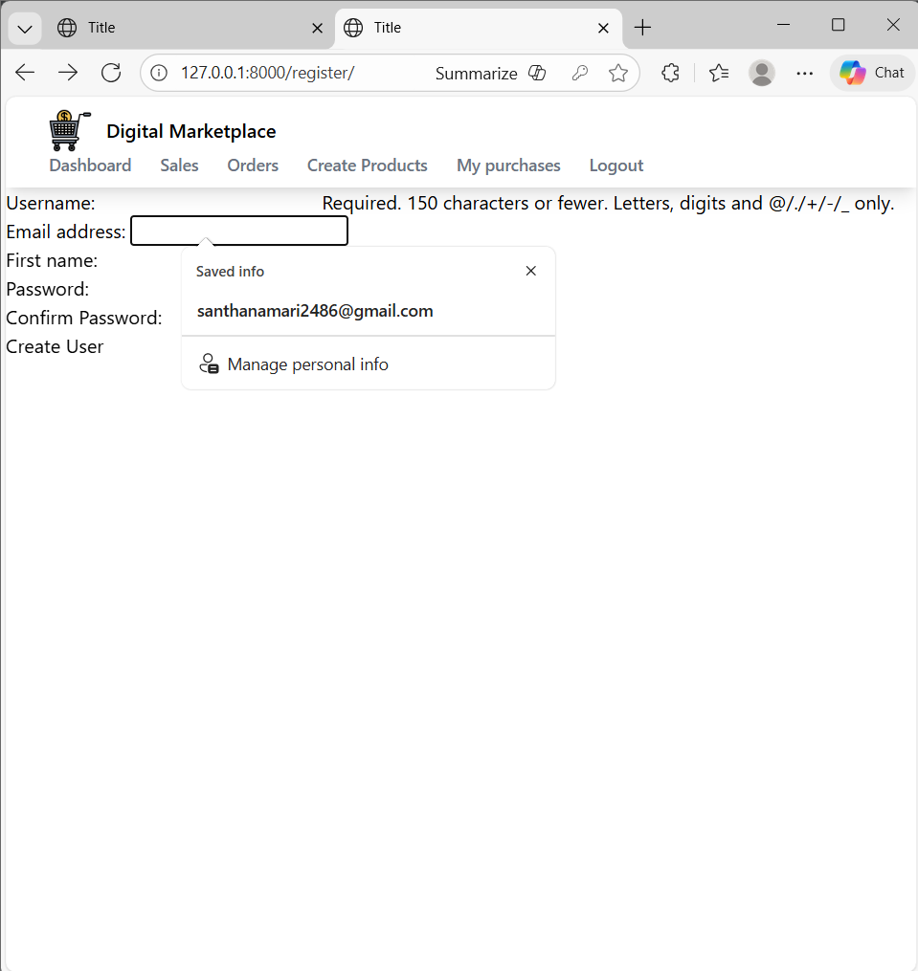

Code

views.py

def register(request):
user_form = UserRegistrationForm()
return render(request, 'myapp/register.html',{'user_form': user_form})

Register.html

{% extends 'myapp/base.html' %}
{% block body %}
<form method="post">
{{ user_form.as_p }}
<button type="submit">Create User</button>
</form>

{% endblock %}

forms.py

class UserRegistrationForm(forms.ModelForm):
password = forms.CharField(label='Password',widget=forms.PasswordInput)
password2 = forms.CharField(label='Confirm Password',widget=forms.PasswordInput)
class Meta:
model = User
fields = ['username', 'email', 'first_name']

def clean_password(self):
if self.cleaned_data['password'] != self.cleaned_data['password2']:
raise forms.ValidationError('Passwords must match')
return self.cleaned_data['password2']

urls.py

path('register/', views.register, name='register'),

____________________________________________________________________________

Handling Registration Post Request

Oc

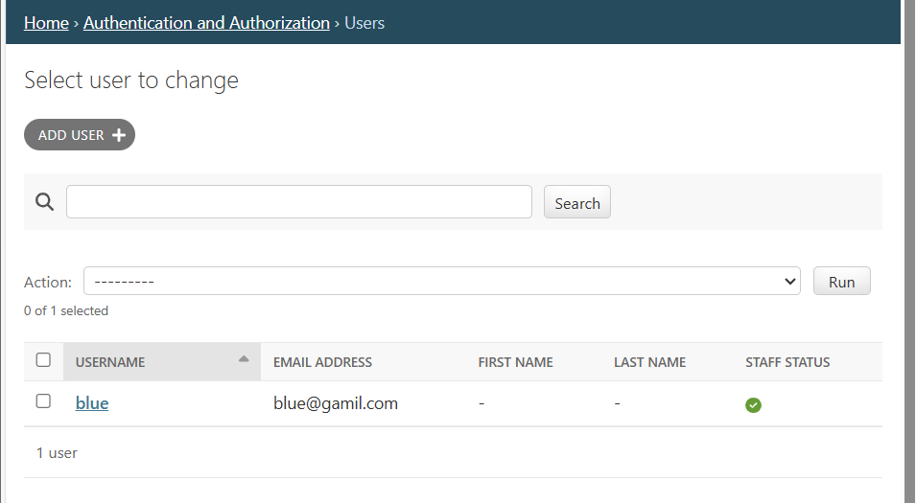

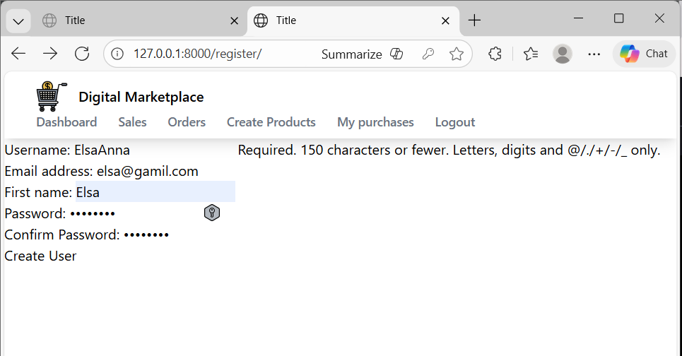

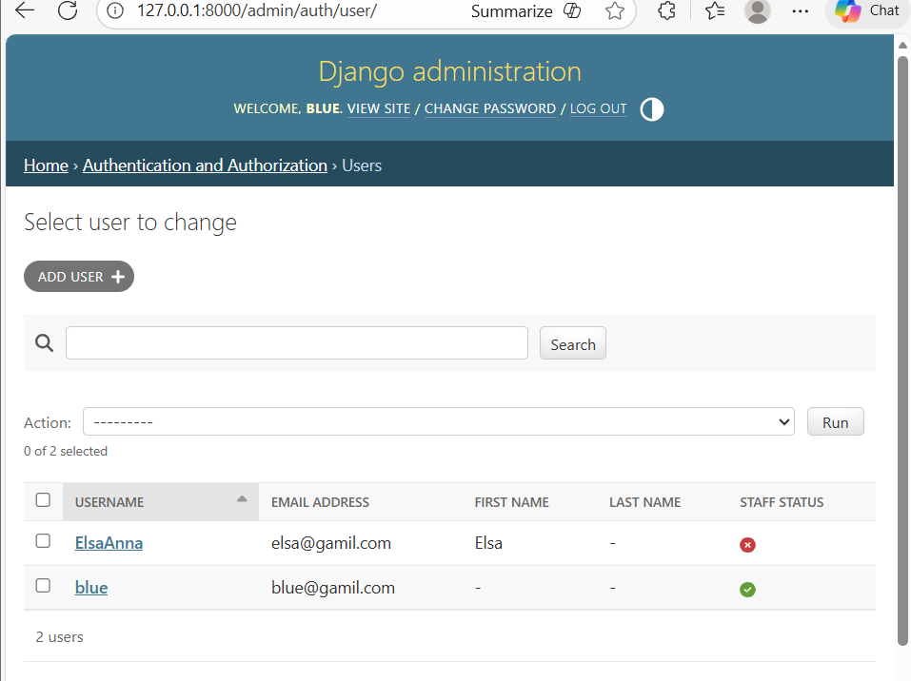

Code

forms.py

class UserRegistrationForm(forms.ModelForm):
password = forms.CharField(
label='Password',
widget=forms.PasswordInput
)
password2 = forms.CharField(
label='Confirm Password',
widget=forms.PasswordInput
)

class Meta:
model = User
fields = ['username', 'email', 'first_name']

def clean(self):
cleaned_data = super().clean()
password = cleaned_data.get('password')
password2 = cleaned_data.get('password2')

if password and password2 and password != password2:
raise forms.ValidationError('Passwords must match')

return cleaned_data

Register.html

{% extends 'myapp/base.html' %}
{% block body %}
<form method="post">
{% csrf_token %}
{{ user_form.as_p }}
<button type="submit">Create User</button>
</form>

{% endblock %}

____________________________________________________________________________

Styling Register Form

Oc

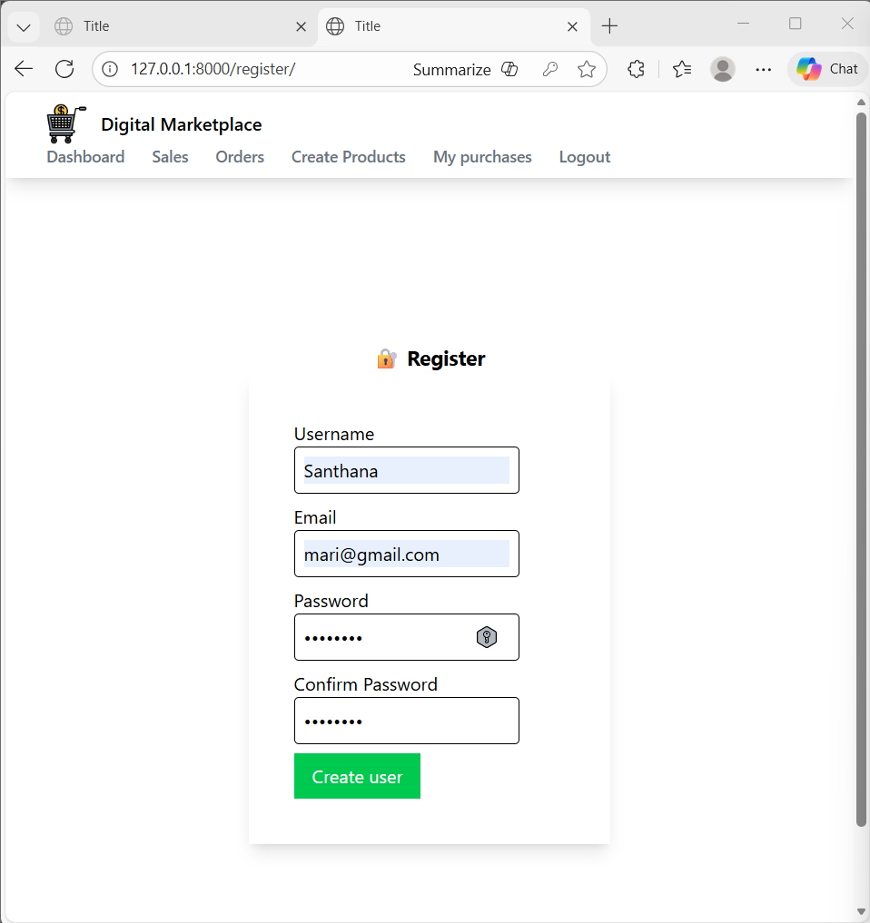

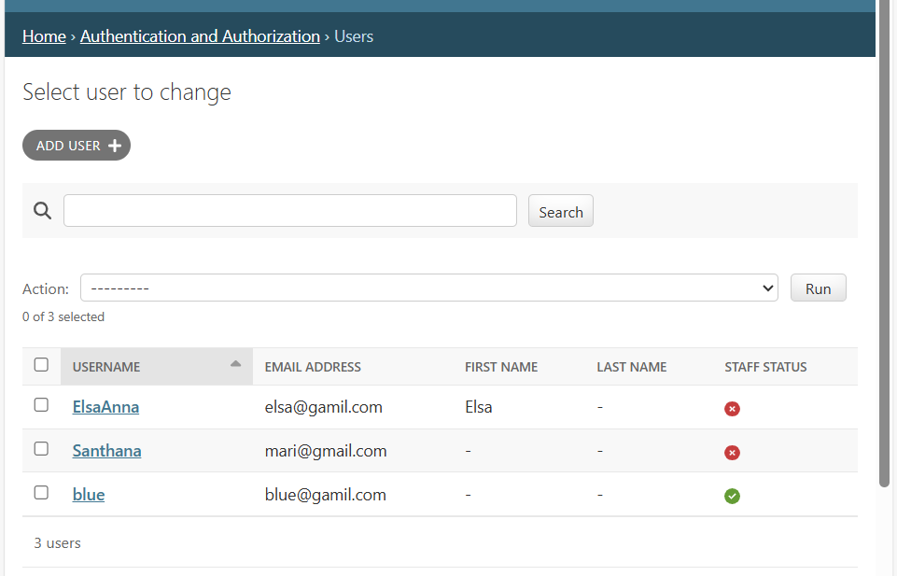

Code

Register.html

{% extends 'myapp/base.html' %}
{% block body %}
<div class="flex flex-col justify-center items-center min-h-screen">
<h1 class="font-bold text-lg">🔐 Register</h1>
<form class="shadow-lg p-10" method="POST">
{% csrf_token %}
<div class="mb-2">
<label>Username</label>
<div class="border rounded py-2 px-2 mr-10">
{{ user_form.username }}
</div>
</div>
<div class="mb-2">
<label>Email</label>
<div class="border rounded py-2 px-2 mr-10">
{{ user_form.email }}
</div>
</div>
<div class="mb-2">
<label>Password</label>
<div class="border rounded py-2 px-2 mr-10">
{{ user_form.password }}
</div>
</div>
<div class="mb-2">
<label>Confirm Password</label>
<div class="border rounded py-2 px-2 mr-10">
{{ user_form.password2 }}
</div>
</div>
<button class="bg-green-500 text-white px-4 py-2" type="submit">Create user</button>
</form>
</div>

{% endblock %}

___________________________________________________________________________

Login Functionality

Oc

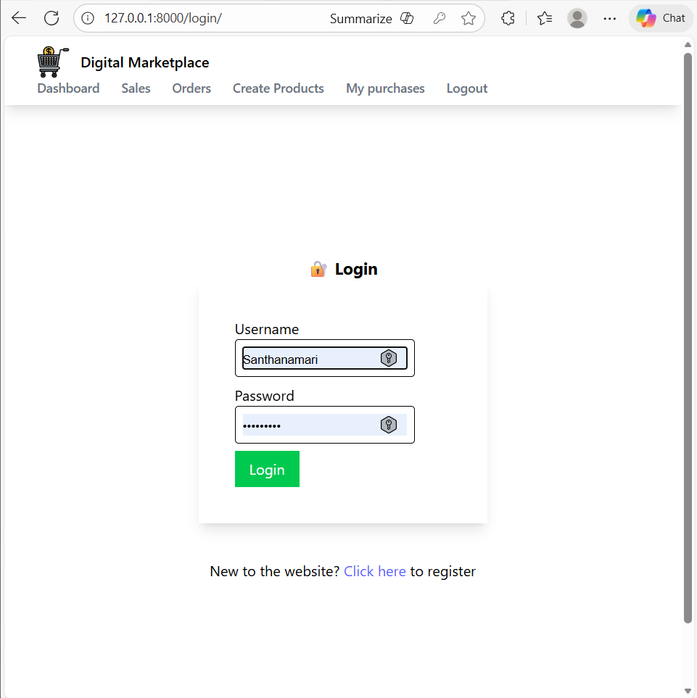

Click here link

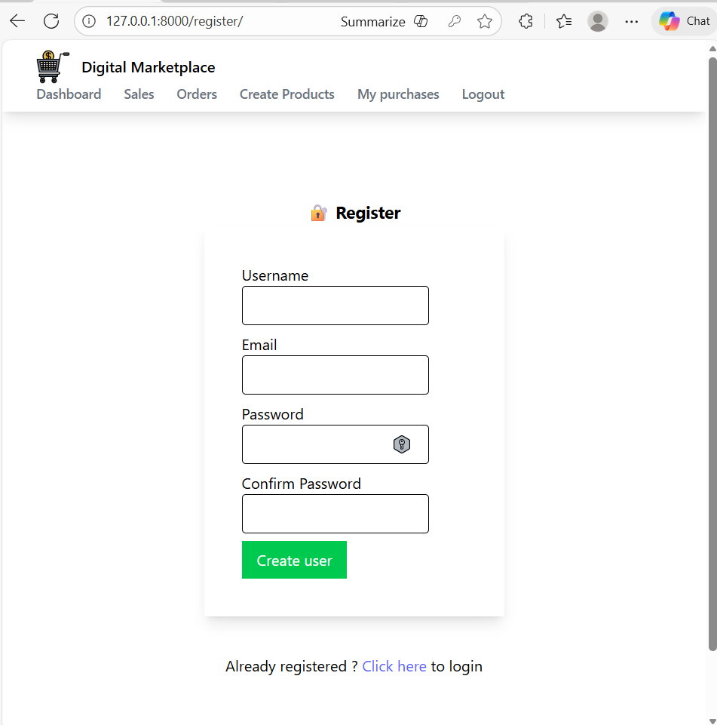
Click here

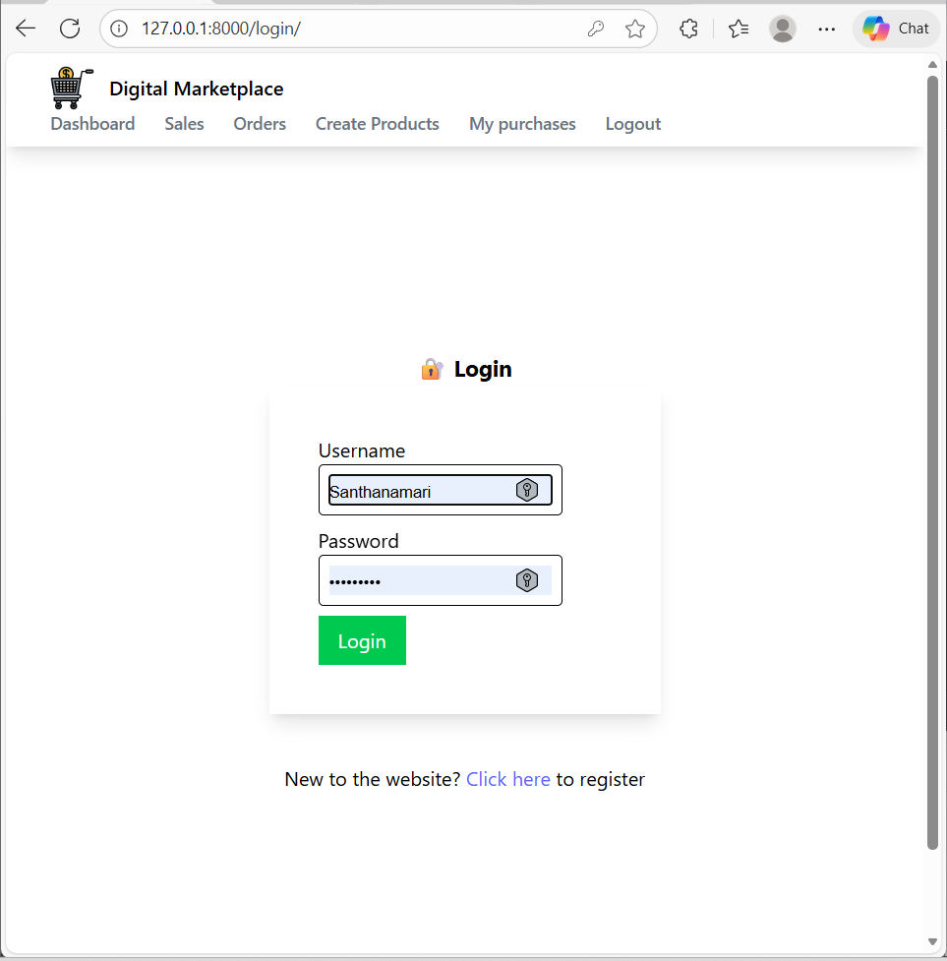

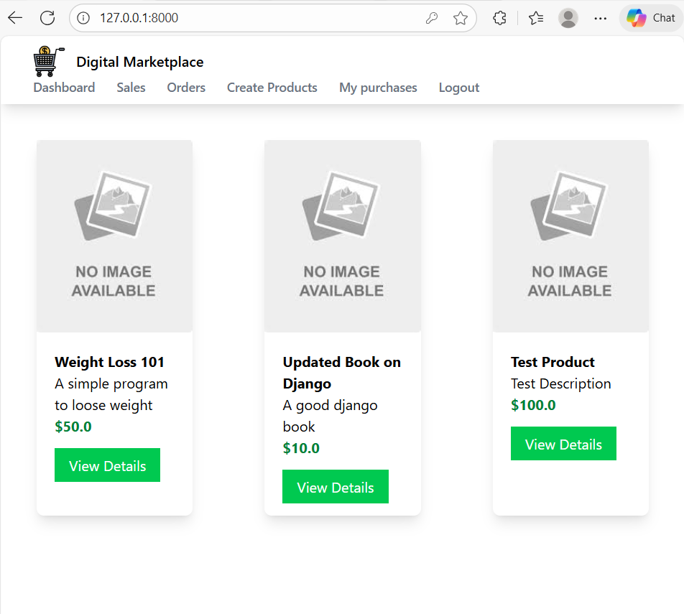

settings.py

LOGIN_REDIRECT_URL = '/'

Login.html

{% extends 'myapp/base.html' %}
{% block body %}
<div class="flex flex-col justify-center items-center min-h-screen">
<h1 class="font-bold text-lg">🔐 Login</h1>
<form class="shadow-lg p-10" method="POST">
{% csrf_token %}
<div class="mb-2">
<label>Username</label>
<div class="border rounded py-2 px-2 mr-10">
{{ form.username }}
</div>
</div>
<div class="mb-2">
<label>Password</label>
<div class="border rounded py-2 px-2 mr-10">
{{ form.password }}
</div>
</div>
<button class="bg-green-500 text-white px-4 py-2" type="submit">Login</button>
</form>
<p class="m-10"> New to the website? <span> <a class="text-indigo-500" href="{% url 'register' %}">Click here</a> to register</span></p>
</div>
{% endblock %}

____________________________________________________________________________
Logout
Oc

Click logout after show login page
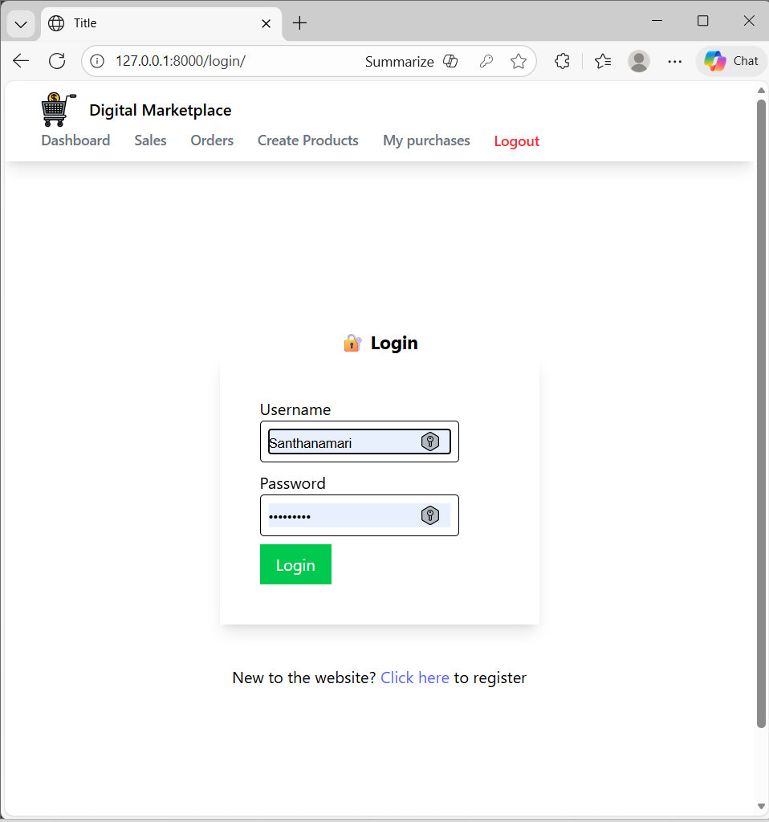

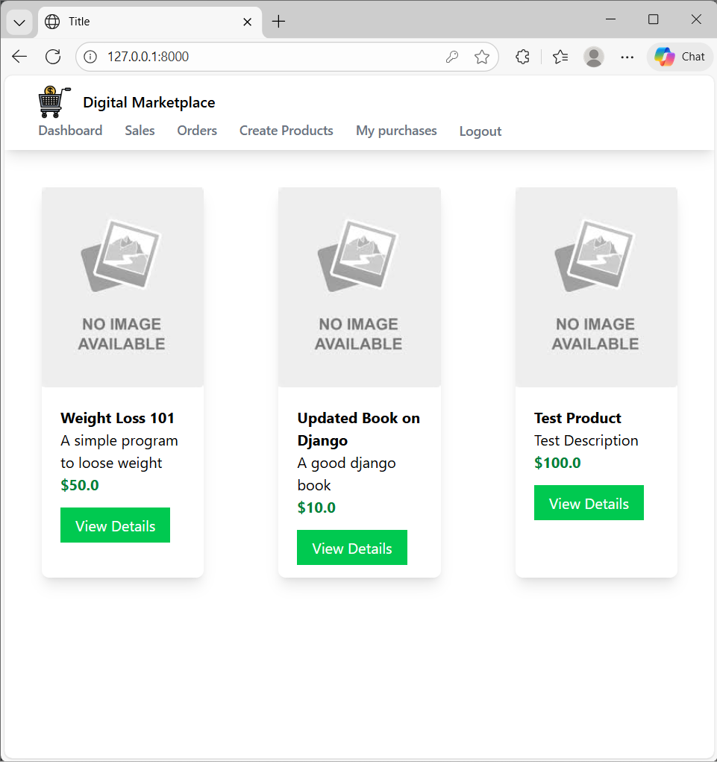

settings.py

LOGOUT_REDIRECT_URL = 'login'

Base.html
<!DOCTYPE html>
<html lang="en">
<head>
<meta charset="UTF-8">
<script src="https://cdn.jsdelivr.net/npm/@tailwindcss/browser@4"></script>
<title>Title</title>
</head>
<body>

<nav class="shadow-lg">
<div class="flex flex-wrap justify-between ml-5 items-center mx-auto px-4 py-2.5">

<a href="" class="flex items-center">
<img class="h-9 mr-3"
src="https://cdn-icons-png.flaticon.com/128/2916/2916141.png">
<span class="self-center text-xml font-semibold">
Digital Marketplace
</span>
</a>

<div class="flex items-center">
<a href="" class="mr-6 text-sm font-medium text-gray-500">Dashboard</a>
<a href="" class="mr-6 text-sm font-medium text-gray-500">Sales</a>
<a href="" class="mr-6 text-sm font-medium text-gray-500">Orders</a>
<a href="" class="mr-6 text-sm font-medium text-gray-500">Create Products</a>
<a href="" class="mr-6 text-sm font-medium text-gray-500">My purchases</a>

<form method="post" action="{% url 'logout' %}" class="mr-6">
{% csrf_token %}
<button type="submit"
class="text-sm font-medium text-gray-500 hover:text-red-500">
Logout
</button>
</form>

</div>
</div>
</nav>

{% block body %}
{% endblock %}

</body>
</html>

Logout.html

{% extends 'myapp/base.html' %}

{% block body %}
<div class="flex flex-col justify-center items-center min-h-screen space-y-4">

<h1 class="text-2xl font-bold">
You have been logged out
</h1>

<a href="{% url 'login' %}"
class="bg-indigo-500 text-white px-4 py-2 rounded">
Login Again
</a>

</div>
{% endblock %}

urls.py
path('logout/',auth_views.LogoutView.as_view(template_name='myapp/logout.html'), name='logout'),

___________________________________________________________________________

Modifying The Product Model
Oc
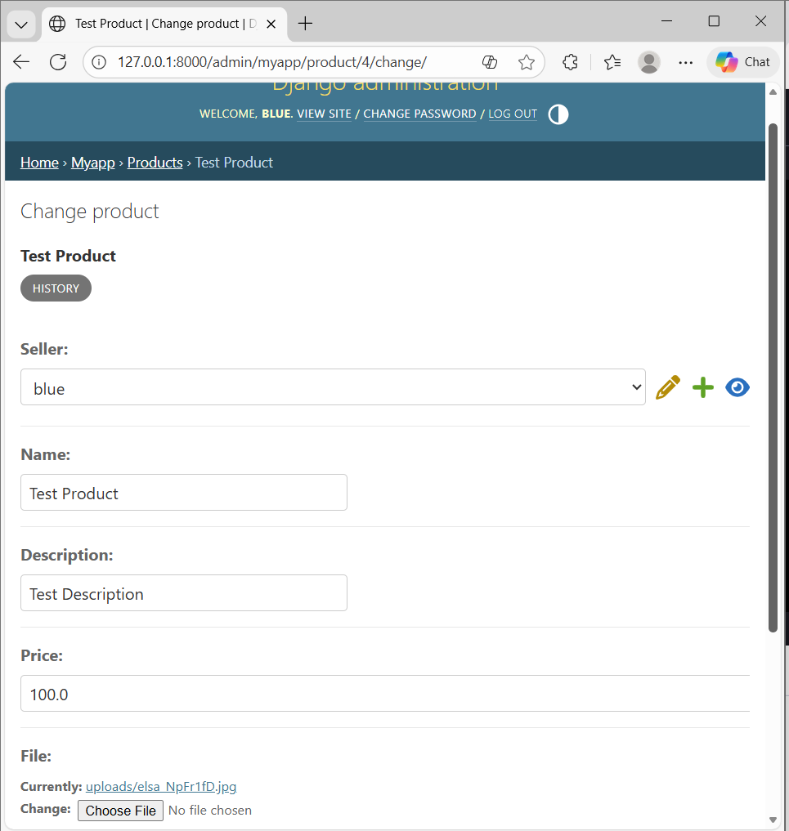

Code

models.py

from django.db import models
from django.contrib.auth.models import User

# Create your models here.
class Product(models.Model):
seller = models.ForeignKey(User, on_delete=models.CASCADE)
name = models.CharField(max_length=100)
description = models.CharField(max_length=100)
price = models.FloatField()
file = models.FileField(upload_to='uploads')

def __str__(self):
return self.name

____________________________________________________________________________

Associating Product With Seller

Oc

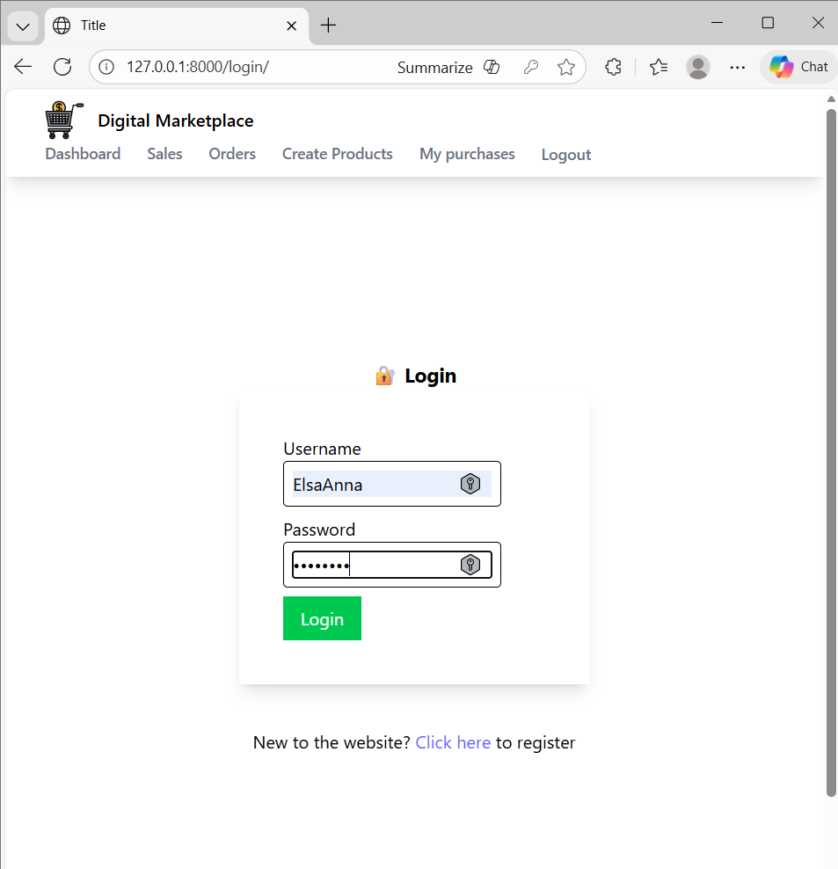
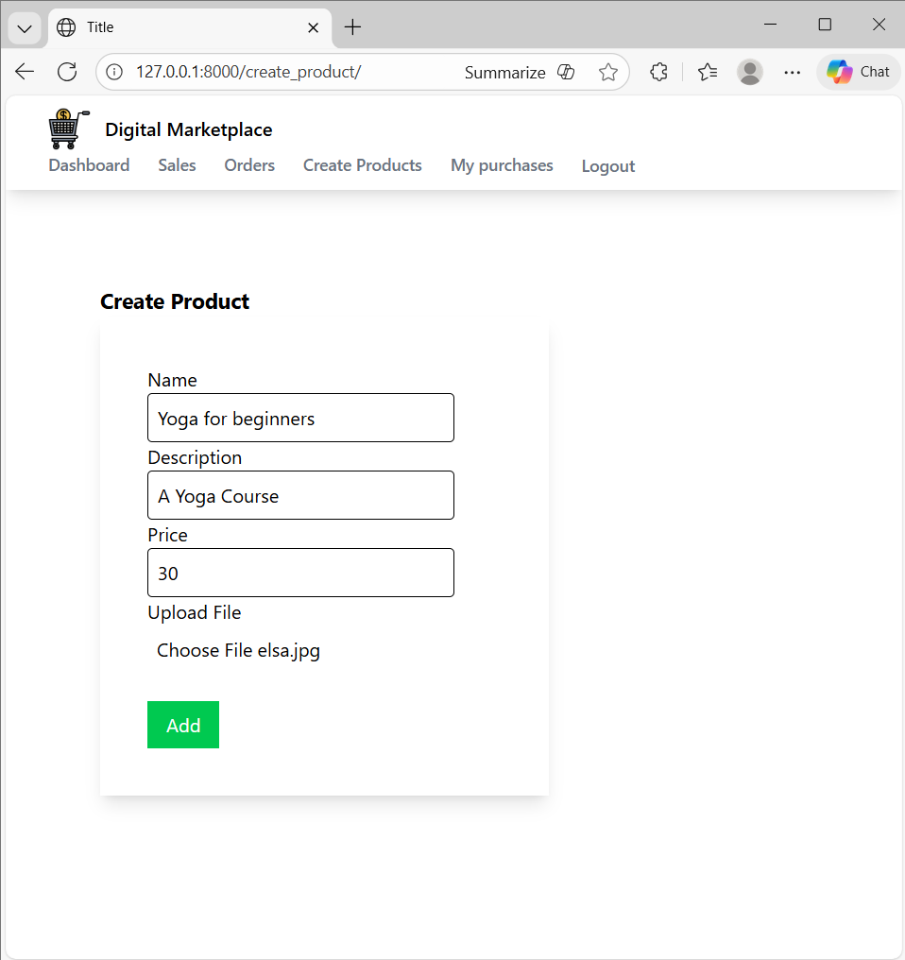

Click add

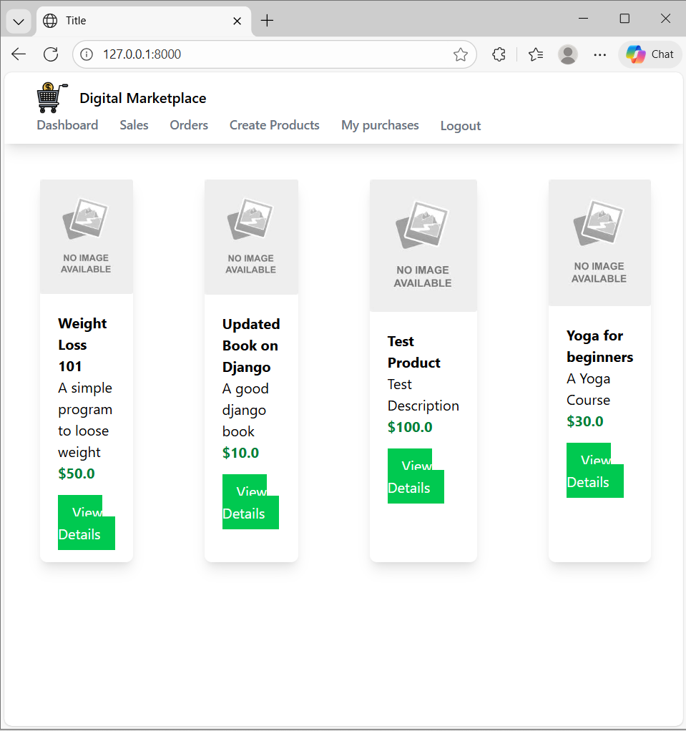
Admin

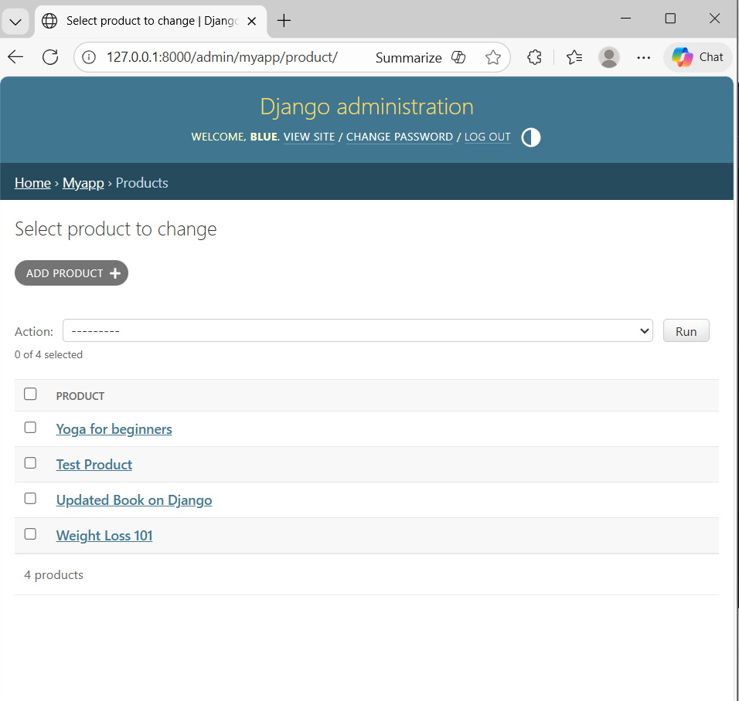
Seller is elsa anna

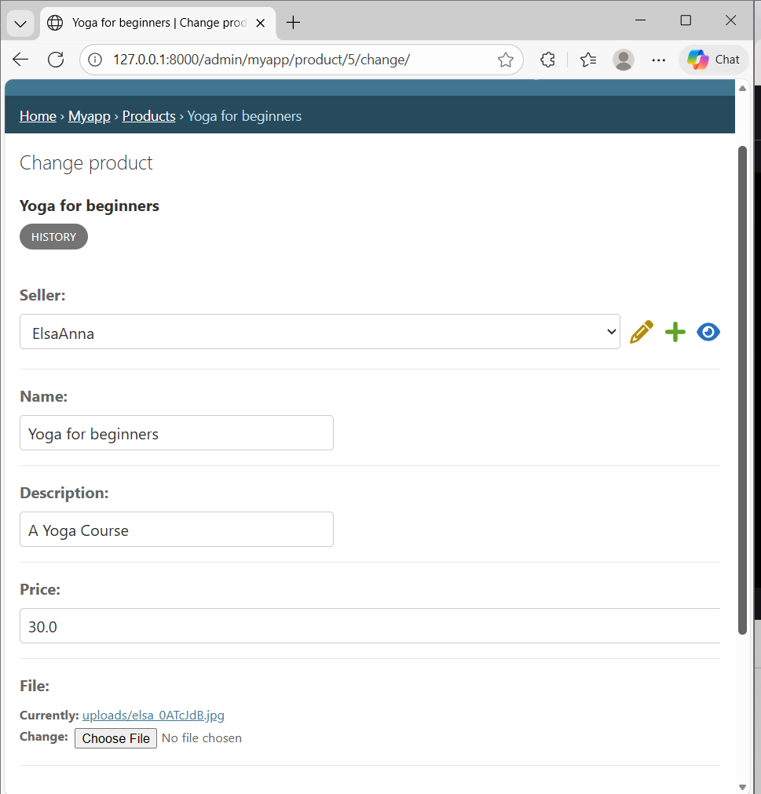

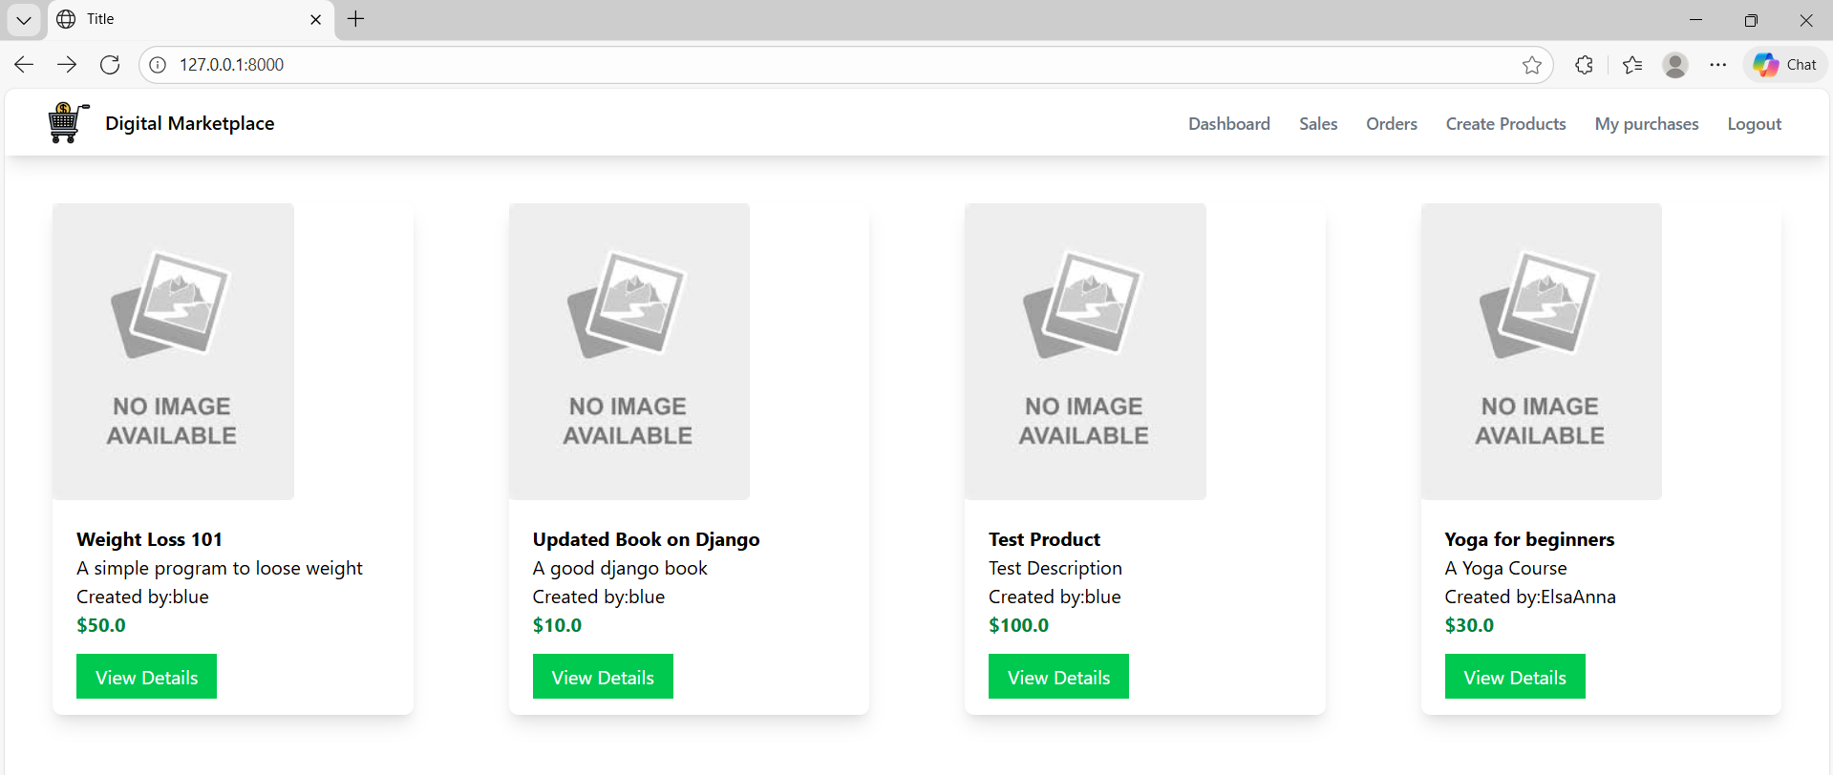

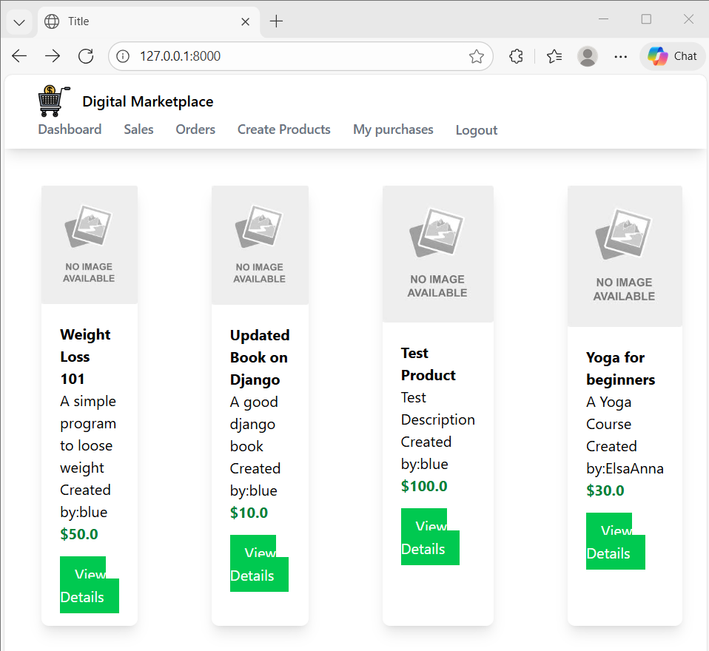

Code

views.py

def create_product(request):
if request.method == "POST":
product_form = ProductForm(request.POST, request.FILES)
if product_form.is_valid():
new_product = product_form.save(commit=False)
new_product.seller = request.user
new_product.save()
return redirect('index')
else:
product_form = ProductForm()

return render(
request,
'myapp/create_product.html',
{'product_form': product_form}
)

models.py

from django.db import models
from django.contrib.auth.models import User

# Create your models here.
class Product(models.Model):
seller = models.ForeignKey(User, on_delete=models.CASCADE)
name = models.CharField(max_length=100)
description = models.CharField(max_length=100)
price = models.FloatField()
file = models.FileField(upload_to='uploads')

def __str__(self):
return self.name

____________________________________________________________________________

