**Excel Assignment - 6**

1. What are the various elements of the Excel interface? Describe how they're used.

1. Quick Access Toolbar

This toolbar is located in the upper left corner of the screen. Its objective is to show the most frequently used Excel commands. We can customize this toolbar based on our preferred commands

### File Tab

Excel 2007's Office button has been replaced by the File tab. We can click it to check the Backstage view, where we can open or save files, create new sheets, print sheets, and perform other file-related operations.

1. Title Bar

The title bar of the spreadsheet is at the top of the window. It displays the active document's name.

### Control Buttons

Control buttons are the symbols that are present in the upper-right side of the window, enabling us to change the labels, minimize, maximize, share, and close the sheet.

### Menu Bar

Under the diskette or save icon or the excel icon (this will depend on the version of the program), labels or bars which enable changing the sheet which is shown. These are the menu bar and contain a File, Insert, Page Layout, Formulas, Data, Review, View, Help, and a Search Bar with a light bulb icon. These menus are divided into subcategories which simplify the distribution of information and analysis of calculations.

### Ribbon/Toolbar

Each menu bar contains several different elements. On the selection of the menu, a sequence of command options/icons will show on a ribbon. For example, if we select the "Home" tab, we will see cut, copy, paste, bold, italic, underline, and more commands. In the same way; we can click on the "Insert" tab, we will see tables, illustrations, additional, recommended graphics, graphics maps, among others. On the other hand, if we select the "Formulas" option. Insert functions, auto sum recently used, finances, logic, text, time, date, etc.

Ribbon/Toolbar is a set of commands organized into three sections.

### Dialog Box Launcher

Dialog box launcher is a very little down arrow that is present in the lower-right corner of a command group on the Ribbon. By clicking on this arrow, we can explore more options related to the concerned group.

### Name box

Show the location of the active cell, row, or column. We have the option of selecting multiple options.

### Formula Bar

Formula bar permits us to observe, insert or edit the information/formula entered in the active cell.

### Scrollbars

Scrollbars are the tools that enable us to **move the document's vertical** and **horizontal** views. We can activate this by clicking on the platform's internal bar or the arrows we have on the sides. Additionally, we can use the **mouse wheel** in order to automatically scroll up or down: or use the directional keys.

### Spreadsheet Area

It is the place where we enter our data. It includes all the **rows, cells, columns**, and **built-in data** in the spreadsheet. We can use shortcuts to perform toolbar activities or formulas of **arithmetic operations (add, subtract, multiply, etc.)**. The insertion point is the blinking vertical bar known as the **"cursor."** It specifies the insertion location of the typing.

### Leaf Bar

Leaf bar is present at the bottom of the spreadsheet, which says **sheet1** is shown. This sheet bar describes the spreadsheet which is currently being worked on. Using this, we can alternate a number of sheets or add a new one as per our convenience.

### Columns Bar

Columns are a vertically ordered series of boxes across the full sheet. This column bar is located below the formula bar. The letters of the alphabet are used to label the columns. Begin with the letter **A** to **Z,** and then after **Z**, it will continue as **AA, AB,** and so on. The number of columns that can be used is limited to **16,384.**

### Rows Bar

The row bar is the left part of the sheet where a sequence of numbers is expressed. Begin with number one (1), and further rows will be added as we move the pointer down. There are a total of **1,048,576** rows available.

### Cells

Cells are those parallelepipeds that divide the spreadsheet into many pieces, separating rows and columns. A spreadsheet's first cell is represented by the first letter of the alphabet and the number one **(A1).**

### Status Bar

The status bar is present at the bottom of the window that displays critical information. It also indicates whether something is incorrect or whether the document is ready to be printed or delivered.

### View Buttons

View buttons are a set of three buttons arranged at the left of the Zoom control, close the screen's right-bottom corner. We can see three different kinds of sheet views in Excel using this method.

* **Normal View:** - Normal view displays the Excel page in normal view.
* **Page Layout View:** - The Page Layout view shows the precise layout of an Excel page it will be printed.
* **Page Break View:** - This displays page break preview before printing.

### Zoom Control

The zoom control is present at the **lower-right** side of the window. It enables us to **ZOOM-IN** or **ZOOM-OUT** a specific area of the spreadsheet. It is represented by magnifying icons with the symbols of **maximizing (+)** or **minimizing (-).**

2. Write down the various applications of Excel in the industry.

* 1. [Business Analysis](https://mallory.com.au/cm/ms-excel-uses-business-workplace/#1-business-analysis)
  2. [People Management](https://mallory.com.au/cm/ms-excel-uses-business-workplace/#2-people-management)
  3. [Managing Operations](https://mallory.com.au/cm/ms-excel-uses-business-workplace/#3-managing-operations)
  4. [Performance Reporting](https://mallory.com.au/cm/ms-excel-uses-business-workplace/#4-performance-reporting)
  5. [Office Administration](https://mallory.com.au/cm/ms-excel-uses-business-workplace/#5-office-administration)
  6. [Strategic Analysis](https://mallory.com.au/cm/ms-excel-uses-business-workplace/#6-strategic-analysis)
  7. [Project Management](https://mallory.com.au/cm/ms-excel-uses-business-workplace/#7-project-management)
  8. [Managing Programs](https://mallory.com.au/cm/ms-excel-uses-business-workplace/#8-managing-programs)
  9. [Contract Administration](https://mallory.com.au/cm/ms-excel-uses-business-workplace/#9-contract-administration)
  10. [Account Management](https://mallory.com.au/cm/ms-excel-uses-business-workplace/#10-account-management)
  11. Finance management

3. On the ribbon, make a new tab. Add some different groups, insert commands in the groups and name them according to their commands added. Copy and paste the screenshot of the steps you followed.

a. Make a new tab & add groups

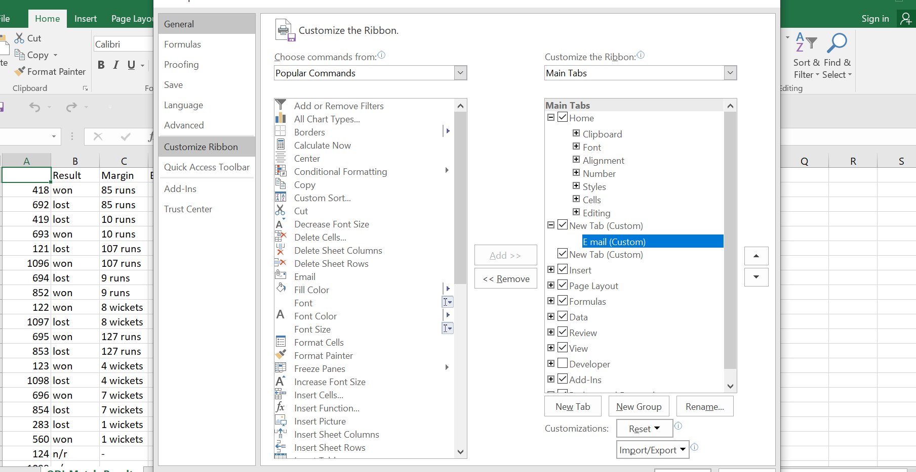

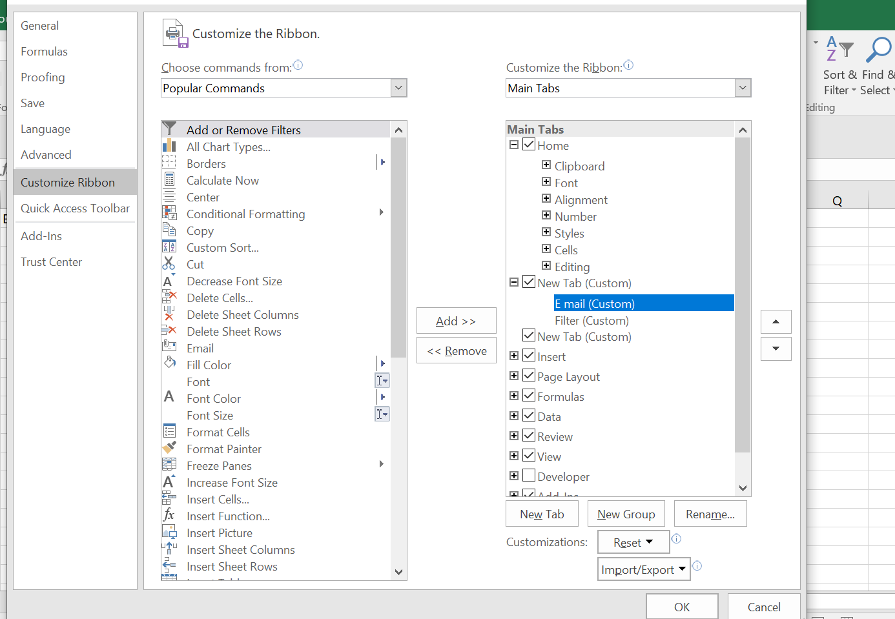

b. Create groups and name them according to their commands

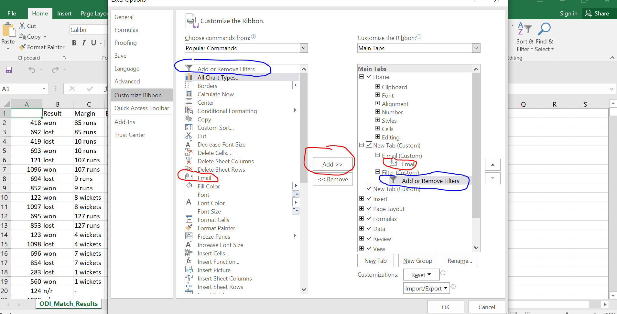

Result

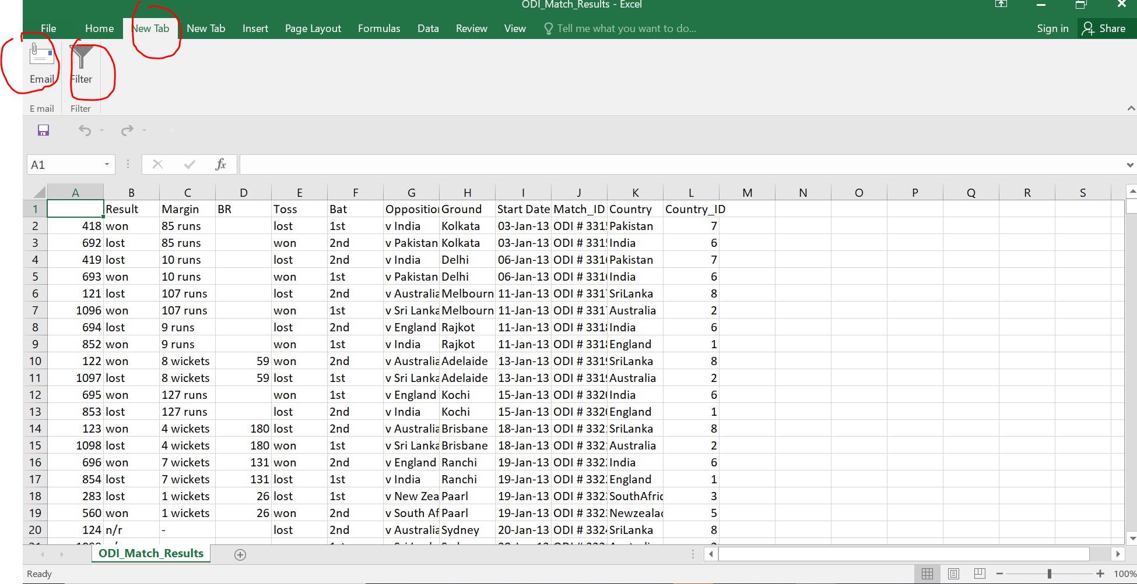

4. Make a list of different shortcut keys that are only connected to formatting with their functions.

|  |  |
| --- | --- |
| **Functions** | **Shortcut Keys** |
| All capital letters | CTRL+SHIFT+A |
| Bold | CTRL+B |
| Case of letters | SHIFT+F3 |
| Decrease font size | CTRL+SHIFT+< |
| Decrease font size 1pt | CTRL+[ |
| Double-underline | CTRL+SHIFT+D |
| Increase font size | CTRL+SHIFT+> |
| Increase font size 1pt | CTRL+] |
| Italic | CTRL+I |
| Remove character formatting (plain text) | CTRL+SPACEBAR |
| Small uppercase letters | CTRL+SHIFT+K |
| Subscript | CTRL+= |
| Superscript | CTRL+SHIFT+PLUS SIGN |
| Underline | CTRL+U |
| Underline words, not spaces | CTRL+SHIFT+W |
| 1.5 line spacing | CTRL+5 |
| Add/remove one line above | CTRL+0 (zero, not O) |
| Center Paragraph | CTRL+E |
| Decrease paragraph indent | CTRL+SHIFT+M |
| Double-space lines | CTRL+2 |
| Hanging indent | CTRL+T |
| Increase paragraph indent | CTRL+M |
| Justify paragraph | CTRL+J |
| Left-align paragraph | CTRL+L |
| Remove hanging indent | CTRL+SHIFT+T |
| Remove paragraph formatting | CTRL+Q |
| Right-align paragraph | CTRL+R |
| Single-space lines | CTRL+1 |

5. What distinguishes Excel from other analytical tools?

1. It’s easy to get started with Excel.
2. It is relatively easy to learn
3. The learning resources are very rich.
4. We can do a lot of things with Excel: modeling, visualization, reports, dynamic charts, etc.
5. It can help you understand the meaning of many operations before further learning other tools (such as Python and R).

6. Create a table and add a custom header and footer to your table.

View->Page layout🡪 Write/Enter header / Footer

Header

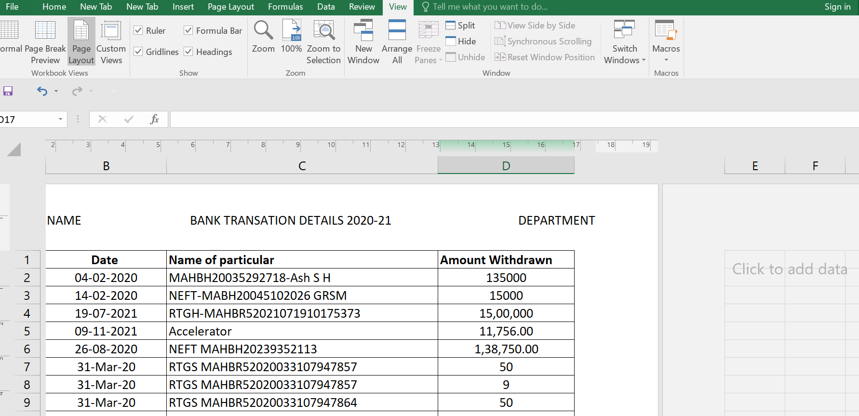

Footer

