Create database custom and create table temperature_data and insert the data into the table

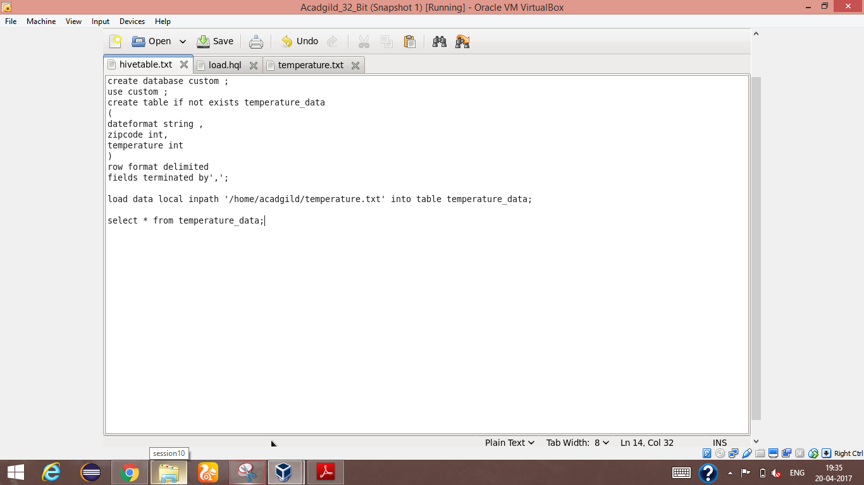

Screen shot to display the scripts to create the table

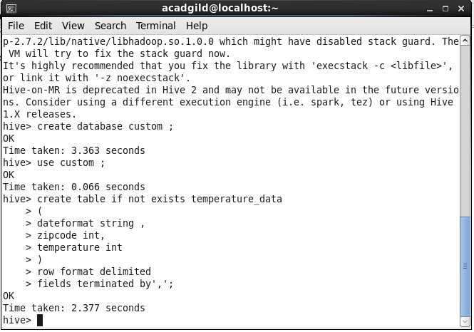

Screen shot to create the DB and create table in that DB

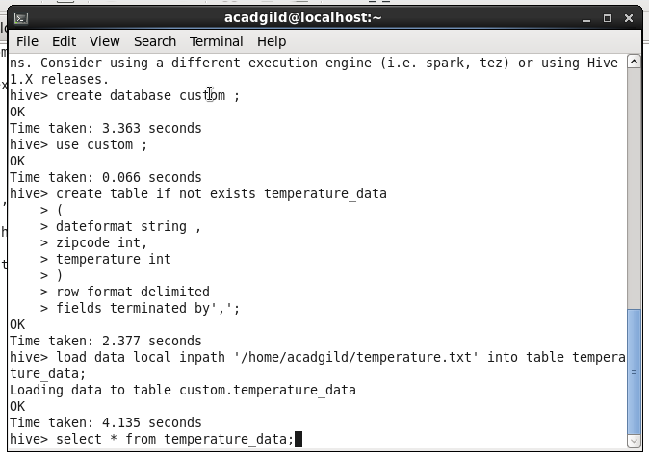

Screen shot showing the data being inserted in the table

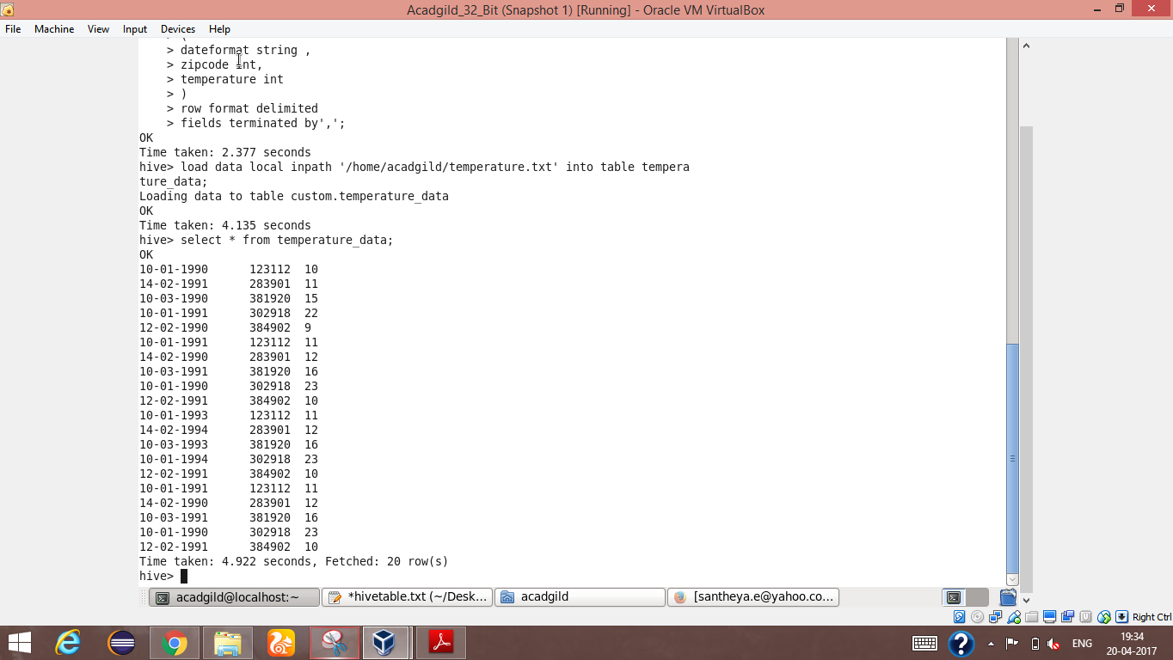

Screen shot showing the inserted data in the table