1. **PWD(print working directory):**

In Unix-like and some other operating systems, the pwd command writes the full pathname of the current working directory to the standard output.

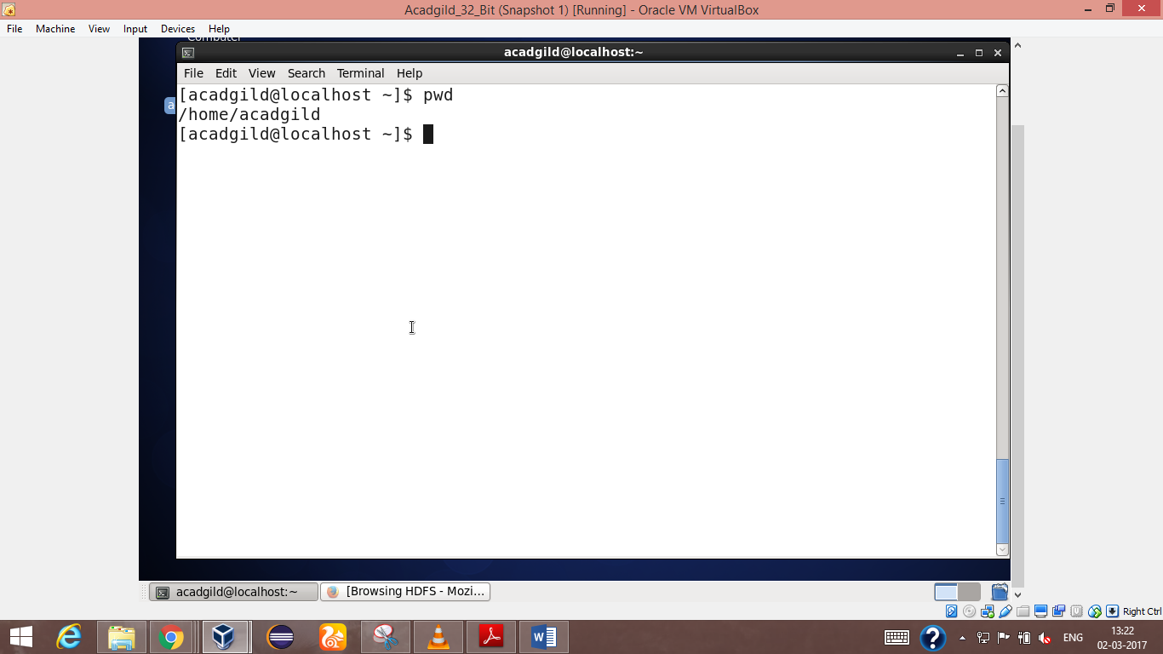

2.Vi(Visual Editor):

Using **vi** you can insert text anywhere in the file very easily. Most of the **vi** commands move the [cursor](http://www.computerhope.com/jargon/c/cursor.htm) around in the file. You can move the cursor forward and backward in units of characters, words, sentences, and paragraphs

The most common way to start a **vi** session is to tell it which file to edit. To edit a file named **filename**, use the command:

SYNTAX:

Vi filename

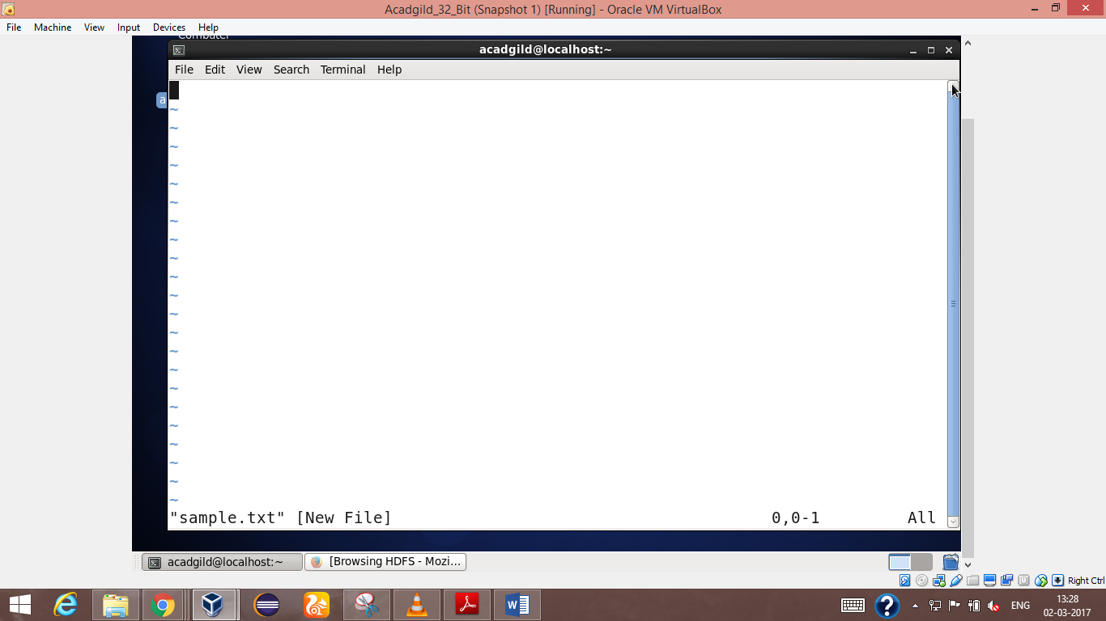

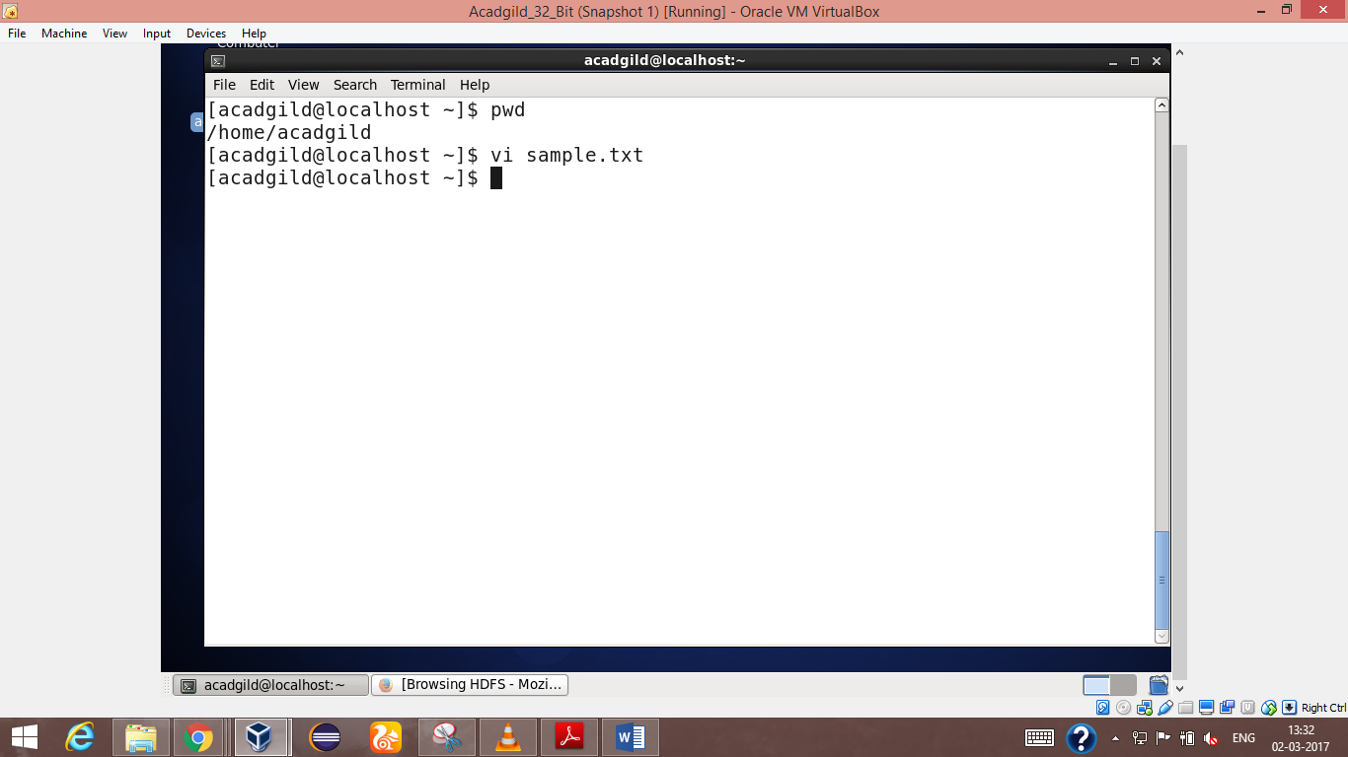

3.touch:

The **touch** command is the easiest way to create new, empty files. It is also used to change the timestamps (i.e., dates and times of the most recent access and modification) on existing files and directories.

SYNTAX:

Touch[option] filename

OPTIONS:

-a ->change only the access time

-c -> do not create any files

-d ->parse the string and use it instead of current time

-f ->Ignored but included for compatibility reasons

-m->change only the modification time

-t ->use this file’s times instead of current time

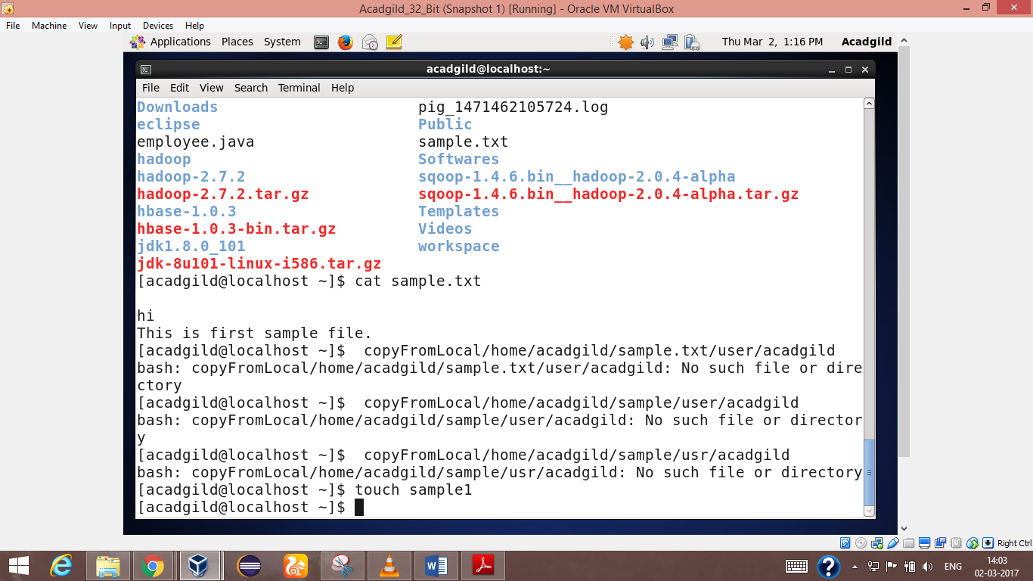

4.mkdir

Short for "make directory", **mkdir** is used to create [directories](http://www.computerhope.com/jargon/d/director.htm) on a [file system](http://www.computerhope.com/jargon/f/filesyst.htm).If the specified *DIRECTORY* does not already exist, **mkdir** creates it.More than one *DIRECTORY* may be specified when calling **mkdir**.

SYNTAX:

Mkdir[option] directory

Options

-m->set file mode

-p->create parent

-v->verbose output

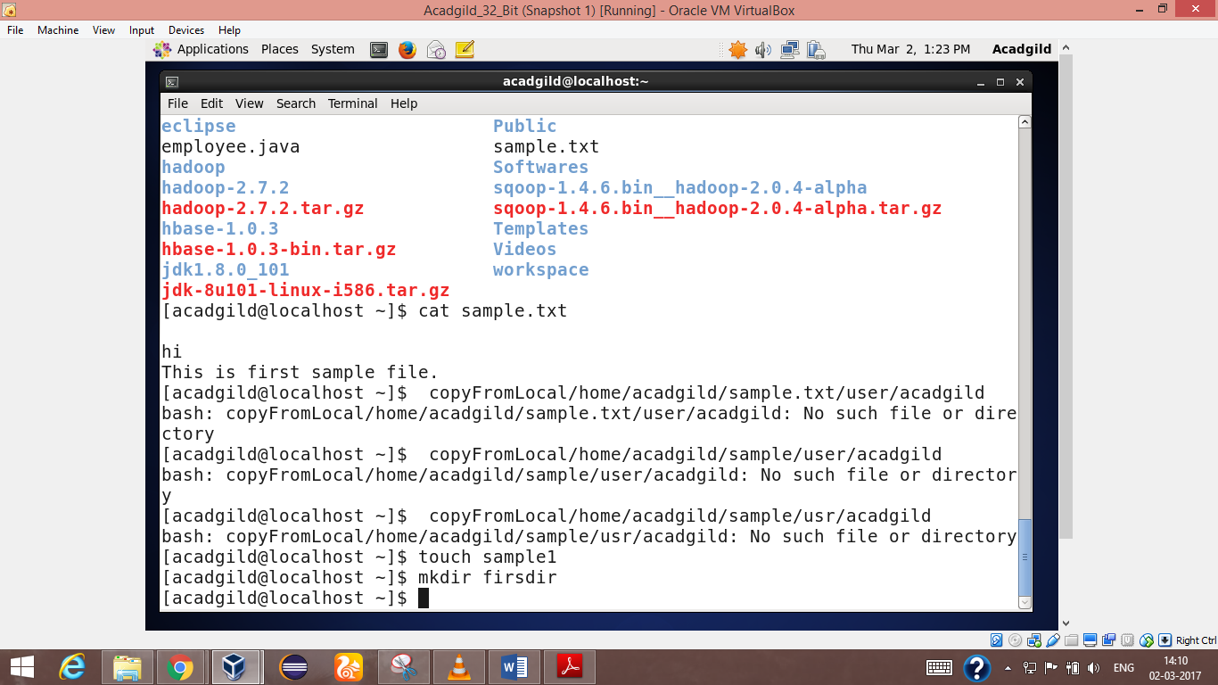

5.rm

The **rm** command removes ([deletes](http://www.computerhope.com/jargon/d/delete.htm)) [files](http://www.computerhope.com/jargon/f/file.htm) or [directories](http://www.computerhope.com/jargon/d/director.htm).

**rm** removes each specified *FILE*. By default, it does not remove directories

**for removing drectory**

rmdir is used

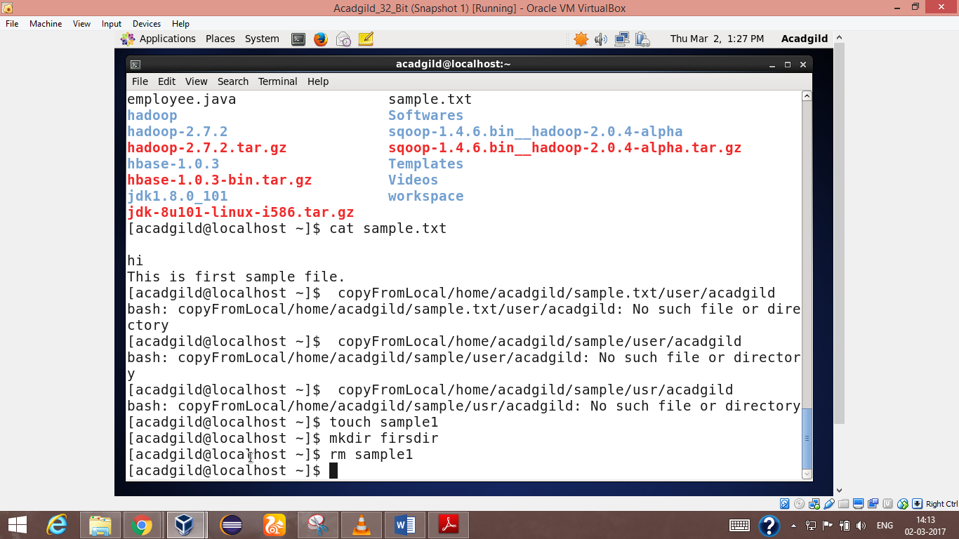

6..ls

Lists the contents of a [directory](http://www.computerhope.com/jargon/d/director.htm). List information about the *FILE*s (the current directory by default). Sort entries alphabetically

Syntax:

ls [option]

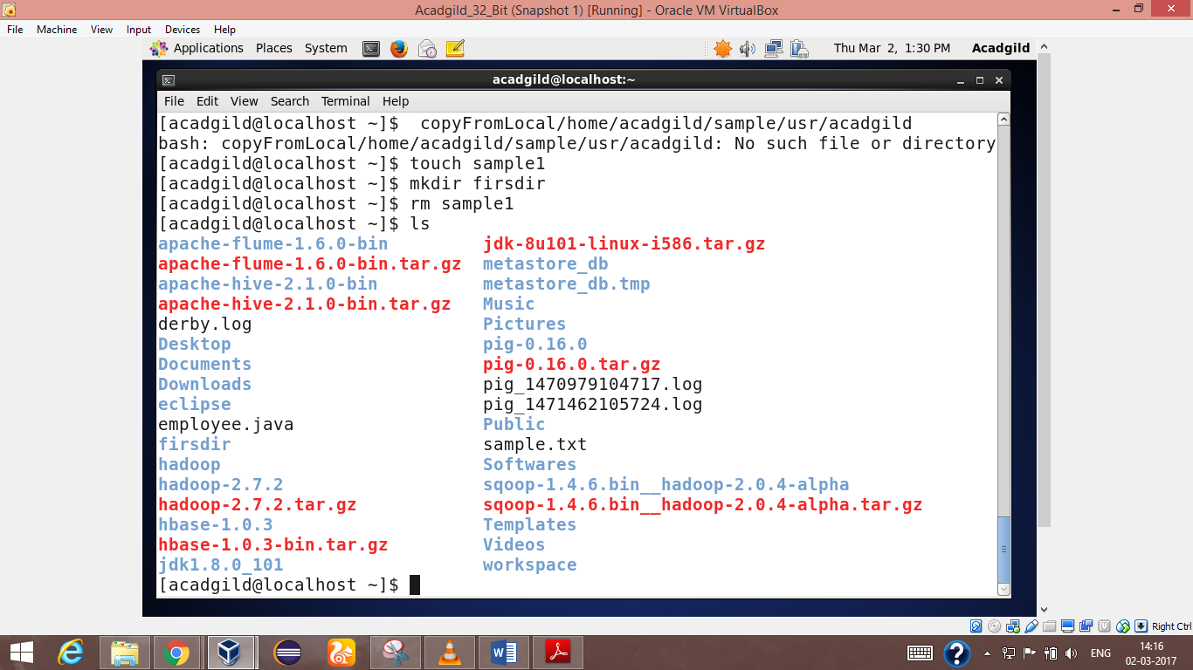

7.echo

**echo** displays a line of text.

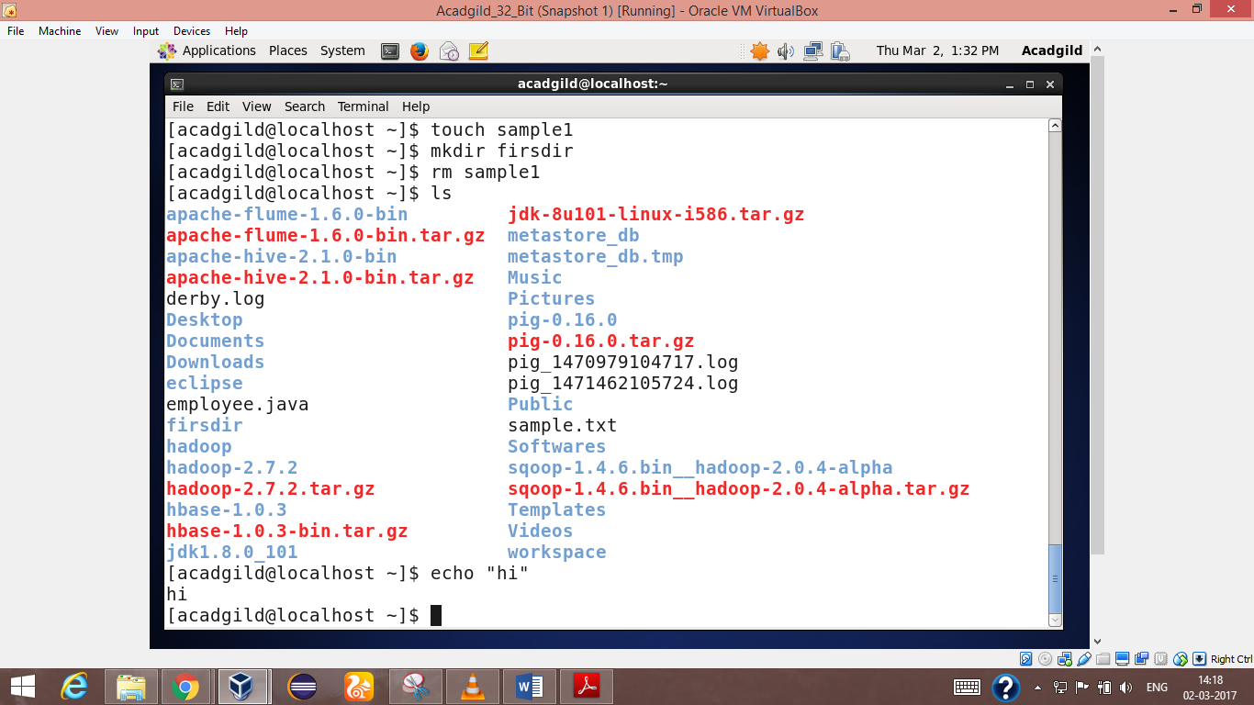

8.cat

**cat** command allows us to create single or multiple files, view contain of file, concatenate files and redirect output in terminal.

**cat** stands for "catenate." It reads [data](http://www.computerhope.com/jargon/d/data.htm) from [files](http://www.computerhope.com/jargon/f/file.htm), and outputs their contents. It is the simplest way to display the contents of a file at the [command line](http://www.computerhope.com/jargon/c/commandi.htm).

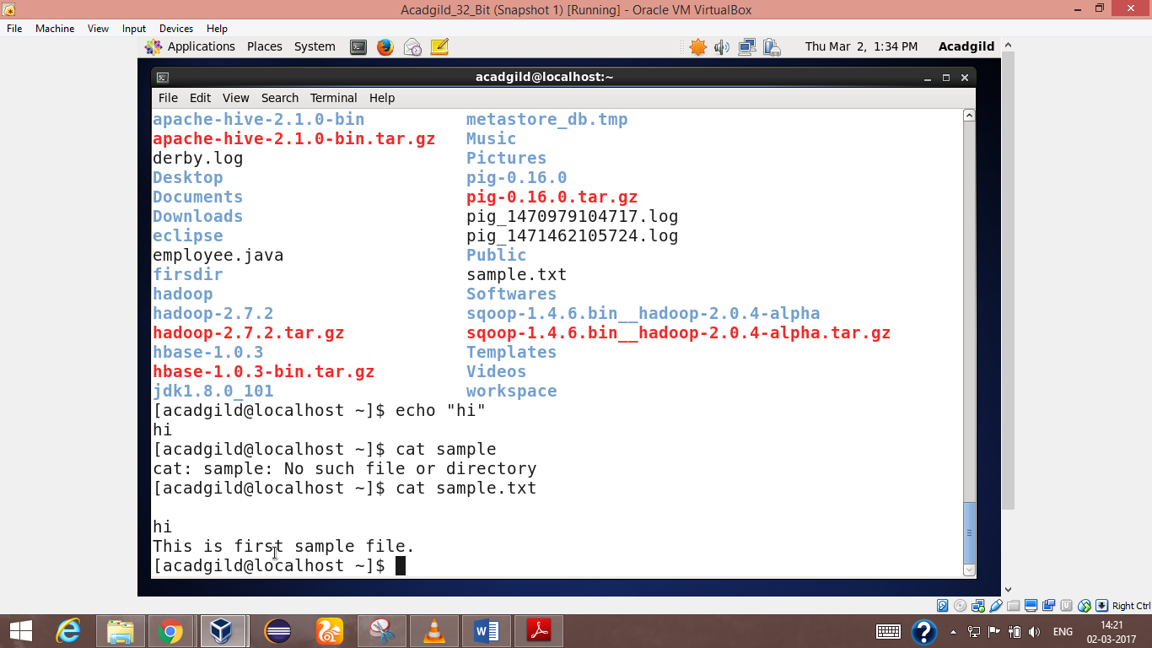

9.who

Displays who is [logged on](http://www.computerhope.com/jargon/s/signon.htm) to the [system](http://www.computerhope.com/jargon/s/system.htm). The **who** command prints information about all users who are currently logged in.

SYNTAX: who[option] …..[file]

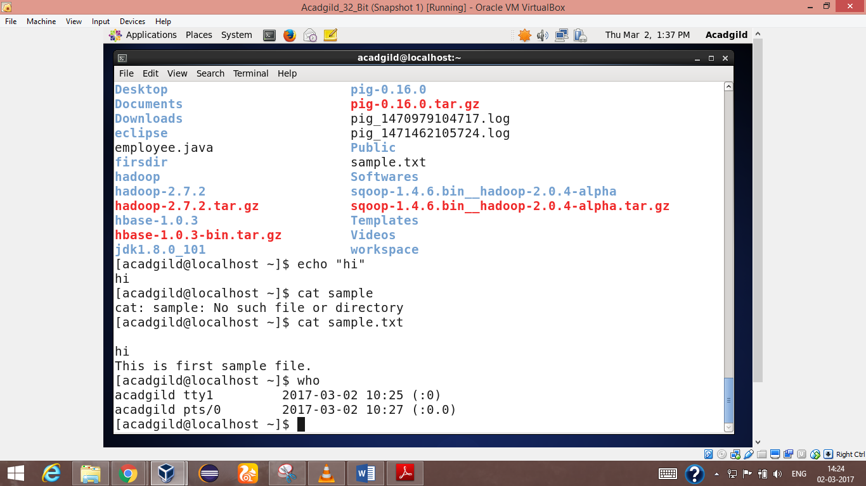

10.cd

The **cd** command is used to change the current directory (i.e., the directory in which the user is currently working) in **Linux**  It allows you to change your [working directory](http://www.computerhope.com/jargon/c/currentd.htm). You use it to move around within the [hierarchy](http://www.computerhope.com/jargon/h/hierfile.htm) of your [file system](http://www.computerhope.com/jargon/f/filesyst.htm).

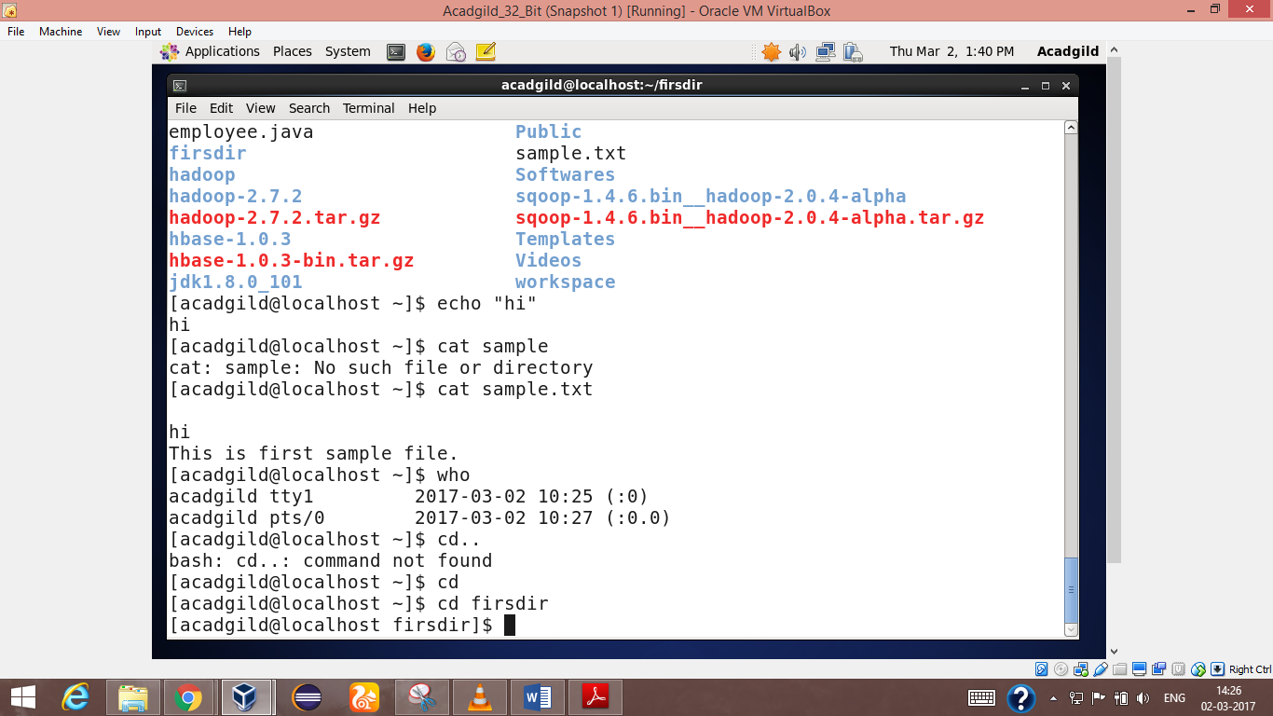

11.date

The **date** command is used to print out, or change the value of, the system's time and date information.

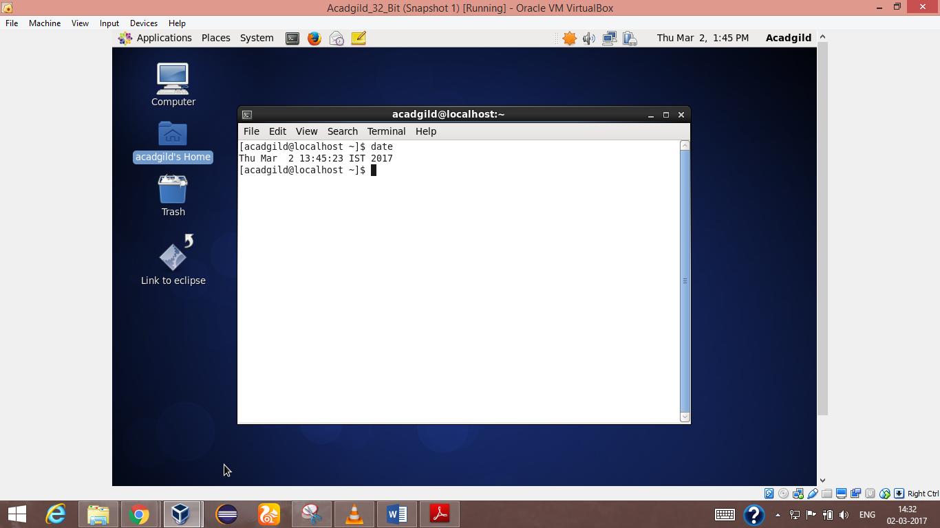

12.cal

**cal** displays the current month at the command line. It's a quick and convenient way to glance at the dates of the month, and can be useful as part of a login script.

Display a conveniently-formatted calendar from the command line.

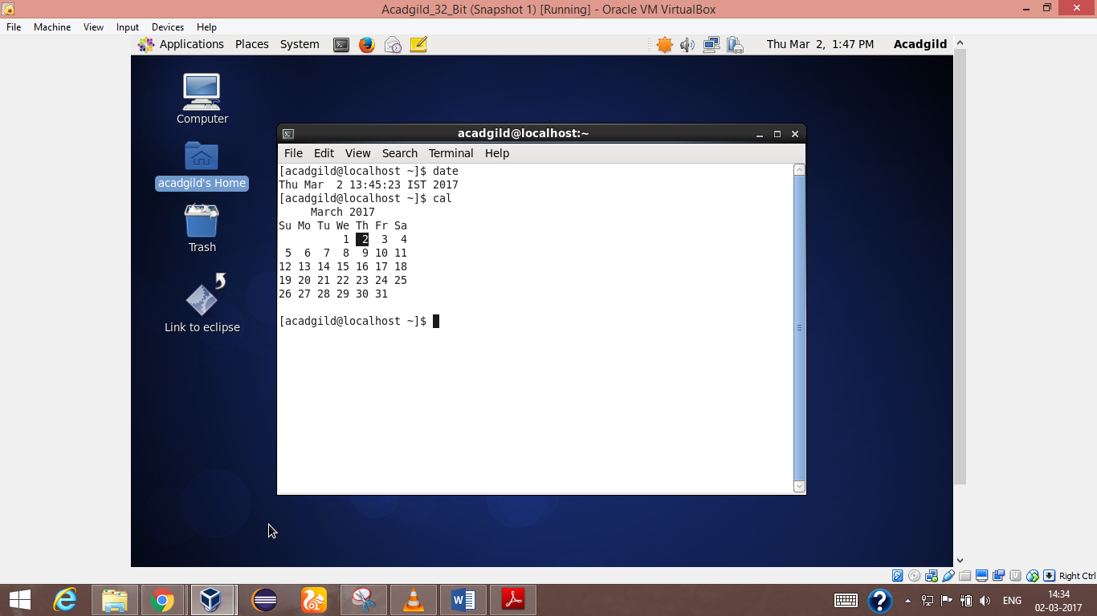

13.mv:

The **mv** command is used to move or [rename](http://www.computerhope.com/jargon/r/rename.htm)files.**mv** renames file *SOURCE* to *DEST*, or moves the *SOURCE* file (or files) to *DIRECTORY*.

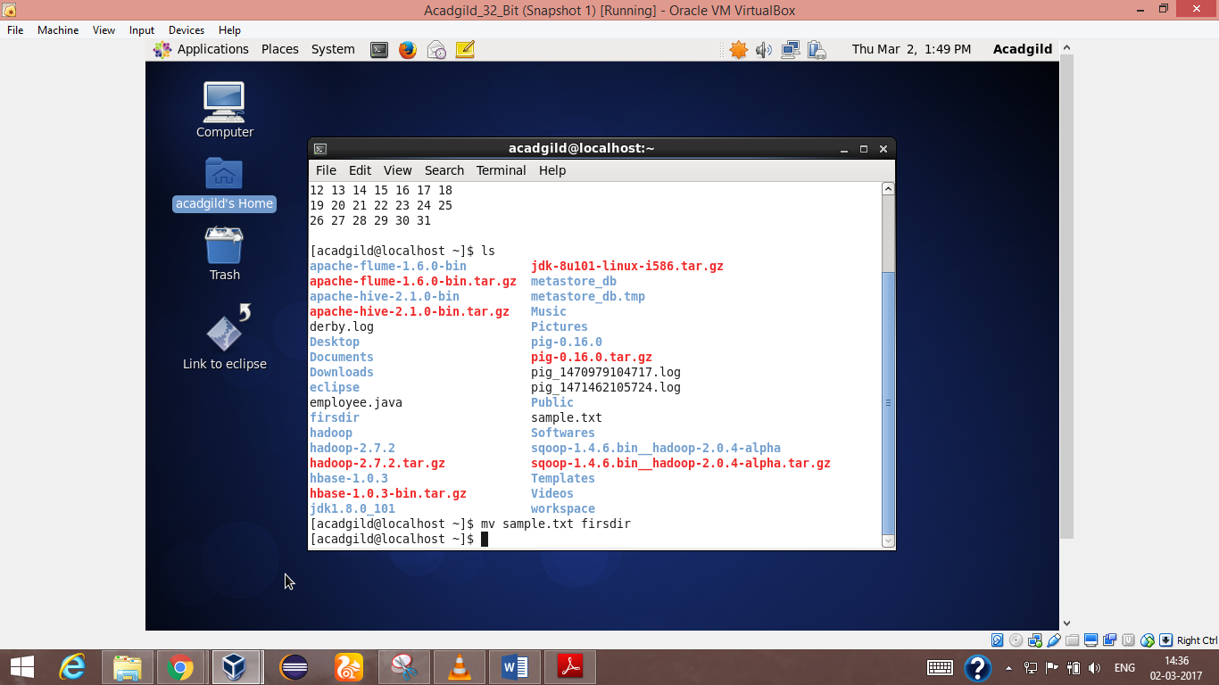

14.cp:

The **cp** command is used to make copies of files and directories. **cp** copies file from *SOURCE* to *DEST*, or copies the *SOURCE* file (or files) to *DIRECTORY*

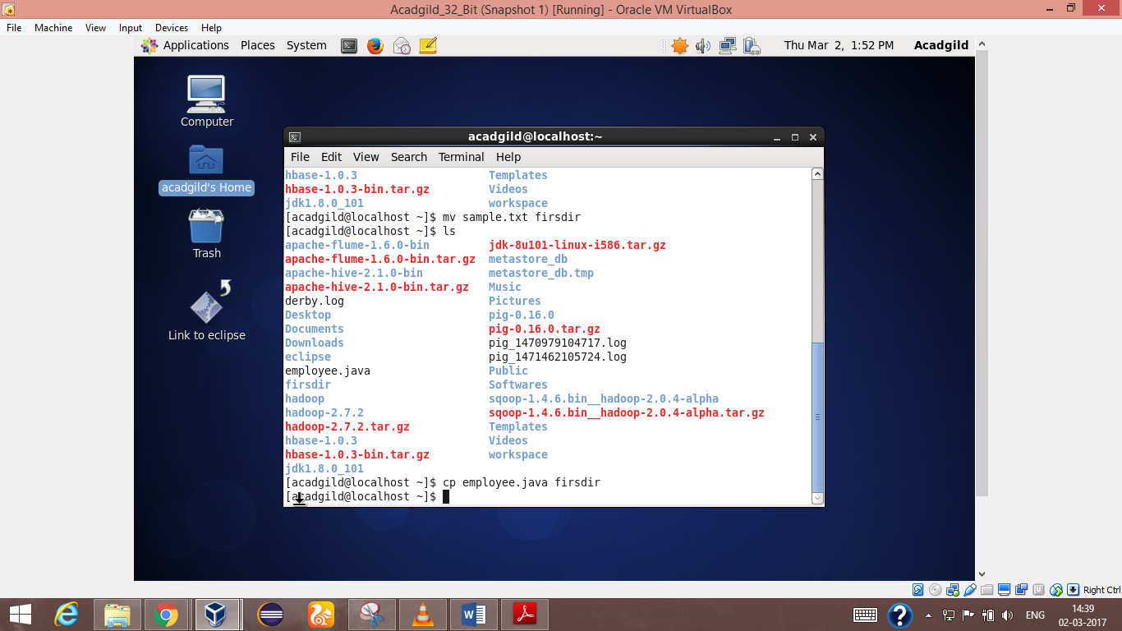

15.which:

Locate the [executable file](http://www.computerhope.com/jargon/e/execfile.htm) associated with a given [command](http://www.computerhope.com/jargon/c/command.htm). **which** returns the [pathnames](http://www.computerhope.com/jargon/p/path.htm) of the [files](http://www.computerhope.com/jargon/f/file.htm) (or [links](http://www.computerhope.com/unix/link.htm)) which would be [executed](http://www.computerhope.com/jargon/e/execute.htm) in the current [environment](http://www.computerhope.com/jargon/e/environm.htm)

