1.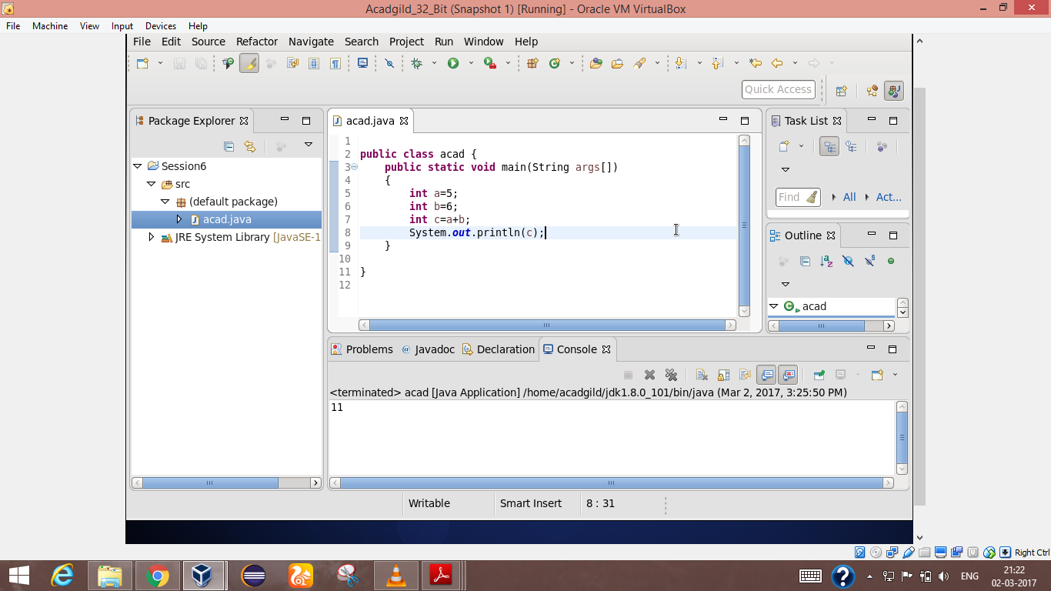

Public class acad

{

Public static void main(String args[])

{

int a=5;

int b=6;

int c=a+b;

System.out.println(c);

}

}

2. 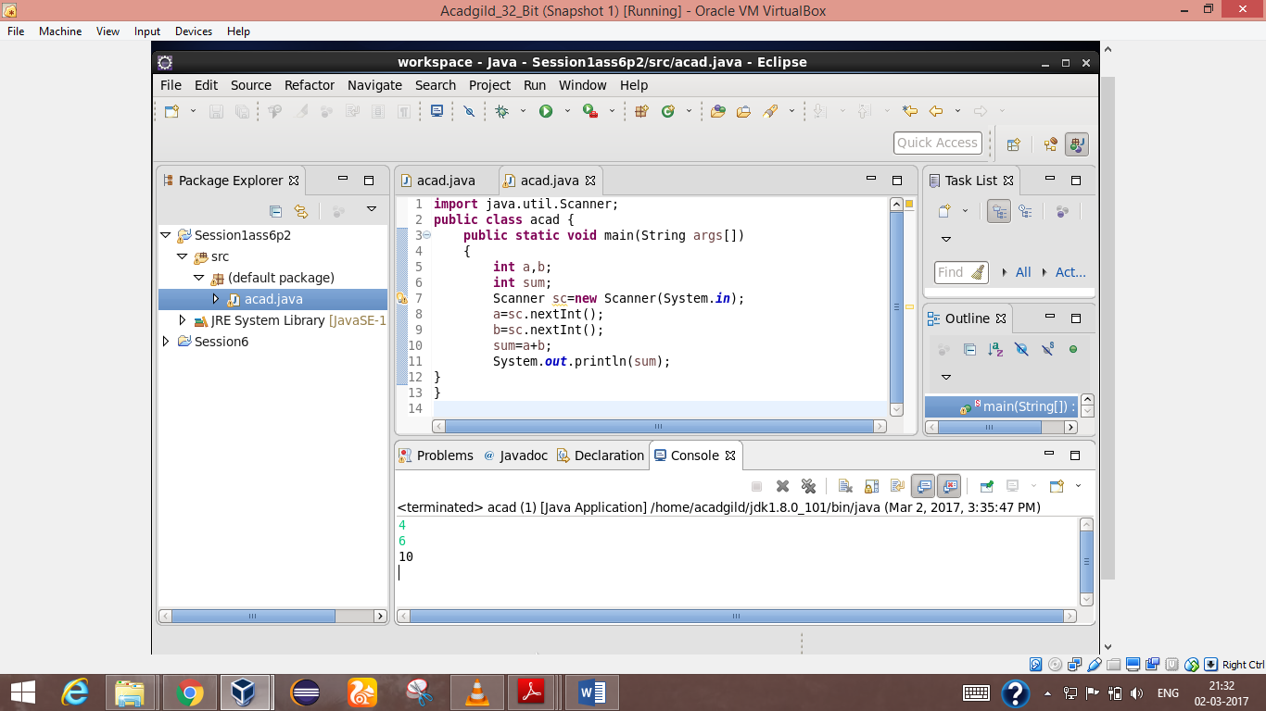

import java.util.scanner;

Public class acad

{

Public static void main(String args[])

{

int a,b;

int sum;

Scanner sc=new Scanner(System.in);a=

a=sc.new nextInt();

b=sc.new nextInt();

sum=a+b;

System.out.println(sum);

}

}

3.

import java.util.scanner;

Public class acad

{

Public static void main(String args[])

{

int a,b;

int sum;

Scanner sc=new Scanner(System.in);a=

a=sc.new nextInt();

b=sc.new nextInt();

System.out.println(“first num is”+a);

System.out.println(“Second num is”+b);

Sum(a,b);

}

Public static void sum(int a,int b)

{

int c=a+b;

System.out.println(“Sum is”+c);

}

}

