IMPORTANCE OF NAMENODE IN HDFS:

1. Name Node is the centre piece of HDFS.
2. Name Node is also known as the Master
3. Name Node only stores the metadata of HDFS – the directory tree of all files in the file system, and tracks the files across the cluster.
4. Name Node does not store the actual data or the dataset. The data itself is actually stored in the Data Nodes.
5. Name Node knows the list of the blocks and its location for any given file in HDFS. With this information Name Node knows how to construct the file from blocks.
6. Name Node is so critical to HDFS and when the Name Node is down, HDFS/Hadoop cluster is inaccessible and considered down.
7. Name Node is a single point of failure in Hadoop cluster.
8. Name Node is usually configured with a lot of memory (RAM). Because the block locations are help in main memory.

(i) creating directory in hdfs :

hadoop fs –mkdir /user/assignment



(ii) Listing the contents present in the directory

hadoop fs –ls

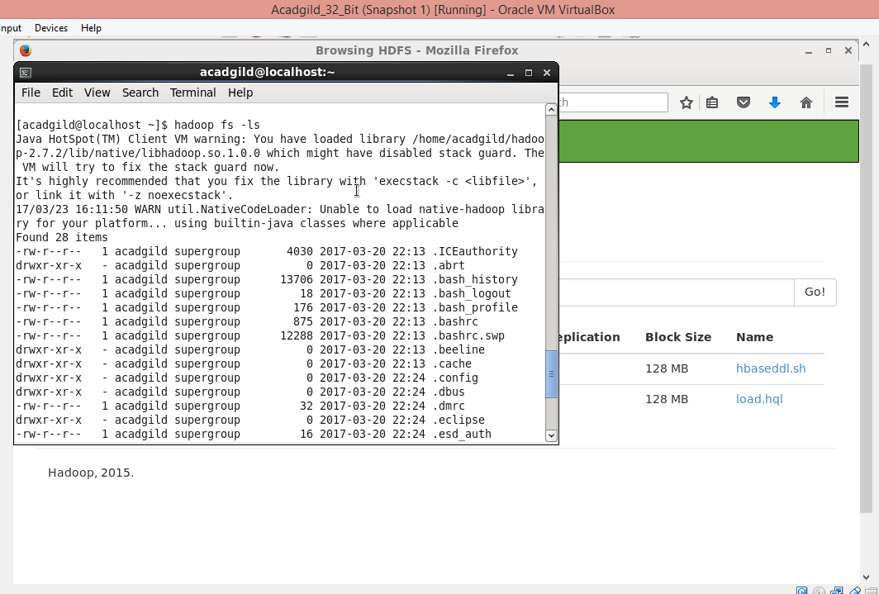

(iii) Upload a file in hdfs

hadoop fs –put /home/acadgild/Downloads/hbaseddl.sh /user/assignment

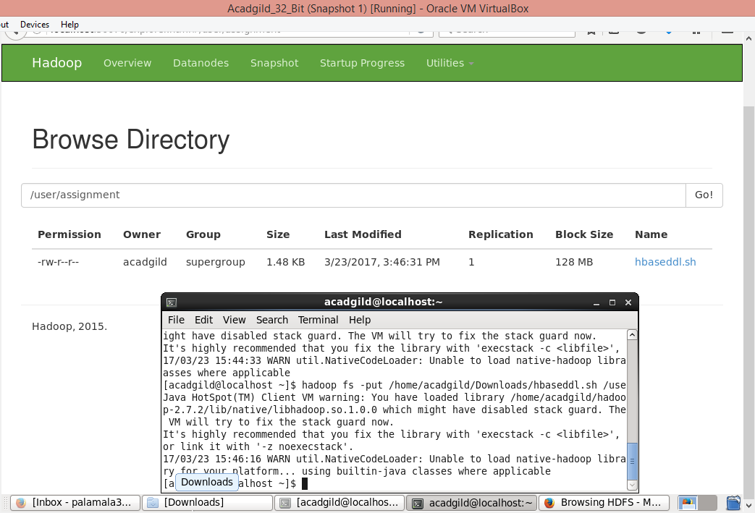

(iv) Download a file to local

hadoop fs –get /user/assignment/hbaseddl.sh /home/acadgild/project

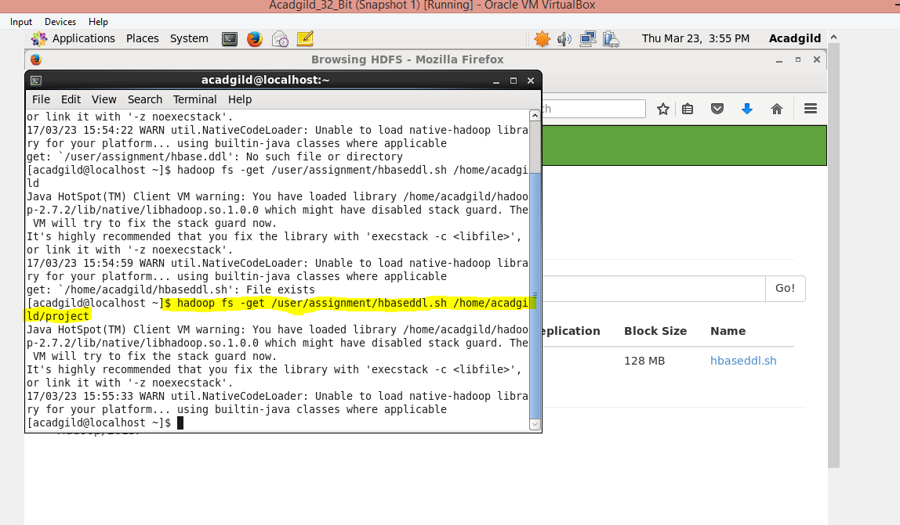

(v) Seeing the contents in hdfs

hadoop fs –cat /user/acadgild/project/data/mob/file.txt

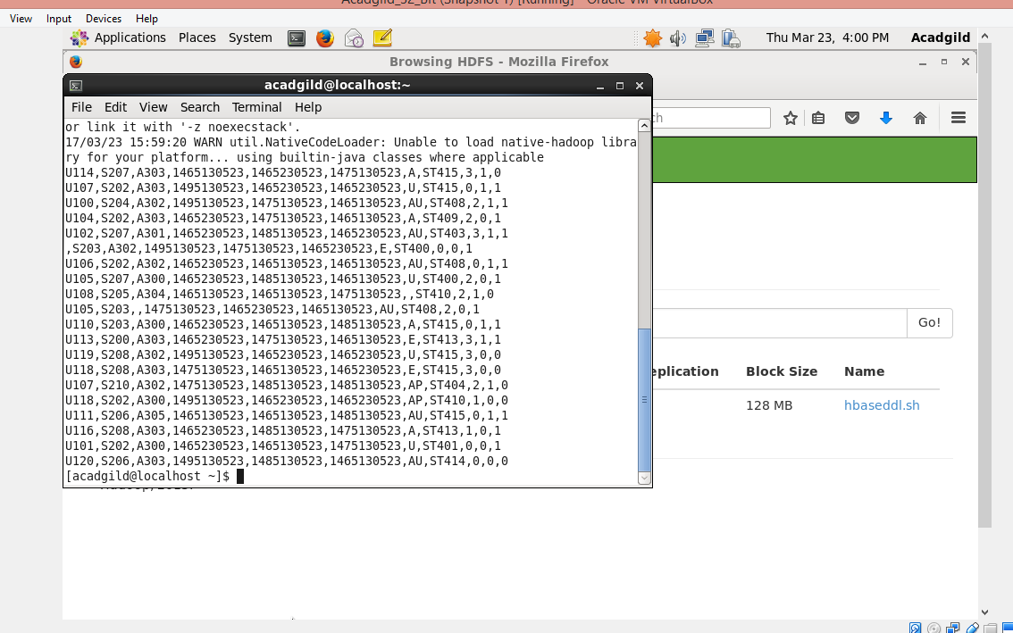

(vi) Copy a file from local to HDFS

hadoop fs –copyFromLocal /home/acadgild/Downloads/load.hql /user/assignment

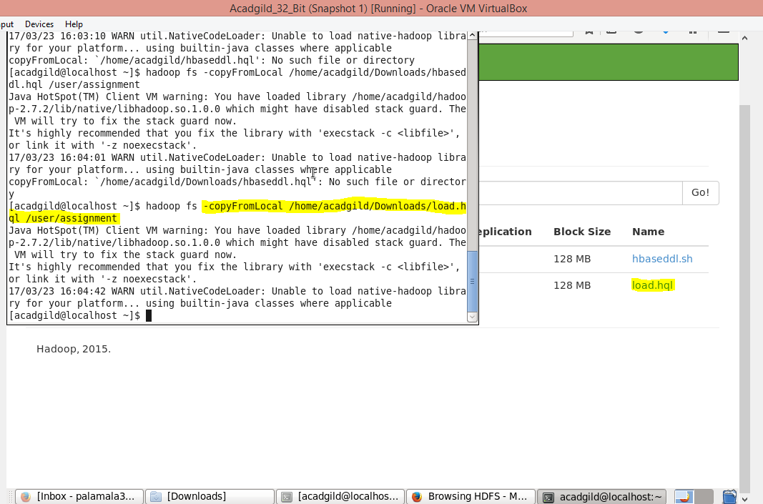

(vii)copy a file to local from hdfs

hadoop fs –copyToLocal /user/acadgild/project/data/web/file.xml /home/acadgild

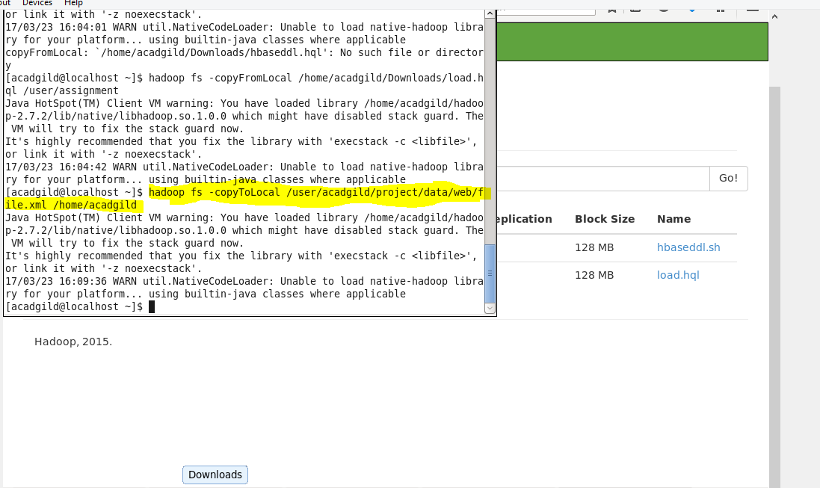

(viii) remove a file from hdfs

hadoop fs –rm /user/acadgild/hbaseddl.sh

