1. Concat

Student_name_concat= foreach stud_details generate CONCAT(firstname,lastname);

Dump student_name_concat;

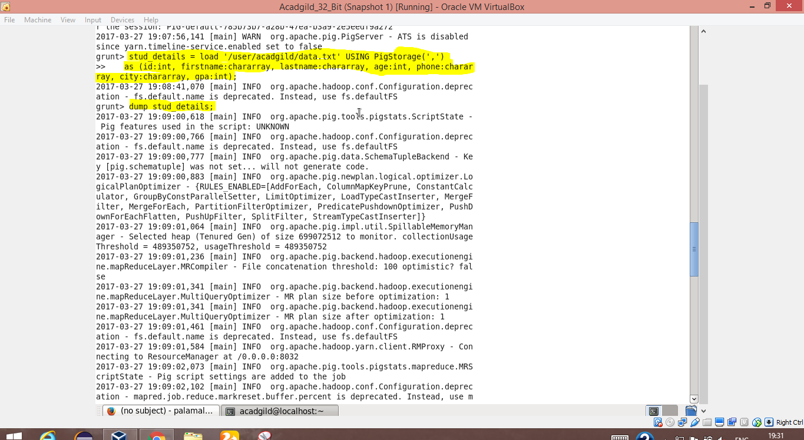

Screen for loading the data

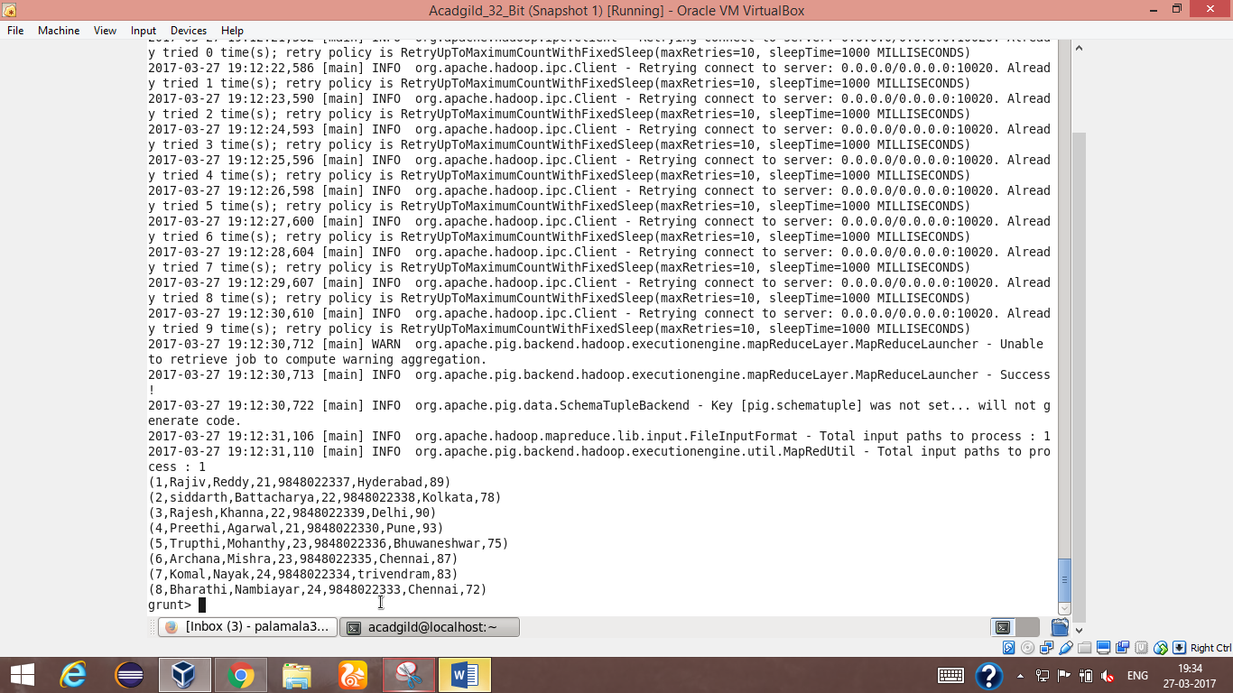

Screen to display the loaded data

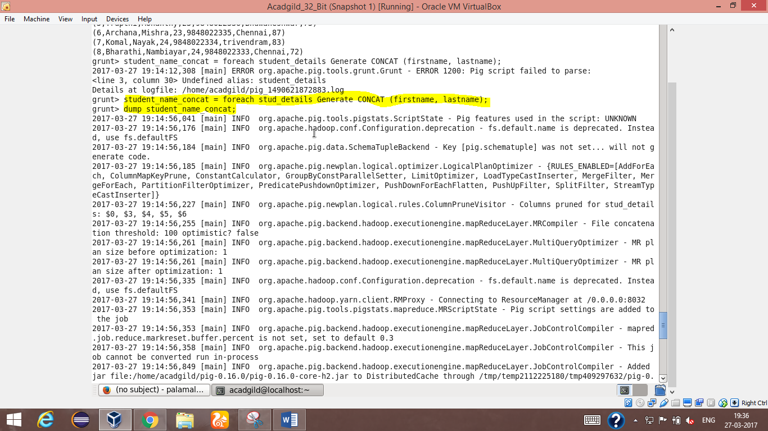

Concat function

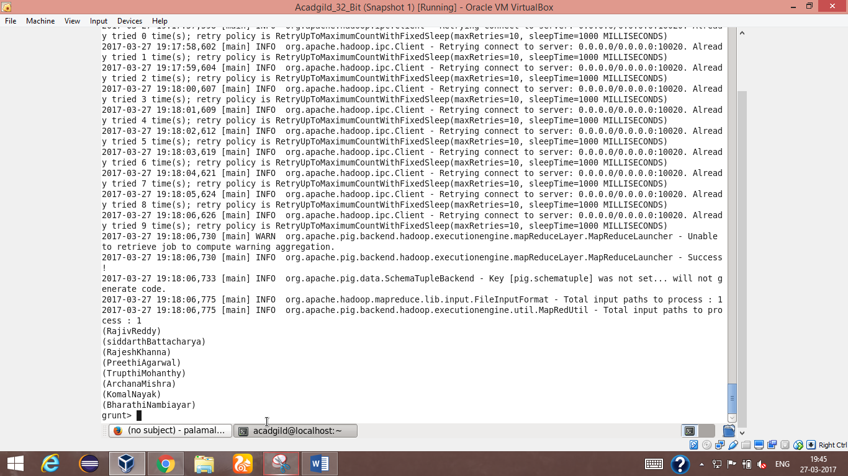

Column where concat is applied

1. Tokenize

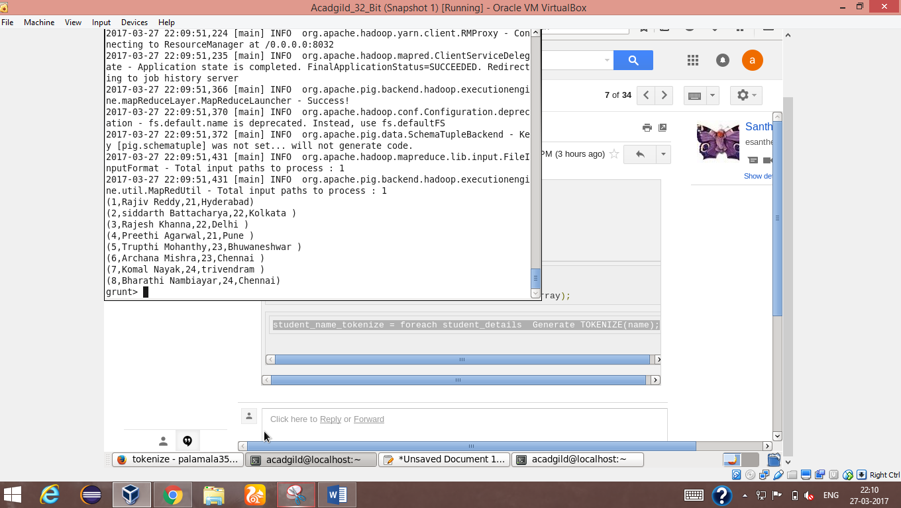

Table where tokenize is going to be done

Student_name_tokenize = foreach student_details GENERATE TOKENIZE(name);

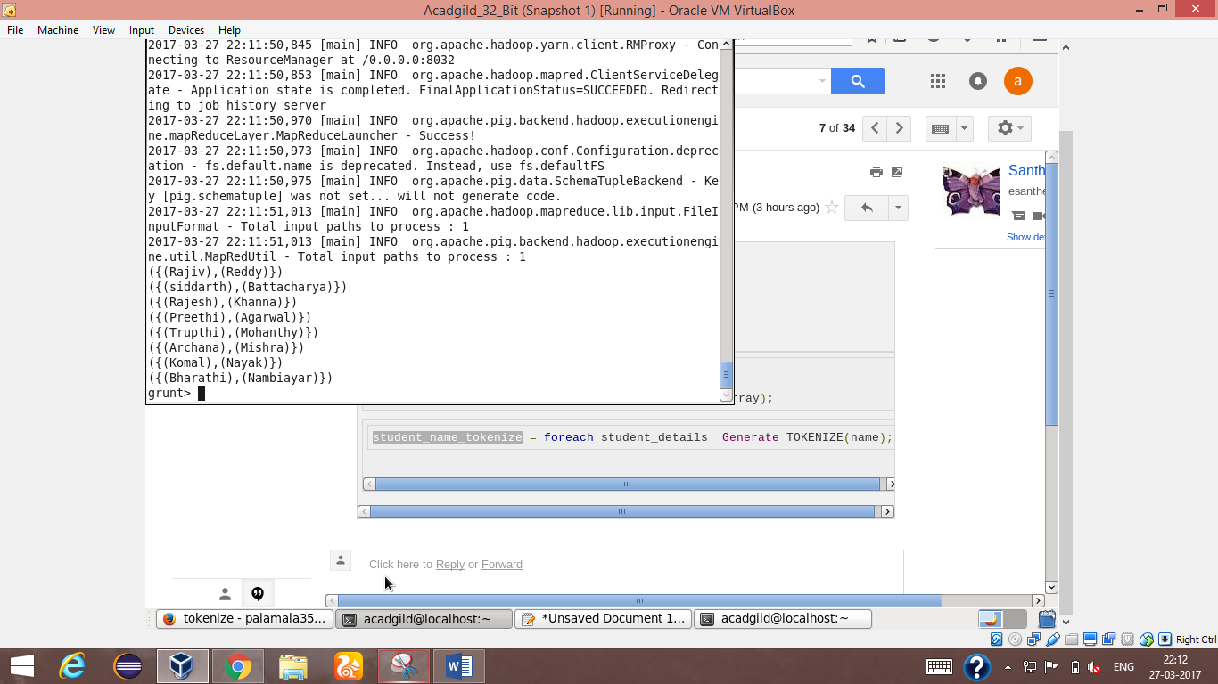

Result of tokenize in column “name”

3.SUM

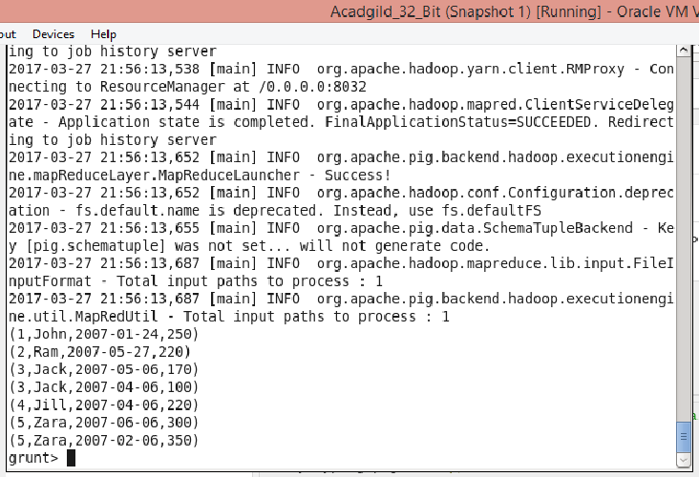

Table where table sum function is going to do

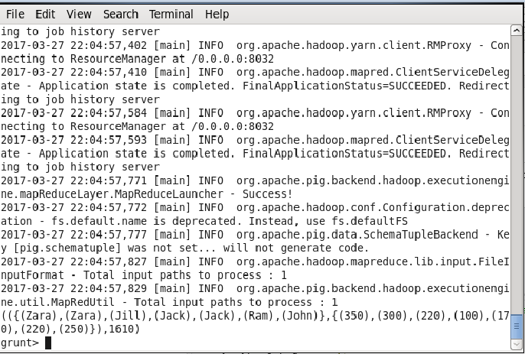

Sum of total pages typed

Student_group_all = group student_details all;

4.MAX

Student_max_gpa = foreach student_group_all generate

(student_details.firstname,student_details.gpa),MAX(student_details.gpa);

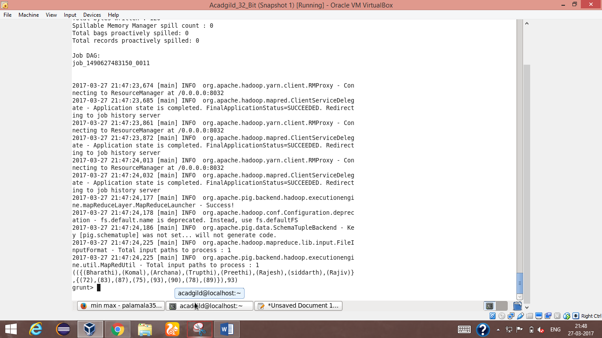

Max gpa among the student

5.MIN

Student_min_gpa = foreach student_group_all generate(student_details.firstname,student_details.gpa),MIN(student_details.gpa);

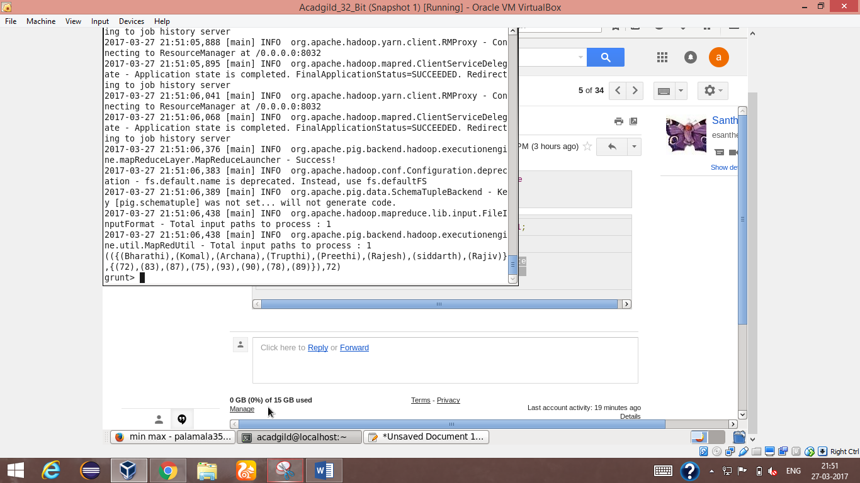

Min gpa among the students

6.Limit

Limit_data = LIMIT student_details 4;

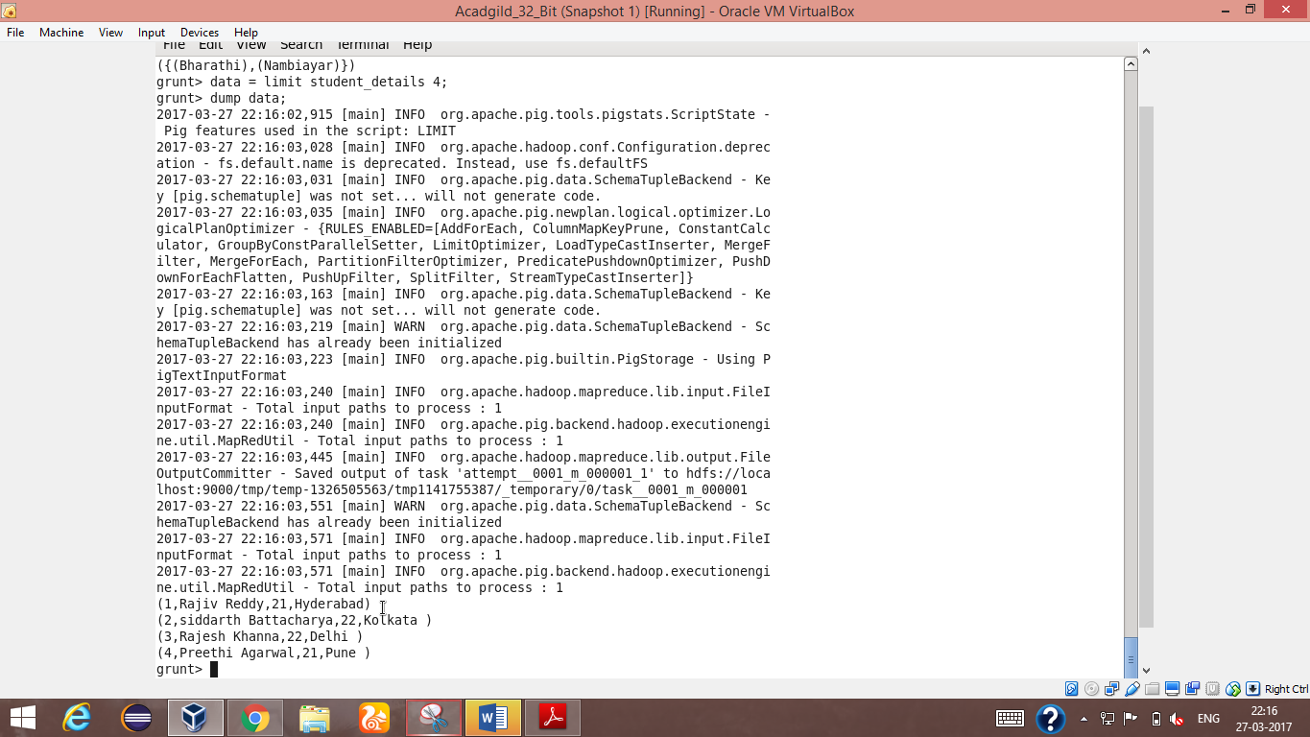

Student details with limited rows of 4

7.Store

Store student_details into ‘/home/acadgild’ ;

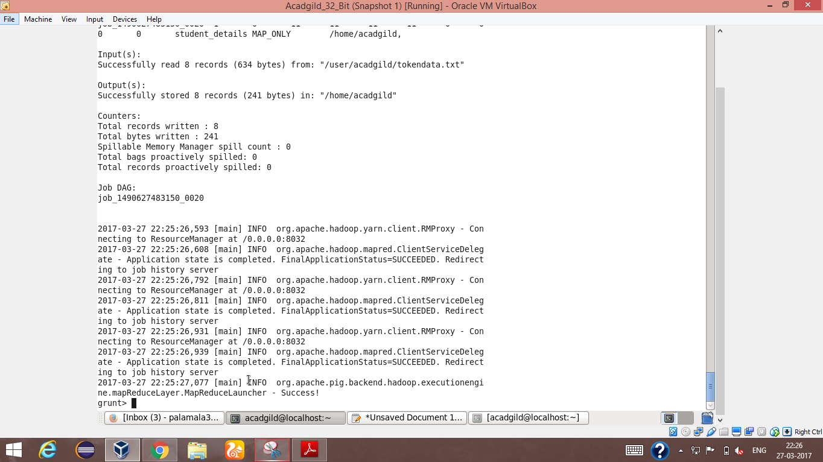

8.Distinct

Student_details_dist = distinct student_details;

Dump student_details_dist;

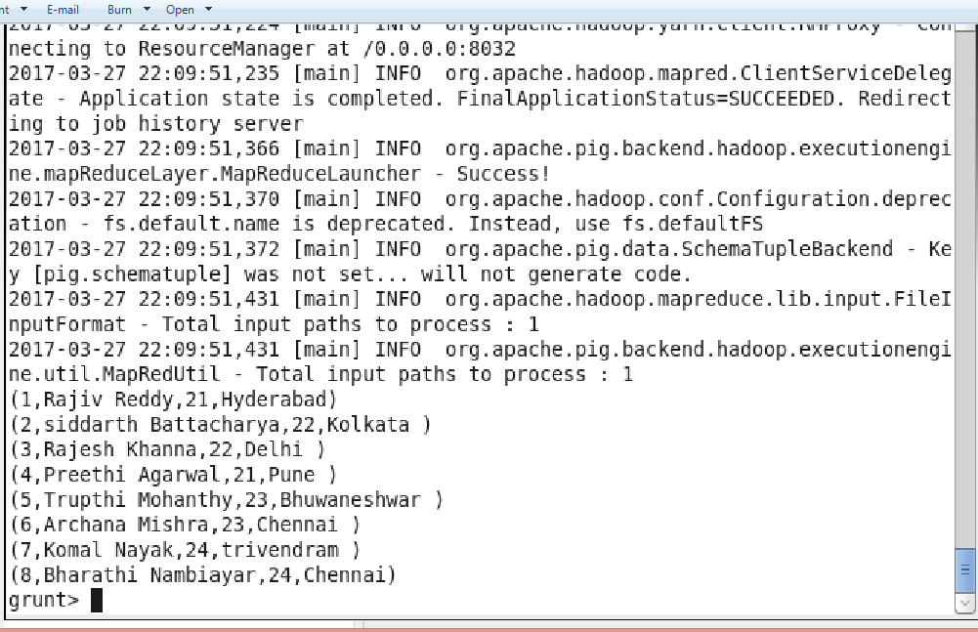

9.flatten

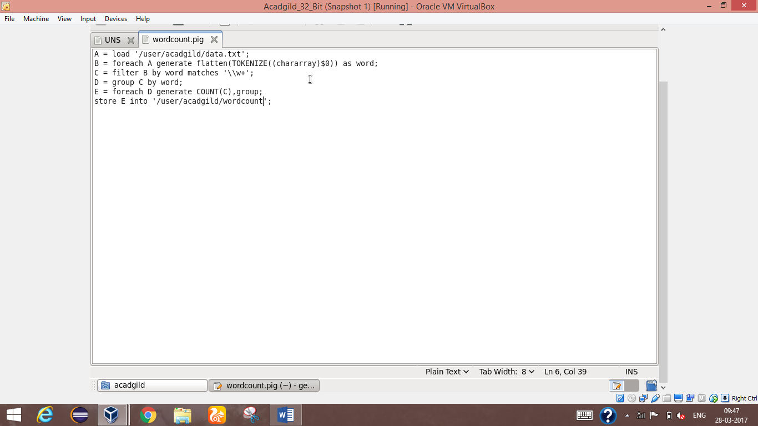

Script for flatten command

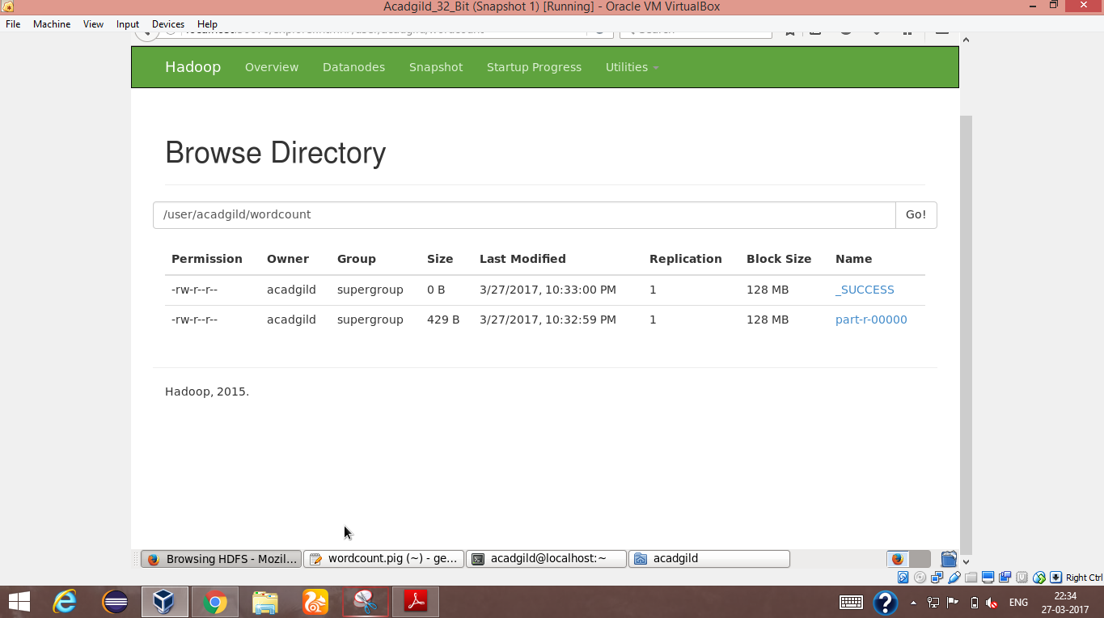

Output for flatten command

10.ISEMPTY

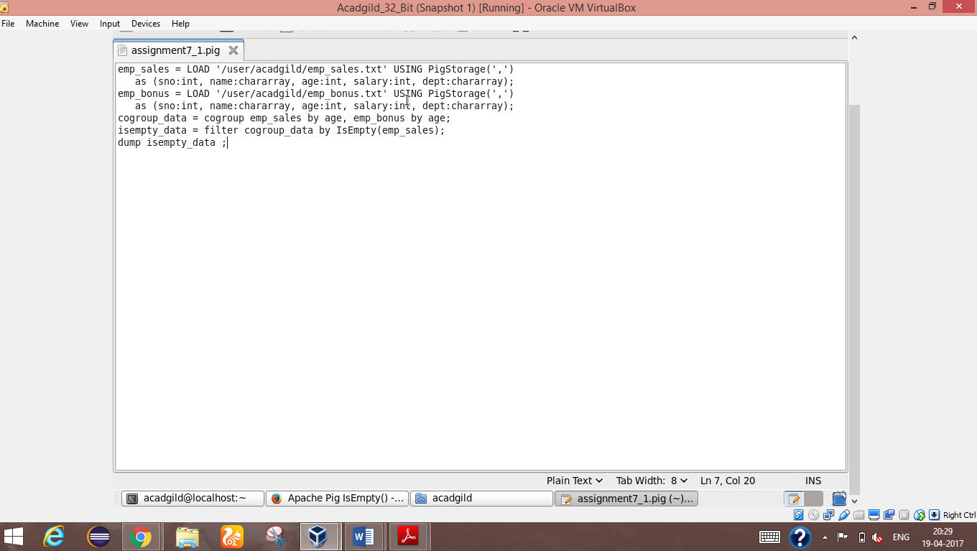

Script for Isempty

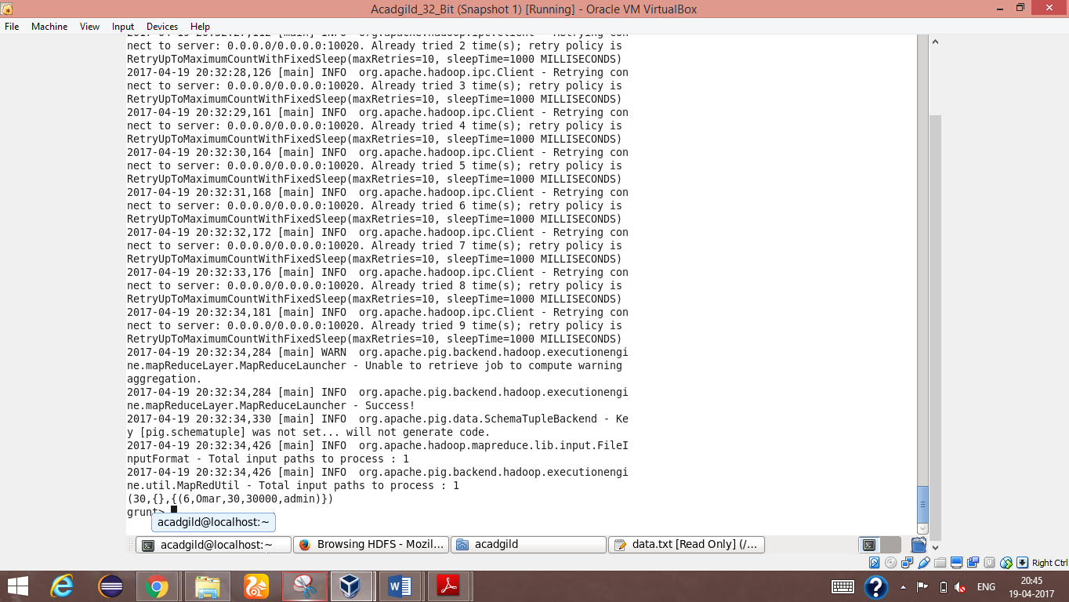

Output screen for Isempty command