Write a program to implement wordcount using pig

This can be done in two ways .

Here they have told only wordcount and didn’t mention whether to count all words in the file or to count the similar words

**Case :1 To count the similar words**

Example :

1,sss,34,rr

1,etu,55,rr

Output :

1 2

sss 1

etu 1

rr 2

**case:2 to count total number of words in the file**

Example :

1,sss,34,rr

1,etu,55,rr

Output :

8

(which counts all the words in the file )

**Case : 1**

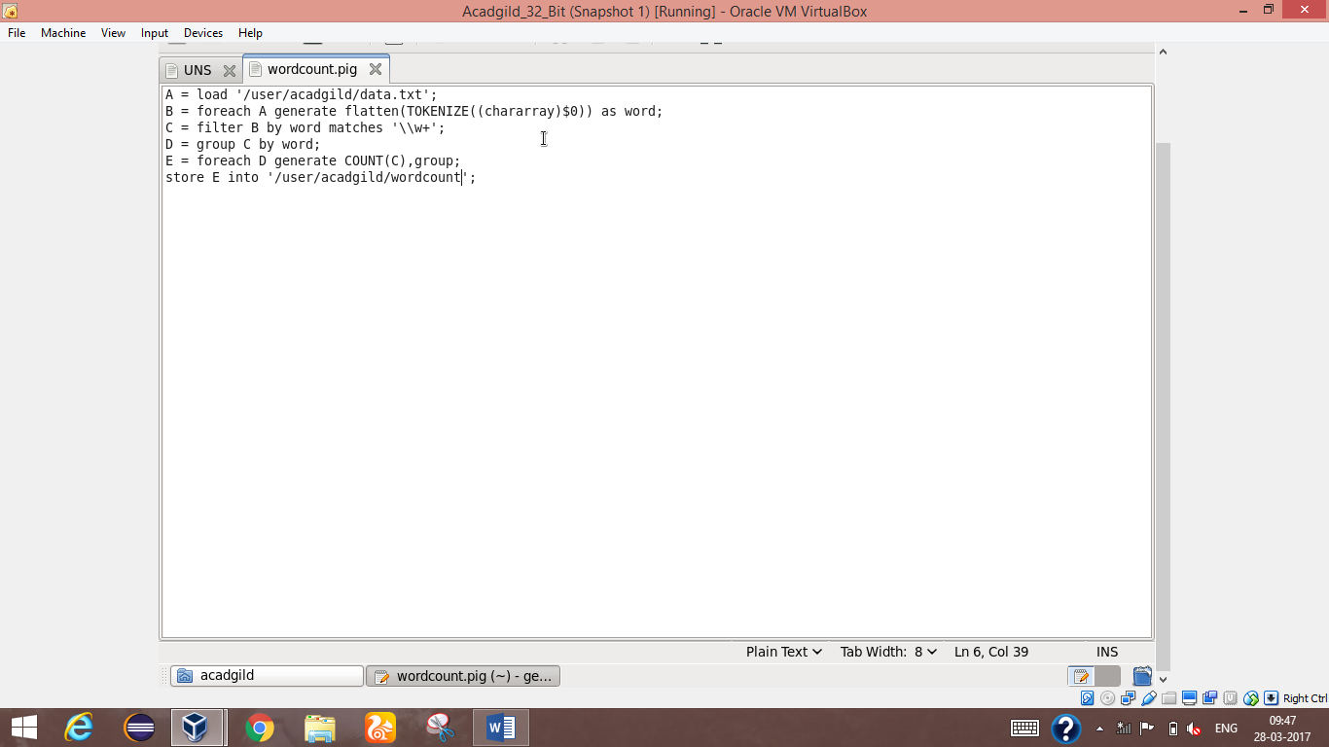

Wordcount program script

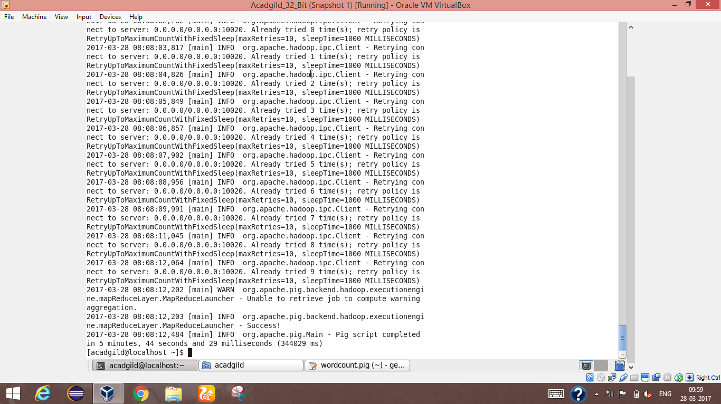

Wordcount script run successfully in terminal

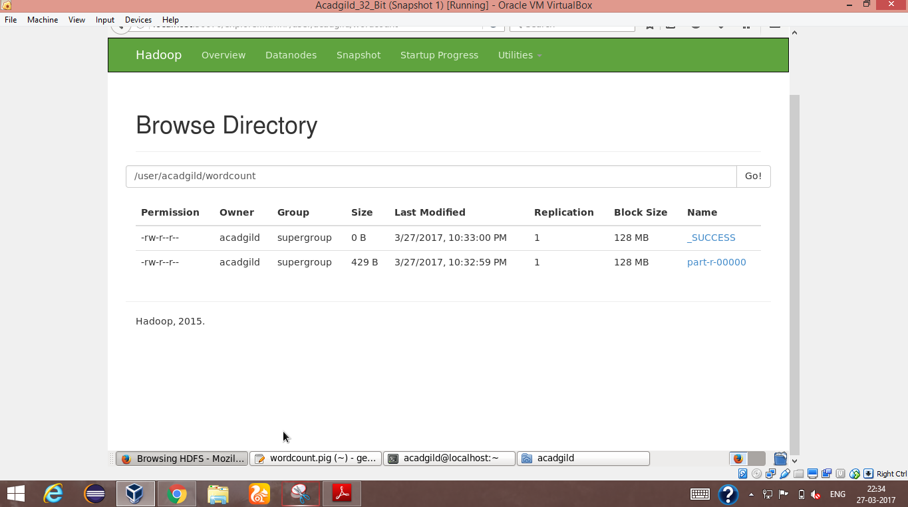

Destination storage

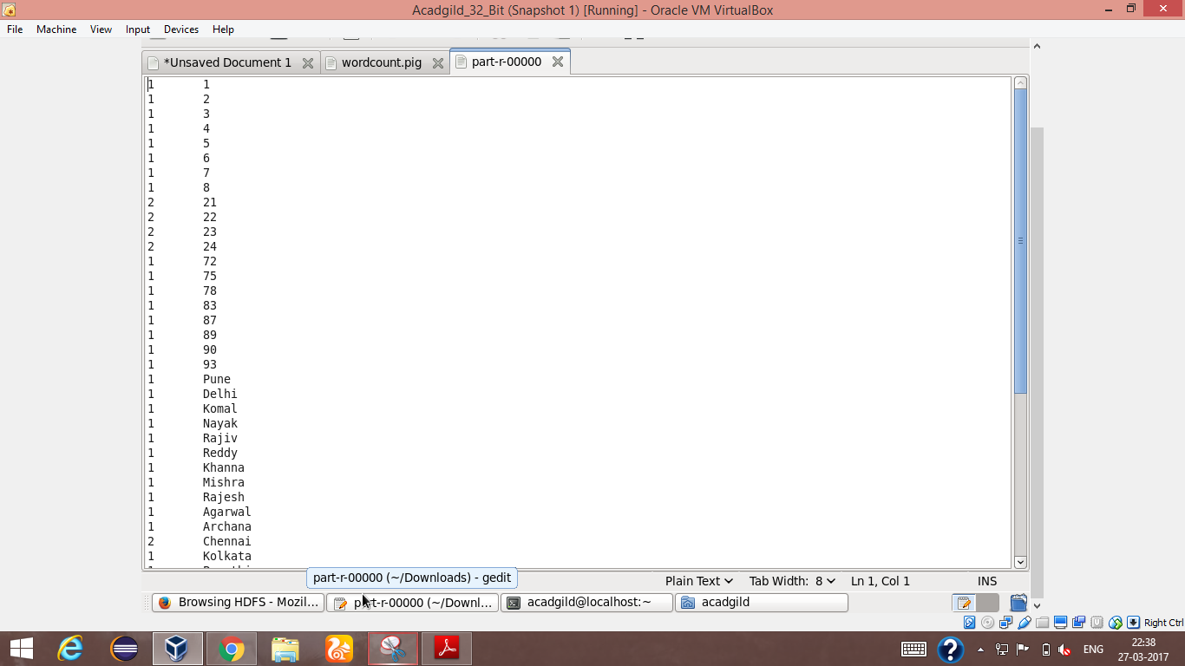

output

Case : 2

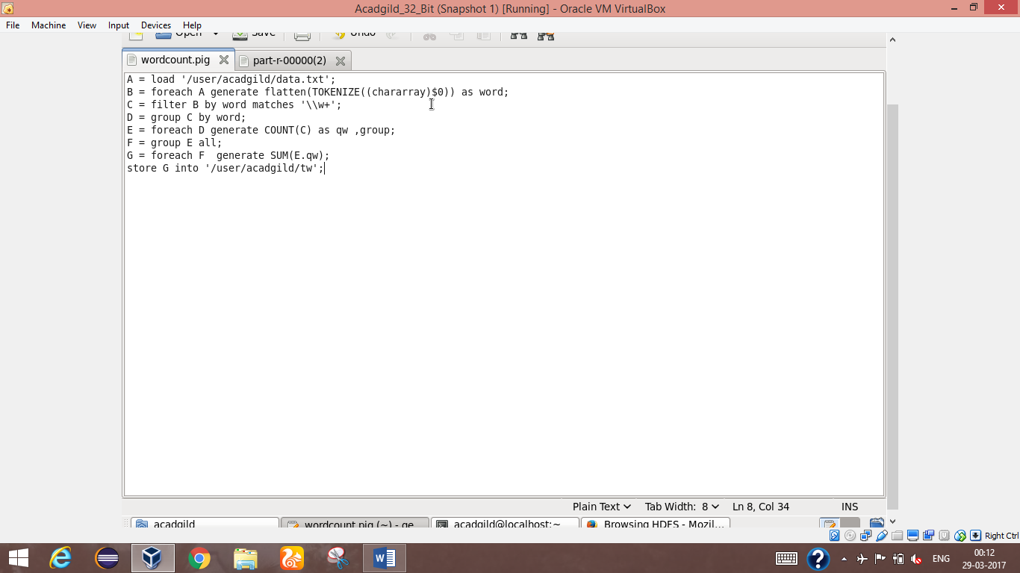

Script for total number of words in the file

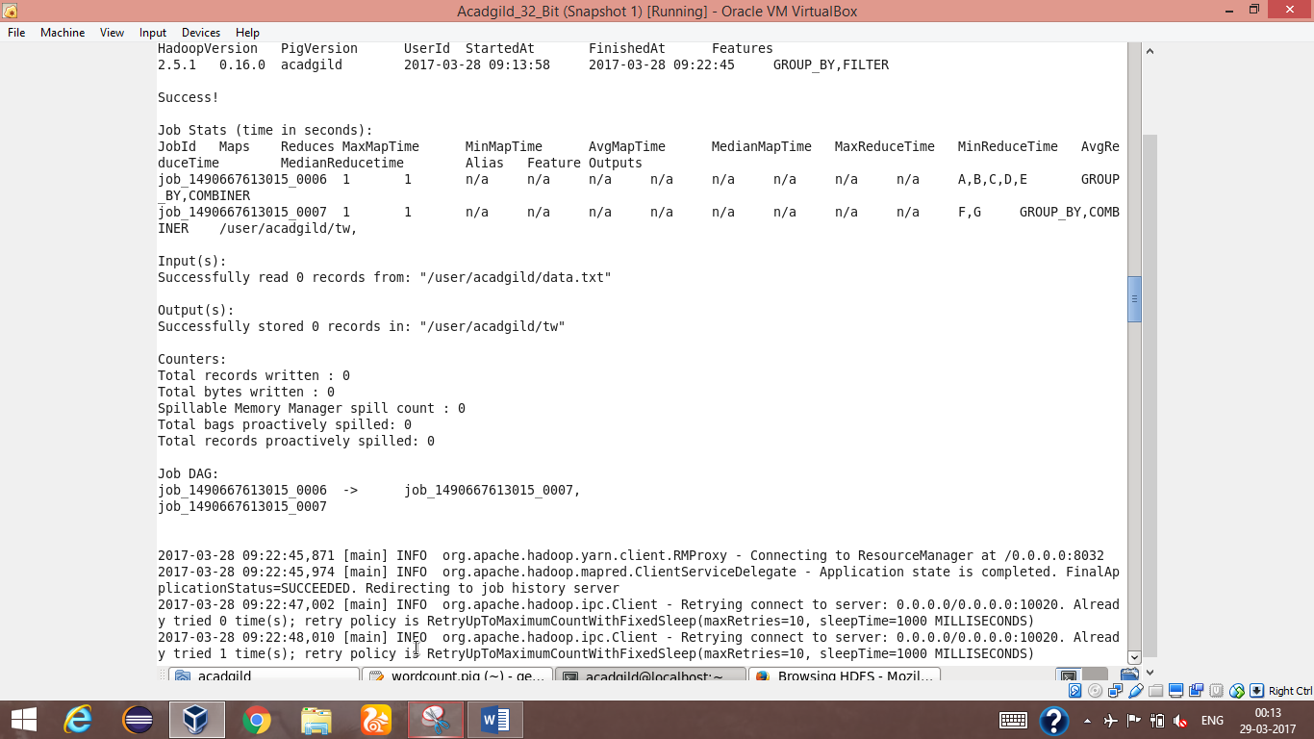

Terminal where the wordcount script run successfully

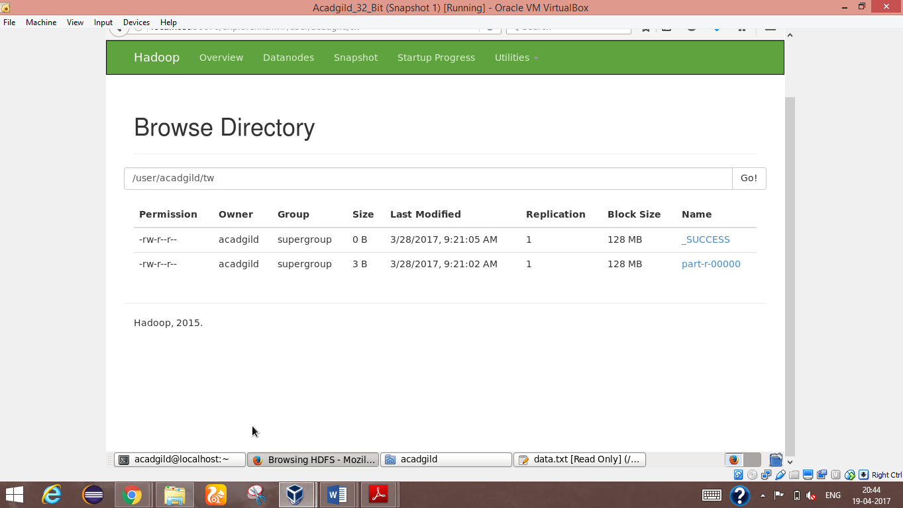

Destination where output is stored

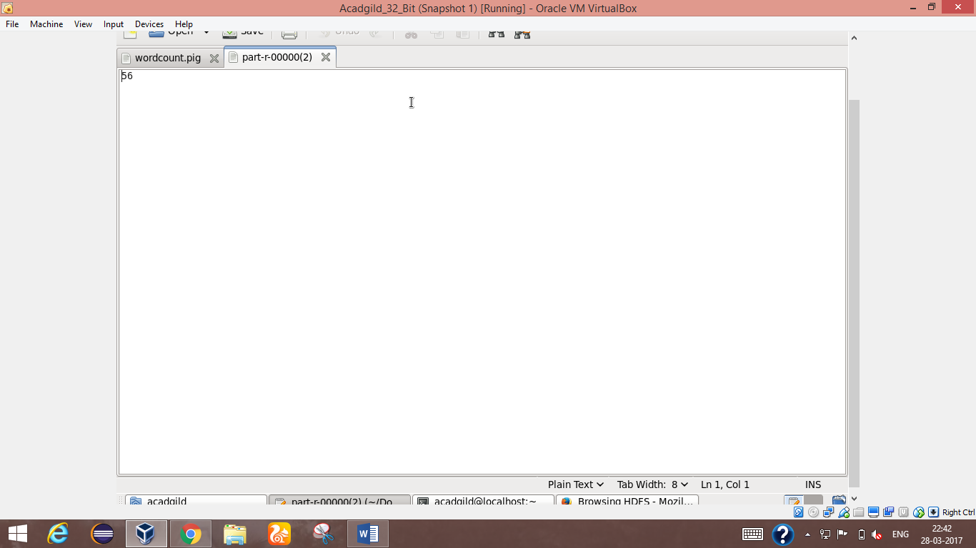

Output shows total number of words in the file