**Design Consideration:**

You can create domain project to store domain objects

* + Have generic DB repository for all the crud operations. We can also user Dependency injection to inject the entity.
  + Can have single database for application and membership
  + Implement viewmodel for views with more than one model. We can have feedback and client future interest in the same view.
  + Need to add validations etc...

**Extra Features added:**

Login/membership feature

Authorize users only for feedback page.

**Technology:**

MVC 5, Entity framework 6, sql server 2012

Other Information:

SQL Server DB bakup attached

Asp memebership aspnet-HealthSystemsDemo-20150131061916.mdf is under App_Data folder

Below are the snap shot of all the screens….

Landing Page

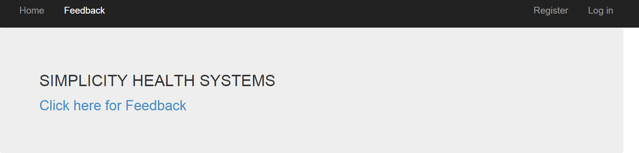

Login Page

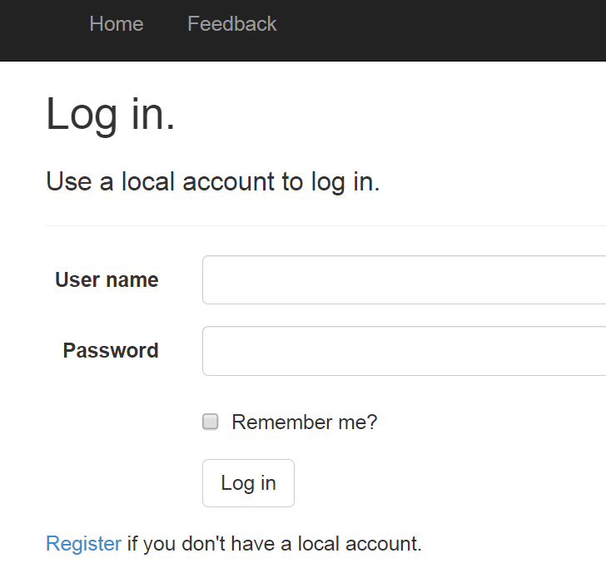

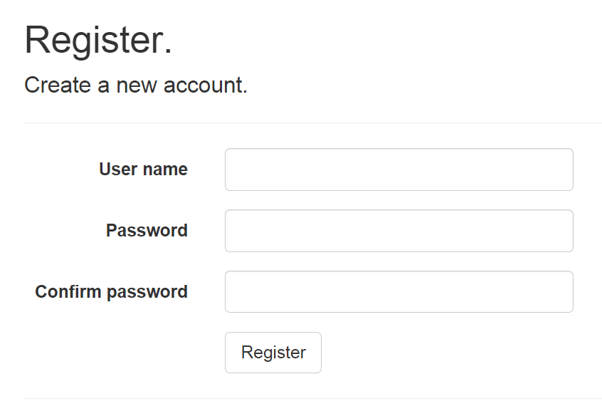

FeedBack Form

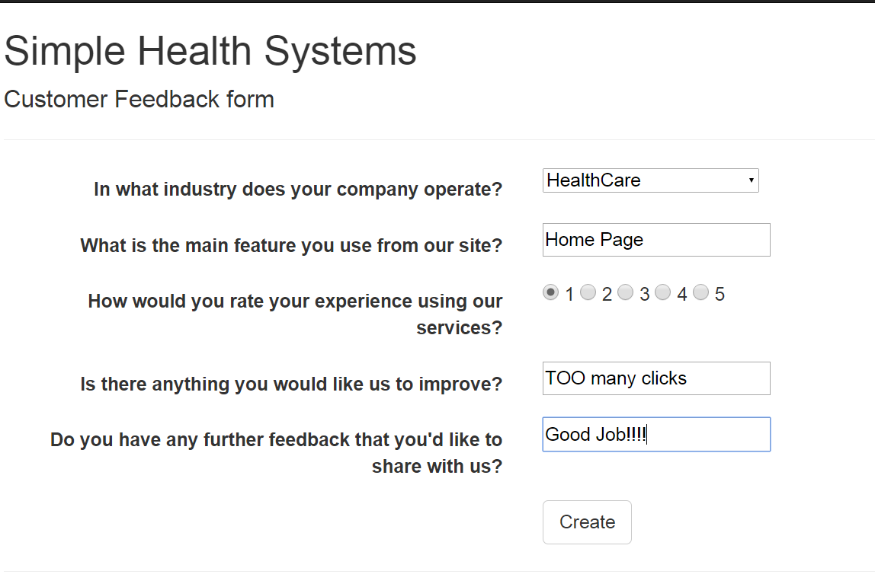

Thank you page



Results Page

