Offline Vision Analyzer

100% local · zero internet required after setup · private by design
A desktop multimodal RAG system that lets you upload scans, charts, diagrams, and PDFs, then ask natural-language questions about them — all powered by local models.
Github link: https://github.com/santhimaddipudi/OfflineVisionAnalyzer
Upload file → EasyOCR (text) + CLIP (image embedding) → ChromaDB
↓
User question → hybrid retrieval → LLaVA (Ollama) → answer + citations

Flow:
Upload scan/chart/diagram
↓
Preprocess image/PDF
↓
Esay OCR extracts OCR
↓
LLaVA answers visual questions
↓
Embed text + image summaries
↓
Store in ChromaDB
↓
User asks question
↓
Retrieve relevant text/images
↓
LLaVA + retrieved context answers locally

Architecture:
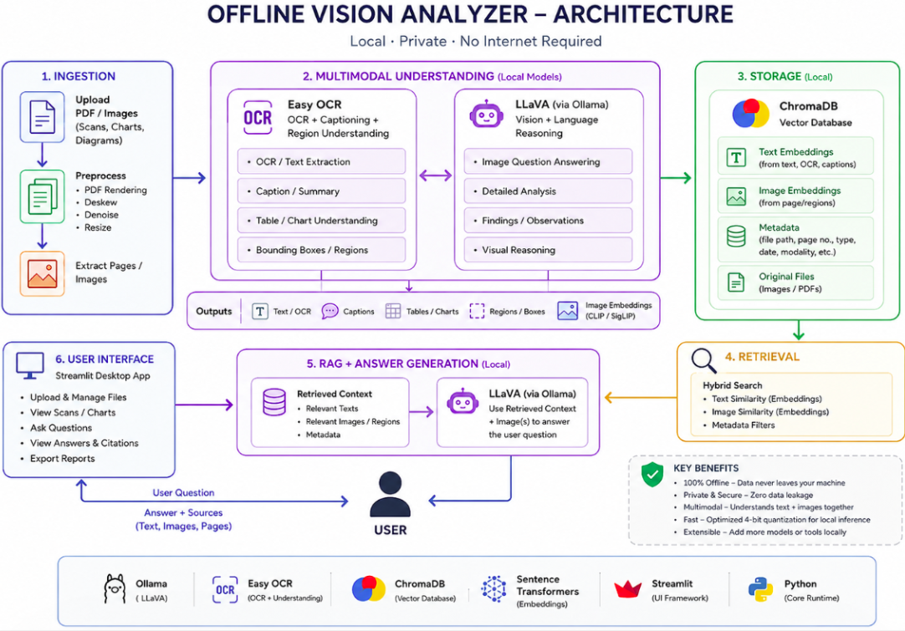

Minimal project structure:
