FITTRACK
Personalized Fitness Recommendations Powered by AI
PROJECT DOCUMENT

TEAM MEMBERS

Anisha begum.C
Sandhiya.S
Monisha.M
Sandhiya.G

1. Introduction
FitTrack is a backend project designed to provide fitness-related functionality through APIs. The project includes fitness recommendation functionality and is tested through API requests and responses. The backend is developed using Node.js and Express.js, with AI functionality used for personalized fitness recommendations.
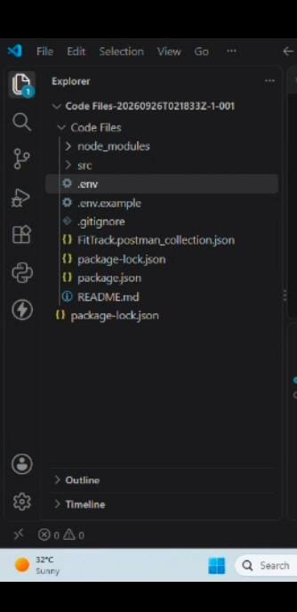

2. Problem Statement
Users may find it difficult to plan workouts that match their fitness goal and experience level. A fitness application can simplify this process by accepting user details and providing personalized recommendations through an API.

3. Objectives
- To develop a backend system for fitness-related functionality.
- To provide personalized workout recommendations using AI.
- To accept user information through REST API requests.
- To test API requests and responses using Postman.
- To handle successful and unsuccessful API requests properly.

4. Technologies Used
- Node.js
- Express.js
- JavaScript
- Google Gemini AI
- Postman
- Visual Studio Code
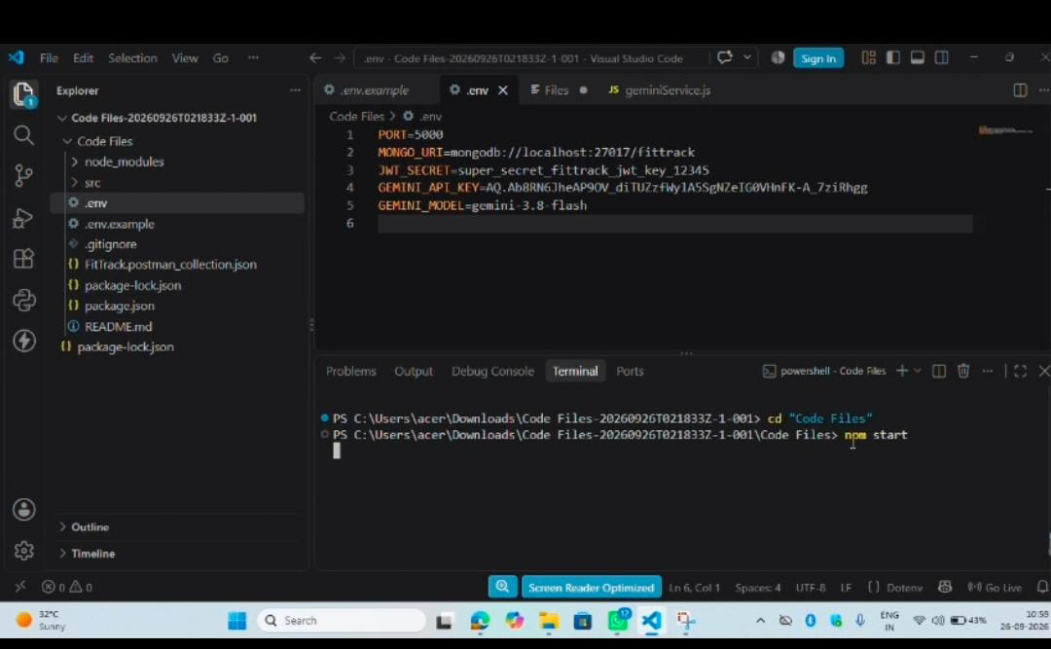

5. Project Workflow
The basic workflow of the project is:
- Create and organize the backend code files.
- Start the backend server.
- Create and configure API endpoints.
- Send requests through Postman.
- Process the request in the backend.
- Use AI functionality where required.
- Return the response in JSON format.
- Verify the output in Postman.
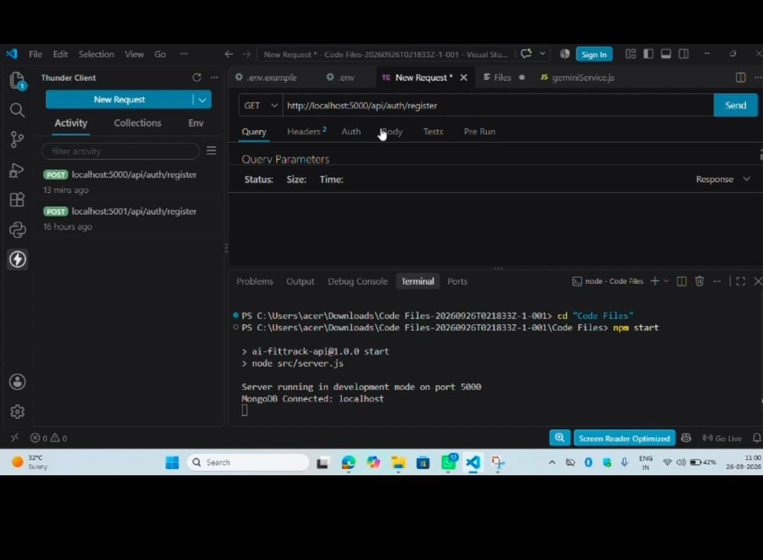

6. API Implementation
The project uses RESTful APIs to communicate with the backend. API requests contain the required input data, and the backend processes the request and returns a JSON response.
- HTTP methods such as GET and POST are used according to the implemented API.
- Request data is sent in JSON format where required.
- The backend validates the required input.
- The API returns a response indicating success or failure.
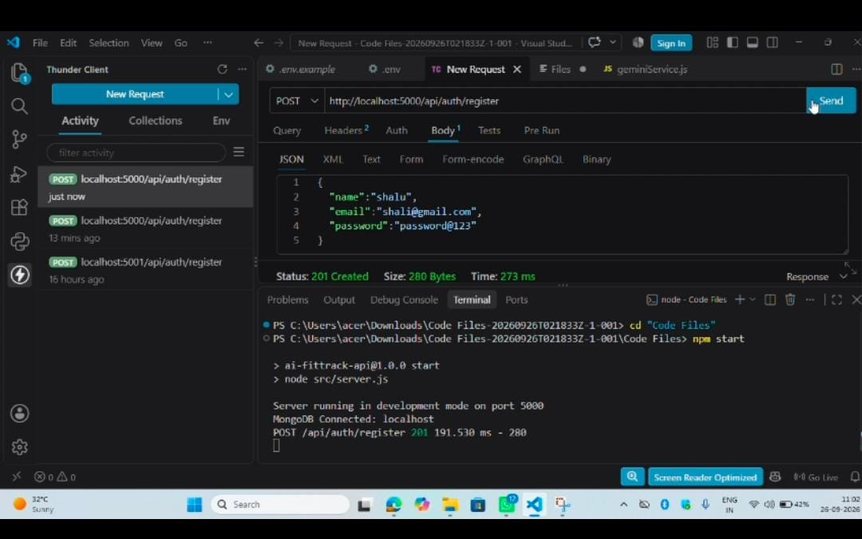

7. AI-Powered Workout Recommendation
The AI recommendation feature accepts fitness-related information such as age, fitness goal, and experience level. The backend sends the required information to the AI service and returns a personalized workout recommendation.
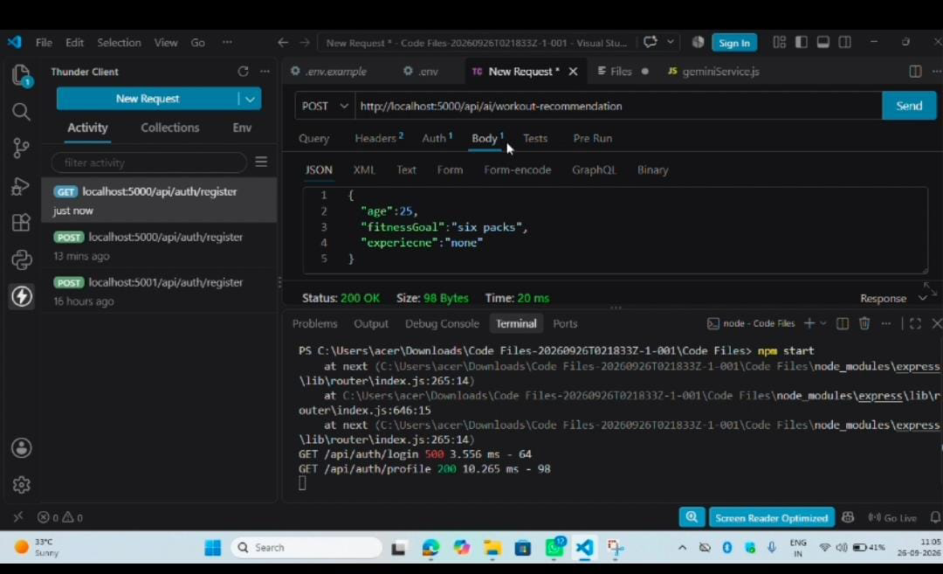

8. API Testing Using Postman
Postman is used to test the implemented APIs. Each request is checked by providing the required input and verifying the JSON response returned by the backend.
For each API screenshot, make sure the screenshot clearly shows the HTTP method, API URL, request body (if applicable), and response.
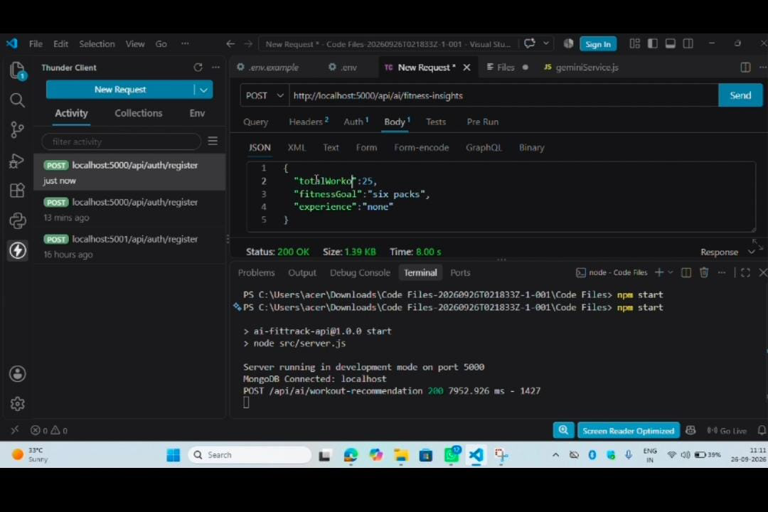

9. Successful Output
The completed API requests return the expected JSON responses. The successful AI recommendation request demonstrates that the backend receives the fitness information, processes it, and returns a recommendation.
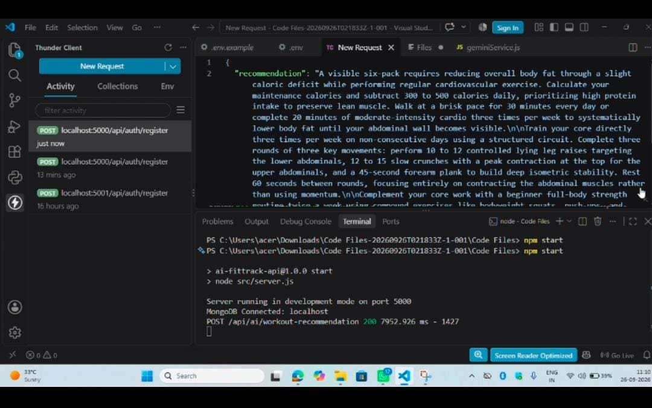

10. Error Handling
The backend also handles invalid or incomplete requests by returning an appropriate error response. This helps identify missing or incorrect input during API testing.

11. Result
The FitTrack project was implemented and tested successfully. The backend APIs can receive requests, process the required data, and return JSON responses. The AI recommendation feature provides personalized fitness recommendations based on the information supplied by the user.

12. Conclusion
FitTrack demonstrates the development and testing of a backend fitness application with AI-powered recommendation functionality. The project provides a structured API-based approach for processing fitness information and generating useful recommendations.

13. Future Enhancements
- Add more fitness-related features.
- Add nutrition recommendations.
- Add fitness progress tracking.
- Add workout reminders.
- Develop a user-friendly frontend application.

