INTRODUCTION

* Event management is the process of creating and maintaining an event. This process spans from the very beginning of planning all the way to post-event strategizing.
* At the start, an event manager makes planning decisions, such as the time, location, and theme of their event. During an event, event managers oversee the event live and make sure things run smoothly. After an event, event managers are tasked with reviewing event data, submitting KPI and ROI findings, and staying on the ball for any post-event offerings.

PROBLEM DEFINITION & DESIGN THINKING

1. Empathy map



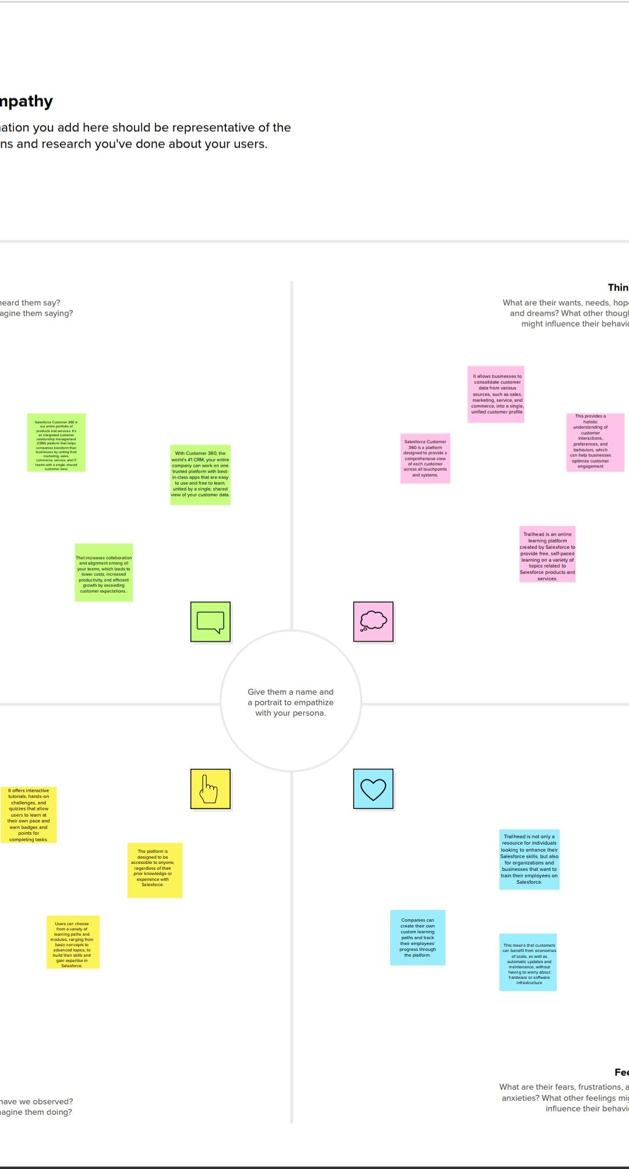

1. Ideation & brainstorming





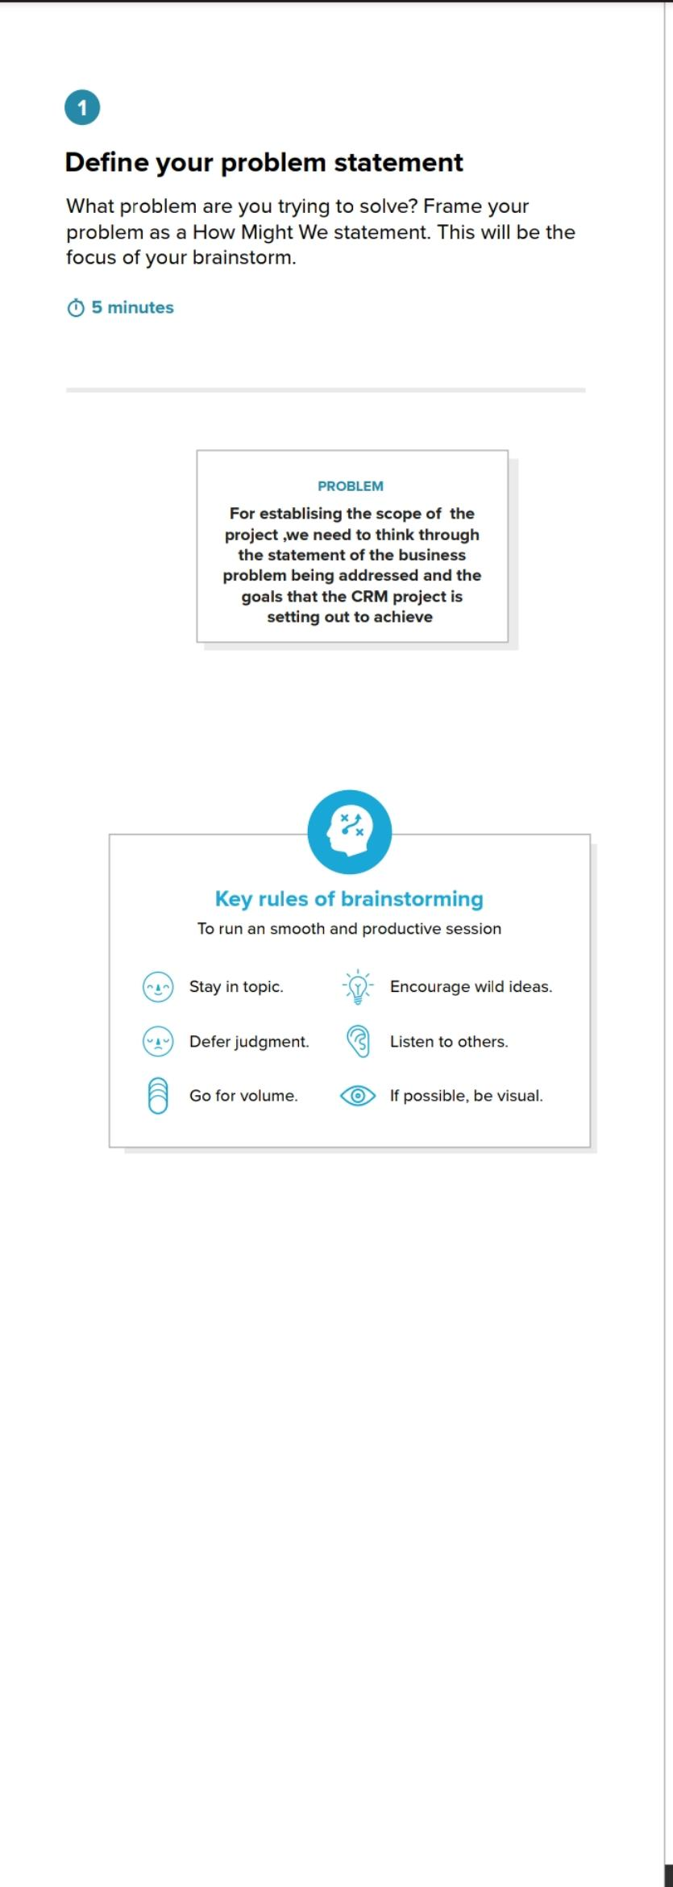

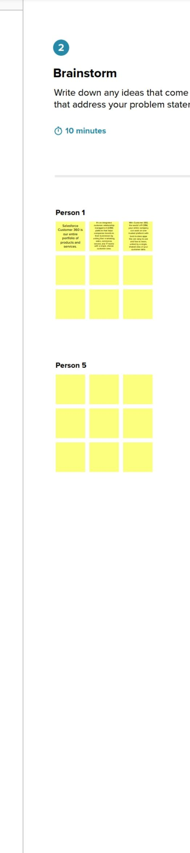



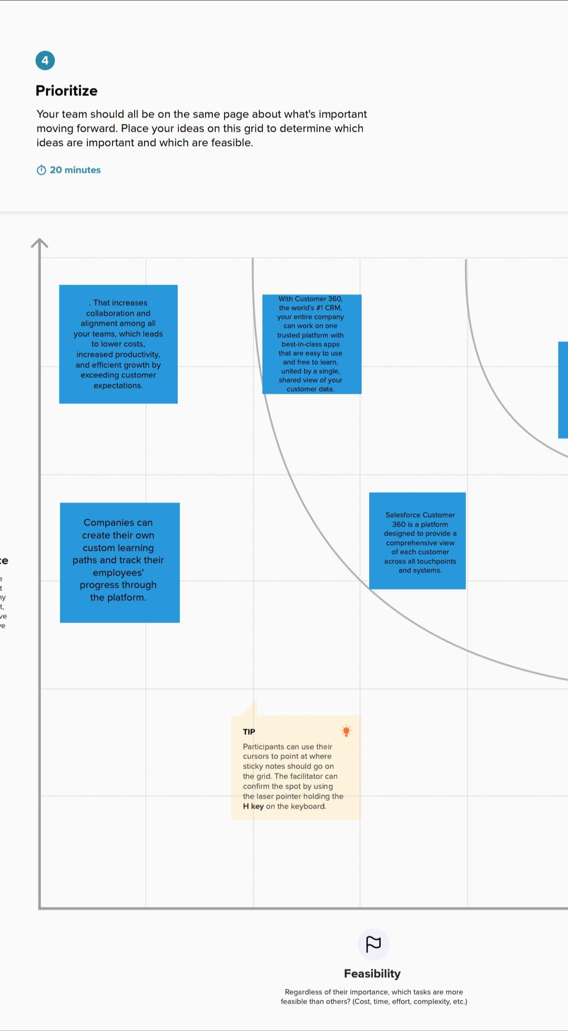

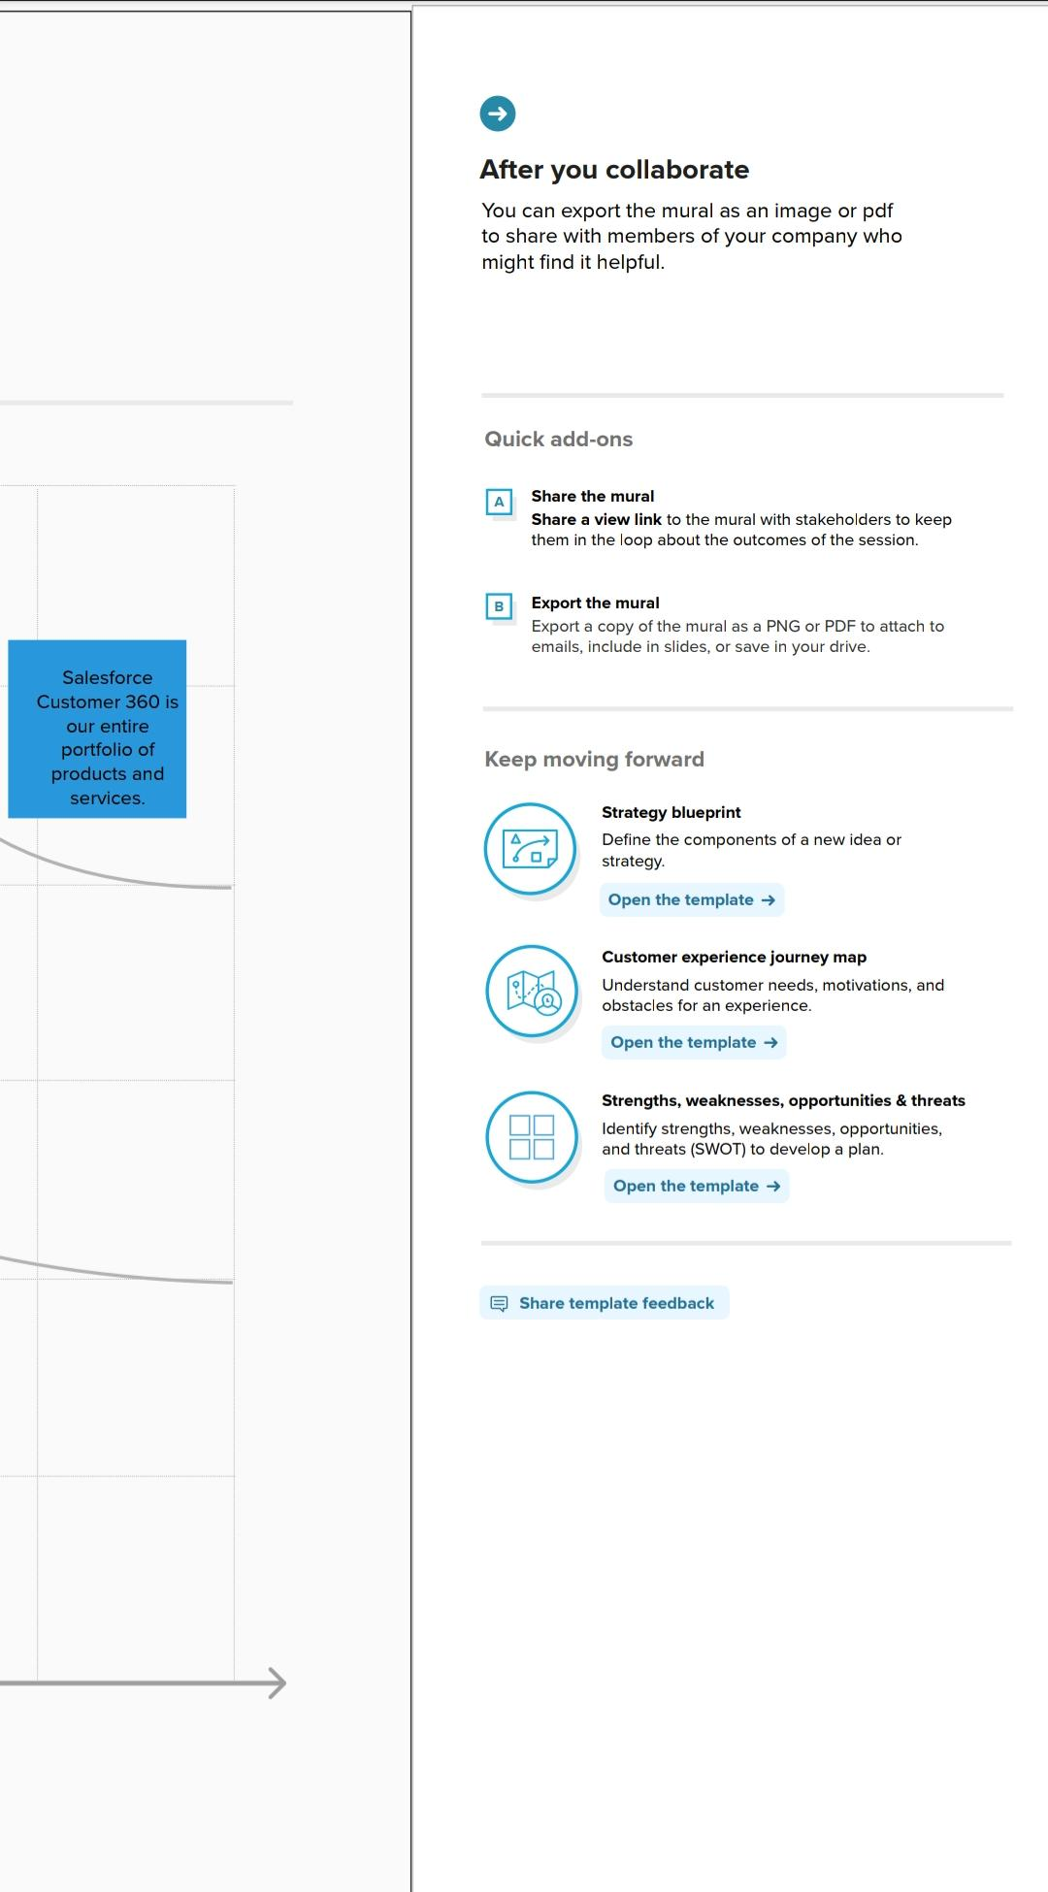

ADVANTAGES AND DISADVANTAGES

Pros :

1. Opportunities for creativity

As an event manager, you can use your creative skills and talents to coordinate the details of parties and celebrations. Your client base might prefer different party styles, allowing you to take creative approaches to each event. This might include determining the color scheme and decorations for an event. The daily routine of an event manager often changes and requires a unique and creative set of skills for these professionals to adapt.

1. Ability to work on different events

An event manager often works on several types of events. For example, they might plan a business conference, holiday party, music festival or product launch. Because of this, an event manager often has an exciting career and interesting responsibilities. You can improve your management abilities with each kind of event you plan by gaining experience in different areas, like managing both corporate events and personal celebrations.

1. Chance to work with diverse clients

Event managers may travel and work with people in different areas to plan their parties and celebrations. You can meet a variety of clients from different backgrounds with unique goals for their events. This allows you to customize your skills and expertise when working with each customer. By working with a diverse group of people, you might improve your communication and social skills and learn new techniques to apply to future clients.

Cons :

1. Unconventional work hours

Event managers often work nights and weekends to complete their responsibilities, sometimes in addition to normal office hours during the weekdays. Event planners may also work during holidays to coordinate seasonal parties and celebrations. While many jobs have a limit to the number of hours for employees to work each day or week, event planners might spend an unlimited amount of time completing their responsibilities. They might work shifts up to 15 hours compared to the traditional nine-hour shift for many professions.

1. Time away from family and friends

Event planners might travel often to manage their tasks. This can result in time spent away from friends and family members. It might be challenging to maintain relationships when you travel frequently. This profession may also require an event planner to balance their work responsibilities with their responsibilities at home.

1. Experience requirements

Event management positions often require applicants to have extensive experience in their field. When starting your career as an event manager, you might seek unpaid internships to gain this experience before advancing to paid positions. While establishing your career and earning experience, you might find little job stability. The experience requirements of a job in event management might cause professionals to begin their careers with unpaid opportunities.

TRAILHEAD PROFILE PUBLIC URL

Team leader :

https://trailblazer.me/id/santhiya4

CONCLUSION

Event Management System is user friendly and cost effective system, it is customized with activities related to event management life-cycle. It provides a new edge to management industry. SolutionDot always keep your objectives and goals on top priority while developing any plan of work.