**PL/SQL EXERCISE**

**Exercise 5: Triggers**

**Scenario 1:** Automatically update the last modified date when a customer's record is updated.

**Question:** Write a trigger **UpdateCustomerLastModified** that updates the LastModified column of the Customers table to the current date whenever a customer's record is updated.

CODE:

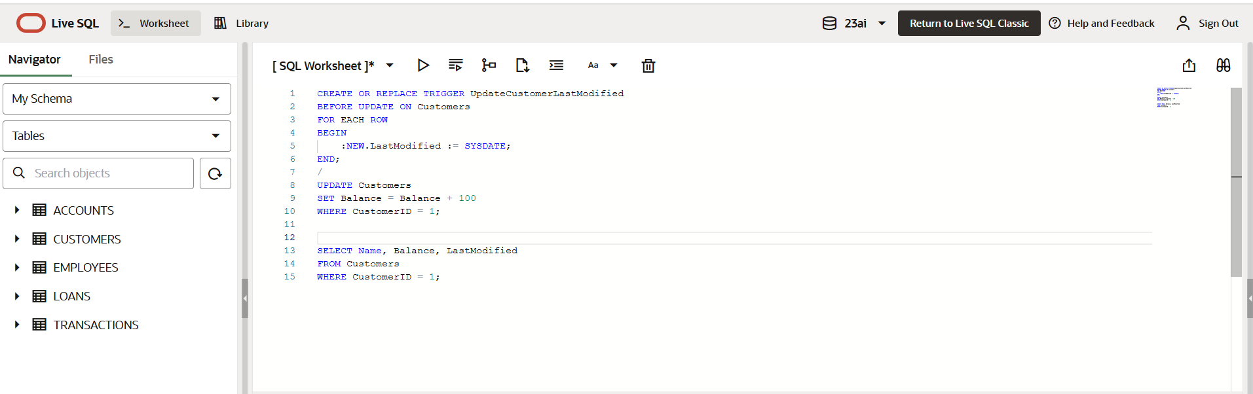

OUTPUT:

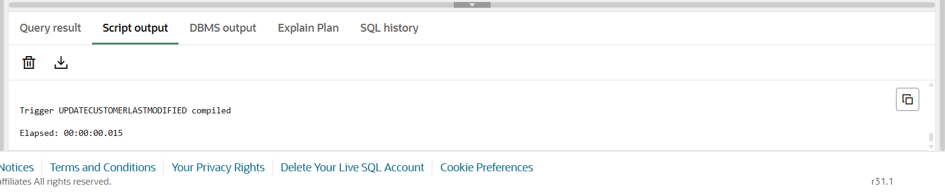

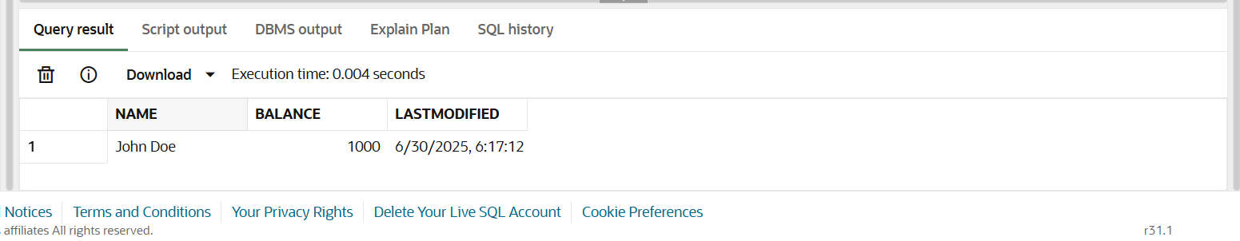

**Scenario 2:** Maintain an audit log for all transactions.

**Question:** Write a trigger **LogTransaction** that inserts a record into an AuditLog table whenever a transaction is inserted into the Transactions table.

CODE:

AUDITLOG TABLE :

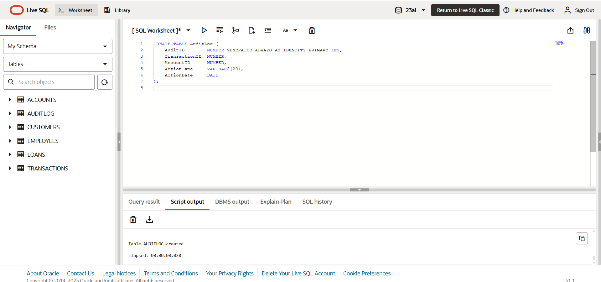

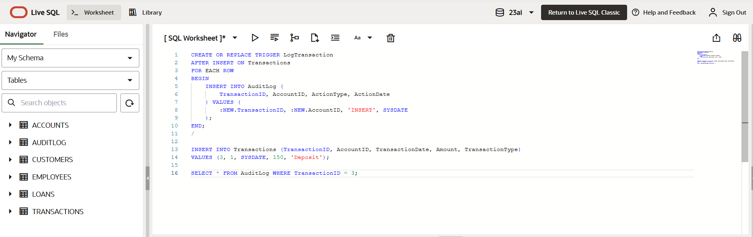

OUTPUT:

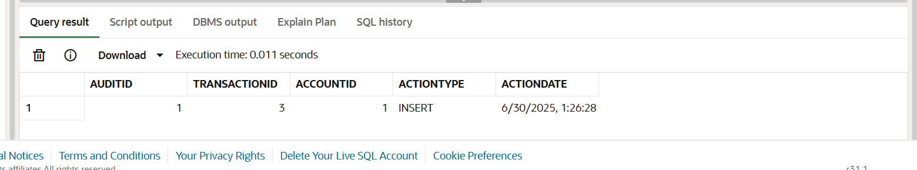

**Scenario 3:** Enforce business rules on deposits and withdrawals.

**Question:** Write a trigger **CheckTransactionRules** that ensures withdrawals do not exceed the balance and deposits are positive before inserting a record into the Transactions table.

CODE:

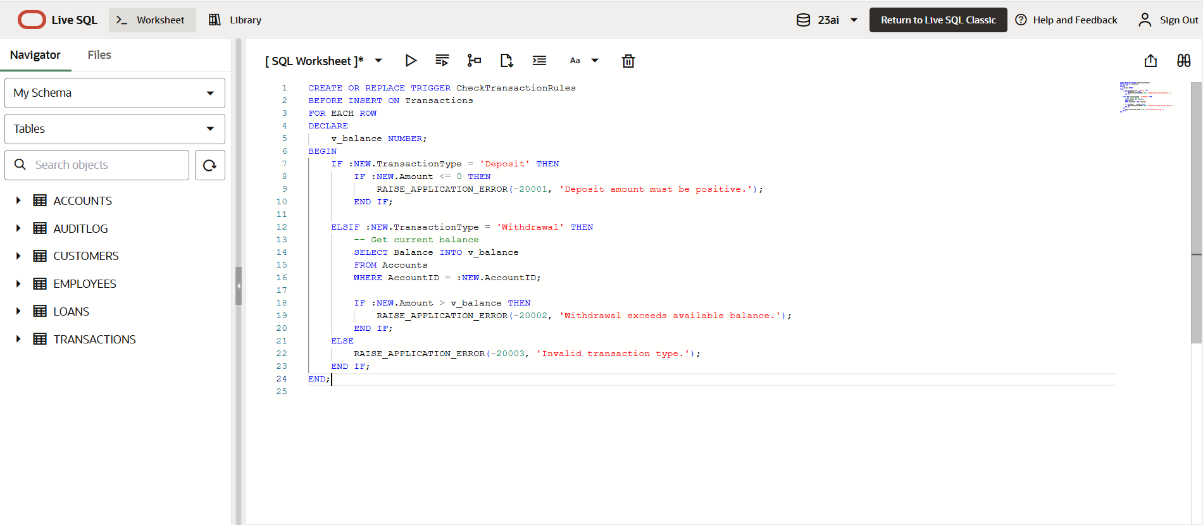

OUTPUT:

