HANDSMEN THREADS: ELEVATING THE ART OF SOPHISTICATION IN MEN'S FASHION
User Story
HandsMen Threads is a men's fashion business that aims to provide customers with a smooth and personalized shopping experience while efficiently managing its business operations. Customers want to explore men's fashion products, check product availability, place orders, receive order confirmations, and stay informed about their purchases. Sales staff need a centralized system to maintain customer information, manage orders, and access customer purchase history so that they can provide better service. Inventory managers need accurate and updated information about product stock levels to avoid shortages and ensure timely restocking. Marketing staff require customer information and purchase history to create effective marketing campaigns and improve customer engagement. Administrators and managers need a centralized view of customers, products, orders, inventory, and marketing activities through reports and dashboards. Salesforce is used to bring these activities together in a single platform and automate important business processes.

1. INTRODUCTION
1.1 Project Overview:
HandsMen Threads is a fashion retail organization focused on quality products and strong customer relationships. As the business grows, manual management of customers, products, orders, and inventory can lead to data errors, delayed communication, and stock-related issues.
The proposed Salesforce solution provides a centralized platform to manage customer, product, order, inventory, financial, and loyalty information. It improves data accuracy and reduces manual work through validation and automation.
The major processes include:
- Customer and product management
- Order management and confirmation
- Loyalty management
- Inventory monitoring and low-stock alerts
- Bulk order and financial processing
- Automated inventory updates
The solution uses Custom Objects, Validation Rules, Lightning App Builder, Record-Triggered Flows, Apex, and Asynchronous Apex.

1.2 Purpose:
The primary purpose of the HandsMen Threads Salesforce project is to create a reliable and automated business management system that improves data accuracy, customer communication, inventory visibility, and operational efficiency.
The system aims to:
- Centralize business information in Salesforce.
- Maintain accurate customer and product records.
- Prevent invalid data from entering the system.
- Automate order confirmation communication.
- Maintain customer loyalty information automatically.
- Monitor product inventory levels.
- Notify warehouse personnel when stock becomes critically low.
- Process bulk orders through scheduled automation.
- Keep financial and inventory information synchronized.
- Reduce repetitive manual activities.
- Provide users with an organized Lightning interface.
- Improve the overall customer experience.

2. IDEATION PHASE
The ideation phase focuses on identifying the major challenges faced by HandsMen Threads in managing customer information, orders, inventory, loyalty activities, and financial operations. Different possible solutions were considered to reduce manual work, improve data accuracy, strengthen customer engagement, and provide better control over business operations.
The ideation process was carried out through problem identification, user empathy analysis, brainstorming of possible solutions, grouping of ideas, and prioritization based on business impact and feasibility.

Key Ideas Identified
• Centralized Customer Management: Maintain customer information and order history in one platform.
• Order Management: Manage customer orders, order status, quantities, payments, and delivery details efficiently.
• Inventory Management: Track product stock and automatically identify low-stock products.
• Automated Notifications: Send order confirmation, payment, delivery, and stock alert emails automatically.
• Data Validation: Use validation rules to prevent incorrect product, order, and inventory data.
• Role-Based Security: Control access to customer, product, order, and inventory information based on user responsibilities.

2.1 Problem statement
PS | User | I'm trying to | But | Because
PS-1 | Customer | Receive confirmation after placing an order | Order updates may depend on manual communication | There is no automatic confirmation process
PS-2 | Sales Staff | Maintain accurate customer and order information | Incorrect or incomplete information may be entered | Data entry is not sufficiently controlled
PS-3 | Customer | Receive appropriate recognition for repeated purchases | Loyalty status may not be updated automatically | Purchase history is not continuously evaluated
PS-4 | Warehouse Team | Monitor product stock levels | Low stock may not be noticed immediately | Stock monitoring may require manual checking
PS-5 | Finance Team | Maintain accurate financial information for orders | Bulk order processing may require repeated manual updates | Order and financial processing are not fully automated
PS-6 | Administrator | Process large numbers of orders efficiently | Bulk processing can be time-consuming | Processing every order individually is inefficient

2.2 Empathy Map Canvas
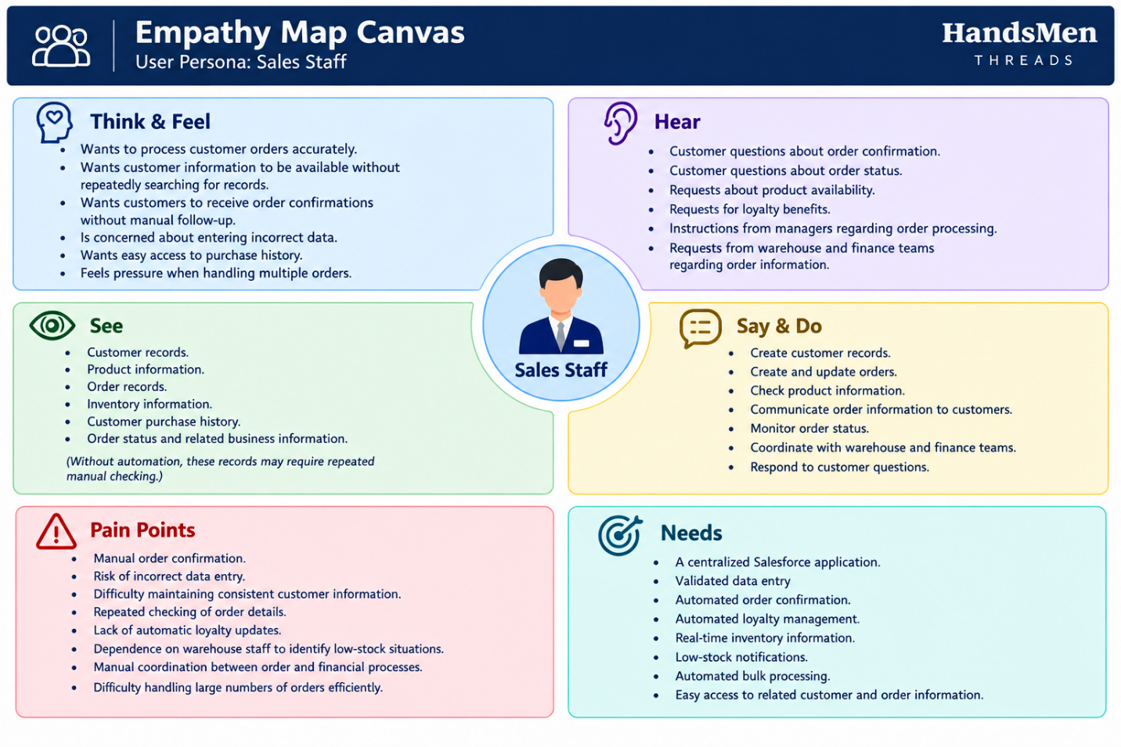
2.3 Brainstorming & Idea Prioritization
The brainstorming activity considered multiple approaches for solving the identified business problems.
Step 1: Brainstormed Ideas
1. Spreadsheet-Based Business Management
Use spreadsheets to maintain customer, product, order, inventory, loyalty, and financial information.
This would be simple to implement but would continue to depend heavily on manual data entry and maintenance.
2. Manual Email-Based Order Confirmation
Sales staff could manually send confirmation emails after an order is confirmed.
This would provide customer communication but would require continuous employee involvement and could result in missed or delayed emails.
3. Standalone Fashion Retail Application
A separate web application could be developed to manage customers, products, orders, inventory, and loyalty information.
This could provide flexibility but would require development and maintenance of a separate application.
4. Salesforce-Based Management System
A centralized Salesforce application could manage the organization's customer, product, order, inventory, loyalty, and financial information.
Salesforce automation could be used to handle repetitive business processes.
5. Automated Order Confirmation
A Salesforce automation could automatically send an email when an order reaches the required confirmation status.

6. Dynamic Loyalty Management
Customer purchase history could be evaluated automatically and the customer's loyalty status could be updated according to predefined business criteria.
7. Proactive Inventory Alert System
The system could monitor stock levels and automatically notify the warehouse team when inventory falls below five units.
8. Scheduled Bulk Order Processing
Asynchronous Apex could be used to process eligible bulk orders automatically at midnight and update related financial and inventory information.
9. Centralized Business Interface
A Lightning application could provide a single interface through which authorized users can access the required business records.
Step 2: Grouping
Group | Ideas | Description
Manual Solutions | Spreadsheet management, manual email confirmation | Simple approaches that require significant user involvement
Standalone / Semi-Automated Solutions | Standalone retail application | Provides greater automation but requires separate application development and maintenance
Salesforce-Based Automated Solution | Salesforce management system, automated confirmation, loyalty automation, stock alerts, scheduled bulk processing, Lightning application | Provides centralized data management, automation, and scalable business processing

Step 3: Idea Prioritization
Each proposed idea is evaluated using four criteria:
- Impact – How significantly the idea improves business operations.
- Feasibility – How realistically the idea can be implemented.
- Cost – Relative implementation and maintenance effort.
- Efficiency – Expected reduction in manual work.
Idea | Impact | Feasibility | Cost
Spreadsheet-based management | Low | High | High
Manual email confirmation | Low | High | High
Standalone retail application | Medium | Medium | Low
Salesforce-based management system | High | High | High
Automated order confirmation | High | High | High
Dynamic loyalty management | High | High | High
Proactive stock alerts | High | High | High
Scheduled bulk order processing | High | Medium | High

3. REQUIREMENT ANALYSIS PHASE
3.1 Customer Journey Map
The customer journey covers the major stages from customer registration and product selection to order processing, inventory verification, notification, and business monitoring.

Stage 1: Customer Registration

User Actions: Provides customer details and registers with HandsMen Threads.
Touchpoints: Customer records and sales staff.
Pain Points: Incomplete or incorrect customer information.
HandsMen Threads Solution: Customer information is maintained centrally with appropriate validation.
Emotion: Interested and hopeful.

Stage 2: Product Selection

User Actions: Selects products and checks price and availability.
Touchpoints: Product records and inventory information.
Pain Points: Difficulty knowing the current stock level.
HandsMen Threads Solution: Centralized product and inventory information helps staff check availability.
Emotion: Interested but unsure.

Stage 3: Order Creation

User Actions: Selects products, enters quantities, and creates an order.
Touchpoints: Order records and sales staff.
Pain Points: Incorrect quantities or incomplete order information.
HandsMen Threads Solution: Validation rules help ensure that required order information is entered correctly.
Emotion: Anxious.

Stage 4: Inventory Verification

User Actions: Checks whether sufficient stock is available for the order.
Touchpoints: Product and inventory records.
Pain Points: Low stock may not be identified quickly.
HandsMen Threads Solution: Inventory information is maintained centrally and low-stock conditions can be identified automatically.
Emotion: Cautious.

Stage 5: Order Processing

User Actions: Order is processed after verification.
Touchpoints: Order records and sales staff.
Pain Points: Manual processing and lack of timely updates.
HandsMen Threads Solution: Salesforce automation supports order processing and updates related records.
Emotion: Uncertain.

Stage 6: Order Confirmation

User Actions: Waits for confirmation after the order is processed.
Touchpoints: Order records and email notifications.
Pain Points: Delayed or manual communication.
HandsMen Threads Solution: Automated email notifications provide order confirmation to customers.
Emotion: Relieved.

Stage 7: Monitoring and Support

User Actions: Customer receives the order, while staff and management monitor business activities.
Touchpoints: Reports, dashboards, customer records, and inventory records.
Pain Points: Difficulty monitoring multiple business activities manually.
HandsMen Threads Solution: Salesforce records, reports, and dashboards provide centralized information for monitoring and decision-making.
Emotion: Satisfied and confident.

3.2 Solution Requirements

Functional Requirements
FR-1: Customer Management
• Description: Manage customer information in a centralized system.
Details: Users should be able to create, update, and view customer records while maintaining accurate and complete information.
FR-2: Product & Inventory Management
Description: Manage product details and stock information.
Details: The system maintains product information such as name, category, price, quantity, and stock status to support inventory monitoring.
FR-3: Order Processing
Description: Create and manage customer orders.
Details: Sales staff can create orders with customer and product information. Validation and automation help reduce incorrect or incomplete order records.
FR-4: Order Confirmation
Description: Automatically notify customers after order confirmation
Details: When an order reaches the required status, an automated email notification is sent to the customer.

FR-5: Customer Loyalty Management
Description: Manage customer loyalty information.
Details: Customer purchase activity is used to support loyalty management and improve customer engagement.
FR-6: Inventory Alerts and Automation
Description: Identify low-stock products and automate repetitive activities.
Details: When inventory falls below the defined threshold, the system can notify the responsible warehouse team. Automated processes also support order and inventory updates.
FR-7: Scheduled Bulk Processing
Description: Process bulk orders and related updates automatically.
Details: Scheduled processing handles large numbers of orders and updates relevant financial and inventory information.
FR-8: Reports and Dashboards
Description: Provide business information for monitoring and decision-making.
Details: Reports and dashboards can be used to monitor orders, inventory, customers, loyalty activities, and overall business performance.
Non-Functional Requirements
NFR-1: Security
Description: Protect business and customer information.
Details: Salesforce security features such as profiles, roles, permission sets, sharing settings, and field-level security should control user access.
Acceptance Criteria:
- Users can access only permitted records and features.
- Restricted information cannot be accessed by unauthorized users.
- Security settings are applied according to user responsibilities.
NFR-2: Usability
Description: Provide a simple and organized user interface.
Details: Lightning App pages, tabs, layouts, and record views should allow users to access required information easily.
Acceptance Criteria:
- Required objects are easily accessible.
- Important information is clearly displayed.
- Users can perform their main tasks with minimal guidance.
NFR-3: Performance
Description: Ensure efficient system operation.
Details: Records, automation, reports, and dashboards should work efficiently during normal business activities.
Acceptance Criteria:
- Normal record operations complete successfully.
- Automation executes when its conditions are satisfied.
- Reports and dashboards load successfully.
NFR-4: Scalability
Description: Support future business growth.
Details: The system should support increasing numbers of customers, products, orders, and inventory records.
Acceptance Criteria:
- New records can be added without changing the basic system design.
- Additional users can be added through existing security configurations.
- Existing automation continues to work as data increases.

NFR-5: Reliability and Availability
Description: Provide reliable access to business information.
Details: Authorized users should be able to access records, automation, reports, and dashboards during normal system operation.
Acceptance Criteria:
- Saved records remain available after successful updates.
- Configured automation executes consistently.
- Business information is available through reports and dashboards.
NFR-6: Data Accuracy
Description: Maintain accurate and consistent business data.
Details: Required fields, validation rules, controlled data entry, and automation help reduce errors and maintain consistency.
Acceptance Criteria:
- Required information cannot be left incomplete.
- Invalid business data is prevented.
- Automated updates maintain consistency between related records.
- Duplicate and inconsistent information is minimized.

3.3 Data Flow Diagram
This is the Level-1 data flow diagram for the main steps of the system.
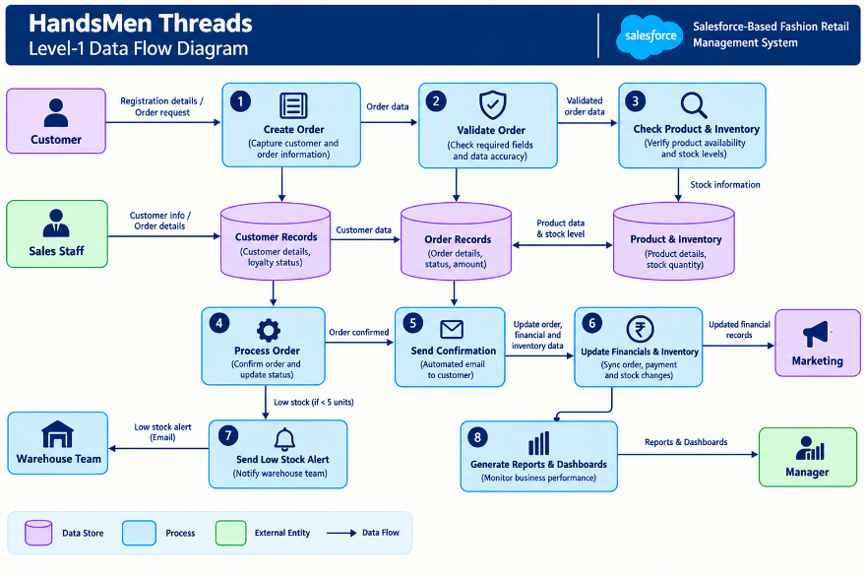

Here is how the diagram maps to the steps:
Step 1 – Customer and Order Input:
Customer and order information is entered into the system.
Step 2 – Validation and Storage:
The system validates the information and stores customer and order records. Product and inventory information is checked.
Step 3 – Inventory Verification:
The system checks the available quantity of the requested products. Low-stock conditions are identified when applicable.
Step 4 – Order Processing:
The order is processed and the relevant order information is updated.
Step 5 – Notification and Updates:
After order confirmation, the customer receives an automated notification. Related inventory and financial information is updated as required.
Step 6 – Monitoring:
Reports and dashboards use the stored business information to help users monitor orders, customers, inventory, loyalty activities, and overall performance.

4. PROJECT DESIGN PHASE

4.1 Problem–Solution Fit
The project design phase defines how the identified business problems will be addressed using Salesforce. It maps each major problem to a suitable Salesforce solution and describes the proposed system architecture.
Problem Statement
The HandsMen Threads Salesforce solution addresses common challenges in managing customers, products, orders, inventory, loyalty activities, and business operations. Salesforce features are used to centralize information, maintain data accuracy, and automate repetitive processes.
Problem sloving mapping
Problem / User Constraint | HandsMen Threads Solution | Salesforce Capability
Customer information may be incomplete or incorrectly entered. | Maintain customer information in a centralized and validated format. | Custom Objects, Fields, Validation Rules
Product information and availability may be difficult to manage manually. | Maintain centralized product and stock information. | Custom Objects, Fields, Lightning App
Sales staff may enter incorrect or incomplete order details. | Validate order information before processing. | Required Fields, Validation Rules, Flows
Customers may not receive timely order updates. | Automatically send confirmation emails after order confirmation. | Record-Triggered Flow, Email Alerts
Low stock may not be identified quickly. | Monitor stock levels and notify the warehouse team when stock falls below the defined threshold. | Flow Automation, Formula Fields, Email Alerts
Customer loyalty updates may require manual effort. | Automatically update loyalty information based on customer purchase activity. | Custom Fields, Flow Automation
Marketing staff may not have organized customer information for customer engagement. | Use centralized customer and purchase information to support marketing activities. | Reports, List Views, Customer Records
Bulk orders may require repetitive manual processing. | Process bulk orders through scheduled automation and update related records. | Scheduled Apex, Batch Apex
Managers may have limited visibility into business activities. | Provide centralized reports and dashboards for monitoring. | Reports, Dashboards, Lightning App

4.2 Proposed Solution
Parameter | Description
Problem | Manual management of customers, products, orders, inventory, loyalty, and business activities can result in inaccurate data, delayed communication, stock issues, and repetitive work.
Solution | A Salesforce-based HandsMen Threads management system that centralizes business information and automates important retail processes.
Novelty | The solution combines data validation, automated order confirmation, loyalty updates, low-stock alerts, and scheduled bulk processing using Salesforce capabilities..
Social Impact | Improves customer service, reduces manual work, provides timely notifications, and helps staff manage business activities more efficiently.
Revenue Model | The system supports fashion product sales by improving customer engagement, loyalty, order processing, and inventory management.
Scalability | The system can support increasing numbers of customers, products, orders, and users. Additional automation and business features can be added as the organization grows.

4.3 Solution Architecture
1. Users Layer
Different users access the system according to their responsibilities.
- Sales Staff
- Warehouse Team
- Marketing Team
- Managers
- Administrators
2. Presentation Layer
The Salesforce Lightning interface provides users with access to business information through:
- Lightning App
- Record Pages
- List Views
- Reports
- Dashboards
3. Automation Layer
Salesforce automation reduces repetitive manual activities and supports business processes through:
- Validation Rules
- Record-Triggered Flows
- Scheduled Flows / Apex
- Batch Apex
- Email Alerts
- Automated record updates
4. Data Layer
The system stores and manages the organization's main business information, including:
- Customer Records
- Product Records
- Order Records
- Inventory Information
- Loyalty Information
- Marketing-related Information
Relationships between these records allow related business information to be connected and managed centrally.
5. Security Layer
Salesforce security controls access to business information based on user responsibilities. The system can use:
- Profiles
- Roles
- Permission Sets
- Sharing Rules
- Field-Level Security
This ensures that users can access the information and functionality required for their roles while protecting restricted business data.

5. PROJECT PLANNING & SCHEDULING
5.1 Project Planning
The HandsMen Threads Salesforce project follows the Agile methodology, where the project is divided into smaller modules called epics and user stories. Development and configuration activities are completed through multiple sprints, allowing the team to review progress and make improvements at each stage.
Product Backlog and Sprint Schedule
Sprint | Functional Requirement / Epic | User Story No. | User Story / Task | Story Points | Priority
Sprint 1 | Developer Setup | USN-1 | As an administrator, I want to configure the Salesforce environment so that the HandsMen Threads system can be developed and tested. | 1 | High
Sprint 1 | Data Management | USN-2 | As an administrator, I want to create the required custom objects so that customer, product, order, inventory, and loyalty information can be stored. | 5 | High
Sprint 2 | Data Management | USN-3 | As a user, I want dedicated tabs for the main business records so that I can easily access the required information. | 3 | High
Sprint 2 | Data Management | USN-4 | As an administrator, I want to create the required fields so that complete and accurate business information can be captured. | 5 | High
Sprint 2 | Data Management | USN-5 | As an administrator, I want to establish relationships between related records so that business information can be connected and managed efficiently. | 5 | High
Sprint 2 | App Management | USN-6 | As a user, I want a centralized HandsMen Threads Lightning App so that I can access the required business records from one interface. | 3 | High
Sprint 3 | Process Automation | USN-7 | As a system, I want validation rules so that incorrect or incomplete customer, product, and order information can be prevented. | 3 | High
Sprint 3 | Process Automation | USN-8 | As a system, I want automated flows to handle order confirmation, loyalty updates, and low-stock notifications so that manual work is reduced. | 5 | High
Sprint 3 | Process Automation | USN-9 | As a system, I want to identify low-stock products and notify the warehouse team when stock falls below the required level. | 3 | High
Sprint 4 | Apex Development | USN-10 | As a system, I want Apex components to handle complex business operations so that required processing can be automated efficiently. | 5 | High
Sprint 5 | Asynchronous Processing | USN-11 | As a system, I want scheduled and batch processing for bulk orders so that large numbers of records can be processed efficiently. | 5 | High
Sprint 5 | Security | USN-12 | As an administrator, I want to configure appropriate user access so that business information is available according to user responsibilities. | 5 | High
Sprint 6 | Reports & Dashboards | USN-13 | As a manager, I want reports and dashboards for orders, inventory, customers, and business activities so that I can monitor performance and make informed decisions. | 4 | High
Epic Summary
Epic | User Stories | Story Points
Developer Setup | USN-1 | 1
Data Management | USN-2 to USN-5 | 18
App Management | USN-6 | 3
Process Automation | USN-7 to USN-9 | 11
Apex Development | USN-10 | 5
Asynchronous Processing | USN-11 | 5
Security | USN-12 | 5
Reports & Dashboards | USN-13 | 4
Total | 13 Stories | 52

Sprint Schedule Summary
Sprint | Main Activities
Sprint 1 | Salesforce setup and creation of core data objects
Sprint 2 | Fields, relationships, tabs, and Lightning App
Sprint 3 | Validation rules, flows, notifications, and inventory alerts
Sprint 4 | Apex development and complex business logic
Sprint 5 | Batch/scheduled processing and security configuration
Sprint 6 | Reports, dashboards, testing, and final review

6. PROJECT DEVELOPMENT PHASE

Milestone 1: Salesforce Developer Account Creation
Definition: A Salesforce Developer Edition provides the environment required to build, test, and demonstrate the HandsMen Threads application.
Key steps:
- Create a Salesforce Developer account.
- Verify the registered email address.
- Log in to Salesforce.
- Open Setup and configure the development environment.
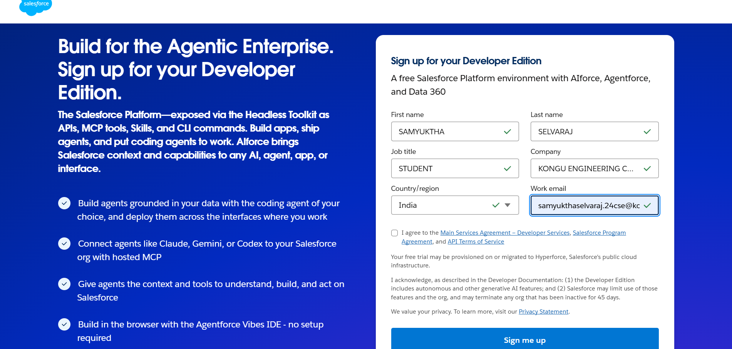
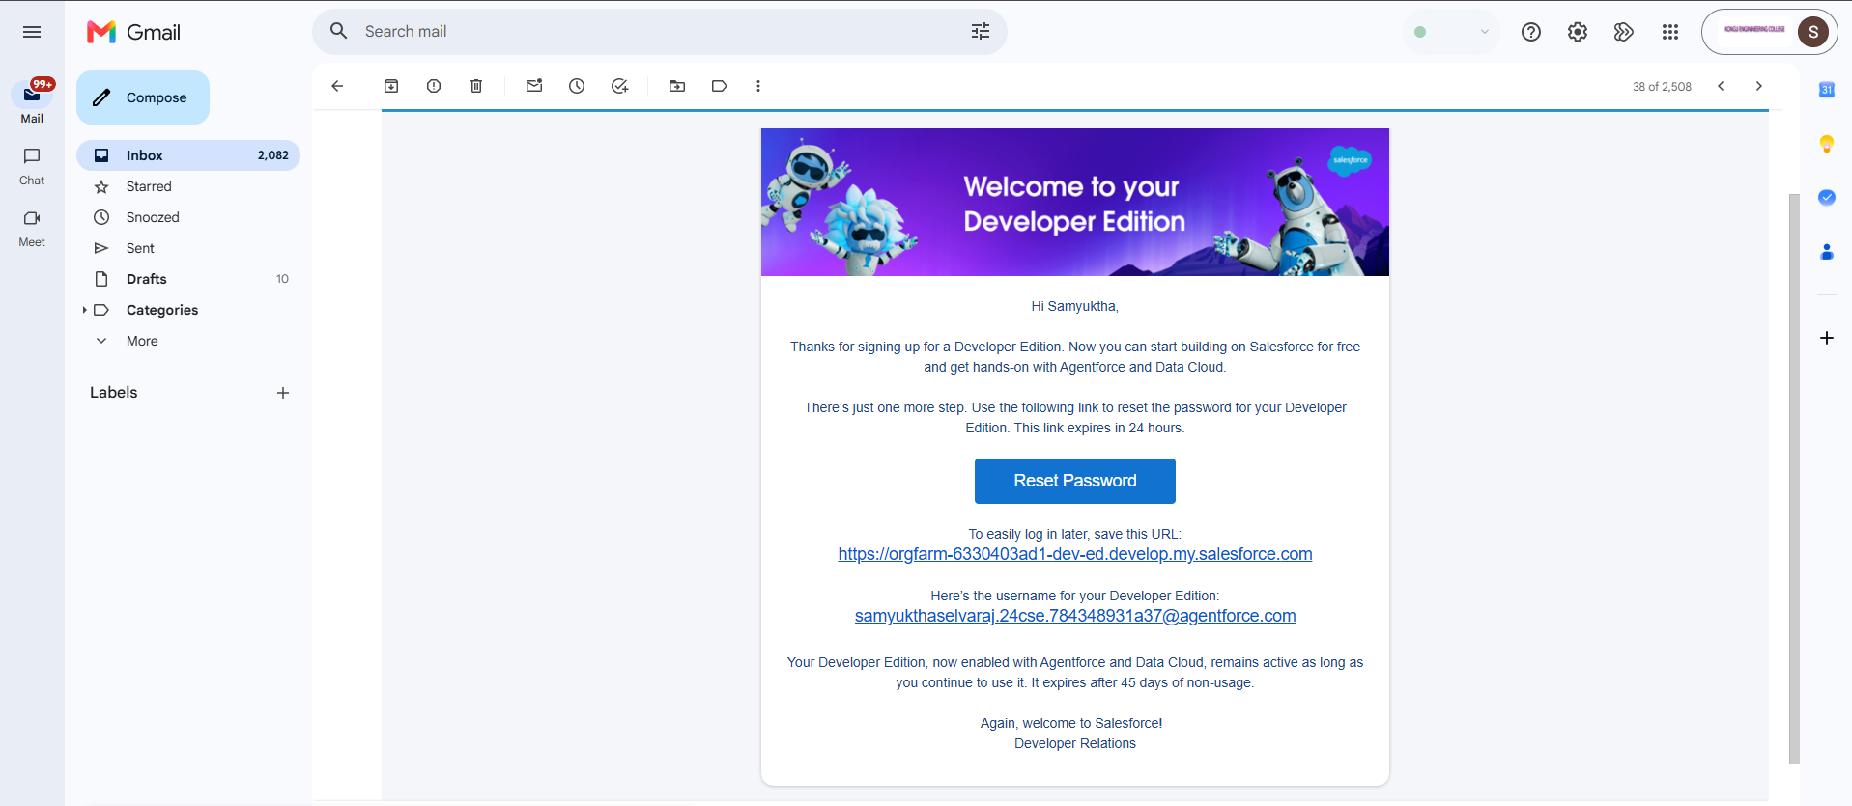

Milestone 2: Custom Object Creation
Definition: Custom Objects are used to store and organize the main business information of HandsMen Threads.
Objects:
- HandsMen Customer – Stores customer details and contact information.
- HandsMen Product – Stores product details such as name, category, price, and availability.
- HandsMen Order – Stores customer order information and order status.
- Inventory – Stores product stock and quantity information.
- Marketing Campaign – Stores marketing and customer engagement information.
Key steps:
- Go to Setup → Object Manager.
- Create the required custom objects.
- Configure object labels and record names.
- Enable required features such as reporting and search.
- Create tabs for the required objects.

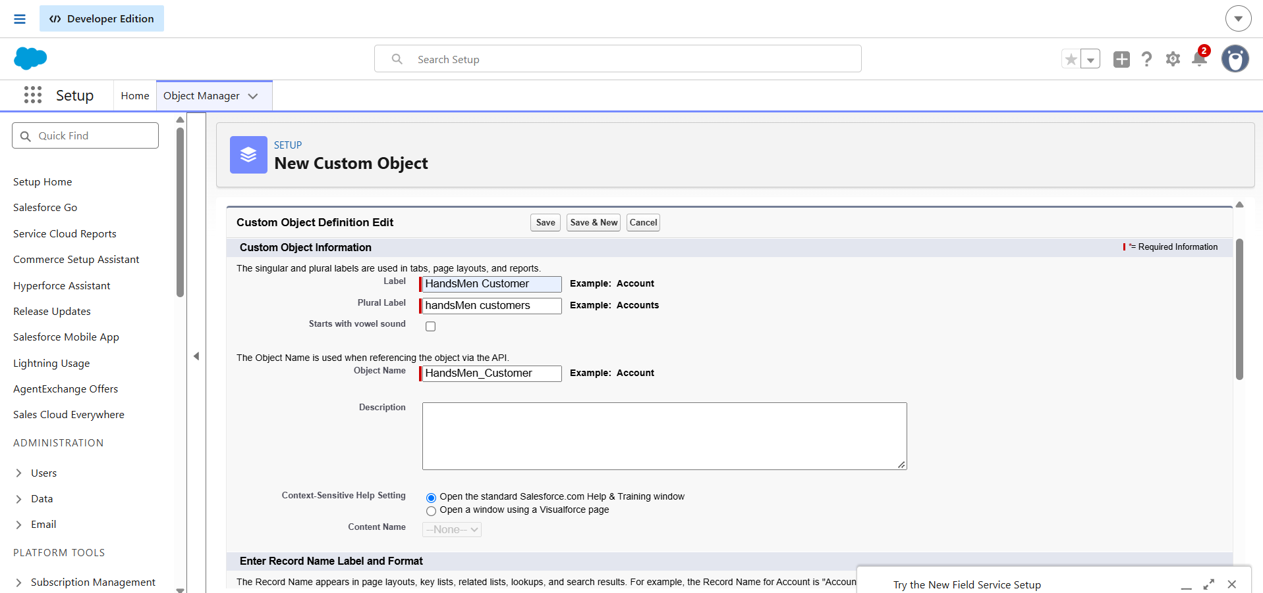
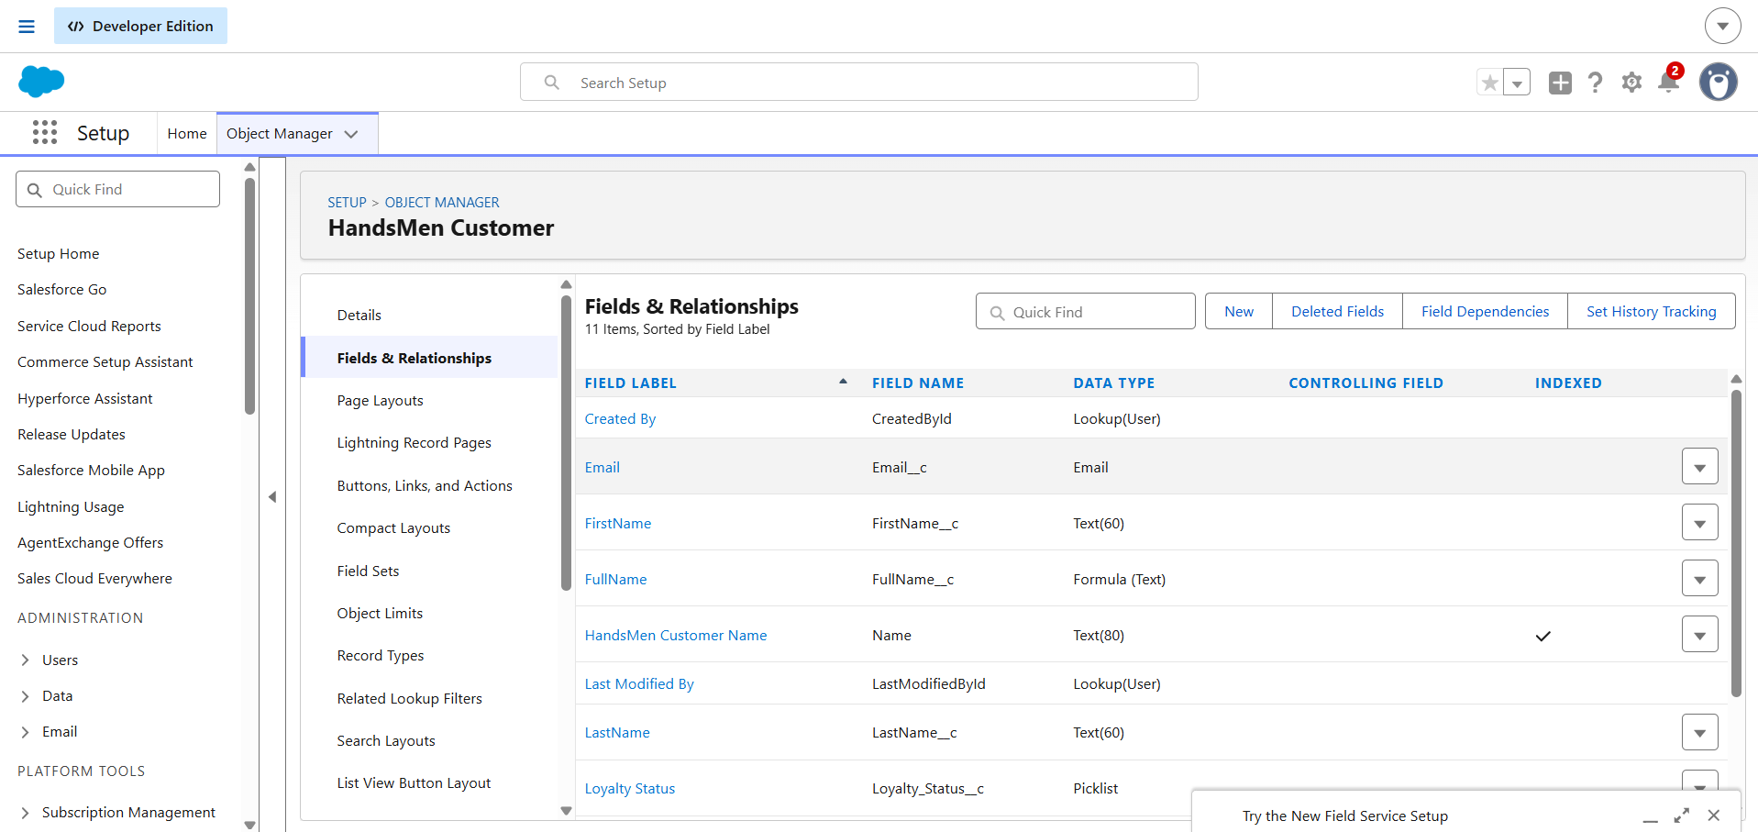
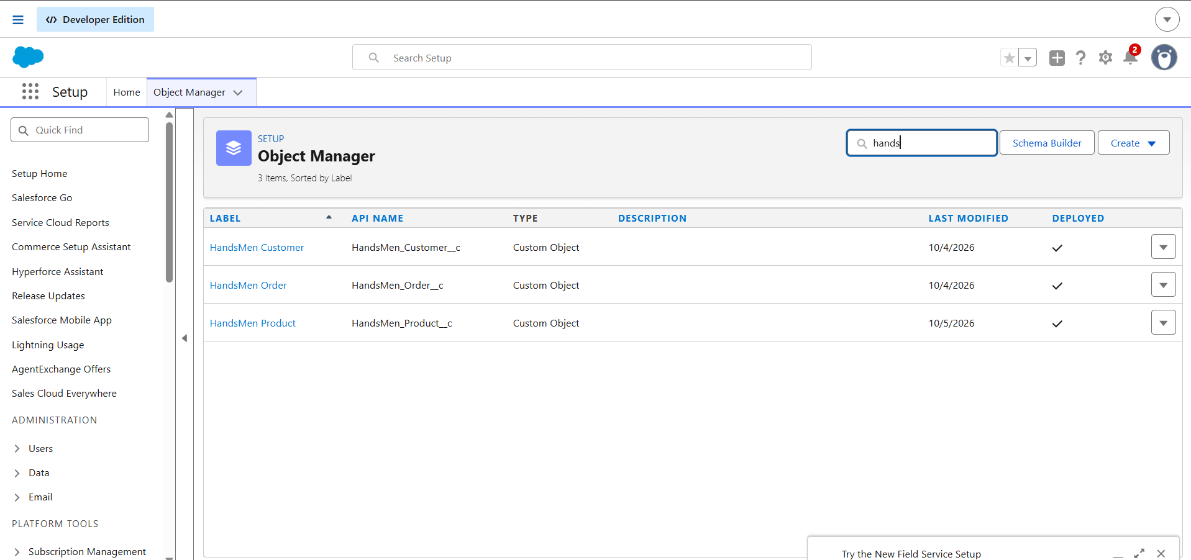

Milestone 3: Tabs Creation
Definition
Custom tabs provide users with direct access to the required HandsMen Threads records.
Create Tabs
- Go to Setup → Tabs → Custom Object Tabs → New.
- Select the required custom object.
- Choose an appropriate tab style.
- Configure tab visibility.
- Save the tab.
- Add the required tabs to the HandsMen Threads Lightning App.
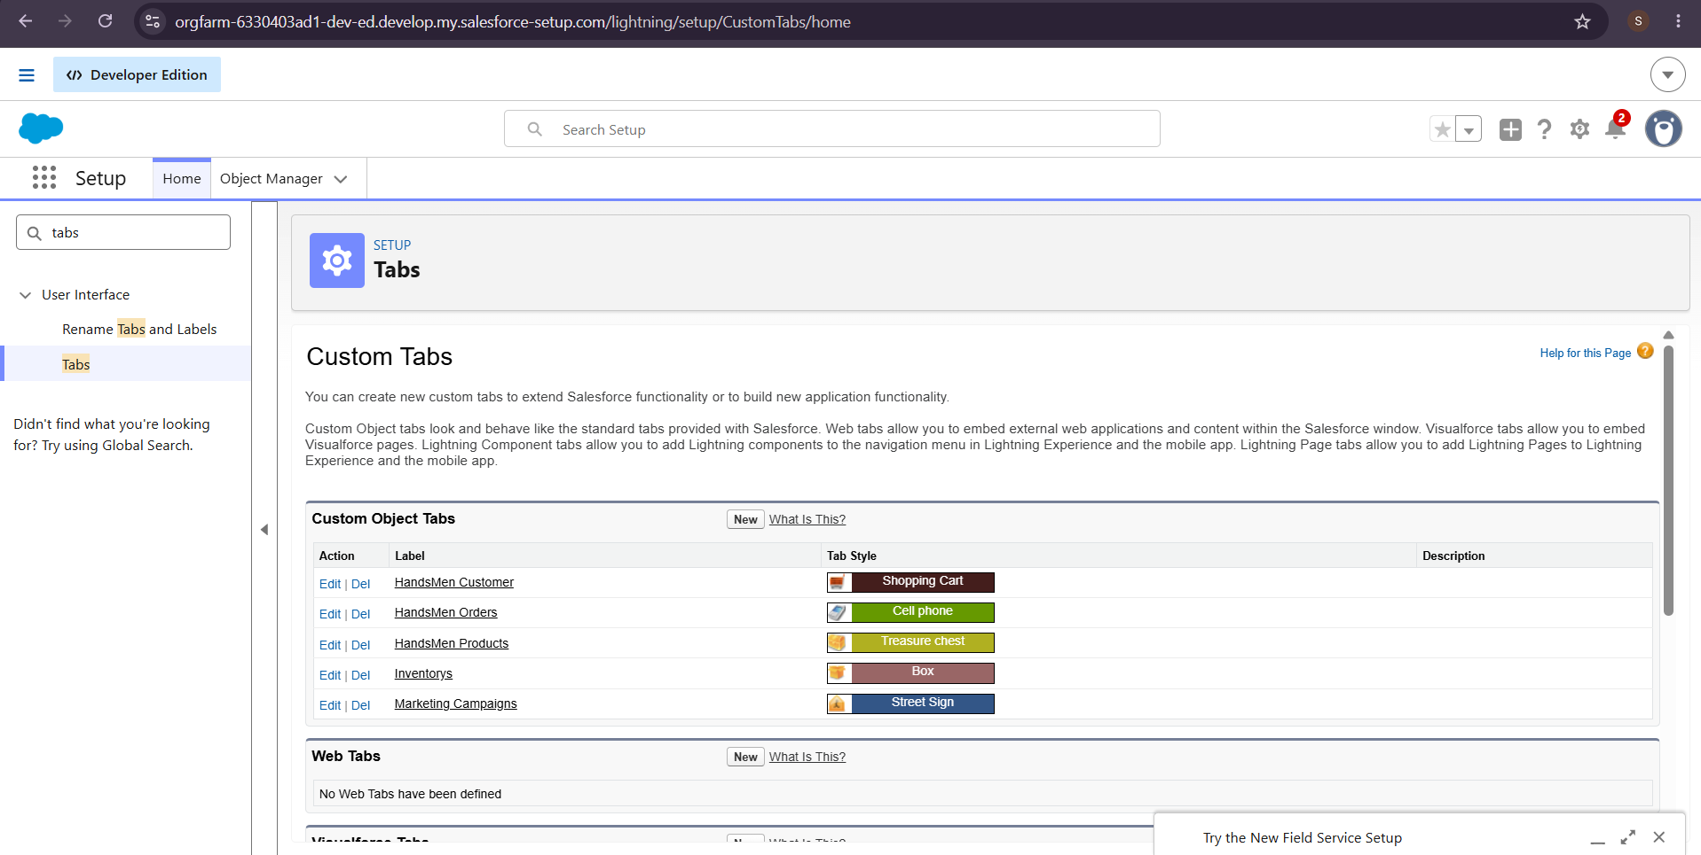

Milestone 4: Lightning App Creation
Definition: The HandsMen Threads Lightning App provides a centralized workspace for managing the organization's business activities.
Key Steps:
- Go to Setup → App Manager → New Lightning App.
- Enter the app name as HandsMen Threads.
- Configure the app navigation and branding.
- Add required tabs such as Customer, Product, Order, Inventory, and Marketing Campaign.
- Add Reports and Dashboards where required.
- Configure app visibility.
- Save and test the application.
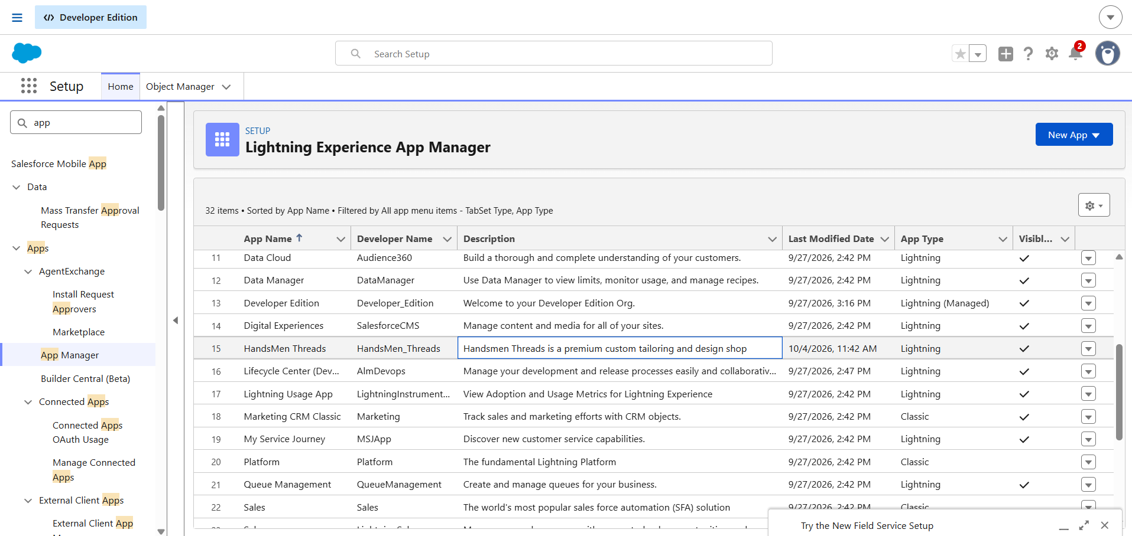

Milestone 5: Fields Creation
Definition: Fields are used to capture the information required for managing customers, products, orders, inventory, and marketing activities.
Key fields:
- Email – Stores the customer's email address.
- Phone – Stores customer contact information.
- Loyalty Status – Stores the customer's current loyalty status.
- Order Status – Tracks the current order stage.
- Order Quantity – Stores the quantity ordered.
- Product Price – Stores product pricing information.
- Stock Quantity – Stores available inventory.
Relationships
Customer → Order
Product → Order
Product → Inventory
Key Steps:
- Go to Object Manager → Object → Fields & Relationships → New.
- Select the appropriate field type.
- Enter the field label and name.
- Configure required values and field-level security.
- Create relationship and formula fields where required.
- Add fields to the appropriate page layouts.
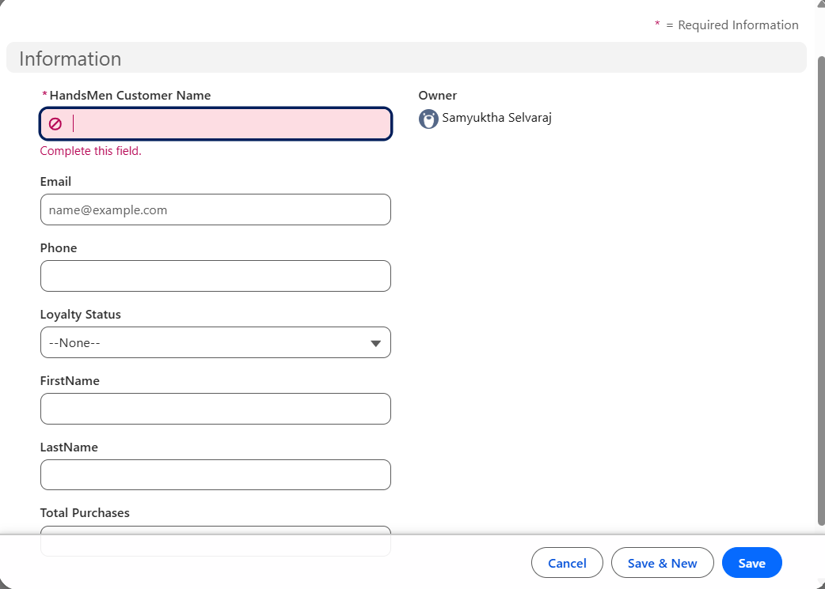
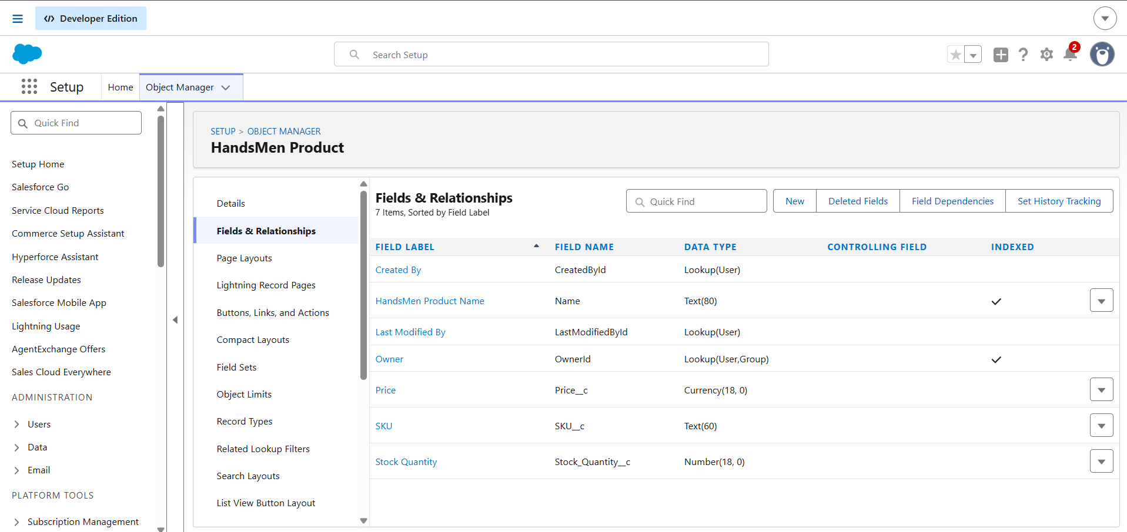
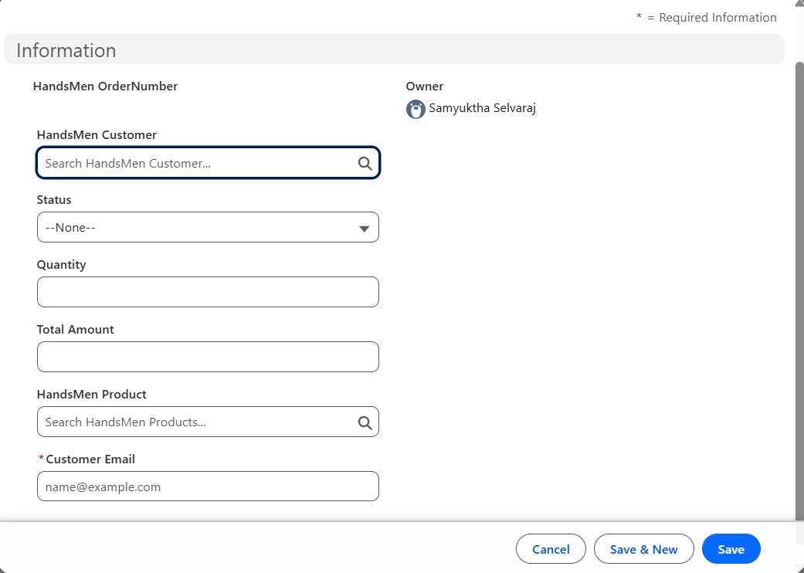

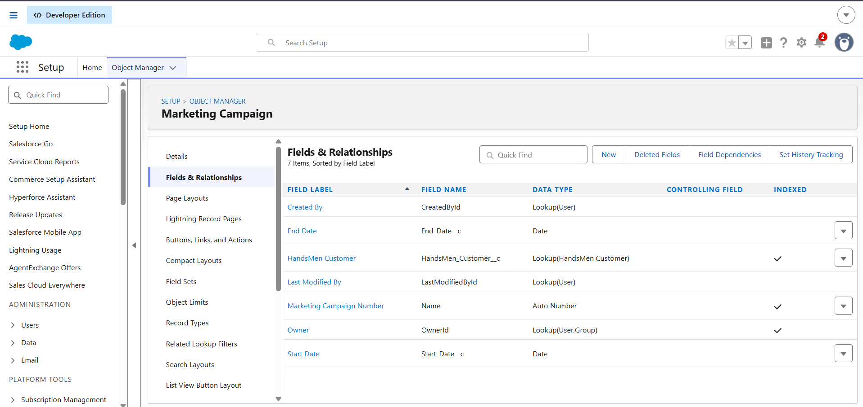

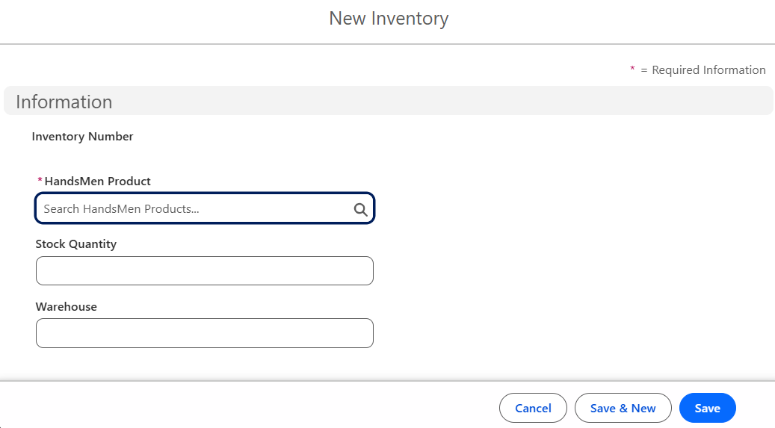
Milestone 6: Data Management – Field Creation & Field Types
Definition: Validation Rules ensure that the information entered into Salesforce follows the required business conditions. They prevent users from saving invalid or incomplete records.
Key steps:
- Go to Setup → Object Manager → Select Object → Validation Rules → New.
- Enter the rule name.
- Define the validation condition using a Salesforce formula.
- Create rules for important customer, product, order, and inventory information.
- Configure suitable error messages.
- Test the rules using valid and invalid sample records.
Examples of validation include:
- Order quantity should be valid.
- Product price should not contain an invalid value.
- Required customer information should be provided.
- Stock quantity should be valid.
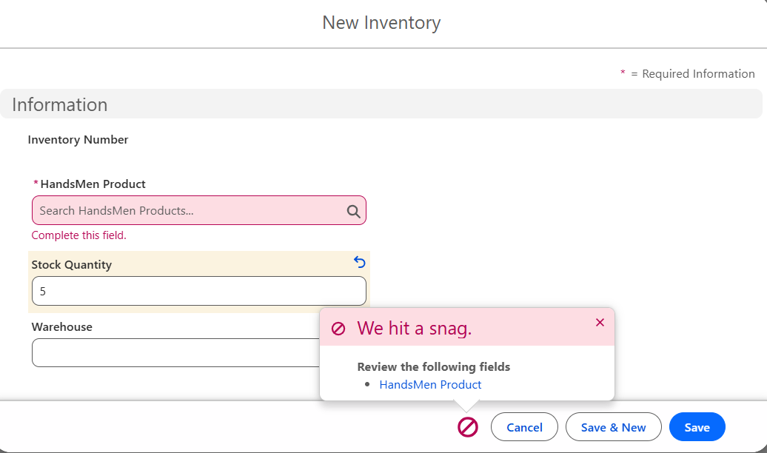
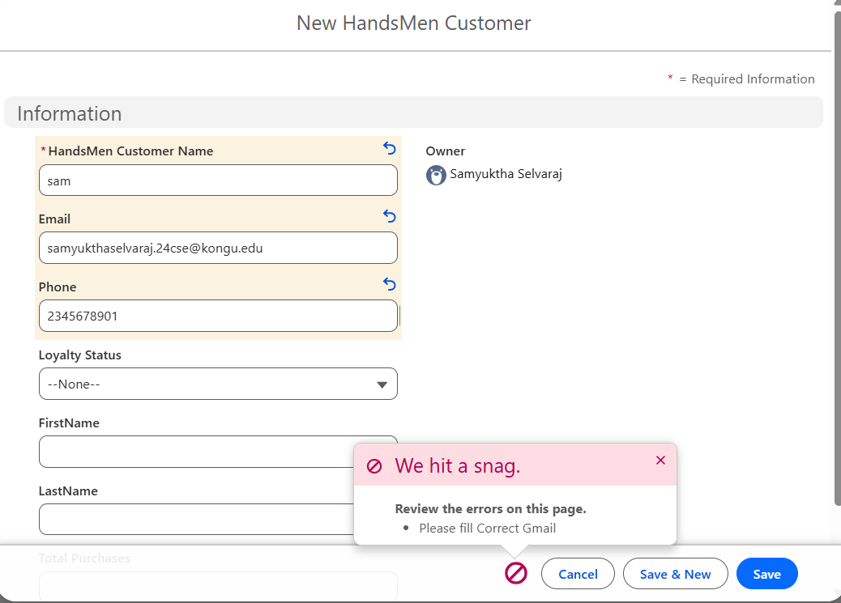
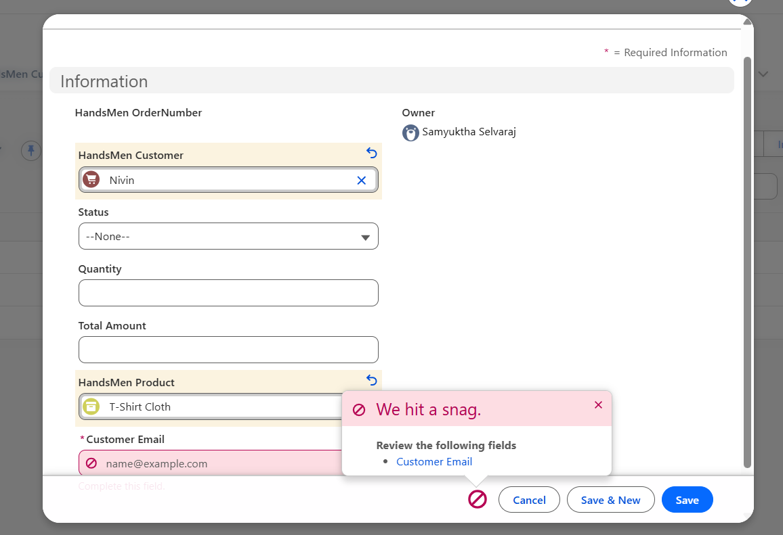

Milestone 7: Data Security – Roles
Definition: Roles and security settings control access to HandsMen Threads records according to user responsibilities.
Key steps:
- Go to Setup → Roles → Set Up Roles.
- Create appropriate roles such as:
Sales Staff
Warehouse Team
Marketing Team
Manager
Administrator
- Arrange the roles according to responsibilities.
- Configure Organization-Wide Defaults and sharing settings where required.
- Assign users to appropriate roles.
- Test access permissions.
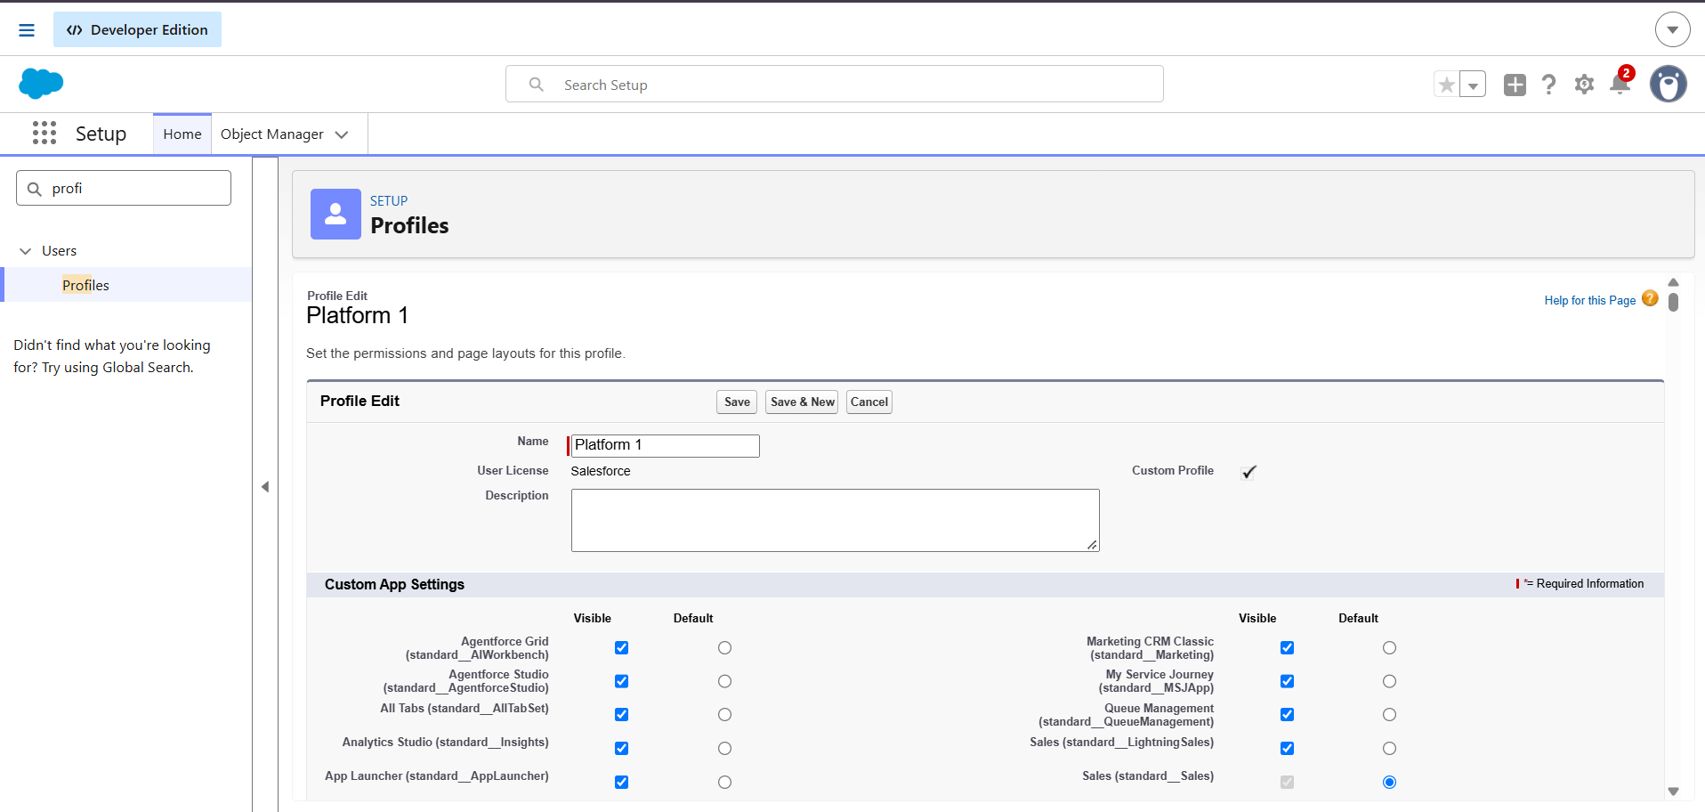
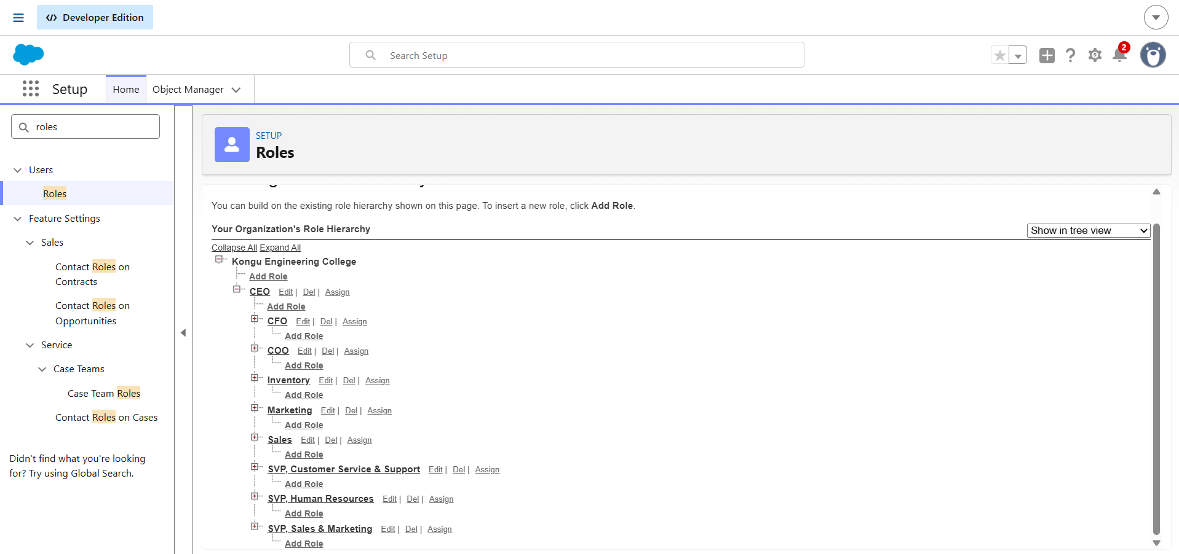

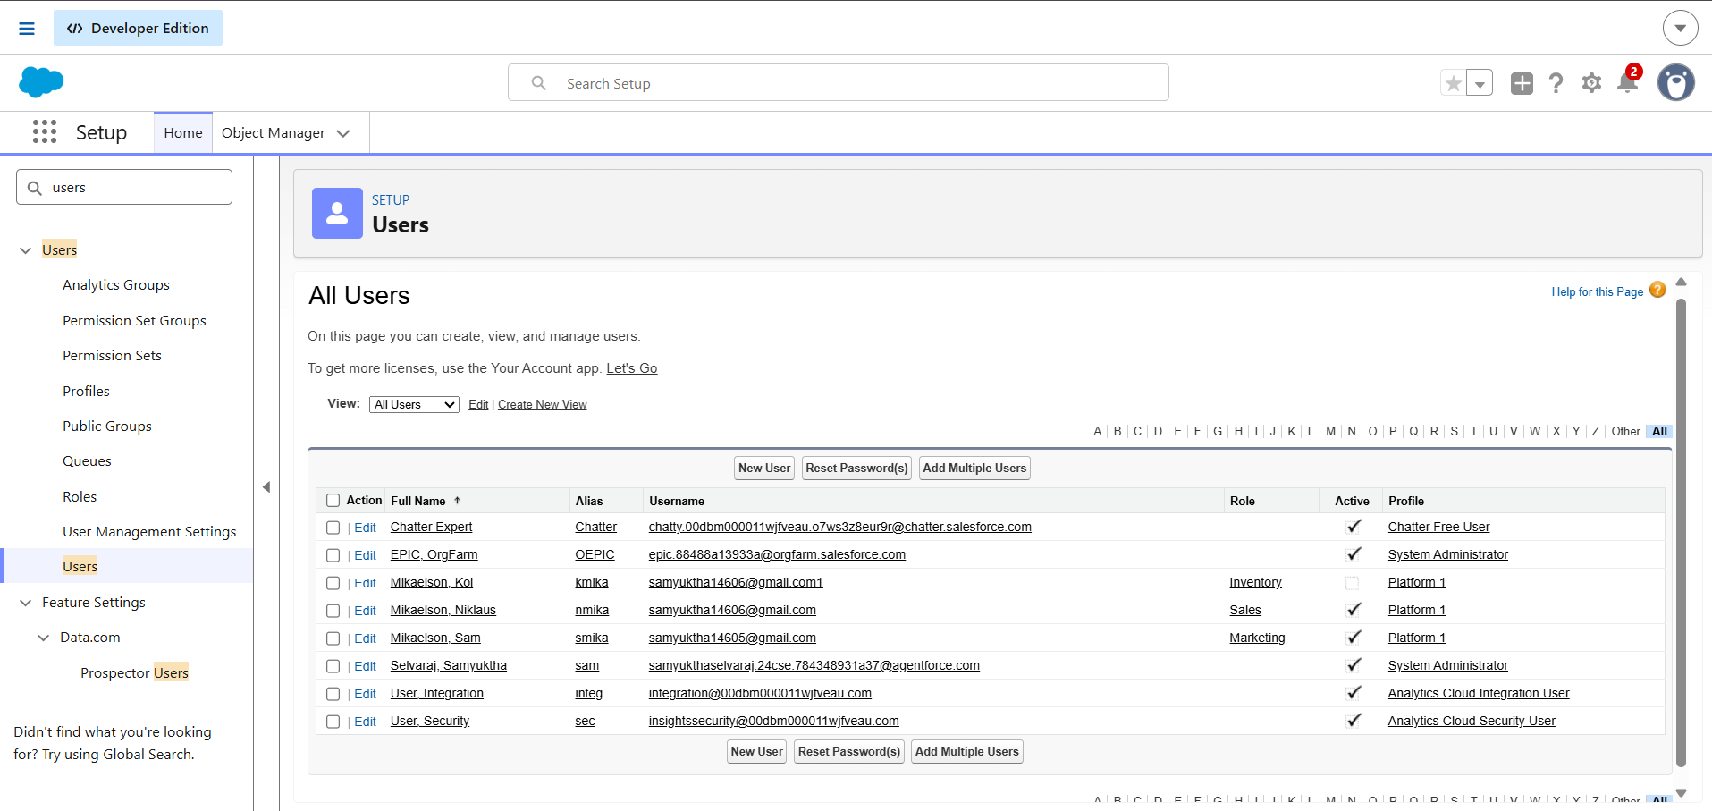

Milestone 8: Email Templates
Definition: Email Templates provide standardized messages for automated business notifications.
Key Templates
- Order Confirmation
- Low Stock Notification
- Loyalty Update
Key steps:
- Go to Setup → Email Templates.
- Create the required email templates.
- Add appropriate merge fields such as customer name, order number, product, quantity, and order status.
- Configure the email subject and message.
- Save and test the templates using sample records.
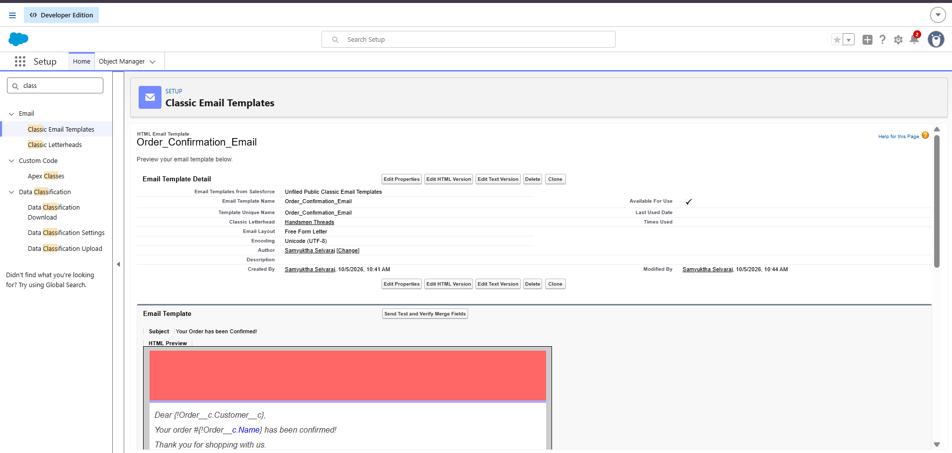
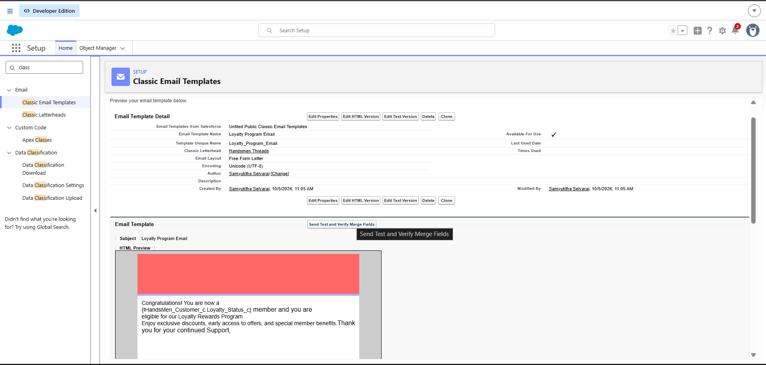
Milestone 9: Email Alert
Definition: Email Alerts automatically send notifications when a defined business condition is satisfied.
Key steps:
- Go to Setup → Email Alerts → New Email Alert.
- Select the required object.
- Select the appropriate email template.
- Add the required recipients.
- Configure the alert to work with the required automation.
- Save and test the email alert.
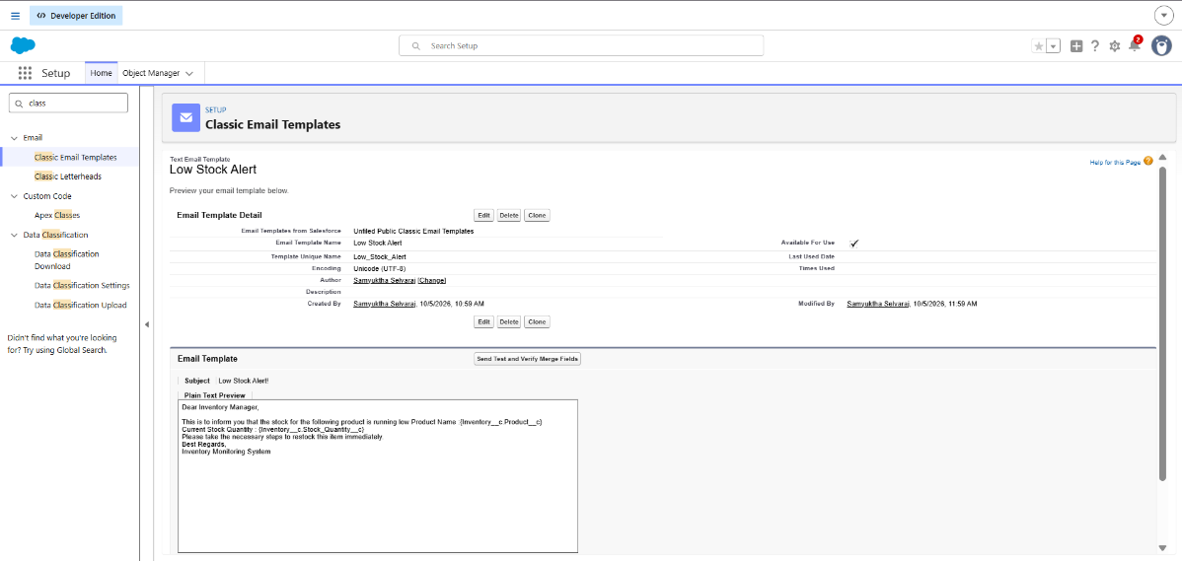

Milestone 10: FLOWS
Definition: Salesforce Flows automate repetitive business processes and reduce manual work.
Main Flows
1. Order Confirmation Flow
Automatically sends an email to the customer when an order is confirmed.
2. Loyalty Update Flow
Updates the customer's loyalty information based on the required purchase conditions.
3. Stock Alert Flow
Identifies products with stock below the defined threshold and sends an alert to the Warehouse Team.
4. Scheduled Processing Flow
Supports scheduled business activities where required.
Key steps:
- Go to Setup → Flows → New Flow.
- Select the appropriate flow type.
- Select the required object and trigger conditions.
- Configure the required actions.
- Add email notifications or record updates.
- Save and activate the flow.
- Test the flow using sample records.
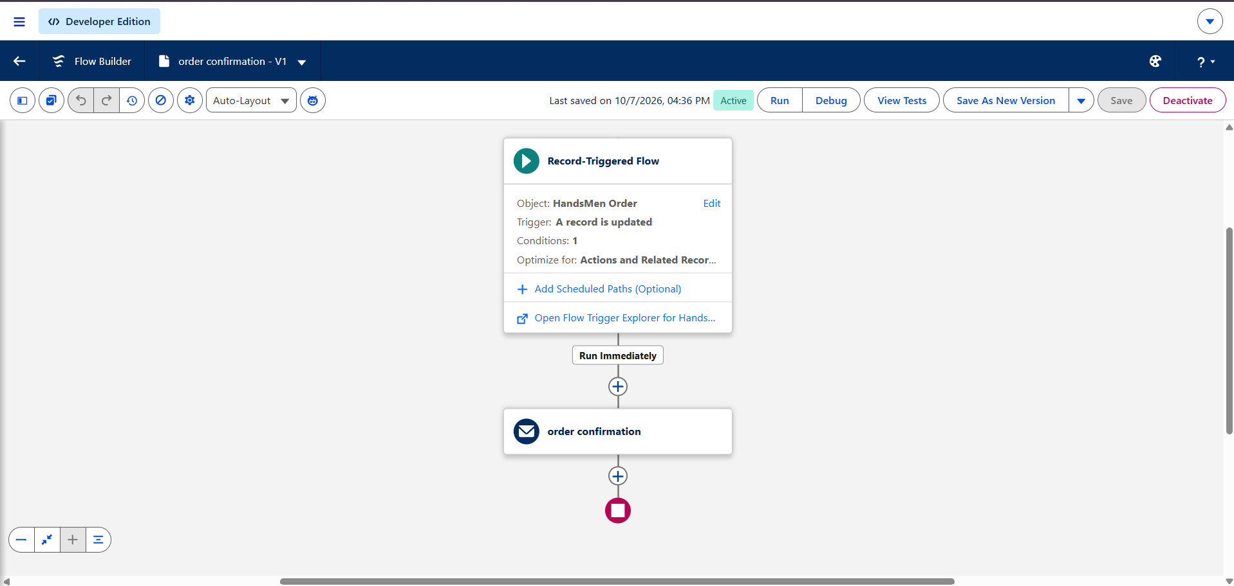
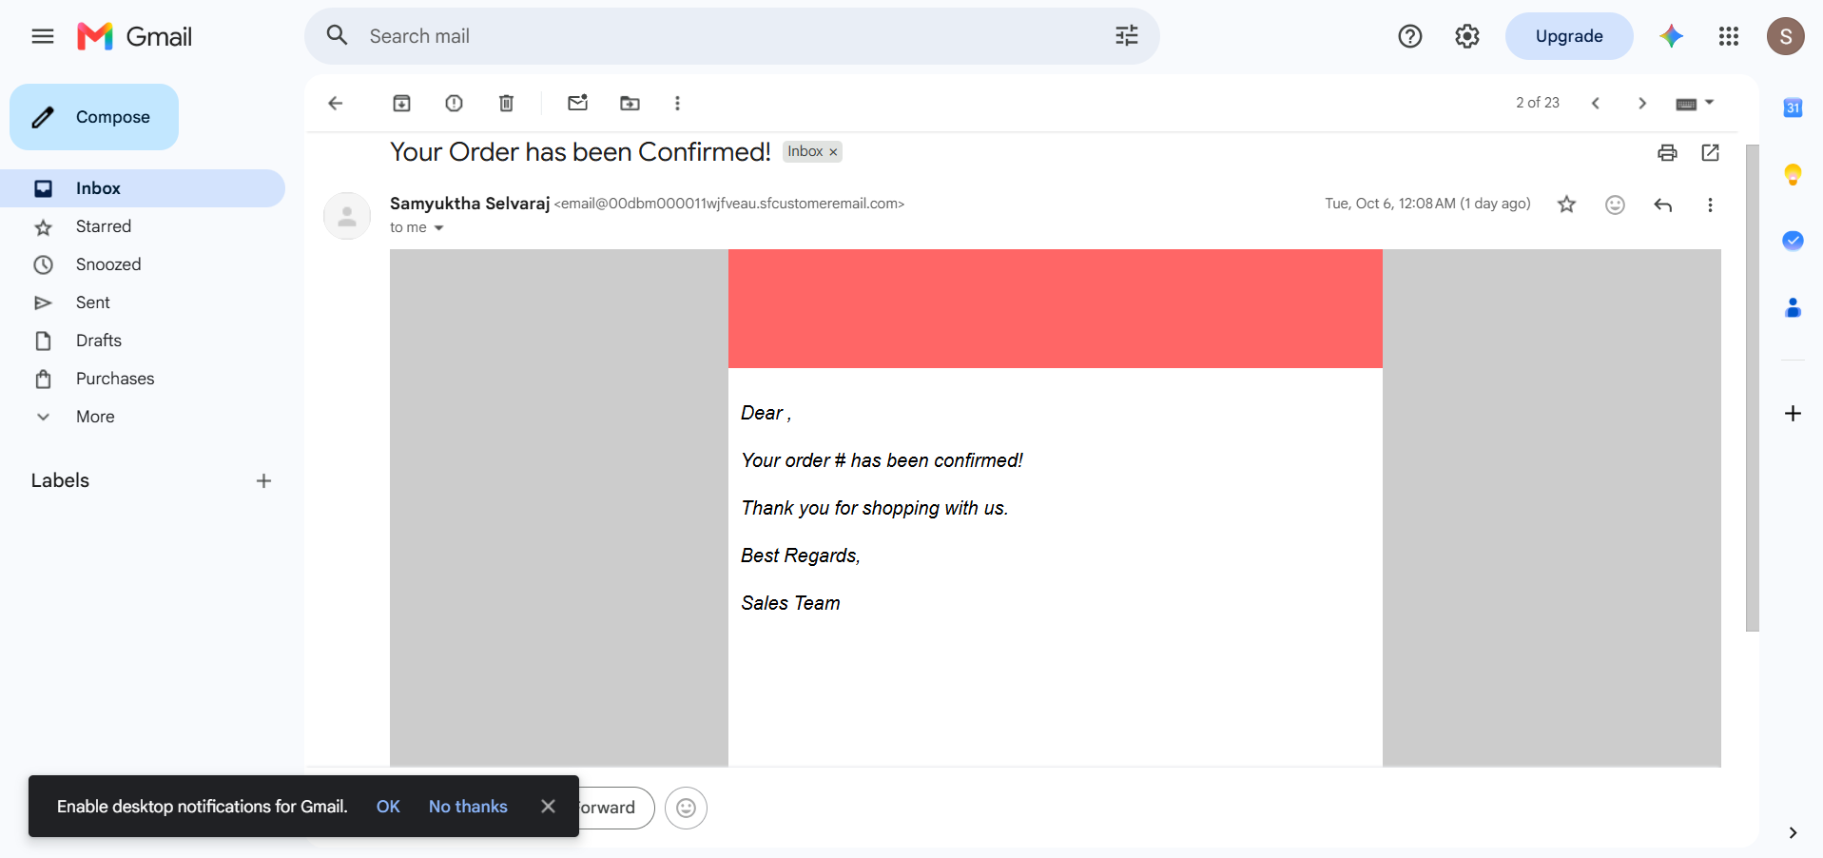
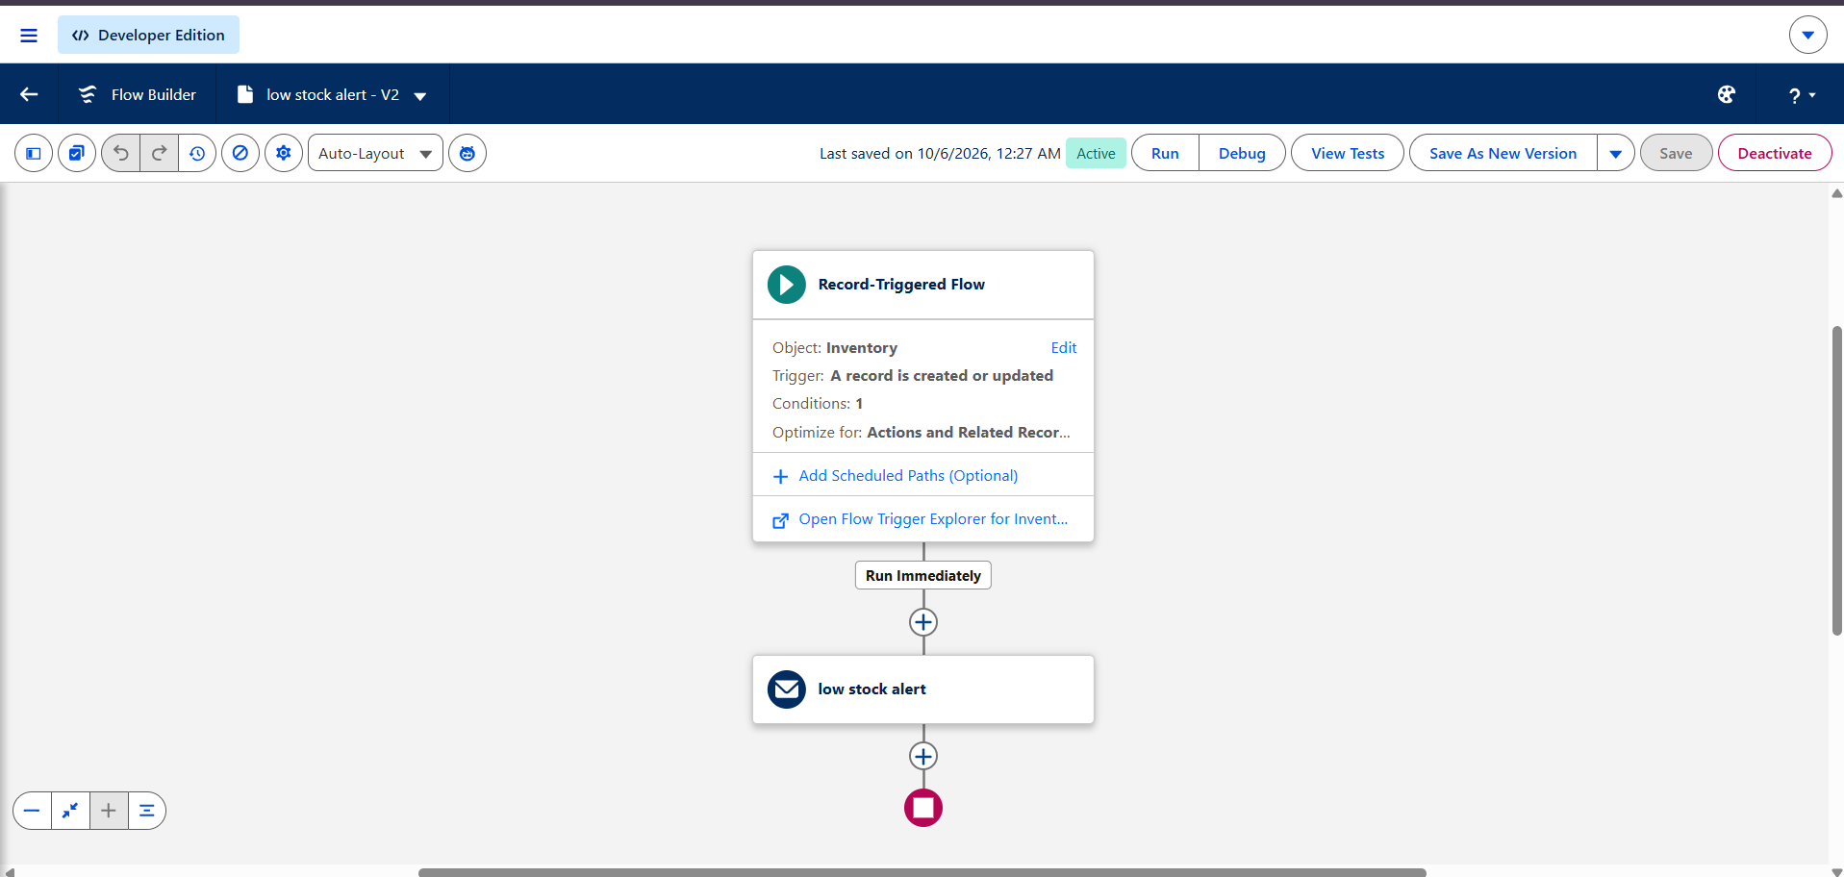
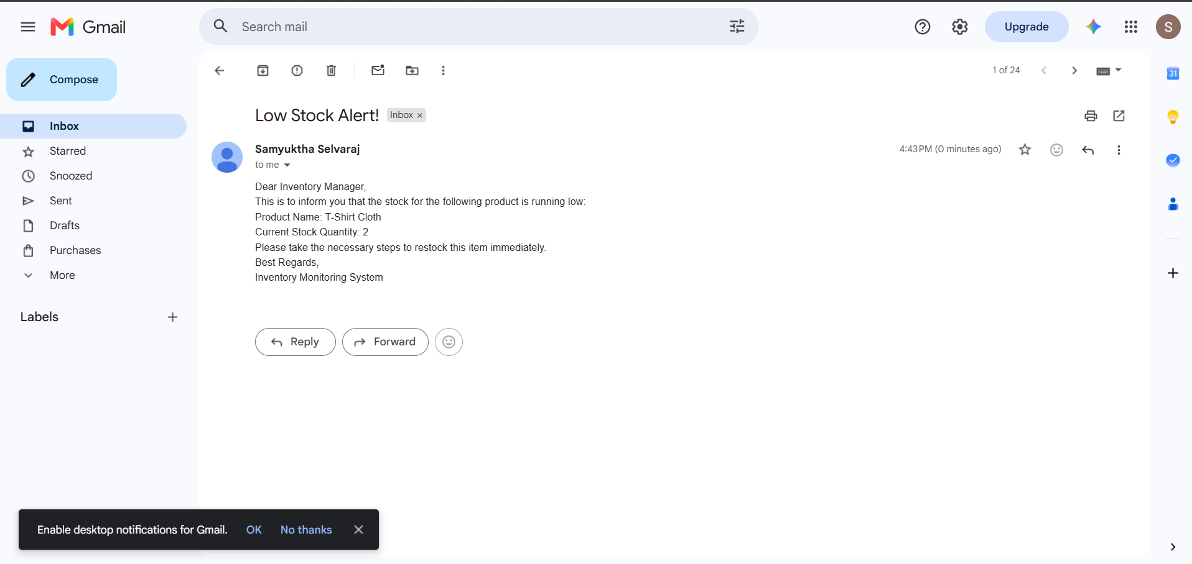
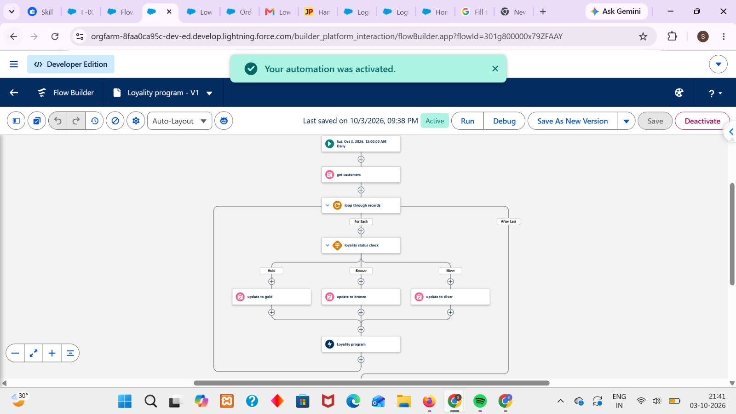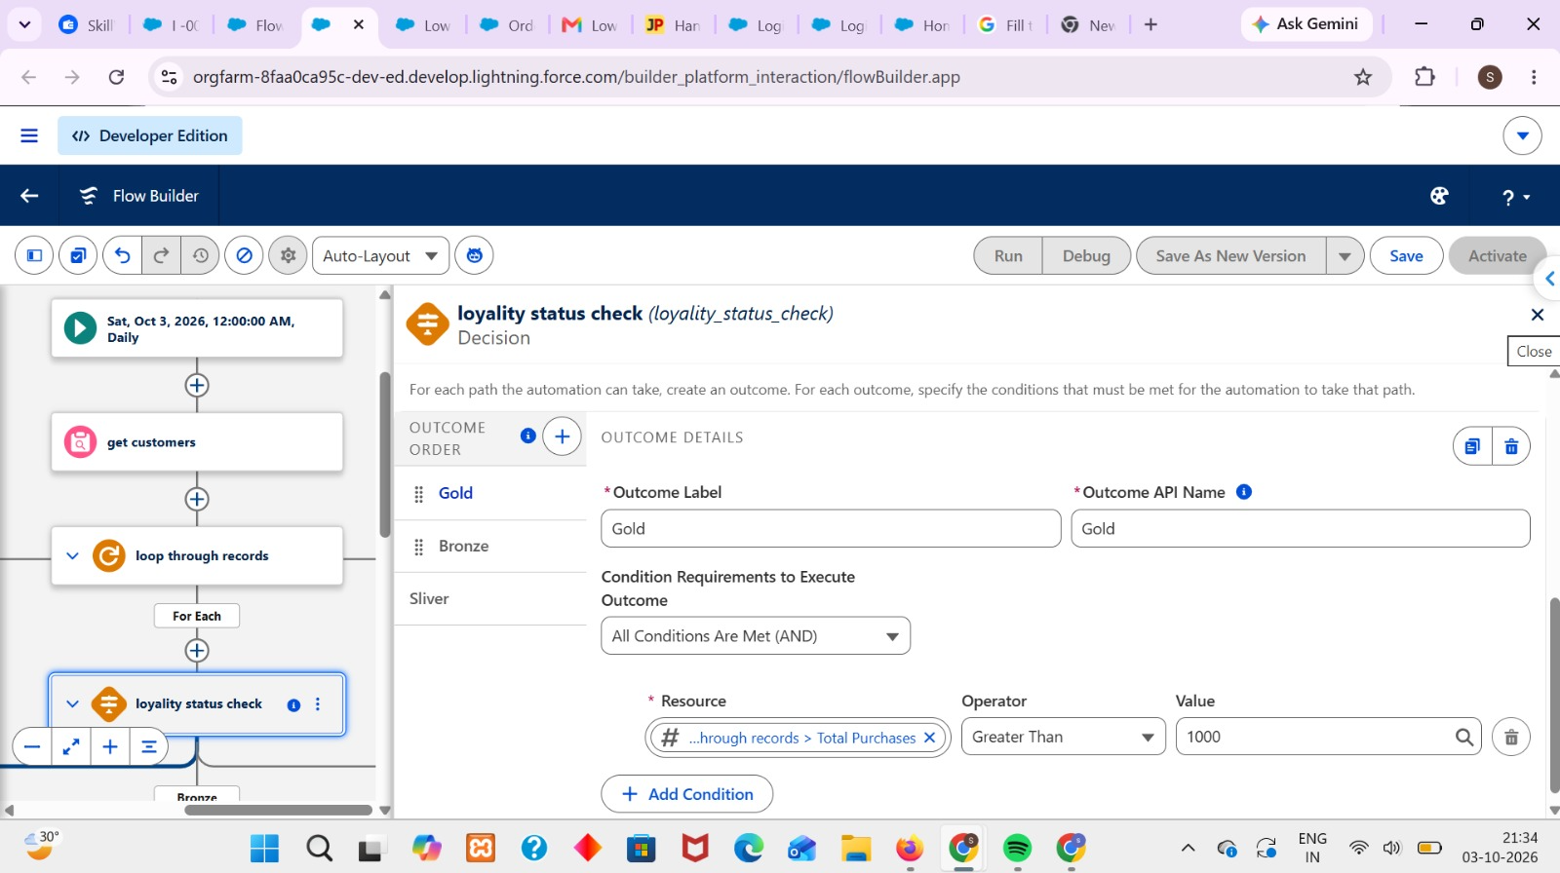

Milestone 11: Apex Class
Definition: Apex Classes are used to implement business logic that may require programmatic processing beyond standard Salesforce configuration and Flow..
Key steps:
- Go to Setup → Apex Classes → New.
- Create the required Apex class.
- Define methods for required business operations.
- Use Salesforce Objects, SOQL, and DML where required.
- Include appropriate error handling.
- Save and compile the class.
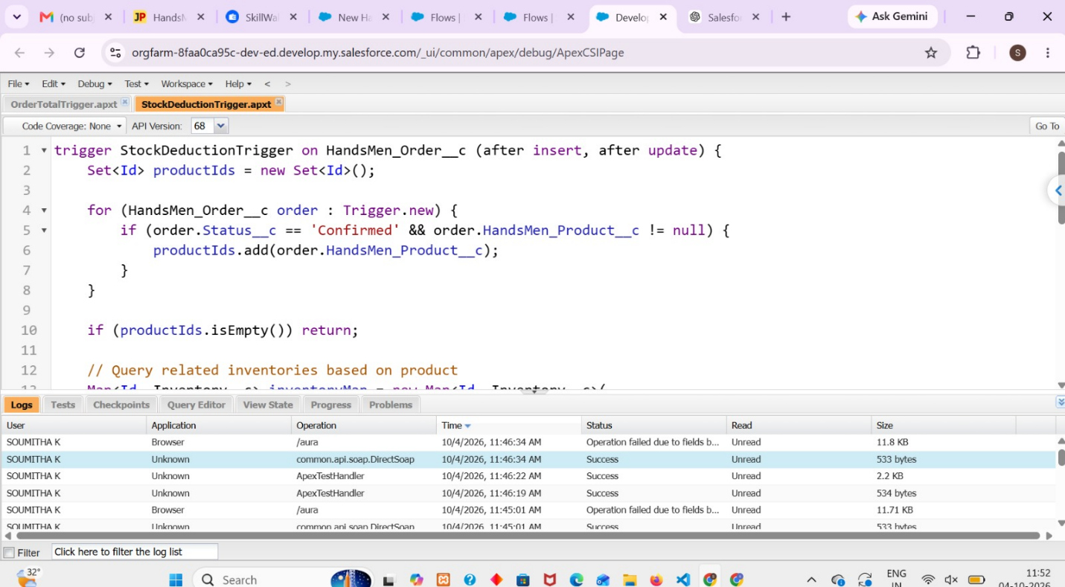
- Test the Apex logic using sample records.
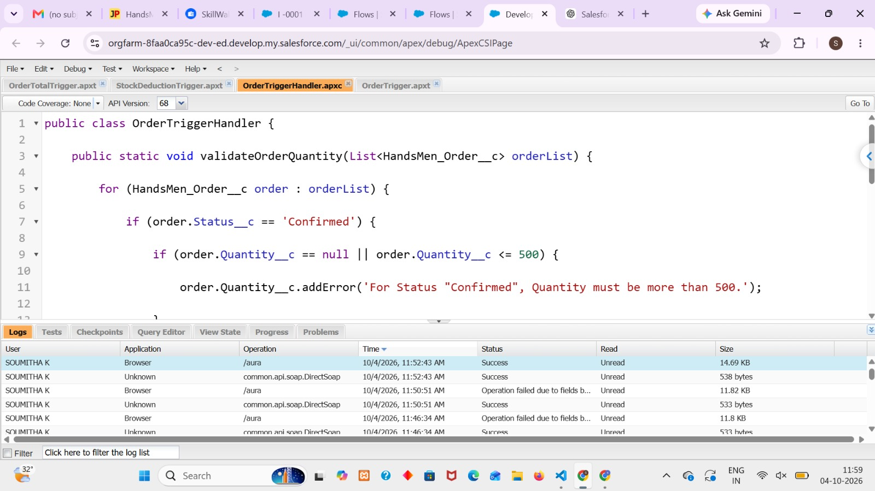
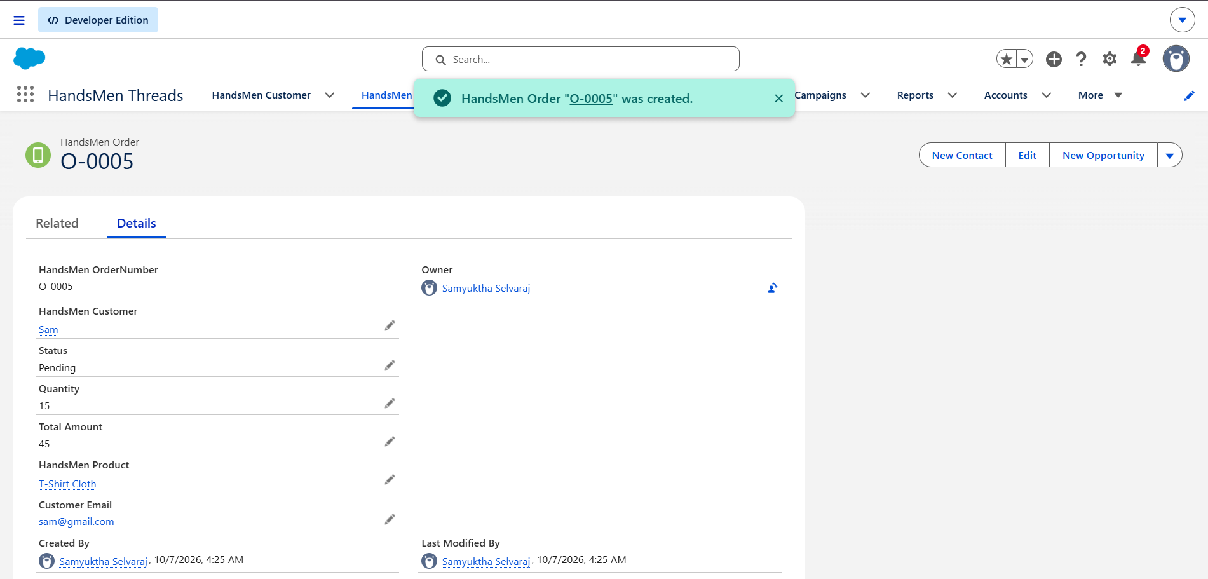

Milestone 12: Batch Jobs – Create Batch Apex
Definition:
Batch Apex is used to process large numbers of Salesforce records efficiently in smaller groups. It is useful for scheduled bulk order processing and related inventory or business updates.
Key steps:
- Create a Batch Apex class implementing the Database.Batchable interface.
- Define the start, execute, and finish methods.
- Use SOQL to retrieve the required records.
- Process records in batches.
- Perform required order, inventory, or business updates.
- Execute the batch job.
- Monitor the job through Setup → Apex Jobs.
- Test the batch process using sample records.
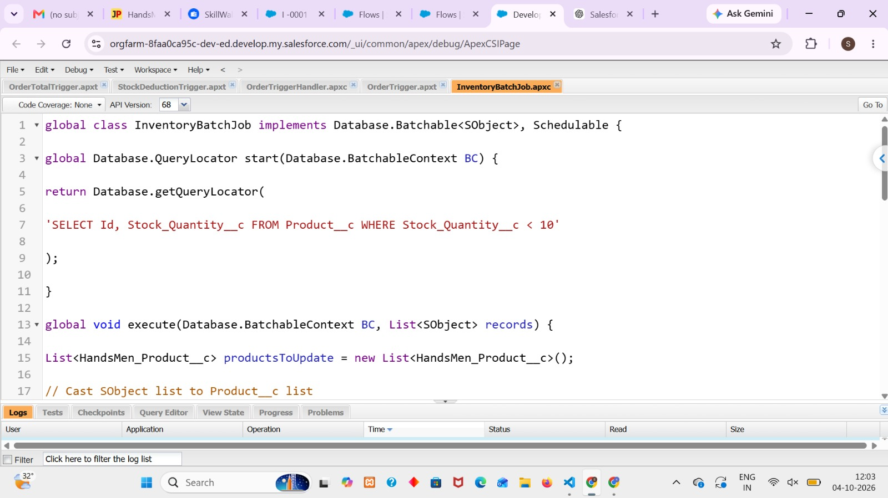
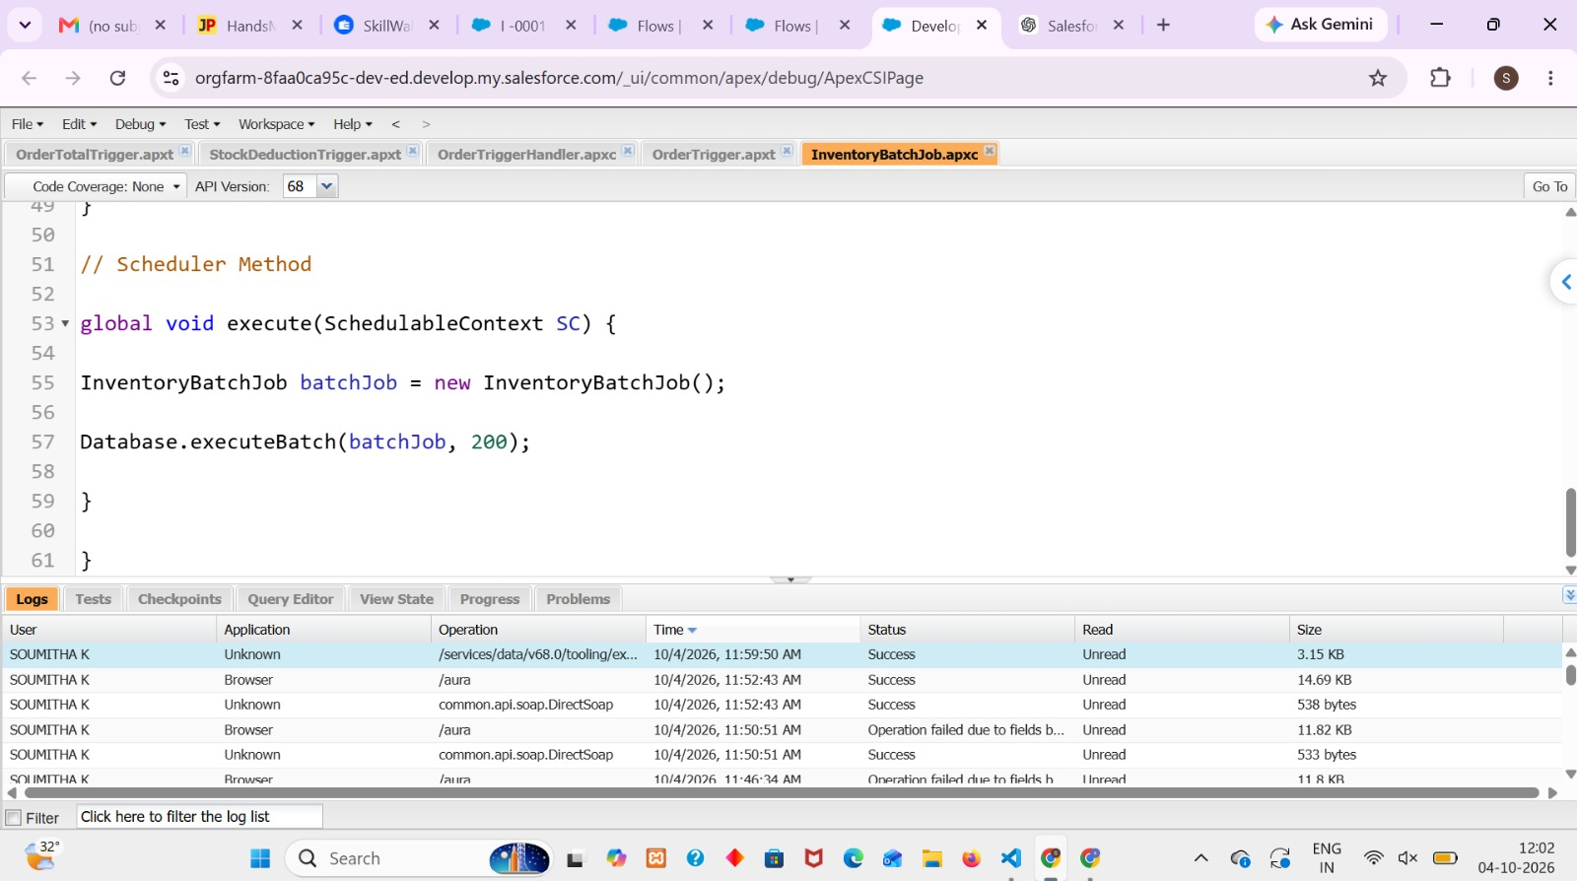

Milestone 13: Conclusion
Project Summary
The HandsMen Threads Salesforce system provides a centralized platform for managing customers, products, orders, inventory, loyalty activities, and marketing information. Salesforce automation reduces repetitive work and helps the organization manage its daily business processes more efficiently.
Outcomes and Benefits
- Efficiency: Reduces repetitive manual activities through automation.
- Accuracy: Validation rules help prevent incorrect or incomplete data.
- Faster Communication: Automated emails provide timely order and stock updates.
- Inventory Management: Low-stock conditions can be identified and communicated quickly.
- Customer Engagement: Loyalty and customer information can be managed centrally.
- Better Visibility: Reports and dashboards help managers monitor business activities.
- Security: Salesforce security features control access to business information.
- Scalability: The solution can support increasing customers, products, orders, and users.

Possible Future Enhancements
- Customer portal for online ordering and order tracking.
- Mobile access for sales and warehouse teams.
- Advanced sales and inventory analytics.
- Payment gateway integration.
- Delivery and logistics integration.
- AI-based demand forecasting and product recommendations.

