Superstore Sales Performance Dashboard
Insights Report

Project Overview
This dashboard analyzes sales performance using the Superstore dataset. It provides insights into revenue, profit, quantity sold, product performance, category contribution, and regional trends to support data-driven business decisions.
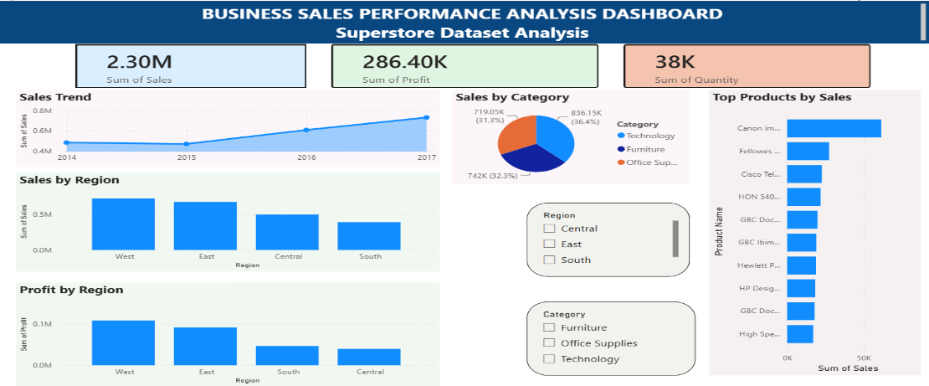

Key Findings
- Total Sales: $2.30 Million
- Total Profit: $286.40 Thousand
- Total Quantity Sold: 38 Thousand Units
Sales Trend
- Sales showed steady growth from 2014 to 2017.
- The highest sales were recorded in 2017.
Category Performance
- Technology generated the highest sales among all categories.
- Furniture and Office Supplies also contributed significantly to overall revenue.
Top Products
- The Canon imageCLASS 2200 Advanced Copier was the highest-selling product.
- Several office and technology products contributed substantially to total sales.
Regional Performance
- The West region achieved the highest sales.
- The East region followed closely in sales contribution.
- The South and Central regions recorded comparatively lower sales.
Profit Analysis
- The West region generated the highest profit.
- Profit contributions from the South and Central regions were lower than those of the West and East regions.

Business Insights
- Strong sales growth indicates increasing market demand over time.
- Technology products are the major drivers of revenue.
- Sales and profit performance are concentrated mainly in the West and East regions.
- Certain regions provide opportunities for improvement and expansion.

Recommendations
1. Focus on High-Performing Categories
- Increase marketing efforts for Technology products.
- Maintain sufficient inventory for top-selling items.
2. Strengthen Regional Performance
- Expand operations and promotional activities in the West and East regions.
- Implement targeted sales strategies to improve performance in the Central and South regions.
3. Product Optimization
- Prioritize high-demand products.
- Monitor low-performing products and optimize inventory levels.
4. Revenue Growth Strategies
- Introduce customer loyalty programs.
- Use regional and category-level insights to improve decision-making and maximize profitability.
5.Tools Used
. Power Bi
. Excel

Conclusion
The dashboard reveals consistent sales growth and highlights the importance of Technology products and the West region in driving overall business performance. By focusing on high-performing categories and strengthening weaker regions, the organization can improve profitability and sustain long-term growth.

