Team Leader:
Santhiya G[25081371802112146]
Team Members:
Bhooshana V[25081371802112110]
Dhana Lakshmi S[25081371802112111]
Indhumathi E[25081371802112114]
Mari Selvi M[25081371802112129]

LegalEase - AI-Powered
Document Generator
Project Documentation Phase | Draft based on supplied source screenshots

Project purpose
LegalEase is a web application for drafting legal documents from user-provided details. The screenshots show a Streamlit
interface, FastAPI backend, Google Gemini-based generation, HTML preview formatting, and PDF/DOCX export helpers.
Evidence note: This documentation reflects features and code visible in the supplied screenshots. It is not a full source-code audit.
Confirm the current implementation and production configuration before relying on it.

System snapshot
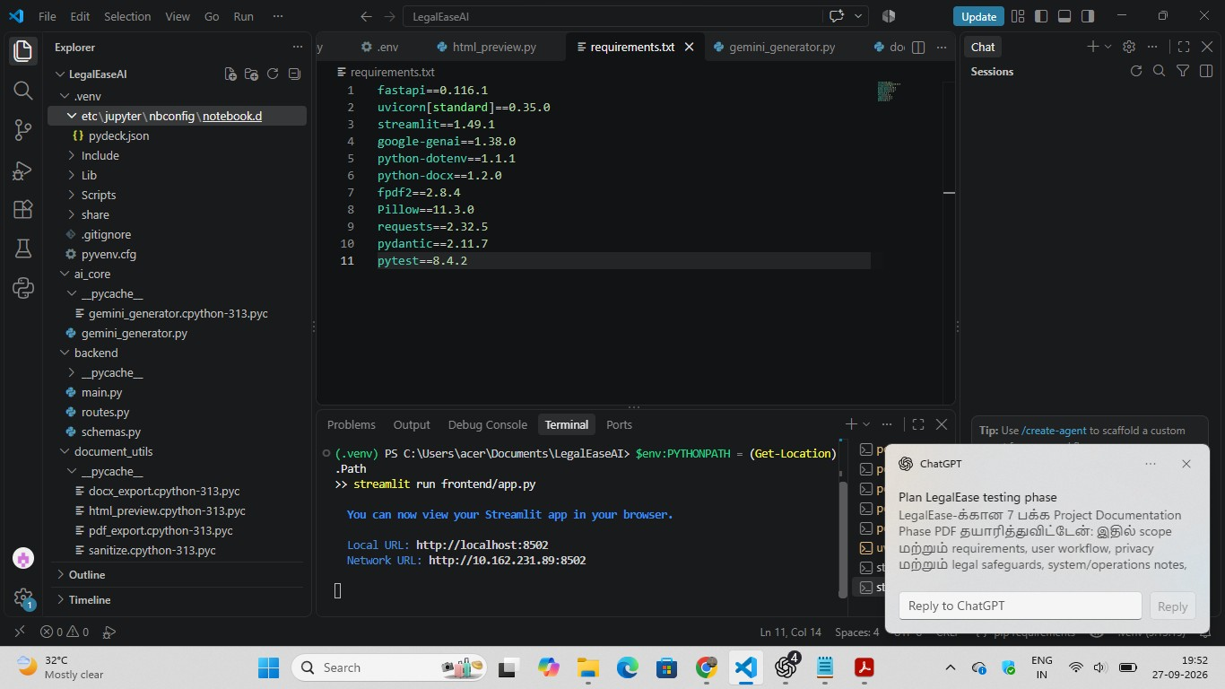

Area Observed in screenshots
Frontend Streamlit app at frontend/app.py. The shown start command is streamlit run frontend/app.py; local URL is http://localhost:8502.
Backend FastAPI app under backend, served by Uvicorn. The visible BACKEND_URL example is http://127.0.0.1:8000.
Generation POST /generate calls a GeminiDocumentGenerator and returns a generated document string.
Document tools Pydantic schemas, text sanitization, HTML preview, PDF export, and DOCX export helper modules are visible.
Scope boundary Login, persistence, jurisdiction support, data retention, and production deployment behavior are not established by these screenshots.
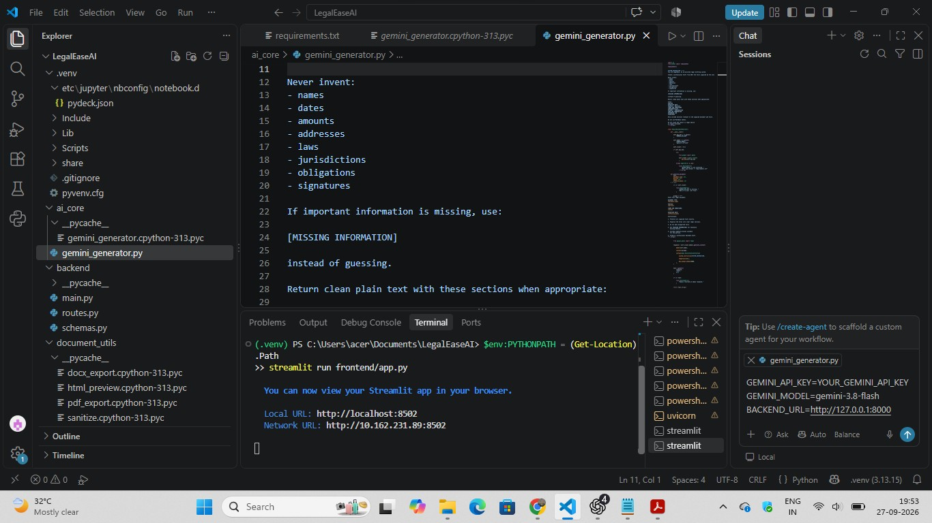

Contents
1. Architecture and API | 2. User workflow | 3. AI/legal safeguards | 4. Setup and dependencies | 5. Security, testing, and release | Appendix: 11 source screenshots
LegalEase - AI-Powered Document Generator | Project Documentation 2

Architecture and API
The visible code follows a frontend-backend pattern. The exact deployment topology, database, authentication, and production network boundaries are not shown.

Stage Observed behavior
- User interface Streamlit collects document type, parties, terms, and effective date, then presents an editable/previewable document and download controls.
- API request Frontend connects to the configured backend URL. FastAPI exposes POST /generate.
- Validation Pydantic DocumentRequest and DocumentResponse models define the request and response shape.
- Draft generation The route invokes GeminiDocumentGenerator to create document text.
- Preview/export Helper modules sanitize/format the text for HTML preview and PDF/DOCX files.
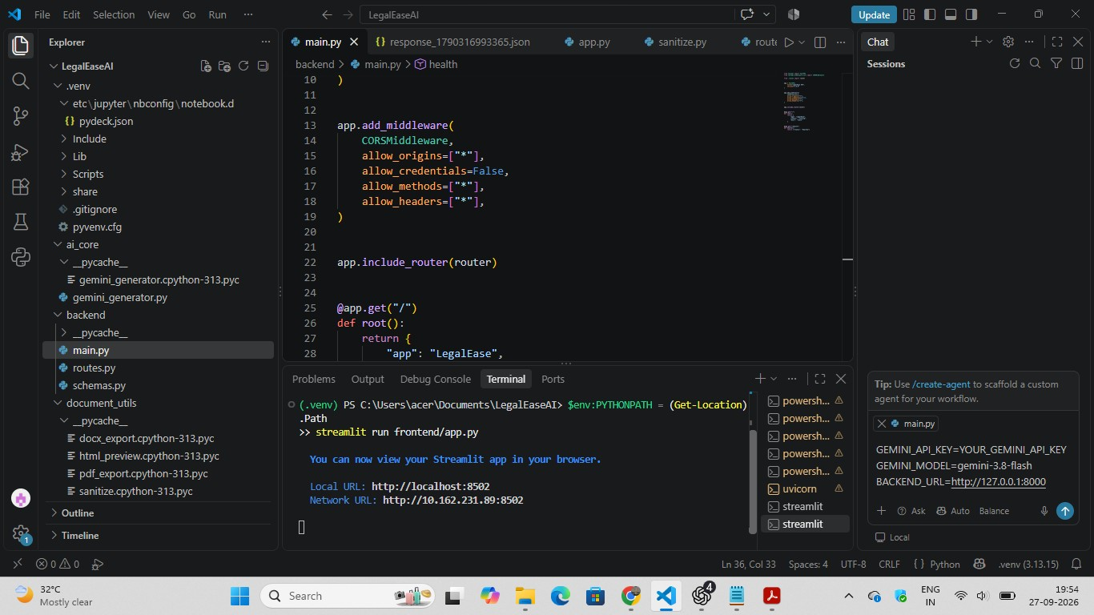
Visible API contract

Item Observed definition
Route POST /generate
Request fields document_type: str; parties: str; terms: str; effective_date: str
Response field document: str
Root route GET / returns app identifier LegalEase.
Deployment review: The backend screenshot shows CORS configured with wildcard origins, methods, and headers, while
credentials are disabled. Replace wildcard settings with the exact trusted frontend origin and required methods/headers for deployment.
LegalEase - AI-Powered Document Generator | Project Documentation 3

User workflow
The flow below combines the visible UI from the earlier screenshot with the fields shown in the supplied backend schema.

01 Choose a document type
Select a supported template. The earlier UI screenshot shows Freelance Work Contract. 02 Enter parties
Provide the correct names and roles for individuals or organizations.

03 Enter terms
Describe the user-provided conditions clearly. Avoid sensitive details unless the privacy design permits them.
- Set effective date
Enter and verify the intended date.
- Generate and review
Generate the draft, check it against the entered information, and edit any errors or omissions.

06 Preview and download
Review formatting. Download PDF or DOCX when available, open the file, and verify content and layout.
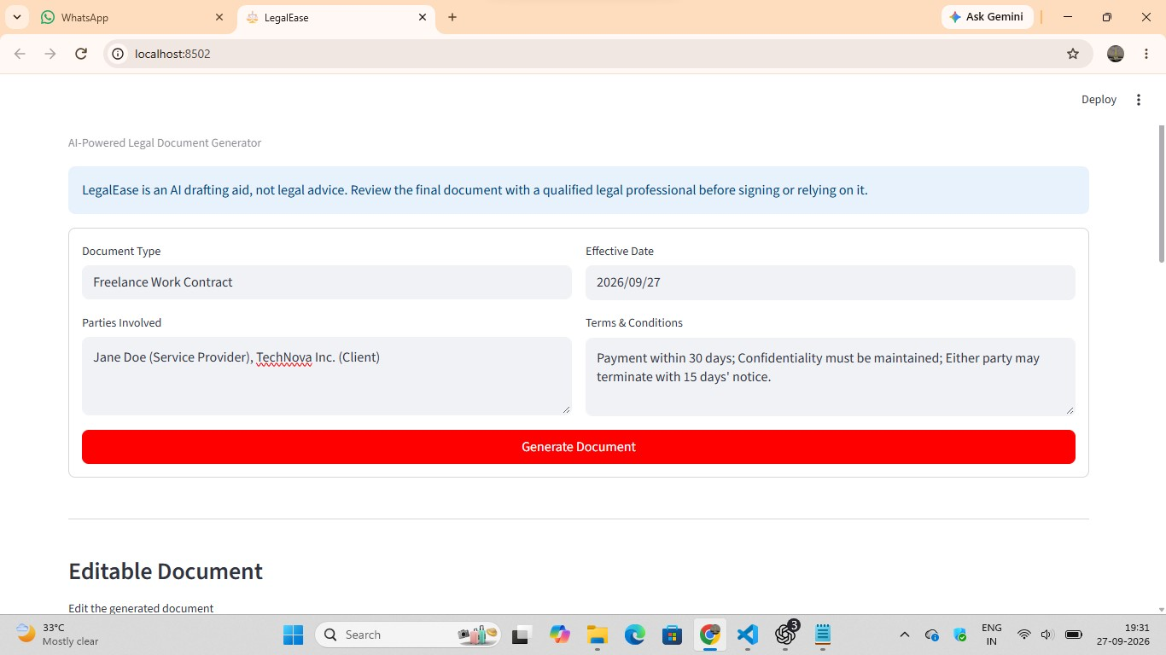
Input and output fields

Field Purpose Type shown
document_type Document template/type String parties People/entities and roles String terms User-provided conditions String effective_date Effective date String document Generated document text String
Confirm in the code: required/optional fields, input limits, date validation, supported templates, and user-facing errors are not visible in the schema screenshot.
LegalEase - AI-Powered Document Generator | Project Documentation 4

AI output and legal safeguards
The Gemini generator screenshot directs the model not to invent names, dates, amounts, addresses, laws, jurisdictions,
obligations, or signatures, and to use [MISSING INFORMATION] when important information is absent. Treat this as a prompt safeguard to test, not a guarantee of correct output.

Review area What to verify
Input fidelity Every party, date, amount, and material term in the result matches the userprovided answers.
Missing facts Unknown information is clearly flagged rather than guessed.
Legal claims Unprovided laws, jurisdictions, obligations, or enforceability claims are flagged for qualified review.
Consistency Parties, dates, payment terms, confidentiality, and termination clauses do not contradict each other.
Human review User reviews and edits the draft; qualified legal professional reviews it for the intended jurisdiction before signing or relying on it.
Template governance Track template/prompt version, jurisdiction, legal reviewer, approval date, and change history.

User-facing limitation
The earlier interface screenshot displays: “LegalEase is an AI drafting aid, not legal advice.
Review the final document with a qualified
legal professional before signing or relying on it.” Keep this notice visible wherever users generate or export drafts.

Document output helpers
Screenshots show sanitize.py escaping text with html.escape; html_preview.py sanitizing/escaping text and converting
newlines; pdf_export.py using FPDF and returning PDF bytes; and docx_export.py using python-docx, with visible code
splitting terms on semicolons. The frontend shows a PDF download named legalease_document.pdf. Verify actual file behavior using representative documents.
LegalEase - AI-Powered Document Generator | Project Documentation 5

Setup, security, and release checks
The visible terminal runs the Streamlit frontend from the project root with streamlit run frontend/app.py. The backend run command and production deployment steps were not shown. Pinned dependencies visible in requirements.txt
fastapi==0.116.1; uvicorn[standard]==0.35.0; streamlit==1.49.1; google-genai==1.38.0; python-dotenv==1.1.1;
python-docx==1.2.0; fpdf2==2.8.4; Pillow==11.3.0; requests==2.32.5; pydantic==2.11.7; pytest==8.4.2.

Configuration names shown
GEMINI_API_KEY, GEMINI_MODEL, and BACKEND_URL are visible in the environment example. A placeholder key value is
shown. Store real credentials in a secure secret store and keep .env files with secrets out of version control. The shown URLs are local-development addresses.

Security and quality checks before release
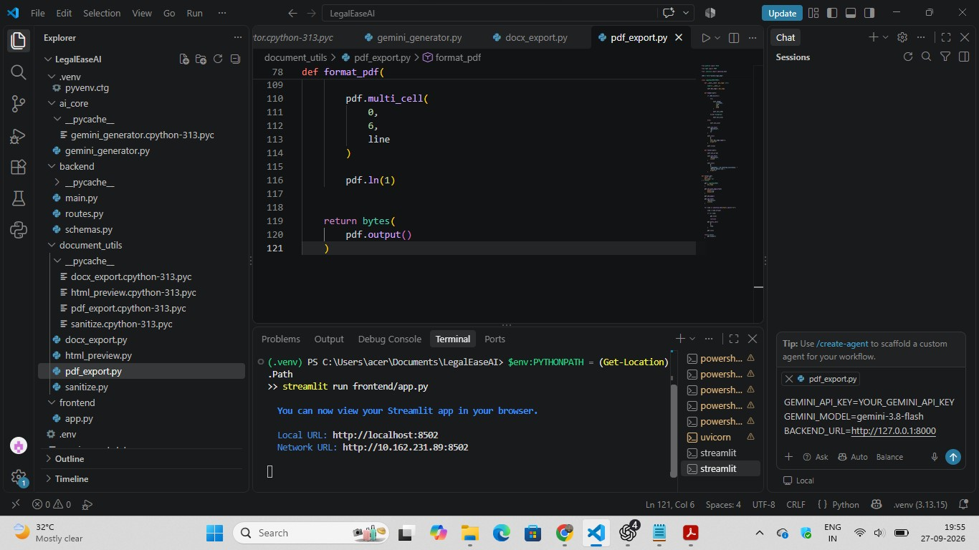

Area Verify
CORS and secrets Restrict origins/methods/headers; protect Gemini credentials from commits, logs, screenshots, and generated files.
Input/output Test HTML-like input, quotes, newlines, Unicode, long text, and valid legal punctuation; check sanitization does not corrupt content.
AI reliability Test missing facts, conflicting terms, malicious instructions in user input, malformed responses, provider errors, timeout, and truncation.
PDF/DOCX Open exports; check names, dates, special characters, pagination, page breaks, and print layout.
Privacy Document what data is sent to Gemini, retention/deletion, logs, access controls, and user disclosures.
Legal review Record intended jurisdiction, qualified reviewer feedback, template/prompt version, approval date, and change process.
Release Record test cases/results, defect log, regression evidence, compatibility, accessibility, critical issue status, owner sign-off, and rollback.
Still to confirm: registration/login implementation; persistence and data deletion; production hosting/network; supported jurisdictions
and templates; actual Gemini model/data settings; backend launch procedure; named maintainers and legal reviewers.
Evidence basis: 11 user-supplied source screenshots and the earlier LegalEase interface screenshot/context. Technical statements are limited to visible evidence. Screenshots are included in timestamp order in the appendix.

This is the output format:
RENTAL AGREEMENT
TITLE
RENTAL AGREEMENT
PARTIES
This Rental Agreement is entered into by and between:
Landlord:
Ravi Kumar
Address: [MISSING INFORMATION]
AND
Tenant:
Arun Kumar
Address: [MISSING INFORMATION]
EFFECTIVE DATE
September 25, 2026
PURPOSE / RECITALS
WHEREAS, the Landlord is the owner of the property located at 12, Main Road, Madurai; and
WHEREAS, the Tenant desires to rent the property for residential use only, and the Landlord agrees to lease
the property to the Tenant under the terms and conditions set forth herein.
TERMS AND CONDITIONS
- Property: The leased premises is located at 12, Main Road, Madurai.
- Use of Property: The Tenant shall use the property for residential use only.
PAYMENT / COMPENSATION
- Monthly Rent: The Tenant shall pay a monthly rent of Rs. 10000.
- Payment Due Date: The monthly rent is payable on the 5th of each month.
- Security Deposit: The Tenant shall provide a security deposit of Rs. 30000.
- Refund of Security Deposit: The security deposit is refundable within 10 days after the Tenant vacates the property, after deducting any unpaid rent or documented damage.
TERM AND TERMINATION
- Term: This agreement is for a term of 11 months, commencing on 2026/09/25 and ending on 2027/08/24.
- Termination: Either party may terminate this agreement with 30 days&#x27; prior notice.
GOVERNING LAW
[MISSING INFORMATION]
LegalEase - AI drafting assistance. Review before use.
RENTAL AGREEMENT
SIGNATURES
Landlord:
___________________________
Ravi Kumar
Date: [MISSING INFORMATION]
Tenant:
___________________________
Arun Kumar
Date: [MISSING INFORMATION]

