1. If email is already in database, then displays “email already exists”.

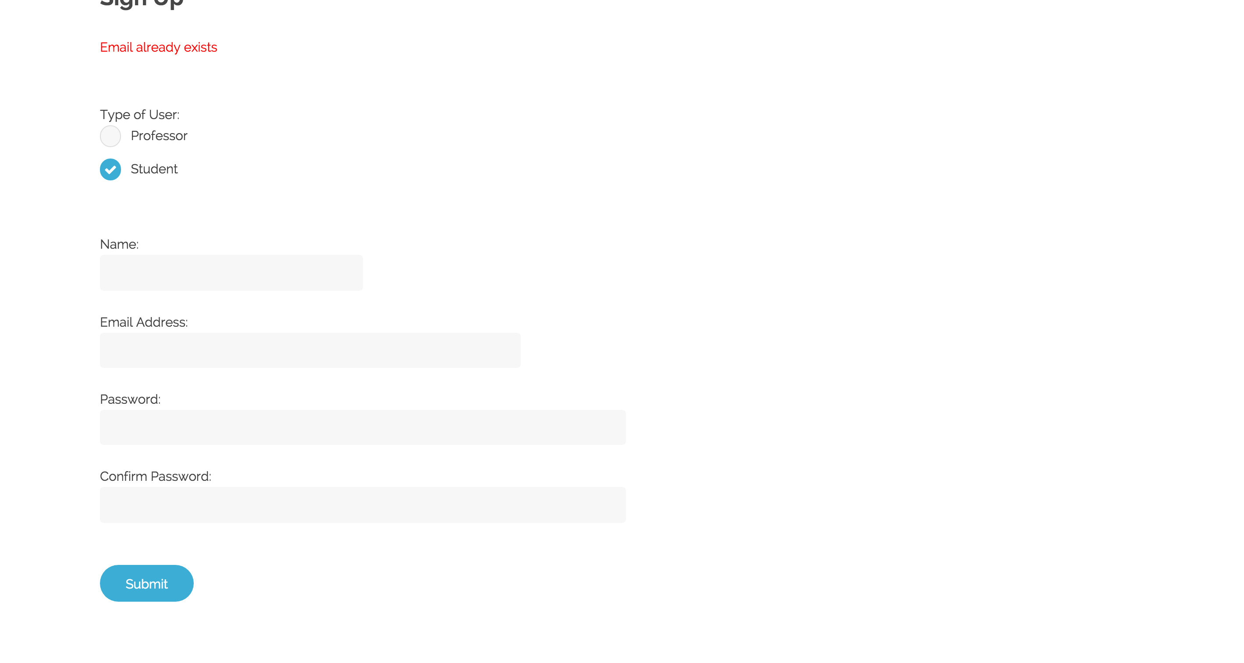

1. If user enters wrong password, “wrong password” is displayed

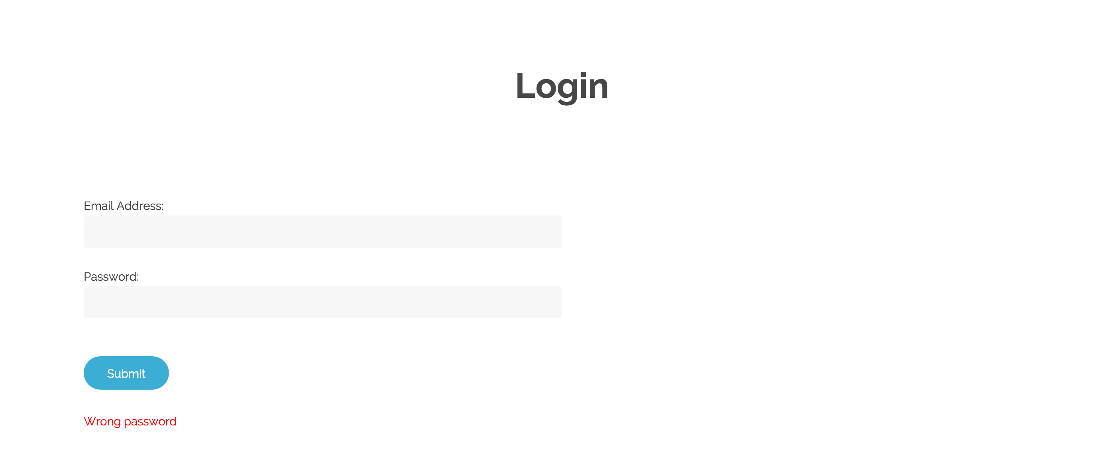

1. “Email not found in database” should appear when account with email is not created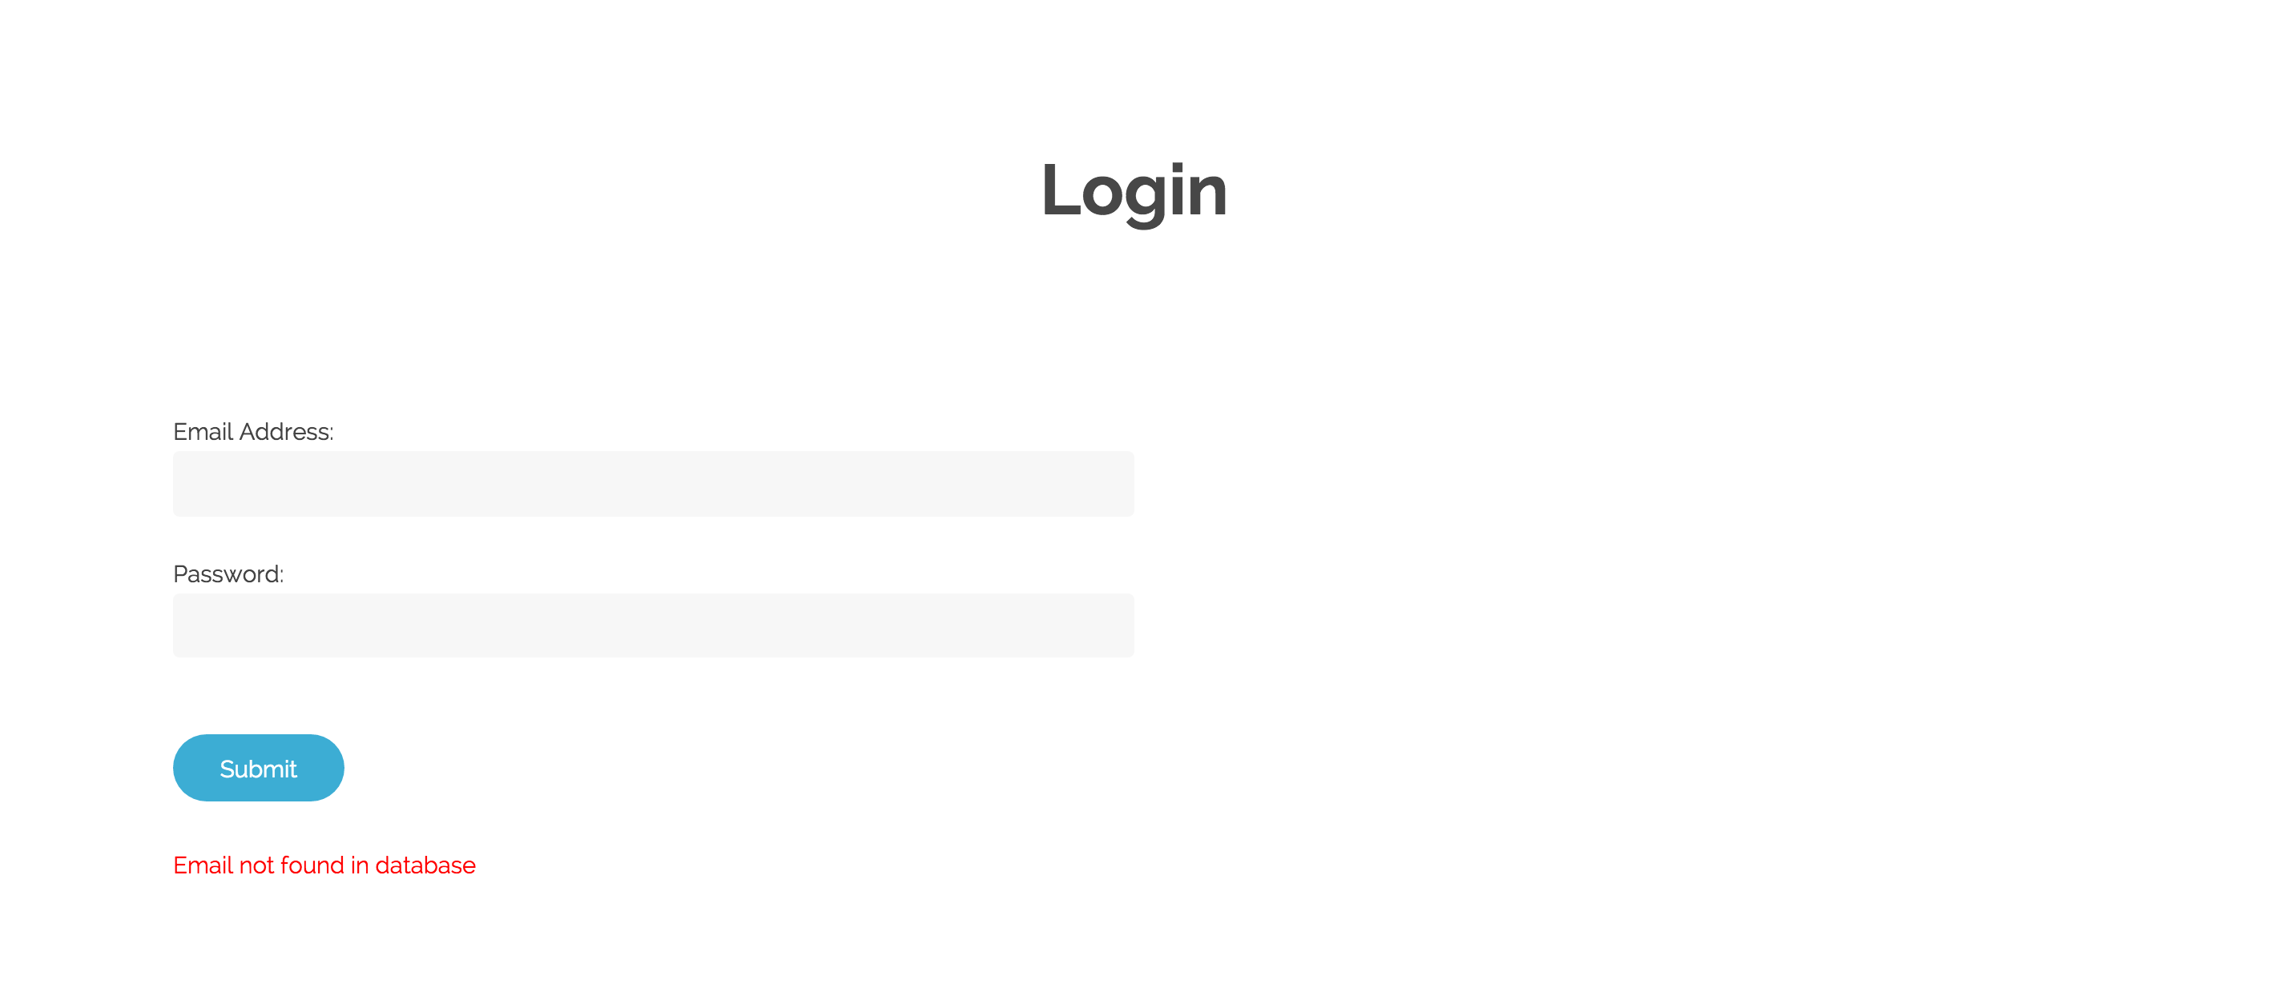
2. If Passwords do not match, then “Passwords do not match” is displayed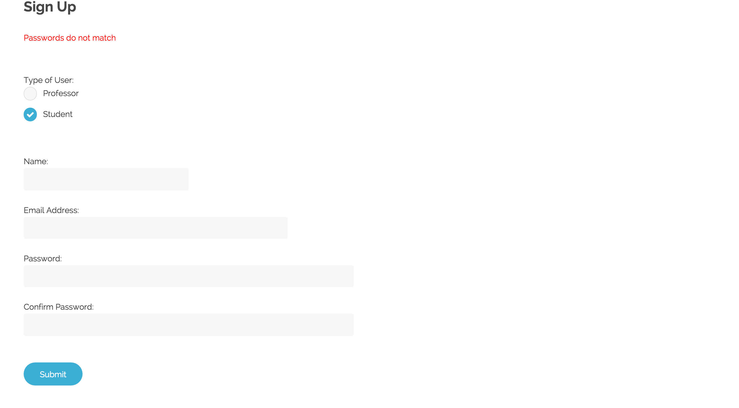
3. When approved is clicked, the professors go to the approved professors table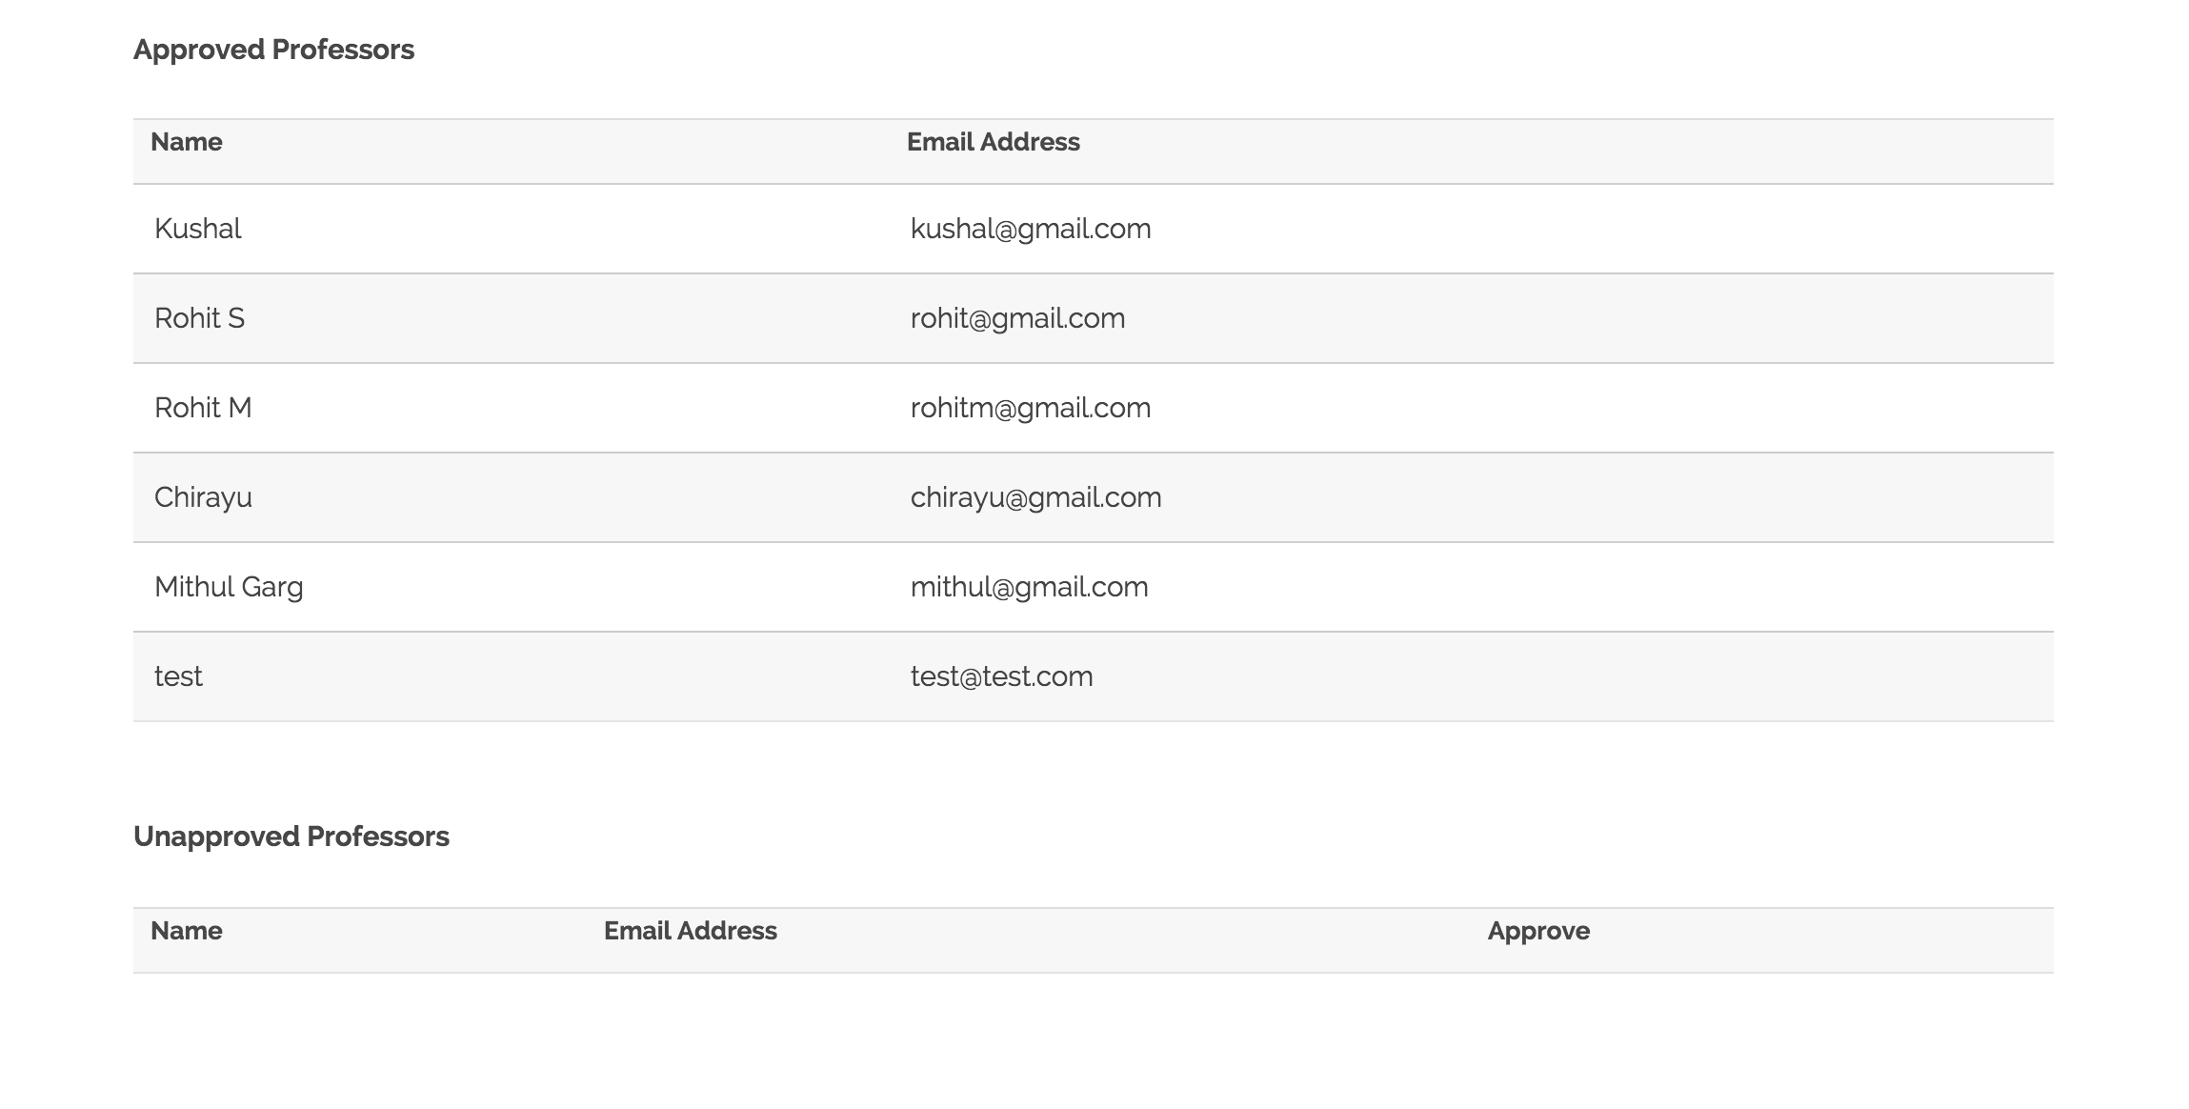
4. This should be displayed when professor is not approved yet.
5. Once the professor is approved, they should see a page to make a course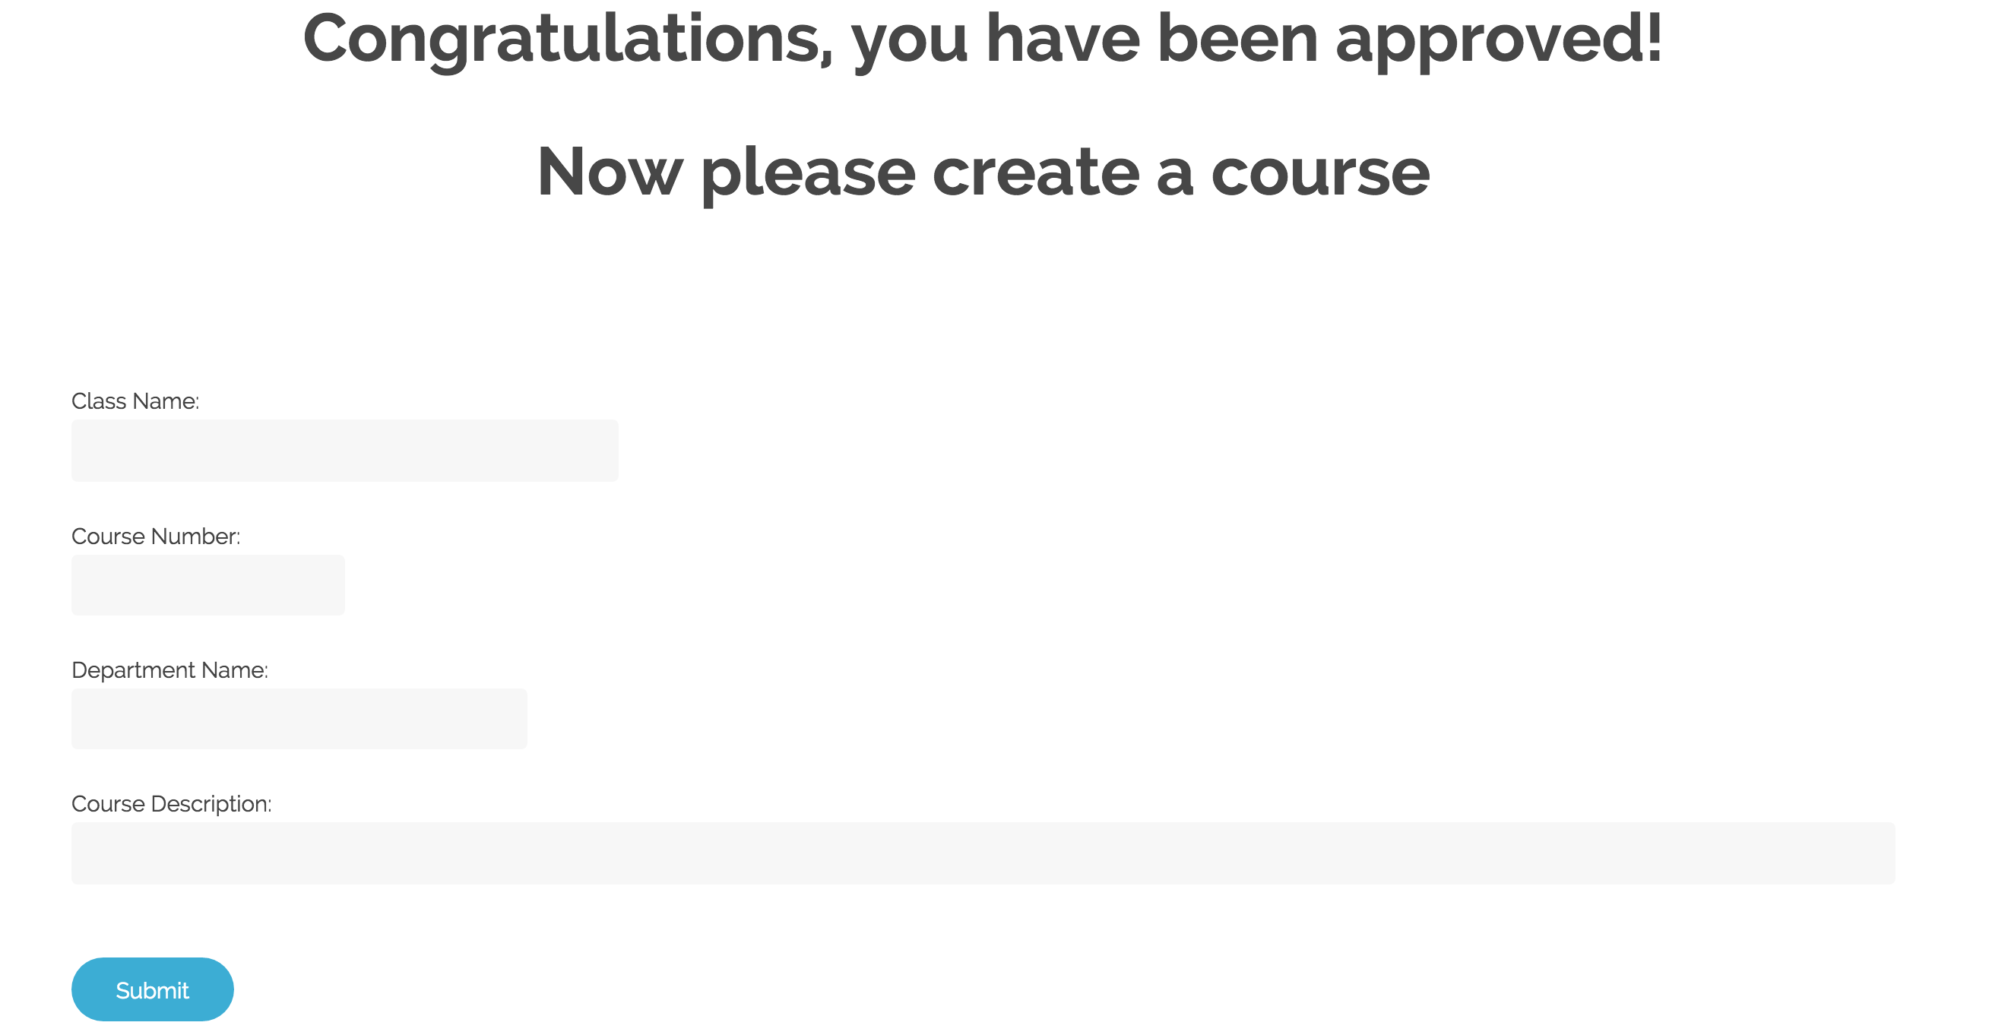
6. Once class is created, it should be displayed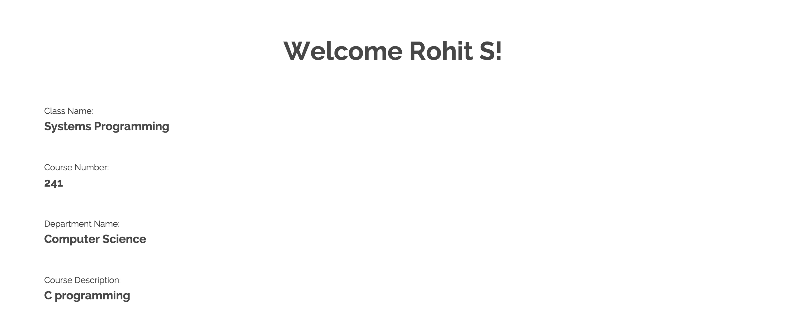
7. Students should be able to track their completed, and incomplete tasks, as well as overdue tasks marked in red