HealixCare HMS
Insurance and TPA Workflow
Version 1.0 | Confidential | Grounded in backend/ and frontend/ source | Document Owner: Product Management / Clinical Operations

1. Purpose
This document describes the Insurance/TPA workflow implemented in backend/routers/tpa.py (15+ endpoints, still in the legacy routers/ structure — not migrated to backend/modules/), and frontend TPA.tsx.

2. Insurance/TPA Flow Diagram (Full Detail)
This diagram expands the pre-authorization-to-claim flow into its full branching, including the patient-pays-and-reimburses path for denied/skipped pre-auth, and flags explicitly that there is no single standardized outbound TPA integration (each insurer is a separate integration point).
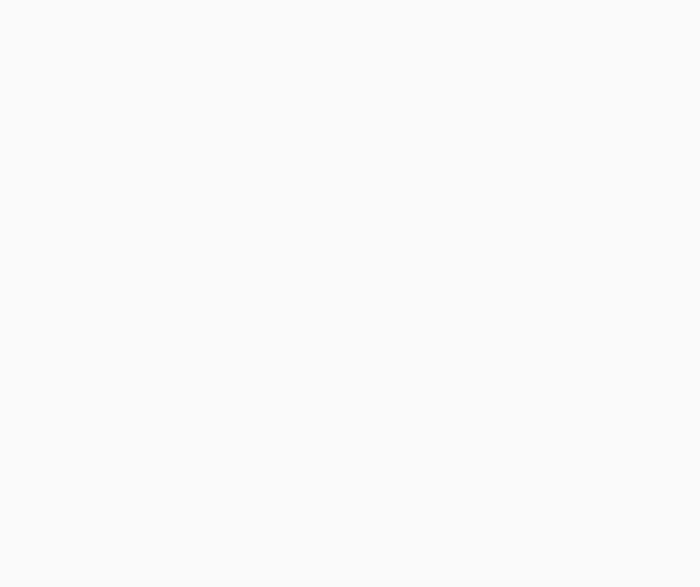
Figure 1 — Insurance/TPA flow, full detail, including the patient-pays-and-reimburses path and the confirmed lack of a standardized TPA integration.

3. Step Detail
Step | Endpoint(s) | Key Tables
TPA master setup | POST /api/v1/tpa/master/add, GET /all | tpa_master
Patient policy link | POST /api/v1/tpa/insurance/link, GET /{patient_id} | patient_insurance
Pre-authorization | POST /api/v1/tpa/pre-auth | Tracks balance insured against sum insured
Claim submission | POST /api/v1/tpa/claims | Submitted per claim; actual outbound call to a specific TPA's API is a per-TPA integration point, not standardized
Claims summary | GET /api/v1/tpa/claims/summary | Aggregate for dashboards

4. Roles Involved
- billing-permissioned role: pre-auth requests, claim submission and tracking.
- admin: TPA master setup, approval oversight.

5. Known Gaps (Confirmed)
- routers/tpa.py is still in the legacy structure — see Application Architecture Document's migration plan; this is one of the candidate modules for Phase 2/Enterprise migration to backend/modules/.
- There is no single standardized outbound TPA API integration — each insurer's actual claim-submission protocol must be implemented per-TPA as hospitals onboard them (see Integration Architecture Document, Section 4).
- No automated claim adjudication — settlement tracking is manual status monitoring, not a rules engine.

6. Relationship to Other Documents
- Builds on: Billing and Payment Workflow (claims originate from a bill).
- Detailed further in: Integration Architecture Document, Section 4 (TPA integration gaps).

7. Document Control
Field | Value
Document Owner | Finance / Billing Operations
Status | Draft v1.0 — grounded in backend/routers/tpa.py
Previous Document | Billing and Payment Workflow
Next Document | Inventory and Procurement Workflow

