HealixCare HMS
Pharmacy Workflow
Version 1.0 | Confidential | Grounded in backend/ and frontend/ source | Document Owner: Product Management / Clinical Operations

1. Purpose
This document describes the Pharmacy workflow implemented in backend/modules/pharmacy/ and backend/routers/pharmacy.py, and frontend Pharmacy.tsx.

2. Pharmacy Flow Diagram (Full Detail)
This diagram expands the e-prescription-to-dispensing flow to show where drug-interaction checking actually happens (at prescribing, in EMR — not re-checked at dispensing), the branch for narcotics/cold-chain items, and the manual nature of the reorder path.
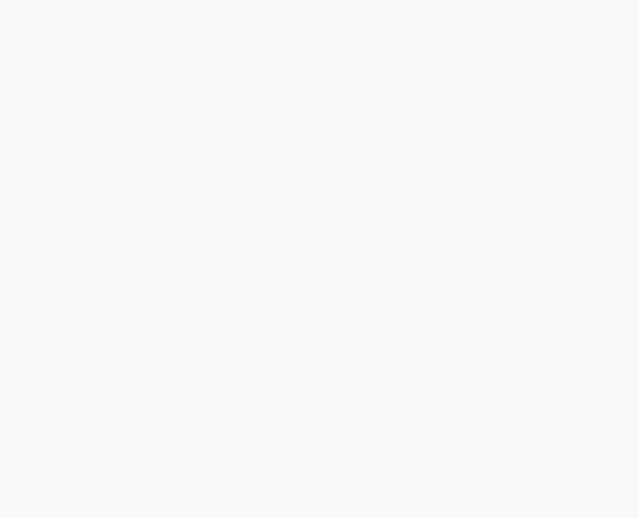
Figure 1 — Pharmacy flow, full detail, showing where interaction checking actually occurs and the manual (not automated) reorder path.

3. Step Detail
Step | Endpoint(s) / Tables | Notes
Drug catalog (master) | GET/POST /api/v1/pharmacy/drugs/add, /all | drugs table — catalog, distinct from stock movement
E-prescription intake | Created via EMR prescriptions, read by Pharmacy | prescriptions table
Drug interaction check | POST /api/v1/emr/drugs/check-interaction | Runs at prescribing time in EMR, not at dispensing time
Stock update | PATCH /api/v1/pharmacy/drugs/{drug_id}/stock | Manual stock adjustment
Dispensing | POST /api/v1/pharmacy/dispense | dispensing table; deducts from drugs/drug_batches
Returns | pharmacy_returns table | Confirmed table exists for return handling
Narcotic tracking | narcotic_register table | Separate register for controlled substances
Cold-chain tracking | cold_chain_log table | For vaccine/temperature-sensitive stock
Dispensing history | GET /api/v1/pharmacy/dispensing/history | Audit trail of dispensing events

4. Roles Involved
- pharmacist: dispensing, stock management (can_view/can_create/can_edit on pharmacy).
- doctor: prescribing only — no dispensing access (V-only on pharmacy per Role Matrix indicative defaults).

5. Known Gaps
- No automated low-stock reorder threshold — alerts are shown in UI from the expiry_date/stock fields, but no scheduled job auto-generates a reorder action (see Feature Backlog Phase 2 item).
- No barcode scanning or automated dispensing machine integration.
- Drug interaction checking happens at prescribing time (EMR), not re-verified at the dispensing step — a pharmacist dispensing a prescription written elsewhere does not get a second automatic interaction check confirmed in code.

6. Relationship to Other Documents
- Builds on: End-to-End Patient Journey, OPD/IPD Workflow (prescription origin).
- Feeds into: Inventory and Procurement Workflow (stock replenishment), Billing and Payment Workflow (pharmacy charges).

7. Document Control
Field | Value
Document Owner | Clinical Operations / Pharmacy
Status | Draft v1.0 — grounded in backend/modules/pharmacy/, routers/pharmacy.py
Previous Document | Radiology Workflow
Next Document | Billing and Payment Workflow

