John has discovered various rocks. Each rock is composed of various elements, and each element is represented by a lower-case Latin letter from 'a' to 'z'. An element can be present multiple times in a rock. An element is called a *gem-element* if it occurs at least once in each of the rocks.

Given the list of N rocks with their compositions, display the number of gem-elements that exist in those rocks.

**Input Format**

The first line consists of an integer, N , the number of rocks.   
Each of the next N lines contains a rock's composition. Each composition consists of lower-case letters of English alphabet.

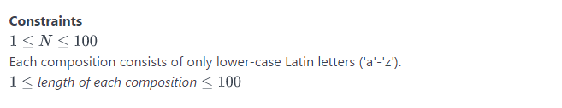

**Output Format**

Print the number of gem-elements that are common in these rocks. If there are none, print 0.

**Sample Input**

3

abcdde

baccd

eeabg

**Sample Output**

2

**Explanation**

Only "a" and "b" are the two kinds of gem-elements, since these are the only characters that occur in every rock's composition.