**Problem**

There are two kangaroos on an x-axis ready to jump in the positive direction (i.e, toward positive infinity). The first kangaroo starts at location X1 and moves at a rate of V1 meters per jump. The second kangaroo starts at location X2 and moves at a rate of V2 meters per jump. Given the starting locations and movement rates for each kangaroo, can you determine if they'll ever land *at the same location at the same time*?

**Input Format**

A single line of four space-separated integers denoting the respective values of X1, V1, X2 and V2.

**Constraints**

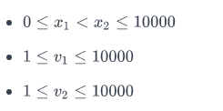

**Output Format**

Print YES if they can land on the same location at the same time; otherwise, print NO.

**Note:** The two kangaroos must land at the same location *after making the same number of jumps*.

**Sample Input 0**

0 3 4 2

**Sample Output 0**

YES

**Explanation 0**

The two kangaroos jump through the following sequence of locations:

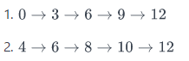

Thus, the kangaroos meet after 4 jumps and we print *YES*.

**Sample Input 1**

0 2 5 3

**Sample Output 1**

NO

**Explanation 1**

The second kangaroo has a starting location that is ahead (further to the right) of the first kangaroo's starting location (i.e., X2 > X1 ). Because the second kangaroo moves at a faster rate (meaning V2 > V1) *and* is already ahead of the first kangaroo, the first kangaroo will never be able to catch up. Thus, we print *NO*.