**Problem**

You have an empty sequence, and you will be given N queries. Each query is one of these three types:

1 x -Push the element x into the stack.

2 -Delete the element present at the top of the stack.

3 -Print the maximum element in the stack.

**Input Format**

The first line of input contains an integer, N. The next N lines each contain an above mentioned query. *(It is guaranteed that each query is valid.)*

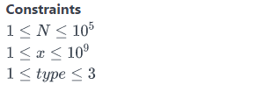  
 **Output Format**

For each type 3 query, print the maximum element in the stack on a new line.

**Sample Input**

10

1 97

2

1 20

2

1 26

1 20

2

3

1 91

3

**Sample Output**

26

91