**Problem**

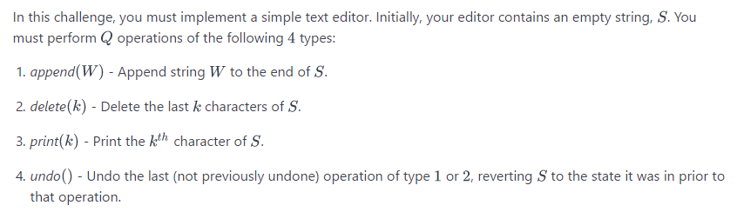

**Input Format**

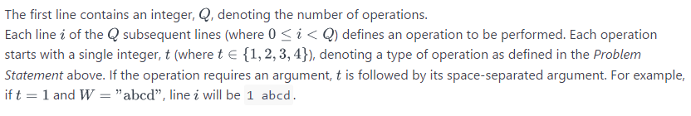

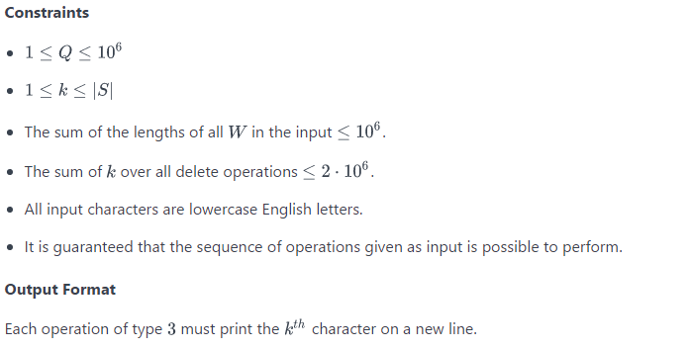

**Sample Input**

8

1 abc

3 3

2 3

1 xy

3 2

4

4

3 1

**Sample Output**

c

y

a

