Ex No: 15 ANALYZE DIFFERENT TYPES OF SERVERS USING
DATE: 20.10.2026 WEBALIZER

AIM:
To analyze the different types of web logs using Webalizer tool.

PROCEDURE:
Step 1: Download Apache web server using- dnf install httpd
Step 2: Configure SELINUX to permissive mode
(open /etc/sysconfig/selinux Put SELINUX=permissive)
Step 3: Start Apache web server using- systemctl start httpd.service
Step 4: Create a directory for webalizer using - mkdir /var/www/html/webalizer
Step 5: Install webalizer using - dnf install webalizer
Step 6: Copy files from /var/www/usage to /var/www/html
Step 7: Open /etc/webalizer.conf file and add the followingLogFile
/var/log/httpd/access_log
LogType clf
Hostname localhost
Output Dir /var/www/html/webalizer
Step 8: Save it and then run webalizer
Step 9: Open in web browser http://localhost/webalizer
Webalizer
#Instructions to install, configure and run Webalizer on Fedora
#Enter the root password after typing su
Su
1. Download Apache web server using- dnf install httpd dnf install httpd
Configure SELINUX to permissive mode
(open /etc/sysconfig/selinux Put SELINUX=permissive)
vi /etc/sysconfig/selinux
Put SELINUX=permissive instead of enforcing
Step 3: Start Apache web server using- systemctl start httpd.service systemctl enable httpd.service systemctl start httpd.service
Step 4: Create a directory for webalizer using - mkdir /var/www/html/webalizer mkdir /var/www/html/webalizer
Step 5: Install webalizer using - dnf install webalizer dnf install webalizer
Step 6: Copy files from /var/www/usage to /var/www/html cp -r /var/www/usage /vaar/www/html
Step 7: Open /etc/webalizer.conf file and add the following- vi /etc/webalizer.conf #add the following lines
LogFile /var/log/httpd/access_log #This is enabled in newer versions of fedora LogType clf
Hostname localhost #For this one you can remove comment denoted by '#' OutputDir /var/www/html/webalizer
Step 8: Save it and then run webalizer save it and then run Webalizer
Step 9: Open in web browser http://localhost/webalizer Open in browser http://localhost/webalizer
Click Oct.2023 link to get the report for this month Before running webalizer, restart httpd server by typing- systemctl restart httpd.service

OUTPUT:
Hosts

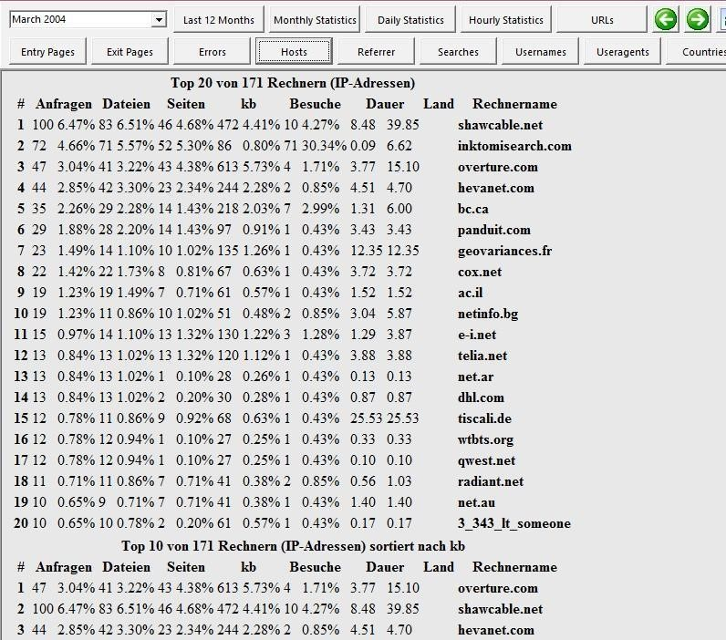

RESULT: Apache server using webalizer tools analyzed

