**PROJECT – 3**

**Deploy flask python web application in AWS cloud**

PART – 1

1. Create IAM User, Assign Roles/Policies, Create VPC, EC2 Instance, with SG-port number 8000

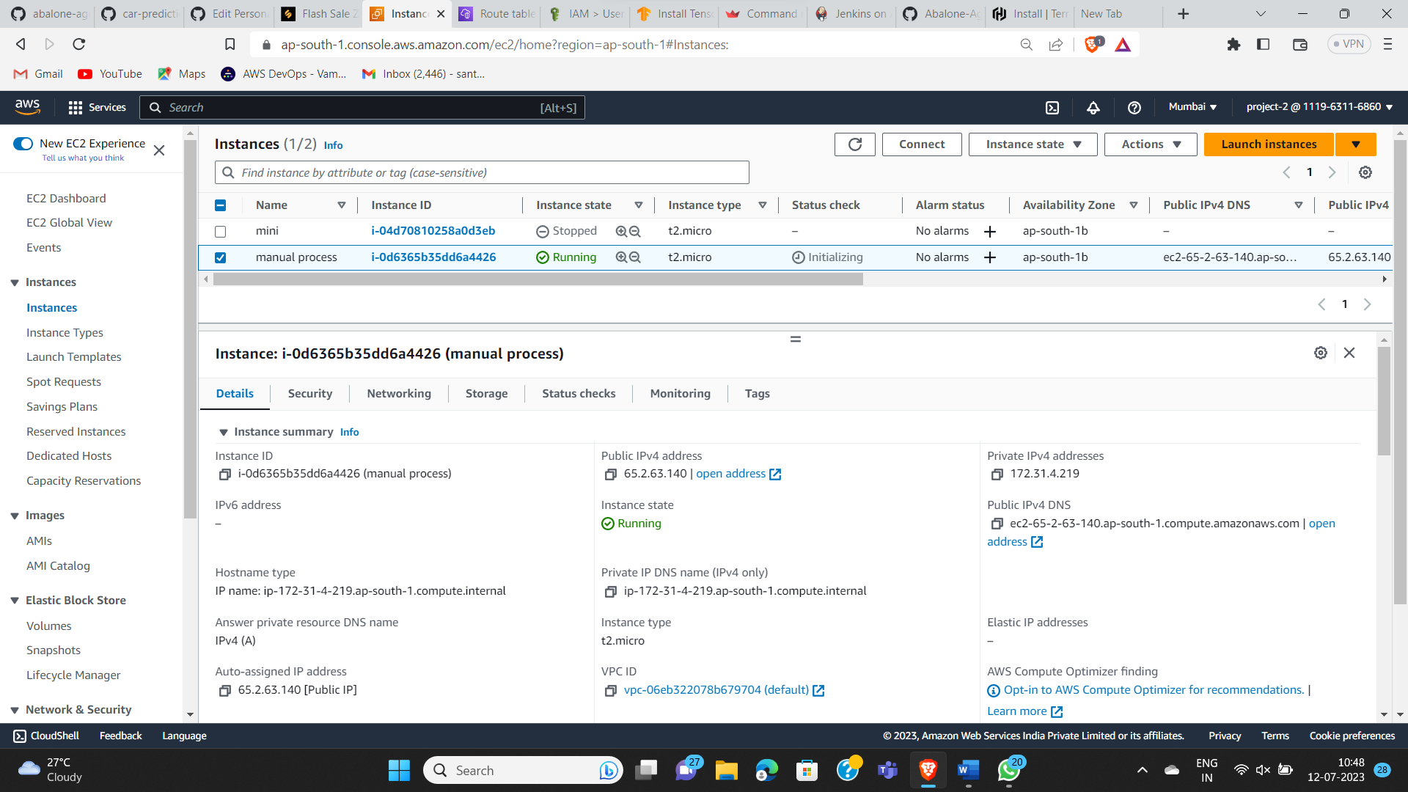

1. Connect to EC2 instance via **ssh -i pem filename username@public ip address**

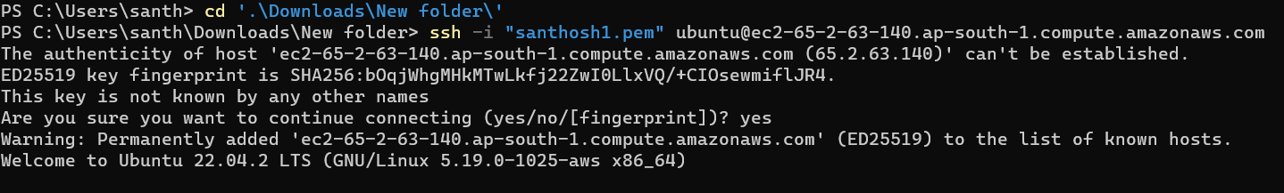

1. Now update the ubuntu machine via **sudo apt update & sudo apt-get full-upgrade -y**

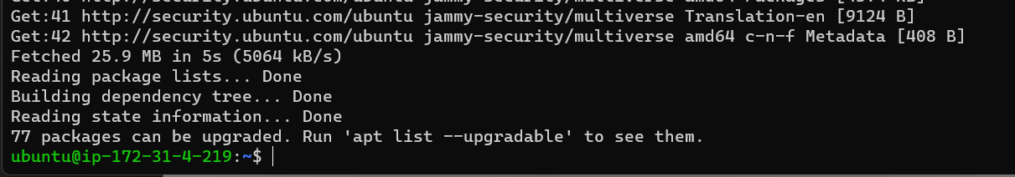

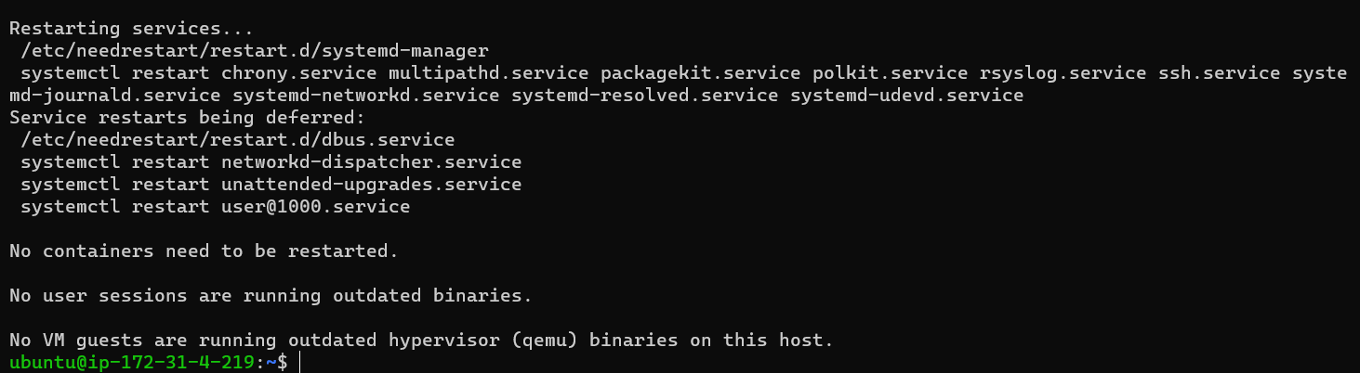

1. Now install the python package requirements by using command

**Sudo apt install python3-pip**

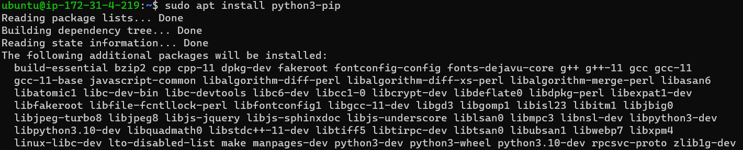

1. Now install python3 by using – **sudo apt install python3**

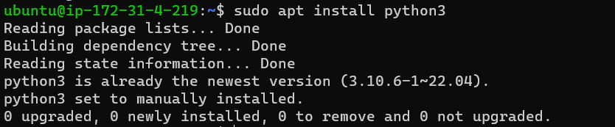

1. Clone the project source code from GitHub to our local machine

-------->git clone <project URL>

Git clone[**https://github.com/santhosh-1105/abalone-age-prediction.git**](https://github.com/santhosh-1105/abalone-age-prediction.git)

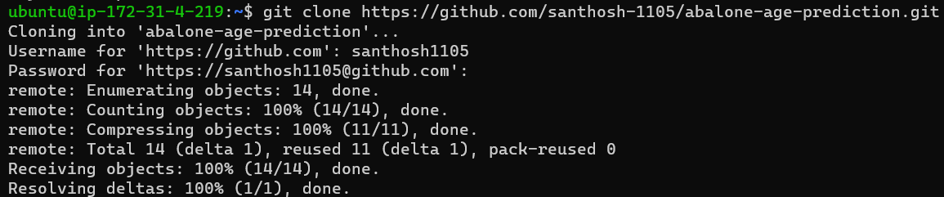

1. Now go to the directory by using- cd and then go into the directory and see the files.

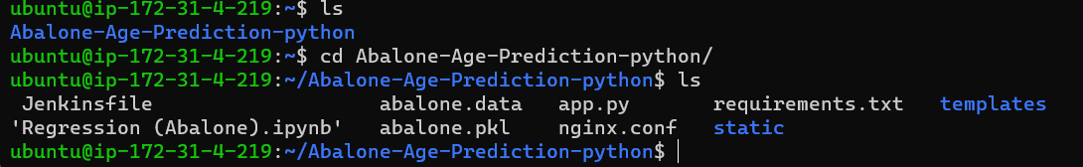

1. Now install the requirements by using – **pip install -r requirements.txt**

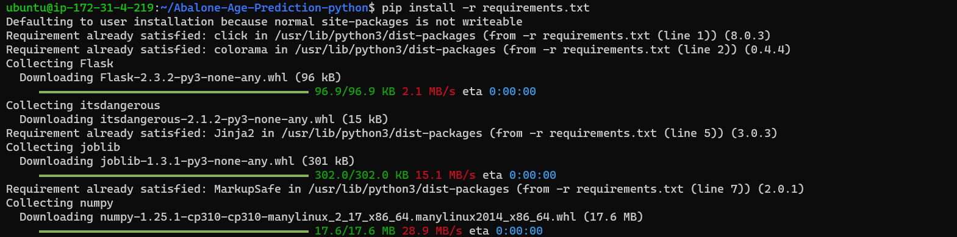

1. Now we have to edit the app.py file. In that we have to change host as (0.0.0.0)

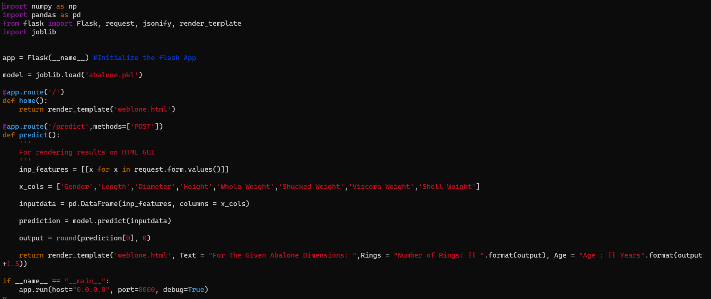

1. After we have to run the app.py file

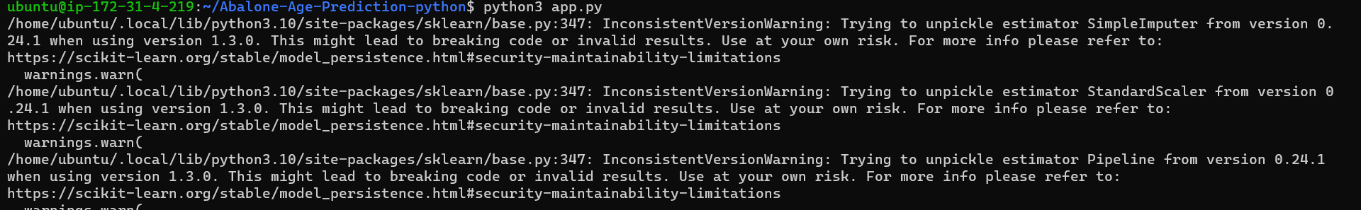

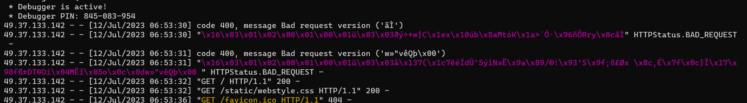

1. Then we have to go to AWS console and copy the public ip address then we get the output.

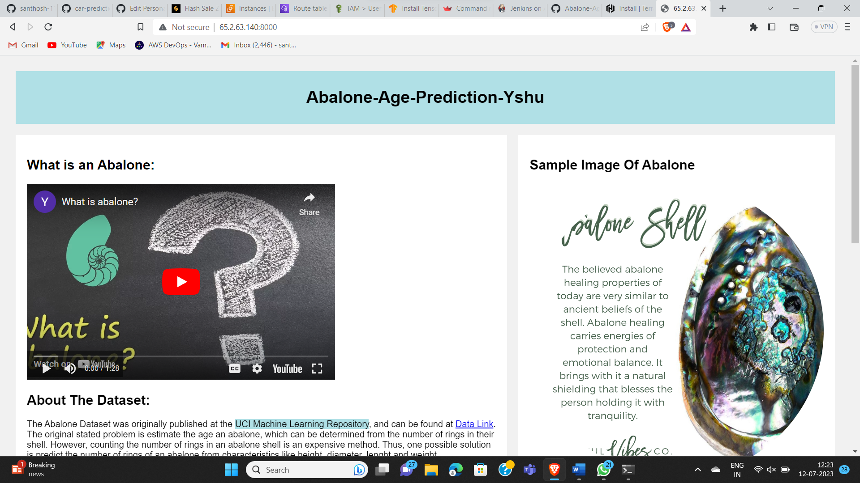

PART – 2

1. Create userdata file using Part – 1 and create data.sh file

Below files are the userdata file which includes data.sh file and also create the terraform files



1. Now we have to install the terraform

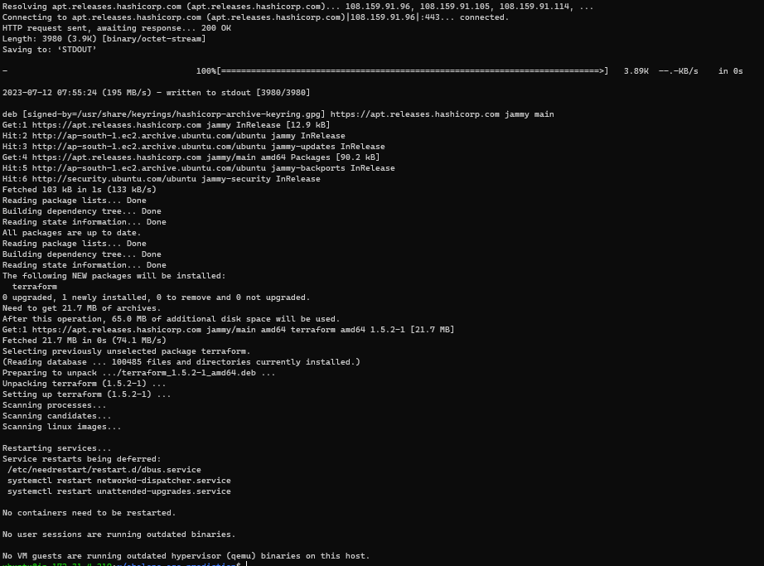

1. Now we have to initiate, validate, plan, apply by using commands

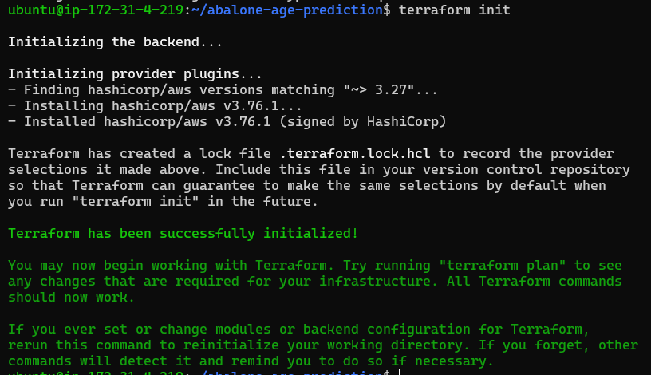 Terraform init, Terraform validate, Terraform plan, Terraform apply





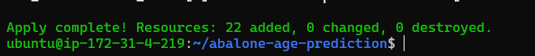

1. Now go to the AWS console and check whether they are cleated or not

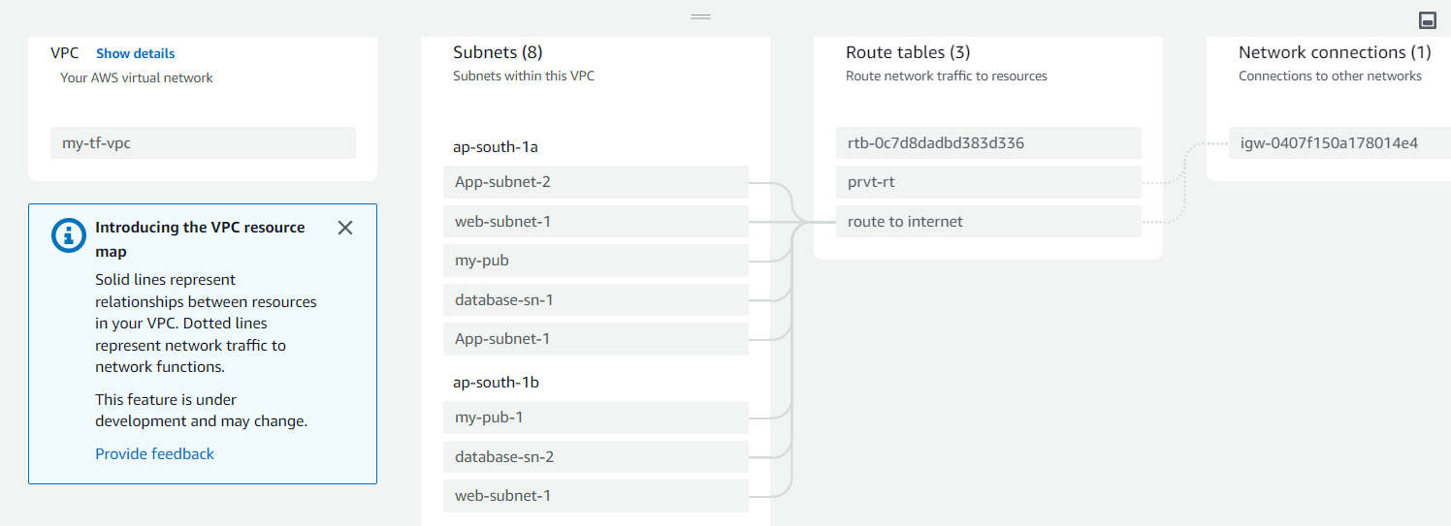

1. Now go to the created instance which was created by the main instance

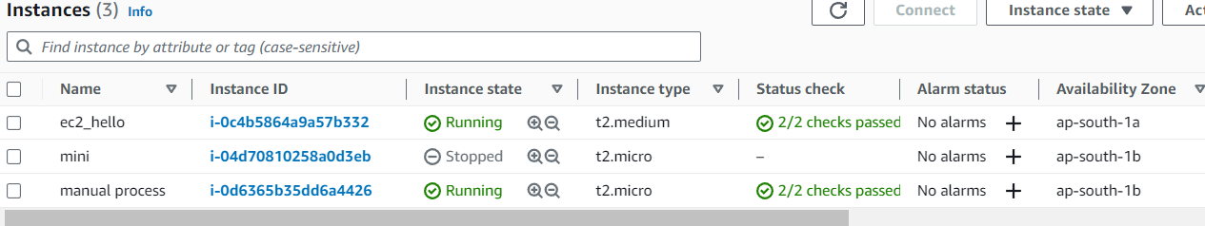

1. Now copy ip address of the newly created instance(ec2_hello) and check the output

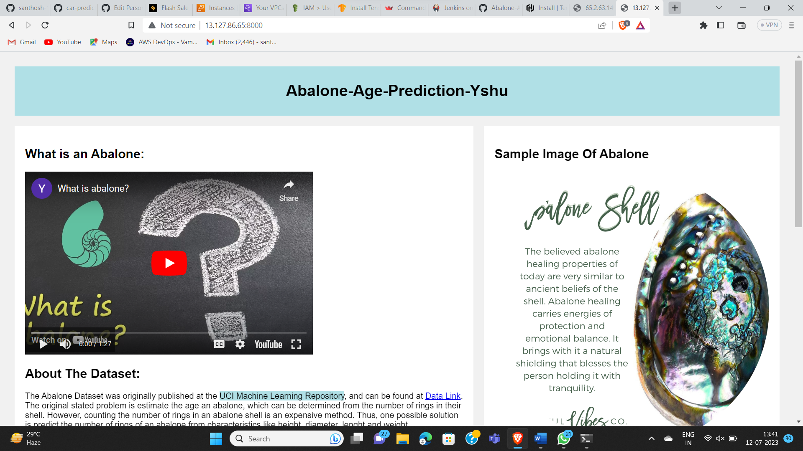

1. After exit from terminal we have see the output by using command- screen -d -m python3 app.py. Which was written in the data.sh file shown below

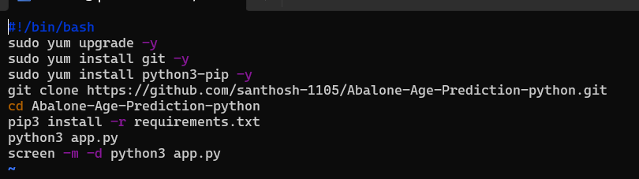

PART – 3

1. Create and install Jenkins in the instance and copy the public ip and browse it with 8080 port number

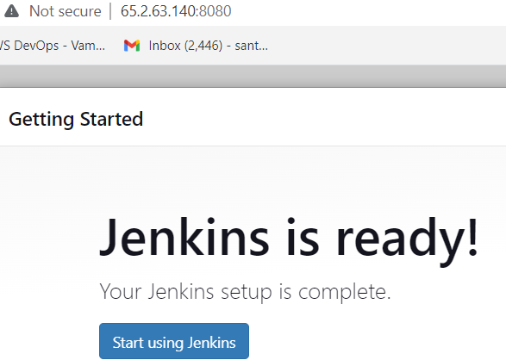

1. use Part - 1 steps and test, build and deploy in manual procedure.