EduDoc Recovery System
The project report submitted to the Bharathiar University in partial fulfilment of the
requirements for the Award of the Degree of

MASTER OF SCIENCE IN COMPUTER SCIENCE
Submitted by
SANTHOSH B

(REG NO: 2432K0430)

Under the Guidance of

Mr . M . ARUN.,MCA.,(phd)
Assistant Professor, Department of Computer Science
DEPARTMENT OF COMPUTER SCIENCE


MARCH 2026

CERTIFICATE

CERTIFICATE
This is to certify that the project work entitled “EduDoc Recovery System” is a bonafide work done by SANTHOSH B(2432K0430) during the period of 2024 – 2026 of his study in the Department of Computer Science at Sri Krishna Adithya College of Arts and Science, Coimbatore, Affiliated to Bharathiar University, in partial fulfilment of requirements for the award of the degree of Master of Science in Computer Science under my supervision and guidance.
The project work is an original work of the candidate and to the best of my knowledge has not been submitted, in part or in full, for any Diploma / Degree / Associate ship / Fellow ship or other similar titles in this or any other University. No portion of the dissertation is a reproduction from any other source, published or unpublished, without acknowledgment.
SIGNATURE OF THE GUIDE

SIGNATURE OF THE HOD SIGNATURE OF THE PRINCIPAL

VIVA –VOCE CONDUCTED ON:

INTERNAL EXAMINER EXTERNAL EXAMINER

DECLARATION

DECLARATION
I hereby declare that the project work entitled “EduDoc Recovery System” submitted to Sri Krishna Adithya College of Arts and Science, Coimbatore Affiliated to Bharathiar University in partial fulfilment of the requirements for the award of the Degree of Master of Science in Computer Science is a record of original work done by me during 2024 - 2025
under the supervision and guidance Mr. M. ARUN.,MCA.,(phd) The report has not been submitted for the award of any Degree / Diploma / Associate ship / Fellowship.

Date: SIGNATURE OF THE CANDIDATE
SANTHOSH B
( REG NO : 2432K0430)

ACKNOWLEDGEMENT

ACKNOWLEDGEMENT
First and foremost, I express my deepest gratitude to the Almighty, whose blessings and guidance have made this wo rk possible. The completion of this work was made possible through the valuable guidance, support, and encouragement of many individuals.
I extend my heartfelt thanks to Smt. S. Malarvizhi, Chairperson & Managing Trustee, Sri Krishna Institutions, Coimbatore, for providing an excellent academic environment that has nurtured my learning and growth.
I am deeply grateful to our Principal, Dr. S. Palaniammal, M.Sc., M.Phil., Ph.D., Sri Krishna Adithya College of Arts and Science, for her invaluable support, encouragement, and leadership, which have greatly inspired me throughout this journey.
I wish to convey my sincere appreciation to Dr. K. Chitra, M.Sc., M.Phil., Ph.D., Associate Professor, Dean-Research for her thoughtful suggestions, valuable insights, and kind cooperation, which significantly contributed to the progress of this work.
I am also profoundly thankful to Dr. K.Geetha, M.Sc., M.Phil., Ph.D., Dean-Computer Science, for her encouragement and helpful advice during the completion of this project.
I extend my special thanks to Dr. D. Shanmuga Priyaa, MCA., M.Phil., Ph.D., Programme Coordinator, for her unwavering support and insightful guidance, which played a pivotal role in shaping this project.
I would like to convey my sincere gratitude to Dr.S.Sheeja, MCA., M.Phill., Ph.D., Assistant Professor, Department of Data Science and Project Head, for her encouragement and support for the successful completion of this mini project

A heartfelt note of gratitude to my internal guide, Mr. M. ARUN.,MCA.,(phd) Assistant Professor, Department of Computer Science, for her dedicated mentorship, valuable insights, and constant encouragement, which have been instrumental in the successful completion of this work.
I am also thankful to all the faculty members of the Department of Computer Science for their support, motivation, and guidance, which have enriched my academic journey.
Lastly, I express my deepest gratitude to my parents for their unconditional love, encouragement, and belief in me. A special thanks to my friends for their constant support, motivation, and for standing by me through every challenge and triumph.

TABLE OF CONTENTS

TABLE OF CONTENTS

CHAPT  ER NO | CONTENTS | PAGE NO
 | CERTIFICATION
 | DECLARATION
 | ACKNOWLEDGEMENT
 | SYNOPSIS
1 | INTRODUCTION
 | 1.1 Introduction | 1
 | 1.2 Importance of The  Project | 2
 | 1.3 About the Project | 3
2 | SYSTEM STUDY
 | 2.1 Existing System | 4
 | 2.2 Drawbacks of Existing  System | 4
 | 2.3 Proposed System | 5
 | 2.4 Advantages of Proposed  System | 5
3 | SYSTEM SPECIFICATION
 | 3.1 Hardware Specifications | 6

 | 3.2 Software Specifications | 6
 | 3.3 Frontend | 7
 | 3.4 Backend | 7
4 | SYSTEM DESIGN AND  DEVELOPMENT
 | 4.1 File Design | 9
 | 4.2 Input Design | 9
 | 4.3 Output Design | 10
 | 4.4 Database Design | 10
 | 4.5 System Development | 11
5 | TESTING AND  IMPLEMENTATION
 | 5.1 Testing | 12
 | 5.2 System Testing | 12
 | 5.3 Testing Methodologies | 13
 | 5.4 Test Cases | 15
 | 5.5 System Implementation | 16
 | 5.6 System Maintenance | 18
6 | CONCLUSION | 19
7 | FUTURE ENHANCEMENT | 20
8 | BIBLIOGRAPHY | 21
9 | APPENDIX
 | 9.1 Data Flow Diagram | 22
 | 9.2 ER Diagram | 23
 | 9.3 Sample Code | 25
 | 9.4 Sample Screenshots | 37

CHAPTER -I
1.INTRODUCTION

  - INTRODUCTION
In the modern digital era, the management and recovery of important documents remain a critical challenge for individuals, especially students and academic professionals. Documents such as mark sheets, transfer certificates, degree certificates, and identity proofs play a vital role in academic and professional growth. However, the loss or damage of such documents often leads to a complicated and time-consuming recovery process.
Traditionally, the process of recovering documents involves visiting institutions physically, filling out manual forms, submitting multiple copies of proofs, and waiting for extended periods without any clear status updates. This not only increases the workload on administrative departments but also causes inconvenience and stress for users.
To overcome these challenges, the EduDoc Recovery System is developed as a web-based solution that digitizes and simplifies the entire document recovery process. The system allows users to register, submit document recovery requests, upload supporting documents such as FIR copies, and track the status of their applications in real time.
The platform also provides an administrative interface where authorized personnel can review requests, verify documents, and approve or reject applications efficiently. By integrating modern technologies such as React for frontend development and Spring Boot for backend services, the system ensures a secure, scalable, and user-friendly experience.
Overall, the introduction of this system aims to transform the traditional document recovery process into a streamlined digital workflow, enhancing efficiency, transparency, and accessibility.

1.2 IMPORTANCE OF PROJECT
The EduDoc Recovery System plays a significant role in addressing the limitations of traditional document recovery methods. In educational institutions, the loss of documents is a common issue faced by students due to various reasons such as misplacement, theft, or natural damage. Recovering these documents through manual processes often leads to delays, confusion, and inefficiency.
This project is important because it introduces a centralized digital platform that simplifies and standardizes the document recovery process. By enabling online submission of requests, the system eliminates the need for physical visits and reduces administrative workload. Users can access the platform from anywhere, making the process more convenient and accessible.
Another key importance of the system is transparency. In traditional systems, users often have no clear information about the status of their requests. This system provides real-time tracking, ensuring that users are always informed about the progress of their applications.
The project also enhances data security and reliability. Sensitive user data and documents are handled securely within the system, reducing the risk of loss or misuse. Additionally, digital storage ensures that records are maintained properly for future reference.
From an institutional perspective, the system improves operational efficiency by automating repetitive tasks and enabling faster decision-making. It also supports better record management and reduces paperwork.
Furthermore, this project demonstrates the practical application of modern web technologies in solving real-world problems, making it highly relevant for academic and professional environments. It contributes to digital transformation initiatives and aligns with the growing trend of e-governance systems.

1.3 ABOUT THE PROJECT
The EduDoc Recovery System is a web-based application designed to facilitate the recovery of lost or damaged academic and official documents through a structured and efficient digital platform. The system is developed using modern technologies such as React for the frontend interface and Spring Boot for backend processing, with MySQL as the database.
The project is designed with two primary user roles: Users (students or applicants) and Administrators (institution authorities).
Users can register and log into the system, fill out a document recovery request form, and upload necessary supporting documents such as FIR copies and identification proofs. Once the request is submitted, it is stored in the database and made available for administrative review.
Administrators have access to a dedicated dashboard where they can view all submitted requests, verify the uploaded documents, and take appropriate actions such as approving or rejecting the requests. The system ensures that all actions are recorded and managed systematically.
One of the key features of the project is the real-time tracking system, which allows users to monitor the status of their requests at any stage. Additionally, the system includes an email notification feature, which keeps users informed about important updates related to their requests.
The project also incorporates secure authentication mechanisms to ensure that only authorized users can access the system. File upload functionality is implemented to handle document attachments efficiently.
Overall, the project aims to provide a reliable, transparent, and user-friendly solution for document recovery in academic environments. It reduces manual effort, minimizes delays, and enhances the overall user experience by leveraging digital technologies.

CHAPTER – II
2.SYSTEM STUDY
System analysis will be performed to determine if it is flexible to design information based on policies and plans of organization and on user requirements and to eliminate the weakness of present system. This chapter discusses the existing system, proposed system and highlights of the system requirements.
2.1 EXISTING SYSTEM
The existing system for document recovery in most educational institutions is primarily manual. Students are required to visit the institution physically, fill out application forms, and submit necessary documents such as identity proof or FIR copies.
The process involves multiple steps including verification by different departments, manual approval, and physical document handling. Communication between students and administration is often limited, and there is no proper system to track the status of requests.
This makes the entire process slow, inefficient, and dependent on manual record-keeping, which increases the chances of errors and delays.
2.2 DRAWBACKS OF EXISTING SYSTEM
The traditional system has several limitations:
- It is time-consuming, as students must visit offices multiple times
- There is no real-time tracking, leading to uncertainty about request status
- The process involves excessive paperwork, increasing complexity
- There is a higher chance of data loss or misplacement of documents
- Communication between users and administrators is limited and unclear
- The system is not user-friendly and lacks accessibility
- It increases the workload on administrative staff
These drawbacks highlight the need for a more efficient and digital solution.

2.3 PROPOSED SYSTEM
The EduDoc Recovery System is a web-based platform designed to overcome the limitations of the existing system. It provides a digital solution where users can register, submit document recovery requests, and upload necessary files online.
The system allows users to track the status of their requests in real time. Administrators can manage and process requests through a centralized dashboard, ensuring faster and more accurate handling.
It also includes features such as secure authentication, document verification, and email notifications to keep users informed throughout the process.
2.4 ADVANTAGES OF PROPOSED SYSTEM
The proposed system offers several benefits:
- Provides online access, eliminating the need for physical visits
- Enables real-time tracking of request status
- Reduces paperwork and manual effort
- Ensures data security and reliability
- Improves transparency in the process
- Enhances user experience with a simple interface
- Reduces administrative workload
- Supports faster processing and decision-making
Overall, the proposed system offers a modern, efficient, and user-friendly solution for document recovery.

CHAPTER – III
3.SYSTEM SPECIFICATION

3.1. HARDWARE SPECIFICATION
The hardware requirements for the EduDoc Recovery System are minimal, as it is a web-based application and does not require high-end infrastructure.
For Development:
- Processor: Intel Core i3 or higher
- RAM: 4 GB minimum (8 GB recommended)
- Hard Disk: 500 GB or above
- System Type: 64-bit system
For Deployment/User Access:
- Any system with a web browser
- Stable internet connection
- Basic input/output devices (keyboard, mouse)

3.2 SOFTWARE SPECIFICATION
The Software requirement for the system include development tools, frameworks, and runtime environments
Operating System:
- Windows 11
Development Tools:
- Visual Studio Code
- Postman (for API testing)
- Git (optional for version control)
Technologies Used:
- Java (JDK 17 or above)
- Node.js and npm
- MySQL Database
Browser Support:
- Google Chrome
- Microsoft Edge
- Mozilla Firefox
3.3 FRONTEND
The frontend of the EduDoc Recovery System is developed using React.js, along with Vite and Tailwind CSS for styling and performance.

It provides an interactive and user-friendly interface where users can easily navigate through the system. The frontend includes features such as user registration, login, dashboard, document request forms, and status tracking.

Modern UI techniques such as responsive design, animations, and clean layouts are used to enhance user experience. The system is designed to be mobile-friendly and accessible across different devices.

The frontend communicates with the backend through REST APIs to send and receive data dynamically.

3.4 BACKEND
The backend of the system is developed using Spring Boot, which handles business logic, data processing, and API management.
It is responsible for managing user authentication, handling document requests, processing file uploads, and storing data in the database. The backend ensures secure communication between the client and server.
The system uses MySQL as the database to store user details, request information, and uploaded document references.
Key backend features include:
- RESTful API development
- Secure authentication and authorization
- File handling (FIR uploads, ID proofs)
- Email notification service
- Admin request management
The backend is designed to be scalable, secure, and efficient, ensuring smooth system performance.

CHAPTER - IV
4.SYSTEM DESIGN AND DEVELOPMENT

4.1 FILE DESIGN
File design in the EduDoc Recovery System focuses on how data is organized, stored, and managed efficiently. The system uses a structured approach where different types of data are handled separately to maintain clarity and performance.
User-related data, document requests, and uploaded files are managed in an organized manner. Uploaded files such as FIR copies and ID proofs are stored securely on the server or in a designated file storage system, while their references (file paths) are stored in the database.
Proper file naming conventions and structured storage help in easy retrieval, reduced redundancy, and better system maintenance.
4.2 INPUT DESIGN
Input design is an important part of the system as it ensures accurate and user-friendly data entry. The system provides well-structured forms for users to enter required information.
Input fields include:
- Personal details (name, email, phone)
- Document request details
- Upload fields for FIR copy and ID proof
Validation techniques are used to ensure correct data entry, such as required fields, proper email format, and file type restrictions. The use of dropdowns, radio buttons, and placeholders improves usability and reduces errors.
The design focuses on simplicity, clarity, and minimizing user effort.

4.3 OUTPUT DESIGN
Output design refers to how the system presents information to users and administrators. The system provides clear and meaningful outputs through dashboards and status displays.
Key outputs include:
- Request status (Pending, Approved, Rejected)
- Confirmation messages after submission
- Admin dashboard reports and request lists, Analytics table
- Email notifications for user to updates
The outputs are designed to be visually clear, informative, and easy to understand. This helps users quickly interpret results and take necessary actions.
4.4 DATABASE DESIGN
The EduDoc Recovery System uses a relational database (MySQL) to store and manage data efficiently.
Main tables include:
- User Table: Stores user credentials and details
- Document Request Table: Stores request information and status
- Personal Details Table: Stores additional user data
- File Data: Stores file paths for uploaded documents
Relationships are maintained between tables to ensure data consistency and integrity. Primary keys and foreign keys are used to link related data.
The database design ensures:
- Data accuracy
- Efficient data retrieval
- Reduced redundancy
- Secure data storage
4.5 SYSTEM DEVELOPMENT
System development involves the process of designing, coding, testing, and deploying the application.
The EduDoc Recovery System is developed using:
- React for frontend development
- Spring Boot for backend services
- MySQL for database management
The development follows a modular approach, where different components such as authentication, document handling, and admin management are built separately and then integrated.
Testing is performed at each stage to ensure functionality and performance. After development, the system is deployed and made accessible to users through a web interface.
The development approach ensures a reliable, scalable, and efficient system.

CHAPTER - V

5.SYSTEM TESTING AND IMPLEMENTATION

5.1 TESTING

Testing is a vital phase in the development of the EduDoc Recovery System, as it ensures that the application functions correctly, securely, and efficiently. It involves evaluating the system to identify errors, bugs, or missing functionalities before deployment.

In this system, testing is carried out for all major functionalities including user registration, login authentication, document request submission, file uploads, and admin approval processes.

Special focus is given to validating user inputs, ensuring proper error handling, and verifying that the system behaves correctly under different conditions.

Testing also ensures that the communication between the frontend (React) and backend (Spring Boot) is accurate and reliable. By performing thorough testing, the system achieves better performance, stability, and user satisfaction.

5.2 SYSTEM TESTING

System testing is a comprehensive level of testing performed on a fully integrated system to evaluate its compliance with specified requirements. In the EduDoc Recovery System , system testing ensures that all components such as frontend (React), backend (Spring Boot), and database (MySQL) work together as a complete system.

Unlike unit or integration testing, system testing focuses on validating the entire application in a real-world scenario. It is usually performed after the completion of development and integration phases.

🔹 Objectives of System Testing:
- To verify that the complete system meets functional and non-functional requirements
- To ensure proper interaction between all modules
- To validate system performance, reliability, and security
- To detect defects that may arise due to integration

Types of System Testing Performed:

- Functional Testing : Ensures all features like login, document request creation, file upload, and tracking are working correctly.
- Performance Testing : Checks system response time and behavior under load, such as multiple users submitting requests simultaneously.
- Security Testing : Validates authentication and authorization mechanisms. Ensures that unauthorized users cannot access protected endpoints.
- Usability Testing : Evaluates how easy and user-friendly the system is. For example, checking whether users can easily navigate the dashboard.
- Compatibility Testing : Ensures the system works across different browsers and devices.

5.3 TESTING METHODOLOGIES

Testing methodologies define structured approaches used to test software effectively. In this project, multiple methodologies are applied to ensure complete validation.

Black Box Testing
This method focuses on testing the functionality without knowing internal code structure. Inputs are given, and outputs are verified. For example -
Entering login credentials and checking if access is granted.

White Box Testing
This method tests internal logic, code structure, and flow of the application.For example - Testing service layer logic in Spring Boot (e.g., status update conditions).

Grey Box Testing
A combination of black box and white box testing. Tester has partial knowledge of the system. For example - Testing API endpoints with knowledge of database structure.

Unit Testing
Individual components or methods are tested independently. For example - Testing a method that saves document requests.

Integration Testing
Ensures that different modules interact correctly. For example - React frontend sending request data to Spring Boot backend and storing it in the database.

System Testing
Testing the complete system as a whole project above

User Acceptance Testing (UAT)
Final testing performed by end-users to verify system usability and functionality. For example - Users testing document submission and tracking features.

Regression Testing
Performed after updates to ensure existing functionality is not affected. For example - After adding FIR upload feature, checking login and request creation still work.

Performance Testing
Evaluates system speed, responsiveness, and stability.

Security Testing
Ensures data protection, authentication, and authorization.

5.4 TEST CASE

A test case is a structured set of conditions used to verify that a specific functionality works correctly.

In the EduDoc Recovery System, several test cases are defined to validate system behavior.

One test case involves verifying the user login functionality. The user enters valid credentials such as email and password. The expected result is successful login and redirection to the dashboard. If invalid credentials are entered, the system should display an error message.

Another test case checks document request submission. The user fills all required fields and uploads necessary files like FIR copy. After submission, the system should store the request in the database and display a confirmation message.

A test case for file download ensures that when the admin or user clicks on the download button, the file is downloaded in the same format as uploaded (PDF, JPG, etc.). The system must preserve the file type and content.

In the admin module, a test case verifies that when an admin updates the status of a request (Approved/Rejected), the change is reflected in the database and visible to the user.

For tracking functionality, when a user enters a valid report ID, the system should display the correct status. If the ID is invalid, an appropriate error message should be shown.

Another test case ensures personal details are saved correctly. When a user enters details and clicks save, the data should persist and be retrievable later.

These test cases help ensure that all system functionalities work accurately and reliably.

5.5 SYSTEM IMPLEMENTATION

System implementation refers to the process of deploying the developed system into a real-world environment and making it available for users.

In the EduDoc Recovery System, implementation involves several stages:

Environment Setup
The development environment is properly configured to support both backend and frontend technologies.
Tools and technologies used include:
- Java & Spring Boot for backend development
- MySQL for database management
- Node.js & Vite for frontend setup
- React & Tailwind CSS for UI design
All required dependencies, libraries, and frameworks are installed and configured. Proper environment variables and project structure are maintained to ensure smooth development.
Backend Implementation
The backend is developed using Spring Boot, which manages the core functionality of the system.
Key responsibilities include:
- Creation of RESTful APIs for communication
- Handling business logic such as request processing and status updates
- Managing database operations using JPA/Hibernate
The backend follows a layered architecture:
- Controller Layer → Handles HTTP requests
- Service Layer → Contains business logic
- Repository Layer → Manages database interactions
Security is implemented using Spring Security, ensuring only authorized users can access protected resources.

Frontend Implementation
The frontend is developed using React with Tailwind CSS to provide a responsive and user-friendly interface.
It includes:
- User authentication (Login/Register)
- Document applying and missing report forms
- Dashboard for users and admin
- Request tracking and status display
React components and hooks are used for efficient state management and dynamic UI updates.

Database Implementation
The system uses a MySQL database to store and manage data efficiently.
Main data stored includes:
- User information
- Document requests (Issuer & Missing reports)
- Personal details and Uploaded files
Tables are designed using proper relationships such as:
- One-to-Many (User → Requests)
- Foreign keys to maintain data integrity

Integration
Frontend and backend are integrated using REST APIs.
- HTTP methods like GET, POST, PUT are used
- Axios or Fetch API is used to send requests
- JSON format is used for data exchange
This ensures seamless communication between user interface and server.

Testing and Debugging
Before deployment, the system is thoroughly tested to ensure reliability.
- Functional testing ensures all features work correctly
- Error handling is implemented for invalid inputs
- Debugging is performed to fix runtime and logical errors

Deployment
The system is deployed either locally or on a server environment.
- Backend runs on Tomcat server (Spring Boot embedded server)
- Frontend runs on a web server (Vite/React build)
After deployment, the system becomes accessible to users.

User Training and Documentation
Users are provided with proper guidance to use the system effectively.
- Instructions for submitting requests
- Tracking application status
- Admin operations for verification
Documentation ensures easy understanding and smooth usage.

5.6 SYSTEM MAINTENANCE

System maintenance involves updating and improving the system after deployment to ensure continuous performance and usability.

Types of Maintenance:
1. Corrective Maintenance
- Fixing bugs and errors
- Example: Fixing file download issues
2. Adaptive Maintenance
- Updating system based on new requirements
- Example: Adding QR code verification feature
3. Perfective Maintenance
- Enhancing performance and usability
- Example: Improving UI design
4. Preventive Maintenance
- Improving system reliability
- Example: optimizing database queries

Activities in Maintenance:
- Monitoring system performance and Updating security features
- Backup and recovery management

CHAPTER – VI
6.CONCLUSION

The EduDoc Recovery System has been successfully developed as an efficient web-based solution to manage the recovery of lost or important documents in a structured and secure manner.

By leveraging modern technologies such as Spring Boot and React, the system ensures a scalable, responsive, and user-friendly platform for both users and administrators.

The application effectively integrates key functionalities including user authentication, document request submission, file upload and download, admin verification, and status tracking.

These features collectively streamline the entire document recovery process, reducing manual effort and improving overall efficiency. The system also maintains data integrity and security through proper access control and reliable backend processing.

Comprehensive testing and validation confirm that the system performs accurately and reliably across different scenarios. The modular design further enhances maintainability and supports future enhancements.

In conclusion, the EduDoc Recovery System, provides a practical and robust solution for digital document management and recovery. With potential future improvements such as advanced verification mechanisms and cloud integration, the system can be extended into a more powerful platform within the domain of e-governance.

CHAPTER – VII
7.FUTURE ENHANCEMENT

The EduDoc Recovery System can be further improved with the following enhancements:

- QR Code Verification - Adding QR codes to approved documents for quick and secure authenticity verification.

- Cloud Storage Integration - Storing files in cloud platforms (e.g., AWS, Google Cloud) to improve scalability and data security.

- AI-Based Document Validation - Automating document verification to reduce manual effort and improve processing speed.

- Integration with Government Systems - Connecting with official databases for faster and more reliable verification.

In conclusion, the suggested enhancements will make the EduDoc Recovery System more secure, scalable, and efficient. Features such as Qr Code Verification, Cloud Storage Integration, AI-Based Document Validation, Imtegration with Government Systems. These improvements will help the system evolve into a more robust and future-ready solution for digital document management.

CHAPTER – VIII
8. BIBLIOGRAPHY

- Sommerville, Software Engineering, 10th ed. Boston, MA, USA: Pearson, 2016.
- R. S. Pressman and B. R. Maxim, Software Engineering: A Practitioner’s Approach, 8th ed. New York, NY, USA: McGraw-Hill, 2015.
- C. Walls, Spring Boot in Action, 1st ed. Shelter Island, NY, USA: Manning Publications, 2016.
- T. Connolly and C. Begg, Database Systems: A Practical Approach to Design, Implementation, and Management, 6th ed. Boston, MA, USA: Pearson, 2014.
- J. J. Garrett, The Elements of User Experience, 2nd ed. Berkeley, CA, USA: New Riders, 2010.
- Spring Boot, “Spring Boot Reference Guide,” [Online]. Available: https://spring.io/projects/spring-boot
- React, “React Documentation,” [Online]. Available: https://react.dev
- MySQL, “MySQL 8.0 Reference Manual,” [Online]. Available: https://dev.mysql.com/doc
- Spring Security, “Spring Security Reference Documentation,” [Online]. Available: https://spring.io/projects/spring-security
- Spring Boot, “Spring Boot Reference Guide,” [Online]. Available: https://spring.io/projects/spring-boot
- React, “React Documentation,” [Online]. Available: https://react.dev
- MySQL, “MySQL 8.0 Reference Manual,” [Online]. Available: https://dev.mysql.com/doc
- Spring Security, “Spring Security Reference Documentation,” [Online]. Available: https://spring.io/projects/spring-security
CHAPTER – IX
9.APPENDIX

9.1 DATA FLOW DIAGRAM
A data-flow diagram is a way of representing a flow of data through a process or a system. The DFD also provides information about the outputs and inputs of each entity and the process itself. A data-flow diagram has no control flow — there are no decision rules and no loops

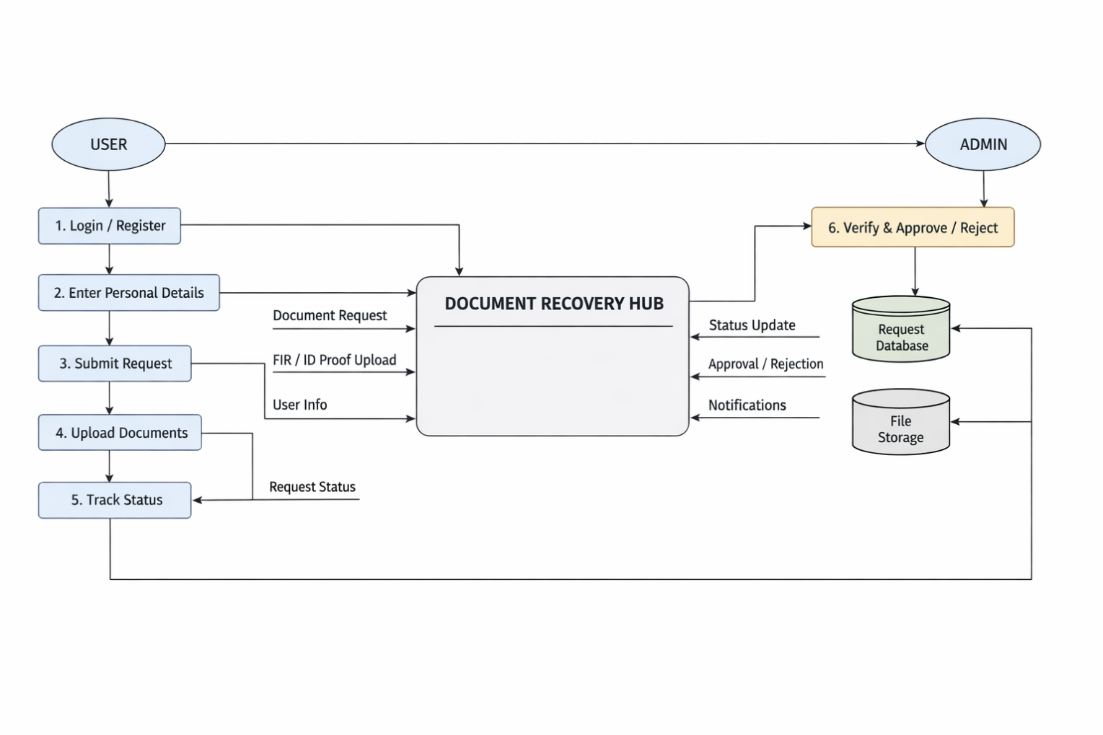

9.2 ER DIAGRAM

An Entity-Relationship (ER) Diagram is a graphical representation used in database design to illustrate the structure of a system by showing entities, their attributes, and the relationships between them.

It helps in understanding how data is stored, organized, and connected within a database. ER diagrams are mainly used during the system design phase to create an efficient and logical database structure.

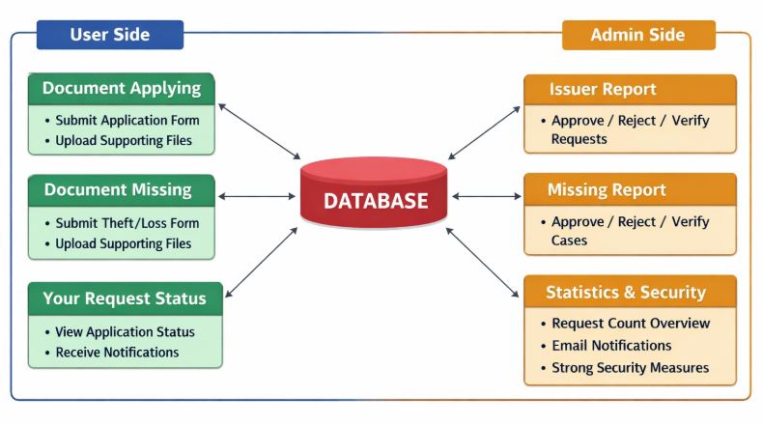

9.3 SAMPLE CODE

UserDashboard.jsx
import { useEffect, useState } from "react";
import DocumentApplyModal from "./DocumentApply";
import { useNavigate } from "react-router-dom";
import UserNavbar from "../../components/navbars/UserNavbar";
export default function UserDashboard() {
const navigate = useNavigate();
const [showApply, setShowApply] = useState(false);
useEffect(() => {
if (showRequests) {
fetch("/api/requests/user", {
headers: {
Authorization: `Basic ${localStorage.getItem("auth")}`,
},
})
.then((res) => res.json())
.then(setRequests);
}
}, [showRequests]);
return (
<>
<UserNavbar />
<div className="max-w-4xl w-full bg-white shadow-xl rounded-2xl p-10 text-center">
<h1 className="text-4xl font-bold text-gray-800 mb-4">
Welcome to Document Recovery Hub
</h1>
<p className="text-gray-600 text-lg mb-8">
Apply for government documents, recover lost certificates,
</p>
<div className="flex flex-wrap justify-center gap-6 mb-6">
<button
onClick={() => setShowApply(true)}
className="flex-1 min-w-[200px] bg-green-500 hover:bg-green-600 text-white px-8 py-3 rounded-xl shadow">
📄 Document Applying
</button>
onClick={() => alert("Document Missing feature coming soon")}
className="bg-yellow-500 hover:bg-yellow-600 px-8 py-3 rounded-xl shadow">
❓ Document Missing
</button> */}
<button
onClick={() => navigate("/user/missing-report")}
className="flex-1 min-w-[200px] bg-yellow-500 hover:bg-yellow-600 text-white px-8 py-3 rounded-xl shadow">
Document Missing
</button>
<button
onClick={() => navigate("/track")}
className="flex-1 min-w-[200px] bg-purple-500 hover:bg-purple-600 text-white px-8 py-3 rounded-xl shadow">
🔍 Track Missing Report
</button>
{showApply && (
<DocumentApplyModal onClose={() => setShowApply(false)} />
)}
{showRequests && (
<div className="fixed inset-0 bg-black/40 flex justify-center items-center z-50">
<div className="bg-white w-full max-w-2xl rounded-xl shadow-lg p-6 relative">
<button
onClick={() => setShowRequests(false)}
className="absolute top-3 right-4 text-xl font-bold">
✕
</button>
<h2 className="text-xl font-bold mb-4 text-center">
Your Document Requests
</h2>
<div className="max-h-[60vh] overflow-y-auto border rounded p-4 space-y-3">
{requests.length === 0 ? (
<p className="text-gray-500 text-center">
No document requests found.
</p>
) : (
requests.map((r) => (
<div
key={r.id}
className="p-3 border rounded hover:bg-gray-100">
<strong>{r.documentType}</strong> —{" "}
<span
className={
r.status === "APPROVED"
? "text-green-600"
: r.status === "REJECTED"
? "text-red-600"
: "text-yellow-600"
}>
{r.status}
</span>
</div>
))
)}
</div>
</div>
</div>
)}
</div>
</>
);}
AdminHome.jsx

import { useNavigate } from "react-router-dom";
import AdminNavbar from "../../components/navbars/AdminNavbar";
import {
Chart,
ArcElement,
Tooltip,
Legend,
CategoryScale,
LinearScale,
PointElement,
LineElement,
} from "chart.js";
export default function AdminHome() {
const navigate = useNavigate()
const [missingStats, setMissingStats] = useState(null);
const [issuerStats, setIssuerStats] = useState(null);
const [filter, setFilter] = useState("all");
const analyticsRef = useRef(null);
useEffect(() => {
axios
.get("/api/missing/admin/analytics")
.then((res) => setMissingStats(res.data))
.catch((err) => console.error(err));
axios
.get("/api/issuer/admin/analytics")
.then((res) => setIssuerStats(res.data))
.catch((err) => console.error(err));
}, []);
if (filter === "all" && missingStats && issuerStats) {
currentStats = {
total: missingStats.total + issuerStats.total,
approved: missingStats.approved + issuerStats.approved,
rejected: missingStats.rejected + issuerStats.rejected,
underVerification: missingStats.underVerification || 0,
pending: missingStats.pending + issuerStats.pending,
};
}
return (
<>
<AdminNavbar />

<div className="bg-gray-50">
{/* ================= HERO SECTION (FULL SCREEN) ================= */}

<section className="h-screen flex items-center justify-center px-6">
<div className="max-w-4xl w-full bg-white shadow-xl rounded-2xl p-12 text-center">
<h1 className="text-4xl font-bold text-gray-800 mb-4">
Welcome, Administrator 👋
</h1>

<p className="text-gray-600 text-lg mb-8">
As an administrator, you verify and manage issued document
requests, approve or reject applications, and monitor missing
document cases.
</p>

<div className="flex flex-col sm:flex-row justify-center gap-6">
<button
onClick={() => navigate("/admin/issuer-reports")}
className="bg-blue-600 hover:bg-blue-700 text-white px-8 py-4 rounded-xl shadow text-lg"
>
📊 Issuer Reports
</button>

<button
onClick={() => navigate("/admin/missing-reports")}
className="bg-yellow-500 hover:bg-yellow-600 text-white px-8 py-4 rounded-xl shadow text-lg"
>
🚨 Missing Reports
</button>
</div>

<button
onClick={scrollToAnalytics}
className="mt-8 bg-purple-600 hover:bg-purple-700 text-white px-8 py-3 rounded-xl shadow text-lg"
>
📈 System Analytics
</button>
</div>
</section>

{currentStats ? (
<>
{/* -------- STATISTICS CARDS -------- */}
<div className="grid grid-cols-2 md:grid-cols-4 gap-6 mb-10">
<div className="bg-blue-100 p-4 rounded-lg">
<h3 className="text-xl font-bold">{currentStats.total}</h3>
<p>Total</p>
</div>

<div className="bg-green-100 p-4 rounded-lg">
<h3 className="text-xl font-bold">{currentStats.approved}</h3>
<p>Approved</p>
</div>
<div className="bg-red-100 p-4 rounded-lg">
<h3 className="text-xl font-bold">{currentStats.rejected}</h3>
<p>Rejected</p>
</div>
<div className="bg-yellow-100 p-4 rounded-lg">
<h3 className="text-xl font-bold">
{currentStats.underVerification}
</h3>
<p>Under Verification</p>
</div>
</div>
{/* -------- EXPORT CSV -------- */}
<button
onClick={() => window.open("/api/missing/admin/export")}
className="mt-10 bg-purple-600 hover:bg-purple-700 text-white px-6 py-3 rounded-lg"
>
⬇ Export Reports (CSV)
</button>
</section>
</div>
</>
);
}

DocumentRequestController.java

package com.example.documenthub.controller;
import com.example.documenthub.entity.DocumentRequest;
import com.example.documenthub.entity.User;
import com.example.documenthub.dto.DocumentRequestDTO;
import com.example.documenthub.service.DocumentRequestService;
import org.springframework.http.ResponseEntity;
import org.springframework.web.bind.annotation.*;
import org.springframework.web.multipart.MultipartFile;
import java.io.IOException;
import java.nio.file.Path;
@RestController
@RequestMapping("/api/requests")
public class DocumentRequestController {
@Autowired
private DocumentRequestService requestService;
@PostMapping(consumes = "multipart/form-data")
public DocumentRequest createRequest(

@RequestParam String documentType,
@RequestParam(required = false) String reason,
@RequestParam(required = false) String applicantName,
@RequestParam(required = false) String phone,

@RequestParam(required = false) String firstName,
@RequestParam(required = false) String lastName,
@RequestParam(required = false) String dob,
@RequestParam(required = false) String addressLine1,
@RequestParam(required = false) String addressLine2,
@RequestParam(required = false) String city,
@RequestParam(required = false) String state,
@RequestParam(required = false) String zipCode,
@RequestParam(required = false) String email,
@RequestParam(required = false) String requestedBy,
@RequestParam(required = false) String schoolName,
@RequestParam(required = false) String grade,
@RequestParam(required = false) String collegeName,
@RequestParam(required = false) String registerNumber,
@RequestParam(required = false) String universityName,
@RequestParam(required = false) String department,
@RequestParam(required = false) String courseName,
@RequestParam(required = false) String deliveryMethod,
@RequestParam(required = false) String specialInstructions,
@RequestParam(value = "firCopy", required = false) MultipartFile firCopy,
@RequestParam(value = "idProof", required = false) MultipartFile idProof,
@RequestParam(value = "oldDocumentImage", required = false) MultipartFile oldDocumentImage
Principal principal
) throws IOException {
DocumentRequest request = new DocumentRequest();
request.setUser(user);
request.setApplicantName(applicantName);
request.setPhone(phone);
request.setReason(reason);
request.setDocumentType(documentType);
request.setFirstName(firstName);
request.setLastName(lastName);
request.setDob(dob);
request.setAddressLine1(addressLine1);
request.setAddressLine2(addressLine2);
request.setCity(city);
request.setState(state);
request.setZipCode(zipCode);
request.setEmail(email);
request.setRequestedBy(requestedBy);
request.setSchoolName(schoolName);
request.setGrade(grade);
request.setCollegeName(collegeName);
request.setRegisterNumber(registerNumber);
request.setUniversityName(universityName);
request.setDepartment(department);
request.setCourseName(courseName);
request.setDeliveryMethod(deliveryMethod);
request.setSpecialInstructions(specialInstructions);
request.setStatus("PENDING");
request.setCreatedAt(LocalDateTime.now());

if (idProof != null && !idProof.isEmpty()) {
Path filePath = uploadDir.resolve(idProof.getOriginalFilename());
idProof.transferTo(filePath);
request.setIdProof(idProof.getOriginalFilename());
}

if (oldDocumentImage != null && !oldDocumentImage.isEmpty()) {
Path filePath = uploadDir.resolve(oldDocumentImage.getOriginalFilename());
oldDocumentImage.transferTo(filePath);
request.setOldDocumentImage(oldDocumentImage.getOriginalFilename());
}

return requestService.createRequest(request)
@PutMapping("/{id}/status")
public DocumentRequest updateStatus(
@PathVariable Long id,
@RequestParam String status
) {
return requestService.updateRequestStatus(id, status);
}
@GetMapping("/user")
public List<DocumentRequest> getUserRequests(Principal principal) {
User user = userService.findByEmail(principal.getName())
.orElseThrow(() -> new RuntimeException("User not found"));
return requestService.getRequestsByUser(user);
}
@GetMapping("/{id}/fir-copy")
public ResponseEntity<byte[]> downloadFirCopy(@PathVariable Long id) {
DocumentRequest request = requestService.findById(id)
.orElseThrow(() -> new RuntimeException("Request not found"));
byte[] firData = request.getFirCopy();
if (firData == null || firData.length == 0) {
return ResponseEntity.notFound().build();
}
return ResponseEntity.ok()
.header(
HttpHeaders.CONTENT_DISPOSITION,
"attachment; filename=fir_request_" + id + ".pdf"
)
.contentType(MediaType.APPLICATION_PDF)
.body(firData);
}
@GetMapping("/{id}/id-proof")
public ResponseEntity<Resource> downloadIdProof(@PathVariable Long id) throws IOException {
DocumentRequest request = requestService.findById(id)
.orElseThrow(() -> new RuntimeException("Request not found"));
String fileName = request.getIdProof();
if (fileName == null) {
throw new RuntimeException("ID Proof not found");
}
Path filePath = Paths.get("uploads").resolve(fileName);
Resource resource = new UrlResource(filePath.toUri());
String contentType = java.nio.file.Files.probeContentType(filePath);
if (contentType == null) {
contentType = "application/octet-stream";
}
return ResponseEntity.ok()
.contentType(MediaType.parseMediaType(contentType)) // ✅ IMPORTANT
.header(HttpHeaders.CONTENT_DISPOSITION,
"attachment; filename=\"" + fileName + "\"")
.body(resource);
}
@GetMapping("/{id}/old-document")
public ResponseEntity<Resource> downloadOldDocument(@PathVariable Long id) throws IOException {
DocumentRequest request = requestService.findById(id)
.orElseThrow(() -> new RuntimeException("Request not found"));
String fileName = request.getOldDocumentImage();
if (fileName == null) {
throw new RuntimeException("Old document not found");
}
Path filePath = Paths.get("uploads").resolve(fileName);
Resource resource = new UrlResource(filePath.toUri());
return ResponseEntity.ok()
.contentType(MediaType.parseMediaType(contentType)) // ✅ IMPORTANT
.header(HttpHeaders.CONTENT_DISPOSITION,
"attachment; filename=\"" + fileName + "\"")
.body(resource);
}
@GetMapping("/admin/request/{id}")
public ResponseEntity<Map<String, Object>> getRequestDetails(@PathVariable Long id) {
DocumentRequest request = requestService.findById(id)
.orElseThrow(() -> new RuntimeException("Request not found"));
Map<String, Object> response = new HashMap<>();
response.put("firstName", request.getFirstName());
response.put("lastName", request.getLastName());
response.put("dob", request.getDob());
response.put("addressLine1", request.getAddressLine1());
response.put("addressLine2", request.getAddressLine2());
response.put("city", request.getCity());
response.put("state", request.getState());
response.put("zipCode", request.getZipCode());
response.put("email", request.getEmail());
response.put("phone", request.getPhone());
response.put("requestedBy", request.getRequestedBy());
response.put("schoolName", request.getSchoolName());
response.put("grade", request.getGrade());
response.put("collegeName", request.getCollegeName());
response.put("registerNumber", request.getRegisterNumber());
response.put("universityName", request.getUniversityName());
response.put("department", request.getDepartment());
response.put("courseName", request.getCourseName());
response.put("reason", request.getReason());
response.put("documentType", request.getDocumentType());
response.put("deliveryMethod", request.getDeliveryMethod());
response.put("specialInstructions", request.getSpecialInstructions());
return ResponseEntity.ok(response);
}}

9.4 SAMPLE SCREENSHOTS

SAMPLE INPUT

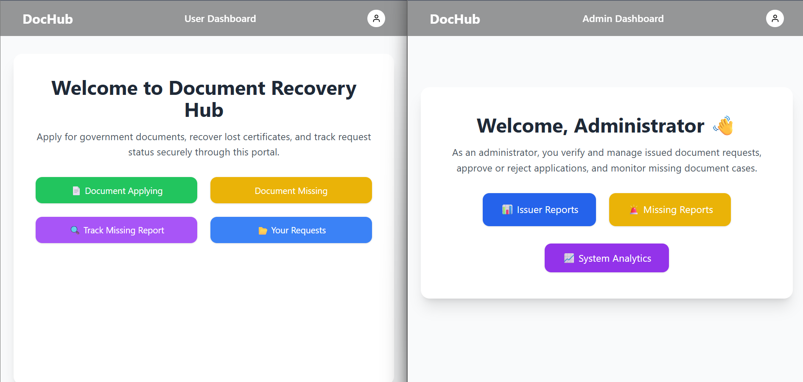

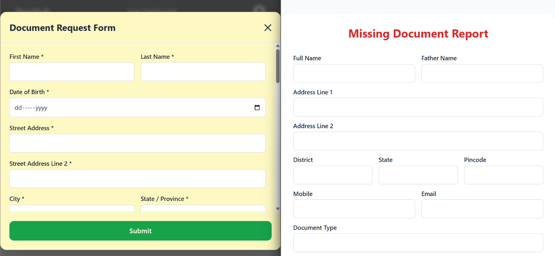

SAMPLE OUTPUT

