Schedule Task : Cron Command

What is cron Command?
The cron tool allows Linux users to execute commands or scripts at a specific date and time. It is very useful to perform regular tasks such as backups, daily scans, /tmp directory cleanup, and restarting the system at a given time.
cron executes scheduled jobs automatically in the background at the specified time. Each user can have their own crontab, stored under /var/spool/cron/username.
Cron jobs can be allowed or disallowed for specific users by adding their username to the 'cron.allow' or 'cron.deny' files.

1. Cron Package Installation
# yum install cronie (or) # yum install crontabs
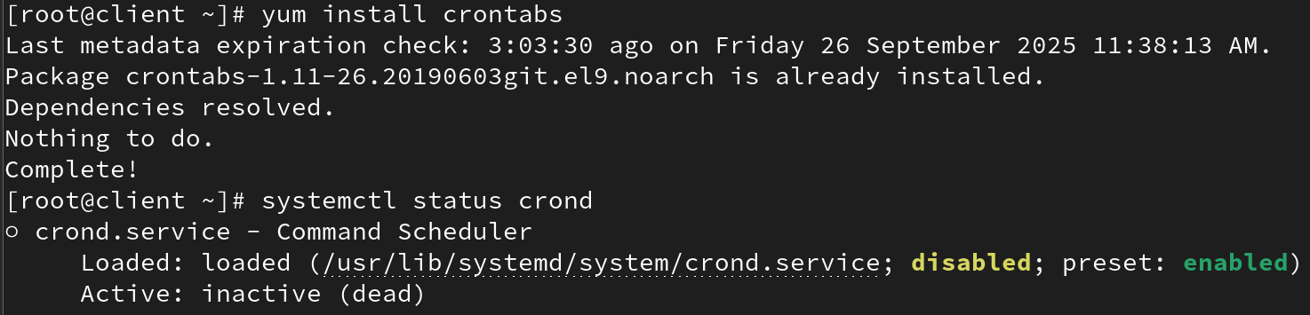

Service Name
The service that runs cron jobs is called crond.
Check its status with:
systemctl status crond
It should show Active: active (running).
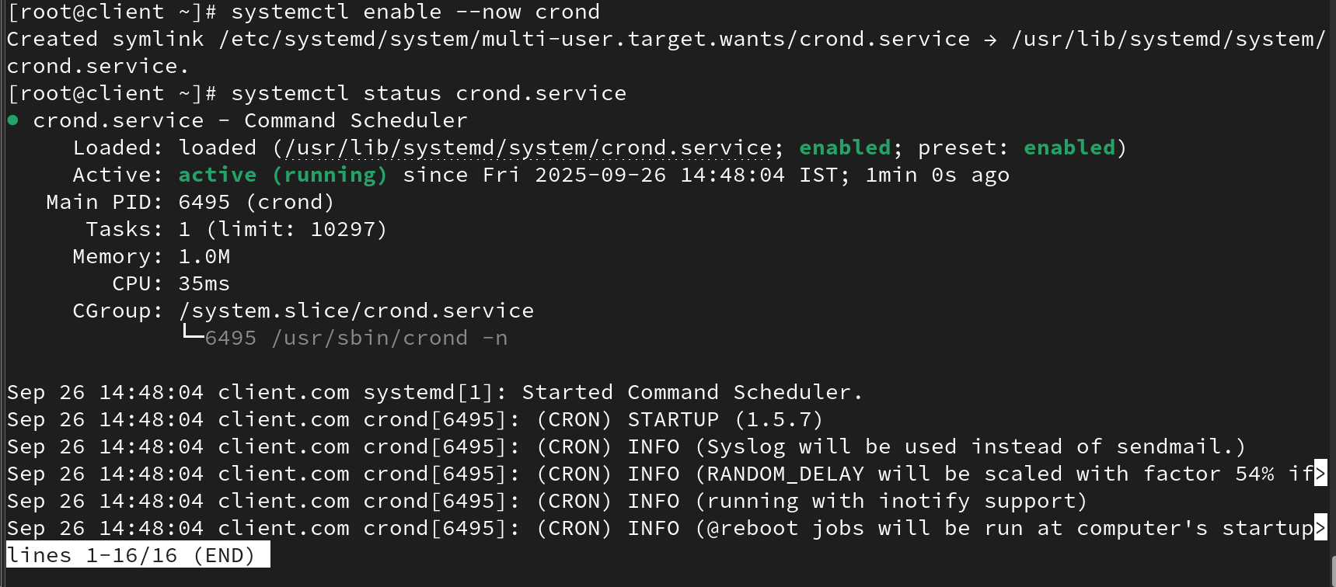
And create edit script file
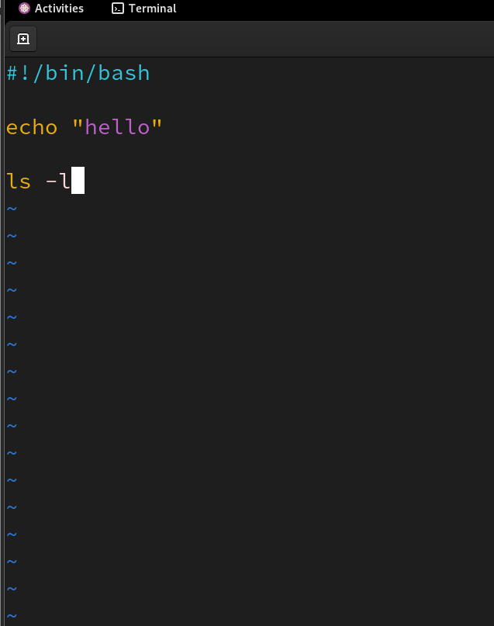

Now give executable permission to the script file
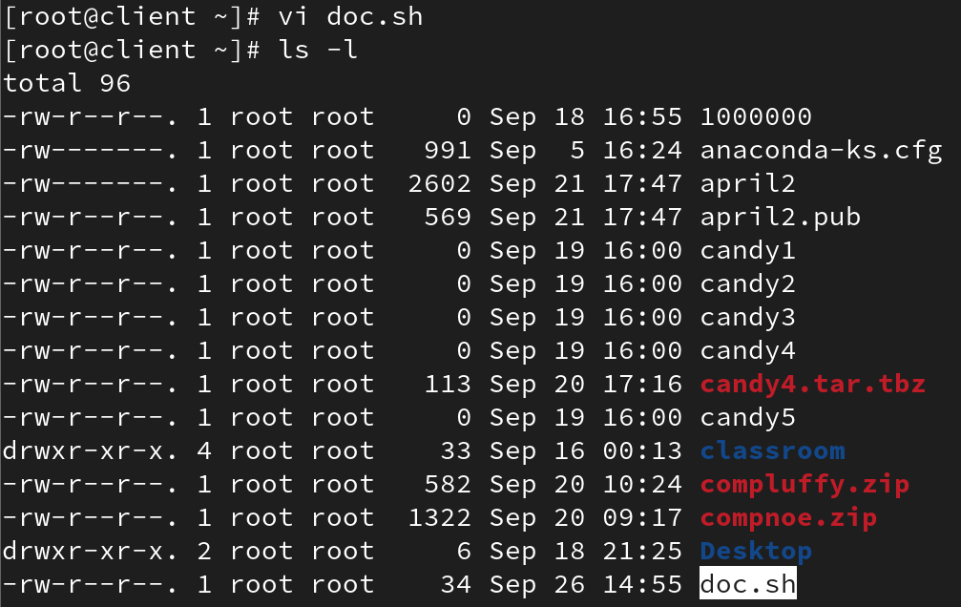
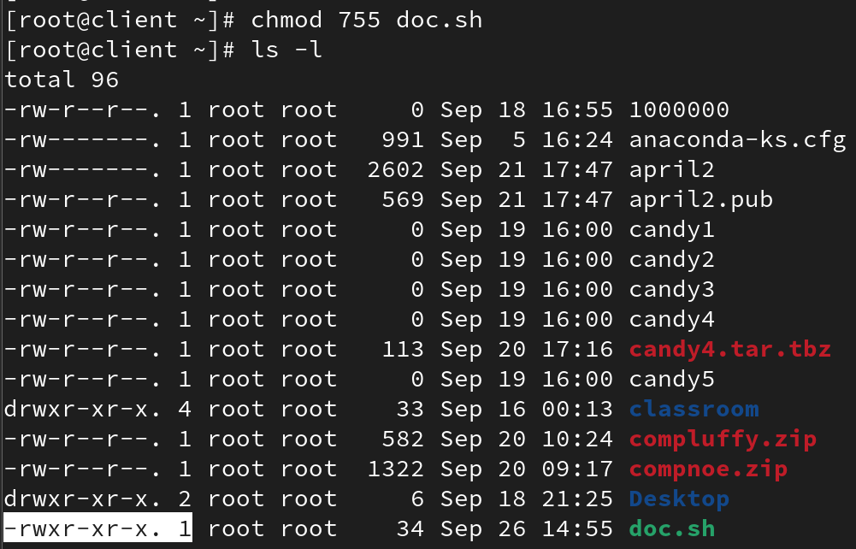

And now run the script fie:
To run a script file
# ./scriptfile
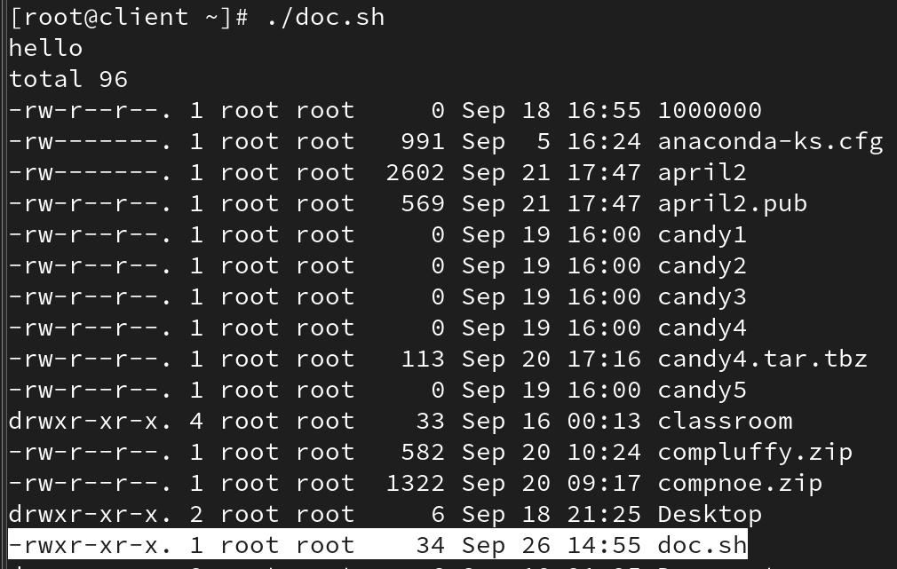

Edit Crontab Entries
Use: crontab -e
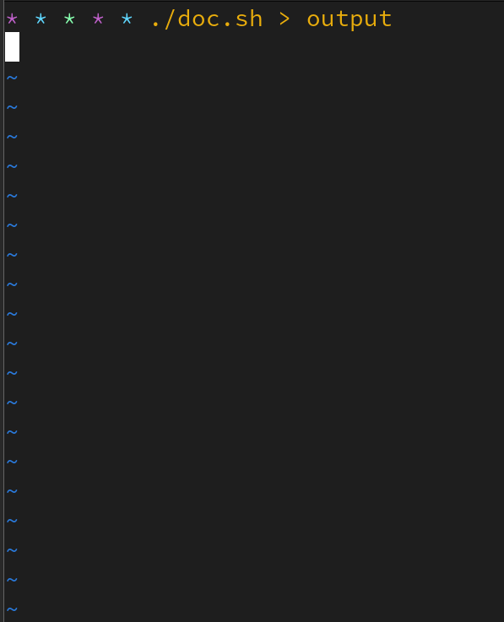
Example entries:
* * * * * script.sh > /tmp/script_out – runs every minute
*/5 * * * * – runs every 5 minutes
0 10 * * * – runs every day at 10:00
30 1 * * * – runs daily at 01:30
30 1,4,5 1-10 * * – runs at 01:30 on days 1–10 of the month and also at 04:30 and 05:30 during those days
Special strings:
@daily – once per day
@reboot – on system startup
@hourly – once per hour
@yearly – once per year

List Existing Cron Jobs
crontab -l
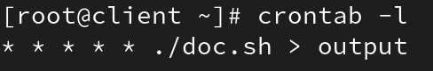

Remove Crontab Entry
crontab -r

And run scheduled scriptfile
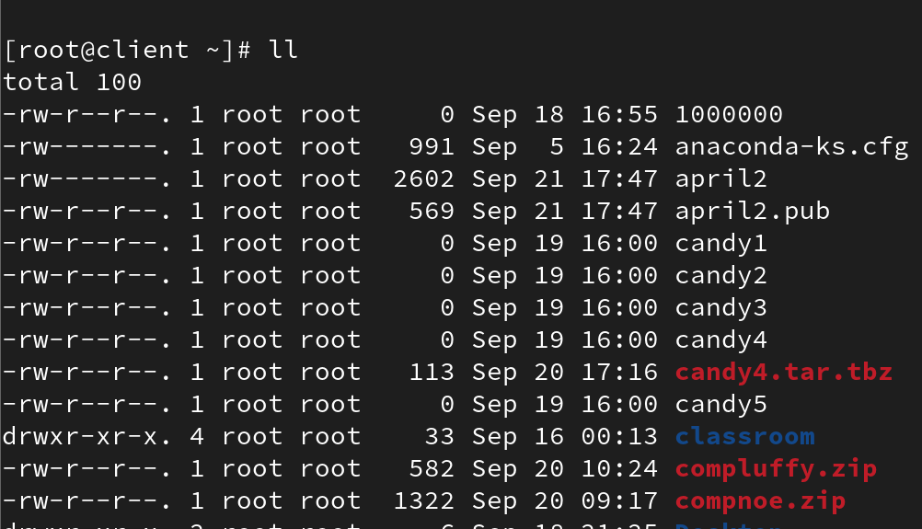
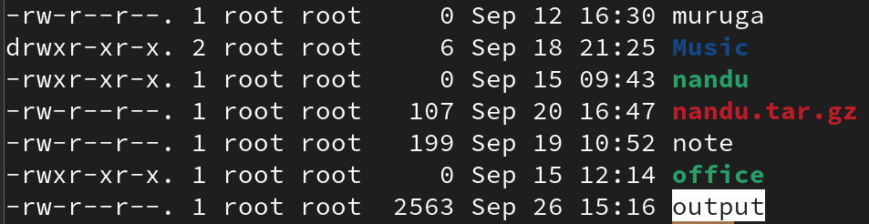

To view live process:
# watch cat scriptfilename
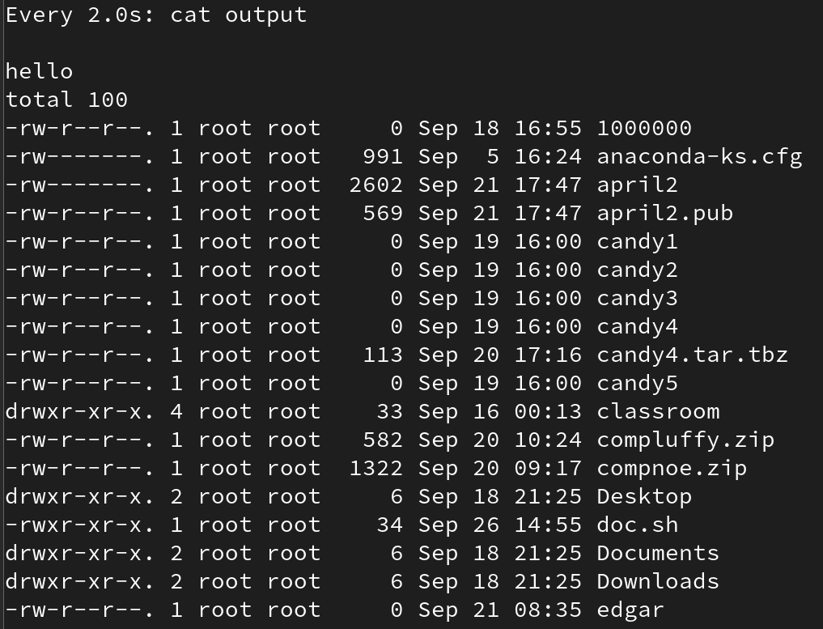

Edit Crontab for a Different User
crontab -u username -e # edit
crontab -u username -r # remove
crontab -u username -l # list

General Syntax of a Cron Job
MIN HOUR DayOfMonth Month DayOfWeek Command
0-59 0-23 1-31 1-12 0-6 Any Linux command or script

Important Notes
- User crontab files are stored in /var/spool/cron/username.
- Cron jobs run using the system timezone. Ensure it matches your expectation.
- If the user account or password is expired, cron jobs for that user will not run.
- If the crond service is stopped, cron jobs will not run.
- If the /var filesystem reaches 100% usage, cron jobs will fail because cron cannot write logs or PID files.

