Logs
Linux maintains various log files to help administrators track system activities and troubleshoot issues. Below is an explanation of some common log files and their purposes:
- /var/log/messages: This is the primary log file that records a wide range of system events, including boot messages, service startup and shutdown, and general system errors.
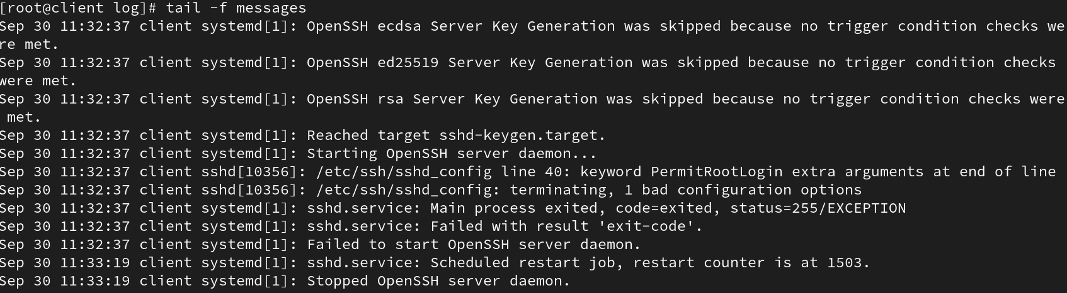

- /var/log/secure: Keeps track of security-related events, such as authentication attempts (successful and failed), sudo usage, and other security-related messages.

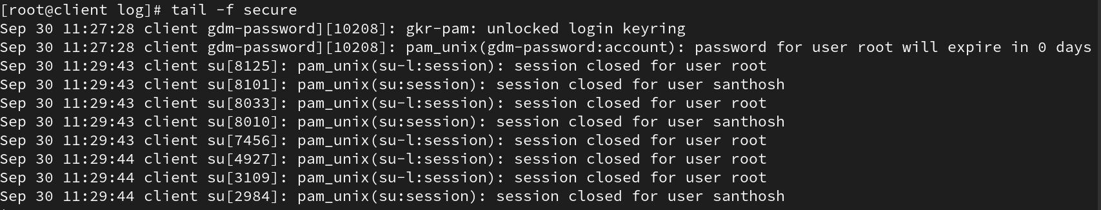

- /var/log/cron: Contains logs generated by the cron daemon, which schedules and executes periodic tasks.

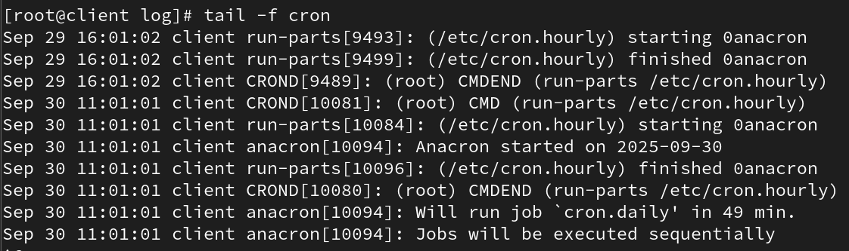

- /var/log/dmesg: Contains kernel ring buffer messages, useful for diagnosing hardware and driver issues.

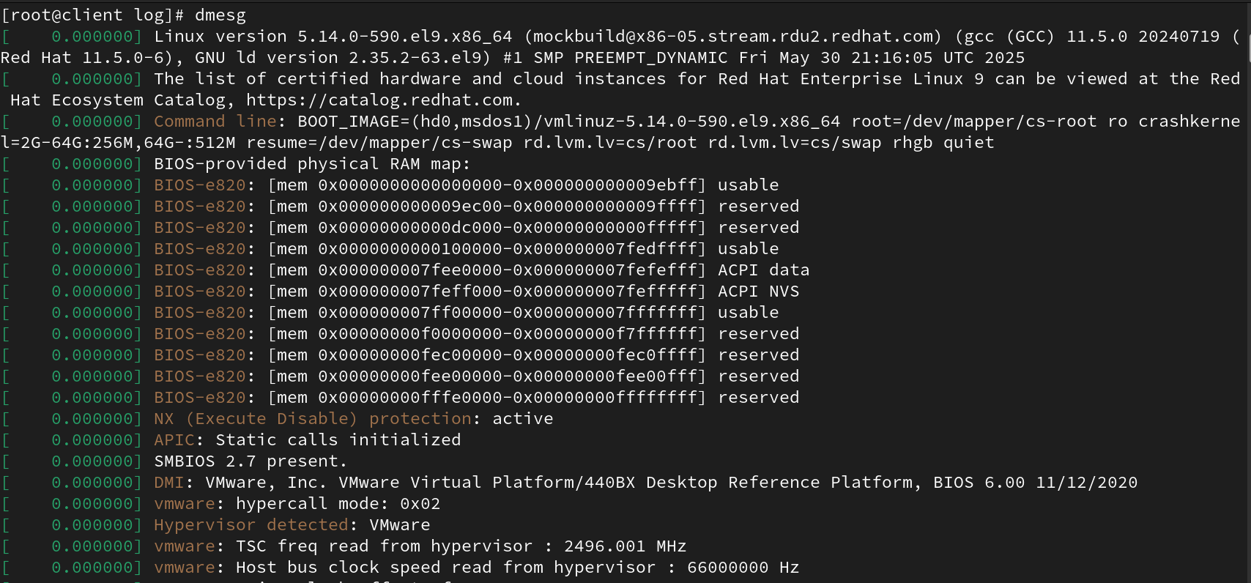

- /var/log/boot.log: Captures messages related to system boot processes, including the startup of various services.

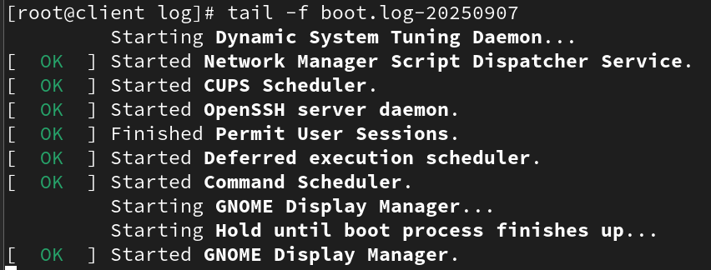

- /var/log/yum.log: Tracks package installation, updates, and removal activities performed using the YUM package manager.

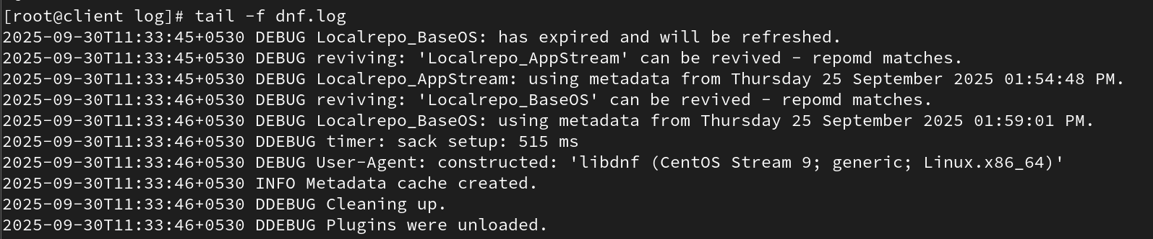

- /var/log/audit/audit.log: Stores audit logs generated by the Linux Auditing System for security auditing and monitoring.

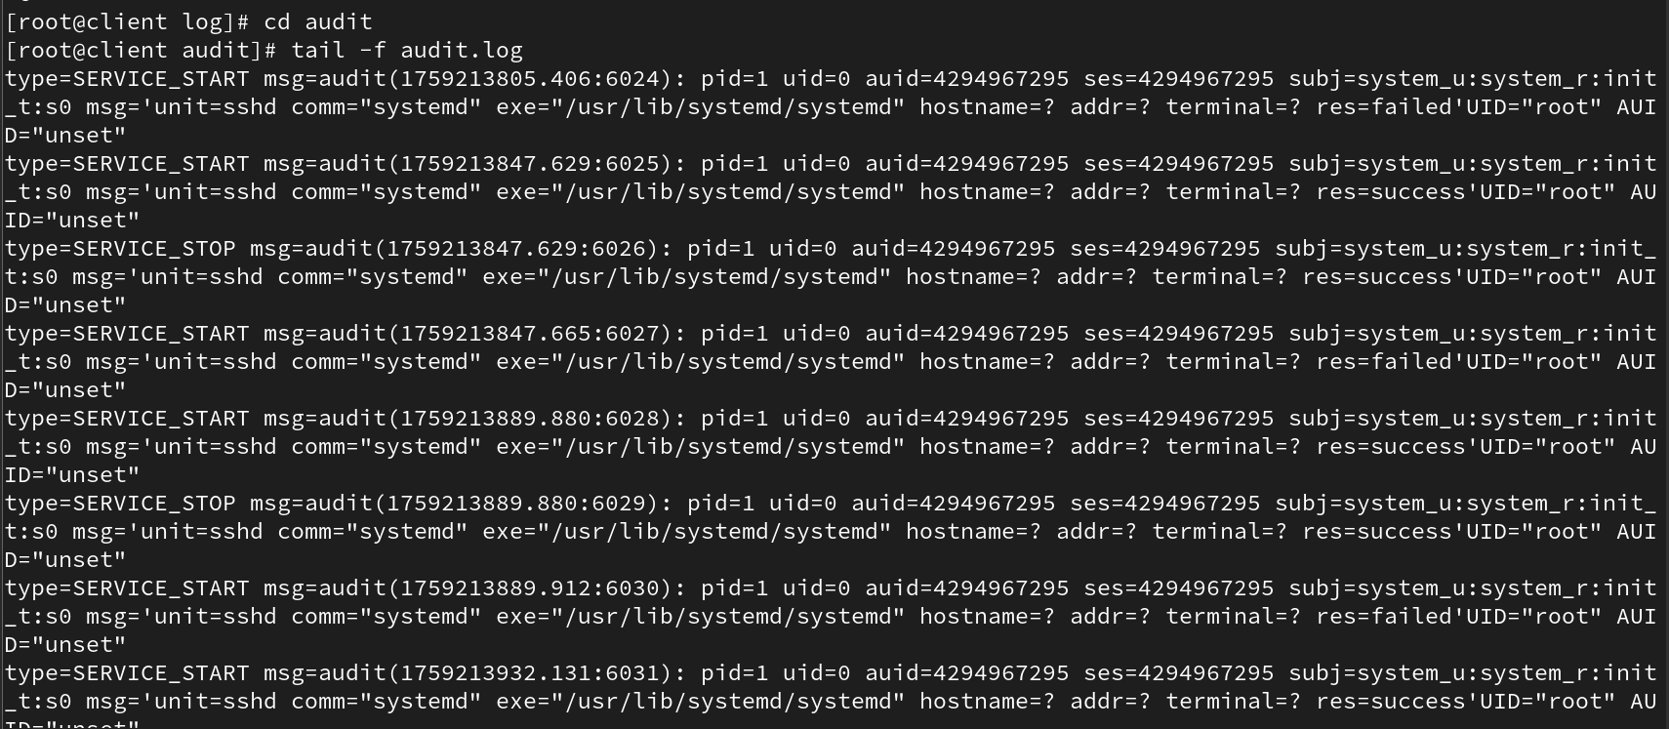

- /var/log/httpd/: Directory containing log files for the Apache web server, including access logs and error logs.

- /var/log/maillog: Logs related to the mail server, including messages sent and received, errors, and other mail server activities.
- /var/log/lastlog: Records the last login time of each user. This is not a regular text file but can be viewed using the 'lastlog' command.

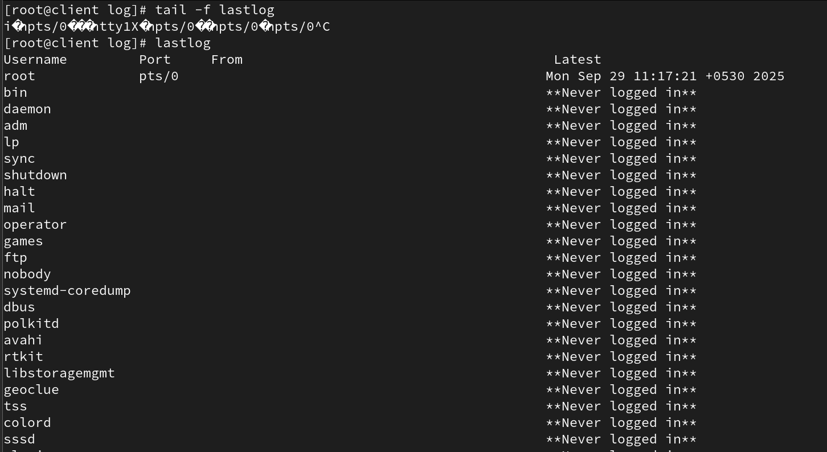

- /var/log/btmp: Records failed login attempts. This is a binary file and can be viewed using the 'lastb' command.

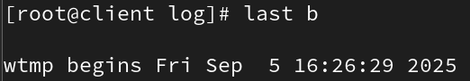

- /var/log/wtmp: Records login and logout events. This binary file can be viewed using the 'last' command.

