Networking

IP Address Classes
Class A – Classful subnet mask is /8. Provides 16,777,216 possible IP addresses (2^24).
Class B – Classful subnet mask is /16. Provides 65,536 possible IP addresses.
Class C – Classful subnet mask is /24. Provides 256 possible IP addresses.

Set Dynamic IP Address
Steps:
1. Select VM → Settings → Add Network Adapter.
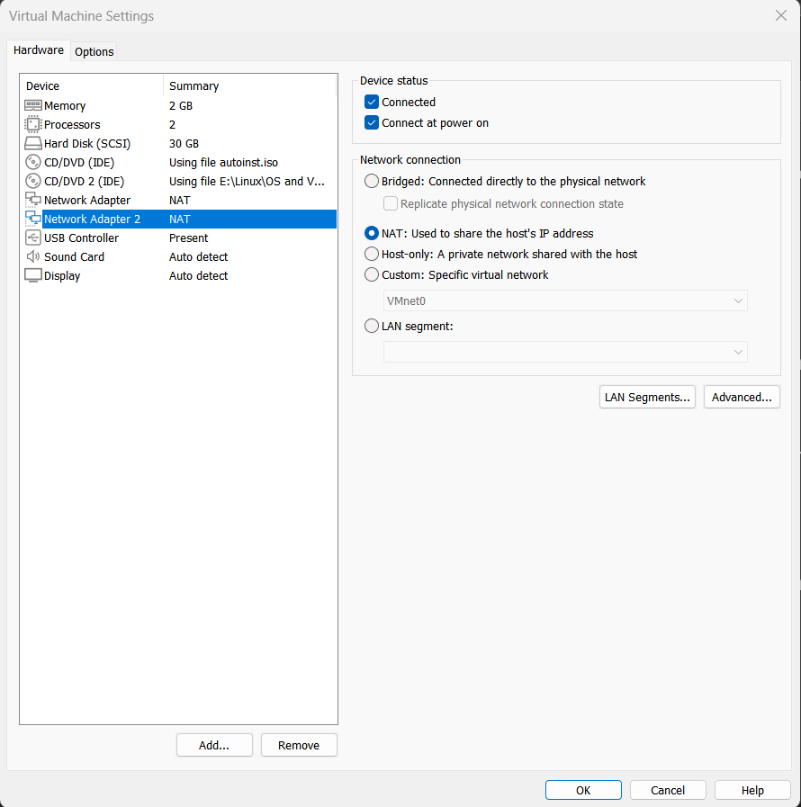
2. Check the interface name:
# ifconfig or #ip a
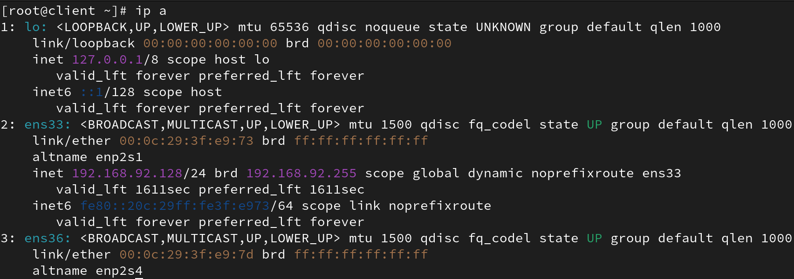
# nmcli device show
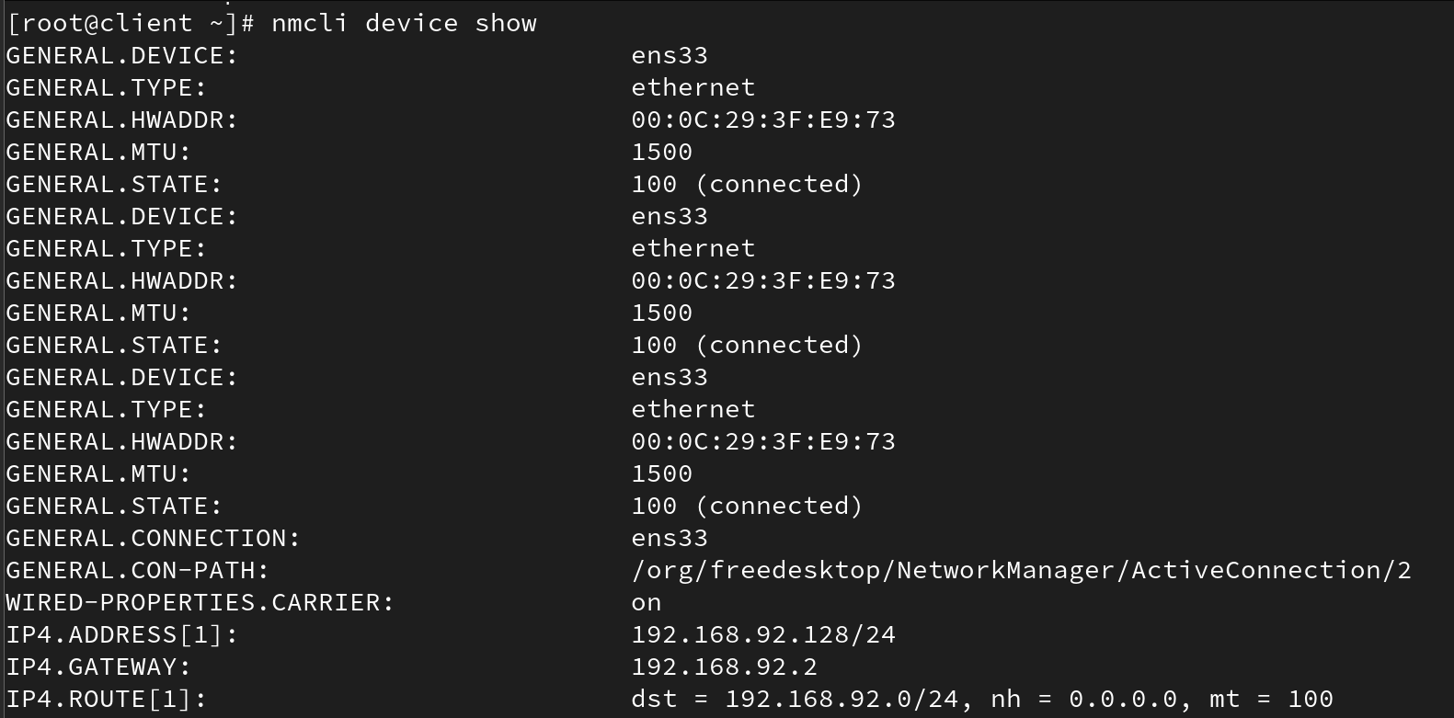
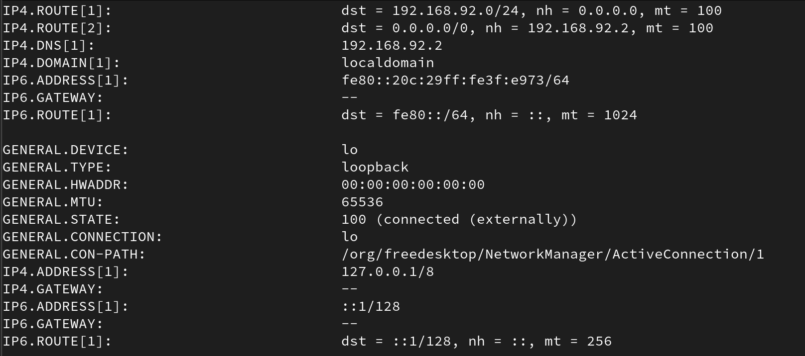
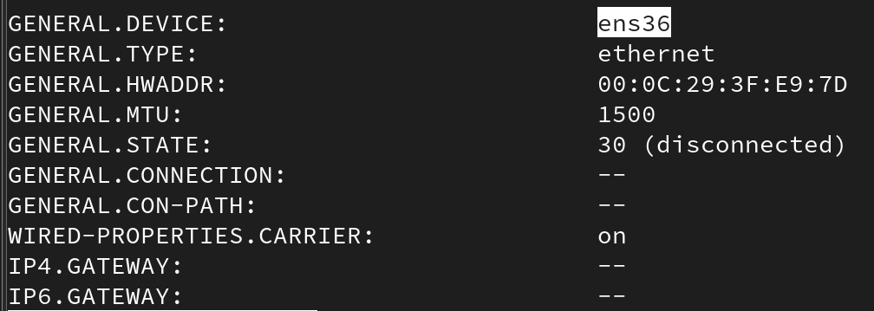
3. Connect the interface:
# nmcli device connect ens36
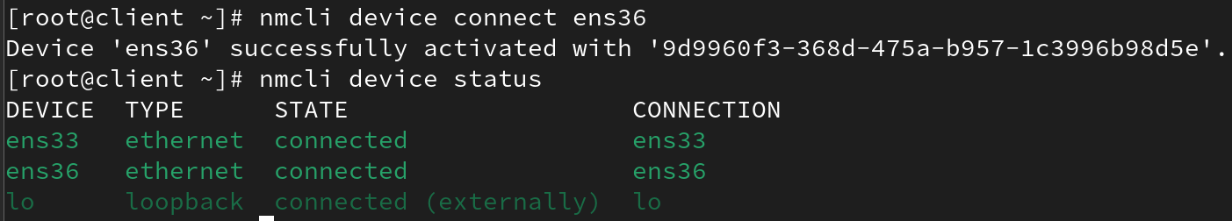

Set Static IP Address
Steps:
1. Select VM → Settings → Add Network Adapter.
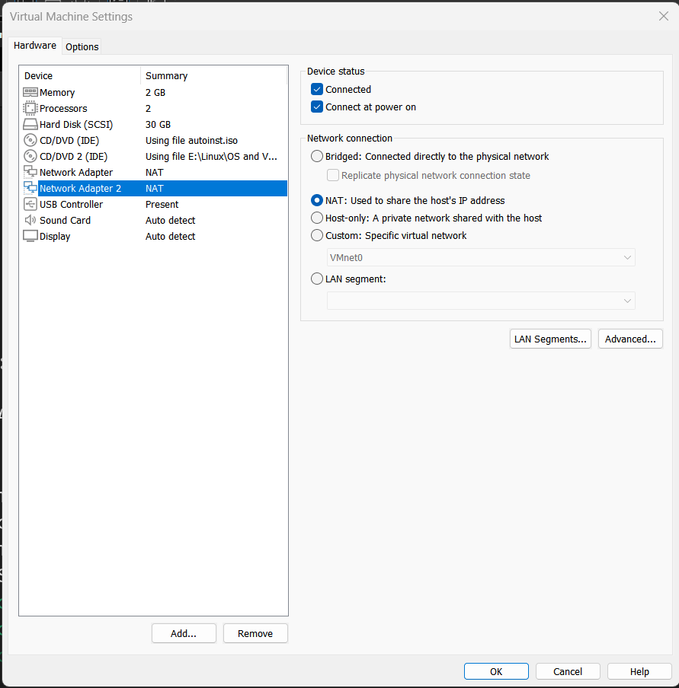
2. Check the interface name:
# ifconfig or #ip a
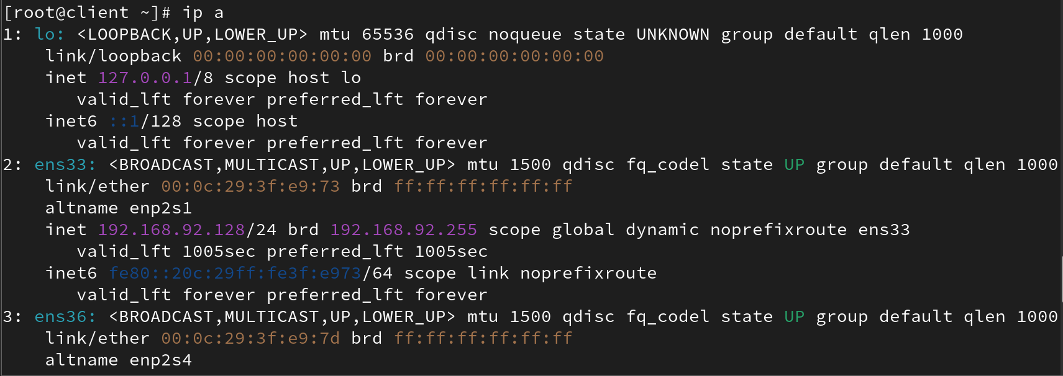
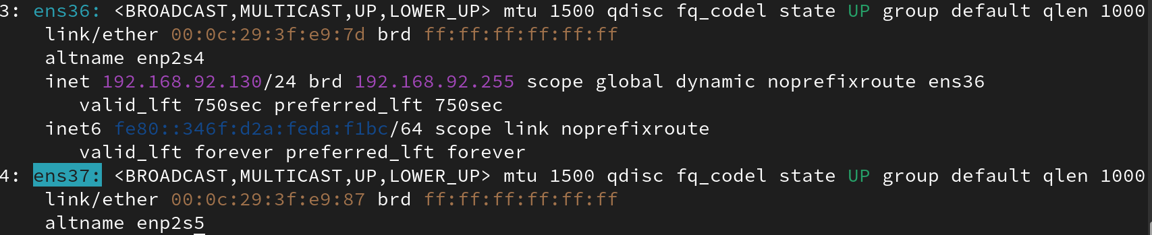
# nmcli device show
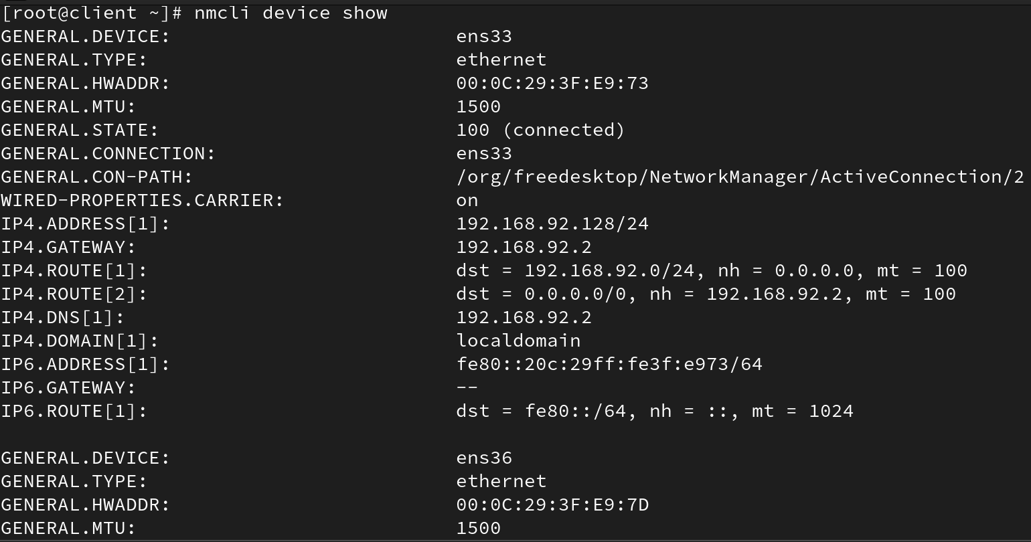
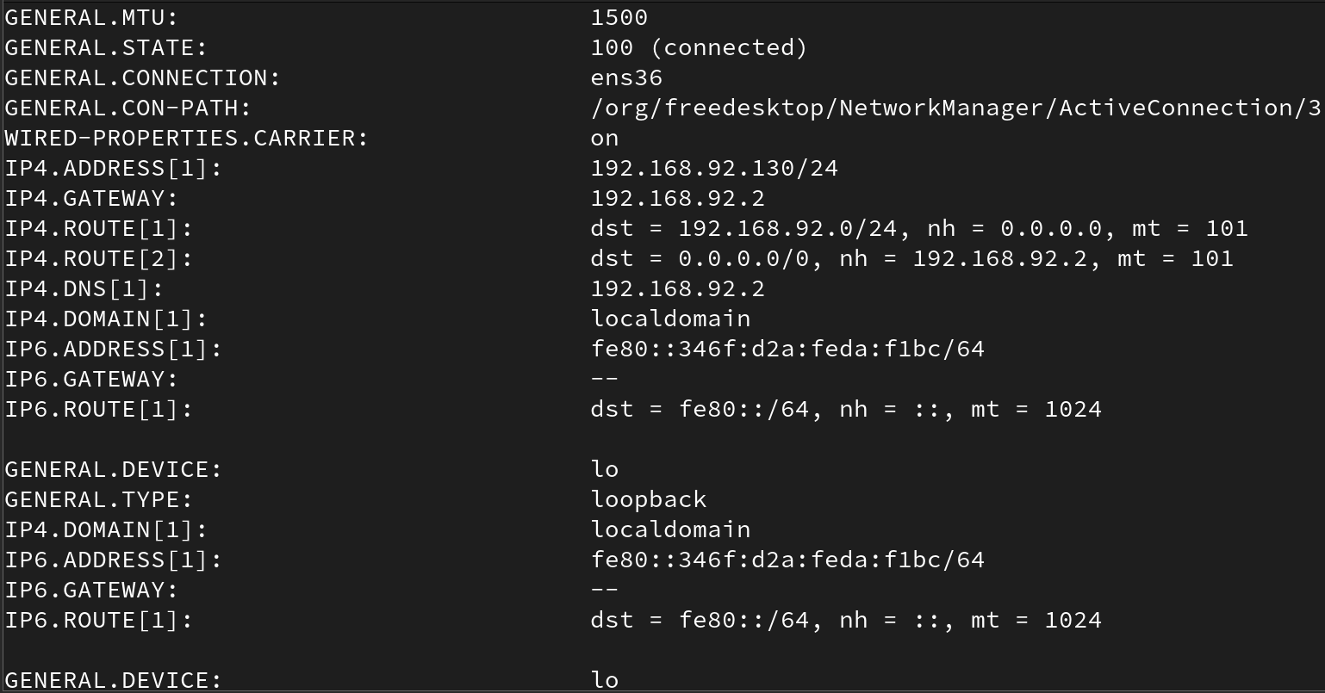
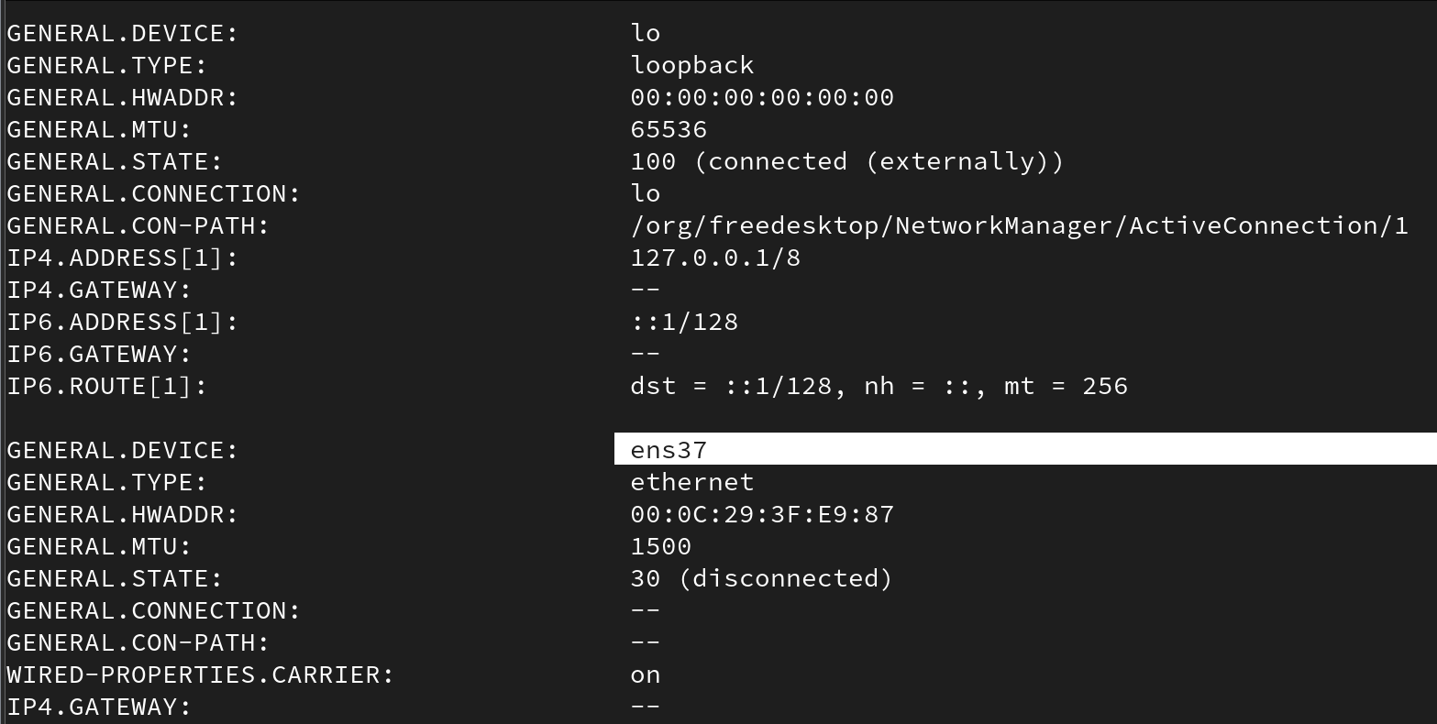
# nmcli connection status
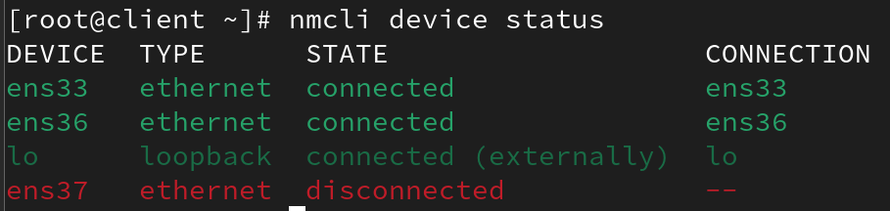

#nmcl device status
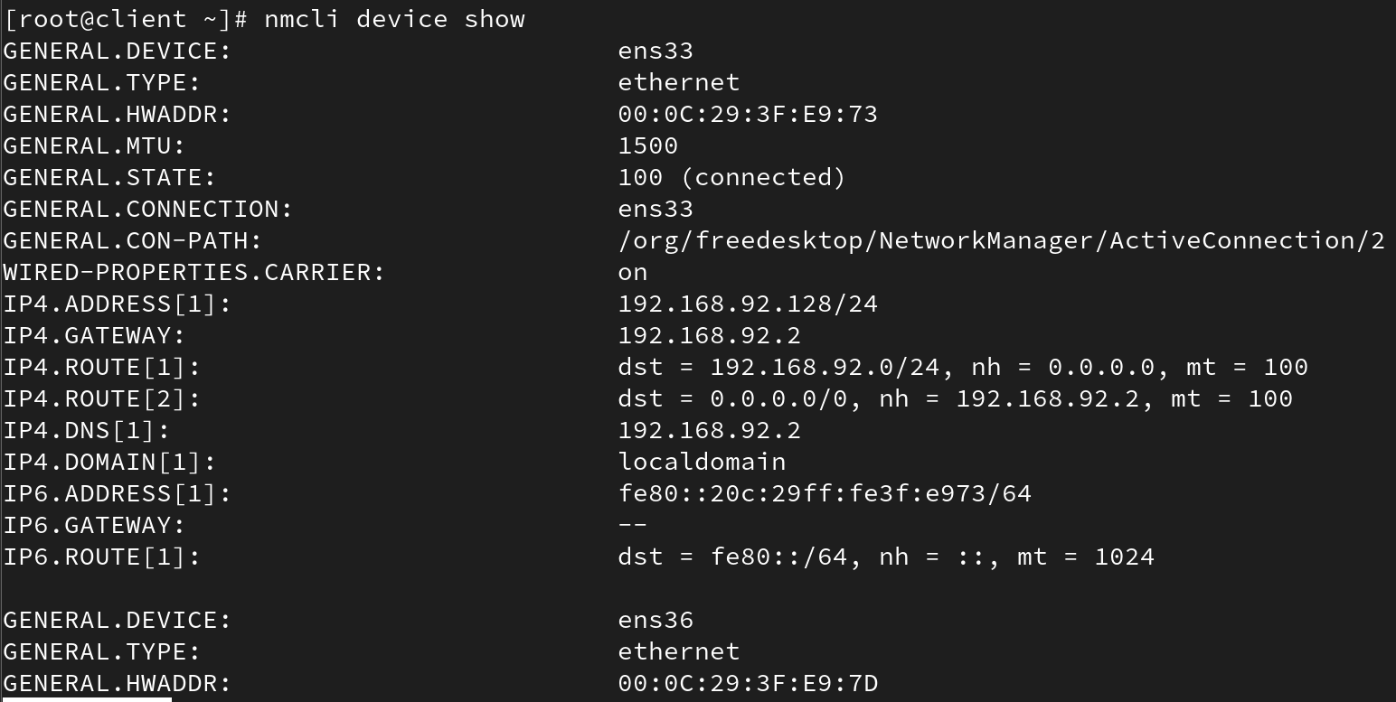
3. Add static IP configuration:
# nmcli con add type ethernet con-name ens160 ifname ens160 ipv4.addresses 192.168.159.51/24 ipv4.gateway 192.168.0.1 autoconnect yes ipv4.method manual
# nmcli con add type ethernet con-name ens160 ifname ens160 ip4 192.168.159.51/24 gw4 192.168.0.1 autoconnect yes ipv4.method manual
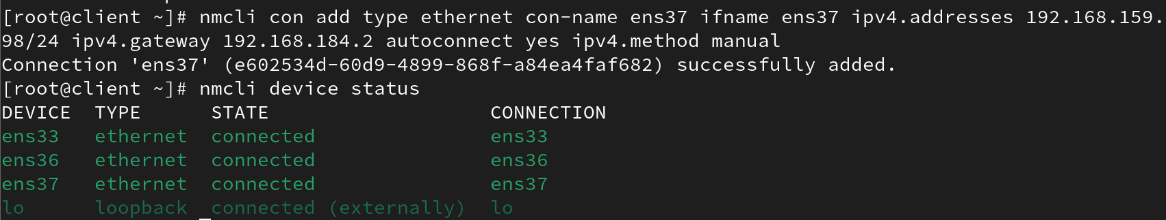

#nmcl device show
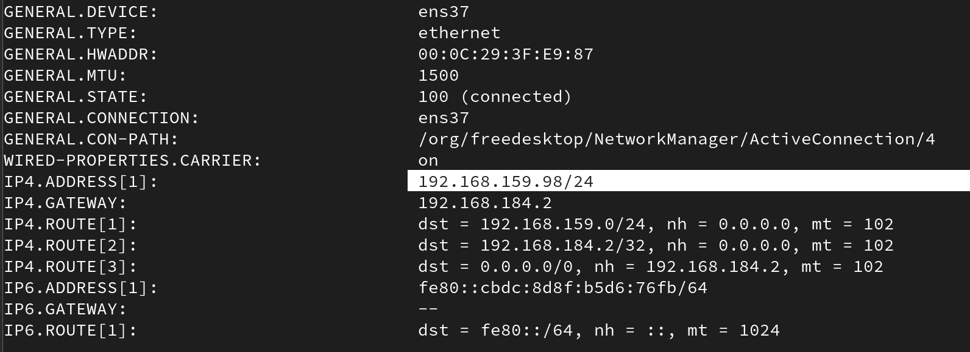

Command to Check Gateway
# netstat -rn
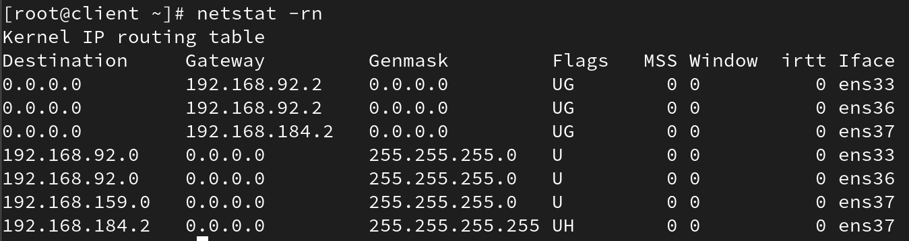
# route -n
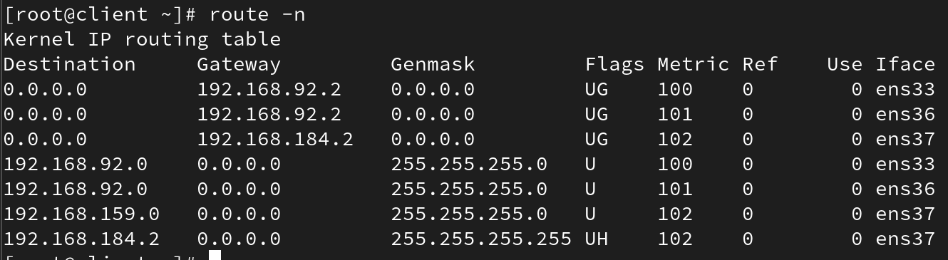

To list ports:
#netstat -pultan
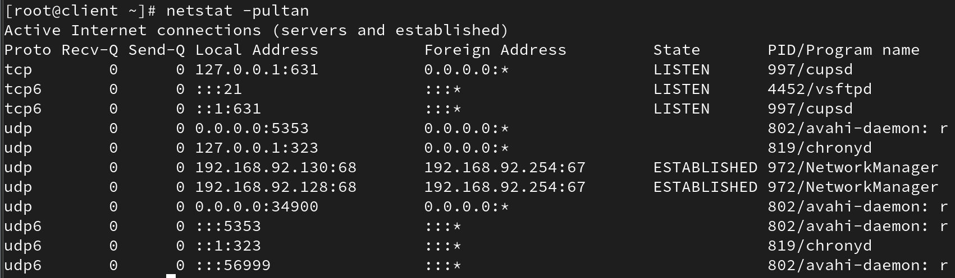

Connection Modify

You have to disconnect the nat before modify
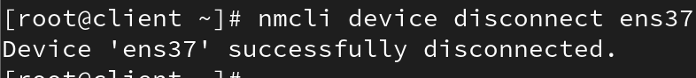
To modify connection parameters:
# nmcli con modify ens160 ipv4.addresses 192.168.2.100/24
# nmcli con mod ens160 ipv4.gateway 192.168.2.1
# nmcli con mod ens160 ipv4.dns 8.8.8.8
# nmcli con mod ens160 ipv4.method manual
# nmcli con mod ens160 connection.autoconnect yes
Or combine in one command:
# nmcli con modify ens160 ipv4.addresses 192.168.2.100/24 ipv4.gateway 192.168.2.1 ipv4.method manual connection.autoconnect yes
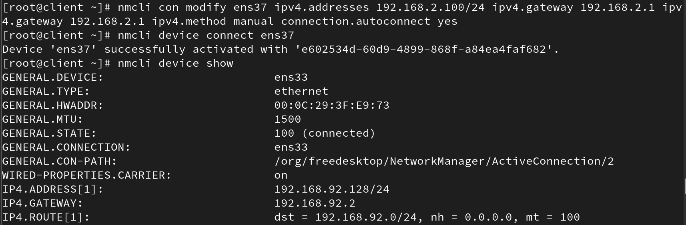
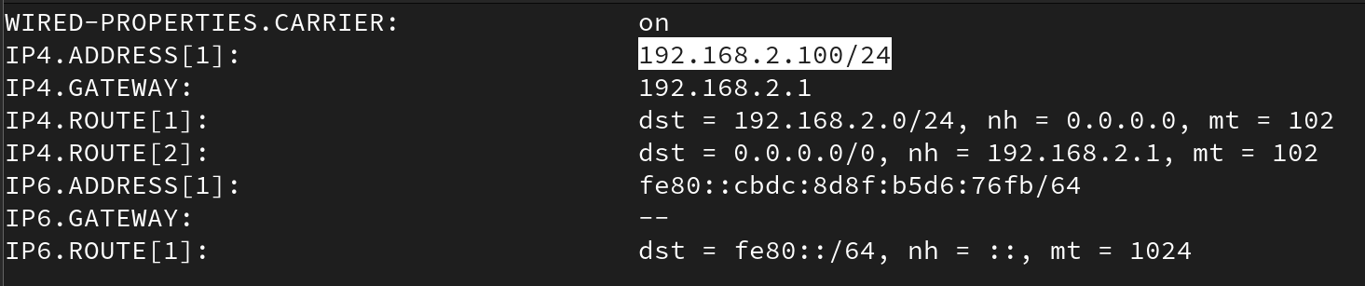

To Monitor IP Packets: iptraf-ng
iptraf-ng is a console-based network monitoring utility for Linux that provides real-time statistics of network traffic. It displays data like current connections, protocol distribution, and network interface statistics. It's useful for troubleshooting, performance monitoring, and identifying unusual network activity.
Usage:
1. Install the tool: # yum install iptraf-ng
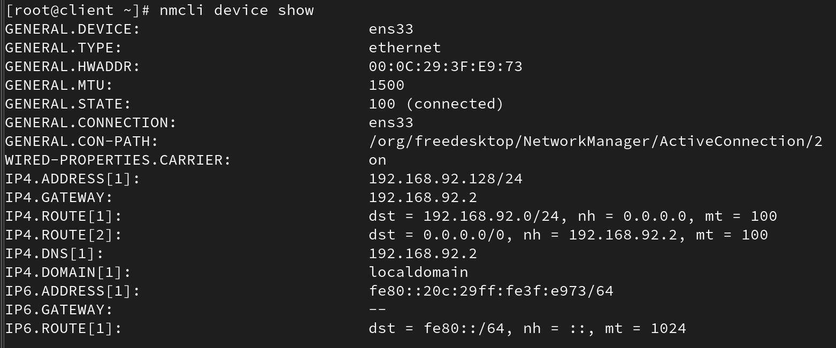
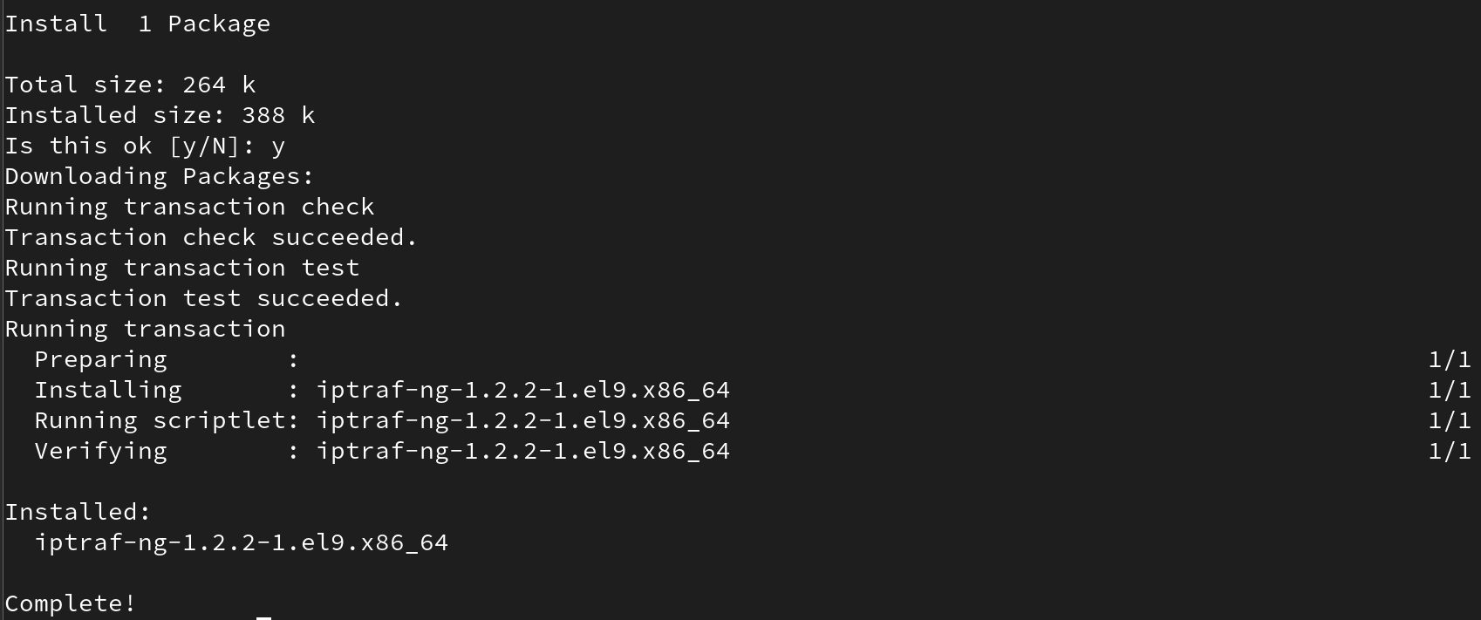
2. Run the command: # iptraf-ng

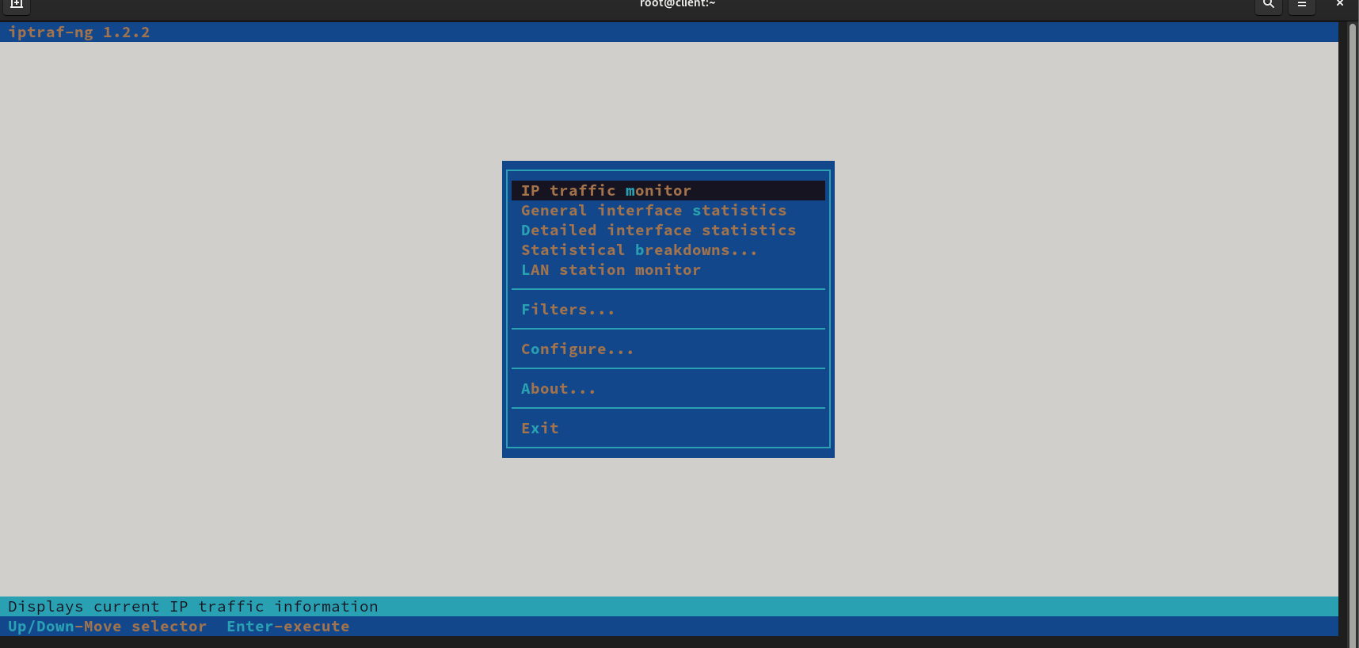
3. Use the interactive interface to select interfaces and view detailed traffic information.
#nmtui
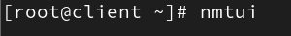
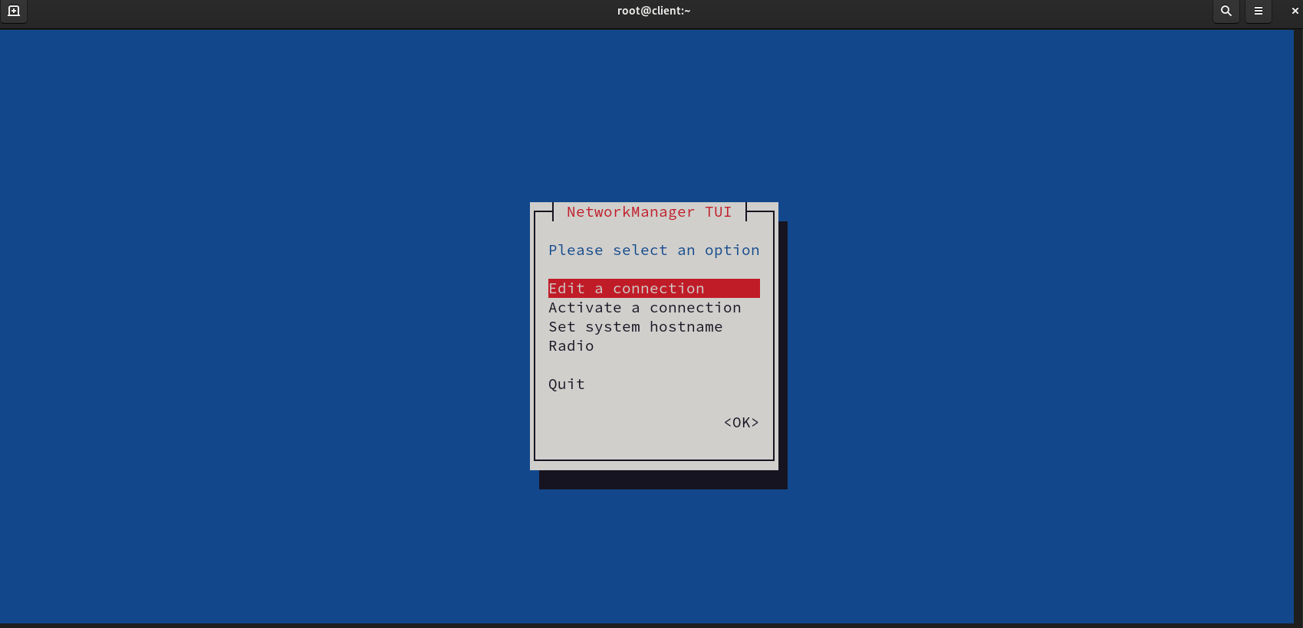
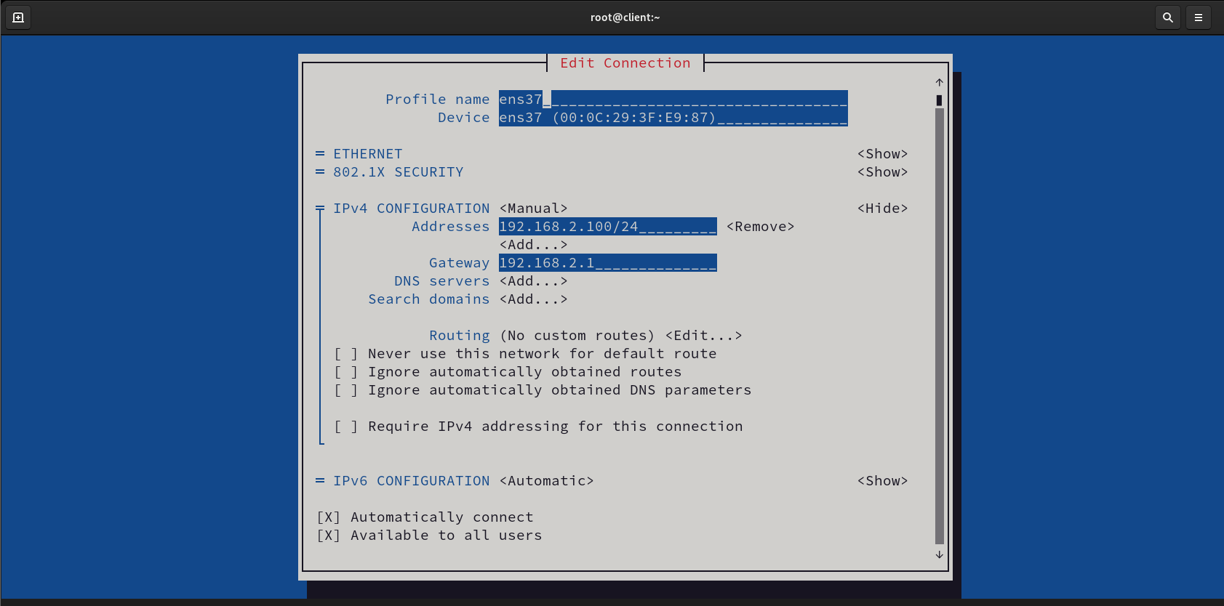
. Use the interactive interface to select interfaces and view detailed traffic information

