SSH

SSH (Secure Shell or Secure Socket Shell)
SSH is a protocol used to securely connect to remote servers. The default port number is 22.
Commands to view IP address:
• ip a
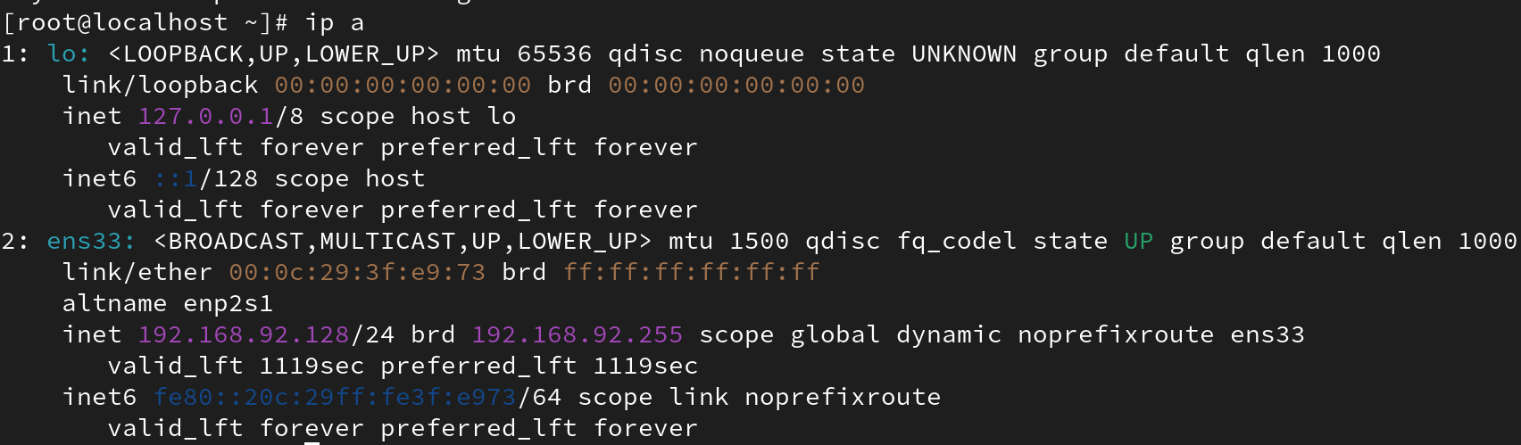

• ifconfig
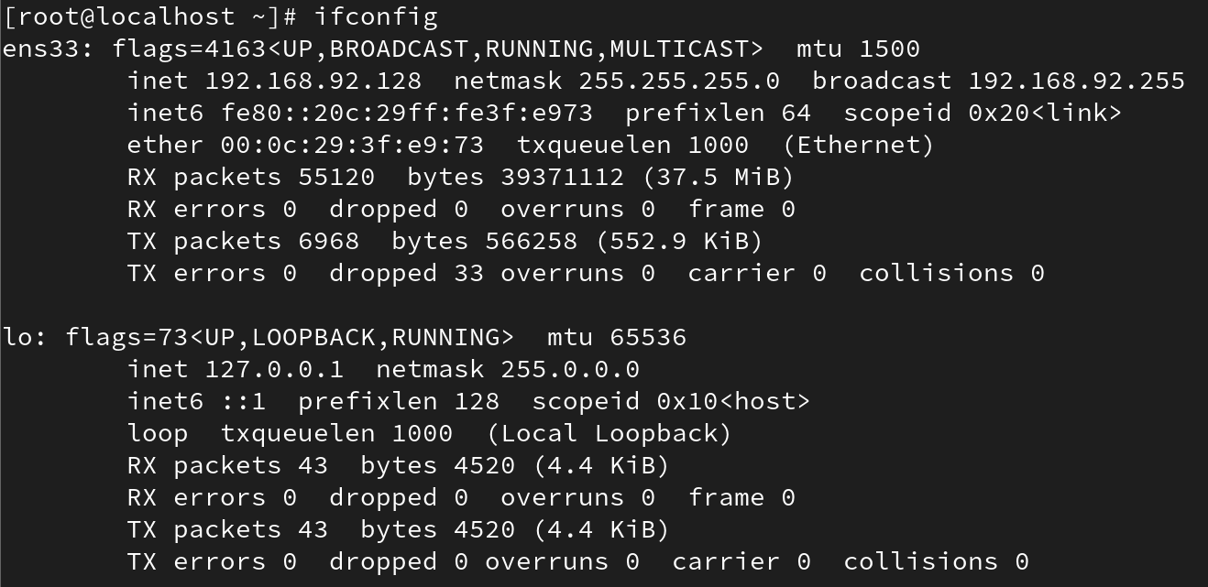
• ip addr
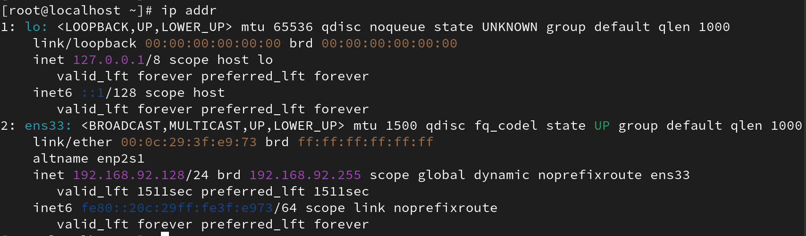
To change hostname:
# hostnamectl set-hostname <new-hostname>
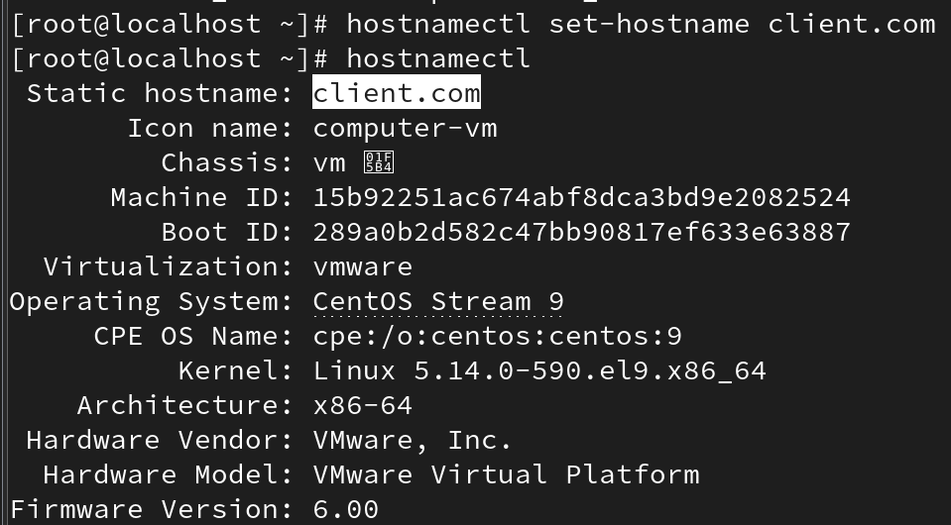
Important configuration files:
• /etc/ssh/sshd_config
• /etc/ssh/ssh_config
To change the port number or other configuration settings,
#vi /etc/ssh/sshd_config and restart the service:
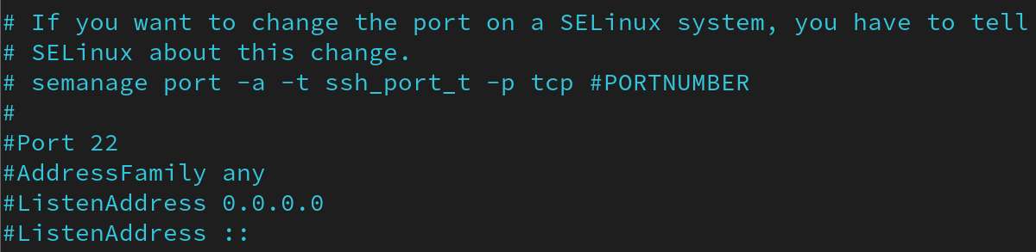
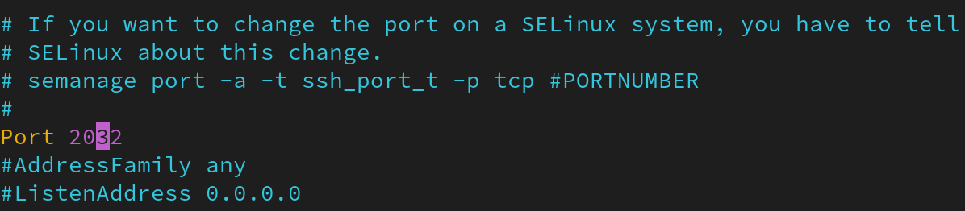

# systemctl restart sshd

SSH Login syntax:
# ssh <username>@<server.IP or server name>
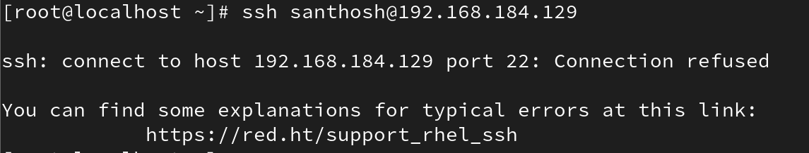
By default, direct root login is not allowed for security reasons.

Secure Copy (SCP)
SCP is used to securely copy files between local and remote systems.
Basic syntax:
# scp <options> <source> <destination>
Example to copy a file from a remote server to local:
# scp root@92.11.11.128:/root/filename /local/destination/
To enable verbose mode:
# scp -v <source> <destination>

SSH Key Generation and Authentication
SSH supports key-based authentication using a pair of keys: public and private.
To generate keys:
# ssh-keygen
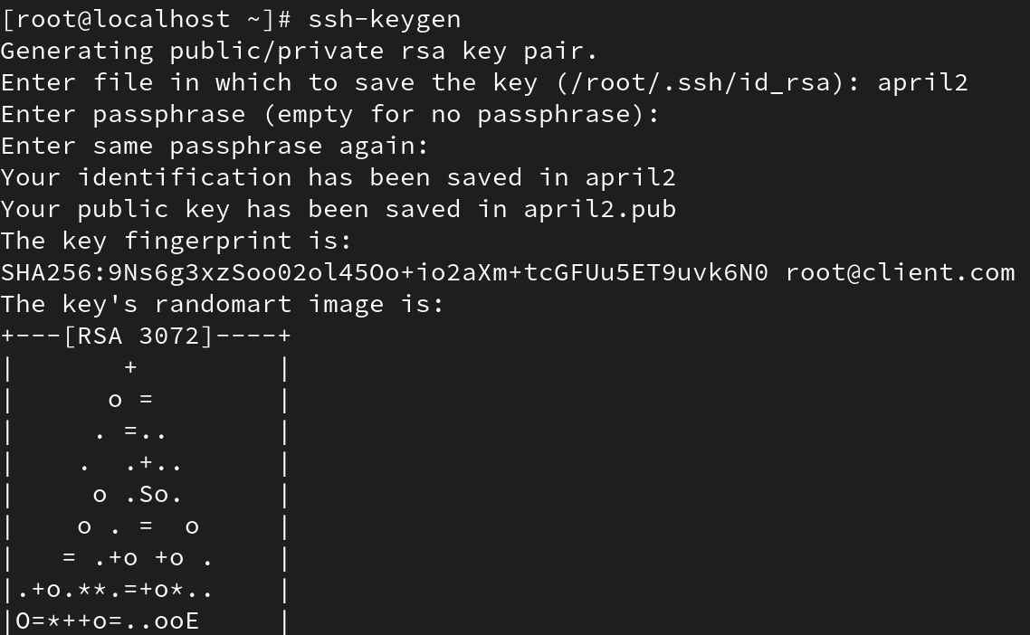

To share the public key with a remote server for passwordless login:
# ssh-copy-id -i /root/.ssh/id_rsa.pub user@server_ip
The -i option specifies the identity file (public key) to use.
To copy a public key to a specific file on the remote server:
# scp /root/.ssh/id_rsa.pub root@192.168.111.129:/home/centos/.ssh/authorized_keys
This places the public key in the remote user’s authorized_keys file, enabling key-based authentication.

