DNS Server Configuration (BIND)

• DNS translates the human-friendly domain name into an IP
address (like 93.184.216.34) so your browser can connect to the
right server. It is called forward lookup zone (A)
• DNS can also do the reverse: mapping an IP address → domain
name. It is called reverse lookup (PTR)
• PORT NUMBER 53
• Service name : named
• Package required : bind bind-utils

Step 1: Install bind and bind-utils packages
These packages are required to configure a DNS server.
- bind: The main DNS server package.
- bind-utils: Provides tools such as *dig*, *nslookup*, *host*, etc.

Command:
yum install bind bind-utils
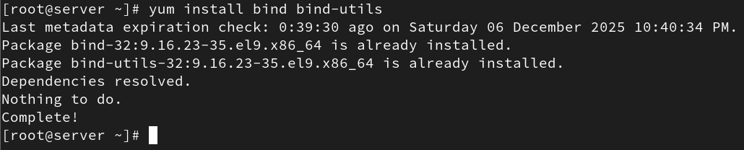

Enable the service after installing

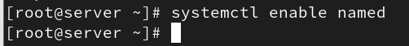

Step 2: Modify /etc/named.conf file
This is the main configuration file of the BIND DNS server.
You remove unnecessary lines from logging to root.key to keep the file clean.
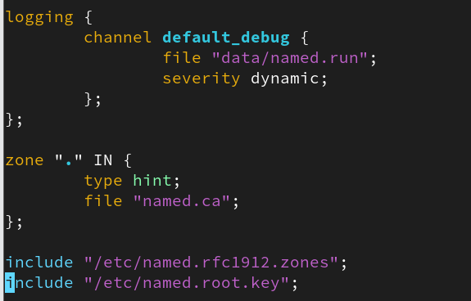

Command:
vim /etc/named.conf

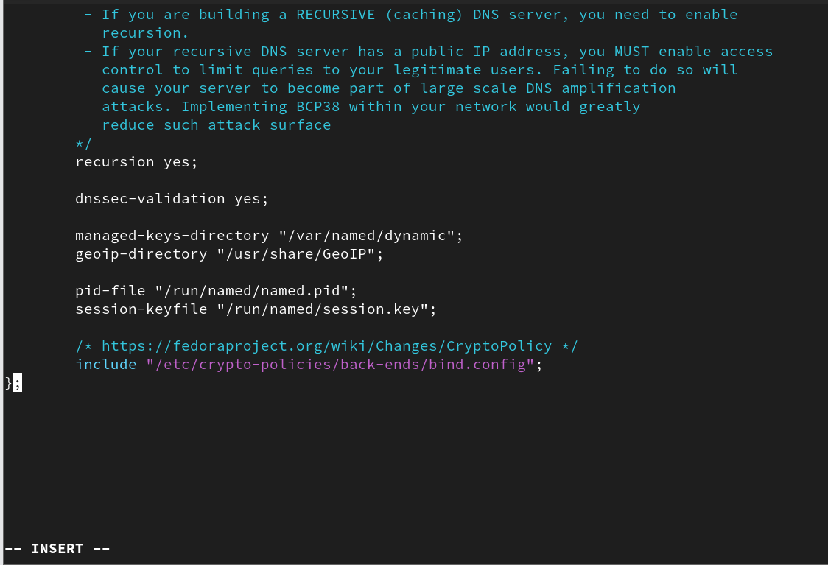

Step 3: Append rfc1912 zones file
This file contains standard recommended DNS zone configurations.
Appending it adds default zone configurations.
Command:
cat /etc/named.rfc1912.zones >> /etc/named.conf

• The file /etc/named.rfc1912.zones contains predefined zone
configurations for common zones
• You import those default common zones into named.conf

Step 4: Update named.conf with custom options
You configure:
- The IP addresses the DNS will listen on (53 is DNS port)
- The directory for DNS zone files
- Allow DNS queries from all clients
- Create a custom zone called glotech.com

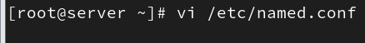

Configuration added:
options {
listen-on port 53 { 127.0.0.1; 192.168.44.10; };
allow-query { localhost; any; };
};

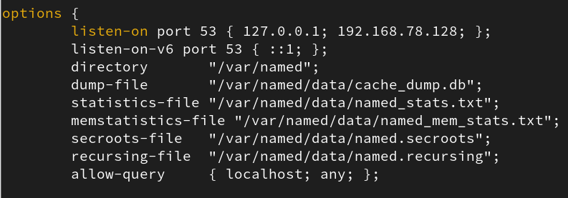

zone "glotech.com" IN {
type master;
file "forward_zone";
};
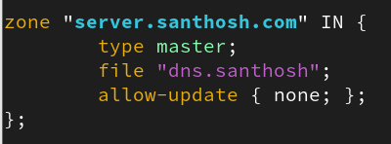

Step 5: Create forward zone file
This file will store DNS records for glotech.com.
We copy a sample file (named.localhost) to use as a template.

Commands:
cd /var/named
cp named.localhost forward_zone

Step 6: Change ownership of the zone file
The named service needs permission to read the zone file.
So, ownership is changed to the *named* user.

Command:
chown named:named forward_zone
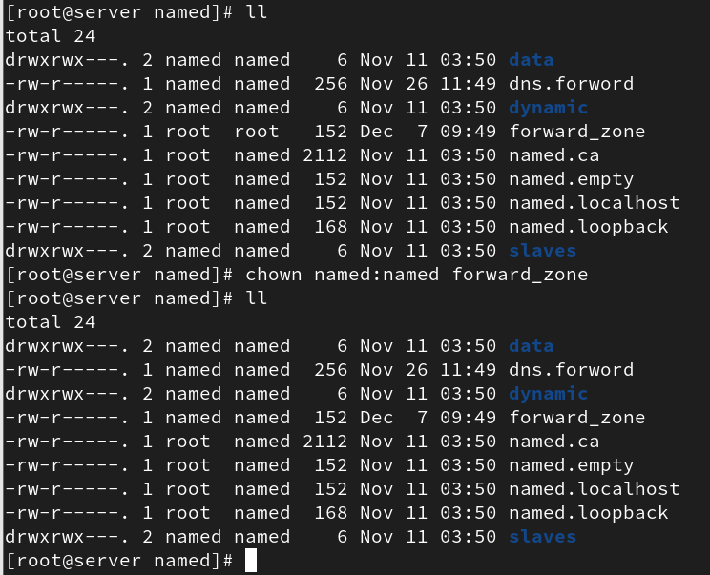

Step 7: Modify forward_zone file
DNS records are added for the domain and hostnames.
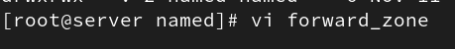

Example records:
glotech.com. IN A 192.168.44.10
server IN A 192.168.44.10
client IN A 192.168.44.11
...
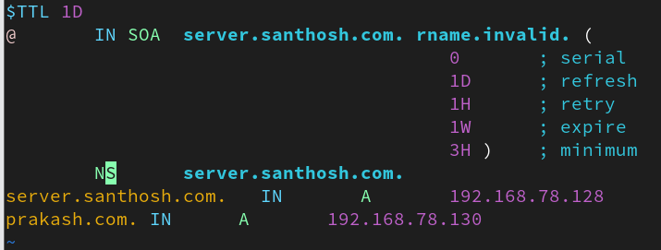

SOA and NS records define the authority and the nameserver for the zone.

Step 8: Update /etc/resolv.conf
This configures the system to use the newly created DNS server.

Content:
search glotech.com
nameserver 192.168.44.10
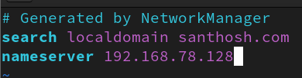

Step 9: Restart DNS service
You restart and enable DNS so it runs on boot.

Commands:
systemctl restart named
systemctl enable named

Step 10: Client-side configuration
Each client must point to the new DNS server by updating /etc/resolv.conf.

Content:
search glotech.com
nameserver 192.168.44.10
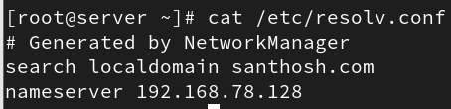

Validation
To test DNS resolution:

Commands:
host glotech.com
nslookup glotech.com
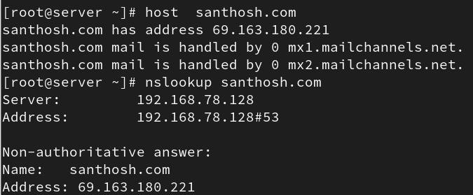

Client side output:
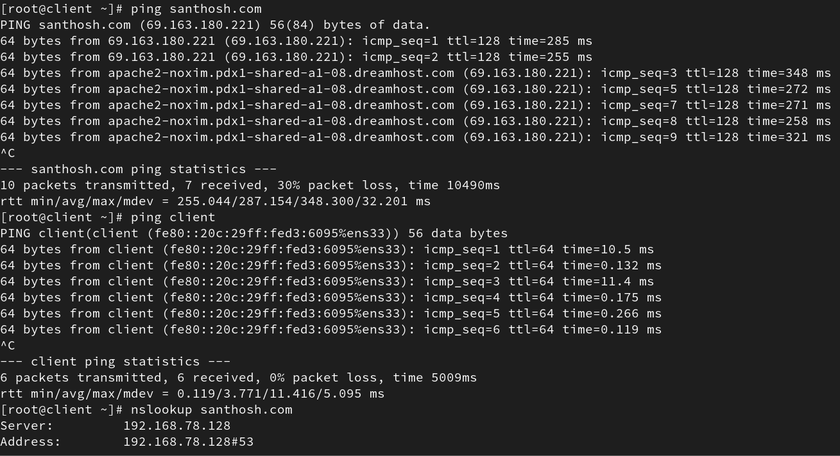
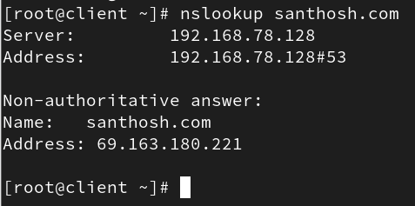

If results show the correct IPs, DNS is workin

This completes the DNS server configuration using BIND.

