FTP (File Transfer Protocal)

Port Number: 20,21
Package Name: vsftpd, ftp

In server:

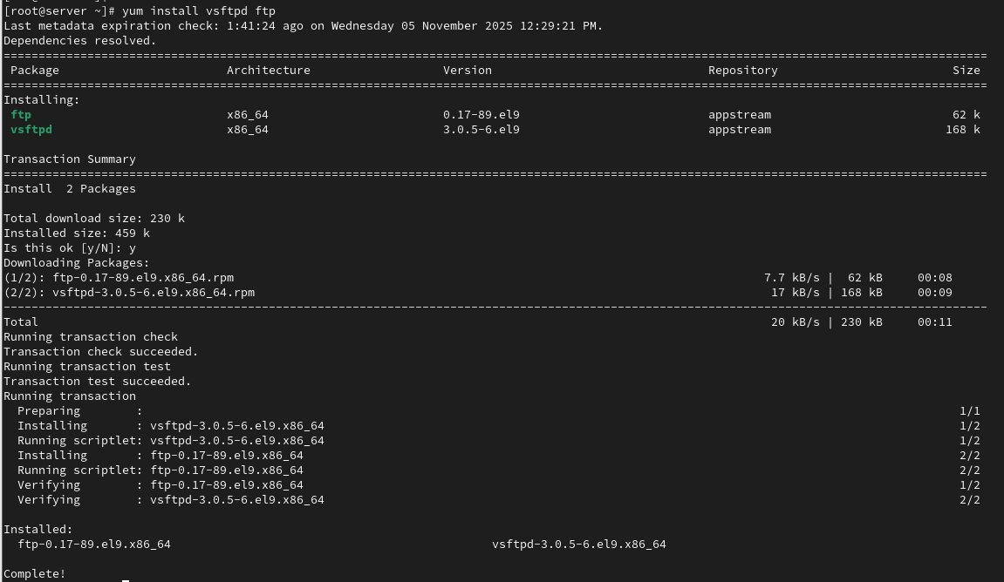

SELINUX=disabled

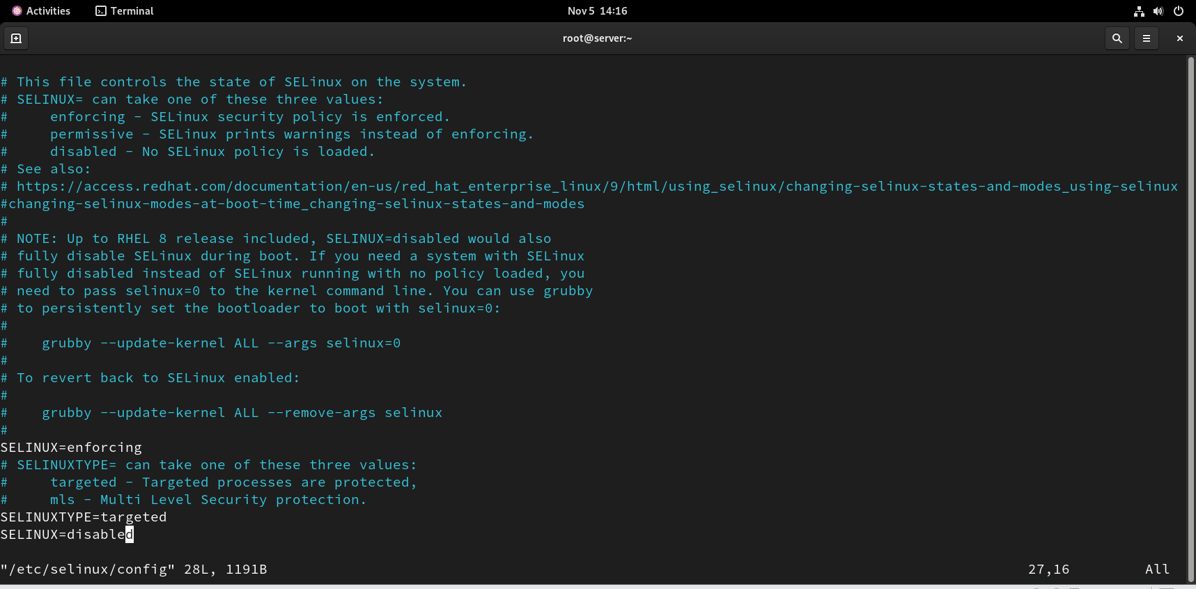

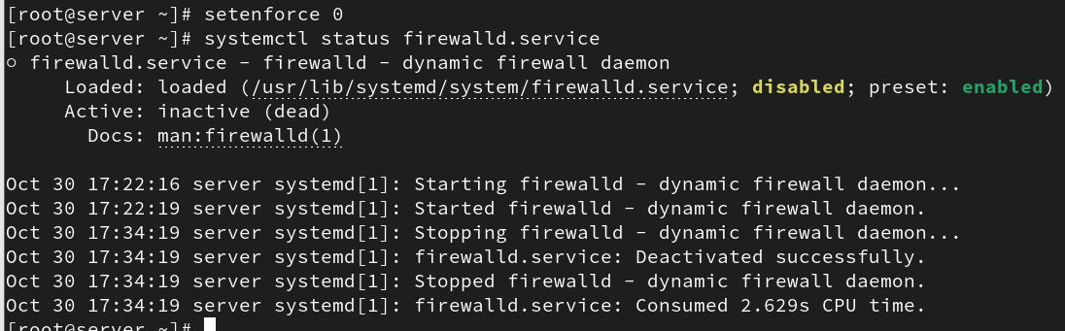

anonymus_enable =YES
anon_upload_enable = YES (Remove # symbol)

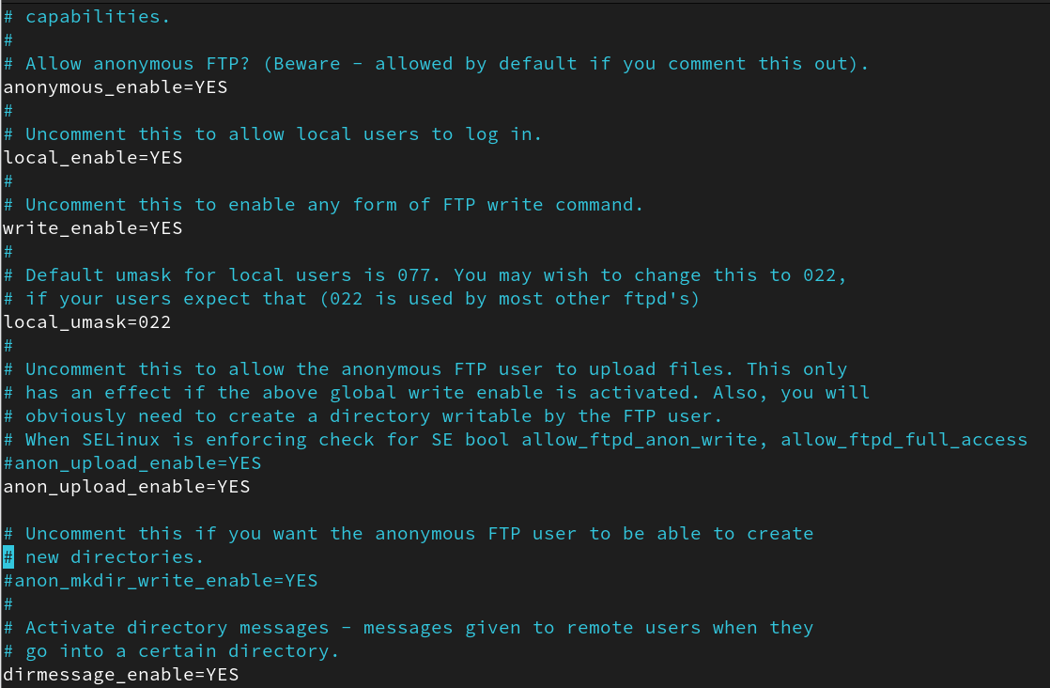

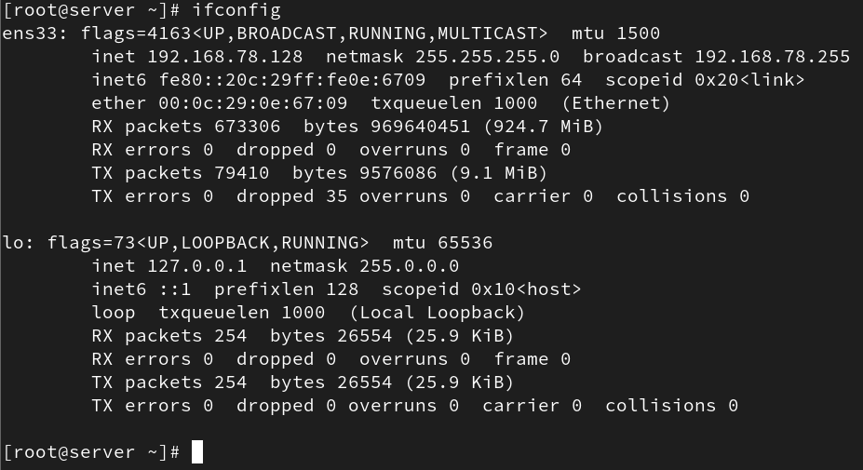

In client:
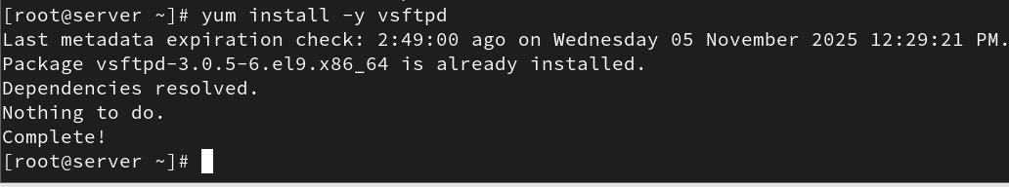

SELINUX=disabled

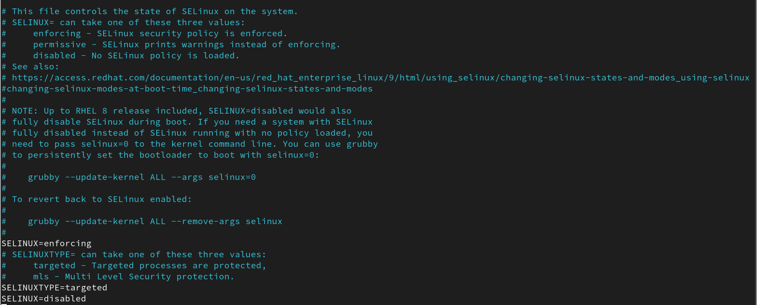

anonymus_enable =YES
anon_upload_enable = YES (Remove # symbol)

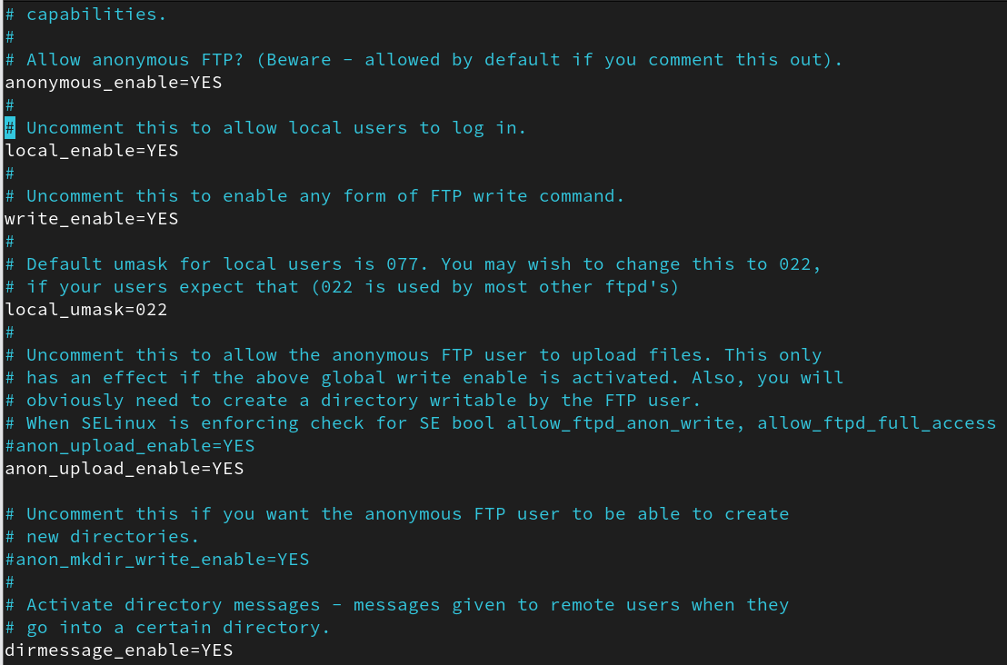

In server:

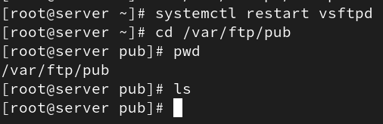

In client:
#ftp server_IP
Name : anonymous
Password: anonymous

